项目名称：LittleApp

登录名：admin 密码：123

在Inner.cs中修改用户名为远程计算机的用户名，密码为远程登录密码

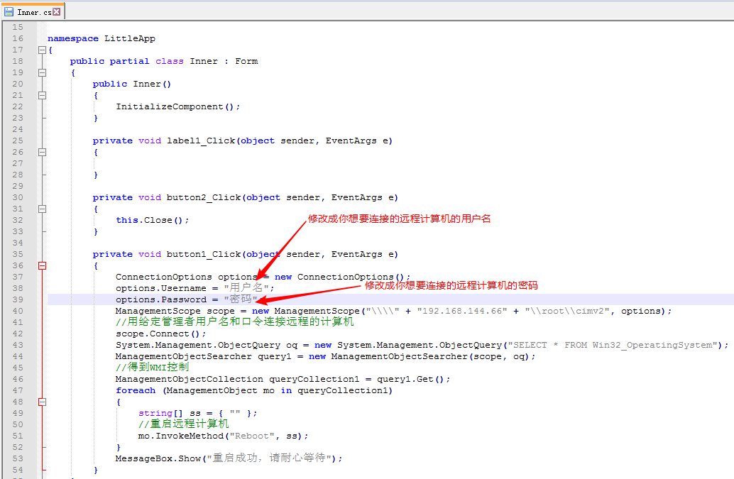

设置窗体：

Remote.cs

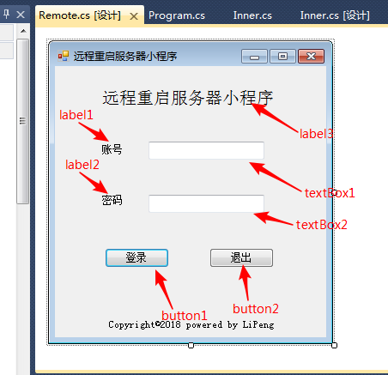

Inner.cs

代码如下：

using System;

using System.Collections.Generic;

using System.ComponentModel;

using System.Data;

using System.Drawing;

using System.Linq;

using System.Text;

using System.Windows.Forms;

using System.Management;

namespace LittleApp

{

public partial class Inner : Form

{

public Inner()

{

InitializeComponent();

}

private void label1_Click(object sender, EventArgs e)

{

}

private void button2_Click(object sender, EventArgs e)

{

this.Close();

}

private void button1_Click(object sender, EventArgs e)

{

ConnectionOptions options = new ConnectionOptions();

options.Username = "用户名";

options.Password = "密码";

ManagementScope scope = new ManagementScope("\\\\" + "192.168.144.66" + "\\root\\cimv2", options);

//用给定管理者用户名和口令连接远程的计算机

scope.Connect();

System.Management.ObjectQuery oq = new System.Management.ObjectQuery("SELECT * FROM Win32_OperatingSystem");

ManagementObjectSearcher query1 = new ManagementObjectSearcher(scope, oq);

//得到WMI控制

ManagementObjectCollection queryCollection1 = query1.Get();

foreach (ManagementObject mo in queryCollection1)

{

string[] ss = { "" };

//重启远程计算机

mo.InvokeMethod("Reboot", ss);

}

MessageBox.Show("重启成功，请耐心等待");

}

}

}

窗体如下：

