Spacetime quantities from causal order: an operational ladder with preregistered validations at finite density
Juneyoung Kim
Independent researcher
lpaiu.cs@gmail.com

Abstract
Causal structure fixes conformal geometry, while volume information fixes scale under standard hypotheses. We ask what finite causal data can operationally reconstruct when each auxiliary ingredient is declared rather than left implicit. In controlled $(1+1)$D (and, for dimension, higher-D) Minkowski models, we organize the procedures as a branched ladder. Order statistics estimate dimension; global event density calibrates proper time from interval cardinality; clock labels yield radar time and unsigned distance; orientation and overlapping charts recover oriented Lorentz maps and an observer atlas; and a local measure profile removes a position-dependent volume-error floor. Three counterexamples delimit these claims: causal order alone fixes no scale, one observer cannot distinguish a spatial reflection, and finite signal speed alone does not imply Lorentzian structure; a Rindler analogue confines radar reconstruction to the expected wedge. Beyond these flat benchmarks, preregistered $(3+1)$D tests probe the two parts of the causal-structure-plus-volume statement. In a vacuum plane wave with exactly flat coordinate volume form and sprinkling law, an order-only statistic detects a deliberately strong pure-Weyl deformation at finite density—an existence result, not a sensitivity measurement. On a frozen Schwarzschild exterior patch, separate stages confirm the paired relation shift and detect single-poset discrimination with incomplete separation. A prediction-anchored stage then finds Poisson counts concordant, within a frozen 2.5% band, with independently certified continuum 4-volume at every rung of a four-rung mass ladder, the deepest anchored at $r=4M$. The contribution is an auditable dependency ledger that states both what each reconstruction requires and where it fails; these controlled validations are not evidence that spacetime is discrete or reducible to causal order.
Keywords: causal sets, spacetime reconstruction, radar coordinates, Poisson sprinkling, preregistered analysis
Submitted to: Classical and Quantum Gravity

1 Introduction
A conservative reading of the causal-set and order-first programs is that, for future- and past-distinguishing Lorentzian spacetimes, causal or chronological structure determines the conformal class. Supplying a volume element fixes the remaining conformal factor, up to diffeomorphism and unit conventions [1, 2, 3, 4, 5, 6]. This paper treats that statement operationally and quantitatively. Rather than ask whether spacetime “is” a causal set, we ask: fix a causal (or null-accessibility) order in a known model; then, supplying an explicitly declared ingredient set, which spacetime quantities can a finite procedure actually reconstruct, with what error, and where does each reconstruction stop?
The value of posing it this way is an explicit ledger. Many individual reconstructions here are standard—proper time from longest chains [7], volume from interval cardinality [1], dimension from ordering fractions [8, 9], radar coordinates from an observer protocol. What is easy to lose, and what we make explicit, is exactly which extra structure each requires and what remains underdetermined without it. The ladder also isolates three instructive negative results: causal order alone does not fix conformal scale; a single observer yields only unsigned distance (a reflection degeneracy); and finite signal speed alone does not imply Lorentzian structure.
The contributions are: (i) a reconstruction ladder that indexes recoverable spacetime quantities by the minimal supplied ingredient set, with per-rung error behaviour in controlled models; (ii) grounded validations of dimension, proper time, radar decomposition, Lorentz-map and atlas consistency, and measure-dependent volume; (iii) three bounding negative results (conformal scale, reflection degeneracy, finite-speed lattice); (iv) a Rindler reconstruction-inaccessibility analogue; and (v) a preregistered $(3+1)$D capstone validation that a pure-Weyl deformation of the light cones—at identical coordinate volume form and sprinkling law—measurably moves the causal order at finite density (section 6), together with its type-D (Schwarzschild) extension, where separate preregistered stages confirm the paired claim and detect single-poset discrimination (section 6.7); and (vi) a certified diamond-volume enclosure and a preregistered, prediction-anchored Poisson-count validation across a four-rung Schwarzschild mass ladder (section 6.8), with an auxiliary instrument audit of the oracle stack (section 6.9). All results are controlled validations, not evidence that geometry reduces to order.
A literature priority search (August 2026) found partial overlap in four areas: causal-order-and-number/volume reconstruction (Braun 2025 [10]; Myrheim 1978 [8]; the number-volume correspondence itself is Sorkin’s [11]), Schwarzschild sprinkle-count verification (Homšak–Veroni [12] §V.1), analytic diamond-volume results (Berthiere–Gibbons–Solodukhin [13]; Roy–Sinha–Surya [14]), and Schwarzschild causal-relation algorithms (He–Rideout [15]; for sprinkling-and-relations tooling more broadly, Cunningham–Krioukov [16]). The directed-rounding volume enclosure and the preregistered equivalence gate against it appear to have no direct precedent in that search (section 6.8); the parallel Alfyorov–Shnyukov estimator [17] measures Weyl curvature from Hasse diagrams and is taken up alongside the capstone’s scope in section 6.6.

2 The reconstruction ladder
We separate the primitive from supplied ingredients and index rungs by the minimal ingredient each requires.
The primitive is:
- Causal / accessibility order. A strict partial order on events (in the continuum models, Minkowski causal precedence; null-inclusive).
The supplied ingredient symbols (these form branches, not one linear hierarchy) are:
- M—global event-density calibration. The conversion between event count and physical volume in the declared sampling model.
- O—observer chain with clock labels. A timelike chain carrying ordered tick labels (an operational clock), defining a radar protocol.
- R—oriented synchronized reference. A second beacon chain with calibrated separation, fixing a spatial side.
- A—observer atlas. Multiple overlapping observer charts.
- W—local measure profile / weights. The physical volume element relative to the support sampling measure, normalized to unit mean over the declared support, so that all scale information belongs to M and W carries only position dependence; a constant profile is therefore $W=1$ and supplies nothing beyond M.
Table 1 lists the rungs (minimal ingredient $→$ what is reconstructed).
Table 1. Rungs of the reconstruction ladder: the minimal ingredient set, what it reconstructs, and what bounds it.
Rung | Ingredient | Reconstructed | Bounded by
Measure branch: order, $+$ global density, $+$ local measure
R0 | order only | flat-sprinkling dimension estimate; uncalibrated chain statistics | manifold/model assumptions; no metric scale
R1 | order + M | timelike proper time (interval cardinality $→$ volume $→$ $τ$) | needs a density
R5 | order + M + W | volume under conformal ambiguity; coarse-graining stability | global and local measure supplied
Observer branch: order, $+$ clocked chain, $+$ orientation, $+$ charts
R2 | order + O | radar time; unsigned radar distance | sign undetermined
R3 | order + O + R | signed coordinates; Lorentz map between protocols | supplied orientation
R4 | order + O + R + A | atlas transition maps (Poincaré); invariant agreement | oriented, calibrated charts
The two branches are not of the same kind, and table 1 groups them rather than presenting six co-equal rungs. The measure branch—order, plus a global density, plus a local measure—is the operational form of the causal-order rigidity theorems plus a volume element [2, 3]; it is where the first negative result bites and where the whole of section 6 operates. The observer branch is protocol arithmetic: once a timelike chain with ordered tick labels, an oriented calibrated beacon and overlapping charts have been supplied, a coordinate system’s worth of structure has been supplied, and radar coordinates follow close to definitionally—those rungs validate bookkeeping, and their bounding result, the reflection degeneracy, is the protocol’s own symmetry made explicit rather than a discovered obstruction. The ledger’s value is the explicit per-rung accounting; the theorem content lives on the measure branch.
Three negative results bound the ladder from below (section 5): conformal scale is not fixed by order alone (motivating M and W); a single observer gives only unsigned distance (motivating R); and finite signal speed alone does not give Lorentzian structure. Figure 1 summarizes the ladder.
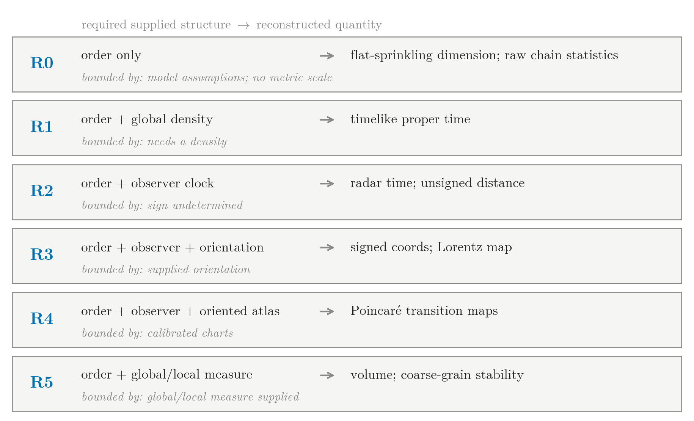
Figure 1. The reconstruction dependency ledger. Each row names a minimal ingredient set and the quantity it unlocks; the observer and measure rows are branches rather than one cumulative linear chain. The “bounded by” line records what that ingredient set still does not supply.

3 Methods: the verified foundation layer
Natural units, $c=1$. The foundation modules were checked for numerical correctness against known results (sprinkling measure, Minkowski causal precedence, longest-chain and interval-cardinality normalizations, Myrheim–Meyer inversion, radar/Lorentz/Rindler formulas); this section states the conventions the results depend on. Figure 2 illustrates the primitive and two of the operational constructions.
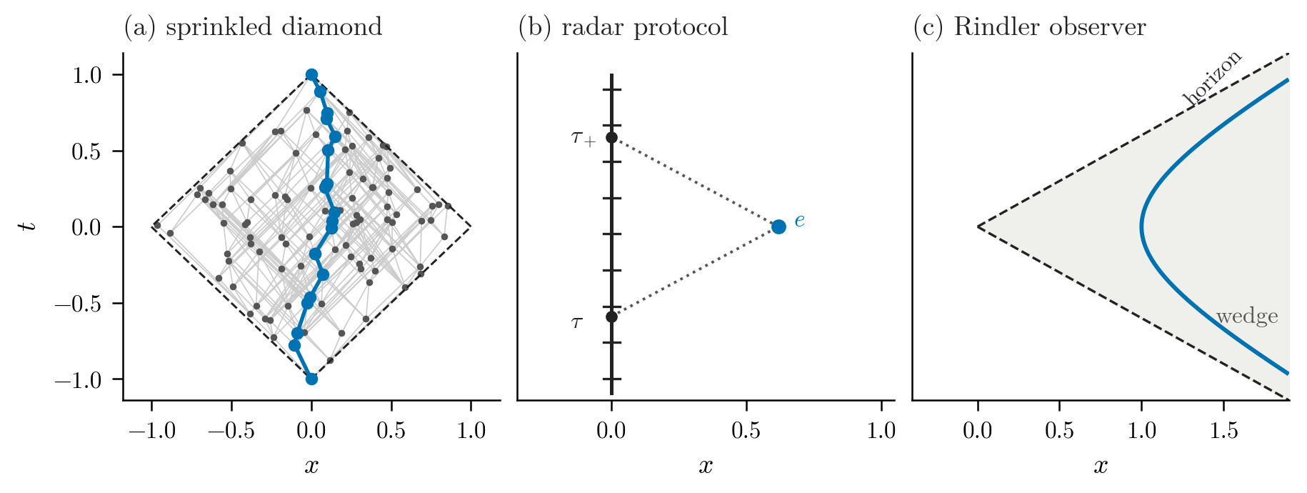
Figure 2. The primitive and two operational constructions (illustrations drawn with the foundation modules at a fixed seed; no measured quantity is displayed). (a) A Poisson sprinkling into a $(1+1)$D causal diamond, with its covering (Hasse) relations in gray and one longest chain between the diamond tips highlighted. (b) The radar protocol: an observer chain with tick labels, and the latest preceding ($τ_{−}$) and earliest succeeding ($τ_{+}$) ticks that bound a target event $e$. (c) An accelerated (Rindler) observer’s worldline; its two-way radar reconstruction is confined to the shaded wedge, whose boundary is the horizon.
- Sprinkling. Events are sampled uniformly with respect to the Minkowski volume in a causal diamond (rejection sampling on the ball-volume slice; equivalently uniform in null coordinates). The $(1+1)$D and $D$-dimensional diamonds and the $(1+1)$D forward cone are provided.
- Causal order. For events $(t,x)$, $i$ precedes $j$ iff $t_{j}−t_{i}>0$ and $(t_{j}−t_{i})^{2}−|x_{j}−x_{i}|^{2}≥−\text{atol}$ (null-inclusive $J^{+}$; strict in time, so irreflexive).
- Longest chain. Topological-sort longest-path dynamic programming on the order; the $(1+1)$D proper-time normalization uses the Brightwell–Gregory constant ($L∼\sqrt{2ρ} τ$, i.e. $L∼2\sqrt{N}$ in a diamond of $N$ events, consistent with section 4.2 and section S1 of the supplementary material), with an endpoint-exclusive counting convention—the chain’s interior elements, two fewer than the count that includes both endpoints—and acknowledged finite-size corrections.
- Interval cardinality. The open Alexandrov interval count $K$ between two events estimates volume $V=K/ρ$; in $(1+1)$D $V=τ^{2}/2$, so $τ_{est}=\sqrt{2K/ρ}$.
- Myrheim–Meyer dimension. The ordering fraction (related pairs over all pairs) is inverted against the known $f(d)$ curve to estimate spacetime dimension in flat Alexandrov intervals.
- Radar coordinates. For a supplied observer chain, $τ_{−}$ and $τ_{+}$ are the latest preceding and earliest succeeding tick labels; radar time is their mean and radar distance their half-difference. A single chain gives unsigned distance; a second oriented chain supplies the sign. Lorentz maps between two inertial protocols are fit on their overlap [18].
- Rindler. An accelerated (Rindler) observer in flat spacetime, with analytic two-way radar ticks; the reconstructible region is the Rindler wedge, with the horizon appearing as a reconstruction-inaccessibility boundary [19].
- Conformal / measure. Positive conformal rescalings preserve causal order while changing volume and clock scale; volume reconstruction then requires supplied measure information (implemented in exp19 as local weights). In the tested uniform random-thinning protocol, reconstruction is stable after density rescaling.

4 Results
Each result is a controlled validation in a known model; we report the grounded number and its producing script.

4.1 R0 — order alone
Dimension. In the declared flat Poisson-sprinkling model, the Myrheim–Meyer order statistic estimates spacetime dimension, as in earlier tests on flat and conformally flat spacetimes [20]: for true dimension 2 the estimate moves $1.95→2.03→2.01→1.99$ at $N=300$, 600, 1200, 2400; for dimension 3, $2.96→2.95→3.00→3.00$; for dimension 4, $4.07→3.97→3.93→3.97$. Endpoint RMSE is lower at $N=2400$ than at $N=300$, with non-monotonic finite-sample fluctuations for dimensions 3 and 4 (exp10; outputs/data/dimension_reconstruction_summary.csv).
Uncalibrated timelike statistic (longest chain). The longest chain follows the Brightwell–Gregory scaling $L∼\sqrt{2ρ} τ$, approached from below at finite density: at $ρ=300$ the normalized length $L/(\sqrt{ρ} τ)$ is 1.325 with endpoints included and 1.085 with endpoints removed, versus the asymptotic $\sqrt{2}≈1.414$. The proper-time estimator reads the endpoint-exclusive length, and its mean error there is $−0.127$; the same chains scored under the inclusive convention give $−0.046$, the two separated by the exact offset $2/\sqrt{2ρ}=0.082$. At this density the median chain carries 12.5 elements including its endpoints, so the two-element difference between the two conventions accounts for most of that residual: at these chain lengths it is a convention effect before it is a finite-size one (exp09; outputs/data/longest_chain_calibration_summary.csv). The approach toward the asymptotic value with $N$ is shown by the chain estimator’s error falling with $N$ in section 4.2. Raw longest-chain length is order-theoretic. Interpreting it as proper time, including the normalization quoted here, belongs to R1 because it requires density and a dimension-specific asymptotic law; absolute scale is not fixed by order alone.

4.2 R1 — order plus measure: timelike proper time
With event density supplied, Alexandrov interval cardinality reconstructs timelike proper time between internal pairs, $τ_{est}=\sqrt{2K/ρ}$. The volume-estimator relative RMSE falls from 0.273 at $N=300$ to 0.105 at $N=2400$. Its separately aggregated RMSE is below the chain estimator’s ($0.382→0.231$) at every $N$, but the volume statistic uses 500 pairs per $N$ whereas the chain statistic uses 125, so this is not a paired comparison, and the chain estimator additionally carries the endpoint-convention offset of section 4.1, so the comparison is not convention-free either (exp07; outputs/data/timelike_pair_reconstruction_summary.csv). In a fixed-interval sanity check, the interval-cardinality formula returns $τ=2.0$ exactly because the full sampling diamond uses $K=N$ and $ρ=N/V$; this is a normalization identity, not an independent accuracy test. The chain estimate converges toward it (0.303 at $N=200$ to 0.0125 at $N=2000$) (exp03; outputs/data/timelike_reconstruction_summary.csv). The observed errors are consistent with finite-sampling noise at the tested settings: the ratio of reconstruction RMSE to the predicted Poisson standard deviation is 0.93–1.07 across $N$ (binomial 1.00–1.14). Smaller bias or other estimator errors are not excluded (exp08; outputs/data/probe_pair_statistical_calibration_summary.csv).

4.3 R2 — order plus observer: radar time and unsigned distance
Given an observer chain with clock labels, radar time and unsigned radar distance are reconstructed from causal accessibility; at $N=300$ the error falls roughly by half per doubling of tick resolution—radar-time RMSE from 0.027 at 16 ticks to 0.0033 at 128 ticks, radar-distance RMSE from 0.071 to 0.0085, with the accessible fraction 1.0 throughout (exp11; outputs/data/discrete_radar_reconstruction_summary.csv). A single observer determines only unsigned distance (the reflection degeneracy of section 5).

4.4 R3 — plus orientation: signed coordinates and the Lorentz map
A second synchronized beacon chain with known separation supplies orientation, lifting the degeneracy to signed $(1+1)$D coordinates. The affine map recovered between two oriented inertial protocols approaches the Lorentz boost, with the fitted-$β$ RMSE falling with tick density. Averaged over $N$ as in figure 3, it falls from 0.00495 at 32 ticks to 0.000975 at 128 ticks for $β=0.3$, and from 0.01345 to 0.00431 for $β=0.6$ (exp13; outputs/data/oriented_radar_lorentz_summary.csv).
Figure 3 collects the convergence behaviour of the first four rungs: dimension recovery (a), timelike proper time (b), observer radar (c), and Lorentz-map recovery (d).
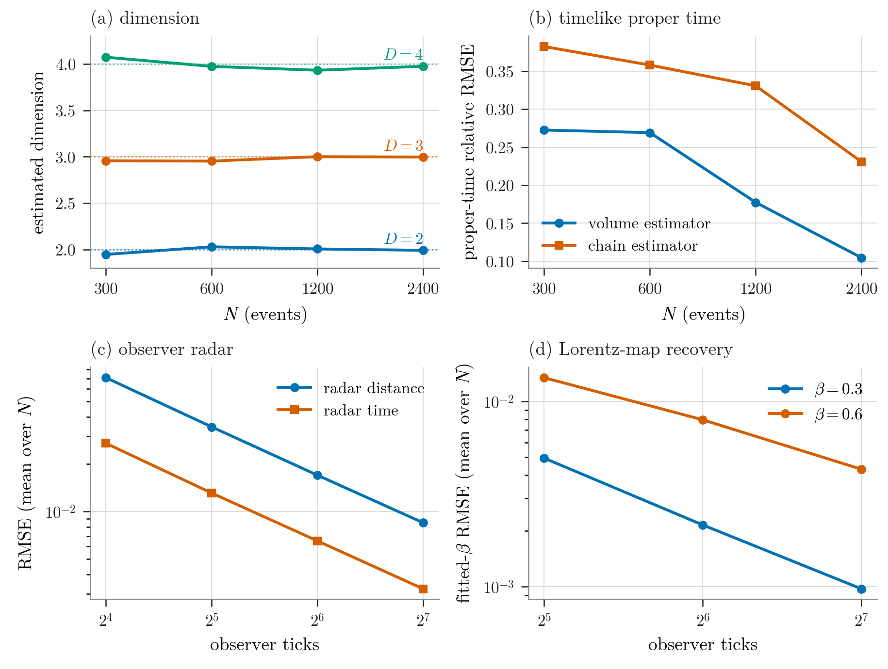
Figure 3. Reconstruction accuracy in controlled models. (a) Myrheim–Meyer dimension estimates lie near $D=2$, 3, 4; endpoint RMSE is lower at $N=2400$ than $N=300$ despite non-monotonic finite-sample fluctuations (exp10). (b) Timelike proper-time relative RMSE falls with $N$, the interval-volume estimator below the separately aggregated longest-chain estimator (exp07). (c) Observer radar time and distance RMSE fall about by half per doubling of clock ticks (exp11). (d) Recovered Lorentz $β$ RMSE falls with clock ticks for two boosts (exp13). Panels (c, d) are means over $N$; axes are logarithmic where noted.

4.5 R4 — plus oriented atlas: transition-map consistency
With overlapping observer charts that retain the synchronized, calibrated orientation reference from R3, affine Lorentz/Poincaré transition maps fit on chart overlaps show approximately consistent composition and invariant agreement, improving with tick density: the mean transition-map $β$ error falls $0.0047→0.0012$ and the invariant-interval RMSE $0.050→0.010$ (ticks $32→128$), while loop closure ($A→B→C$ versus direct $A→C$) has a $β$-composition error of $0.0072→0.0017$ (exp14; outputs/data/observer_atlas_transition_summary.csv, outputs/data/observer_atlas_loop_summary.csv). On exact analytic input the same transition/loop machinery recovers the maps to machine precision ($β$ error $∼5.6×{10}^{−17}$, RMSE $∼4×{10}^{−17}$) (exp15; outputs/data/exact_poincare_map_sanity.csv).

4.6 R5 — plus conformal measure: volume and coarse-graining
Positive conformal rescalings preserve causal order while changing volume and clock scale: under constant (1.0/1.5/2.0) and sinusoidal rescalings the causal matrix is unchanged and the reconstructed dimension is identical (2.020), while the proper-time ratio tracks 1.0/1.5/2.0 and the volume ratio 1.0/2.25/4.0 (exp18; outputs/data/conformal_order_ambiguity_summary.csv). Two different things must therefore be supplied, and they fail differently when withheld: a scale (M, one number) and a shape (W, a field). The profile exp19 tests is genuinely position-dependent—$Ω(t)=1+0.3sin(πt/T)$ moves the local volume element by a factor of 3.45 across the diamond (0.49 to 1.69) while leaving every global summary near flat: the diamond volume moves by 2.7% (exp18’s sinusoidal row). A reconstruction holding only the global density therefore has almost no bias to correct (unweighted volume bias $−0.0057$ to $−0.0028$), but it carries a position-dependent error that no single rescaling removes: its relative RMSE stalls at $0.373→0.298→0.300$ across the tested $N$. Supplying the local weights removes the floor: the weighted relative RMSE falls $0.235→0.176→0.119$, tracking the flat-profile sampling floor ($0.234→0.174→0.118$) to within 1.3%, and the unweighted-to-weighted volume-RMSE ratio grows $2.0→2.8→4.3$ with $N$—the signature of a removed systematic rather than of reduced noise. What R5 demonstrates is the replacement of a non-vanishing error floor by flat-case, noise-limited error scaling—a consistency statement, not a bias correction (exp19; outputs/data/weighted_conformal_volume_summary.csv).
The constant-1.5 profile in the same table is a control, not the result: a constant weight rescales estimate and truth alike, so its weighted relative RMSE equals the flat profile’s at every tested $N$, and its unweighted bias ($∼−0.29$) is exactly the missing global factor—a normalization identity in the sense of section 4.2, whose repair is R1’s ingredient M, not W. The analytic volume/proper-time formulas are verified to $∼1×{10}^{−7}$ (exp20; outputs/data/conformal_volume_exact_sanity.csv). Under random thinning, density-rescaled reconstruction is stable (volume RMSE $0.018→0.009$, dimension steady $∼2.0$) while the uncorrected estimate blows up to RMSE 0.270 (bias $−0.183$) at 25% retention. The thinning is uniform, so its keep probability is a single global scalar: a robustness statement about M, not a second W-level result (exp23; outputs/data/thinning_coarse_graining_summary.csv). The same measure information could be encoded in the sampling law instead of as post-hoc weights; that variant was not run. Figure 4 shows the measure dependence directly.
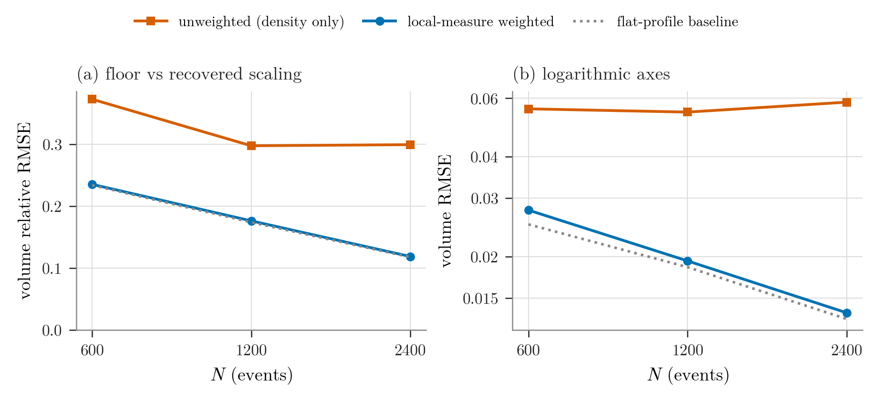
Figure 4. R5: what the local measure buys. For the position-dependent profile, the unweighted estimate’s relative error stalls at a floor that no global recalibration removes, while the weighted estimate falls with $N$ onto the flat-profile sampling floor (a); panel (b) shows the same comparison in absolute volume RMSE on logarithmic axes, where the two carry visibly different slopes. The constant-profile arm is not plotted—it is a normalization identity, R1’s ingredient (section 4.6). Order alone fixes no absolute scale, and no scale alone fixes a profile.

4.7 Horizon analogue — Rindler reconstruction-inaccessibility
For an accelerated (Rindler) observer in flat spacetime, two-way radar reconstruction is confined to the Rindler wedge, and nothing leaks out of it: in every configuration the classification records zero false positives and zero false negatives, precision $=$ recall $=1.0$. That scoring is against the events finite clock coverage makes accessible, not against the ideal wedge; measured against the ideal wedge the same reconstruction is incomplete, recovering a fraction 0.74 to 0.84 of it, because part of the wedge lies beyond the observer’s tick range. The wedge itself covers about a quarter of events (accessible fraction $∼0.25$), and the in-wedge radar-time RMSE falls with tick resolution (e.g. $0.0098→0.0023$) (exp16; outputs/data/rindler_horizon_reconstruction_summary.csv). Comparing observers directly, all events are accessible to the inertial observer while only $∼0.25$ (ideal wedge) / $∼0.21$ (finite clock coverage) are accessible to the Rindler observer, and no event is Rindler-accessible but inertial-inaccessible—a strict subset (exp17; outputs/data/inertial_vs_rindler_accessibility.csv). This is a controlled flat-spacetime horizon analogue, not a black-hole simulation.

5 Negative results that bound the ladder
- Order fixes neither scale nor profile. Positive conformal rescalings leave the causal order invariant while changing physical volume and clock scale (section 4.6). Absolute scale requires a supplied measure (ingredient M), and position dependence a supplied profile (ingredient W); order alone supplies uncalibrated order statistics, not a proper-time scale.
- A single observer gives only unsigned distance. One chain’s radar distance is $|x|$: two targets at $x=+0.1$ and $x=−0.1$ return the identical single-observer distance 0.1, while the two-chain oriented protocol recovers the signed positions $+0.1$ and $−0.1$. Signed coordinates therefore require an orientation reference (ingredient R) (exp12; outputs/data/single_observer_reflection_degeneracy.csv).
- Finite signal speed alone does not give Lorentzian structure. After calibrating density at the final time, a regular finite-speed lattice shares the continuum model’s leading quadratic count growth: finite-$t$ counts differ before the calibration time ($t=5$: 21 vs 14.75) and agree at it by construction ($t=30$: 496 vs 496). Yet its edges lie only along the two lightcone diagonals (465 each), so it has a discrete symmetry, not the continuous Lorentz symmetry of a sprinkled causal set (exp05; outputs/data/finite_speed_lattice_growth.csv). Finite speed is necessary but not sufficient; statistical Lorentz compatibility is the additional structure. That it cannot suffice is a theorem—no Lorentz-invariant regular discretization of Minkowski exists [21], which is the standard argument for random sprinkling [22]—and the lattice also shows why the diagnosis must be embedding-level: on a causal diamond the light-cone lattice’s ordering fraction approaches the sprinkled value $1/4$, so the R0 dimension estimator reads $d=2$ for it as well, and what separates the two is where the edges lie, not the order statistic used here.
An exploratory spacelike-distance proxy (common-past / common-future / enclosing-interval counts) is reported as boundary-dependent and not a validated spacelike estimator: the counts vary strongly with the sampling region rather than tracking spacelike distance cleanly (exp06; outputs/data/spacelike_distance_proxy_summary.csv).

6 Capstone validation: finite-density detectability of the conformal class
The ladder reconstructs quantities from supplied ingredients inside flat models; section 5 bounds it from below. This section caps it from the other side, with the converse of the first negative result. Section 4.6 showed that within a conformal class, order carries no scale: positive rescalings leave the causal matrix unchanged. By the theorems that motivate the program, order determines the conformal class itself—so across conformal classes order must differ. Whether that difference survives finite density, for a curvature channel that touches nothing but the order, is the question this capstone answers affirmatively, as a preregistered experiment (P14 in the program’s internal numbering; within this program, the first finite-density crossing of the conformal-flatness ceiling, via a 4D type N pure-Weyl construction).

6.1 The $(1+1)$D conformal ceiling
Every $(1+1)$D metric is conformally flat, so in the $(1+1)$D stages of this program (and its curvature-focused companions P12–P13) curvature could reach the order only through the volume-coefficient channel: those experiments tested curvature entering through the measure/counting channel, and the channel in which order directly carries a conformal-class difference could not be tested there at all. This was an intended dimensional limit of the models, not a confounded experiment: Weyl curvature—the conformal-class content of curvature—is identically zero below four spacetime dimensions, so a direct test needs a 4D construction built so that the measure channel is exactly frozen while the conformal class moves.

6.2 Pure-Weyl control construction
The construction is a vacuum plane wave in Brinkmann coordinates with profile $A(u)(x^{2}−y^{2})$ on a constant-$A$ slab: Ricci-flat, Petrov type N, with $detg=−1$ identically. Because $detg=−1$, the coordinate volume form and the Poisson sprinkling law are identical to flat spacetime. That identity supports the strongest form of pairing, and C1 uses it: C1’s control reading is the same sprinkled point set read with $A=0$, so for C1 any difference between the two readings is a functional of the relation change alone—it cannot be a sampling artifact, an intensity mismatch, or a calibration residual. C2 deliberately does not pair: its two arms are independent, unpaired sprinkling streams drawn under the identical sprinkling law, with finite-sample variation controlled by its frozen interval rules rather than removed by pairing—because its claim is about telling one ensemble’s posets from the other’s, not about a within-point-set counterfactual (section 6.3). What is not identical between geometries is the causal-diamond volume: the light-cone boundary tilts, and at equal proper time the curved-arm diamond volume sits 0.4% ($wT=1$) to 7.3% ($wT=2$) above flat—a deterministic design check pins both numbers, against the closed form $V_{A}/V_{0}=1+(wT)^{4}/252+O((wT)^{8})$—the plane-wave instance of the small-causal-diamond volume expansion [23, 24], whose leading correction at Ricci-flatness is fourth order in the curvature scale. Those percentages describe a small diamond on the axis, and the frozen operating point is neither small nor on-axis: the probe chain selected aniso-a1.0, a slab spanning $1/π=0.318$ of the way to the first conjugate point, on a box elongated three to one along the focusing transverse axis. The order statistic therefore reads mostly off-axis pairs in the direction where the cones open, which is why its response is a factor of three rather than a few percent. This is a deliberately strong operating point, not a weak-curvature probe. “Same measure” here means the volume form and sprinkling law only, never interval volumes; conflating the two was the central error of this stage’s first design draft, caught in review before the freeze, and the distinction is load-bearing.

6.3 Finite-density detection design
An exploratory probe chain (four probes and a confirmation stage, run on seed streams disjoint from everything that follows) selected the operating point—slab $(1.0,1.0,2.0,6.0)$, $w=1.0$, expected 300 events per sprinkling—and the primary statistic, the global relation fraction (the one candidate computable from a single poset alone). The preregistered stage then froze two claims with deliberately different boundaries, never merged into one sentence:
- C1 (paired ensemble mean). The estimand is $θ_{Δ}=E[f_{A}−f_{0}]$, the ensemble mean of the net change of the relation fraction over paired readings of the same points—not any single point set’s displacement, and not the gained-plus-lost total motion. Confirmation requires the 95% Student-$t$ interval of the mean paired difference ($n=3000$ sprinklings) to sit entirely above a frozen margin $ε_{Δ}=3.579×{10}^{−4}$, an operational margin anchored to the probe chain’s confirmed block.
- C2 (single-poset classifier, independent replication). A frozen classifier reading only the single-poset relation fraction must separate curved from flat ensembles ($n=4800$ per unpaired arm) under three frozen interval rules (standardized separation, AUC with an exact boundary bound at complete separation, balanced accuracy), each with its own equivalence band. This claim replicates the probe chain’s confirmation stage on fresh seeds; its failure would have been reported as a conflicting replication, never a retroactive cancellation.
The stage verdict POSITIVE requires both claims confirmed, certified as a joint event before execution (4000/4000 joint-effect replicates; the null branches certify each claim’s equivalence power separately at an exact Clopper–Pearson [25] 95% lower bound of at least 0.90; a joint equivalence verdict is deliberately not defined, because its joint null rate sits below that floor at the frozen sizes).

6.4 Preregistered result
The campaign ran once, from a clean checkout of the freeze commit, on frozen seeds, and recorded the executing commit in the artifact. Both claims confirmed; the stage is POSITIVE (table 2). Figure 5 shows both claims.
Table 2. Preregistered capstone verdicts. Both claims confirmed; the stage is POSITIVE. The BA interval is the frozen unclipped Wald construction and exceeds the quantity’s range; see the text below.
Claim | Verdict | Result (95% CI)
C1 paired ensemble mean, $n=3000$ | confirmed | mean 0.0502929 $[0.0501046,0.0504812]$; lower end $140×$ the margin $3.579×{10}^{−4}$
C2 classifier replication, $n=4800$/arm | confirmed | separation $s=11.198$ $[11.035,11.362]$; AUC $=1.0$ $[0.999232,1.0]$; balanced accuracy $=1.0$ $[0.986,1.014]$
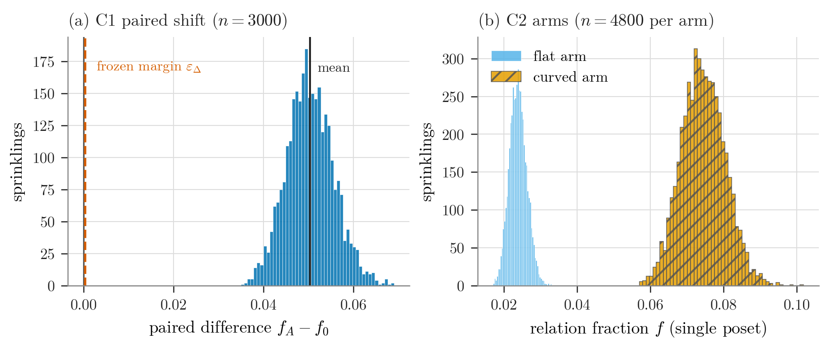
Figure 5. (a) The distribution of the paired per-sprinkling relation-fraction differences $f_{A}−f_{0}$ ($n=3000$), with mean 0.0502929 (95% CI $[0.0501046,0.0504812]$); the CI lower end is $140×$ the frozen margin $ε_{Δ}=3.579×{10}^{−4}$ (marked); (b) the single-poset relation-fraction samples of the two unpaired arms ($n=4800$ per arm), which are completely separated (the frozen exact-bound AUC interval is $[0.999232,1.0]$). Both panels are drawn from the committed artifact (docs/prereg/p14_prereg_results.json); no value is typed in.
The size of the effect is worth stating in the statistic’s own units, which the margin ratio hides: averaged over the paired readings the relation fraction runs 0.023830 flat against 0.074123 curved, a factor of 3.11. The two arms’ relation-fraction samples are completely separated (the minimum curved-arm value exceeds the maximum flat-arm value in 4800 draws per arm); the AUC interval at complete separation is the frozen exact bound, not the degenerate Wald interval. The balanced-accuracy interval got no such treatment: its frozen construction is an unclipped Wald interval on a worst-case standard error, so at BA $=1.0$ it reaches 1.014, outside the range the quantity can take. That is what the preregistration licenses and it is printed as it stands; no verdict depends on it, because the gate reads only the lower end. For orientation only, not as a re-scored gate: the construction the later S5 stage uses for the same quantity—a Clopper–Pearson interval per arm, Bonferroni-combined—gives $[0.998176,1.0]$ on the held-out halves the frozen classifier scores. Every relation census in both claims recorded zero ambiguous and zero escalated pairs. The two sentences the stage licenses were fixed in the preregistration before execution and are recorded in the artifact; in translation they are C1, the paired ensemble mean shift exceeds $ε_{Δ}$, and C2, the probe chain’s separation is independently reproduced (docs/prereg/p14_prereg_results.json; section S2 of the supplementary material records the language of the frozen originals and what holds these renderings to them).

6.5 What this establishes
At a fixed box, density, and profile, an order-only statistic separates flat from curved ensembles: the conformal-class information that order carries by theorem is present in the order at finite density, in the one construction where the sprinkling measure is exactly frozen. The claim is existence, not sensitivity (section 6.6). Together with section 4.6 this closes the conformal story in both directions—within a class, order is blind to scale; across classes, at least at this operating point, order visibly moves.

6.6 What the plane-wave result alone does not establish
It says nothing about sensitivity. The frozen operating point was chosen to be strong, and two things follow that the stage cannot answer: no density or amplitude sweep was run, so the density at which the separation fails is unmeasured; and the slab is elongated three to one along the focusing transverse axis, so whether the effect survives at an isotropic box is untested. Beyond that, it is not a general-Weyl discriminator (the plane wave is Petrov type N and its exact volume form is unrepresentative); it is not Weyl-tensor recovery (detection and recovery are different claims; no reconstructed quantity is produced, which is why this is a capstone boundary experiment and not a new ladder rung); it does not establish box- or density-independence (the licensed sentence is bound to the frozen operating point); and, by itself, it does not open the Schwarzschild generalization. Both claim classes are carried there by the separate preregistered extensions of section 6.7—the C1 paired claim confirmed, C2 single-poset discrimination detected with incomplete separation; the diamond-volume oracle is now certified, and its direct-MC instrument audit is complete as an auxiliary result (section 6.9; supplementary material, section S2), and the prediction-anchored Poisson-count stage is executed across a four-rung mass ladder, CONCORDANT at every rung (section 6.8).
The detection/recovery line also places this stage among its neighbours. The field’s canonical curvature estimator, the Benincasa–Dowker action [26], reads the Ricci scalar—identically zero in both of this paper’s test spacetimes—so the conformal-class channel probed here is complementary to it rather than in competition; and the parallel Alfyorov–Shnyukov estimator [17], which recovers $E_{ij}E^{ij}$ from Hasse-diagram covariances on pp-wave diamonds, works in this same channel and makes the stronger claim—recovery, where this stage establishes detection—so it is the natural sequel this stage does not attempt.

6.7 Type-D extension: preregistered C1-paired confirmation and C2-unpaired detection in Schwarzschild
The paired half of the capstone design transfers to the Schwarzschild exterior on a measure identity: in Schwarzschild coordinates the volume element is $\sqrt{−g}=r^{2}sinθ$—independent of the mass and equal to the flat spherical element—so one sprinkle of a coordinate patch serves both geometries, exactly as $detg=−1$ served the plane wave. What the identity controls is the sampling measure; individual diamond volumes differ under the two causal structures, and that difference is part of the signal (the section 6.2 distinction, unchanged). The frozen patch is the S1 solver domain ($M=1$, exterior shell $r∈[10,20]$, polar cap, coordinate-time extent 40), with $N∼Poisson(300)$ events per reading and the S1 predicate at tolerance $1×{10}^{−8}$ with escalation to $1×{10}^{−10}$. A separate cost measurement (S1) prices that causal-predicate component—about 0.77 ms per pair on the tested solver, patch, and tolerance, roughly $360×$ the plane-wave predicate (docs/prereg/p14_s1_cost.json).
An exploration stage (S3, seed-ledger disciplined, preserved with its raw per-reading arrays) measured the paired shift and sized a preregistered confirmation (S4). The frozen rule (docs/prereg/p14_s4_schwarzschild_c1.md) fixes two gates evaluated on identified intervals with strict comparisons: a primary detection gate (identified CI95 above the frozen threshold $ε_{det}=0.0036$, about 10% of the exploration anchor, in the frozen negative direction) and a secondary replication gate (the independent two-sample Welch CI95 of the S4$−$S3 difference inside $±ε_{rep}=±0.0012$, one exploration reading-SD); a verified inclusion makes the joint verdict numerically equivalent to the replication gate at these margins. Branch powers were certified before the freeze by resampling both blocks from a conservatively scaled empirical distribution (20000/20000 on every branch, exact Clopper–Pearson 95% lower bound 0.9998), with a constructed negative-control battery proving each gate can fail. The campaign ran once, from the exact freeze checkout, with an 8-file content-addressed manifest verified at entry and at exit; the frozen gates and results are in table 3.
Table 3. S4 frozen gates and results.
Gate | Frozen condition | Result | Verdict
A: C1 detection (primary) | identified CI95 top $<−0.0036$ | CI95 $[−0.036211, −0.035953]$ | pass ($10×$ margin)
B: replication (secondary) | Welch CI95 of S4$−$S3 inside $±0.0012$ | $[−0.000183, +0.000194]$ | REPLICATED
Stage verdict: CONFIRMED. The census recorded zero ambiguous pairs and one escalated pair, resolved at the tighter tolerance. The two sentences the stage licenses, in translation (docs/prereg/p14_s4_results.json), are on the frozen Schwarzschild coordinates and domain, the paired ensemble mean shift exceeds the frozen detection threshold in the frozen direction—a finite-density causal census detects the light-cone deformation of type-D vacuum curvature at C1 grade; a program-internal statement, and the independent two-sample difference between the S4 and S3 blocks lies inside the replication band: the exploration effect is quantitatively reproduced.
A second, separate preregistered stage (S5) carries the single-poset claim class. Guided by a committed stored-data feasibility audit (docs/prereg/p14_c2_feasibility_audit.json, exploratory, zero additional solver calls, conservatively anchored), its rule (docs/prereg/p14_s5_schwarzschild_c2.md) declares—before sizing and independently of the confirmation data—AUC 0.60 as the minimum practically useful single-poset discrimination. Two independent arms (fresh Schwarzschild and fresh flat sprinkles; 300 readings each by a pre-declared minimum-$n$ rule with directly certified branch powers) score each reading by its global relation fraction; the primary gate is an unclipped DeLong [27] AUC CI95 with a four-way outcome (detected / equivalent-at-margin / direction-reversed / inconclusive, strict comparisons, identified-agreement across the curved bound series), and a secondary out-of-sample balanced-accuracy gate uses a deterministic Clopper–Pearson–Bonferroni interval with a train-half-only threshold. The campaign ran once from its own exact freeze checkout; the frozen gates and results are in table 4.
Table 4. S5 frozen gates and results.
Gate | Frozen condition | Result | Verdict
Primary: AUC (DeLong) | CI95 lower $>0.60$ | AUC 0.9734, CI95 $[0.9630, 0.9837]$ | DETECTED
Secondary: out-of-sample BA | joint CI95 lower $>0.60$ | BA 0.9033, CI95 $[0.8356, 0.9500]$ | pass
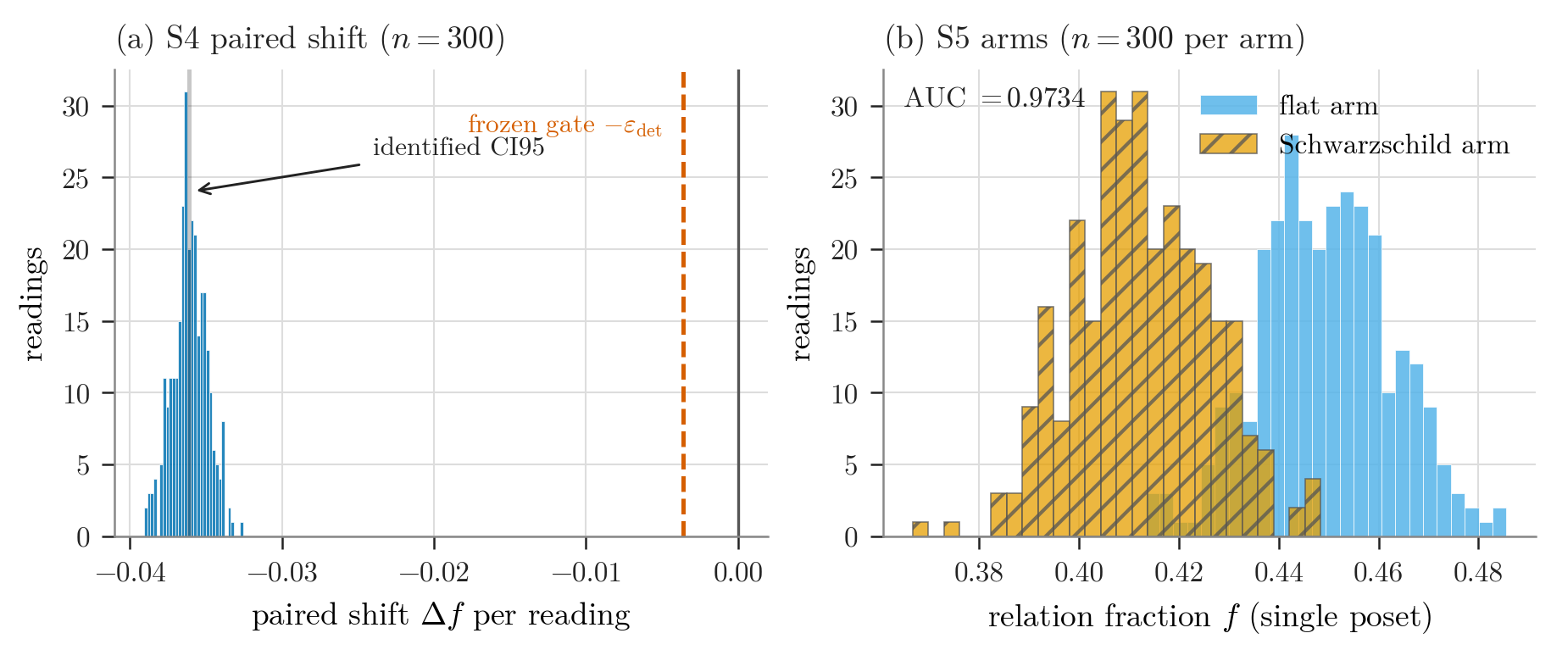
Figure 6. The Schwarzschild extension. (a) The per-reading paired shift under the frozen Schwarzschild domain: the identified CI95 $[−0.036211,−0.035953]$ lies an order of magnitude beyond the frozen detection threshold $ε_{det}=0.0036$ (frozen negative direction). (b) The per-reading global relation fraction of the two independent arms, discriminating with AUC 0.9734 (DeLong CI95 $[0.9630,0.9837]$)—strong but, unlike the plane-wave C2, incomplete separation. Drawn from the committed artifacts (docs/prereg/p14_s4_results.json, docs/prereg/p14_s5_results.json); no value is typed in.
Zero ambiguous and zero escalated pairs; both identified bound series agree. The two sentences this stage licenses, in translation (docs/prereg/p14_s5_results.json), are on the frozen Schwarzschild domain and density, the global relation fraction of a single causal set carries information that discriminates flat from Schwarzschild ensembles above chance—AUC CI95 lower bound above 0.60; a program-internal statement, and the joint 95% lower bound of out-of-sample balanced accuracy exceeds 0.60: out-of-training discrimination holds; a secondary verdict.
What this extends, and at what grade: on the same frozen Schwarzschild domain, the two claim classes of the plane-wave capstone are now each supported by a separate preregistered stage (figure 6)—the C1 paired claim CONFIRMED (S4), C2 single-poset discrimination DETECTED (S5). There was no joint primary verdict.
The two stages also differ in what they can resolve, and the difference is one of design rather than of curvature type. C1 reads the same sprinkled points twice, so its estimator sees only the relation change: the paired readings correlate at 0.9965 and pairing removes 99.3% of the spread, leaving a paired SD of 0.001135 against a detection threshold an order of magnitude away. What pairing removes is the shared point configuration itself, not the event count—that count correlates with the paired difference at $−0.018$ and is not the nuisance that matters. C2 reads two independent arms and so removes none of that spread: its pooled SD of 0.013428 is an order of magnitude larger, and against that the same geometric effect is worth 2.73 standard deviations rather than 31.8. Much of the gap is the base rate: the flat-arm relation fraction averages 0.0238 in the plane wave against 0.4491 here, and a fraction near one half carries the largest sampling variance. That, not type D versus type N, is why the plane wave’s C2 separated completely and this one does not (AUC $≈0.973$; no completeness gate was preregistered). A single-poset statistic that recovers what pairing sees is a natural next preregistration; recovering it after the fact would forfeit the freeze. The secondary BA verdict neither strengthens nor combines with the primary.
The extension establishes no mass-generality (a single frozen $M$) and uses no diamond-volume oracle (margins operationally anchored or independently declared)—the mass ladder and the certified-volume anchor belong to the separate stage of section 6.8, which does not promote these two verdicts. Execution provenance for both stages, including the executed-freeze manifest snapshots—and the capstone’s own freeze ordering, mechanical gates, and commit-ancestry contract—is in section S2 of the supplementary material.

6.8 Prediction-anchored Poisson counts across a mass ladder
Every verdict so far is anchored operationally: a margin taken from an exploration block, or a threshold declared before sizing. This stage is different. The diamond-volume oracle certifies an interval for the continuum 4-volume $V$ of a fixed causal diamond, by directed-rounding arithmetic and before any count data exists; a Poisson sprinkling then supplies a count of elements certified to lie inside that same diamond. The question is whether the operational instrument realizes the certified prediction. Nothing in sections 6–6.7 is used to answer it, and the answer cannot be tuned after the fact: the endpoints, the intensity, the tolerance and the decision rule are all frozen in the rung’s preregistration before its seed is drawn. The stage also closes a loop the flat ladder left open: rung R1 consumed a supplied density to convert counts into volumes, validated there against targets the same machinery produced; here that same count-to-volume conversion—the number-volume correspondence at the root of the causal-set program [11]—is confronted, on a Schwarzschild diamond, with a volume certified independently of it.
The instrument. Points are sprinkled at a frozen intensity $A$ into the certified box, and each point’s membership is decided by the certified causal predicate on both legs. A point the predicate cannot decide at the frozen tolerance is not guessed: it is counted as ambiguous ($U_{amb}$) and enters the decision only through the conservative end of the interval. Each rung first runs a fixed-$n$ ambiguity pilot (exact Clopper–Pearson plus an exact Poisson tail bound at $α=0.01$, tail budget $1×{10}^{−3}$) that must certify $U_{max}≤30$ before the count campaign is sized; the campaign’s membership test short-circuits on a decided first leg, so a point the campaign calls ambiguous is necessarily one the pilot’s test would also call ambiguous, and the pilot’s bound transfers a fortiori.
The frozen rule. From the realized $(K_{certain},U_{amb})$ the rule builds a deliberately conservative outer count interval—the exact Garwood [28] lower limit at $K_{certain}$, the upper limit at $K_{certain}+U_{amb}$, each tail at level 0.025, so the ambiguous points can only widen the interval outward and never move it toward agreement. Rescaled by the intensity this is a volume interval $C=[L/A,U/A]$, and the quantity gated is the identified discrepancy against the certified enclosure,
$$\begin{matrix}D=[C_{lo}−V_{hi}, C_{hi}−V_{lo}], \text{required to lie in }[−B,+B], \\ B=τV_{ref}, τ=2.5\%,\end{matrix}$$
with three ways out and no fourth: contained gives CONCORDANT, disjoint gives DISCORDANT, and anything else gives INCONCLUSIVE, published as it falls. The arithmetic is 96-bit end to end, and contract tests prove at the integer boundaries that the frozen acceptance window is exactly the set of counts the decision function calls CONCORDANT, so “the sizing” and “the verdict” cannot drift apart. The gate is a confidence-interval form of the two one-sided tests procedure [29, 30] on exact intervals, in the model-validation sense of requiring a discrepancy to fall inside a pre-set band [31]; its statistical novelty is the preregistered application against a certified enclosure, not the apparatus.
The ladder. One rung would establish the gate at one geometry. To ask whether the agreement is a property of the instrument rather than of a lucky configuration, the same gate is carried across a preregistered mass ladder. The certified shell $[10,20]$ and the anchors $(12,18)$ stay fixed in absolute coordinates, so no rung is an isometric copy of another: the pre-frozen dimensionless indicator is the compactness $μ=2M/r_{c}$ at the anchor midpoint $r_{c}=15$, and the executed ladder spans a factor of three in it. The mass is not the only thing that moves, and the second motion narrows what the ladder can show. The diamond’s coordinate-time window is retuned per rung by the frozen rule $dt(M)=8.5 T_{min}(M)/T_{min}(1)$, so that each rung opens the same multiple of its own minimal flight time; the whole diamond therefore scales with that flight time. The consequence is worth stating plainly: the certified volumes track $(dt/dt_{1})^{2}$ to 0.007%, 0.021% and 0.144% at $M=1.4$, 1.8 and 3.0, so their mass-specific content sits one to two orders of magnitude below the $τ=2.5\%$ band the gate applies. The deep end is not a free choice either: every mass-generic lemma certifies exactly on $M∈[0.92,3.33]$—bounded above by the photon sphere $3M$ reaching the shell floor at $M=10/3$—and the deepest rung $M=3.0$ keeps a certified margin of a tenth of the shell floor on that binding condition—by certification rather than by taste—its inner anchor at $r=4M$ between the photon sphere and the ISCO. The patch-level lemmas are mass-generic only under stated conditions (horizon below the shell, $K<0$, $w$ monotone, $Q>0$, the L2a patch bound, four L4 margins, an L5 winding cross-check), and each is re-certified per rung as an interval comparison—nothing is inherited silently from $M=1$.
Four rungs were executed, each from its own exact freeze checkout, with its own seed, once (table 5).
Table 5. The four executed mass-ladder rungs. Part (a) gives the design, membership counts, and verdict.
$μ$ | $M$ | pilot | $N$ | $K_{certain}/U_{amb}$ | verdict
$0.1333$ | $1.0$ | $k=0$ | 26,831,117 | 53,285 / 0 | CONCORDANT
$0.1867$ | $1.4$ | $k=1$ | 15,057,284 | 53,829 / 1 | CONCORDANT
$0.2400$ | $1.8$ | $k=0$ | 9,847,124 | 53,513 / 0 | CONCORDANT
$0.4000$ | $3.0$ | $k=0$ | 4,605,671 | 53,606 / 0 | CONCORDANT

Table 5 (continued). Part (b) gives the certified-volume and interval comparison used by the gate.
$μ$ | quantity | value or interval
$0.1333$ | certified $V$ | $[56.492959,57.060667]$
$0.1333$ | $C$ | $[56.205871,57.169553]$
$0.1333$ | $D$ | $[−0.854796,+0.676594]$
$0.1333$ | $B$ | $1.419420$
$0.1867$ | certified $V$ | $[64.336198,64.982744]$
$0.1867$ | $C$ | $[64.307488,65.405648]$
$0.1867$ | $D$ | $[−0.675256,+1.069450]$
$0.1867$ | $B$ | $1.616487$
$0.2400$ | certified $V$ | $[73.968637,74.711920]$
$0.2400$ | $C$ | $[73.695211,74.956037]$
$0.2400$ | $D$ | $[−1.016709,+0.987400]$
$0.2400$ | $B$ | $1.858507$
$0.4000$ | certified $V$ | $[121.225021,122.443280]$
$0.4000$ | $C$ | $[120.802632,122.867592]$
$0.4000$ | $D$ | $[−1.640649,+1.642571]$
$0.4000$ | $B$ | $3.045854$
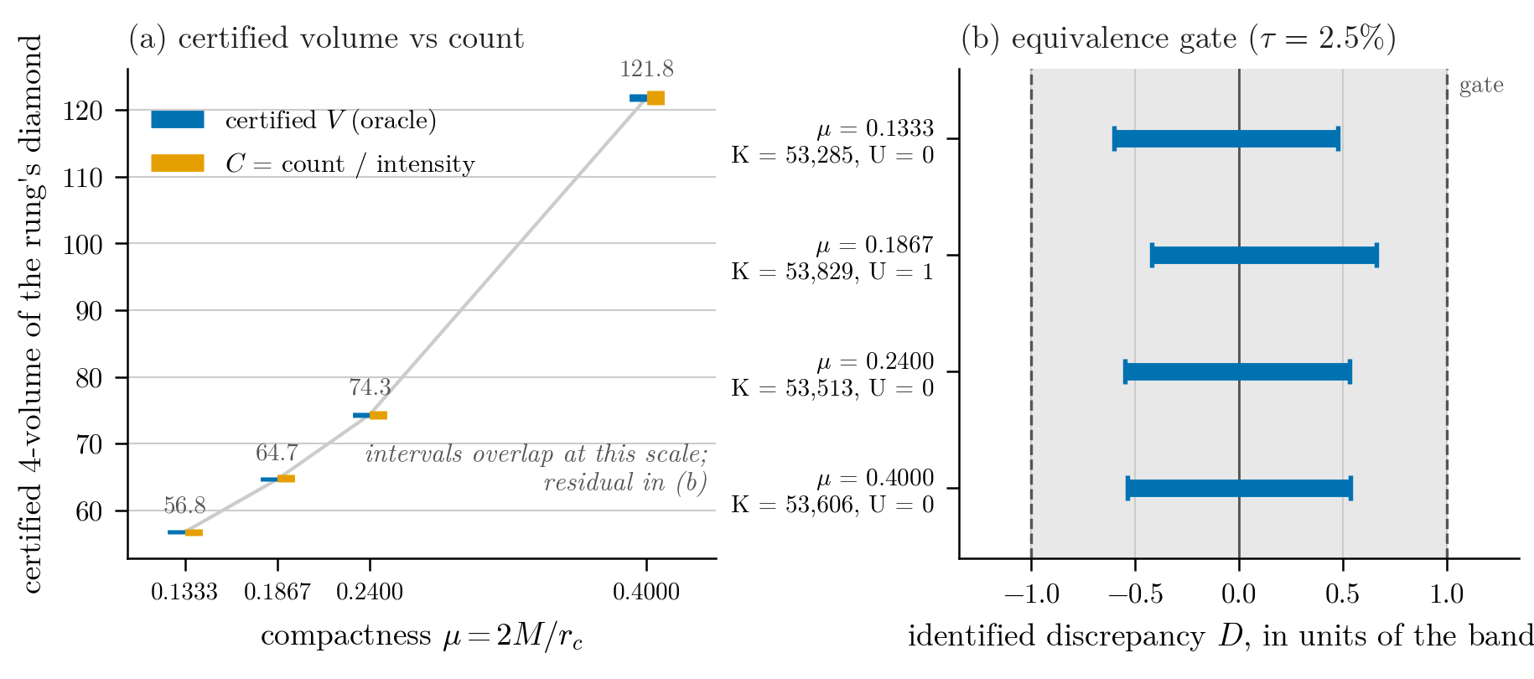
Figure 7. The executed ladder. (a) At each preregistered compactness, the certified continuum volume (blue) and the volume implied by the sprinkled count (orange). The intervals overlap at plot scale across a threefold span in $μ$—that overlap, at each rung independently, is the result; the cross-rung span is not itself a curvature signal (section 6.8). (b) The residual made visible: each rung’s identified discrepancy $D$ divided by that rung’s own band $B=τV_{ref}$, so the rungs are comparable despite different bands; the shaded region is the gate. Every rung is contained, with roughly half the band to spare, and the $μ=0.1867$ rung’s asymmetry is its single ambiguous point widening the interval outward as the rule provides. Both panels are generated from the same artifacts the contract tests re-derive (latex/figures/make_journal_figures.py, reading the same artifacts as the manuscript’s figures/make_ladder_figure.py); no value is typed in.
The certified volume grows monotonically with the compactness (57 to 65 to 74 to 122), and the realized discrepancy stays well inside the band at every rung (figure 7). The $M=1.4$ pilot returned the program’s first non-zero ambiguous count ($k=1$); it was absorbed exactly as the sizing had provisioned, and it is visible in that rung’s asymmetric $D$, which is the conservative widening working as designed rather than a defect.
What this establishes. On each preregistered rung independently, an operational finite-density instrument realized that rung’s independently certified continuum volume to within $τ=2.5\%$, under a rule fixed before the data existed. This is the first place in the program where a measurement is confronted with a certified prediction rather than with an operational anchor, and the confrontation is repeated at four masses rather than one—the deepest with its inner anchor between the photon sphere and the ISCO. What the repetition buys is not four independent curvature probes—the volumes are near-degenerate across rungs, as stated above—but the re-certification of every patch-level lemma and a fresh run of the causal predicate at each mass, none of it inherited from $M=1$.
What it does not establish. The rungs are separate preregistered stages: each verdict stands alone, there is no joint primary verdict, and no interpolation, extrapolation, or composite cross-rung statistic is claimed—in particular nothing is claimed at compactness between or beyond the four tested values. Agreement of a count with a volume is not a test of causal-set theory, and it is not evidence that spacetime is discrete; it is a statement that this instrument, at these operating points, reproduces the continuum measure it was pointed at. It upgrades neither the C1/C2 verdicts of sections 6–6.7 nor the auxiliary O4b instrument audit, none of which use it. And the result is bounded by its construction exactly as the capstone is: one fixed diamond, one fixed density per rung, a Schwarzschild exterior shell, and a tolerance chosen to be feasible rather than to be sharp.

6.9 The certified volume oracle and its auxiliary instrument audit
The diamond-volume oracle behind section 6.8 is fully certified: the static-spacetime reductions derived in the public note (docs/theory/schwarzschild_volume_oracle_note.md) were completed by an MPFR directed-rounding flight-time certification, a uniform anchor-diamond containment proof, and a certified cell-refinement integrator, and the frozen configuration’s volume was computed once from an exact freeze checkout: $V∈[56.212737,57.348019]$, relative half-width $0.009997≤0.01$, target-met (docs/prereg/p14_o3_volume.json). That certification (O3) is the one the O4b audit below consumes. O3’s width would have consumed most of the section 6.8 count stage’s 2.5% band, so the same configuration was re-certified at half the target width (O3$′$), giving $V∈[56.492959,57.060667]$—strictly inside O3, and the interval the $μ=0.1333$ rung is gated against (docs/prereg/p14_o3p_volume.json). The two are distinct certifications of the same diamond at different target widths, never combined.
An auxiliary instrument audit (O4b) then consumed that certified volume: at the single frozen Schwarzschild configuration, the sampler, the S1 volume response, and the certified oracle were found CONCORDANT under a frozen composite error budget of 3.25% with simultaneous coverage $≥95\%$—G1 volume interval $[56.448806185841875,$ $56.9822829864225]$ against the certified $[56.212737,57.348019]$ (identified discrepancy $[−0.8992123405928396,$ $0.7695461186219887]$, band $1.7034113309135284$), G2 leak upper bound $0.14195058753928652$ within budget $0.14195094424279403$ with zero leaking points. The audit’s campaign run completed both gates and stopped at a publication-wiring defect—a software defect in the result-publication step; no gate, seed, or datum was affected—and the verdict was recovered by re-applying the frozen decision functions to the preserved sufficient statistics (run_kind: recovered_completed_campaign in docs/prereg/p14_o4b_results.json—no new seed, no solver call, no resampling, no gate change), with the recovery authenticated and bit-exactness enforced by contract tests (supplementary material, section S2). This audit upgrades nothing in sections 6–6.7; what it is and is not is bounded in section 8. The prediction-anchored claim is carried by the section 6.8 ladder, which does not use this audit and is not promoted by it.

7 Discussion
The ladder is a branched accounting device, not a single cumulative chain—and its two branches carry different kinds of content (section 2): the measure branch the theorem content, the observer branch protocol arithmetic. Across its dependency rows it recovers a substantial fraction of operational Lorentzian geometry—dimension, timelike duration, radar decomposition, Lorentz and Poincaré consistency, volume—from a causal order plus short, explicit ingredient sets. It is equally a list of what each reconstruction costs: absolute scale costs a measure; a signed spatial coordinate costs an orientation; a metric-not-merely-conformal statement costs a volume element; Lorentzian structure is not bought by finite speed alone. Stating both directions together is the point: it turns “causal structure fixes the conformal class, and a volume element fixes the remaining conformal factor” from a slogan into a per-quantity operational ledger with measured error behaviour.
This framing also clarifies what the program does not show and sets up the open question. Everything here is reconstruction inside known models: the geometry is put in (by sprinkling from Minkowski or by a supplied protocol) and recovered. It does not address whether geometry could emerge from an order that was not built from a geometry—the representability question—which requires a validated discriminator and is taken up separately. The section 6 capstone sharpens the boundary from the other side: the one piece of geometry that order itself carries—the conformal class—is not merely present by theorem but legible to an order-only statistic at finite density, exactly where the measure channel is frozen and only the light cones move; how far that legibility extends before it fails is unmeasured.
The Schwarzschild and mass-ladder stages add a second axis to that boundary. Every verdict in the flat ladder and the plane-wave capstone is anchored operationally—a margin taken from an exploration block, a threshold declared before sizing. The section 6.8 stage is the first confrontation with a certified prediction instead, and what it buys is deliberately narrow: not new physics, but the demonstration that an operational finite-density instrument can be held to an interval-arithmetic enclosure fixed before any data existed, at four masses, with the near-degeneracy of the cross-rung volume comparison stated rather than hidden. The provenance discipline that makes the confrontation checkable—frozen decision rules, content-addressed evidence bundles, contract tests that recompute every printed figure from its committed artifact—is, we would argue, a contribution in its own right.
The usual scope statements are gathered here rather than in a separate section. Results are controlled and mostly $(1+1)$D (dimension is checked to 4D; the capstone and its extensions are $(3+1)$D). The constants are convention-dependent (chain endpoint convention, null-inclusive causal relation, Myrheim–Meyer normalization); we state each where it is used. The spacelike proxy is exploratory. R5’s local-measure evidence is one profile family at one amplitude; the dose-response of the unweighted error floor to the profile amplitude is not measured. Generalizing beyond type N is partially opened rather than closed: the Schwarzschild extensions carry both claim classes there (section 6.7), and the certified oracle and count ladder anchor the volume side (sections 6.8 and 6.9).
The natural next question—whether observer-relative distance order can be validated as recovering latent geometry, as opposed to being reconstructed from a supplied one—is the subject of a companion paper (in preparation) that builds a preregistered discriminator on this foundation, measures its dose-response to geometry dilution and its dimension selection in $(2+1)$D, and then carries it to orders produced by growth dynamics and by an action-weighted 2D-order ensemble. At $N=600$, random-start post-burn-in configurations at $β=2$ and $β=8$ pass the frozen instrument, while the $β=32$ bipartite-start control is structurally blocked (it fails at chain extraction, before any geometry gate). These are not certified equilibrium draws, and the companion study did not establish an equilibrium transition or finite-size scaling.

8 Claim boundary
Every result in this paper is stated at full strength, with its non-claims, in the section that establishes it; this section is the index. The repository’s claim_boundary.md carries the same boundary in long form, held to the frozen artifacts by the contract tests of section 9.
Table 6. The claim boundary as an index. Each row names a result, the grade at which it is claimed, the section that establishes it, and the section that bounds it.
Result | Grade | Estab. | Bounded
Flat-ladder reconstructions R0–R5 (dimension; proper time; radar time and unsigned distance; Lorentz map; atlas; volume and its coarse-graining stability) | controlled validations in declared models, each with its supplied ingredients named | §4.1–4.6 | §5
Rindler wedge as the reconstructible region | controlled validation; scored against finite clock coverage | §4.7 | §4.7
No absolute scale, conformal factor, signed coordinates, or unique atlas from order alone; finite speed does not imply relativity | bounding constructions in the stated senses | §5 | §5
Plane-wave capstone: paired mean under a pure-Weyl deformation (C1) and frozen single-poset classifier (C2) | both claims confirmed; stage POSITIVE | §6.4 | §6.6: one frozen operating point; no general-Weyl discriminator, no Weyl-tensor recovery, no box- or density-independence
Schwarzschild extension: S4 paired confirmation, S5 single-poset discrimination | CONFIRMED; DETECTED with incomplete separation | §6.7 | §6.7: separate stages, no joint primary verdict, no mass-generality; no verdict uses the volume oracle
Mass-ladder Poisson count on each of the four preregistered rungs, $μ∈\{0.1333$, $0.1867$, $0.2400$, $0.4000\}$ at $τ=2.5\%$ | CONCORDANT at every rung, per rung | §6.8 | §6.8: no joint or cross-rung verdict, no interpolation, no extrapolation; promotes no earlier verdict
O4b direct-MC instrument audit | CONCORDANT, auxiliary | §6.9 | §6.9: instrument statement only
Beyond table 6 we claim nothing: not that spacetime is reducible to, or emerges from, causal order; not that causal order alone yields absolute scale, the conformal factor, signed coordinates, or a unique atlas; not that finite signal speed implies relativity; not that any finite validation establishes a physical theory; and, for the count stage, nothing about causal-set theory or the discreteness of spacetime—a count agreeing with a volume says the instrument reproduces the measure it was pointed at. Reconstructing a geometry that was put into the model is not deriving geometry from order.

9 Reproducibility
Foundation-layer baseline commit 325df55. Every number in sections 4 and 5 has a cited experiments/exp*.py producer and expected summary path. All 19 cited summary tables are committed under figures/data/, regenerated in one recorded environment (CPython 3.11.9, numpy 2.4.6, matplotlib 3.11.1) from the unmodified baseline producers; artifact_manifest.md records the regeneration, per-file row counts, and raw SHA-256 digests under the repository’s LF storage-boundary rule, and a contract test recomputes every digest. The submission gate—the 19 legacy tables plus the finalized section 6 evidence bundle, provenance-locked—is met. Conventions (sprinkling measure, causal relation, chain and interval normalizations, Myrheim–Meyer inversion) are fixed in the foundation modules and stated in section 3.
Section 6 carries no regeneration debt: every number it cites lives in a committed artifact, and the repository’s test suite recomputes the capstone’s metrics, verdicts, and sentences from the stored raw samples, reproduces a prefix of every frozen seed stream, and asserts the commit-ancestry contract of section S2 of the supplementary material. The stage runner (experiments/positive_control/p14_prereg.py) exposes three modes—preflight, manifest, campaign—and the campaign mode refuses to run unless the freeze manifest exists, its recorded preflight digest matches the committed artifact, and the certified source digests match the checked-out files.
Section 6.7 inherits the same standard for both of its stages: each runner (experiments/positive_control/s4_schwarzschild_c1.py, experiments/positive_control/s5_schwarzschild_c2.py) refuses to run unless an 8-file content-addressed freeze manifest matches the checked-out protocol surface byte-for-byte, verified at entry and re-verified at exit, behind a fail-closed CLI; contract tests recompute the CONFIRMED (S4) and DETECTED (S5) verdicts—including the DeLong interval, the balanced-accuracy threshold and Clopper–Pearson–Bonferroni interval, and the frozen sentences—from the stored per-reading arrays through the frozen gate functions; and the seed ledger separates fresh allocation from deterministic replay, with replay output owned by a separate path that can never replace a fresh-observation artifact.
Section 6.8’s four rungs meet the same standard independently. Each rung’s ambiguity pilot and count campaign run behind their own frozen, content-addressed manifests (docs/prereg/p14_*_count_freeze_manifest.json, with the executed surfaces preserved alongside), from a clean exact checkout recorded in the artifact at entry and exit; the per-rung runners are experiments/oracle/o5_count_campaign.py and experiments/oracle/s6_m{14,18,30}_count.py, and tests/test_paper_a_count_integration.py re-derives the printed per-rung table from the artifacts. The commit chain per rung is in section S2 of the supplementary material.
The auxiliary O4b instrument audit (section 6.9) meets the same standard with one addition. Its campaign runner refuses to run except on the clean exact checkout of the approved freeze SHA against a 25-file content-addressed manifest with an environment lock; the executed surface is preserved byte-for-byte as docs/prereg/p14_o4b_executed_freeze_manifest.json. Because the run stopped at a publication-wiring defect after both gates completed, the published verdict is a recovery: experiments/oracle/o4b_recover.py re-applies the frozen decision functions (empirical-Bernstein interval, Clopper–Pearson bound, frozen sizing constants) to the preserved sufficient statistics, authenticates its inputs against the SHA-256 of the committed incident and checkpoint records with a two-file cross-check, and refuses to publish unless the recomputation reproduces the preserved verdict bit-for-bit; contract tests (tests/test_o4b_recover.py) pin the recomputation, the tamper refusals, and the published artifact, and regression tests (tests/test_o4b_wiring_fixes.py) drive the repaired main() path end to end. No new seed was drawn, no solver called, no point resampled, and no gate changed anywhere in the recovery.

Acknowledgements and disclosure
This work was carried out with substantial assistance from AI language models (Anthropic Claude), used for literature search, code and manuscript drafting, numerical analysis, and adversarial review of the author’s own claims. The AI systems are not authors and bear no responsibility: the author takes full responsibility for every claim, number, and citation here.
How the output was verified, and how far that verification reaches. Every quantitative result in sections 4–6.8 is produced by a committed experiment script whose output file is pinned by a content-addressed manifest that a contract test recomputes, so the artifacts cannot drift unnoticed. The manuscript’s own transcription of those artifacts is machine-checked across the whole results arc: every figure printed in sections 4 through 6.7 is re-derived from its artifact and matched against the sentence that prints it, section 6.8’s per-rung table is re-derived the same way, and the auxiliary audit’s figures are pinned verbatim—so a hand-typed value fails the build, and so does one that silently moves to a neighbouring claim. The claim list is itself guarded: every numeral in sections 4–6.7 must be one the contract derives or one it names as an accepted exclusion with a reason, the exclusions being row selectors, rung labels and construction settings rather than results, so a figure added later cannot slip past unchecked. Provenance runs by two routes, both digest-locked at the artifact. The legacy results of sections 4 and 5 name their producing experiment (exp03–exp23) and its committed summary table, audited in producer_audit.md. The preregistered results of sections 6–6.8 name their own frozen artifacts—p14_prereg_results.json for the capstone, p14_s4_results.json and p14_s5_results.json for the Schwarzschild extensions, the per-rung count records for section 6.8, and p14_o4b_results.json for the auxiliary audit—each with its executed freeze manifest. What the contract does not do is stated too: it holds the printed characters to the committed artifact, not the artifact to nature, it re-runs no experiment, and it reaches sections 4–6.8 and the auxiliary audit’s figures only; numbers quoted elsewhere in the paper are still checked by reading. Writing it corrected two transcriptions that reading had passed (section 4.3’s radar-distance RMSE and section 6.4’s C2 separation statistic), which is why the reach is now stated as a contract rather than as care; the claim boundary’s copies of the same figures are held to the same artifacts, because that is where one of the two had been copied as well. The preregistered stages ran once each from an exact clean checkout of a merged freeze commit, under frozen decision rules, with their verdicts computed by the frozen code rather than asserted in prose. Every bibliographic entry was checked against an authoritative record (arXiv, Crossref, or the publisher) and then re-checked independently; the priority assessments in the companion records name the sources that were fetched.

Data availability statement
All data supporting the results of this study are version-controlled in the public repository at https://github.com/lpaiu-cs/causal-spacetime: the 19 digest-locked summary tables under figures/data/, and the preregistered evidence bundles and frozen artifacts of sections 6–6.8 and the auxiliary audit. Every cited file is pinned by a content-addressed manifest whose digests the repository’s contract tests recompute.

References
[1] Bombelli L, Lee J, Meyer D and Sorkin R D 1987 Space-time as a causal set Phys. Rev. Lett. 59 521–4
[2] Malament D B 1977 The class of continuous timelike curves determines the topology of spacetime J. Math. Phys. 18 1399–404
[3] Hawking S W, King A R and McCarthy P J 1976 A new topology for curved space-time which incorporates the causal, differential, and conformal structures J. Math. Phys. 17 174–81
[4] Kronheimer E H and Penrose R 1967 On the structure of causal spaces Proc. Camb. Phil. Soc. 63 481–501
[5] Sorkin R D 2005 Causal sets: discrete gravity (notes for the Valdivia Summer School), in Lectures on Quantum Gravity ed A Gomberoff and D Marolf (New York: Springer) pp 305–27 (arXiv:gr-qc/0309009)
[6] Surya S 2019 The causal set approach to quantum gravity Living Rev. Relativ. 22 5
[7] Brightwell G and Gregory R 1991 The structure of random discrete spacetime Phys. Rev. Lett. 66 260–3
[8] Myrheim J 1978 Statistical geometry Preprint CERN-TH-2538
[9] Meyer D A 1988 The Dimension of Causal Sets PhD Thesis Massachusetts Institute of Technology
[10] Braun M 2025 Spacetime reconstruction by order and number (arXiv:2507.01907)
[11] Sorkin R D 1997 Forks in the road, on the way to quantum gravity Int. J. Theor. Phys. 36 2759–81
[12] Homšak V and Veroni S 2024 Boltzmannian state counting for black hole entropy in Causal Set Theory (arXiv:2404.11670)
[13] Berthiere C, Gibbons G and Solodukhin S N 2016 Comparison theorems for causal diamonds Nucl. Phys. B 904 494–508
[14] Roy M, Sinha D and Surya S 2013 Discrete geometry of a small causal diamond Phys. Rev. D 87 044046
[15] He S and Rideout D 2009 A causal set black hole Class. Quantum Grav. 26 125015
[16] Cunningham W J and Krioukov D 2018 Causal set generator and action computer Comput. Phys. Commun. 233 123–33
[17] Alfyorov D and Shnyukov I 2026 Weyl curvature from the Hasse diagram: a parameter-free bridge formula for causal sets (Zenodo) DOI: 10.5281/zenodo.19364212
[18] Perlick V 2008 On the radar method in general-relativistic spacetimes, in Lasers, Clocks and Drag-Free Control (Astrophysics and Space Science Library vol 349) ed H Dittus, C Lammerzahl and S G Turyshev (Berlin: Springer) pp 131–52
[19] Rindler W 1966 Kruskal space and the uniformly accelerated frame Am. J. Phys. 34 1174–8
[20] Reid D D 2003 Manifold dimension of a causal set: tests in conformally flat spacetimes Phys. Rev. D 67 024034
[21] Bombelli L, Henson J and Sorkin R D 2009 Discreteness without symmetry breaking: a theorem Mod. Phys. Lett. A 24 2579–87
[22] Dowker F, Henson J and Sorkin R D 2004 Quantum gravity phenomenology, Lorentz invariance and discreteness Mod. Phys. Lett. A 19 1829–40
[23] Gibbons G W and Solodukhin S N 2007 The geometry of small causal diamonds Phys. Lett. B 649 317–24
[24] Wang J 2019 Geometry of small causal diamonds Phys. Rev. D 100 064020
[25] Clopper C J and Pearson E S 1934 The use of confidence or fiducial limits illustrated in the case of the binomial Biometrika 26 404–13
[26] Benincasa D M T and Dowker F 2010 The scalar curvature of a causal set Phys. Rev. Lett. 104 181301
[27] DeLong E R, DeLong D M and Clarke-Pearson D L 1988 Comparing the areas under two or more correlated receiver operating characteristic curves: a nonparametric approach Biometrics 44 837–45
[28] Garwood F 1936 Fiducial limits for the Poisson distribution Biometrika 28 437–42
[29] Schuirmann D J 1987 A comparison of the two one-sided tests procedure and the power approach for assessing the equivalence of average bioavailability J. Pharmacokinet. Biopharm. 15 657–80
[30] Lakens D 2017 Equivalence tests: a practical primer for $t$ tests, correlations, and meta-analyses Soc. Psychol. Personal. Sci. 8 355–62
[31] Robinson A P and Froese R E 2004 Model validation using equivalence tests Ecol. Model. 176 349–58

