Dear Editors of Classical and Quantum Gravity,
Please consider my manuscript, “Spacetime quantities from causal order: an operational ladder with preregistered validations at finite density,” for publication in Classical and Quantum Gravity as a Research Paper.
Causal structure determines conformal geometry, while volume information fixes the remaining scale under standard hypotheses. The manuscript asks the corresponding finite-data question: which spacetime quantities can explicit procedures reconstruct from events and causal order, what additional structure does each require, and what remains ambiguous when that structure is absent?
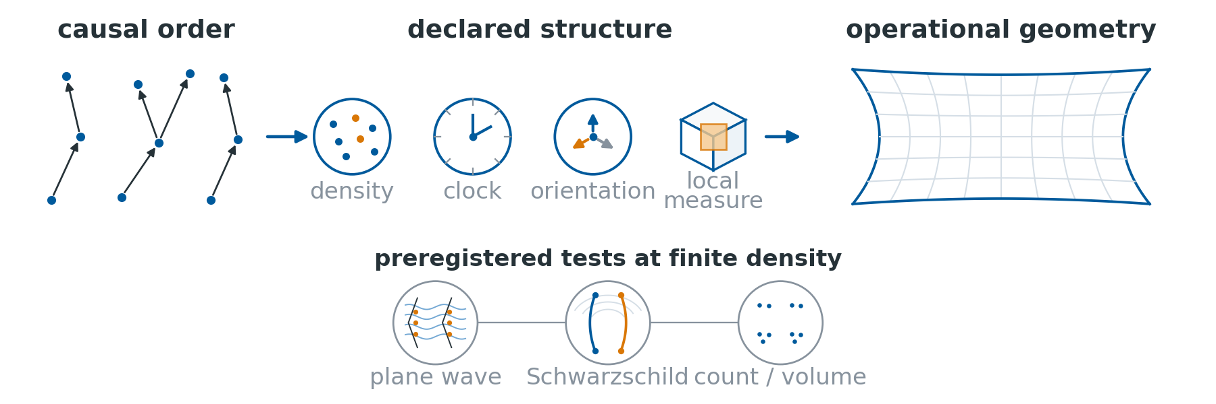
From causal order to operational geometry: declared structure enables specific reconstructions (top), tested in a plane wave, a Schwarzschild exterior, and a four-rung count/volume ladder (bottom).
The main contribution is a branched dependency ledger from causal order to dimension estimates, proper-time calibration, radar coordinates, oriented Lorentz maps, observer atlases, and measure-dependent volume reconstruction. Each step declares its input and finite-density behaviour. Counterexamples mark hard boundaries: order alone supplies no metric scale, a single observer leaves a reflection ambiguity, and finite signal speed alone does not imply Lorentzian geometry.
Preregistered curved-space stages test the ledger at specified operating points. In a vacuum plane wave with the flat comparator’s coordinate volume form and sprinkling law, an order-only statistic detects a deliberately strong pure-Weyl deformation. A frozen Schwarzschild exterior stage confirms paired causal-relation shifts and single-poset discrimination with incomplete separation. A four-rung mass ladder compares sprinkled counts with independently certified continuum four-volumes under a frozen 2.5% equivalence rule.
The manuscript fits CQG by connecting Lorentzian causal structure, discrete-spacetime methods, black-hole exterior numerics, and operational measurement. Its claims are deliberately conservative: these are validations of reconstruction procedures, not evidence that spacetime is discrete or reducible to causal order. Decision rules were archived before execution, and reported figures are regenerated from version-controlled artifacts.
The manuscript is original, has not been published previously, and is not under consideration elsewhere. There are no conflicts of interest. The code and supporting data are identified in the Data Availability Statement.
Thank you for your consideration.
Sincerely,
Juneyoung Kim
Independent researcher
lpaiu.cs@gmail.com

