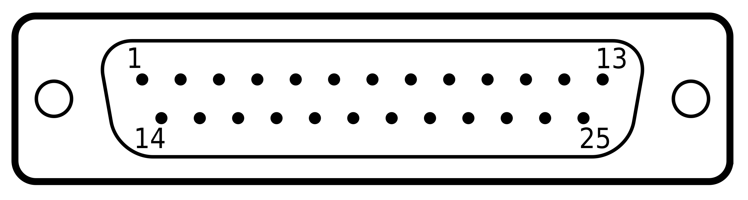

1. **LED 1** (+12V)
2. **LED 1** (GND)
3. **Motion_detector_1** (VCC)

**Motion_detector_2** (VCC)

**Analog_intesity_ligh_sensor** (VCC)

4. **Motion_detector_2** (OUT)

5.  **Motion_detector_1** (GND)

**Motion_detector_2** (GND)

**DHT11** (GND)

**Waterproof_soil_temprature_sensor** (GND)

6. **Fan** (PWM)

7.  **Motion_detector_1** (OUT)

8.  **Temprature_sensor _exterior** (GND)

**Analog_intesity_ligh_sensor** (GND)

**Fan** (GND)

**Step_motor**(GND)

9. **Step_motor** (VCC)

10. **DHT11** (VCC)

11. **DHT11** (DATA)

12. **Soil**  **Moisture_detection** (+)

13. **Soil Moisture_detection** (-)

14. **Fan** (+12V)

15. **Waterproof_soil_temprature_sensor** (DATA)

16. **Waterproof_soil_temprature_sensor** (VCC)

17. **Temprature_sensor _exterior** (S/DATA)

18. **Temprature_sensor_module** (VCC)

19. **Motor** (IN1)

20. **Motor** (IN2)

21. **Motor** (IN3)

22. **Motor** (IN4)

23. **Analog_intesity_ligh_sensor** (DATA)

24. **LED 2** (GND)

25. **LED 2** (+12V)