## Overview

In this activity, you will stand up a working prototype based on the design you create in the previous activity. Again, you only have 30 minutes, so **prioritize creating the most basic version of each page and UI element**. Remember that you will be iterating on this site for the rest of this week, so it doesn’t need to be perfect.

Part of a front-end developer’s job is to select front-end technologies. Use either HTML, CSS, JavaScript (JS), or WordPress.

### User Story

Your client is a hobby shop. They want to create a resource on various hobbies with pages on:

* How to get started
* Tips for practice and improving
* Related hobbies

You can make a prototype of how the site works for one hobby before you develop the whole site.

## Instructions

### Part 1: Prepare to Develop (5 min)

1. Before you write code or customize your content management system (CMS), you will need to set up the project.

**If using Visual Studio (VS) Code:**

* 1. Create a new repository for this project.
  2. Create your HTML, CSS, and JS files. You should have three HTML files and one CSS file at a minimum.
  3. Download [Bootstrap](https://getbootstrap.com/docs/4.1/getting-started/download/) and/or [jQuery](https://jquery.com/download/) if you intend to use them.
  4. Add basic HTML, like !DOCTYPE html and <title>.
  5. Link CSS and JS files to each HTML page using <link> and <script> tags.

*Tip:* You can quickly test links by adding body { background-color: red; } to the CSS file. Test scripts by adding alert(‘Hello, World!’); to the JS file.

**If using WordPress:**

* 1. Navigate to [WordPress.com](https://wordpress.com/) and log in.
  2. Click on **+ Add new site** in the left menu.
  3. Give your site a name and select the free domain.
  4. Select the theme and font pairing that most closely resembles your design.

*Tip:* This is easy to change later, so don’t stress too much over this choice.

* 1. On the “Which features will you need?” page, click on **Skip for now**.
  2. On the “Select a plan” page, select the free plan.

### Part 2: Block Out Pages (15 min)

1. Start by creating or customizing the elements that appear on every page, like headers, navbars, footers, and so forth.

**If using VS Code:** You will need to copy and paste these elements to every HTML file.

*Tip:* Adding borders around elements (* { border: 1px solid red; }) can help a lot when blocking out sections.

1. Create the layout for each page.

**If using VS Code:** Use Bootstrap, Flexbox, or CSS Grid to arrange sections. Remember to focus on blocking out sections before adding content.

**If using WordPress:** Use the **+** button in each page’s editor to find the most fitting blocks.

*Tip:* Use filler content like [lorem ipsum](https://www.lipsum.com/feed/html) and [placeholder images](https://placeholder.com/) while you are focusing on the layout of each page.

1. If your site needs any additional functionality, add it now.

**If using VS Code:** Don’t focus on fixing bugs or unintended behaviors; leave it for the iterations later on.

**If using WordPress:** Add widgets to get as close to your intention as possible.

*Tip:* If you don’t have enough time to implement a feature (or if there is no widget), you can often use a screenshot of your wireframe as a stand-in.

### Part 3: Add Content (5 min)

1. Fill your site with content. Remember that this is a prototype, so there only needs to be enough content to get the basic idea across.
   1. Make sure that every part of your site has at least some content, even if it is filler.
   2. Write headings and links.
   3. Fill in body text.

### Part 4: Wrap Up and Share (5 min)

1. Publish your site.

**If using VS Code:**

* 1. Navigate to your repository on [GitHub.com](https://github.com/).
  2. Click on **Settings** in the navbar under the name of your repository.



* 1. Scroll down to the “GitHub Pages” section. Click on the dropdown under “Source” and select **main**.

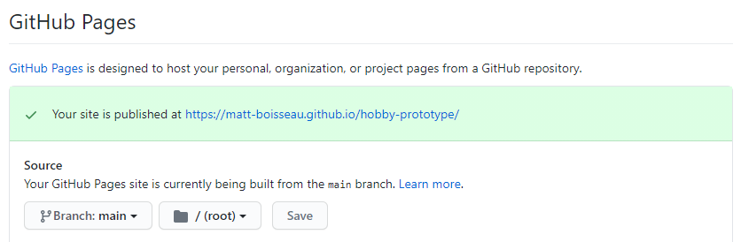

* 1. Press **Save**. The page will reload.
  2. Scroll down to the “GitHub Pages” section again. Copy the URL after the message: “Your site is ready to be published at…”

**If Using WordPress:**

* 1. At the top of your site preview, you should see a message: “Your site hasn't been launched yet. Only you can see it until it is launched.” Click on **Launch Site**.



* 1. On the next page, select **Skip Purchase** to the right of your “.wordpress.com” URL. Then, click on **Continue with your free site**.



* 1. Your site is now live! Click on **Visit site** once more to see the public site. Copy the URL of your site from the URL bar.

1. Share the URL of your site in Slack.