8/31/2020

Chung Le [lpc0045]

Assessment #1

DATABASE ADMINISTRATION

Assessment #1

# General Data Protection Regulation (GDPR)

The GDPR applies wherever you are processing ‘personal data’. This means if you can identify an individual either directly or indirectly, the GDPR will apply - even if they are acting in a professional capacity.

The impact of GDPR on your business will likely require substantial modifications to how you process, store and protect your customers’ data. So that storing personal data of EU residents is only legal when there’s consent. Additionally, businesses must erase personal data upon request and report data breaches within 72 hours to supervisory authorities.

Solution

I will tell people what I am are doing with their information. This includes business purposes for processing their personal data, company lawful basis for processing, how long you plan to retain the data, and who it will be shared with. So follow the GDPR guide is the best way to avoid any problem in the future.

# Backup, Restore, Security and Role Management

## Connect to server

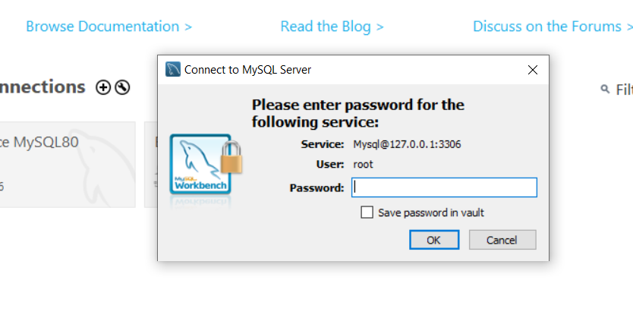

## Create User Account

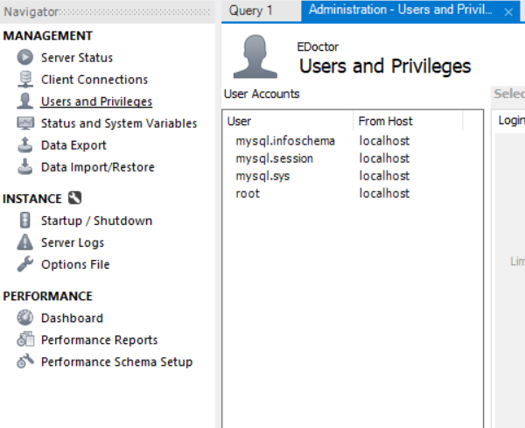

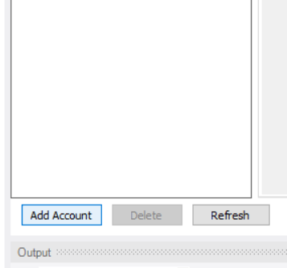

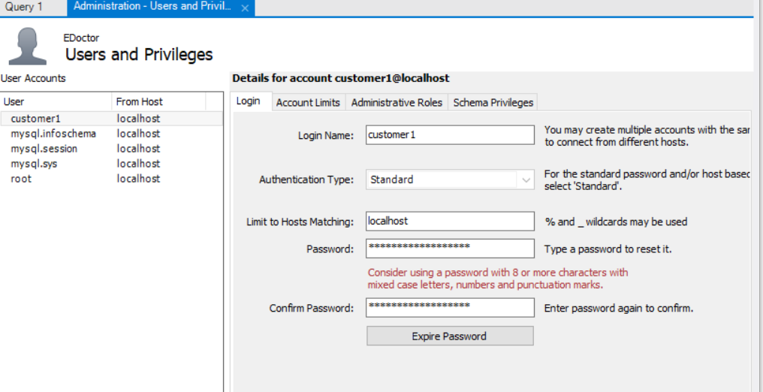

## Account Limit

## Add Permission

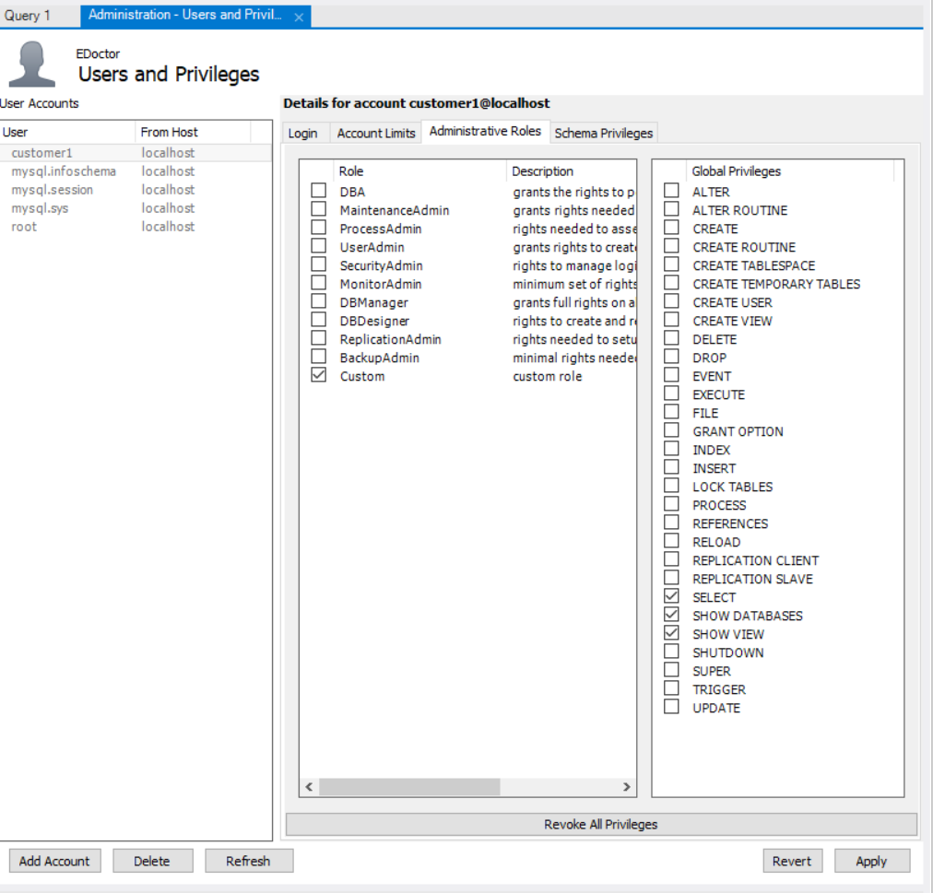

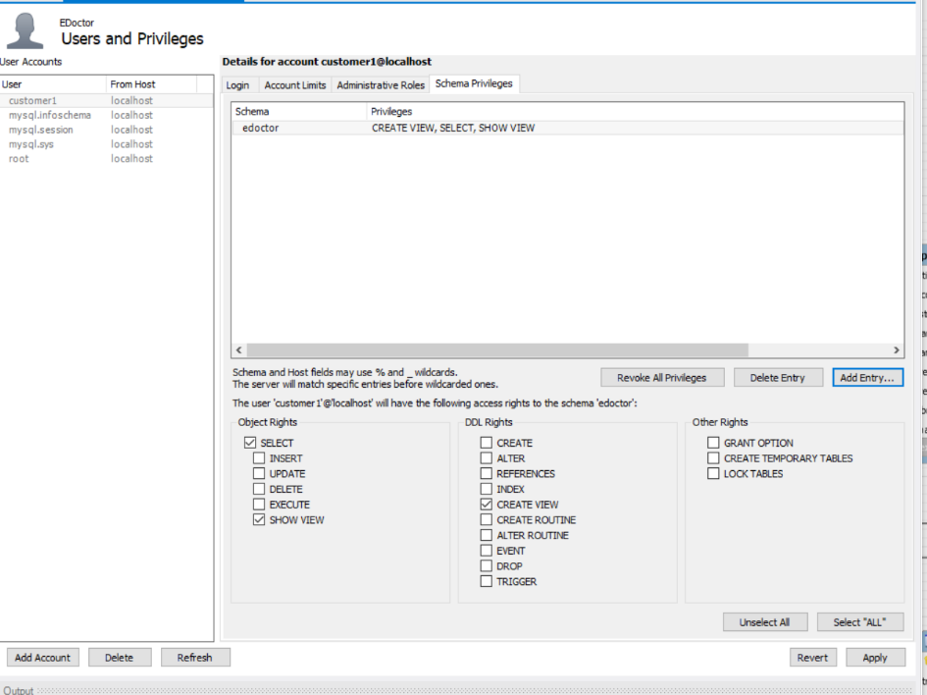

## Back up

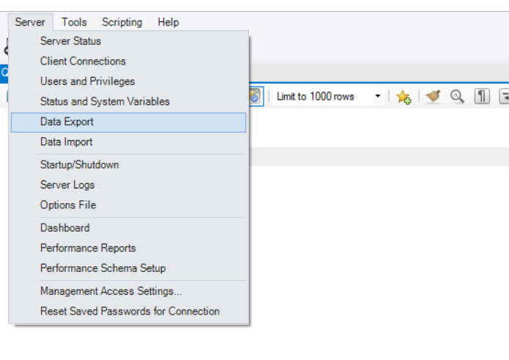

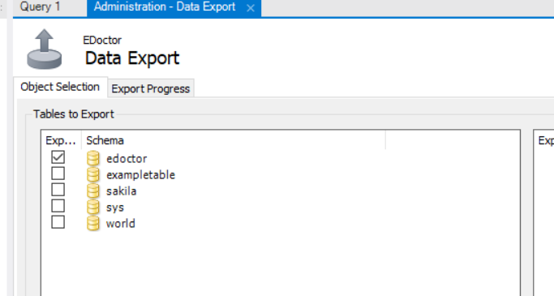

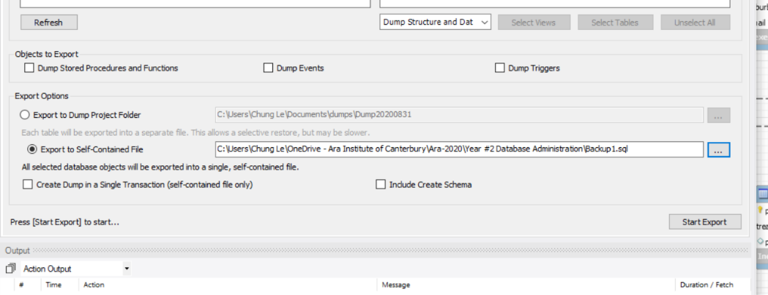

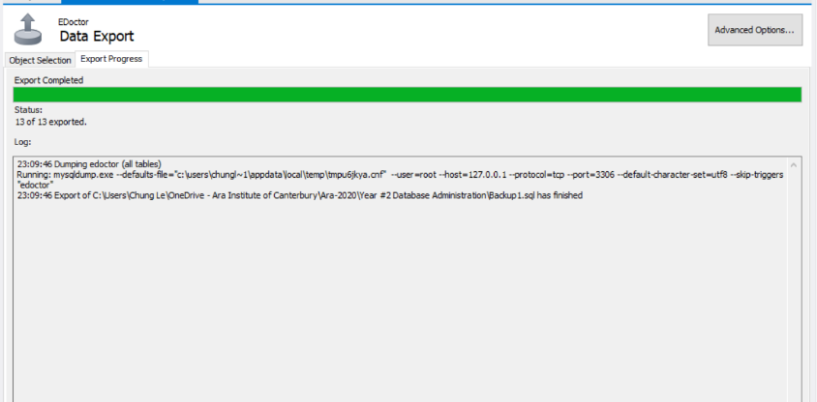

## Restore

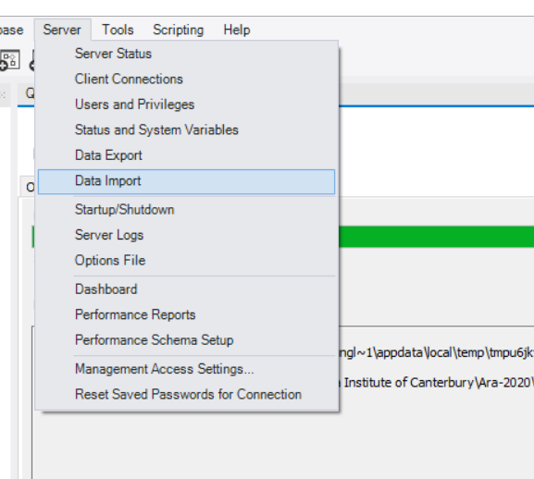

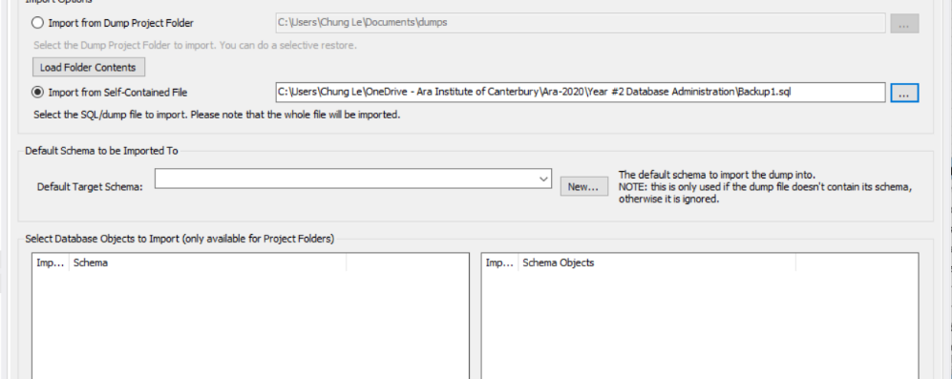

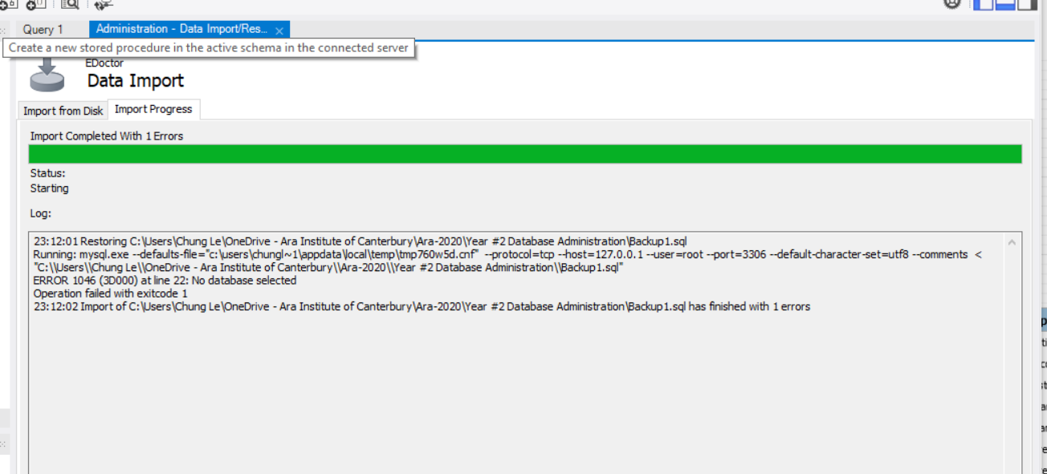

# Performance Review

MySQL database is similar with SQL server which I have learn before last semester so everything works perfectly for me. This first Assessment giving me a chance to apply what I have learned before. It gives me change to create database base on the Health Problem and my idea is that create the website that could connect Doctor with Patient remotely thought web. So, the patient from rural area do not have to travel to far just too talk with doctor. And in big city, patient don’t have to spend time for waiting or take day off just for appointment.