**Coffee shop management and sales website**

# **I. Overview**

## **1. Introduction**

Coffee shop management and sales website helps improve customer experience and promote business growth. Provides a comprehensive solution for store management

Software for coffee shop management with functions applied to a specific coffee shop. The system specifically describes the tasks that need to be done in a coffee shop model, can perform the following tasks: staff management, inventory management, sales management or menu list; in addition, there is also revenue and expenditure management, statistical reporting data.

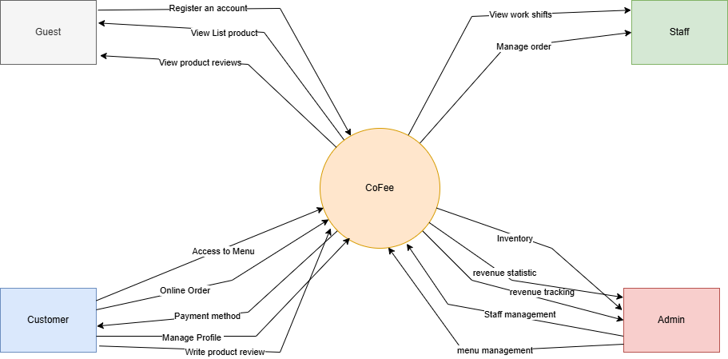

**Figure 1 - Product overview**

## **2. User Requirements**

### **2.1. Actors**

| **#** | **Actor** | **Description** |
| --- | --- | --- |
| 1 | Guest | Guest is a person who accesses the Cofee system without logging. |
| 2 | Customer | Customers are people who have accounts in the Cofee system. They have access to the website to order and review product quality. |
| 3 | Staff | The staff is the one who can manage basic operations such as create order confirmations, update product information in the system. |
| 4 | Admin | The administrator is responsible for managing employees and has access to all system functions. |

### **2.2. Use case**

### ***2.2.1. Guest***

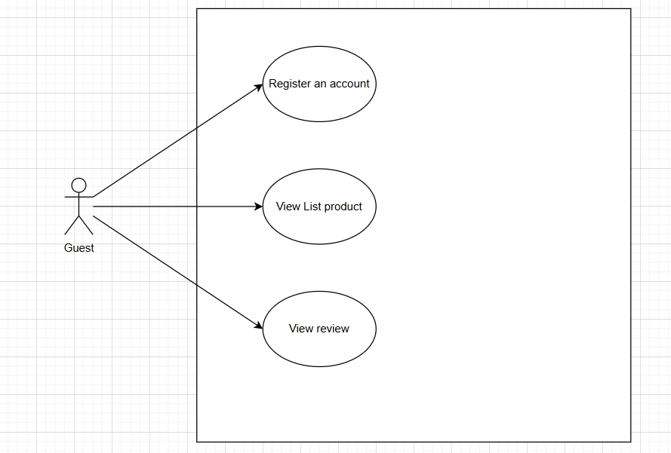

### ***2.2.2. Customer***

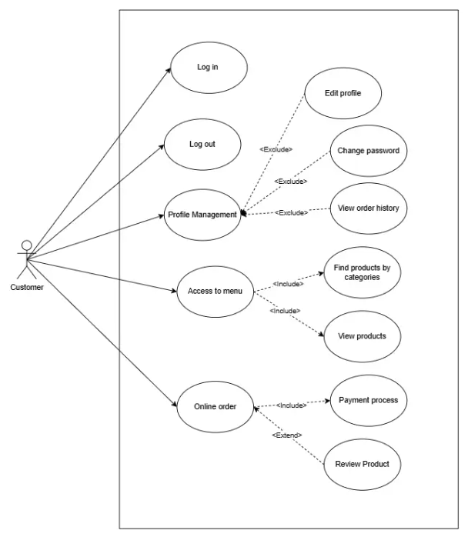

### ***2.2.1. Staff***

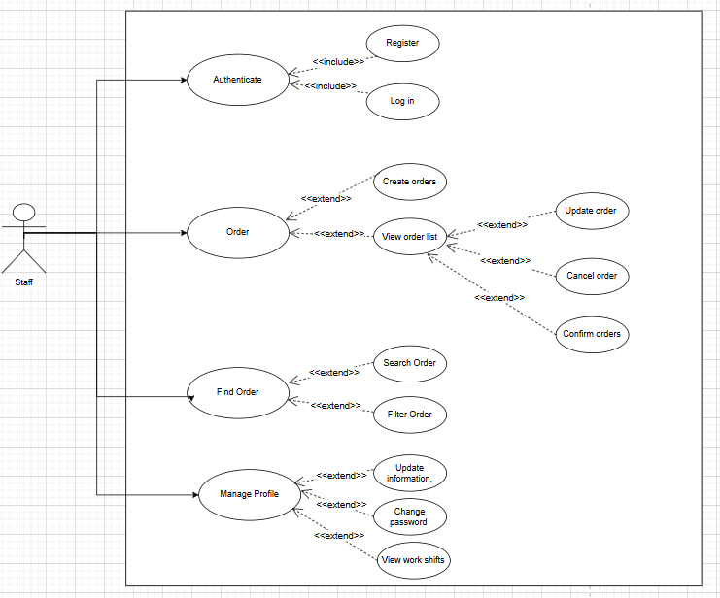

### ***2.2.1. Admin***

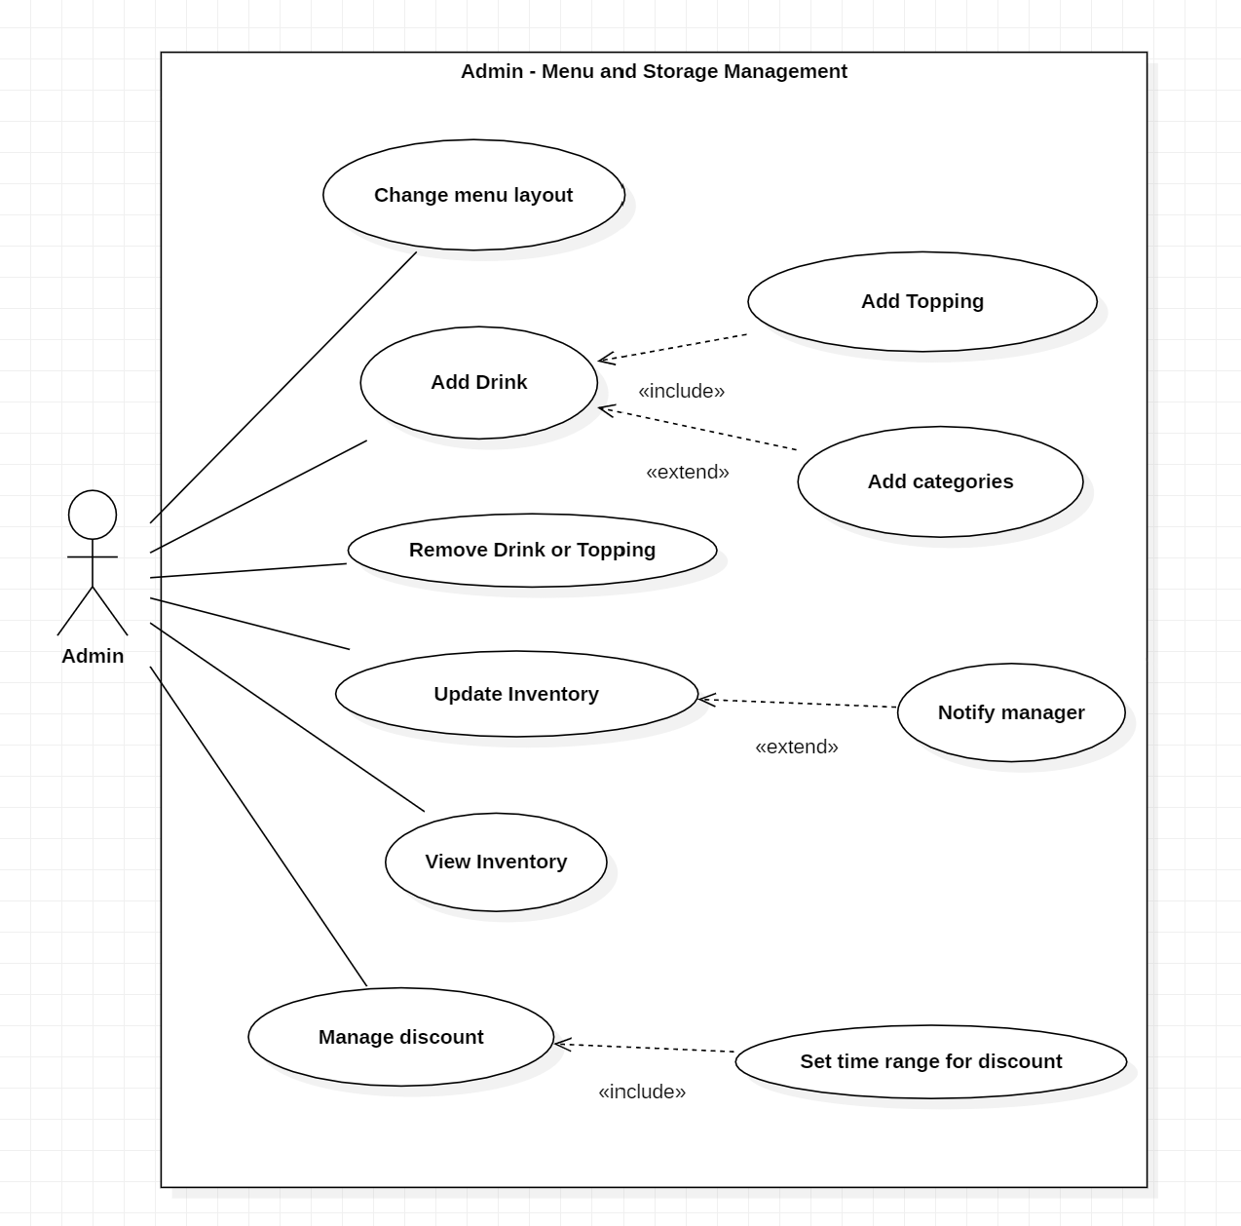

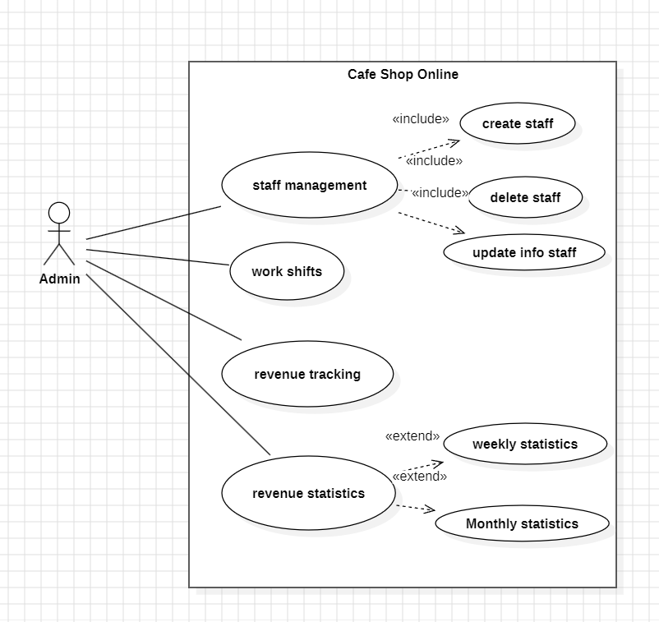

### **2.3. Descriptions**

**Below is a summary of the use cases present in the FPTeam system:**

| **ID** | **USE CASE** | **ACTORS** |
| --- | --- | --- |
| UC-1 | Sign up | Guest, Customer |
| UC-2 | Sign in | Customer, Staff, Admin |
| UC-3 | Logout | Customer, Staff, Admin |
| UC-4 | Forgot password | Customer, Staff |
| UC-5 | Manage profile | Customer, Staff |
| UC-5.1 | Change password | Customer, Staff, Admin |
| UC-5.2 | View order history | Customer |
| UC-6 | Access to menu | Guest, Customer |
| UC-6.1 | Search products | Guest, Customer |
| UC-6.2 | View products | Guest, Customer |
| UC-7 | Order drink online | Customer |
| UC-7.1 | Process payment | Customer |
| UC-7.2 | Review product | Customer |
| UC-8 | Manage Order | Staff |
| UC-8.1 | Create orders | Staff |
| UC-8.2 | View order lists | Staff |
| UC-8.3 | Update order | Staff |
| UC-8.4 | Cancel order | Staff |
| UC-8.5 | Confirm order | Staff |
| UC-9 | Find order | Staff |
| UC-9.1 | Search order | Staff |
| UC-9.2 | Filter order | Staff |
|  | View his/her work shifts | Staff |
| UC-10 | Manage staff | Admin |
| UC-10.1 | Create staff | Admin |
| UC-10.2 | Update staff info | Admin |
| UC-10.3 | Delete staff | Admin |
| UC-11 | Manage work shifts | Admin |
| UC-12 | Track revenue | Admin |
| UC-13 | Statistic revenue | Admin |
| UC-13.1 | Statistic revenue | Admin |
| UC-14 | Change menu layout | Admin |
| UC-15 | Add drink | Admin |
| UC-15.1 | Add topping | Admin |
| UC-15.2 | Add category | Admin |
| UC-16 | Remove drink, topping, category | Admin |
| UC-17 | Update Inventory | Admin |
| UC-17.1 | Notify manager | Admin |
| UC-18 | View inventory | Admin |
| UC-19 | Manage discount | Admin |
| UC-20 | Receive Notification | Customer, Admin, Staff |

## **3. Functional Requirements**

### **3.1 System Functional Overview**

#### ***3.1.1 Screens Flow***

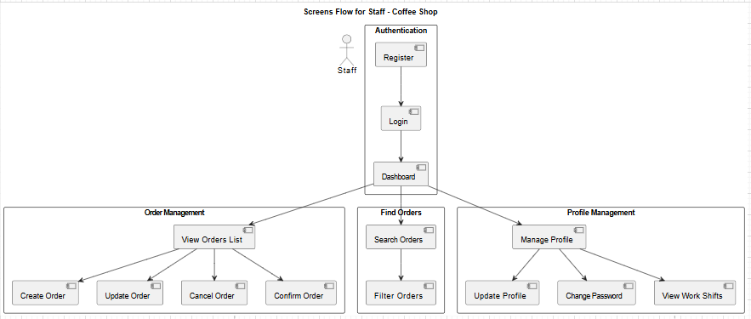

**Screens Flow for Staff**

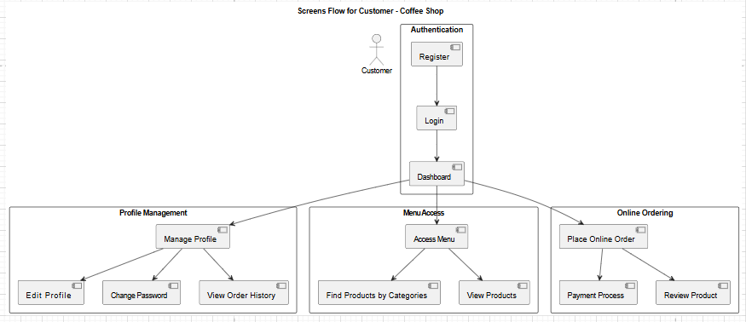

**Screens Flow for Customer**

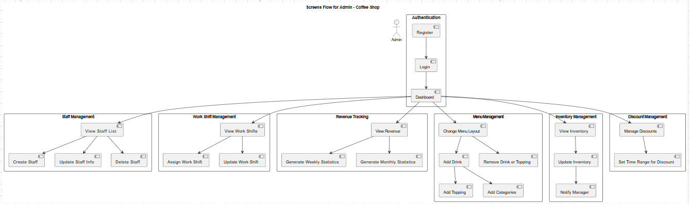

**Screens Flow for Admin**

### **3.2 System Functional Description**

### ***3.2.1. Sign up***

| Use Case ID | UC-01 | Use Case Name | Sign up |
| --- | --- | --- | --- |
| Created By | ThienLC | Date Created | 19 Jan 2025 |
| Primary Actor | Guest | Secondary Actor |  |
| Description | Guests register a new account on the system. | | |
| Priority | Must have | | |
| Trigger | A Guest clicks on the register button | | |
| Pre-conditions | PRE-1: Guest is not logged in | | |
| Post-conditions | POST-1: New account is created for the guest  POST-2: Redirect guest to the login page | | |
| Basic flow | 1. Guest clicks register button  2. Guest fills in registration form  3. System validates input  4. System creates new account for guest | | |
| Alternative flow | None | | |
| Exception | **Invalid input data:**  - System displays error message  **Duplicate data:**  - System displays error message | | |
| Business rules | BR-09 | | |

|  | | Menu page, Homepage | | | | |
| --- | --- | --- | --- | --- | --- | --- |
| Description | | Guests register a new account on the system. | | | | |
| Screen Access | | At homepage, click to [Register] button | | | | |
| Screen Content | | | | | | |
| Item | | Type | Data | | Description | |
| Username | | Text field – string (50) |  | | Input of Username | |
| Email | | Text field - string (255) |  | | Input of Email | |
| Password | | Text field - string (60) |  | | Input of Password | |
| Phone number | | Text field - string (11) |  | | Input of Phone number | |
| Gender | | Text field - string (10) | - Male  - Female | | Input of gender | |
| Address | | Text field - string(255) |  | | Input address of user | |
| Register | | Button |  | | User clicks to submit register form | |
| Screen Actions | | | | | | |
| Action Name | Description | | | Success | | Failure |
| Submit register form | User fill all the field and then click to Register button or press “Enter” | | | Show success message “Register successful” and then redirect use to the Login page | | 1. Database connection is error => Show **MSG01**  2. Empty Username=> Show error message “Username is required”  3. Empty Email => Show error message “Email is required”  4. Empty Password => Show error message “Password is required”  5. Empty Address=> show error message “Address is required”  6. Empty Phone number => Show error message “Phone number is required”  7. Empty Gender => Show error message “Gender is required” |

### ***3.2.2 Sign in***

| Use Case ID | UC-02 | Use Case Name | Sign in |
| --- | --- | --- | --- |
| Created By | ThienLC | Date Created | 19 Jan 2025 |
| Primary Actor | Guest | Secondary Actor |  |
| Description | Guest provides login credentials to access their account | | |
| Priority | Must have | | |
| Trigger | A Guest clicks on the login button | | |
| Pre-conditions | PRE-1: Guest is not logged in  PRE-2: Guest has already registered in the platform | | |
| Post-conditions | POST-1: Guest is logged into their account | | |
| Basic flow | 1. Guest clicks login button  2. Guest enters username and password  3. System validates credentials  4. System logs guest into account | | |
| Alternative flow | None | | |
| Exception | **Login data is invalid:**  - System display error message  **Account is not existed:**  - System display error message  **Wrong username or password:**  - System display message | | |
| Business rules | BR-10 | | |

### 

|  | | Sign in | | | | |
| --- | --- | --- | --- | --- | --- | --- |
| Description | | Guests login to system | | | | |
| Screen Access | | At homepage, click to [Login] button | | | | |
| Screen Content | | | | | | |
| Item | | Type | Data | | Description | |
| Email | | Text field – string (255) |  | | Input of Email | |
| Password | | Text field - string (60) |  | | Input of password | |
| Login | | Button |  | | User click to submit login form | |
| Screen Actions | | | | | | |
| Action Name | Description | | | Success | | Failure |
| Submit login form | User fill all the field and then click to Register button or press “Enter” | | | Show success message “Login successful” and then redirect use to the Homepage | | 1. Database connection is error => Show notification “Send API fail”  2. Wrong email or password => Show error message “Incorrect email or password” |

### 

### ***3.2.3 Logout***

#### 

| Use Case ID | UC-03 | Use Case Name | Sign out |
| --- | --- | --- | --- |
| Created By | ThienLC | Date Created | 19 Jan 2025 |
| Primary Actor | Customer, Staff, Admin | Secondary Actor |  |
| Description | User logs out and becomes a Guest | | |
| Priority | Must have | | |
| Trigger | A Guest clicks on the logout button | | |
| Pre-conditions | PRE-1: User is logged in | | |
| Post-conditions | POST-1: User session is destroyed, user is now Guest | | |
| Basic flow | 1. User clicks logout button  2. System destroys user session  3. System redirects user to guest homepage | | |
| Alternative flow | None | | |
| Exception | None | | |
| Business rules |  | | |

### 

|  | | Logout | | | | |
| --- | --- | --- | --- | --- | --- | --- |
| Description | | Guests logout of system | | | | |
| Screen Access | | At any page with authorization, click to the avatar at the navigation bar, then click logout. | | | | |
| Screen Content | | | | | | |
| Item | | Type | Data | | Description | |
| Logout | | Button |  | | User click to logout of the system | |
| Screen Actions | | | | | | |
| Action Name | Description | | | Success | | Failure |
| Logout | User click to Logout | | | Destroy session and redirect user to Login page | | 1. Database connection is error => Show notification “Send API fail” |

### 

### ***3.2.4 Forgot Password***

| Use Case ID | UC-04 | Use Case Name | Forgot password |
| --- | --- | --- | --- |
| Created By | ThienLC | Date Created | 19 Jan 2025 |
| Primary Actor | Customer, Staff | Secondary Actor |  |
| Description | Guest resets forgotten password | | |
| Priority | Must have | | |
| Trigger |  | | |
| Pre-conditions | PRE-1: Guest is not logged in  PRE-2: Guest has an account | | |
| Post-conditions | POST-1: Guest receives password reset instructions  POST-2: System redirects guest to the login page | | |
| Basic flow | 1. Guest clicks forgot password link  2. Guest enters email address  3. System validates email  4. System sends reset code to email  5. Guest enters new password | | |
| Alternative flow | None | | |
| Exception | **Invalid email:**  - System displays error  **Wrong code:**  - System displays error  **Invalid password:**  - System displays error | | |
| Business rules | BR-11 BR-12 | | |

### 

|  | | Menu page, Homepage | | | | |
| --- | --- | --- | --- | --- | --- | --- |
| Description | | Guests register a new account on the system. | | | | |
| Screen Access | | At Sign up page, click to [Forgot Password] button | | | | |
| Screen Content | | | | | | |
| Item | | Type | Data | | Description | |
| Email | | Text field – string (255) |  | | Input of Email | |
| Next | | Button |  | | User clicks to send a verification code via email | |
| Verification code | | Text fields - string (6) |  | | User enters the verification code received via email | |
| Password | | Text fields - string (60) |  | | User enters the new password | |
| Confirm | | Button |  | | User clicks to submit recover password form | |
| Screen Actions | | | | | | |
| Action Name | Description | | | Success | | Failure |
| Verify email | User fill email field and click Next or press “enter” | | | Slide to verification code stage | | 1. Database connection is error => Show notification “Send API fail”  2. Empty Email => Show error message “Email is required”  3. Non-existent email => Show error message “Email does not match with any account” |
| Verification code | User enter the code received via Email | | | Slide to set password stage | | 1. Database connection is error => Show notification “Send API fail”  2. Incorrect code => Show error message “Incorrect code” |
| Set password | User enter the new password and then click Confirm button or press “Enter” | | | Show the success message “Recovered successful” and redirect user to the login page | | 1. Database connection is error => Show notification “Send API fail”  2. Empty password => Show notification “Password is required” |

### 

### ***3.2.5 Manage profile***

| Use Case ID | UC-05 | Use Case Name | Manage profile |
| --- | --- | --- | --- |
| Created By | ThienLC | Date Created | 19 Jan 2025 |
| Primary Actor | Guest | Secondary Actor |  |
| Description | Guests change their personal information | | |
| Priority | Must have | | |
| Trigger | A Guest clicks on the save change button | | |
| Pre-conditions | PRE-1: User is logged in  PRE-2: Guest has an account | | |
| Post-conditions | POST-1: Information has been changed | | |
| Basic flow | 1. Guest clicks profile button  2. Guest fills in the form with the information that needs to be changed  3. System validates input  4. System accepts guest request | | |
| Alternative flow | None | | |
| Exception | **Invalid input data:**  - System displays error message | | |
| Business rules | BR-16 | | |

### 

|  | | Profile page | | | | |
| --- | --- | --- | --- | --- | --- | --- |
| Description | | Guests change their personal information | | | | |
| Screen Access | | At Profile, click to [Save change] button | | | | |
| Screen Content | | | | | | |
| Item | | Type | Data | | Description | |
| Username | | Text field – string (50) |  | | Input of Username | |
| Email | | Text field - string (255) |  | | Input of Email | |
| Password | | Button |  | | User clicks to go to the password change form | |
| Phone number | | Text field - string (11) |  | | Input of Phone number | |
| Gender | | Text field - string (10) | - Male  - Female | | Input of gender | |
| Address | | Text field - string(255) |  | | Input address of user | |
| Save change | | Button |  | | User clicks to submit info form | |
| Screen Actions | | | | | | |
| Action Name | Description | | | Success | | Failure |
| Submit info form | User fill all the field and then click to Save Change button or press “Enter” | | | Show success message “Change information successfully” and then redirect use to the Profile page | | 1. Database connection is error => Show notification “Send API fail” |

### ***3.2.5.1 Change Password***

| Use Case ID | UC-05-01 | Use Case Name | Change Password |
| --- | --- | --- | --- |
| Created By | ThienLC | Date Created | 19 Jan 2025 |
| Primary Actor | Customer, Staff, Admin | Secondary Actor |  |
| Description | Users change their passwords | | |
| Priority | Must have | | |
| Trigger | A Guest clicks on the save change button on Change Password form | | |
| Pre-conditions | PRE-1: User is logged in  PRE-2: Guest has an account | | |
| Post-conditions | POST-1: Password has been changed | | |
| Basic flow | 1. Guest clicks profile button  2. Guest clicks password button  3. System redirects to change password form  2. Guest fills in the form with new Password and confirm it  3. System validates input  4. System accepts guest request | | |
| Alternative flow | None | | |
| Exception | **Invalid input data:**  - System displays error message | | |
| Business rules | BR-16 | | |

### 

|  | | Change Password page | | | | |
| --- | --- | --- | --- | --- | --- | --- |
| Description | | Guests change their Password | | | | |
| Screen Access | | At Profile, click to [Password] button | | | | |
| Screen Content | | | | | | |
| Item | | Type | Data | | Description | |
| Old Password | | Text |  | | Input current Password | |
| Password | | Text |  | | Input new Password | |
| Confirm Password | | Text |  | | Input new Password for confirm | |
| Save change | | Button |  | | User clicks to submit info form | |
| Screen Actions | | | | | | |
| Action Name | Description | | | Success | | Failure |
| Submit info form | User fill all the field and then click to Save Change button or press “Enter” | | | Show success message “Change Password successfully” and then redirect use to the Profile page | | 1. Database connection is error => Show notification “Send API fail”  2. The system notifies "The old password is incorrect or the new password does not meet the requirements or the confirmation of the new password is incorrect" |

### 

### ***3.2.5.2 View order history***

| Use Case ID | UC-05 - 02 | Use Case Name | View order history |
| --- | --- | --- | --- |
| Created By | MinhNT | Date Created | 19 Jan 2025 |
| Primary Actor | Customer | Secondary Actor |  |
| Description | Customers view their past order history, including details like date, items ordered, and total amount spent. | | |
| Priority | Must have | | |
| Trigger | A Customer clicks on the “View order history” button | | |
| Pre-conditions | PRE-1: Customer is logged in to their account.  PRE-2: Customer has placed at least one order. | | |
| Post-conditions | POST-1: System displays the customer's order history. | | |
| Basic flow | 1. Customer logs into their account.  2. Customer navigates to the "Profile" page.  3. Customer click on the “View order history” button  4. System retrieves and displays a list of past orders with relevant details. | | |
| Alternative flow | If no orders exist, the system displays a message stating "No orders found." | | |
| Exception | **Cannot retrieve order history:**  - System displays error message | | |
| Business rules | BR-29 | | |

### 

| Screen | |  | | | | |
| --- | --- | --- | --- | --- | --- | --- |
| Description | | Customer views a list of their past orders | | | | |
| Screen Access | | At the customer dashboard, click on [Order History]. | | | | |
| Screen Content | | | | | | |
| Item | | Type | Data | | Description | |
| Order ID | | Text | Interger | | Unique ID for each order. | |
| Order Date | | Text | DateTime | | The date when the order was placed. | |
| Order Status | | Dropdown | Enum | | Current status of the order. | |
| Total Price | | Text | Decimal | | Total cost of the order. | |
| Views Detail | | Button |  | | Button to view detailed order information. | |
| Screen Actions | | | | | | |
| Action Name | Description | | | Success | | Failure |
| View Details | Customer clicks the "View Details" button. | | | Display detailed order information. | | 1. Database connection error => Show MSG02.  2. Unable to retrieve data => Show MSG03. |

### 

### 

### 

### 

### 

### 

### 

### ***3.2.6 Access to menu***

| Use Case ID | UC-06 | Use Case Name | Access to menu |
| --- | --- | --- | --- |
| Created By | MinhNT | Date Created | 19 Jan 2025 |
| Primary Actor | Guest, Customer | Secondary Actor |  |
| Description | Users can access the menu to browse available coffee and products. | | |
| Priority | Must have | | |
| Trigger | A user visits the website and clicks on the "Menu" section. | | |
| Pre-conditions | PRE-1: Website is functional. | | |
| Post-conditions | POST-1: System displays the menu to the user. | | |
| Basic flow | 1. The user navigates to the website.  2. The user selects the "Menu" option.  3. The system displays a list of available products. | | |
| Alternative flow | If no products are available, the system displays a "No products available" message. | | |
| Exception | **Menu fails to load:**  - System displays error message | | |
| Business rules | BR-30 | | |

| Screen | |  | | | | |
| --- | --- | --- | --- | --- | --- | --- |
| Description | | Customers view a menu listing all available items. | | | | |
| Screen Access | | At the home page, click on [Menu]. | | | | |
| Screen Content | | | | | | |
| Item | | Type | Data | | Description | |
| Item Name | | Text | String | | Name of the menu item. | |
| Category | | Dropdown | Enum | | Category of the item | |
| Price | | Text | Decimal | | Price of the menu item. | |
| Add to Cart | | Button |  | | Button to add the item to the cart.. | |
| Screen Actions | | | | | | |
| Action Name | Description | | | Success | | Failure |
| Add to Cart | Customer clicks "Add to Cart". | | | Item is added to the cart successfully. | | 1. Invalid input => MSG09. |

### 

### 

### 

### 

### 

### ***3.2.6.1 Search products***

| Use Case ID | UC-06 - 01 | Use Case Name | Search products |
| --- | --- | --- | --- |
| Created By | MinhNT | Date Created | 19 Jan 2025 |
| Primary Actor | Guest, Customer | Secondary Actor |  |
| Description | Users can search for specific products using keywords. | | |
| Priority | Must have | | |
| Trigger | A user enters a keyword in the search bar and clicks "Search." | | |
| Pre-conditions | PRE-1: Website is functional.  PRE-2: Products are listed in the system. | | |
| Post-conditions | POST-1: System displays the search results. | | |
| Basic flow | 1. The user navigates to the website.  2. The user enters a keyword in the search bar.  3. The system displays a list of products matching the keyword. | | |
| Alternative flow | If no matches are found, the system displays a "No results found" message. | | |
| Exception | **Search function fails:**  - System displays error message | | |
| Business rules | BR-31 | | |

### 

| Screen | |  | | | | |
| --- | --- | --- | --- | --- | --- | --- |
| Description | | Customers search for specific products in the menu. | | | | |
| Screen Access | | At the home page, enter keywords in the search bar and click [Search]. | | | | |
| Screen Content | | | | | | |
| Item | | Type | Data | | Description | |
| Search Query | | Text | String | | Keywords entered by the customer. | |
| Search Results | | List | Array | | Display products matching the search query. | |
| Screen Actions | | | | | | |
| Action Name | Description | | | Success | | Failure |
| Search | Customer clicks "Search". | | | Display matching products | | 1. No search results => MSG08. |

### 

### 

### ***3.2.6.2 View products***

| Use Case ID | UC-06 - 02 | Use Case Name | Search products |
| --- | --- | --- | --- |
| Created By | MinhNT | Date Created | 19 Jan 2025 |
| Primary Actor | Guest, Customer | Secondary Actor |  |
| Description | Users can view product details such as name, price, and description. | | |
| Priority | Must have | | |
| Trigger | A user clicks on a product from the menu or search results. | | |
| Pre-conditions | PRE-1: Website is functional.  PRE-1: Product exists in the system. | | |
| Post-conditions | POST-1: System displays product details to the user. | | |
| Basic flow | 1. The user selects a product.  2. The system displays the product's details. | | |
| Alternative flow | If the product is out of stock, the system displays an "Out of Stock" message. | | |
| Exception | **Product details fail to load**  - System displays error message | | |
| Business rules |  | | |

### 

| Screen | |  | | | | |
| --- | --- | --- | --- | --- | --- | --- |
| Description | | Customers view a menu listing all available items. | | | | |
| Screen Access | | At the home page, click on [Menu]. | | | | |
| Screen Content | | | | | | |
| Item | | Type | Data | | Description | |
| Product Name | | Text | String | | Name of the product. | |
| Description | | Text | String | | Details about the product. | |
| Price | | Text | Decimal | | Price of the product. | |
| Add to Cart | | Button |  | | Button to add the item to the cart. | |
| Screen Actions | | | | | | |
| Action Name | Description | | | Success | | Failure |
| Add to Cart | Customer clicks "Add to Cart". | | | Item is added to the cart successfully. | | 1. Invalid input => MSG09. |

### 

### ***3.2.7 Order drinks online***

| Use Case ID | UC-07 | Use Case Name | Search products |
| --- | --- | --- | --- |
| Created By | MinhNT | Date Created | 19 Jan 2025 |
| Primary Actor | Customer | Secondary Actor |  |
| Description | Customers can place online orders for drinks. | | |
| Priority | Must have | | |
| Trigger | A customer selects items and proceeds to checkout. | | |
| Pre-conditions | PRE-1: The customer is logged in.  PRE-2: Products are available in stock. | | |
| Post-conditions | POST-1: Order is successfully placed.  POST-2: Order details are saved in the system. | | |
| Basic flow | 1. The customer logs into their account.  2. The customer selects drinks and adds them to the cart.  3. The customer proceeds to checkout and confirms the order.  4. The system saves the order and displays a confirmation. | | |
| Alternative flow | If an item is unavailable, the system notifies the user and suggests alternatives. | | |
| Exception | **Payment fails:**  - System displays error message | | |
| Business rules | BR-32 | | |

### 

| Screen | |  | | | | |
| --- | --- | --- | --- | --- | --- | --- |
| Description | | Customers place an order for drinks. | | | | |
| Screen Access | | At the menu page, click [Add to Cart] and then [Checkout]. | | | | |
| Screen Content | | | | | | |
| Item | | Type | Data | | Description | |
| Cart Items | | List | Array | | Items the customer added to the cart. | |
| Total Price | | Text | Decimal | | Total price of items in the cart.. | |
| Place Order | | Button |  | | Button to confirm the order | |
| Screen Actions | | | | | | |
| Action Name | Description | | | Success | | Failure |
| Place Order | Customer clicks "Place Order". | | | Order is confirmed | | 1. Required fields empty => MSG01. |

### 

### ***3.2.7.1 Process payment***

| Use Case ID | UC-07 - 01 | Use Case Name | Search products |
| --- | --- | --- | --- |
| Created By | MinhNT | Date Created | 19 Jan 2025 |
| Primary Actor | Customer | Secondary Actor |  |
| Description | Customers can customers complete payment for online orders | | |
| Priority | Must have | | |
| Trigger | The customer proceeds to payment after placing an order. | | |
| Pre-conditions | PRE-1: Customer has a valid payment method. | | |
| Post-conditions | POST-1: Payment is processed successfully.  POST-2: The system updates the order status to "Paid." | | |
| Basic flow | 1. The customer selects a payment method.  2. The customer enters payment details.  3. The system processes the payment.  4. The system confirms payment success. | | |
| Alternative flow | If the payment method is invalid, the system prompts the user to retry. | | |
| Exception | **Payment gateway is unavailable**  - System notifies the user to try again later. | | |
| Business rules | BR-33 | | |

| Screen | |  | | | | |
| --- | --- | --- | --- | --- | --- | --- |
| Description | | Customers complete payment for an order. | | | | |
| Screen Access | | At the checkout page, click [Proceed to Payment]. | | | | |
| Screen Content | | | | | | |
| Item | | Type | Data | | Description | |
| Payment Method | | Dropdown | Enum | | Selected payment method (e.g., credit card). | |
| Amount | | Text | Decimal | | Total price to be paid. | |
| Confirm Payment | | Button |  | | Button to process the payment. | |
| Screen Actions | | | | | | |
| Action Name | Description | | | Success | | Failure |
| Confirm Payment | Customer clicks "Confirm". | | | Payment is processed successfully. | | 1. Invalid input => MSG09. |

### 

### ***3.2.7.2 Review products***

| Use Case ID | UC-07 - 02 | Use Case Name | Search products |
| --- | --- | --- | --- |
| Created By | MinhNT | Date Created | 19 Jan 2025 |
| Primary Actor | Customer | Secondary Actor |  |
| Description | Customers can leave reviews and ratings for purchased products. | | |
| Priority | Must have | | |
| Trigger | The customer selects a product they have purchased and chooses to leave a review. | | |
| Pre-conditions | PRE-1: Customer has purchased the product. | | |
| Post-conditions | POST-1: The review is saved and displayed on the product page. | | |
| Basic flow | 1. The customer navigates to their order history.  2. The customer selects a purchased product.  3. The customer writes a review and submits it.  4. The system saves the review and confirms submission. | | |
| Alternative flow | If the review exceeds the character limit, the system prompts the user to shorten it. | | |
| Exception | **System fails to save the review**  - System displays error message | | |
| Business rules | BR-34 | | |

| Screen | |  | | | | |
| --- | --- | --- | --- | --- | --- | --- |
| Description | | Customers leave a review for a product they purchased. | | | | |
| Screen Access | | On the order history page, click [Review Product]. | | | | |
| Screen Content | | | | | | |
| Item | | Type | Data | | Description | |
| Rating | | Stars | Integer | | Customer rating (1–5 stars). | |
| Review | | Text Area | String | | Written feedback from the customer. | |
| Submit Review | | Button |  | | Button to submit review. | |
| Screen Actions | | | | | | |
| Action Name | Description | | | Success | | Failure |
| Submit Review | Customer clicks "Submit". | | | Review is saved successfully. | | 1. Required fields empty => MSG01. |

### 

### ***3.2.8. Manage Order***

### ***3.2.8.1 Create order***

| Use Case ID | UC-8.1 | Use Case Name | Create Orders |
| --- | --- | --- | --- |
| Created By | TuanNM | Date Created | 19 Jan 2025 |
| Primary Actor | Staff | Secondary Actor |  |
| Description | Staff creates a new order for customers. | | |
| Priority | Must have | | |
| Trigger | A customer requests to place an order. | | |
| Pre-conditions | * PRE-1: Staff is logged into the system. * PRE-2: Customer information is available. | | |
| Post-conditions | * POST-1: New order is created. * POST-2: Order is added to the order list. | | |
| Basic flow | 1. Staff navigates to the order creation page. 2. Staff enters customer details and order information. 3. Staff submits the order. 4. System validates the input. 5. System saves the new order. | | |
| Alternative flow | None | | |
| Exception | **Invalid input data:**  - System displays error message  **Duplicate data:**  - System displays error message | | |
| Business rules | BR-01,BR-02 | | |

| Screen | |  | | | | |
| --- | --- | --- | --- | --- | --- | --- |
| Description | | Staff creates a new order by inputting customer and order details. | | | | |
| Screen Access | | At the staff dashboard, click on [Create Order]. | | | | |
| Screen Content | | | | | | |
| Item | | Type | Data | | Description | |
| Customer name | | Text field-string | 50 | | Input for the customer name. | |
| Customer contact | | Text field-string | 20 | | Input for customer phone. | |
| Quantity | | Number field interger | 1-99 | | Quantity of each item. | |
| Order Items | | Dropdown multiple | List | | Select items to add to order. | |
| Submit | | Button |  | | Submit Order Form | |

### 

| Action Name | Description | | | Success | | Failure |
| --- | --- | --- | --- | --- | --- | --- |
| Submit order  form | Staff fills in all fields and clicks submit. | | | Display success message, "Order Created Successfully." | | 1. Database connection error => Show MSG02.  2. Empty required fields => Show MSG01.  3. Invalid quantity => Show MSG04 |

### 

### 

### 

### ***3.2.8.2 View order lists***

| Use Case ID | UC-8.2 | Use Case Name | View Order Lists |
| --- | --- | --- | --- |
| Created By | TuanNM | Date Created | 19 Jan 2025 |
| Primary Actor | Staff | Secondary Actor |  |
| Description | Staff views a list of all orders in the system. | | |
| Priority | Must have | | |
| Trigger | Staff clicks on the "Order List" menu option. | | |
| Pre-conditions | **PRE-01:** Staff is logged into the system. | | |
| Post-conditions | **POST-01:** List of all orders is displayed. | | |
| Basic flow | 1. Staff navigates to the order list page.  2.System retrieves and displays the order list. | | |
| Alternative flow | None | | |
| Exception | **System error: Unable to retrieve order list.** | | |
| Business rules | BR-03 | | |

| Screen | |  | | | | |
| --- | --- | --- | --- | --- | --- | --- |
| Description | | Staff views a list of all orders in the system. | | | | |
| Screen Access | | At the staff dashboard, click on [Order List]. | | | | |
| Screen Content | | | | | | |
| Item | | Type | Data | | Description | |
| OrderID | | Text | Interger | | Unique ID for each order. | |
| Customer Name | | Text | String | | Name of the customer. | |
| Status | | Dropdown | Enum | | Current status of the order. | |
| Total Price | | Text | Decimal | | Total cost of the order. | |
| Views Detail | | Button |  | | Button to view detailed order information. | |
| Screen Actions | | | | | | |
| Action Name | Description | | | Success | | Failure |
| View Details | Staff clicks the "View Details" button. | | | Display detailed order information. | | 1. Database connection error => Show MSG02.  2. Unable to retrieve data => Show MSG03. |

### 

### ***3.2.8.3 Update order***

| Use Case ID | UC-8.3 | Use Case Name | Update Order |
| --- | --- | --- | --- |
| Created By | TuanNM | Date Created | 19 Jan 2025 |
| Primary Actor | Staff | Secondary Actor |  |
| Description | Staff updates details of an existing order. | | |
| Priority | Must have | | |
| Trigger | Staff clicks the "Edit" button for an order. | | |
| Pre-conditions | **PRE-01:** Staff is logged into the system.  **PRE-02:**Order exists. | | |
| Post-conditions | **POST-01:** Order details are updated. | | |
| Basic flow | 1. Staff selects an order to edit.  2.Staff updates the necessary fields.  3.Staff submits the changes.  4.System validates and saves the updated order. | | |
| Alternative flow | None | | |
| Exception | Invalid input data: System displays an error message.  System error: Order update fails. | | |
| Business rules | BR-04 | | |

| Screen | |  | | | | |
| --- | --- | --- | --- | --- | --- | --- |
| Description | | Staff updates details of an existing order. | | | | |
| Screen Access | | At the order list, click on the [Edit] button for the desired order. | | | | |
| Screen Content | | | | | | |
| Item | | Type | Data | | Description | |
| Order ID | | Text field - readonly | Integer | | Unique ID for each order. | |
| Customer Name | | Text field - string | 50 | | Input for the customer name. | |
| Customer Contact | | Text field - string | 20 | | Input for customer phone. | |
| Order Items | | Dropdown - multiple | List | | Select items to add to order. | |
| Quantity | | Number field - integer | 1-99 | | Quantity of each item. | |
| Submit | | Button |  | | Submit updated order. | |
| Screen Actions | | | | | | |
| Action Name | Description | | | Success | | Failure |
| Submit Order Update | Staff modifies the form and clicks submit. | | | Display success message, "Order Updated Successfully." | | 1. Database connection error => Show MSG02.  2. Empty required fields => Show MSG01.  3. Order not editable => Show MSG06. |

### 

### ***3.2.8.4 Cancel order***

| Use Case ID | UC-8.4 | Use Case Name | Cancel order |
| --- | --- | --- | --- |
| Created By | TuanNM | Date Created | 19 Jan 2025 |
| Primary Actor | Staff | Secondary Actor |  |
| Description | Staff cancels an existing order. | | |
| Priority | Must have | | |
| Trigger | Staff clicks the "Cancel" button for an order. | | |
| Pre-conditions | **PRE-01:** Staff is logged into the system.  **PRE-02:**Order exists and is eligible for cancellation. | | |
| Post-conditions | **POST-01:** The approval list's status is updated and an rejected notification is displayed | | |
| Basic flow | 1. Access to the platform  2. Choose “Plan” tab  3. Click on “Reject”  4. Confirm the action | | |
| Alternative flow | None | | |
| Exception | Order status is updated to "Canceled." | | |
| Business rules | BR-05 | | |

| Screen | |  | | | | |
| --- | --- | --- | --- | --- | --- | --- |
| Description | | Staff clicks the "Cancel" button for an order. | | | | |
| Screen Access | | At the order list, click on the [Cancel] button for the desired order. | | | | |
| Screen Content | | | | | | |
| Item | | Type | Data | | Description | |
| Order ID | | Text | Interger | | Unique ID for each order. | |
| Cancel Confirmation | | Modal Dialog | Boolean | | Confirms cancellation. | |
| Confirm Cancel | | Button |  | | Confirms cancellation. | |
| Screen Actions | | | | | | |
| Action Name | Description | | | Success | | Failure |
| Confirm Cancellation | Staff confirms the action. | | | Order status updated to "Canceled." | | 1. Database connection error => Show MSG02.  2. Unable to cancel => Show MSG06. |

### 

### ***3.2.8.5 Confirm order***

| Use Case ID | UC-8.5 | Use Case Name | Confirm order |
| --- | --- | --- | --- |
| Created By | TuanNM | Date Created | 19 Jan 2025 |
| Primary Actor | Staff | Secondary Actor |  |
| Description | Staff confirms a pending order | | |
| Priority | Must have | | |
| Trigger | Staff clicks the "Confirm" button for an order. | | |
| Pre-conditions | **PRE-01:** Staff is logged into the system.  **PRE-02:**Order exists and is in a pending state. | | |
| Post-conditions | **POST-01:** Order status is updated to "Confirmed." | | |
| Basic flow | 1. Staff selects an order to confirm. 2. Staff confirms the action. 3. System updates the order status to "Confirmed." | | |
| Alternative flow | None | | |
| Exception | **System error: Order confirmation fails.** | | |
| Business rules | BR-06 | | |

| Screen | |  | | | | |
| --- | --- | --- | --- | --- | --- | --- |
| Description | | Staff confirms a pending order | | | | |
| Screen Access | | At the order list, click on the [Confirm] button for the desired | | | | |
| Screen Content | | | | | | |
|  | | | | | | |
| Item | | Type | Data | | Description | |
| Order ID | | Text | Interger | | Unique ID for each order. | |
| Confirm Confirmation | | Modal Dialog | Boolean | | Confirms confirmation. | |
| Confirm Button | | Button |  | | Confirms the order. | |
| Screen Actions | | | | | | |
| Action Name | Description | | | Success | | Failure |
| Confirm Order Action | Staff confirms the action. | | | Order status updated to "Confirmed." | | 1. Database connection error => Show MSG02.  2. Unable to confirm => Show MSG07. |

### 

### ***3.2.9 Find Order***

### ***3.2.9.1 Search order***

| Use Case ID | UC-9.1 | Use Case Name | Search order |
| --- | --- | --- | --- |
| Created By | TuanNM | Date Created | 19 Jan 2025 |
| Primary Actor | Staff | Secondary Actor |  |
| Description | Staff searches for a specific order using a search bar. | | |
| Priority | Must have | | |
| Trigger | Staff enters a search query in the search bar | | |
| Pre-conditions | **PRE-01:**Staff is logged into the system. | | |
| Post-conditions | **POST-01:** Search results are displayed. | | |
| Basic flow | 1. Staff enters a search term. 2. System retrieves matching orders. 3. System displays the search results. | | |
| Alternative flow | None | | |
| Exception | No matching orders: System displays "No results found."  System error: Search fails. | | |
| Business rules | BR-07 | | |

| Screen | |  | | | | |
| --- | --- | --- | --- | --- | --- | --- |
| Description | | Staff searches for a specific order using a search bar. | | | | |
| Screen Access | | At the staff dashboard, input search query in [Search Orders] bar. | | | | |
| Screen Content | | | | | | |
| Item | | Type | Data | | Description | |
| Search bar | | Text field | String | | Input for search query. | |
| Search result | | List View | List | | Displays matching orders. | |
| Screen Actions | | | | | | |
| Action Name | Description | | | Success | | Failure |
| Execute Search | Staff enters query and presses search. | | | Display list of matching orders. | | 1. Database connection error => Show MSG02.  2. No results => Show MSG08. 3. Invalid input => Show MSG09. |

### 

### ***3.2.9.2 Filter order***

| Use Case ID | UC-9.2 | Use Case Name | Filter order |
| --- | --- | --- | --- |
| Created By | TuanNM | Date Created | 19 Jan 2025 |
| Primary Actor | Staff | Secondary Actor |  |
| Description | Staff filters orders based on specified criteria. | | |
| Priority | Must have | | |
| Trigger | Staff selects filter criteria and applies them. | | |
| Pre-conditions | **PRE-01:**Staff is logged into the system. | | |
| Post-conditions | **POST-01:**Filtered list of orders is displayed. | | |
| Basic flow | 1. Staff selects filter criteria. 2. Staff applies the filter. 3. System retrieves and displays matching orders. | | |
| Alternative flow | None | | |
| Exception | System error: Filter operation fails. | | |
| Business rules | BR-08 | | |

| Screen | |  | | | | |
| --- | --- | --- | --- | --- | --- | --- |
| Description | | Staff filters orders based on specified criteria. | | | | |
| Screen Access | | At the order list, use the [Filter] feature to specify criteria. | | | | |
| Screen Content | | | | | | |
| Item | | Type | Data | | Description | |
| Filter Criteria | | Dropdown | Enum | | Select criteria for filtering. | |
| Apply Filter | | Button |  | | Executes the filter operation. | |
| Filtered Results | | View list | list | | Displays orders matching criteria. | |
| Screen Actions | | | | | | |
| Action Name | Description | | | Success | | Failure |
| Apply Filter | Staff selects and applies filters. | | | Display filtered list of orders. | | 1. Database connection error => Show MSG02.  2. No results => Show MSG10. 3. Invalid input => Show MSG09. |

### 

## 

## 

## 

## 

## 

## 

## 

## 

### ***3.2.14 Change menu layout***

| Use Case ID | UC-14 | Use Case Name | Change menu layout |
| --- | --- | --- | --- |
| Created By | MyLPD | Date Created | 19 Jan 2025 |
| Primary Actor | Admin | Secondary Actor | None |
| Description | This use case describes the process for the Admin to modify the layout of the cafe menu displayed on the website or app. The layout changes include altering item arrangements, categories, sections, and styling to improve user experience or accommodate new design requirements. | | |
| Priority | Low | | |
| Trigger | The Admin decides to update the menu layout due to customer feedback, seasonal offerings, or business needs. | | |
| Pre-conditions | PRE-01: The Admin is logged into the system with appropriate permissions.  PRE-02: A menu layout exists in the system. | | |
| Post-conditions | POST-01: The updated menu layout is saved and visible on the cafe's website or app.  POST-02: Customers can view the new menu layout without errors. | | |
| Basic flow | 1. The Admin logs into the system. 2. The Admin navigates to the "Menu Layout" section. 3. The Admin selects the layout editor or chooses a predefined template. 4. The Admin modifies the layout, including item arrangement, categories, and styles. 5. The Admin previews the changes. 6. The Admin confirms and saves the new menu layout. 7. The system updates the menu layout on the website or app. | | |
| Alternative flow | None | | |
| Exception | E1: System error occurs during editing:   * The system notifies the Admin of the error: **MSG03** * Changes are not saved, and the Admin can retry the update process. | | |
| Business rules | None | | |

### 

|  | | Menu Layout Management | | | | |
| --- | --- | --- | --- | --- | --- | --- |
| Description | | This section outlines the screens, content, and actions required to implement the "Change menu layout" use case. | | | | |
| Screen Access | | * Admin logs in to the system and navigates through the "Admin Panel" to access the "Menu Layout" section. * Available under the "Customization" menu options. | | | | |
| Screen Content | | | | | | |
| Item | | Type | Data | | Description | |
| Layout Editor | | Section | Layout templates | | Provides a list of predefined templates or a custom editor. | |
| Item Categories | | Dropdown | Existing categories | | Allows Admin to rearrange menu categories. | |
| Items List | | Draggable | Menu items | | Allows Admin to reorder or remove menu items. | |
| Style Options | | Button | Colors, fonts | | Provides styling options for text, background, and borders. | |
| Preview Section | | Display | Rendered layout | | Shows a live preview of the updated menu layout. | |
| Screen Actions | | | | | | |
| Action Name | Description | | | Success | | Failure |
| Select Template | Admin selects a predefined layout template. | | | Template is loaded successfully. | | Error MSG03 is displayed. |
| Rearrange Categories | Admin drags and drops categories to rearrange. | | | Changes are reflected in the layout preview. | | Error MSG03 is displayed. |
| Edit Item Arrangement | Admin drags menu items to reorder them. | | | Changes are reflected in the layout preview. | | Error MSG03 is displayed. |
| Save Changes | Admin saves the updated layout. | | | Layout changes are applied to the website/app. | | Error MSG03 is displayed. |
| Preview Layout | Preview Layout | | | Layout is displayed in the preview section. | | Error MSG03 is displayed. |

### ***3.2.15. Add Drink***

| Use Case ID | UC-15 | Use Case Name | Add drink |
| --- | --- | --- | --- |
| Created By |  | Date Created | 19 Jan 2025 |
| Primary Actor | Admin | Secondary Actor | None |
| Description | This use case describes the process for Admin to add a new drink item to the cafe's menu. This includes specifying details such as the drink name, price, category, description, and any special attributes (e.g., hot/cold, size options). | | |
| Priority | High | | |
| Trigger | Admin decides to add a new drink to the menu due to customer demand, seasonal promotions, or updates to the cafe offerings. | | |
| Pre-conditions | PRE-01: The Admin is logged into the system with appropriate permissions.  PRE-02: The drink categories are defined in the system. | | |
| Post-conditions | POST-01: The new drink is successfully added to the menu.  POST-02: The new drink is visible to customers on the website or app. | | |
| Basic flow | 1. The Admin navigates to the "Menu Management" section. 2. The Admin selects the "Add Drink" option. 3. The Admin fills out the form with the following details:  * Drink name * Description * Price * Category (e.g., hot drinks, cold drinks) * Size options (if applicable) * Availability (e.g., seasonal or always available)  1. The Admin reviews the entered information. 2. The Admin confirms and saves the new drink. 3. The system adds the new drink to the menu and displays a confirmation message. | | |
| Alternative flow | None | | |
| Exception | E1: Required fields are not filled:   * The system notifies the Admin of missing fields with an error message MSG11.   E2: Required fields are invalid:   * The system notifies the Admin of invalid fields with an error message MSG12.   E3: System error during saving:   * The system displays an error message MSG03. * The Admin can retry the process. | | |
| Business rules | BR-13, BR-14, BR-15 | | |

### 

### 

|  | | Add Drink Screen | | | | |
| --- | --- | --- | --- | --- | --- | --- |
| Description | | Admin adds a new beverage for the cafe. | | | | |
| Screen Access | | * The Admin navigates to the "Menu Management" section. * The Admin selects the "Add Drink" option from the menu management interface. | | | | |
| Screen Content | | | | | | |
| Item | | Type | Data | | Description | |
| Drink Name | | Text Input | Name | | Field for the name of the new drink. | |
| Description | | Text Area | Description | | Field for a detailed description of the drink. | |
| Price | | Numeric Input | Price | | Field for entering the price of the drink. | |
| Category | | Dropdown | Categories | | Dropdown to select the category | |
| Size Options | | Checkbox List | Sizes | | Options for sizes (e.g., small, medium, large). | |
| Availability | | Toggle | Availability | | Option to set drink availability as seasonal or always available. | |
| Save Button | | Button | Save | | Button to save the newly added drink. | |
| Cancel Button | | Button | Cancel | | Button to cancel the process and return to the previous screen. | |
| Screen Actions | | | | | | |
| Action Name | Description | | | Success | | Failure |
| Save Drink | Save the new drink to the menu. | | | Drink is added, and a confirmation message appears. | | Error MSG03 is displayed. |
| Cancel | Cancels the drink addition process. | | | Return to the menu management page. | | None |

### ***3.2.15.1 Add Topping***

| Use Case ID | UC-15.1 | Use Case Name | Add Topping |
| --- | --- | --- | --- |
| Created By |  | Date Created | 19 Jan 2025 |
| Primary Actor | Admin | Secondary Actor | None |
| Description | This use case describes the process for the Admin to add a new topping option to the cafe's menu. This includes specifying details such as the topping name, price, availability, and any associated categories (e.g., drinks or food items). | | |
| Priority | Medium | | |
| Trigger | The Admin decides to add a new topping due to customer demand, seasonal offerings, or updates to menu customization options. | | |
| Pre-conditions | PRE-01: The Admin is logged into the system with appropriate permissions.  PRE-02: The topping categories (e.g., for drinks, desserts) are defined in the system. | | |
| Post-conditions | POST-01: The new topping is successfully added to the menu.  POST-02: The topping is available as an option for customers when customizing drinks or food items. | | |
| Basic flow | 1. The Admin navigates to the "Menu Management" section. 2. The Admin selects the "Add Topping" option under the beverage. 3. The Admin fills out the form with the following details:    1. Topping name    2. Price    3. Associated categories (e.g., drinks, desserts)    4. Availability (e.g., seasonal or always available) 4. The Admin reviews the entered information. 5. The Admin confirms and saves the new topping. 6. The system adds the new topping to the menu and displays a confirmation message. | | |
| Alternative flow | None | | |
| Exception | E1: Required fields are not filled:   * The system notifies the Admin of missing fields with an error message MSG11.   E2: Required fields are invalid:   * The system notifies the Admin of invalid fields with an error message MSG12.   E3: System error during saving:   * The system displays an error message MSG03. * The Admin can retry the process. | | |
| Business rules | None | | |

### 

### 

|  | | Add Topping Screen | | | | |
| --- | --- | --- | --- | --- | --- | --- |
| Description | | Admin adds a new topping for a beverage. | | | | |
| Screen Access | | * The Admin navigates to the "Menu Management" section. * The Admin selects the "Add Topping" option from the menu management interface. | | | | |
| Screen Content | | | | | | |
| Item | | Type | Data | | Description | |
| Topping Name | | Text Input | Name | | Field for the name of the new topping. | |
| Description | | Text Area | Description | | Field for a detailed description of the topping. | |
| Price | | Numeric Input | Price | | Field for entering the price of the topping. | |
| Availability | | Toggle | Availability | | Option to set topping availability as seasonal or always available. | |
| Save Button | | Button | Save | | Button to save the newly added topping. | |
| Cancel Button | | Button | Cancel | | Button to cancel the process and return to the previous screen. | |
| Screen Actions | | | | | | |
| Action Name | Description | | | Success | | Failure |
| Save Topping | Save the new topping to the menu. | | | Topping is added, and a confirmation message appears. | | Error MSG03 is displayed. |
| Cancel | Cancels the topping addition process. | | | Return to the menu management page. | | None |

### ***3.2.15.2 Add Category***

| Use Case ID | UC-15.2 | Use Case Name | Add Category |
| --- | --- | --- | --- |
| Created By | MyLPD | Date Created | 19 Jan 2025 |
| Primary Actor | Admin | Secondary Actor | None |
| Description | This use case describes the process for the Admin to add a new category to the cafe's menu. Categories help organize menu items (e.g., drinks, desserts, main courses) for better customer experience and efficient management. | | |
| Priority | High | | |
| Trigger | The Admin decides to add a new category due to changes in menu organization, the addition of new items, or to improve customer navigation. | | |
| Pre-conditions | PRE-01: The Admin is logged into the system with appropriate permissions.  PRE-02: No duplicate category with the same name exists in the system. | | |
| Post-conditions | POST-01: The new category is successfully added to the menu.  POST-02: The category becomes available for assigning items like drinks, toppings, or other menu items. | | |
| Basic flow | 1. The Admin navigates to the "Menu Management" section. 2. The Admin selects the "Add Category" option. 3. The Admin fills out the form with the following details: 4. Category name 5. Description (optional) 6. Display order (optional)   4. The Admin reviews the entered information.  5. The Admin confirms and saves the new category.  6. The system adds the new category to the menu and displays a confirmation message. | | |
| Alternative flow | None | | |
| Exception | E1: Required fields are not filled:  The system notifies the Admin of missing fields with an error message MSG13.  E2: Duplicate category name:  The system displays an error message MSG14, indicating the category name is already in use.  E3: System error during saving:  The system displays an error message MSG03.  The Admin can retry the process. | | |
| Business rules | BR-13, BR-14 | | |

### 

### 

|  | | Add Category | | | | |
| --- | --- | --- | --- | --- | --- | --- |
| Description | |  | | | | |
| Screen Access | | The Admin navigates to the "Menu Management" section.  The Admin selects the "Add Category" option from the menu management interface. | | | | |
| Screen Content | | | | | | |
| Item | | Type | Data | | Description | |
| Category Name | | Text Input | Name | | Field for the name of the new category. | |
| Description | | Text Area | Description | | Optional field to provide a description for the category. | |
| Display Order | | Numeric Input | Display Order | | Optional field to specify the display order of the category. | |
| Save Button | | Button |  | | Button to save the newly added category. | |
| Cancel Button | | Button |  | | Button to cancel the process and return to the previous screen. | |
| Screen Actions | | | | | | |
| Action Name | Description | | | Success | | Failure |
| Save Category | Save the new category to the menu. | | | Category is added, and a confirmation message appears. | | Error MSG03 is displayed. |
| Cancel | Cancels the category addition process. | | | Returns to the menu management page. | | None |

### ***3.2.16 Remove drink, topping, category***

| Use Case ID | UC-16 | Use Case Name | Remove drink, topping, category |
| --- | --- | --- | --- |
| Created By | MyLPD | Date Created | 19 Jan 2025 |
| Primary Actor | Admin | Secondary Actor | None |
| Description | This use case describes the process for Admin to remove a drink, topping, or category from the cafe's menu. Admin may remove items for reasons such as discontinued offerings, low demand, or seasonal changes. | | |
| Priority | High | | |
| Trigger | The Admin decides to remove a drink, topping, or category due to business requirements or menu updates. | | |
| Pre-conditions | PRE-01: The Admin is logged into the system with appropriate permissions.  PRE-02: The drink, topping, or category exists in the menu.  PRE-03: No menu items are dependent on the selected category or topping (if applicable). | | |
| Post-conditions | POST-01: The selected drink, topping, or category is removed from the menu.  POST-02: The change is reflected on the website or app for customers.  POST-03: If a category is removed, all associated items are reassigned to a default category or flagged for reassignment. | | |
| Basic flow | 1. The Admin navigates to the "Menu Management" section. 2. The Admin selects the "Remove" option for a drink, topping, or category. 3. The system prompts the Admin with a confirmation dialog displaying the item details to be removed. 4. The Admin confirms the removal. 5. The system deletes the selected item and displays a confirmation message. 6. The system updates the menu to reflect the change. | | |
| Alternative flow | AF1: If the Admin tries to remove a category with dependent items:   1. The system displays a message listing the dependent items. 2. The Admin must either reassign the items to another category or confirm their removal. | | |
| Exception | E1: System error during removal:  The system displays an error message MSG03.  The Admin can retry the process. | | |
| Business rules | BR-17, BR-18 | | |

### 

|  | | Remove Item | | | | |
| --- | --- | --- | --- | --- | --- | --- |
| Description | |  | | | | |
| Screen Access | | * The Admin navigates to the "Menu Management" section. * The Admin selects the "Remove" option for a drink, topping, or category from the list of menu items. | | | | |
| Screen Content | | | | | | |
| Item | | Type | Data | | Description | |
| Item List | | List View | Menu Items | | Displays a list of drinks, toppings, and categories available for removal. | |
| Item Details | | Modal/Pop-Up | Item Info | | Displays details (e.g., name, type, dependencies) of the selected item. | |
| Confirmation Dialog | | Modal/Pop-Up | Confirmation Prompt | | Asks Admin to confirm the removal of the selected item. | |
| Remove Button | | Button | Remove | | Button to finalize and remove the selected item. | |
| Cancel Button | | Button | Cancel | | Button to cancel the removal process and return to the menu. | |
| Screen Actions | | | | | | |
| Action Name | Description | | | Success | | Failure |
| Remove Item | Removes the selected item from the menu. | | | Item is removed, and a confirmation message appears. | | Error MSG03 is displayed. |
| Cancel | Cancels the removal process. | | | Return to the menu management page. | | None |

### ***3.2.17 Update Inventory***

| Use Case ID | UC-15.1 | Use Case Name |  |
| --- | --- | --- | --- |
| Created By | MyLPD | Date Created | 19 Jan 2025 |
| Primary Actor | Admin | Secondary Actor | None |
| Description | This use case describes the process for the Admin to update the inventory levels of items (e.g., drinks, toppings, ingredients) in the system. This includes adding new stock, deducting used stock, or marking items as out of stock. | | |
| Priority | High | | |
| Trigger | The Admin updates the inventory due to stock arrival, usage tracking, or the need to mark items as out of stock. | | |
| Pre-conditions | PRE-01: The Admin is logged into the system with appropriate permissions.  PRE-02: Inventory items are already defined in the system. | | |
| Post-conditions | POST-01: The inventory levels of the selected items are updated in the system.  POST-02: Changes are reflected in real-time on the menu for customers. | | |
| Basic flow | 1. The Admin navigates to the "Inventory Management" section. 2. The Admin selects the "Update Inventory" option. 3. The Admin views the list of inventory items, including current stock levels. 4. The Admin updates the inventory levels by:    1. Increasing stock (e.g., when new stock arrives).    2. Decreasing stock (e.g., when stock is used or discarded).    3. Marking items as out of stock. 5. The Admin reviews the changes. 6. The Admin confirms and saves the updates. 7. The system updates the inventory levels and displays a confirmation message. | | |
| Alternative flow | None | | |
| Exception | E1: System error during update:  The system displays an error message MSG03.  The Admin can retry the process.  E2: Invalid stock values entered (e.g., negative values):  The system displays an error message MSG16 and rejects the input. | | |
| Business rules | BR-19, BR-20, BR-21 | | |

### 

### 

|  | | Update Inventory | | | | |
| --- | --- | --- | --- | --- | --- | --- |
| Description | |  | | | | |
| Screen Access | | * The Admin navigates to the "Inventory Management" section. * The Admin selects the "Update Inventory" option from the menu. | | | | |
| Screen Content | | | | | | |
| Item | | Type | Data | | Description | |
| Item List | | List View | Inventory Items | | Displays the list of all inventory items with their current stock levels. | |
| Stock Adjustment | | Numeric Input | Stock Change | | Input field to increase or decrease stock levels. | |
| Out of Stock Toggle | | Toggle | Availability | | Option to mark an item as out of stock. | |
| Save Button | | Button | Save | | Button to save the inventory updates. | |
| Cancel Button | | Button | Cancel | | Button to cancel the process and return to the previous screen. | |
| Screen Actions | | | | | | |
| Action Name | Description | | | Success | | Failure |
| Save Inventory Update | Updates the stock levels in the system. | | | Inventory is updated, and a confirmation message appears. | | Error MSG03 is displayed. |
| Cancel | Cancels the inventory update process. | | | Returns to the inventory management page. | | None |

### ***3.2.18 View Inventory***

| Use Case ID | UC-18 | Use Case Name | View Inventory |
| --- | --- | --- | --- |
| Created By |  | Date Created | 19 Jan 2025 |
| Primary Actor | Admin | Secondary Actor | None |
| Description | This use case describes the process for the Admin to view the current inventory levels of all items, including drinks, toppings, and ingredients. This provides real-time visibility into stock availability, low-stock warnings, and out-of-stock items. | | |
| Priority | Medium | | |
| Trigger | The Admin wants to monitor inventory levels to make restocking decisions or ensure menu availability. | | |
| Pre-conditions | PRE-01: The Admin is logged into the system with appropriate permissions.  PRE-02: Inventory items exist in the system. | | |
| Post-conditions | POST-01: The Admin successfully views the inventory levels.  POST-02: Low-stock or out-of-stock items are clearly indicated. | | |
| Basic flow | 1. The Admin navigates to the "Inventory Management" section. 2. The Admin selects the "View Inventory" option. 3. The system displays the list of inventory items, including the following details:    1. Item name    2. Current stock level    3. Low-stock indicator (if applicable)    4. Out-of-stock status (if applicable) 4. The Admin reviews the inventory data. | | |
| Alternative flow | None | | |
| Exception | E1: No items in the inventory:  The system displays a message MSG17 indicating that no inventory items are available. | | |
| Business rules | BR-22, BR-23, BR-24 | | |

### 

### 

|  | | View Inventory | | | | |
| --- | --- | --- | --- | --- | --- | --- |
| Description | | Admin views the inventory of the cafe. | | | | |
| Screen Access | | * The Admin navigates to the "Inventory Management" section. * The Admin selects the "View Inventory" option from the menu. | | | | |
| Screen Content | | | | | | |
| Item | | Type | Data | | Description | |
| Item List | | List View | Inventory Items | | Displays all inventory items, including their stock levels. | |
| Stock Level | | Numeric Display | Current Stock | | Shows the current stock count for each item. | |
| Low-Stock Indicator | | Icon/Text | Low Stock | | Highlights items below the low-stock threshold. | |
| Out-of-Stock Status | | Icon/Text | Out of Stock | | Clearly marks items that are currently unavailable. | |
| Refresh Button | | Button | Refresh | | Allows the Admin to reload the latest inventory data. | |
| Screen Actions | | | | | | |
| Action Name | Description | | | Success | | Failure |
| Refresh Inventory View | Reloads the inventory data in real-time. | | | Updated inventory data is displayed. | | Error MSG03 is displayed. |
| View Low Stock Items | Filters and displays only low-stock items. | | | Low-stock items are displayed. | | None |
| View Out of Stock | Filters and displays only out-of-stock items. | | | Out-of-stock items are displayed. | | None |

### ***3.2.19. Manage discount***

| Use Case ID | UC-19 | Use Case Name | Manage discount |
| --- | --- | --- | --- |
| Created By | MyLPD | Date Created | 19 Jan 2025 |
| Primary Actor | Admin | Secondary Actor | None |
| Description | This use case describes the process for the Admin to create, update, or remove discounts applied to menu items. Discounts can be percentage-based, flat-rate, or tied to specific conditions (e.g., seasonal offers, happy hour, or bulk orders). | | |
| Priority | High | | |
| Trigger | The Admin wants to add, modify, or remove discounts to attract customers, promote items, or reflect business strategies. | | |
| Pre-conditions | PRE-01: The Admin is logged into the system with appropriate permissions.  PRE-02: The menu items to which discounts are applied exist in the system. | | |
| Post-conditions | POST-01: The discount is successfully created, updated, or removed.  POST-02: The changes are reflected on the website or app for customers. | | |
| Basic flow | **Create or Update a Discount**   1. The Admin navigates to the "Discount Management" section. 2. The Admin selects the "Add Discount" or "Edit Discount" option. 3. The Admin provides the following details:    1. Discount name (e.g., "Happy Hour Special")    2. Discount type (percentage or flat rate)    3. Discount value (e.g., 20%, $5 off)    4. Applicable items or categories    5. Start and end dates (if applicable)    6. Conditions (e.g., minimum order value, bulk quantity, time of day) 4. The Admin previews the discount details. 5. The Admin confirms and saves the changes. 6. The system applies the discount and displays a confirmation message.   **Remove a Discount**   1. The Admin navigates to the "Discount Management" section. 2. The Admin selects a discount from the list. 3. The Admin chooses the "Remove Discount" option. 4. The system prompts the Admin to confirm the removal. 5. The Admin confirms, and the system removes the discount. | | |
| Alternative flow | None | | |
| Exception | E1: System error occurs during saving or removing discounts:  The system displays an error message MSG03.  The Admin can retry the process.  E2: Attempt to set conflicting discounts (e.g., two discounts on the same item for the same time period):  The system notifies the Admin with an error message MSG19. | | |
| Business rules | BR-25, BR-26, BR-27, BR-28 | | |

### 

### 

|  | | Discount Management | | | | |
| --- | --- | --- | --- | --- | --- | --- |
| Description | | The Admin manages discount in the cafe. | | | | |
| Screen Access | | The Admin navigates to the "Discount Management" section from the main menu. | | | | |
| Screen Content | | | | | | |
| Item | | Type | Data | | Description | |
| Discount List | | List View | Discount Details | | Displays all active and expired discounts. | |
| Discount Name | | Text Input | Name | | Field to specify the discount's name. | |
| Discount Type | | Dropdown | Type (Percentage, Flat Rate) | | Allows selection of discount type. | |
| Discount Value | | Numeric Input | Value | | Field to specify discount percentage or flat amount. | |
| Applicable Items | | Multi-Select | Items or Categories | | Allows selection of specific menu items or categories. | |
| Date Range | | Date Picker | Start and End Dates | | Specifies the validity period for the discount. | |
| Conditions | | Text Input | Conditions | | Specifies any conditions for applying the discount (optional). | |
| Save Button | | Button | Save | | Button to save or update the discount. | |
| Remove Button | | Button | Remove | | Button to delete an existing discount. | |
| Screen Actions | | | | | | |
| Action Name | Description | | | Success | | Failure |
| Save Discount | Saves the new or updated discount in the system. | | | Discount is saved, and a confirmation message appears. | | Error MSG03 or MSG19 is displayed. |
| Remove Discount | Removes the selected discount from the system. | | | Discount is removed, and a confirmation message appears. | | Error MSG03 or MSG19 is displayed. |

### ***3.2.20. Create Staff***

### 

| Use Case ID | UC-20 | Use Case Name | Create Staff |
| --- | --- | --- | --- |
| Created By | ThinhPP | Date Created | 19 Jan 2025 |
| Primary Actor | Admin | Secondary Actor | None |
| Description | This use case describes the process to add a new sales person. Helps the manager to easily monitor the shop.. | | |
| Priority | Low | | |
| Trigger | The administrator decides to add staff based on the number of products sold. | | |
| Pre-conditions | PRE-01: The Admin is logged into the system with appropriate permissions.  PRE-02: There is a staff layout in the system. | | |
| Post-conditions | POST-01: The updated staff layout is saved and visible on the cafe's website or app.  POST-02: Admin can view the new staff layout without errors. | | |
| Basic flow | 1. The Admin logs into the system. 2. The Admin navigates to the "Staff Layout" section. 3. The administrator selects the employee he wants to create and selects confirm. | | |
| Alternative flow | None | | |
| Exception | E1: System error occurs during editing:   * The system notifies the Admin of the error: **MSG03** * Changes are not saved, and the Admin can retry the update process. | | |
| Business rules | None | | |

### 

### 

|  | | Staff Management | | | | |
| --- | --- | --- | --- | --- | --- | --- |
| Description | | The Admin manages staff in the cafe. | | | | |
| Screen Access | | The Admin navigates to the "Create Staff" section from the staff menu in”Staff Management” button. | | | | |
| Screen Content | | | | | | |
| Item | | Type | Data | | Description | |
| Staff Name | | Text Input | Name | | Displays all active and expired discounts. | |
| Discount Name | | Text Input | Name | | Field to specify the discount's name. | |
| Discount Value | | Numeric Input | Value | | Field to specify discount percentage or flat amount. | |
| Applicable Items | | Multi-Select | Items or Categories | | Allows selection of specific menu items or categories. | |
| Date Range | | Date Picker | Start and End Dates | | Specifies the validity period for the discount. | |
| Conditions | | Text Input | Conditions | | Specifies any conditions for applying the discount (optional). | |
| Save Button | | Button | Save | | Button to save or update the discount. | |
| Remove Button | | Button | Remove | | Button to delete an existing discount. | |
| Screen Actions | | | | | | |
| Action Name | Description | | | Success | | Failure |
| Confirm | Saves the new or updated discount in the system. | | | Discount is saved, and a confirmation message appears. | | Error MSG03 or MSG19 is displayed. |

### ***3.2.21. Delete Staff***

| Use Case ID | UC-21 | Use Case Name | Delete Staff |
| --- | --- | --- | --- |
| Created By | ThinhPP | Date Created | 19 Jan 2025 |
| Primary Actor | Admin | Secondary Actor | None |
| Description | This use case describes the process to remove an employee when the administrator finds it inappropriate. | | |
| Priority | Low | | |
| Trigger | The Admin decides to delete a staff layout when the Admin feel it inappropriate. | | |
| Pre-conditions | PRE-01: The Admin is logged into the system with appropriate permissions.  PRE-02: A staff layout exists in the system. | | |
| Post-conditions | POST-01: The updated menu layout is saved and visible on the cafe's website or app.  POST-02: Admin can view the new staff layout without errors after change. | | |
| Basic flow | 1. The Admin logs into the system. 2. The Admin navigates to the "Staff Manegement" section. 3. The Admin selects the layout trash icon and click “confirm”. | | |
| Alternative flow | None | | |
| Exception | E1: System error occurs during editing:   * The system notifies the Admin of the error: **MSG03** * Changes are not saved, and the Admin can retry the update process. | | |
| Business rules | None | | |

## 

|  | | Staff Management | | | | |
| --- | --- | --- | --- | --- | --- | --- |
| Description | | The Admin manages staff in the cafe. | | | | |
| Screen Access | | The Admin navigates to the "trash icon" section from the menu staff in Staff Management | | | | |
| Screen Content | | | | | | |
| Item | | Type | Data | | Description | |
| Staff List | | List View | Discount Details | | Displays all active and expired discounts. | |
| Staff Name | | Text Input | Name | | Field to specify the discount's name. | |
| Discount Type | | Dropdown | Type (Percentage, Flat Rate) | | Allows selection of discount type. | |
| Discount Value | | Numeric Input | Value | | Field to specify discount percentage or flat amount. | |
| Applicable Items | | Multi-Select | Items or Categories | | Allows selection of specific menu items or categories. | |
| Date Range | | Date Picker | Start and End Dates | | Specifies the validity period for the discount. | |
| Conditions | | Text Input | Conditions | | Specifies any conditions for applying the discount (optional). | |
| Save Button | | Button | Save | | Button to save or update the discount. | |
| Remove Button | | Button | Remove | | Button to delete an existing discount. | |
| Screen Actions | | | | | | |
| Action Name | Description | | | Success | | Failure |
| Save Discount | Saves the new or updated discount in the system. | | | Discount is saved, and a confirmation message appears. | | Error MSG03 or MSG19 is displayed. |
| Remove Discount | Removes the selected discount from the system. | | | Discount is removed, and a confirmation message appears. | | Error MSG03 or MSG19 is displayed. |

### ***3.2.22. Update Staff***

### 

| Use Case ID | UC-22 | Use Case Name | Update Staff |
| --- | --- | --- | --- |
| Created By | ThinhPP | Date Created | 19 Jan 2025 |
| Primary Actor | Admin | Secondary Actor | None |
| Description | This use case describes the process to add a new sales person. Helps the manager to easily monitor the shop.. | | |
| Priority | Low | | |
| Trigger | The administrator decides to update staff info based. | | |
| Pre-conditions | PRE-01: The Admin is logged into the system with appropriate permissions.  PRE-02: There is a staff layout in the system. | | |
| Post-conditions | POST-01: The updated staff layout is saved and visible on the cafe's website or app.  POST-02: Admin can view the new staff info layout without errors. | | |
| Basic flow | 1. The Admin logs into the system. 2. The Admin navigates to the "Staff Layout" section. 3. The administrator selects “pencil icon” and selects confirm. | | |
| Alternative flow | None | | |
| Exception | E1: System error occurs during editing:   * The system notifies the Admin of the error: **MSG03** * Changes are not saved, and the Admin can retry the update process. | | |
| Business rules | None | | |

### 

|  | | Staff Management | | | | |
| --- | --- | --- | --- | --- | --- | --- |
| Description | | The Admin manages staff in the cafe. | | | | |
| Screen Access | | The Admin navigates to the "pencil icon" section from the menu staff in Staff Management | | | | |
| Screen Content | | | | | | |
| Item | | Type | Data | | Description | |
| Staff List | | List View | Discount Details | | Displays all active and expired discounts. | |
| Staff Name | | Text Input | Name | | Field to specify the discount's name. | |
| Discount Type | | Dropdown | Type (Percentage, Flat Rate) | | Allows selection of discount type. | |
| Discount Value | | Numeric Input | Value | | Field to specify discount percentage or flat amount. | |
| Applicable Items | | Multi-Select | Items or Categories | | Allows selection of specific menu items or categories. | |
| Date Range | | Date Picker | Start and End Dates | | Specifies the validity period for the discount. | |
| Conditions | | Text Input | Conditions | | Specifies any conditions for applying the discount (optional). | |
| Save Button | | Button | Save | | Button to save or update the discount. | |
| Remove Button | | Button | Remove | | Button to delete an existing discount. | |
| Screen Actions | | | | | | |
| Action Name | Description | | | Success | | Failure |
| Save Discount | Saves the new or updated discount in the system. | | | Discount is saved, and a confirmation message appears. | | Error MSG03 or MSG19 is displayed. |
| Remove Discount | Removes the selected discount from the system. | | | Discount is removed, and a confirmation message appears. | | Error MSG03 or MSG19 is displayed. |

### ***3.2.23. Works shift***

### 

| Use Case ID | UC-23 | Use Case Name | Work Shift |
| --- | --- | --- | --- |
| Created By | ThinhPP | Date Created | 19 Jan 2025 |
| Primary Actor | Admin | Secondary Actor | None |
| Description | This use case describes the process of tracking employees and shifts. | | |
| Priority | Low | | |
| Trigger | The manager decides what hours to assign employees to make it easier to check the store. | | |
| Pre-conditions | PRE-01: The Admin is logged into the system with appropriate permissions.  PRE-02: There is a staff layout in the system. | | |
| Post-conditions | POST-01: The updated staff layout is saved and visible on the cafe's website or app.  POST-02: Admin can view the employee shift layout without errors. | | |
| Basic flow | 1. The Admin logs into the system. 2. The Admin navigates to the "Staff Layout" section. 3. The administrator selects “shifts” to update work shift | | |
| Alternative flow | None | | |
| Exception | E1: System error occurs during editing:   * The system notifies the Admin of the error: **MSG03** * Changes are not saved, and the Admin can retry the update process. | | |
| Business rules | None | | |

### 

### ***3.2.24. Revenue Tracks***

| Use Case ID | UC-24 | Use Case Name | Revenue Tracks |
| --- | --- | --- | --- |
| Created By | ThinhPP | Date Created | 19 Jan 2025 |
| Primary Actor | Admin | Secondary Actor | None |
| Description | This use case describes the process of tracking in/out revenue of a store. | | |
| Priority | Low | | |
| Trigger | The manager tracks the store's daily sales. | | |
| Pre-conditions | PRE-01: The Admin is logged into the system with appropriate permissions.  PRE-02: There is a staff layout in the system. | | |
| Post-conditions | POST-01: The updated staff layout is saved and visible on the cafe's website or app.  POST-02: Admin can view the revenue layout without errors. | | |
| Basic flow | 1. The Admin logs into the system. 2. The Admin navigates to the "Staff Layout" section. 3. The administrator selects “Revenue” to tracks revenue. | | |
| Alternative flow | None | | |
| Exception | E1: System error occurs during editing:   * The system notifies the Admin of the error: **MSG03** * Changes are not saved, and the Admin can retry the update process. | | |
| Business rules | None | | |

### ***3.2.25. Revenue Statistics***

| Use Case ID | UC-25 | Use Case Name | Revenue Statistics |
| --- | --- | --- | --- |
| Created By | ThinhPP | Date Created | 19 Jan 2025 |
| Primary Actor | Admin | Secondary Actor | None |
| Description | This use case describes the process of tracking the up and down sales statistics of a store. | | |
| Priority | Low | | |
| Trigger | The administrator racking the up and down sales statistics of a store. | | |
| Pre-conditions | PRE-01: The Admin is logged into the system with appropriate permissions.  PRE-02: There is a staff layout in the system. | | |
| Post-conditions | POST-01: The updated staff layout is saved and visible on the cafe's website or app.  POST-02: Admin can view the revenue statistics layout without errors. | | |
| Basic flow | 1. The Admin logs into the system. 2. The Admin navigates to the "Staff Layout" section. 3. The administrator selects “Statistics” to view revenue statistics of store | | |
| Alternative flow | None | | |
| Exception | E1: System error occurs during editing:   * The system notifies the Admin of the error: **MSG03** * Changes are not saved, and the Admin can retry the update process. | | |
| Business rules | None | | |

## **5. Requirement Appendix**

### **5.1 Business Rules**

| **ID** | **Rule Definition** |
| --- | --- |
| BR-01 | Orders must contain at least one item. |
| BR-02 | Order details must be complete. |
| BR-03 | Orders are displayed in reverse chronological order. |
| BR-04 | Updated orders must meet all validation criteria. |
| BR-05 | Only pending orders can be canceled. |
| BR-06 | Only pending orders can be confirmed. |
| BR-07 | Search supports both order ID and customer name. |
| BR-08 | Filters include date range, status, and customer name criteria. |
| BR-09 | Users must provide a valid email address, password to register |
| BR-10 | Users must provide valid email address and password to login |
| BR-11 | Users must provide an existing email address. |
| BR-12 | The code sent via email is valid for limited time |
| BR-13 | Each drink, topping, category must have a unique name within its category. |
| BR-14 | Price must be a positive number. |
| BR-15 | Categories and sizes must conform to existing options in the system. |
| BR-16 | Users must provide a valid information |
| BR-17 | Categories cannot be removed if they have dependent items unless the Admin chooses to reassign or delete the items. |
| BR-18 | Removed items must be logged in the system for auditing purposes. |
| BR-19 | Inventory stock levels cannot be negative. |
| BR-20 | All changes to inventory must be logged for auditing purposes. |
| BR-21 | Out-of-stock items are automatically removed from customer-facing menus. |
| BR-22 | Low-stock warnings are triggered when inventory levels fall below a predefined threshold. |
| BR-23 | Out-of-stock items are highlighted clearly in the list. |
| BR-24 | Inventory data must be updated in real time and reflect the latest stock levels. |
| BR-25 | Discounts must not result in negative pricing. |
| BR-26 | Only one active discount can be applied to a specific item or category at a time unless otherwise configured. |
| BR-27 | All discounts must have a defined start and end date unless marked as "permanent." |
| BR-28 | System logs all discount changes for auditing purposes. |
| BR-29 | Order history is retained in the system for up to 12 months |
| BR-30 | All users can access the menu without logging in. |
| BR-31 | Search results should display relevant matches first. |
| BR-32 | Orders are only processed during business hours. |
| BR-33 | Payment details must be encrypted during processing. |
| BR-34 | Reviews can only be submitted for purchased products. |
| BR-35 |  |
| BR-36 |  |
| BR-37 |  |
| BR-38 |  |
| BR-39 |  |
| BR-40 |  |
| BR-41 |  |
| BR-42 |  |
| BR-43 |  |
| BR-44 |  |
| BR-45 |  |
| BR-46 |  |
| BR-47 |  |
| BR-48 |  |
| BR-49 |  |
| BR-50 |  |
| BR-51 |  |

**Table 7 - Business Rules**

### **5.2 Common Requirements**

### 

| **#** | **Description** |
| --- | --- |
| 1 | All data list in the system must be supported with pagination, and search. |
| 2 | Image formats is supported are PNG, JPG, and JPEG. |

**Table 8 - Common Requirements**

### **5.3 Application Messages List**

| **#** | **Message code** | **Message Type** | **Context** | **Content** |
| --- | --- | --- | --- | --- |
| 1 | MSG01 | Toast message | Input-required fields are empty | *The * field is required.* |
| 2 | MSG02 | Toast message | Database connection error | *Unable to connect to the database.* |
| 3 | MSG03 | Toast message | System error | Unable to retrieve data. Please try again later. |
| 4 | MSG04 | Toast message | Invalid input | *Quantity must be a positive number.* |
| 5 | MSG05 | Toast message | Empty list | *No orders found.* |
| 6 | MSG06 | Toast message | Order not found or invalid | *The order does not exist or cannot be processed.* |
| 7 | MSG07 | Toast message | Already confirmed | *The order has already been confirmed.* |
| 8 | MSG08 | Toast message | No search results | *No orders match your search criteria.* |
| 9 | MSG09 | Toast message | Invalid input | *The input data is invalid.* |
| 10 | MSG10 | Toast message | No filter results | *No orders match your filter criteria.* |
| 11 | MSG11 | In line | Empty beverage field | *Please fill out <required field> of the beverage* |
| 12 | MSG12 | In line | Invalid beverage field | *<Required field> is invalid. <detail>* |
| 13 | MSG13 |  |  |  |

**Table 9 - Application Messages List**