Cloud computing is a virtualization-based technology that reduces the cost of IT infrastructure. It provides a solution of IT infrastructure in low cost.

## What is Cloud Computing?

**Cloud computing** means on demand delivery of IT resources via the internet with pay-as-you-go pricing. It provides a solution of IT infrastructure in low cost.

Cloud Computing can be defined as delivering computing power( CPU, RAM, Network Speeds, Storage OS software) a service over a network (usually on the internet) rather than physically having the computing resources at the customer location.

What is Distributed computing?

Distributed computing is a computing concept that, in its most general sense, refers to multiple computer systems working on a single problem. In distributed computing, a single problem is divided into many parts, and each part is solved by different computers. As long as the computers are networked, they can communicate with each other to solve the problem. If done properly, the computers perform like a single entity.

The ultimate goal of distributed computing is to maximize performance by connecting users and IT resources in a cost-effective, transparent and reliable manner.

## Benefits of Cloud Computing

1. Lower IT infrastructure and computer costs for users
2. Improved performance
3. Fewer Maintenance issues
4. Instant software updates
5. Improved compatibility between Operating systems
6. Backup and recovery
7. Performance and Scalability
8. Increased storage capacity
9. Increase data safety

## Types of Clouds

1. [**Private Cloud**](https://data-flair.training/blogs/private-cloud-tutorial/)
2. Public Cloud
3. [Hybrid Cloud](https://data-flair.training/blogs/what-is-hybrid-cloud-computing/)
4. Community Cloud

## Cloud Computing Services

The three major Cloud Computing Offerings are

* **Software as a Service (SaaS)**
* **Platform as a Service (PaaS)**
* **Infrastructure as a Service (IaaS)**

## Cloud Computing Services

* **Software as a Service (SaaS)**
* **Platform as a Service (PaaS)**
* **Infrastructure as a Service (IaaS)**

SaaS is a software distribution model in which applications are hosted by a cloud service provider and made available to customers over internet. SaaS is also known as **"On-Demand Software"**.

**PaaS cloud computing platform** is a developer programming platform which *is created for the programmer to develop, test, run and manage the applications*.

IaaS is one of the layers of cloud computing platform wherein the customer organization outsources its IT infrastructure such as servers, networking, processing, storage, virtual machines and other resources. Customers access these resources over internet i.e. cloud computing platform, on a pay-per-use model.

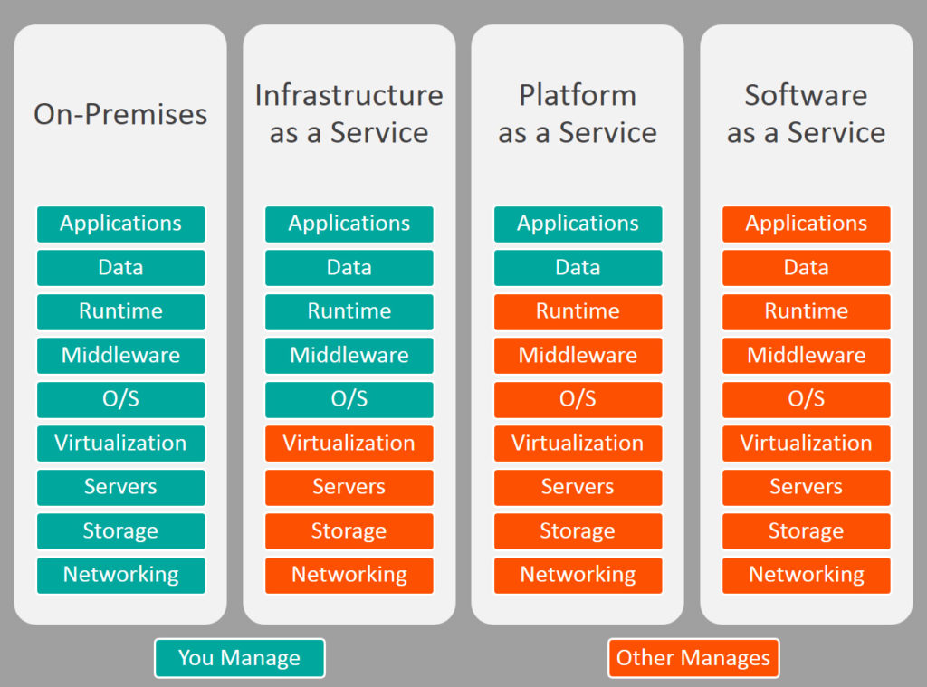

Physical vs virtual machine:

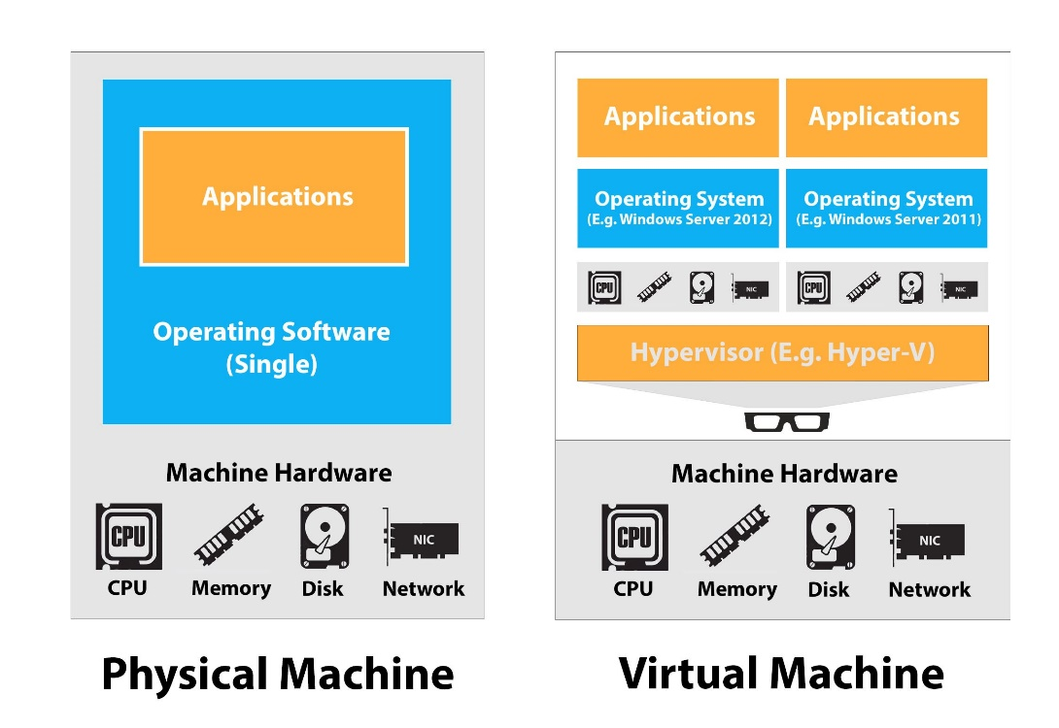

Virtual machine:

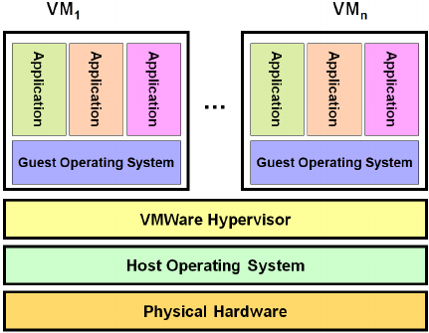

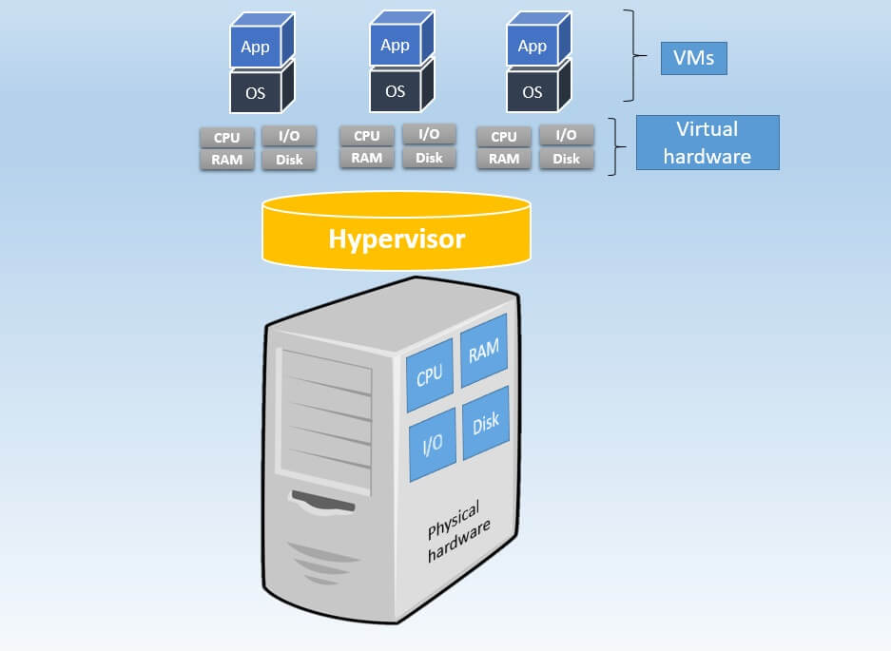

Physical server:

