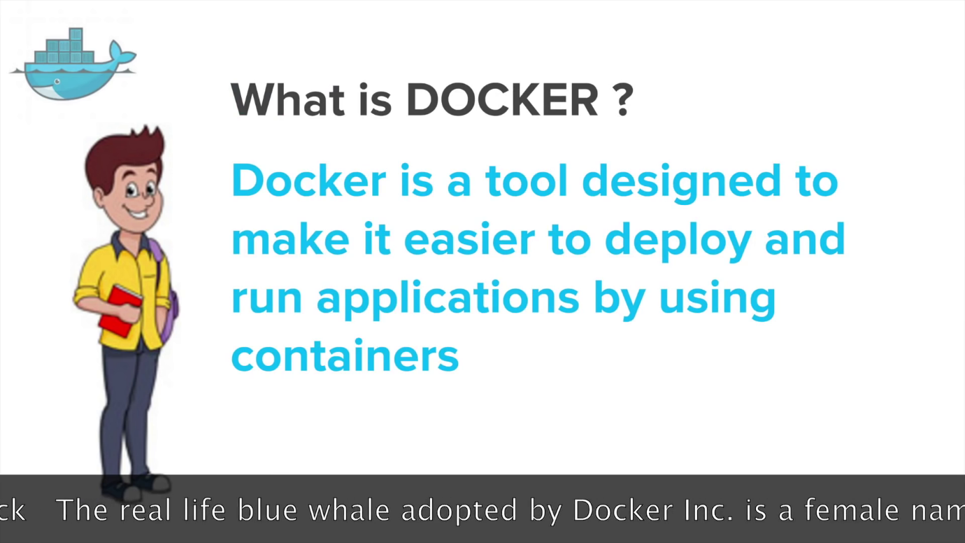

VM vs Container

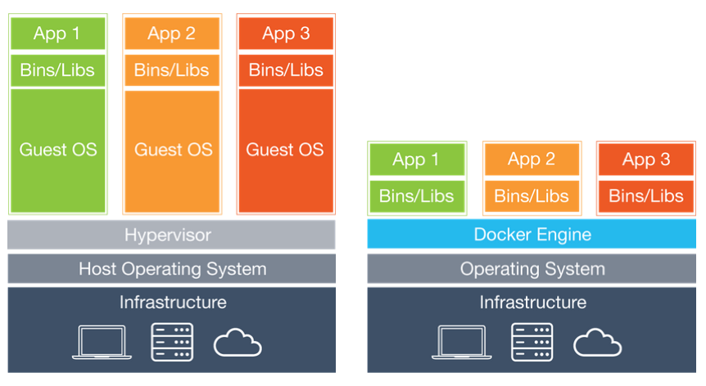

# [**etc/ bin/ and lib/**](https://stackoverflow.com/questions/16643142/what-do-these-directory-is-used-for-in-linux-etc-bin-and-lib)

* etc -> To keep configuration files
* lib -> To keep libraries that can be used by installed software or other softwares in your system.
* bin -> Binary files

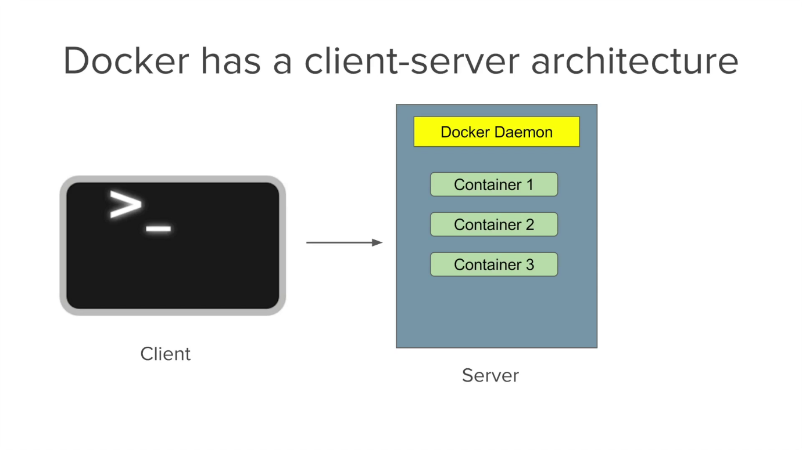

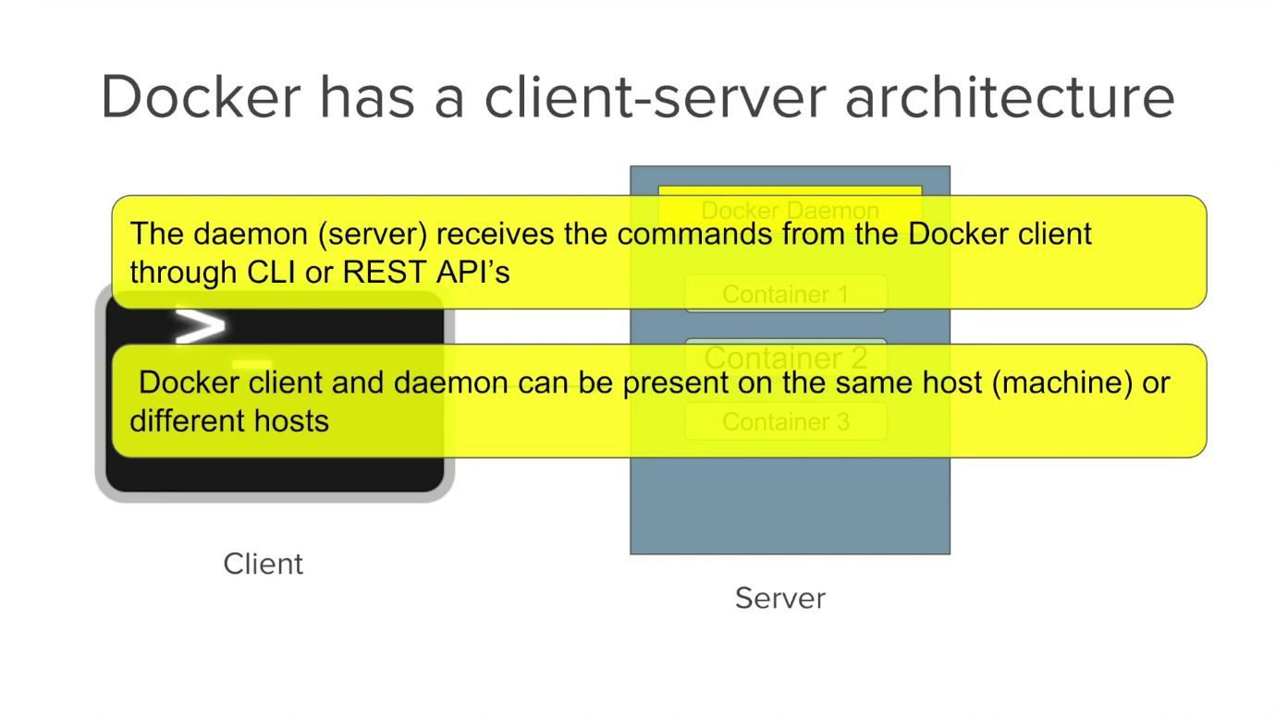

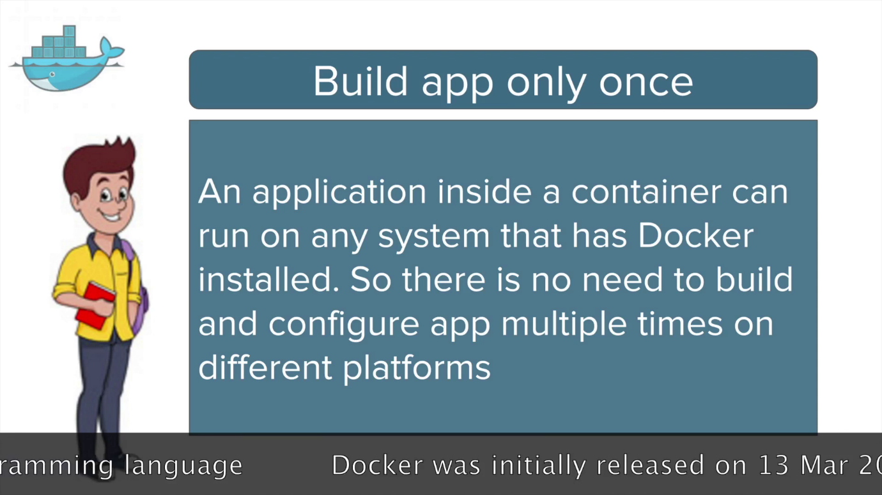

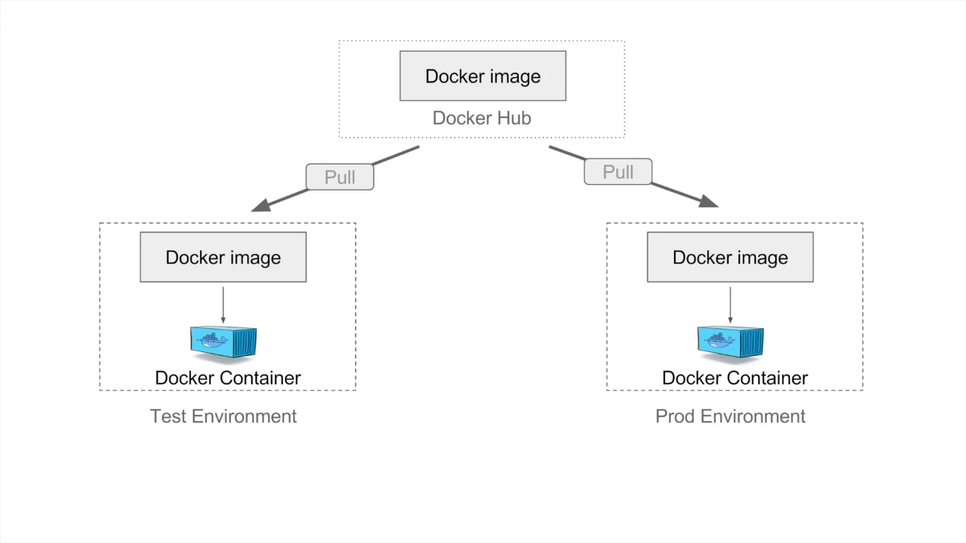

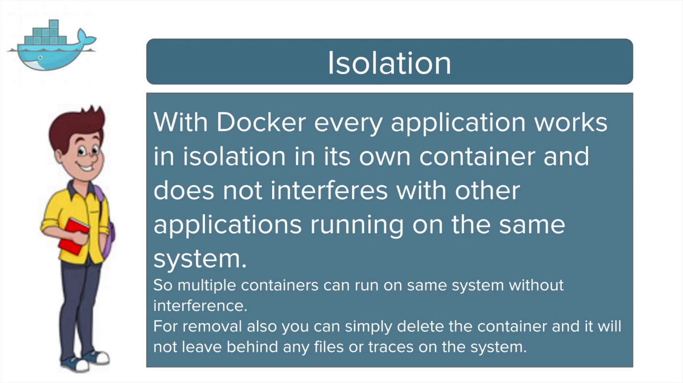

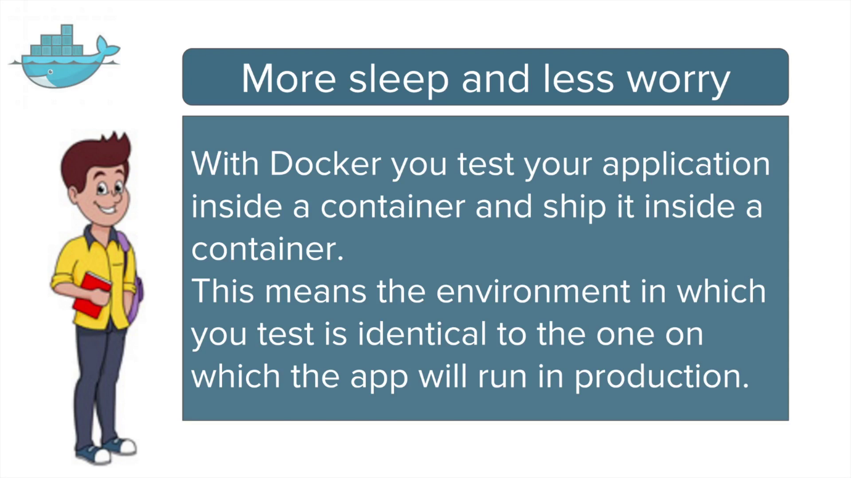

What is difference between docker and docker-ce.

**Docker commands:**

**Docker build :** Build an image from a Dockerfile

**Ex: docker build -t aaa-docker .**

**docker build -t aaa-docker -f /lakshman/Dockerfile**

**Docker tag:**

**docker tag SOURCE_IMAGE[:TAG] TARGET_IMAGE[:TAG]**

**Ex: docker tag aaa-dockerimg aaa-repo-can:data**

**Docker pull to download images from registry**

**Ex: docker pull aaa-core-docker-candidates.repo.lab.pl.alcatel-lucent.com/aaa-dockerimg:19A.20190516061205**