**What is Openstack?**

OpenStack is a collection of open source software modules that provides a framework to create and manage both [public cloud](https://searchcloudcomputing.techtarget.com/definition/public-cloud) and [private cloud](https://searchcloudcomputing.techtarget.com/definition/private-cloud) infrastructure.

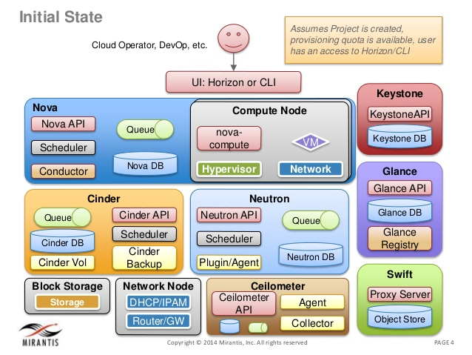

**Components of Openstack?**

**Compute (Nova)**

Nova can be deployed using hypervisor technologies such as KVM, VMware, LXC, XenServer, etc. **It is used to manage numerous virtual machines and other instances that handle various computing tasks**.

### ****Image Service (Glance):****

### **Glance** provides image services to OpenStack. In this case, "images" refers to images (or virtual copies) of hard disks. Glance allows these images to be used as templates when deploying new virtual machine instances.

OpenStack Glance supports Raw, VirtualBox (VDI), VMWare (VMDK, OVF), Hyper-V (VHD), and Qemu/KVM (qcow2) virtual machine images.

### Object storage (Swift)

### OpenStack Object Storage (Swift) is a scalable redundant storage system. Objects and files are written to multiple disk drives spread throughout servers in the data center, with the OpenStack software responsible for ensuring data replication and integrity across the cluster.

### ****Swift**** is a storage system for objects and files. Rather than the traditional idea of a referring to files by their location on a disk drive, developers can instead refer to a unique identifier referring to the file or piece of information and let OpenStack decide where to store this information. This makes scaling easy, as developers don’t have the worry about the capacity on a single system behind the software. It also allows the system, rather than the developer, to worry about how best to make sure that data is backed up in case of the failure of a machine or network connection.

### ****Dashboard (Horizon)****

### OpenStack Horizon is a web-based graphical interface that cloud administrators and users can access to manage [OpenStack](https://searchcloudcomputing.techtarget.com/definition/OpenStack) compute, storage and networking services.

### ****Identity Service (Keystone)****

Keystone provides a central list of users, mapped against all the OpenStack services, which they can access. It integrates with existing backend services such as LDAP while acting as a common authentication system across the cloud computing system.

**Keystone** provides identity services for OpenStack. It is essentially a central list of all of the users of the OpenStack cloud, mapped against all of the services provided by the cloud, which they have permission to use. It provides multiple means of access, meaning developers can easily map their existing user access methods against Keystone.

### ****Networking (Neutron)****

### OpenStack Networking (Neutron) is a system for managing networks and [IP addresses](https://en.wikipedia.org/wiki/IP_address). OpenStack Networking ensures the network is not a bottleneck or limiting factor in a cloud deployment,[[*citation needed*](https://en.wikipedia.org/wiki/Wikipedia:Citation_needed)] and gives users self-service ability, even over network configurations.

Users can create their own networks, control traffic, and connect servers and devices to one or more networks. Administrators can use [software-defined networking](https://en.wikipedia.org/wiki/Software-defined_networking) (SDN) technologies like [OpenFlow](https://en.wikipedia.org/wiki/OpenFlow) to support high levels of [multi-tenancy](https://en.wikipedia.org/wiki/Multi-tenancy) and massive scale. OpenStack networking provides an extension framework that can deploy and manage additional network services—such as [intrusion detection systems](https://en.wikipedia.org/wiki/Intrusion_detection_system) (IDS), load balancing, firewalls, and virtual private networks (VPN).

### ****Block Storage (Cinder)****

OpenStack Block Storage (Cinder) provides persistent [block-level storage](https://en.wikipedia.org/wiki/Block_(data_storage)) devices for use with OpenStack compute instances. The block storage system manages the creation, attaching and detaching of the block devices to servers. Block storage volumes are fully integrated into OpenStack Compute and the Dashboard allowing for cloud users to manage their own storage needs

### Orchestration (Heat)[[edit](https://en.wikipedia.org/w/index.php?title=OpenStack&action=edit&section=11)]

Heat is a service to [orchestrate](https://en.wikipedia.org/wiki/Orchestration_(computing)) multiple composite cloud applications using templates, through both an OpenStack-native REST API and a CloudFormation-compatible Query API.[[70]](https://en.wikipedia.org/wiki/OpenStack#cite_note-70)

**Heat** is the orchestration component of OpenStack, which allows developers to store the requirements of a cloud application in a file that defines what resources are necessary for that application. In this way, it helps to manage the infrastructure needed for a cloud service to run.

### ****Telemetry (Ceilometer)****

Ceilometer delivers a single point of contact for billing systems obtaining all of the measurements to authorize customer billing across all [OpenStack core components](http://vmokshagroup.com/blog/openstack-the-open-cloud-computing-platform/). By monitoring notifications from existing services, developers can collect the data and may configure the type of data to meet their operating requirements.

**Ceilometer** provides telemetry services, which allow the cloud to provide billing services to individual users of the cloud. It also keeps a verifiable count of each user’s system usage of each of the various components of an OpenStack cloud. Think metering and usage reporting.