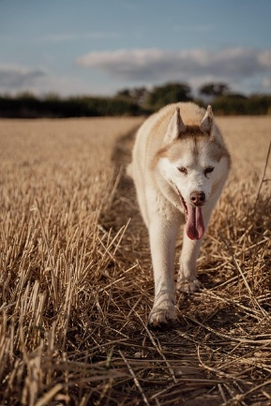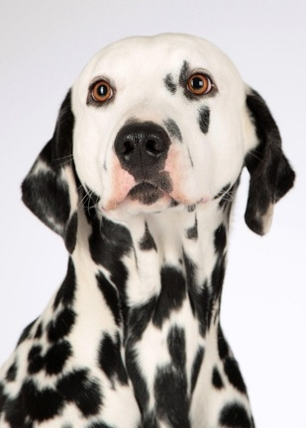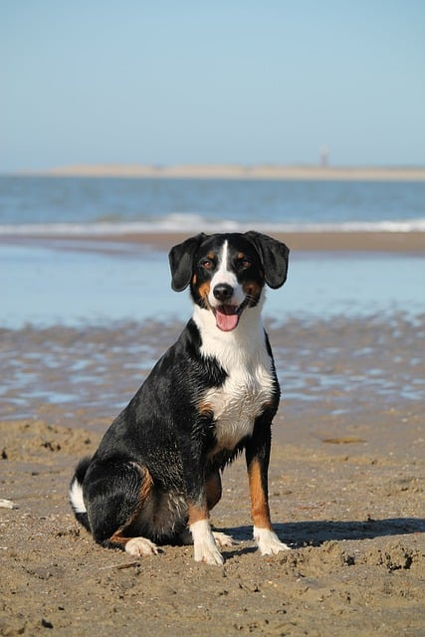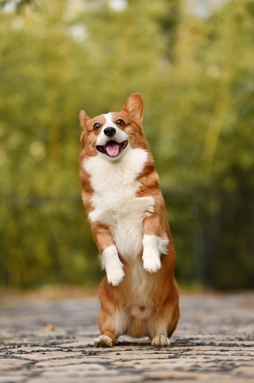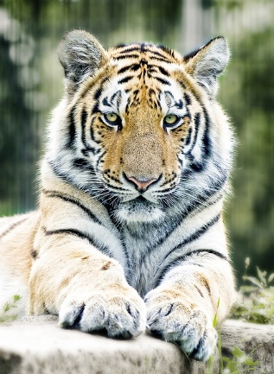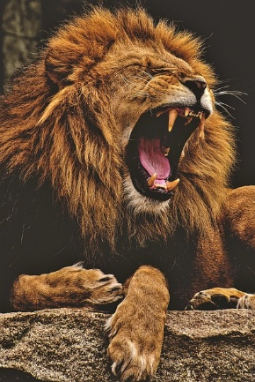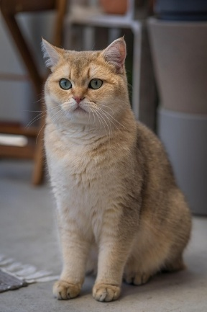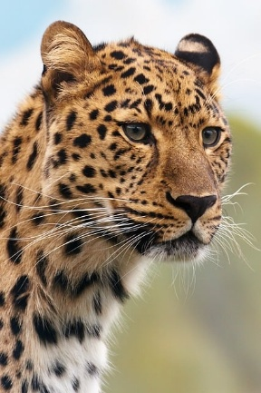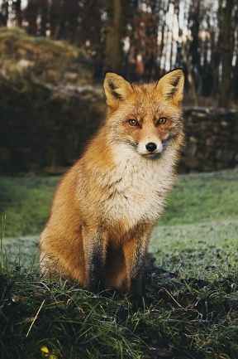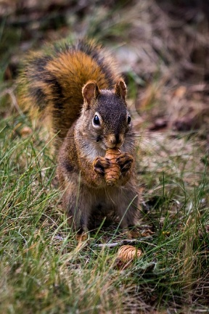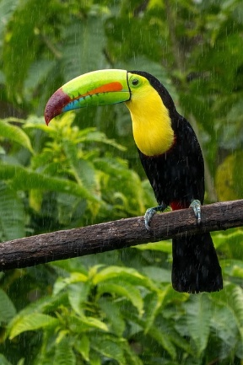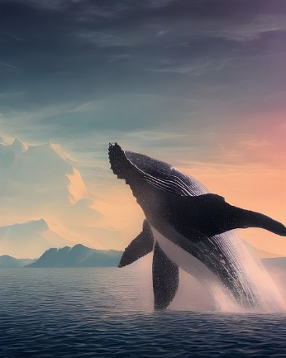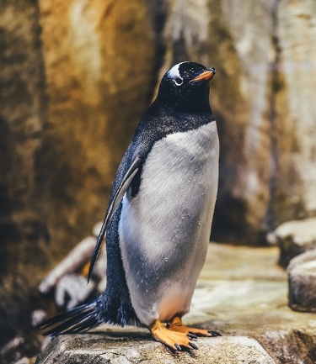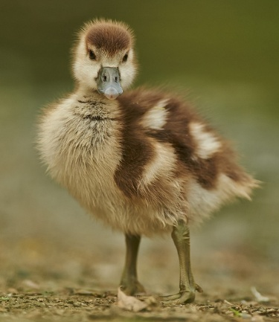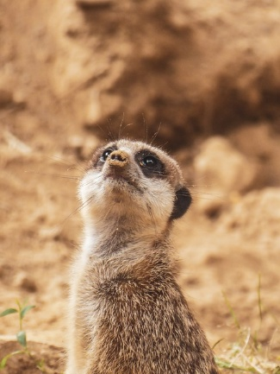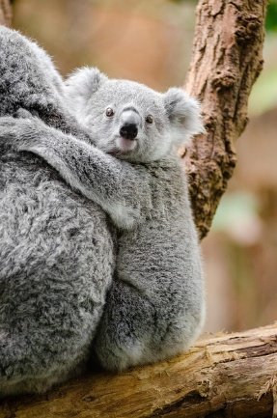

**dog1.jpg**

**dog2.jpg**

**dog4.jpg**

**dog3.jpg**

**meerkat.jpg**

**koala.jpg**

**duck.jpg**

**squirrel.jpg**

**cat.jpg**

**whale.jpg**

**fox.jpg**

**tucan.jpg**

**tiger.jpg**

**penguin.jpg**

**lion.jpg**

**leopard.jpg**

**potatoes.jpg**

**popcorn.jpg**

**fries.jpg**

**cookies.jpg**

**cake.jpg**

**croissants.jpg**

**pizza.jpg**

**apples.jpg**

**bread.jpg**

**burger.jpg**

**pasta.jpg**