**Suicide Death Rates Dataset**

**Problem Statement:** Suicide rates vary significantly by demographic factors, including age, race, and sex. Understanding these variations can help in targeting mental health interventions.

**Hypothesis:** Certain demographic groups (e.g., men or specific age groups) have significantly higher suicide rates than others, and economic factors or social support availability may be contributing factors.

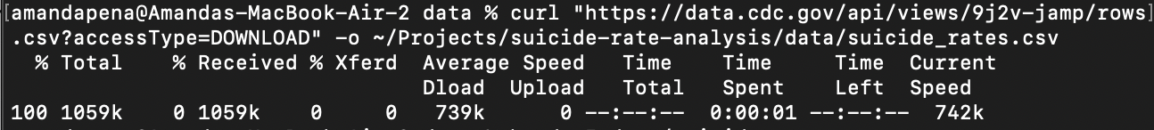

* Using curl, download your data file.

* Display the first 5 rows, using the head command to figure out which columns I would like to use.

* Use awk to create a file with the filtered data/columns.
* Push the created file to GitHub

* Create an awk command to gather initial data.
* I used the awk command to extract death rates for the White group. The output shows varying rates from around 4.3 to 26.6, suggesting there’s some fluctuation in suicide rates for White individuals. My hypothesis is that certain groups (like men or specific age groups) have higher suicide rates, and factors like economic conditions or social support play a role. To support this hypothesis, I would need to compare these rates with other groups (like Black or Hispanic people) to see if White males, specifically, have higher rates.

**Early conclusions:** The suicide death rates for the White group vary, with some years showing relatively high rates (up to 26.6) and others lower rates (as low as 4.3), suggesting potential year-to-year variability. At this stage, comparing these rates with other demographic groups is necessary to determine if the White group consistently has higher rates, supporting my hypothesis.