Flat plate

(x-axis in ms)

Dial setting: 300

Delta p = 0.11

Type flow: Fully laminar

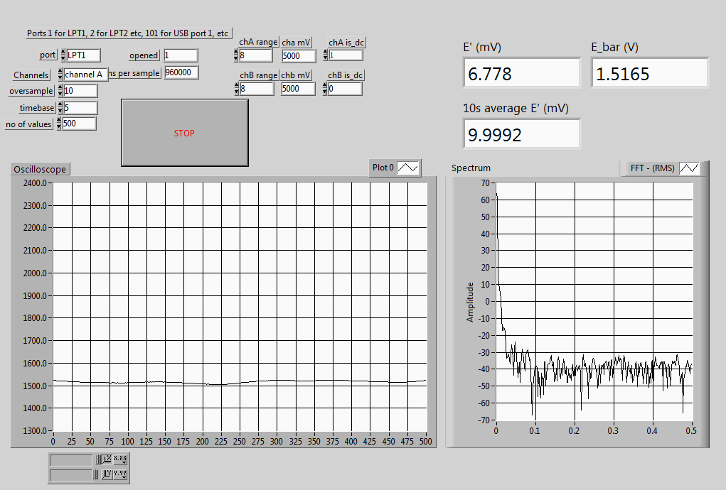

Dial setting: 650

Type flow: start of transition

Delta p = 1.04

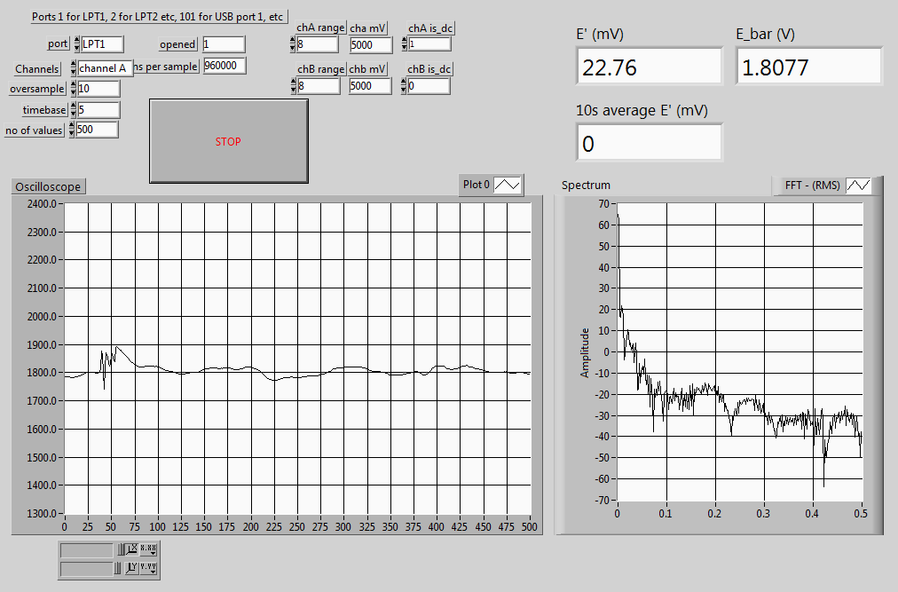

Dial setting: 820

Flow type: turbulent

Delta p = 1.59

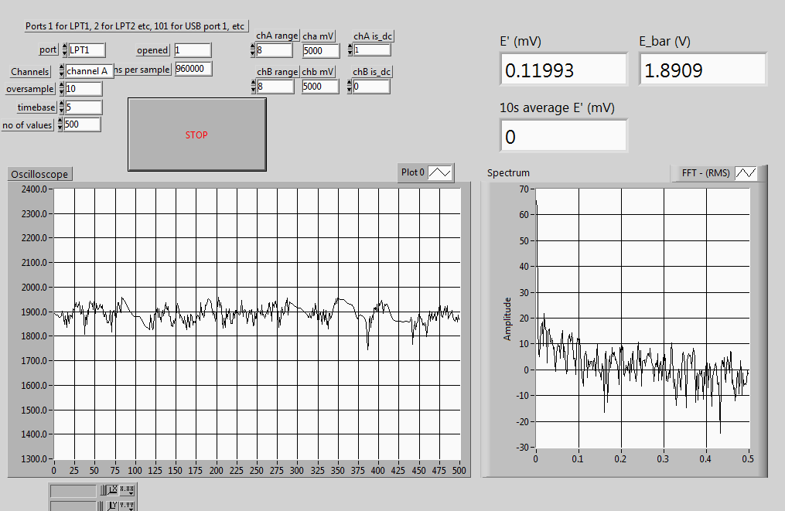

Dial setting: 1000

Flow type: fully developed

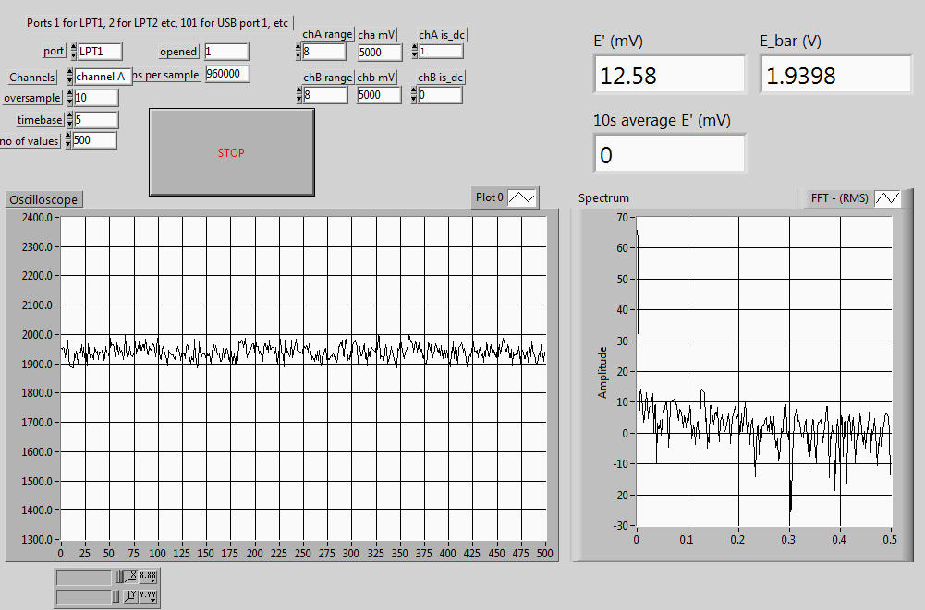

With protrusion (roughness element):

Speed: 300

Delta p = 0.11

Laminar

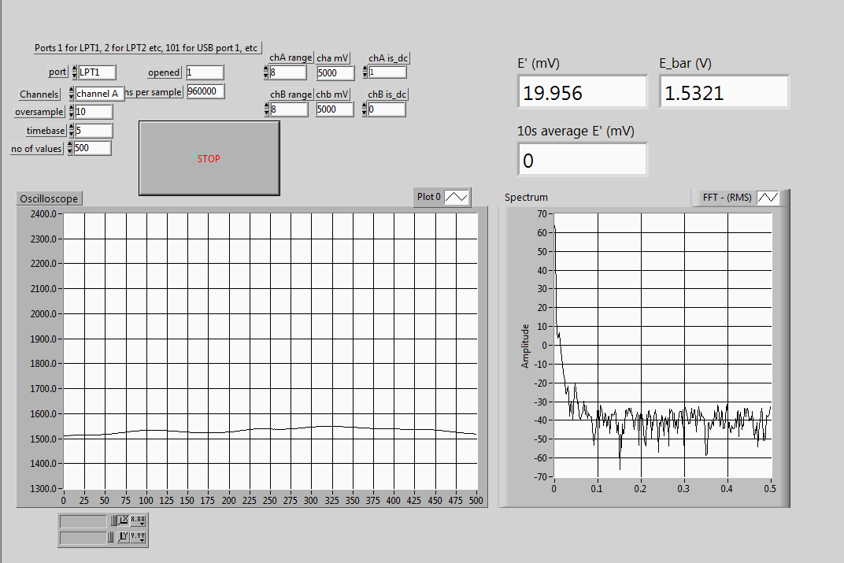

Speed: 370

Delta p = 0.34

Transition to turbulence

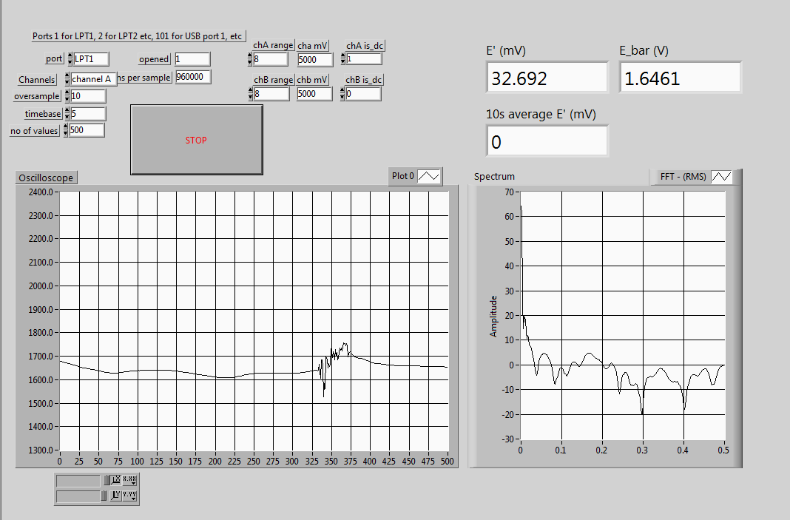

Speed: 430

Delta p = 0.47

Fully turbulent

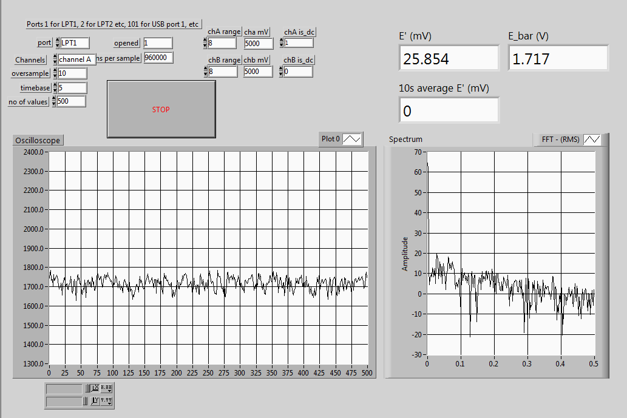

**WITH TRIP WIRE**

Dp = 0.04

Dial setting: 200

Observation: turbulent everywhere

