Mobile Computing 2021  
Homework1  
Lassi Perälä  
2559371

# WHAT I DID

I created a good base for the assisted reminder application. The application should fill all the minimum requirements. I also implemented the extra requirements such as **Account creation process**, **Other data storage method than** **SharedPreferences** and **Tutorial or a help activity**.

# FUNCTIONALITIES

**Main screen** with the chance to log into an existing account or sign in with a new account. The “?” boxes are used to give the user some tutorial/tips if needed. You should be able to find at least 3 of these in the application.

**Log in screen** is used to log in with an existing account. If the account does not exist or if the password/username is typed wrong, the application will let the user know. SQLite databases are used to compare the user input to the stored values.

**Sign in screen** is used to create a new account. If the fields are left empty or the passwords do not match, the application will let the user know. If the username and passwords are written correctly, the application will use SQLite databases to store the information.

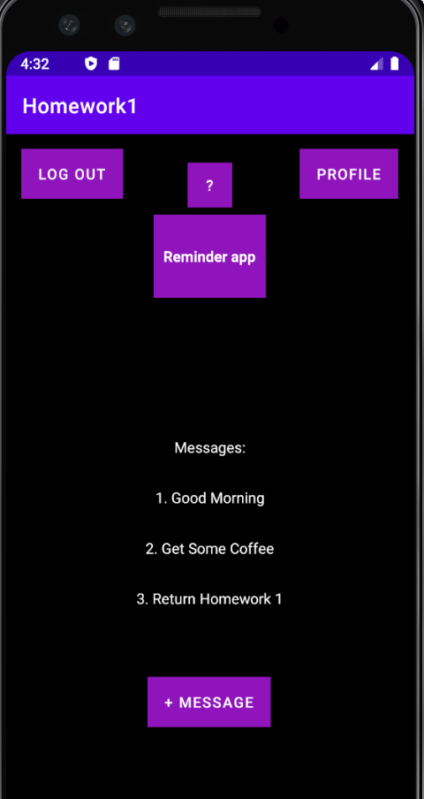**Main (message) screen** contains all the rest of the required features. There are three placeholder messages located in the section where the reminders will be in the future. There is a **+Message** button that will be used to add new reminders. **Profile** button will let the user edit his/her info. The **Log out** button can be used to return to the Main screen.

# Challenges

# Minimum requirements

### Bindings

In the beginning of the development, it was a bit difficult to understand how the **bindings** work. I tried to follow the exercise lecture videos, but I was still confused. In the end of the day, I understood what they are used for.

### build.gradle

This is tightly connected to my binding challenges. I did not notice that,

buildFeatures **{** viewBinding = true  
**}**

was added and synced in the build.gradle. I ended up wasting couple of hours on this.

# Extra requirements

### Data Storage

I decided to use **SQLite for the data storage**. I did not pay much attention to the SharedPreferences, but I am quite sure that the SQLite was not the easiest way to go. After going trough some youtube tutorials I started to get the hang of SQLite for my needs.

A good guide on how to create and add data to the data base (used mostly with the Sign in action):  
<https://www.youtube.com/watch?v=OxHNcCXnxnE>

Another good guide on how to read the data and use it (used mostly with the username/password validation):  
<https://www.youtube.com/watch?v=vov_rsFWkmM>

### Data validation

Learning how to use the database indexes and compare them to the user inputs was a bit hard to understand in the beginning. Especially as most of the guides suggested the usage of indexes by doing for example:  
>data.get(i).userName  
This form kept giving me unexpected errors that weren’t always so easy to detect. I ended up using:  
>data[i].userName  
for indexing which ended up working very well.

# GitHub https://github.com/lperala/Homework1