Hi, Carlie -

Here is the list of security risks I’ve come up with and the backup method I’d prefer.

**Security Risks**

* Physical Security
  + Natural disasters
  + Vandalism
  + Theft
  + Damage to software
  + Damage to hardware
* Network Security
  + Distributed denial of service
  + Malware
  + Ransomware
  + Phishing
  + Viruses
  + Hacking
* Application Security
  + Security misconfiguration
  + Using components with known vulnerabilities
  + Data leaks and exposure
  + Insufficient logging and monitoring
* File Security
  + Worms
  + Trojans
  + Spyware
  + Spam
  + Adware
  + Rootkits
* User Security
  + Compromised user accounts
  + No identity management
  + Weak passwords
  + Social engineering
  + User resistance
* Procedural Security
  + Users not logging out
  + Users not locking device when stepping away
  + Not training users on security
  + Dumpster diving

**Backup Method Preferred**

* Weekly Full Backup with Daily Incremental Backup
  + I chose this method because a full backup saves all the files and it will have to be done initially anyway. Daily incremental backups will back up any changes since the last backup, incremental or full. The incremental backups take less space than a daily full backup and are faster than full or differential. On the off chance that we lose data, the restoration will be a little slower since there will be incremental pieces to put together with the last full backup, but I don’t feel it’s enough of a difference to go a different route.

Let me know if you have any questions.

Leah

Hi, Carlie -

Attached please find my list of pros and cons for in house maintenance versus outsourced maintenance. My thoughts are to go with outsourced.

| **In House Pros** | **In House Cons** | **Outsourced Pros** | **Outsourced Cons** |
| --- | --- | --- | --- |
| Higher understanding of business and expectations | More expensive | Personnel issues problem of outsourced company | Loss of control |
| Less downtime. | Lack of range of expertise | Experts | Staff turnover and loss of knowledge |
| Shorter response time when available | May work slower | Staffing flexibility | Management redundancy |
| Team is invested | Unanticipated costs | Cost savings | Availability-may not be able to respond immediately when issues occur |
| Predictable costs | Small department could become overwhelmed | Increased quality | Cybersecurity risks |
| Immediate access to techs |  |  | Communication issues |

Thanks.

Leah

Hi, Carlie -

Here is the Cost Feasibility for the in house build along with the NPV.

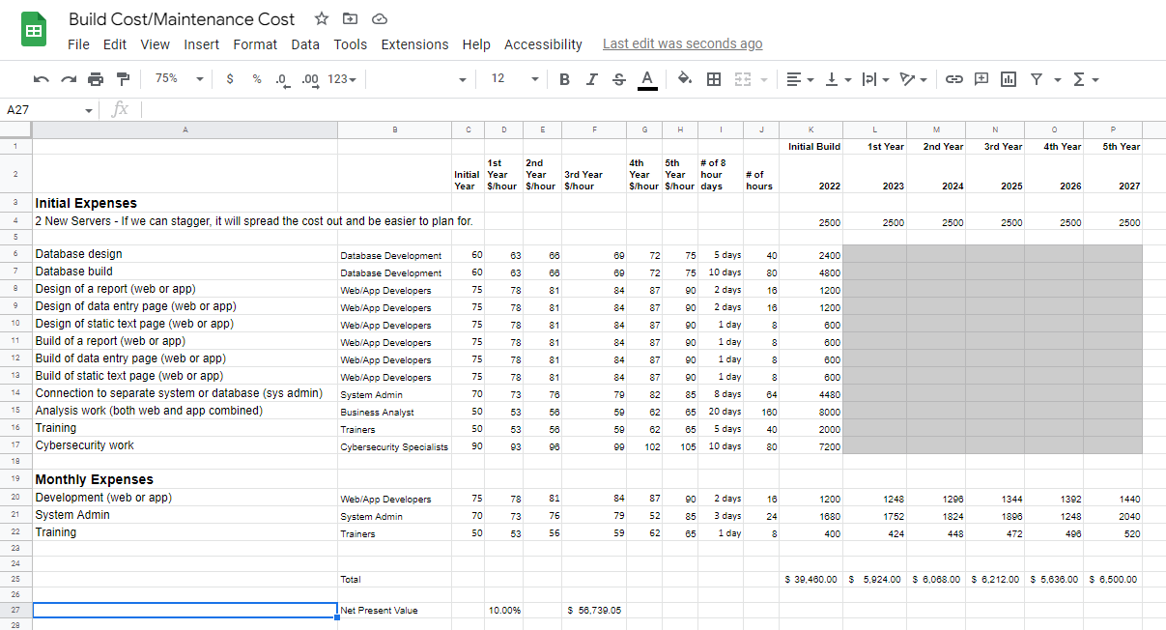

Give me a call with any questions.

Thanks.

Leah