Oct 12, 2022

Hi, Carlie -

Attached are the Use Case Diagram, Object Model, Object Table, and Instances that you asked for. I hope the information is helpful.

Thanks -

Leah

**Use Case Diagram**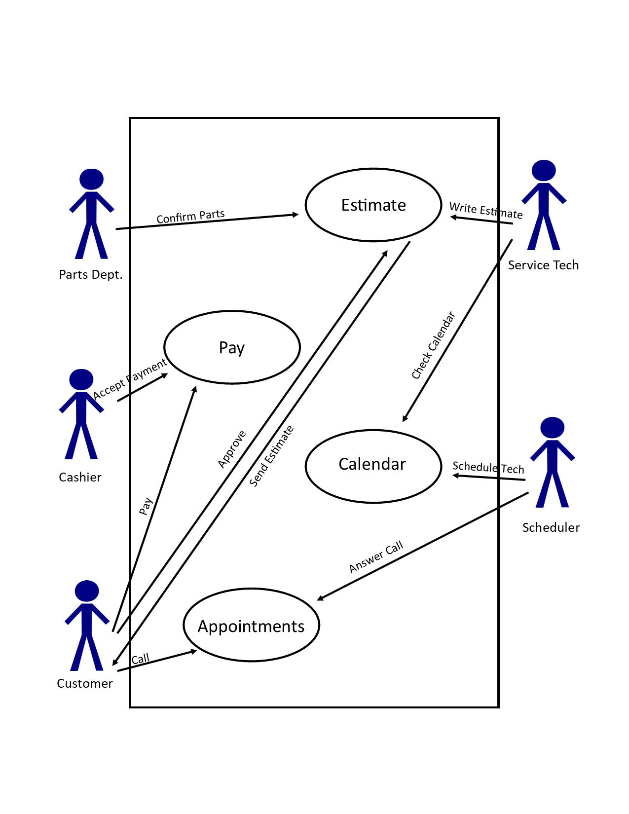

**Object Model**

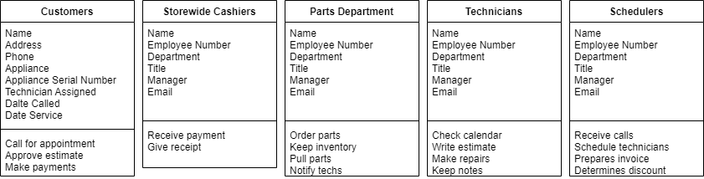

**Object Table**

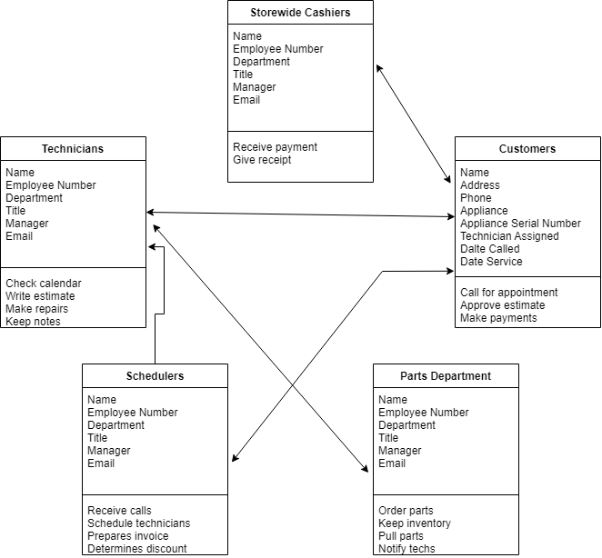

**Instances**

