Hi, Carlie -

Attached is the hierarchy diagram you requested along with the mockups for the menu, input, contact, and informational web pages. The validation rules for the input form are listed underneath it.

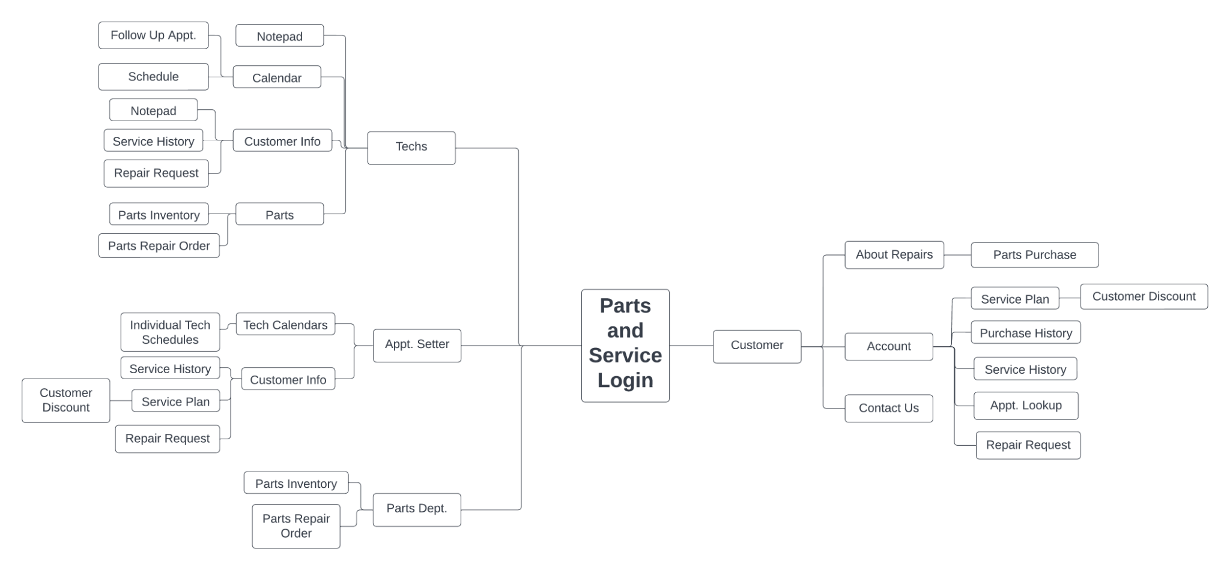

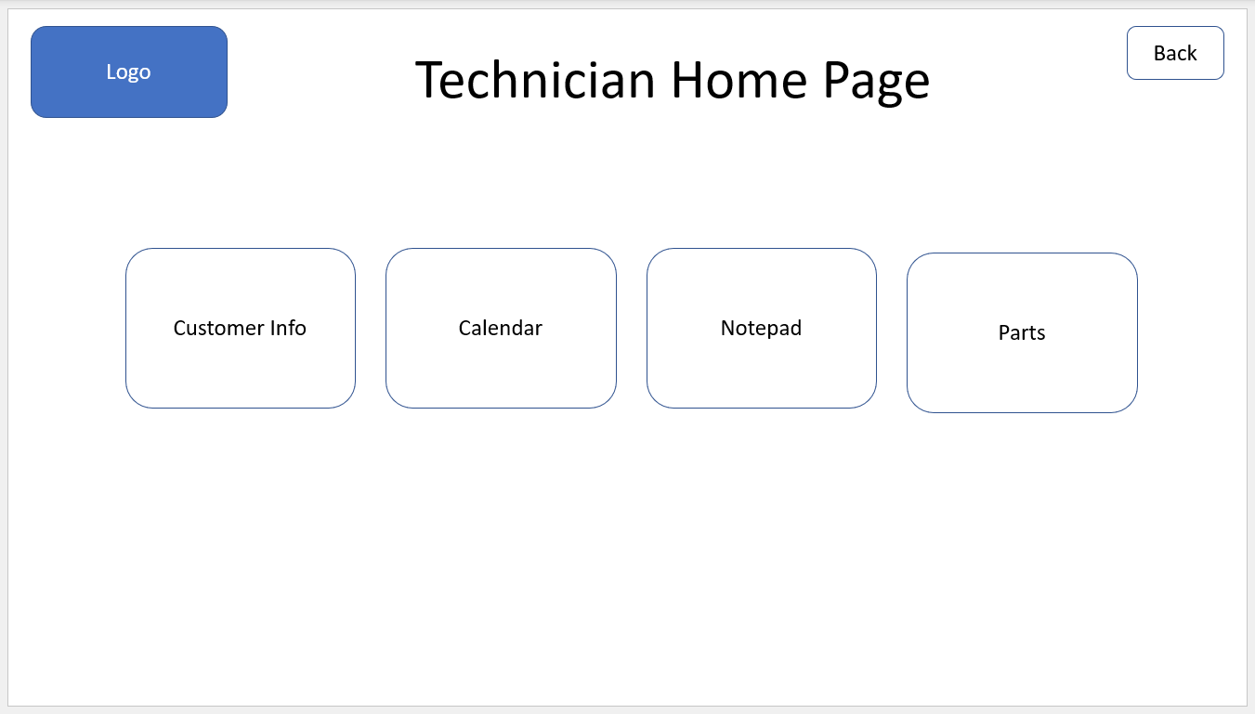

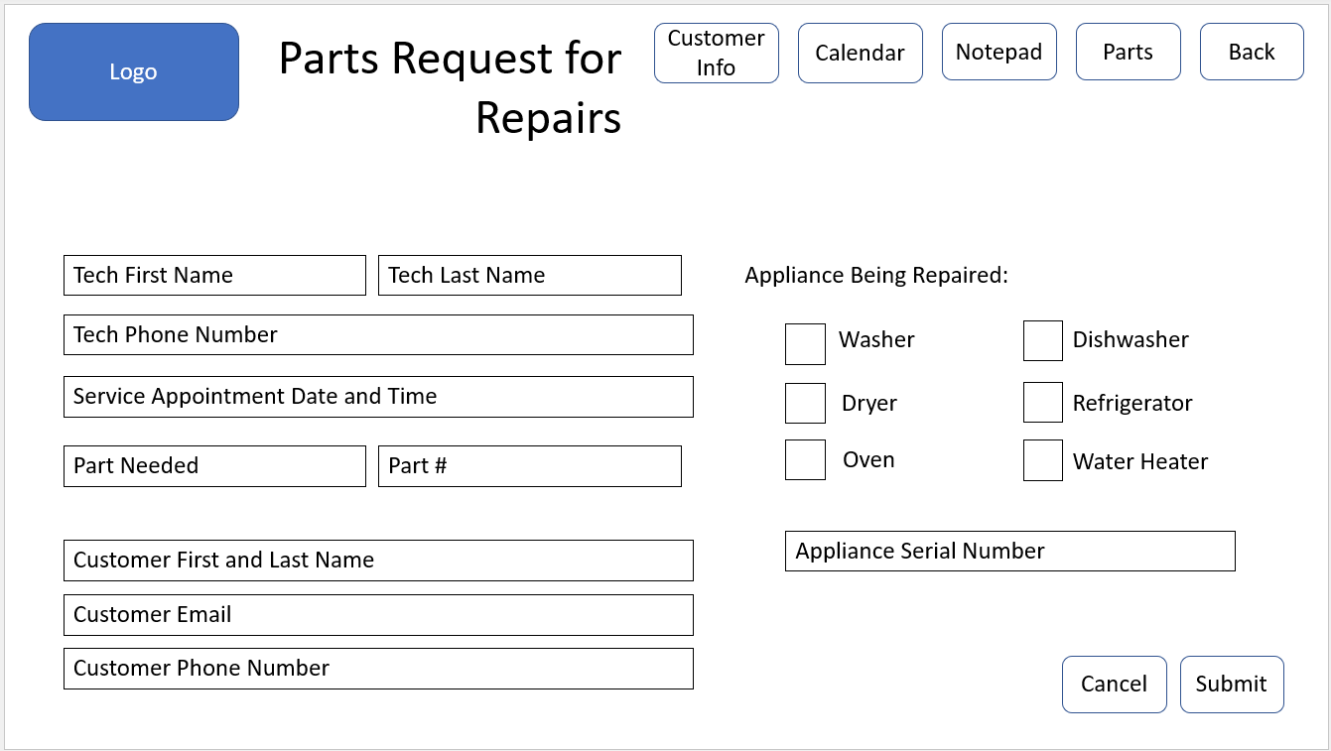

Validation Rules:

* Tech First and Last Name - data type check for alphabetic field and existence check
* Tech Phone Number - data type check for numeric field and existence check
* Service Appointment Date and Time - Date format and Time format
* Part needed - data type check for alphabetic field
* Part # - data type check for numeric field 6 numbers long and existence check
* Customer First and Last Name - data type check for alphabetic field
* Customer Email - check for standard email format
* Customer Phone Number - check for standard area code and phone number
* Appliance Serial Number - data check for alphanumeric number 10 digits long and existence check

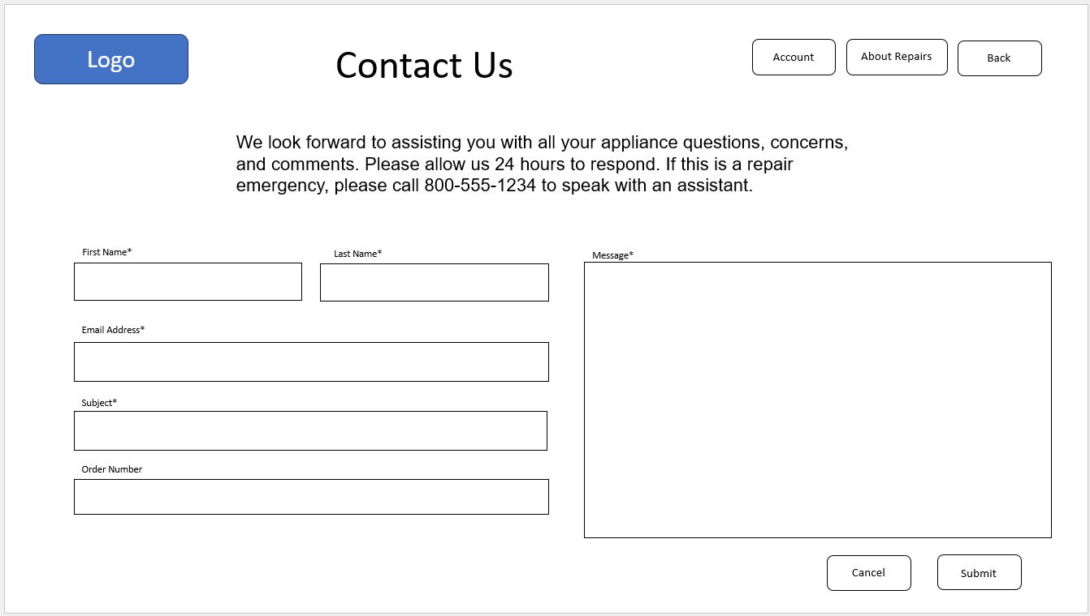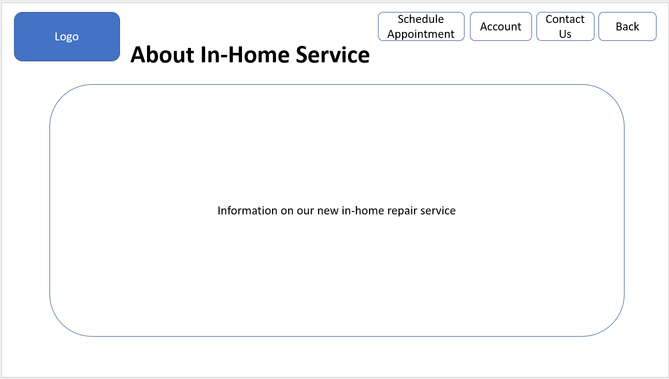

Hi, Carlie -

The new application should run on all types of devices as the techs will need to use it in the field and customers will want to access it wherever they are. I would suggest a responsive web design to handle those situations. A responsive web design will allow the application to be viewed on desktops, tablets, and smartphones by adjusting the layout and content based on the screen size and resolution of the user’s device. It will allow the website content to flow across all screens, and render it to look great on all devices. It also makes it unnecessary to maintain different versions of the website for mobile and desktop and saves time, resources and efforts.

As far as prototyping the system, I don’t think it’s necessary. As long as we’ve evaluated the needs, researched the current industry standards and prioritized the requirements, we’ll be in a good position to develop a useful and pleasant environment for everyone to use. The prototype does have some advantages, such as:

* Actively involves the users
* Detects missing functionality easily
* Feedback is very quick
* Ensures customer satisfaction and comfort
* Flexibility so changes can be made easily
* Possibly saves money

But I feel that the disadvantages outweigh the advantages in this instance.

* Time consuming process due to multiple changes and tests
* Demanding users may expect the final product soon after seeing the early prototype
* Poor decision making due to wanting to produce the final product quickly
* Poor documentation due to changing requirements by the users
* High upfront costs
* Insufficient analysis of the overall product which could lead to a poorly engineered and complex system

Let me know if you have any other questions.

Leah

Hi, Carlie -

Here are the mockups of the reports you asked for.

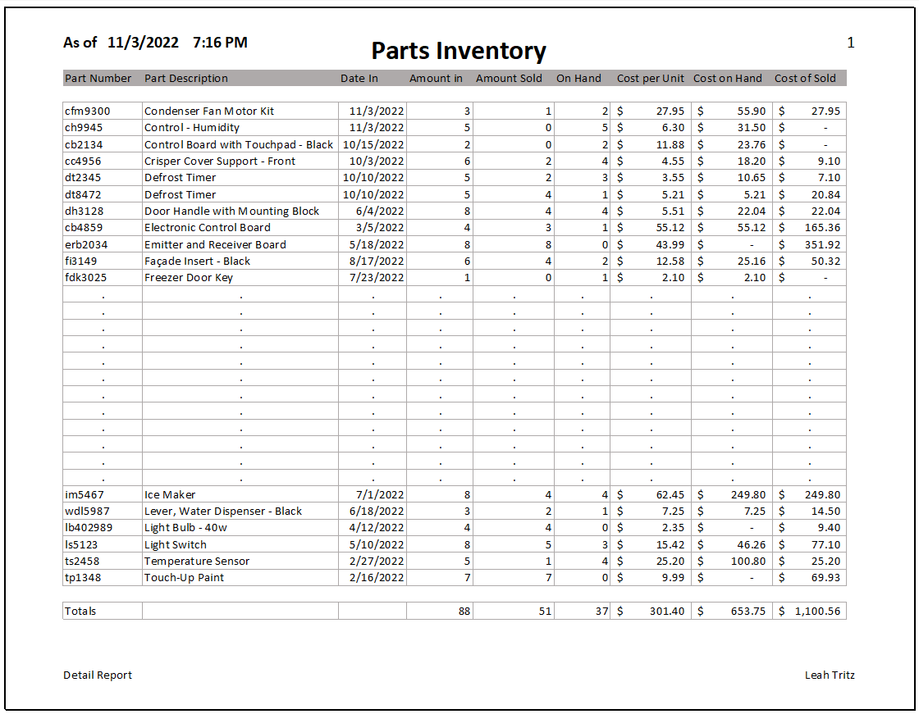

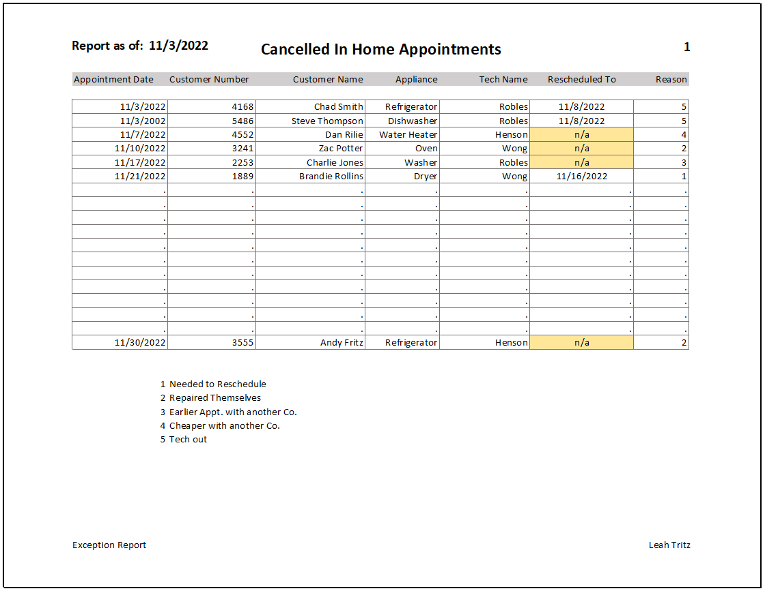

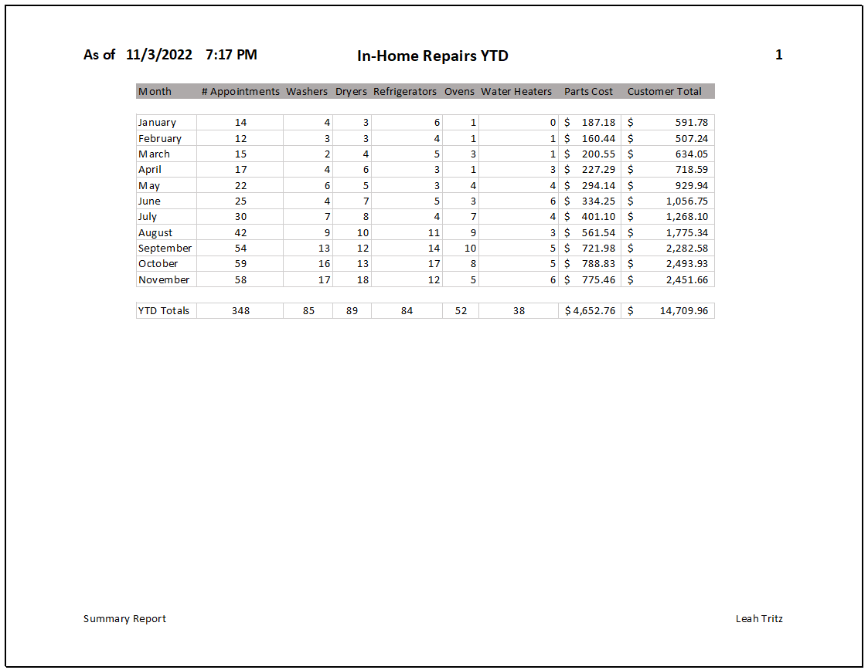

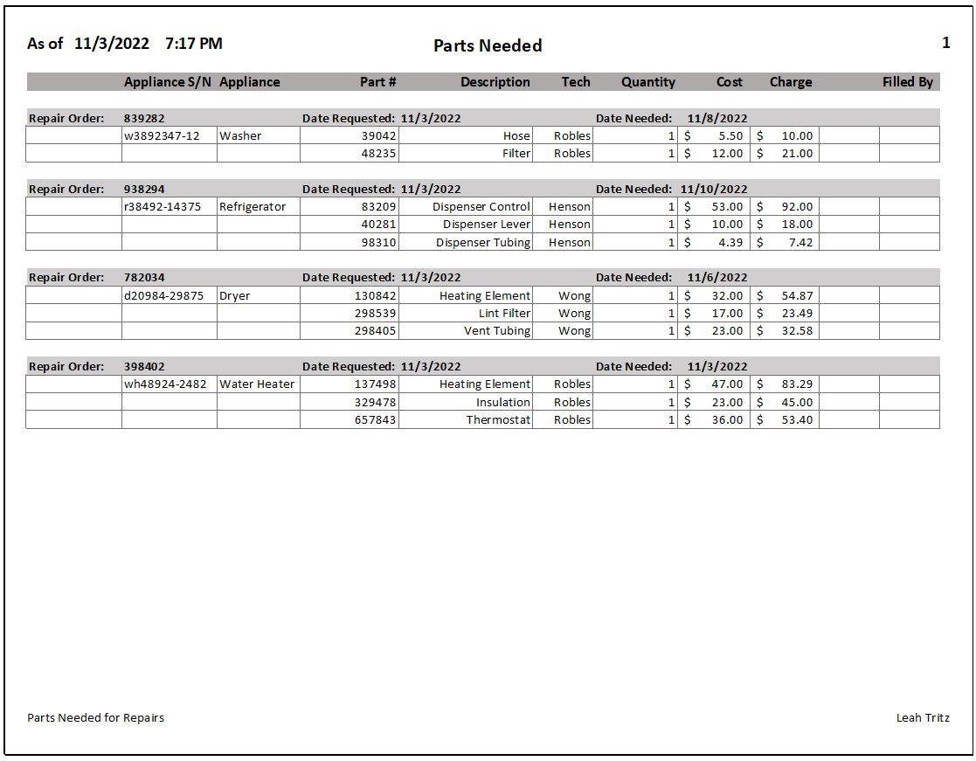

I plan on delivering all the reports electronically. The detail report has a tendency to be long and the others can be printed as needed. The report that Mr. Farley receives will be set up so as the parts are pulled for the technicians, they can be marked off as to which employee pulled them. Printing the parts request report every 2 hours would use quite a bit of paper and we want to be environmentally conscious.

If you see anything you’d like revised or added, please let me know.

Thanks -

Leah