Hi, Carlie -

The following is the ERD I drew out that you had requested. Let me know if you have any questions or are looking for other information.

Leah

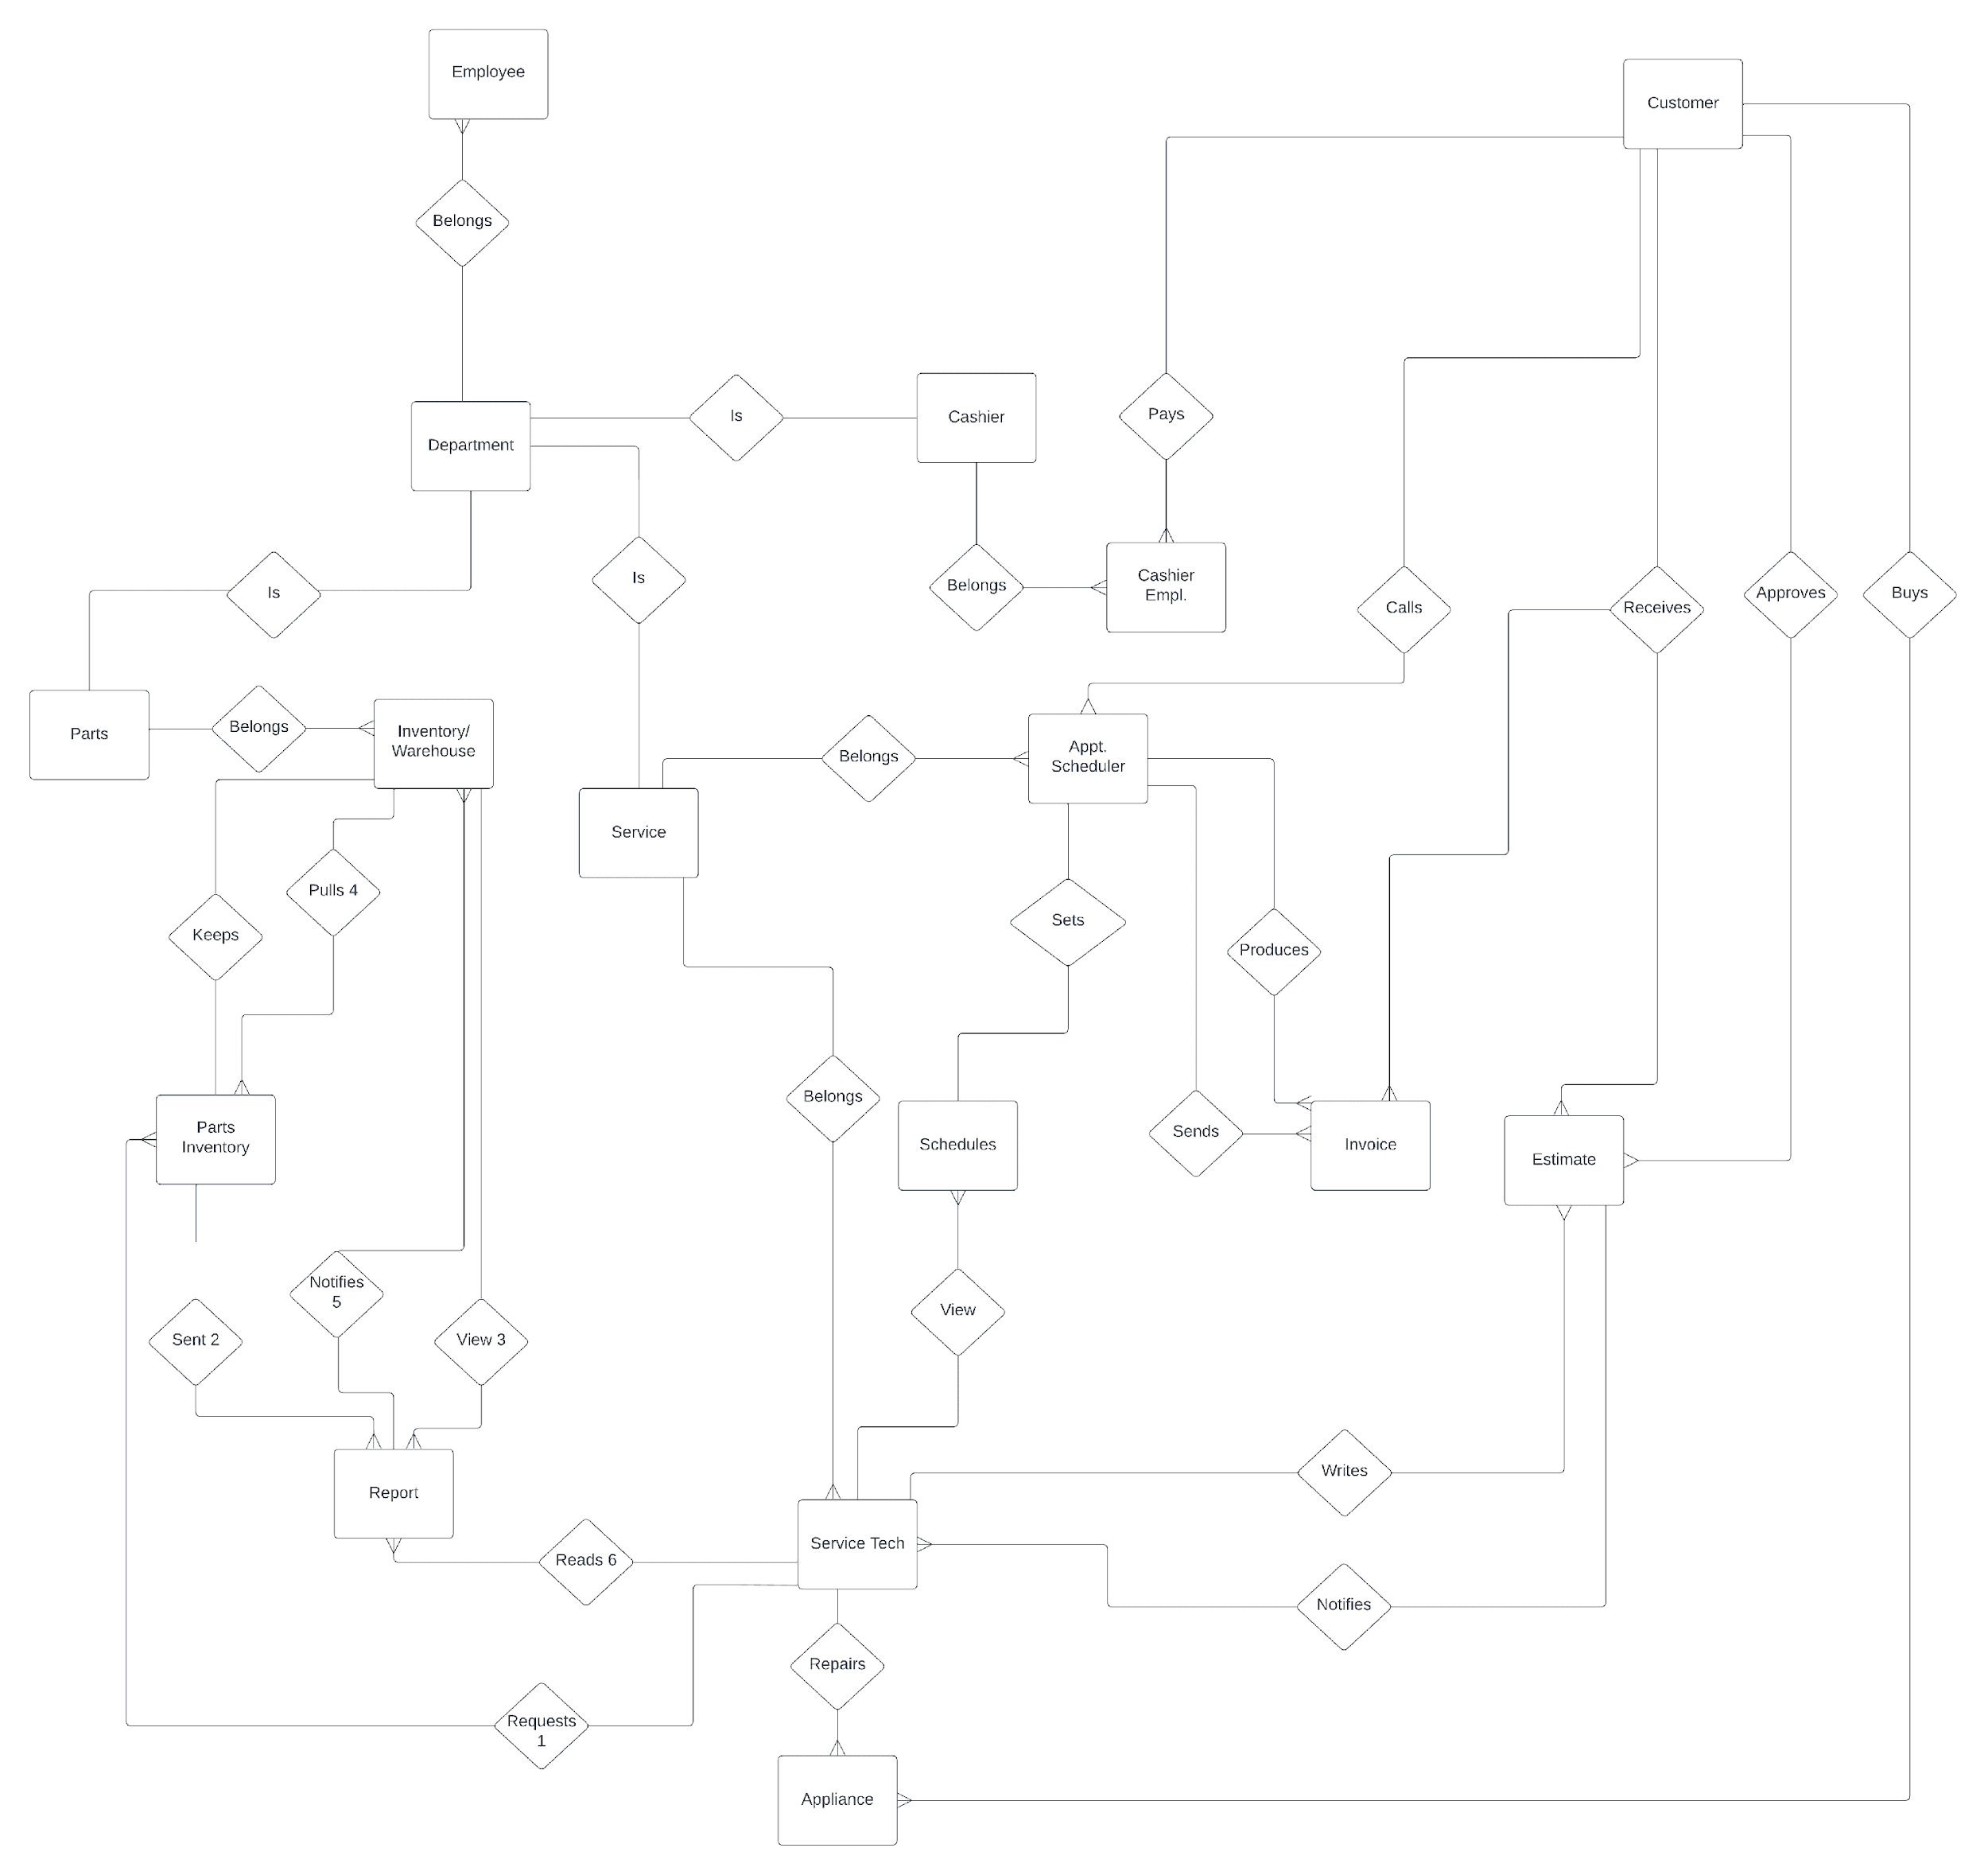

Hi, Carlie -

I’m attaching the tables for the structure you requested. Primary keys are marked. Following the relationship layout are the tables with sample data in each. I hope this helps. Please let me know if you have any questions or concerns.

Thanks - Leah



