Follow Along Lab

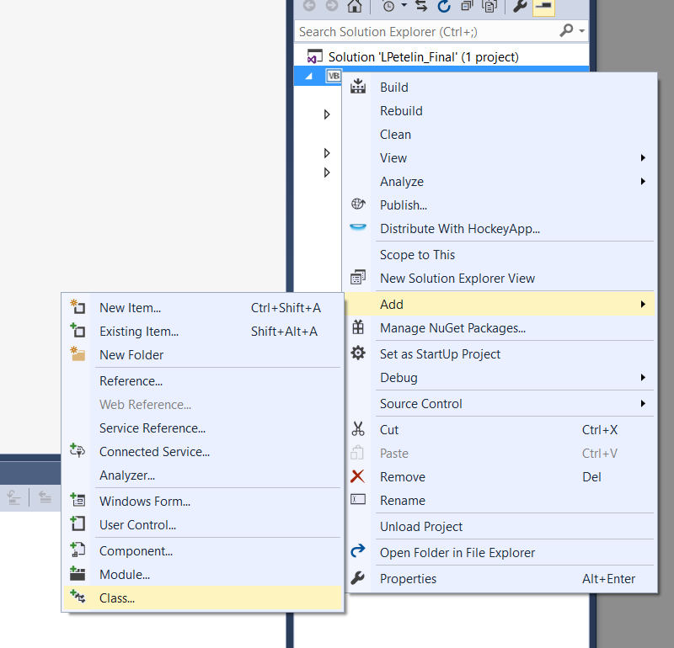1. Create a new project, right click on your project’s name and add a class to the project. It can be named whatever. I chose to name it Stopwatch since we will be working with the label and making it act as a stopwatch.

2. At the top, we need to let the class know that it is going to be inheriting the Label control. We also need to set up global Timer and Date variables.

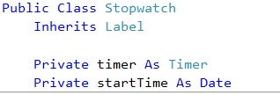

3. Next we need to code the constructor, where we initialize the timer and add a new method Timer_Tick() that is called every time the timer ticks. 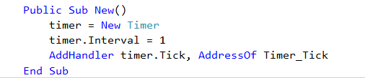

4. Now we create the Timer_Tick() method, declare and initialize a timespan variable which keeps track of how much time has taken place since the startTime. Then we display it onto our label.



5. Next we code the two methods that start the stopwatch, and stop the stopwatch.

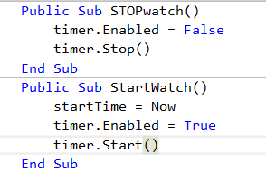

6. Next, build your project, add 2 buttons, and our new Stopwatch control onto the form. So that it looks like this.

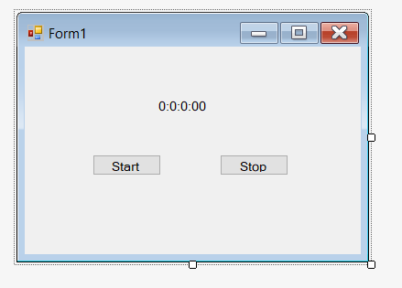

After you build your project, the Stopwatch control should appear at the top of the toolbox.

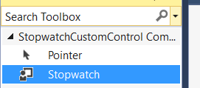

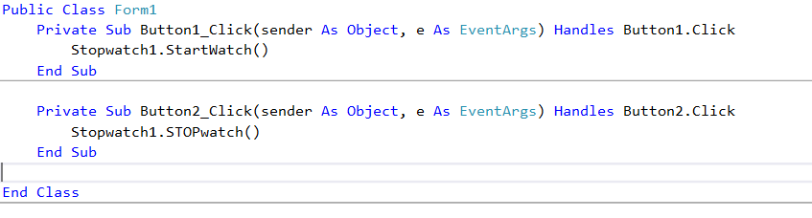7. Finally, double click the buttons, set one to start the stopwatch and one to stop the stopwatch. Call the methods from the class we just created.

Our label now acts as a stopwatch!

