**Instructions on Making a Peanut Butter and Jelly(Jam) Sandwich**

(1 Serving)

***BEFORE BEGINNING: This instruction set assumes you have at least two slices of bread, jar of peanut butter, and a jar jelly/jam. These items are required before proceeding with instructions.***

1. Start with a plate or open napkin on a clean working surface.
2. Place two slices of bread on the plate/napkin side by side.
3. Open the jar of peanut butter. With a knife/spoon, scoop out a dollop of peanut butter, approximately the size displayed in Figure 1 below.

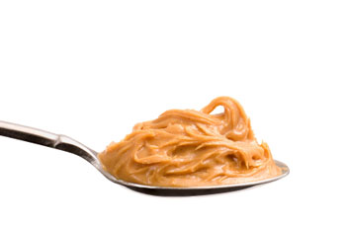

**Figure 1**

1. Pick up one of the slices of bread and place in the palm of your hand. Place the dollop of peanut butter in the middle of one side of the slice of bread. Gently spread the peanut butter from the middle of the slice to the edges ensuring full coverage of the slice. Do not go beyond the edges! NOTE: Be careful not to use too much pressure when spreading the peanut butter to avoid tearing of the bread.
2. Based on your love of peanut butter, add more peanut butter as desired. When done, place the peanut butter slice back on the plate/napkin.
3. Prepare application of jelly to second slice of bread. Pick up the second slice of bread.
   * If the jelly/jam is in a squeeze bottle container (Figure 2), open the top, squeeze and disperse the same amount of jelly /jam shown in Figure 1 onto the second slice. When done, spread the jelly evenly over the slice to ensure full coverage being careful not to go beyond the edges of the bread.



**Figure 2**

* + If jelly/jam is in a jar, open the jar of jelly/jam. With a knife/spoon, scoop out a dollop of jelly/jam, approximately the size displayed in Figure 1 onto the second slice. Spread the jelly/jam evenly over the slice to ensure full coverage being careful not to go beyond the edges.

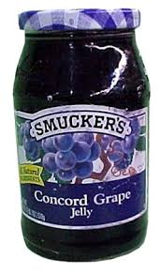

**Figure 3**

1. Based on your love of jelly/jam, add more jam/jelly as desired, but avoid adding too much jelly as this can saturate the bread and result in a soggy mess of a sandwich. Place the jellied slice back on the plate.
2. Assembly of Sandwich: Pick up the peanut butter bread slice and carefully place it on top of the jelly slice so the peanut butter and jelly sides are touching and the edges of the bread are aligned as closely as possible. The two slices have now become a sandwich.
3. Very gently, press the top of the sandwich so the peanut butter and jelly/jam mesh.
4. Evaluate your sandwich.
   * If your sandwich looks similar to Figure 5, you have successfully made a peanut butter and jelly sandwich and can now enjoy eating it.
   * If your hand is covered with jelly and/or peanut butter, you misapplied the slices in step 8 above. Clean your hand. To fix, choose one of the options below:
     + If you have a 3rd slice of bread available, make a triple decker. Add more of the spread that was just cleaned from your hand following step 4 or 6 above; or
     + Throw the sandwich away and start over from step 2.
   * If peanut butter and/or jelly/jam has seeped from the edges of your sandwich, similar to what’s shown in Figure 4, too much peanut butter and/or jelly was used. Scrape the edges clean with spoon/fork. Discard excess. You can now enjoy eating the sandwich.

**Figure 4**

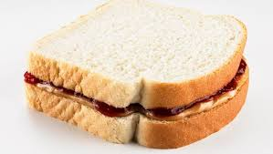

**Figure 5**

