孟德尔随机化分析报告

1. 方法

1.1 GWAS数据获取
通过IEU OpenGWAS数据库（https://gwas.mrcieu.ac.uk/）获取疾病相关的GWAS数据。

1.2 eQTL的MR分析
通过双样本MR分析来探讨候选基因与疾病风险之间的因果关系，将单核苷酸多态性（SNPs）定义为工具变量（IVs）。从血液eQTL的数据获取候选基因的eQTL数据（https://www.eQTLGen.com），作为暴露因素，并通过IEU OpenGWAS数据库获得疾病的GWAS数据作为结局因素。

1.3 工具变量筛选
首先，进行工具变量的筛选。通过R包TwoSampleMR（https://mrcieu.github.io/TwoSampleMR/）读取暴露因素并确定与暴露因素独立相关的SNP，将它们作为评估暴露因素和结局之间因果关系的工具变量（IVs）。筛选指标：包括P<5×10⁻⁸，寻找与暴露因素显著相关的工具变量（SNP）；使用clump=TRUE，r2=0.001，kb=10000这三个指标去掉存在连锁不平衡（LD）的工具变量（SNP）。去掉与结局显著相关的工具变量（剔除F-statistics<10的SNPs），并将暴露因素-工具变量-结局进行匹配。SNP数目尽量大于3个；保留最小等位基因频率MAF>1%位点；排除具有中等位基因频率的回文SNP；使用Harmonise函数协调exposure和outcome位点。

1.4 孟德尔随机化分析
为探讨候选基因与疾病风险之间的因果关系，使用TwoSampleMR软件包（https://mrcieu.github.io/TwoSampleMR/）进行MR分析（五种算法：Inverse variance weighted、MR Egger、Weighted median、Simple mode、Weighted mode），并基于IVW方法的结果来评估候选基因与疾病风险之间的关系（P<0.05）。我们还采用Cochran的Q统计量来检验异质性，其中p>0.05表明不存在异质性。使用MR-Egger回归和MR-PRESSO分析评估潜在的水平多效性，p>0.05表明不存在水平多效性。还进行留一法检验来判断结果具有可靠性。最后，为了验证正向分析的结果不受反向因果效应的干扰，基于IVW方法，用R包TwoSampleMR进行Steiger方向性分析（correct_causal_direction=1/TRUE，steiger_test_adj<0.05才能说明通过了反向的检验，如果计算出NA，则视为不通过。）

2. 结果

2.1 孟德尔随机化分析结果
按照方法所述，对20个候选基因进行双样本孟德尔随机化分析，以探讨候选基因与疾病风险之间的因果关系。本次分析未发现显著的因果关系（IVW方法P值均≥0.05）。所有暴露的IVW效应值（OR）范围为0.847至1.057。经过异质性检验、水平多效性检验和方向性分析后，共有1个基因通过三重筛选（包括ENSG00000079459），作为因果靶点进行后续分析。

表1 不同暴露因素的孟德尔随机化分析结果
Exposure | Outcome | Method | SNP | p_value | OR
ENSG00000079459 | Disease | IVW | 8 | 0.0465 | 0.967
 | Disease | MR-Egger | 8 | 0.1804 | 0.958
 | Disease | Weighted median | 8 | 0.0520 | 0.966
 | Disease | Weighted mode | 8 | 0.8554 | 0.966
 | Disease | Simple mode | 8 | 0.8348 | 0.966
ENSG00000185000 | Disease | IVW | 3 | 0.0852 | 0.911
 | Disease | MR-Egger | 3 | 0.4743 | 0.851
 | Disease | Weighted median | 3 | 0.0614 | 0.905
 | Disease | Weighted mode | 3 | 0.5369 | 0.905
 | Disease | Simple mode | 3 | 0.4503 | 0.911
ENSG00000106546 | Disease | IVW | 5 | 0.1325 | 1.057
 | Disease | MR-Egger | 5 | 0.5512 | 1.051
 | Disease | Weighted median | 5 | 0.2132 | 1.057
 | Disease | Weighted mode | 5 | 0.8445 | 1.033
 | Disease | Simple mode | 5 | 0.6719 | 1.071
ENSG00000198431 | Disease | IVW | 3 | 0.2979 | 0.847
 | Disease | MR-Egger | 3
 | Disease | Weighted median | 3
 | Disease | Weighted mode | 3
 | Disease | Simple mode | 3
ENSG00000073756 | Disease | IVW | 9 | 0.3125 | 1.036
 | Disease | MR-Egger | 9 | 0.1464 | 1.094
 | Disease | Weighted median | 9 | 0.4750 | 1.034
 | Disease | Weighted mode | 9 | 0.5852 | 1.096
 | Disease | Simple mode | 9 | 0.6483 | 0.962
ENSG00000131791 | Disease | IVW | 3 | 0.3598 | 0.967
 | Disease | MR-Egger | 3 | 0.6168 | 0.894
 | Disease | Weighted median | 3 | 0.2965 | 0.960
 | Disease | Weighted mode | 3 | 0.5815 | 0.955
 | Disease | Simple mode | 3 | 0.4933 | 0.960
ENSG00000134824 | Disease | IVW | 4 | 0.4069 | 1.014
 | Disease | MR-Egger | 4 | 0.4386 | 1.029
 | Disease | Weighted median | 4 | 0.3510 | 1.016
 | Disease | Weighted mode | 4 | 0.9171 | 1.018
 | Disease | Simple mode | 4 | 0.9463 | 0.989
ENSG00000125629 | Disease | IVW | 3 | 0.4606 | 1.045
 | Disease | MR-Egger | 3 | 0.6391 | 1.182
 | Disease | Weighted median | 3 | 0.6942 | 1.026
 | Disease | Weighted mode | 3 | 0.9251 | 1.022
 | Disease | Simple mode | 3 | 0.7177 | 0.960
ENSG00000100300 | Disease | IVW | 4 | 0.6021 | 0.957
 | Disease | MR-Egger | 4 | 0.5758 | 1.085
 | Disease | Weighted median | 4 | 0.4187 | 0.963
 | Disease | Weighted mode | 4 | 0.9188 | 0.962
 | Disease | Simple mode | 4 | 0.7690 | 0.894
ENSG00000109819 | Disease | IVW | 4 | 0.6494 | 0.988
 | Disease | MR-Egger | 4 | 0.8629 | 1.019
 | Disease | Weighted median | 4 | 0.6962 | 0.990
 | Disease | Weighted mode | 4 | 0.9738 | 0.994
 | Disease | Simple mode | 4 | 0.5190 | 0.865
ENSG00000099194 | Disease | IVW | 6 | 0.6634 | 1.026
 | Disease | MR-Egger | 6 | 0.4580 | 1.199
 | Disease | Weighted median | 6 | 0.8301 | 1.017
 | Disease | Weighted mode | 6 | 0.9783 | 1.006
 | Disease | Simple mode | 6 | 0.8799 | 0.977
ENSG00000116133 | Disease | IVW | 4 | 0.7844 | 1.012
 | Disease | MR-Egger | 4 | 0.5765 | 0.950
 | Disease | Weighted median | 4 | 0.8637 | 1.008
 | Disease | Weighted mode | 4 | 0.9952 | 0.999
 | Disease | Simple mode | 4 | 0.3684 | 1.146
ENSG00000108846 | Disease | IVW | 18 | 0.7975 | 0.996
 | Disease | MR-Egger | 18 | 0.7261 | 0.990
 | Disease | Weighted median | 18 | 0.9716 | 0.999
 | Disease | Weighted mode | 18 | 0.9918 | 0.998
 | Disease | Simple mode | 18 | 0.9066 | 1.008
ENSG00000069667 | Disease | IVW | 3 | 0.8155 | 0.977
 | Disease | MR-Egger | 3 | 0.9019 | 1.033
 | Disease | Weighted median | 3 | 0.9726 | 0.996
 | Disease | Weighted mode | 3 | 0.9858 | 1.004
 | Disease | Simple mode | 3 | 0.9209 | 1.015
ENSG00000112304 | Disease | IVW | 5 | 0.8267 | 0.991
 | Disease | MR-Egger | 5 | 0.9290 | 1.008
 | Disease | Weighted median | 5 | 0.6617 | 0.979
 | Disease | Weighted mode | 5 | 0.8748 | 0.977
 | Disease | Simple mode | 5 | 0.9367 | 0.990
ENSG00000145675 | Disease | IVW | 4 | 0.8465 | 0.987
 | Disease | MR-Egger | 4 | 0.7247 | 0.946
 | Disease | Weighted median | 4 | 0.7362 | 0.974
 | Disease | Weighted mode | 4 | 0.8571 | 0.969
 | Disease | Simple mode | 4 | 0.8172 | 0.969
ENSG00000176170 | Disease | IVW | 4 | 0.8572 | 1.006
 | Disease | MR-Egger | 4 | 0.3249 | 1.069
 | Disease | Weighted median | 4 | 0.6111 | 1.017
 | Disease | Weighted mode | 4 | 0.9116 | 1.019
 | Disease | Simple mode | 4 | 0.9552 | 1.008
ENSG00000186480 | Disease | IVW | 9 | 0.8791 | 0.991
 | Disease | MR-Egger | 9 | 0.4766 | 1.133
 | Disease | Weighted median | 9 | 0.8768 | 1.011
 | Disease | Weighted mode | 9 | 0.9887 | 0.997
 | Disease | Simple mode | 9 | 0.9360 | 0.987
ENSG00000090661 | Disease | IVW | 3 | 0.9023 | 0.996
 | Disease | MR-Egger | 3 | 0.6055 | 1.058
 | Disease | Weighted median | 3 | 0.9694 | 0.999
 | Disease | Weighted mode | 3 | 0.9836 | 1.002
 | Disease | Simple mode | 3 | 0.6255 | 0.956
ENSG00000113161 | Disease | IVW | 4 | 0.9753 | 1.002
 | Disease | MR-Egger | 4 | 0.6701 | 0.901
 | Disease | Weighted median | 4 | 0.9674 | 0.997
 | Disease | Weighted mode | 4 | 0.9890 | 1.002
 | Disease | Simple mode | 4 | 0.7507 | 0.954

表1结果显示，所有候选基因的IVW方法分析均未发现显著因果关联（p≥0.05）。 所有暴露的IVW效应值（OR）范围为0.847至1.057。

2.2 敏感性分析结果

表2 暴露与疾病之间的敏感性分析
Exposure | Outcome | Method | Heterogeneity_Q | Q_df | Q_P_value | Egger_intercept_pval | MR_PRESSO_global_p
ENSG00000079459 | Disease | Inverse variance weighted | 9.4823 | 7 | 0.2199 | 0.649806 | 0.4670
 | Disease | MR Egger | 9.1349 | 6 | 0.1661 | 0.649806 | 0.4670
ENSG00000185000 | Disease | Inverse variance weighted | 0.3043 | 2 | 0.8589 | 0.709964
 | Disease | MR Egger | 0.0642 | 1 | 0.7999 | 0.709964
ENSG00000106546 | Disease | Inverse variance weighted | 5.0617 | 4 | 0.2810 | 0.930658 | 0.4090
 | Disease | MR Egger | 5.0466 | 3 | 0.1684 | 0.930658 | 0.4090
ENSG00000198431 | Disease | Inverse variance weighted | 0.9427 | 1 | 0.3316
ENSG00000073756 | Disease | Inverse variance weighted | 7.2183 | 8 | 0.5133 | 0.239729 | 0.4340
 | Disease | MR Egger | 5.5675 | 7 | 0.5911 | 0.239729 | 0.4340
ENSG00000131791 | Disease | Inverse variance weighted | 0.5046 | 2 | 0.7770 | 0.706486
 | Disease | MR Egger | 0.2579 | 1 | 0.6116 | 0.706486
ENSG00000134824 | Disease | Inverse variance weighted | 3.7017 | 3 | 0.2955 | 0.566516 | 0.5050
 | Disease | MR Egger | 3.0061 | 2 | 0.2225 | 0.566516 | 0.5050
ENSG00000125629 | Disease | Inverse variance weighted | 4.0887 | 2 | 0.1295 | 0.698279
 | Disease | MR Egger | 3.2370 | 1 | 0.0720 | 0.698279
ENSG00000100300 | Disease | Inverse variance weighted | 11.6409 | 3 | 0.0087 | 0.323133 | 0.1910
 | Disease | MR Egger | 6.3076 | 2 | 0.0427 | 0.323133 | 0.1910
ENSG00000109819 | Disease | Inverse variance weighted | 4.3007 | 3 | 0.2308 | 0.764153 | 0.4850
 | Disease | MR Egger | 4.0615 | 2 | 0.1312 | 0.764153 | 0.4850
ENSG00000099194 | Disease | Inverse variance weighted | 5.7510 | 5 | 0.3312 | 0.501087 | 0.4000
 | Disease | MR Egger | 5.0606 | 4 | 0.2811 | 0.501087 | 0.4000
ENSG00000116133 | Disease | Inverse variance weighted | 1.4721 | 3 | 0.6887 | 0.428530 | 0.6880
 | Disease | MR Egger | 0.5022 | 2 | 0.7779 | 0.428530 | 0.6880
ENSG00000108846 | Disease | Inverse variance weighted | 26.0622 | 17 | 0.0733 | 0.765017 | 0.1360
 | Disease | MR Egger | 25.9125 | 16 | 0.0553 | 0.765017 | 0.1360
ENSG00000069667 | Disease | Inverse variance weighted | 0.4140 | 2 | 0.8130 | 0.813692
 | Disease | MR Egger | 0.3232 | 1 | 0.5697 | 0.813692
ENSG00000112304 | Disease | Inverse variance weighted | 2.6783 | 4 | 0.6130 | 0.822036 | 0.6960
 | Disease | MR Egger | 2.6181 | 3 | 0.4543 | 0.822036 | 0.6960
ENSG00000145675 | Disease | Inverse variance weighted | 0.4667 | 3 | 0.9261 | 0.755897 | 0.9270
 | Disease | MR Egger | 0.3400 | 2 | 0.8437 | 0.755897 | 0.9270
ENSG00000176170 | Disease | Inverse variance weighted | 3.2711 | 3 | 0.3517 | 0.267434 | 0.4650
 | Disease | MR Egger | 0.9547 | 2 | 0.6204 | 0.267434 | 0.4650
ENSG00000186480 | Disease | Inverse variance weighted | 7.4562 | 7 | 0.3830 | 0.418032 | 0.7140
 | Disease | MR Egger | 6.6220 | 6 | 0.3572 | 0.418032 | 0.7140
ENSG00000090661 | Disease | Inverse variance weighted | 0.8284 | 2 | 0.6609 | 0.545678
 | Disease | MR Egger | 0.0787 | 1 | 0.7791 | 0.545678
ENSG00000113161 | Disease | Inverse variance weighted | 0.9723 | 3 | 0.8079 | 0.646127 | 0.8540
 | Disease | MR Egger | 0.6860 | 2 | 0.7096 | 0.646127 | 0.8540

表2 结果显示，异质性检验，1个暴露因素存在显著异质性，19个不存在异质性（Q p>0.05）；水平多效性检验，-18个暴露因素存在水平多效性，38个不存在水平多效性（p>0.05）。

2.3 可视化结果

图1 散点图（SNP效应）
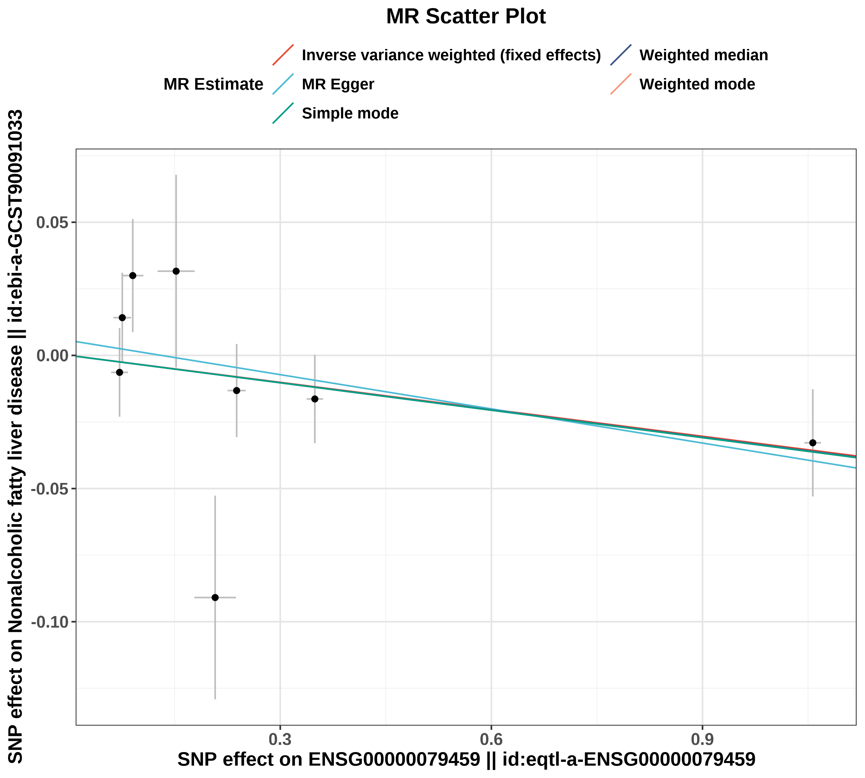
图1：x轴代表SNP对暴露的影响，y轴代表SNP对结局的影响。每一个点代表了一个工具变量SNP，每个点上的线实际反映的是95%置信区间。横坐标是SNP对暴露因素的效应；纵坐标是SNP对结局因素的效应，两个效应之比即暴露对结局的效应，即图中彩色线的斜率。不同颜色的线表示不同的算法，不同算法的线总体斜向上，则表示随着基因水平的升高，疾病的发病风险升高；不同算法的线总体斜向下，则表示随着基因水平的升高，疾病的发病风险降低。
图2 森林图（SNP效应）
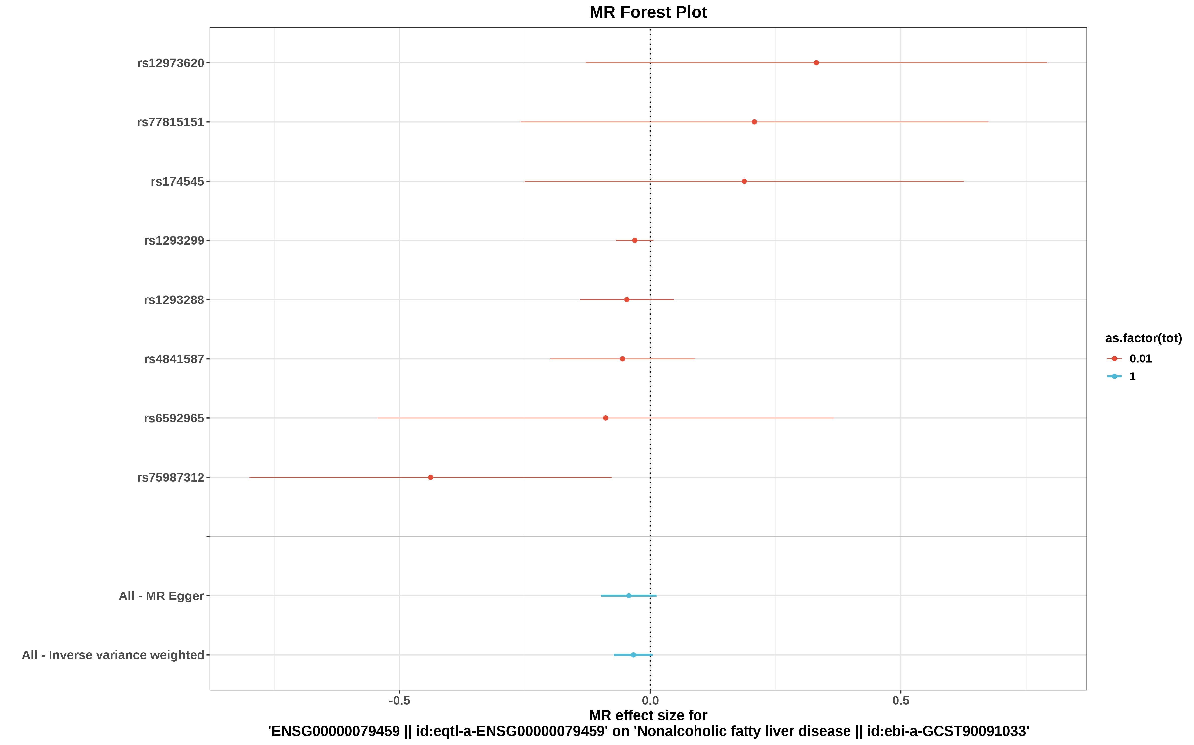
图2：每一条水平实线反映的是单个SNP对结局的效应。横坐标为效应值（OR），纵坐标为SNP名称。当效应值的95%置信区间不跨越0时，表明该SNP与结局存在显著关联。看最下面的红线（IVW算法），红线完全在0左边，说明基因水平增加能降低疾病的发病风险；红线完全在0右边，说明基因水平增加能增加疾病的发病风险。
图3 漏斗图（异质性）
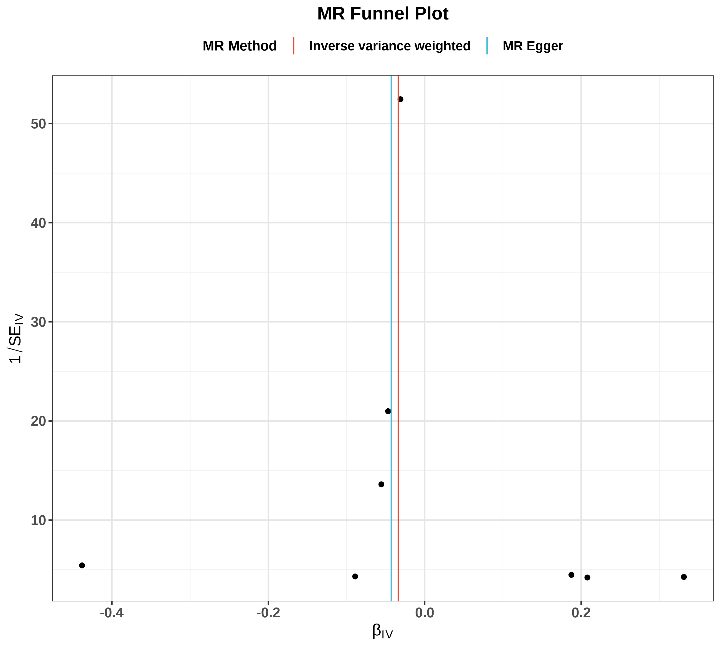
图3：可以观察SNP的异质性，主要关注IVW线的左右两边的点是否大致对称。如果有特别离群的点，说明存在离群值，分析结果的可靠性需要谨慎解读。
图4 逐个剔除检验图（敏感性）
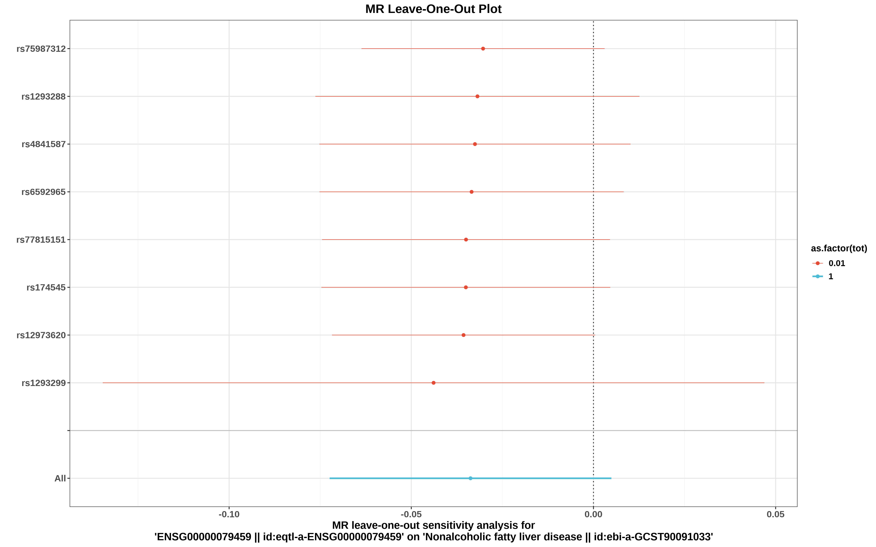
图4：孟德尔随机化逐个剔除检验。逐步剔除每个SNP后，重新计算IVW效应值（图中每一条水平线代表剔除对应SNP后的IVW效应值和95%置信区间，最右端的菱形代表纳入全部SNP时的IVW合并效应）。若剔除某个SNP后结果发生显著改变，说明该SNP对结果影响较大，可能存在异常值。

