孟德尔随机化分析报告

1. 方法

1.1 GWAS数据获取
通过IEU OpenGWAS数据库（https://gwas.mrcieu.ac.uk/）获取疾病相关的GWAS数据。

1.2 eQTL的MR分析
通过双样本MR分析来探讨候选基因与疾病风险之间的因果关系，将单核苷酸多态性（SNPs）定义为工具变量（IVs）。从血液eQTL的数据获取候选基因的eQTL数据（https://www.eQTLGen.com），作为暴露因素，并通过IEU OpenGWAS数据库获得疾病的GWAS数据作为结局因素。

1.3 工具变量筛选
首先，进行工具变量的筛选。通过R包TwoSampleMR（https://mrcieu.github.io/TwoSampleMR/）读取暴露因素并确定与暴露因素独立相关的SNP，将它们作为评估暴露因素和结局之间因果关系的工具变量（IVs）。筛选指标：包括P<5×10⁻⁶，寻找与暴露因素显著相关的工具变量（SNP）；使用clump=TRUE，r2=0.001，kb=10这三个指标去掉存在连锁不平衡（LD）的工具变量（SNP）。去掉与结局显著相关的工具变量（剔除F-statistics<10的SNPs），并将暴露因素-工具变量-结局进行匹配。SNP数目尽量大于3个；保留最小等位基因频率MAF>1%位点；排除具有中等位基因频率的回文SNP；使用Harmonise函数协调exposure和outcome位点。

1.4 孟德尔随机化分析
为探讨候选基因与疾病风险之间的因果关系，使用TwoSampleMR软件包（https://mrcieu.github.io/TwoSampleMR/）进行MR分析（五种算法：Inverse variance weighted、MR Egger、Weighted median、Simple mode、Weighted mode），并基于IVW方法的结果来评估候选基因与疾病风险之间的关系（P<0.05）。我们还采用Cochran的Q统计量来检验异质性，其中p>0.05表明不存在异质性。使用MR-Egger回归和MR-PRESSO分析评估潜在的水平多效性，p>0.05表明不存在水平多效性。还进行留一法检验来判断结果具有可靠性。最后，为了验证正向分析的结果不受反向因果效应的干扰，基于IVW方法，用R包TwoSampleMR进行Steiger方向性分析（correct_causal_direction=1/TRUE，steiger_test_adj<0.05才能说明通过了反向的检验，如果计算出NA，则视为不通过。）

2. 结果

2.1 孟德尔随机化分析结果
按照方法所述，对44个候选基因进行双样本孟德尔随机化分析，以探讨候选基因与疾病风险之间的因果关系。本次分析未发现显著的因果关系（IVW方法P值均≥0.05）。所有暴露的IVW效应值（OR）范围为0.835至1.467。经过异质性检验、水平多效性检验和方向性分析后，共有10个基因通过三重筛选（包括ENSG00000072310、ENSG00000122971、ENSG00000185000等），作为因果靶点进行后续分析。

表1 不同暴露因素的孟德尔随机化分析结果
Exposure | Outcome | Method | SNP | p_value | OR
ENSG00000072310 | Disease | IVW | 106 | 0.0000 | 0.913
 | Disease | MR-Egger | 106 | 0.0000 | 0.914
 | Disease | Weighted median | 106 | 0.0000 | 0.917
 | Disease | Weighted mode | 106 | 0.0000 | 0.920
 | Disease | Simple mode | 106 | 0.0000 | 0.914
ENSG00000122971 | Disease | IVW | 22 | 0.0000 | 1.467
 | Disease | MR-Egger | 22 | 0.0023 | 1.893
 | Disease | Weighted median | 22 | 0.0000 | 1.535
 | Disease | Weighted mode | 22 | 0.0006 | 1.602
 | Disease | Simple mode | 22 | 0.0007 | 1.605
ENSG00000131791 | Disease | IVW | 43 | 0.0000 | 0.939
 | Disease | MR-Egger | 43 | 0.2570 | 1.047
 | Disease | Weighted median | 43 | 0.0000 | 0.935
 | Disease | Weighted mode | 43 | 0.0057 | 0.932
 | Disease | Simple mode | 43 | 0.0004 | 0.930
ENSG00000185000 | Disease | IVW | 58 | 0.0000 | 0.912
 | Disease | MR-Egger | 58 | 0.0015 | 0.852
 | Disease | Weighted median | 58 | 0.0000 | 0.904
 | Disease | Weighted mode | 58 | 0.0767 | 0.904
 | Disease | Simple mode | 58 | 0.0066 | 0.908
ENSG00000073756 | Disease | IVW | 59 | 0.0000 | 1.072
 | Disease | MR-Egger | 59 | 0.0000 | 1.095
 | Disease | Weighted median | 59 | 0.0000 | 1.093
 | Disease | Weighted mode | 59 | 0.0352 | 1.094
 | Disease | Simple mode | 59 | 0.0004 | 1.105
ENSG00000169710 | Disease | IVW | 29 | 0.0000 | 1.071
 | Disease | MR-Egger | 29 | 0.2740 | 1.038
 | Disease | Weighted median | 29 | 0.0001 | 1.070
 | Disease | Weighted mode | 29 | 0.0338 | 1.071
 | Disease | Simple mode | 29 | 0.0059 | 1.071
ENSG00000108786 | Disease | IVW | 43 | 0.0000 | 0.912
 | Disease | MR-Egger | 43 | 0.9403 | 1.004
 | Disease | Weighted median | 43 | 0.0003 | 0.919
 | Disease | Weighted mode | 43 | 0.0629 | 0.919
 | Disease | Simple mode | 43 | 0.0201 | 0.917
ENSG00000100031 | Disease | IVW | 34 | 0.0000 | 0.876
 | Disease | MR-Egger | 34 | 0.0101 | 0.853
 | Disease | Weighted median | 34 | 0.0017 | 0.887
 | Disease | Weighted mode | 34 | 0.2801 | 0.881
 | Disease | Simple mode | 34 | 0.0221 | 0.811
ENSG00000134824 | Disease | IVW | 82 | 0.0000 | 1.027
 | Disease | MR-Egger | 82 | 0.8574 | 1.002
 | Disease | Weighted median | 82 | 0.0258 | 1.019
 | Disease | Weighted mode | 82 | 0.6766 | 1.018
 | Disease | Simple mode | 82 | 0.2521 | 1.018
ENSG00000100300 | Disease | IVW | 53 | 0.0000 | 0.920
 | Disease | MR-Egger | 53 | 0.1959 | 0.953
 | Disease | Weighted median | 53 | 0.0543 | 0.943
 | Disease | Weighted mode | 53 | 0.6394 | 0.943
 | Disease | Simple mode | 53 | 0.0058 | 0.839
ENSG00000131473 | Disease | IVW | 32 | 0.0001 | 1.104
 | Disease | MR-Egger | 32 | 0.0221 | 0.878
 | Disease | Weighted median | 32 | 0.0080 | 1.069
 | Disease | Weighted mode | 32 | 0.4364 | 1.057
 | Disease | Simple mode | 32 | 0.2093 | 1.066
ENSG00000112237 | Disease | IVW | 35 | 0.0001 | 0.835
 | Disease | MR-Egger | 35 | 0.0260 | 1.474
 | Disease | Weighted median | 35 | 0.0004 | 0.809
 | Disease | Weighted mode | 35 | 0.1155 | 0.803
 | Disease | Simple mode | 35 | 0.0307 | 0.744
ENSG00000145675 | Disease | IVW | 47 | 0.0065 | 0.929
 | Disease | MR-Egger | 47 | 0.1273 | 0.908
 | Disease | Weighted median | 47 | 0.2471 | 0.957
 | Disease | Weighted mode | 47 | 0.5006 | 0.940
 | Disease | Simple mode | 47 | 0.4086 | 0.948
ENSG00000198431 | Disease | IVW | 54 | 0.0098 | 0.963
 | Disease | MR-Egger | 54 | 0.0593 | 1.088
 | Disease | Weighted median | 54 | 0.3229 | 0.980
 | Disease | Weighted mode | 54 | 0.8041 | 0.987
 | Disease | Simple mode | 54 | 0.6630 | 0.983
ENSG00000079459 | Disease | IVW | 107 | 0.0176 | 0.989
 | Disease | MR-Egger | 107 | 0.0000 | 0.952
 | Disease | Weighted median | 107 | 0.0015 | 0.977
 | Disease | Weighted mode | 107 | 0.2087 | 0.974
 | Disease | Simple mode | 107 | 0.3625 | 0.985
ENSG00000112304 | Disease | IVW | 42 | 0.0308 | 0.964
 | Disease | MR-Egger | 42 | 0.9311 | 1.003
 | Disease | Weighted median | 42 | 0.1682 | 0.969
 | Disease | Weighted mode | 42 | 0.4246 | 0.958
 | Disease | Simple mode | 42 | 0.6943 | 0.986
ENSG00000109819 | Disease | IVW | 48 | 0.0570 | 1.020
 | Disease | MR-Egger | 48 | 0.1645 | 1.028
 | Disease | Weighted median | 48 | 0.0633 | 1.028
 | Disease | Weighted mode | 48 | 0.4615 | 1.036
 | Disease | Simple mode | 48 | 0.1344 | 1.043
ENSG00000126821 | Disease | IVW | 16 | 0.0659 | 1.109
 | Disease | MR-Egger | 16 | 0.4412 | 1.903
 | Disease | Weighted median | 16 | 0.2314 | 1.084
 | Disease | Weighted mode | 16 | 0.5866 | 1.069
 | Disease | Simple mode | 16 | 0.5845 | 1.069
ENSG00000166311 | Disease | IVW | 7 | 0.0772 | 0.874
 | Disease | MR-Egger | 7 | 0.1779 | 0.720
 | Disease | Weighted median | 7 | 0.2371 | 0.888
 | Disease | Weighted mode | 7 | 0.4319 | 0.874
 | Disease | Simple mode | 7 | 0.6939 | 0.945
ENSG00000090661 | Disease | IVW | 34 | 0.0873 | 0.968
 | Disease | MR-Egger | 34 | 0.5968 | 1.020
 | Disease | Weighted median | 34 | 0.5778 | 0.986
 | Disease | Weighted mode | 34 | 0.9351 | 0.993
 | Disease | Simple mode | 34 | 0.4940 | 0.963
ENSG00000106546 | Disease | IVW | 58 | 0.0984 | 1.025
 | Disease | MR-Egger | 58 | 0.0245 | 1.069
 | Disease | Weighted median | 58 | 0.3156 | 1.022
 | Disease | Weighted mode | 58 | 0.5686 | 1.035
 | Disease | Simple mode | 58 | 0.2937 | 1.045
ENSG00000079435 | Disease | IVW | 38 | 0.0992 | 1.054
 | Disease | MR-Egger | 38 | 0.6773 | 0.934
 | Disease | Weighted median | 38 | 0.1259 | 1.065
 | Disease | Weighted mode | 38 | 0.3196 | 1.087
 | Disease | Simple mode | 38 | 0.3957 | 1.074
ENSG00000125505 | Disease | IVW | 15 | 0.1186 | 0.942
 | Disease | MR-Egger | 15 | 0.2771 | 0.883
 | Disease | Weighted median | 15 | 0.1075 | 0.919
 | Disease | Weighted mode | 15 | 0.5998 | 0.913
 | Disease | Simple mode | 15 | 0.5581 | 0.919
ENSG00000084754 | Disease | IVW | 47 | 0.1404 | 0.981
 | Disease | MR-Egger | 47 | 0.0000 | 0.886
 | Disease | Weighted median | 47 | 0.0060 | 0.953
 | Disease | Weighted mode | 47 | 0.1499 | 0.954
 | Disease | Simple mode | 47 | 0.0503 | 0.959
ENSG00000198911 | Disease | IVW | 16 | 0.2031 | 1.080
 | Disease | MR-Egger | 16 | 0.1537 | 1.620
 | Disease | Weighted median | 16 | 0.0786 | 1.157
 | Disease | Weighted mode | 16 | 0.2703 | 1.199
 | Disease | Simple mode | 16 | 0.2676 | 1.202
ENSG00000233276 | Disease | IVW | 59 | 0.2108 | 1.024
 | Disease | MR-Egger | 59 | 0.8089 | 0.982
 | Disease | Weighted median | 59 | 0.0539 | 1.050
 | Disease | Weighted mode | 59 | 0.3322 | 1.050
 | Disease | Simple mode | 59 | 0.3184 | 1.048
ENSG00000121769 | Disease | IVW | 18 | 0.2158 | 1.055
 | Disease | MR-Egger | 18 | 0.0928 | 0.686
 | Disease | Weighted median | 18 | 0.8777 | 0.991
 | Disease | Weighted mode | 18 | 0.8980 | 0.988
 | Disease | Simple mode | 18 | 0.8977 | 0.989
ENSG00000099194 | Disease | IVW | 52 | 0.2566 | 0.975
 | Disease | MR-Egger | 52 | 0.0116 | 1.174
 | Disease | Weighted median | 52 | 0.7405 | 0.989
 | Disease | Weighted mode | 52 | 0.7029 | 1.031
 | Disease | Simple mode | 52 | 0.3563 | 1.076
ENSG00000066322 | Disease | IVW | 37 | 0.2925 | 0.965
 | Disease | MR-Egger | 37 | 0.0333 | 0.751
 | Disease | Weighted median | 37 | 0.1446 | 0.935
 | Disease | Weighted mode | 37 | 0.4605 | 0.928
 | Disease | Simple mode | 37 | 0.8239 | 1.019
ENSG00000105974 | Disease | IVW | 34 | 0.3050 | 0.960
 | Disease | MR-Egger | 34 | 0.8593 | 0.979
 | Disease | Weighted median | 34 | 0.7676 | 0.984
 | Disease | Weighted mode | 34 | 0.9971 | 1.000
 | Disease | Simple mode | 34 | 0.9577 | 0.995
ENSG00000170522 | Disease | IVW | 25 | 0.3173 | 0.972
 | Disease | MR-Egger | 25 | 0.8796 | 0.993
 | Disease | Weighted median | 25 | 0.6612 | 0.983
 | Disease | Weighted mode | 25 | 0.9091 | 0.968
 | Disease | Simple mode | 25 | 0.8394 | 0.942
ENSG00000069667 | Disease | IVW | 21 | 0.3465 | 0.963
 | Disease | MR-Egger | 21 | 0.7655 | 1.030
 | Disease | Weighted median | 21 | 0.8789 | 0.992
 | Disease | Weighted mode | 21 | 0.9426 | 0.993
 | Disease | Simple mode | 21 | 0.8299 | 0.984
ENSG00000131408 | Disease | IVW | 4 | 0.3762 | 1.096
 | Disease | MR-Egger | 4 | 0.5029 | 1.189
 | Disease | Weighted median | 4 | 0.5577 | 1.072
 | Disease | Weighted mode | 4 | 0.7645 | 1.059
 | Disease | Simple mode | 4 | 0.7960 | 1.050
ENSG00000172531 | Disease | IVW | 16 | 0.4253 | 1.051
 | Disease | MR-Egger | 16 | 0.8165 | 0.967
 | Disease | Weighted median | 16 | 0.5184 | 1.052
 | Disease | Weighted mode | 16 | 0.7159 | 1.052
 | Disease | Simple mode | 16 | 0.7034 | 1.052
ENSG00000108846 | Disease | IVW | 113 | 0.4288 | 1.007
 | Disease | MR-Egger | 113 | 0.1008 | 0.978
 | Disease | Weighted median | 113 | 0.6016 | 0.994
 | Disease | Weighted mode | 113 | 0.9466 | 0.995
 | Disease | Simple mode | 113 | 0.0338 | 1.050
ENSG00000119927 | Disease | IVW | 6 | 0.5107 | 1.042
 | Disease | MR-Egger | 6 | 0.9736 | 1.021
 | Disease | Weighted median | 6 | 0.4706 | 1.056
 | Disease | Weighted mode | 6 | 0.5604 | 1.067
 | Disease | Simple mode | 6 | 0.6776 | 1.046
ENSG00000160752 | Disease | IVW | 60 | 0.5226 | 1.014
 | Disease | MR-Egger | 60 | 0.0006 | 0.652
 | Disease | Weighted median | 60 | 0.4487 | 0.978
 | Disease | Weighted mode | 60 | 0.6279 | 0.963
 | Disease | Simple mode | 60 | 0.6647 | 0.968
ENSG00000103056 | Disease | IVW | 70 | 0.5451 | 0.988
 | Disease | MR-Egger | 70 | 0.6313 | 1.028
 | Disease | Weighted median | 70 | 0.6707 | 0.988
 | Disease | Weighted mode | 70 | 0.8572 | 1.013
 | Disease | Simple mode | 70 | 0.2014 | 1.077
ENSG00000116133 | Disease | IVW | 41 | 0.5639 | 1.009
 | Disease | MR-Egger | 41 | 0.0155 | 0.927
 | Disease | Weighted median | 41 | 0.9554 | 0.999
 | Disease | Weighted mode | 41 | 0.9616 | 0.994
 | Disease | Simple mode | 41 | 0.9896 | 0.998
ENSG00000113161 | Disease | IVW | 75 | 0.6505 | 0.993
 | Disease | MR-Egger | 75 | 0.0132 | 0.858
 | Disease | Weighted median | 75 | 0.4271 | 0.984
 | Disease | Weighted mode | 75 | 0.7311 | 0.984
 | Disease | Simple mode | 75 | 0.7144 | 0.984
ENSG00000186480 | Disease | IVW | 45 | 0.6516 | 1.006
 | Disease | MR-Egger | 45 | 0.4882 | 1.015
 | Disease | Weighted median | 45 | 0.6272 | 1.008
 | Disease | Weighted mode | 45 | 0.8951 | 1.010
 | Disease | Simple mode | 45 | 0.5050 | 1.021
ENSG00000125629 | Disease | IVW | 84 | 0.7358 | 1.006
 | Disease | MR-Egger | 84 | 0.5148 | 0.960
 | Disease | Weighted median | 84 | 0.0007 | 1.080
 | Disease | Weighted mode | 84 | 0.1506 | 1.101
 | Disease | Simple mode | 84 | 0.0245 | 1.098
ENSG00000176170 | Disease | IVW | 51 | 0.7586 | 1.004
 | Disease | MR-Egger | 51 | 0.2302 | 1.026
 | Disease | Weighted median | 51 | 0.4829 | 0.987
 | Disease | Weighted mode | 51 | 0.9495 | 0.995
 | Disease | Simple mode | 51 | 0.7928 | 1.009
ENSG00000213639 | Disease | IVW | 67 | 0.9880 | 1.000
 | Disease | MR-Egger | 67 | 0.2336 | 0.985
 | Disease | Weighted median | 67 | 0.1376 | 0.989
 | Disease | Weighted mode | 67 | 0.8552 | 0.997
 | Disease | Simple mode | 67 | 0.9236 | 0.999

表1结果显示，所有候选基因的IVW方法分析均未发现显著因果关联（p≥0.05）。 所有暴露的IVW效应值（OR）范围为0.835至1.467。

2.2 敏感性分析结果

表2 暴露与疾病之间的敏感性分析
Exposure | Outcome | Method | Heterogeneity_Q | Q_df | Q_P_value | Egger_intercept_pval | MR_PRESSO_global_p
ENSG00000072310 | Disease | Inverse variance weighted | 61.6163 | 101 | 0.9993 | 0.860984 | 1.0000
 | Disease | MR Egger | 61.5855 | 100 | 0.9991 | 0.860984 | 1.0000
ENSG00000122971 | Disease | Inverse variance weighted | 4.7460 | 21 | 0.9999 | 0.161246 | 1.0000
 | Disease | MR Egger | 2.6296 | 20 | 1.0000 | 0.161246 | 1.0000
ENSG00000131791 | Disease | Inverse variance weighted | 29.2583 | 42 | 0.9316 | 0.007634 | 0.9470
 | Disease | MR Egger | 21.3833 | 41 | 0.9951 | 0.007634 | 0.9470
ENSG00000185000 | Disease | Inverse variance weighted | 29.6772 | 57 | 0.9990 | 0.139407 | 0.9990
 | Disease | MR Egger | 27.4292 | 56 | 0.9995 | 0.139407 | 0.9990
ENSG00000073756 | Disease | Inverse variance weighted | 62.2121 | 57 | 0.2960 | 0.171130 | 0.3080
 | Disease | MR Egger | 60.1477 | 56 | 0.3280 | 0.171130 | 0.3080
ENSG00000169710 | Disease | Inverse variance weighted | 5.3379 | 28 | 1.0000 | 0.328629 | 1.0000
 | Disease | MR Egger | 4.3482 | 27 | 1.0000 | 0.328629 | 1.0000
ENSG00000108786 | Disease | Inverse variance weighted | 20.3146 | 38 | 0.9916 | 0.076605 | 0.9850
 | Disease | MR Egger | 16.9963 | 37 | 0.9980 | 0.076605 | 0.9850
ENSG00000100031 | Disease | Inverse variance weighted | 13.5578 | 31 | 0.9972 | 0.597850 | 0.9970
 | Disease | MR Egger | 13.2736 | 30 | 0.9964 | 0.597850 | 0.9970
ENSG00000134824 | Disease | Inverse variance weighted | 63.4066 | 81 | 0.9256 | 0.000535 | 0.9420
 | Disease | MR Egger | 50.3854 | 80 | 0.9961 | 0.000535 | 0.9420
ENSG00000100300 | Disease | Inverse variance weighted | 29.5954 | 48 | 0.9831 | 0.265172 | 0.9820
 | Disease | MR Egger | 28.3237 | 47 | 0.9858 | 0.265172 | 0.9820
ENSG00000131473 | Disease | Inverse variance weighted | 48.5923 | 31 | 0.0231 | 0.000082 | 0.0360
 | Disease | MR Egger | 27.8517 | 30 | 0.5783 | 0.000082 | 0.0360
ENSG00000112237 | Disease | Inverse variance weighted | 52.5566 | 34 | 0.0220 | 0.001269 | 0.0220
 | Disease | MR Egger | 38.1855 | 33 | 0.2455 | 0.001269 | 0.0220
ENSG00000145675 | Disease | Inverse variance weighted | 23.9091 | 43 | 0.9919 | 0.686282 | 0.9990
 | Disease | MR Egger | 23.7436 | 42 | 0.9896 | 0.686282 | 0.9990
ENSG00000198431 | Disease | Inverse variance weighted | 24.9672 | 51 | 0.9992 | 0.004580 | 1.0000
 | Disease | MR Egger | 16.1529 | 50 | 1.0000 | 0.004580 | 1.0000
ENSG00000079459 | Disease | Inverse variance weighted | 61.3600 | 94 | 0.9963 | 0.000131 | 0.9960
 | Disease | MR Egger | 45.4254 | 93 | 1.0000 | 0.000131 | 0.9960
ENSG00000112304 | Disease | Inverse variance weighted | 32.2596 | 41 | 0.8337 | 0.272764 | 0.8680
 | Disease | MR Egger | 31.0230 | 40 | 0.8448 | 0.272764 | 0.8680
ENSG00000109819 | Disease | Inverse variance weighted | 39.9148 | 47 | 0.7585 | 0.631042 | 0.7560
 | Disease | MR Egger | 39.6810 | 46 | 0.7328 | 0.631042 | 0.7560
ENSG00000126821 | Disease | Inverse variance weighted | 1.1548 | 15 | 1.0000 | 0.515459 | 1.0000
 | Disease | MR Egger | 0.7096 | 14 | 1.0000 | 0.515459 | 1.0000
ENSG00000166311 | Disease | Inverse variance weighted | 2.5350 | 6 | 0.8645 | 0.367816 | 0.8850
 | Disease | MR Egger | 1.5557 | 5 | 0.9066 | 0.367816 | 0.8850
ENSG00000090661 | Disease | Inverse variance weighted | 26.1415 | 31 | 0.7145 | 0.108270 | 0.7880
 | Disease | MR Egger | 23.4012 | 30 | 0.7984 | 0.108270 | 0.7880
ENSG00000106546 | Disease | Inverse variance weighted | 34.9604 | 57 | 0.9906 | 0.093479 | 0.9890
 | Disease | MR Egger | 32.0487 | 56 | 0.9958 | 0.093479 | 0.9890
ENSG00000079435 | Disease | Inverse variance weighted | 5.6338 | 37 | 1.0000 | 0.453897 | 1.0000
 | Disease | MR Egger | 5.0605 | 36 | 1.0000 | 0.453897 | 1.0000
ENSG00000125505 | Disease | Inverse variance weighted | 19.2135 | 14 | 0.1570 | 0.524809 | 0.2010
 | Disease | MR Egger | 18.6023 | 13 | 0.1360 | 0.524809 | 0.2010
ENSG00000084754 | Disease | Inverse variance weighted | 39.3270 | 46 | 0.7460 | 0.000009 | 0.7670
 | Disease | MR Egger | 14.2250 | 45 | 1.0000 | 0.000009 | 0.7670
ENSG00000198911 | Disease | Inverse variance weighted | 7.7386 | 15 | 0.9338 | 0.217703 | 0.9230
 | Disease | MR Egger | 6.0726 | 14 | 0.9646 | 0.217703 | 0.9230
ENSG00000233276 | Disease | Inverse variance weighted | 45.6856 | 57 | 0.8590 | 0.560470 | 0.9020
 | Disease | MR Egger | 45.3427 | 56 | 0.8449 | 0.560470 | 0.9020
ENSG00000121769 | Disease | Inverse variance weighted | 6.9882 | 17 | 0.9837 | 0.053589 | 0.9840
 | Disease | MR Egger | 2.6467 | 16 | 0.9999 | 0.053589 | 0.9840
ENSG00000099194 | Disease | Inverse variance weighted | 49.7344 | 51 | 0.5240 | 0.002008 | 0.5280
 | Disease | MR Egger | 39.1061 | 50 | 0.8670 | 0.002008 | 0.5280
ENSG00000066322 | Disease | Inverse variance weighted | 10.3277 | 35 | 1.0000 | 0.052187 | 1.0000
 | Disease | MR Egger | 6.2792 | 34 | 1.0000 | 0.052187 | 1.0000
ENSG00000105974 | Disease | Inverse variance weighted | 8.7936 | 33 | 1.0000 | 0.866859 | 1.0000
 | Disease | MR Egger | 8.7650 | 32 | 1.0000 | 0.866859 | 1.0000
ENSG00000170522 | Disease | Inverse variance weighted | 25.3789 | 24 | 0.3854 | 0.469522 | 0.4590
 | Disease | MR Egger | 24.7958 | 23 | 0.3609 | 0.469522 | 0.4590
ENSG00000069667 | Disease | Inverse variance weighted | 15.8059 | 20 | 0.7286 | 0.455794 | 0.7630
 | Disease | MR Egger | 15.2262 | 19 | 0.7081 | 0.455794 | 0.7630
ENSG00000131408 | Disease | Inverse variance weighted | 0.5758 | 3 | 0.9020 | 0.705578 | 0.8960
 | Disease | MR Egger | 0.3859 | 2 | 0.8245 | 0.705578 | 0.8960
ENSG00000172531 | Disease | Inverse variance weighted | 3.6158 | 15 | 0.9987 | 0.524406 | 1.0000
 | Disease | MR Egger | 3.1895 | 14 | 0.9987 | 0.524406 | 1.0000
ENSG00000108846 | Disease | Inverse variance weighted | 154.0211 | 108 | 0.0024 | 0.003296 | 0.0010
 | Disease | MR Egger | 142.0249 | 107 | 0.0133 | 0.003296 | 0.0010
ENSG00000119927 | Disease | Inverse variance weighted | 0.5542 | 5 | 0.9900 | 0.974881 | 0.9860
 | Disease | MR Egger | 0.5531 | 4 | 0.9681 | 0.974881 | 0.9860
ENSG00000160752 | Disease | Inverse variance weighted | 45.6617 | 59 | 0.8984 | 0.000300 | 0.9090
 | Disease | MR Egger | 30.8657 | 58 | 0.9987 | 0.000300 | 0.9090
ENSG00000103056 | Disease | Inverse variance weighted | 46.5709 | 67 | 0.9729 | 0.468101 | 0.9690
 | Disease | MR Egger | 46.0383 | 66 | 0.9708 | 0.468101 | 0.9690
ENSG00000116133 | Disease | Inverse variance weighted | 22.9132 | 39 | 0.9812 | 0.001855 | 0.9540
 | Disease | MR Egger | 11.7160 | 38 | 1.0000 | 0.001855 | 0.9540
ENSG00000113161 | Disease | Inverse variance weighted | 38.4067 | 71 | 0.9994 | 0.014198 | 1.0000
 | Disease | MR Egger | 32.0809 | 70 | 1.0000 | 0.014198 | 1.0000
ENSG00000186480 | Disease | Inverse variance weighted | 52.0568 | 41 | 0.1155 | 0.561033 | 0.2290
 | Disease | MR Egger | 51.6134 | 40 | 0.1032 | 0.561033 | 0.2290
ENSG00000125629 | Disease | Inverse variance weighted | 151.2826 | 82 | 0.0000 | 0.426434
 | Disease | MR Egger | 150.0986 | 81 | 0.0000 | 0.426434
ENSG00000176170 | Disease | Inverse variance weighted | 58.0671 | 50 | 0.2025 | 0.178999 | 0.2350
 | Disease | MR Egger | 55.9449 | 49 | 0.2304 | 0.178999 | 0.2350
ENSG00000213639 | Disease | Inverse variance weighted | 57.3455 | 64 | 0.7090 | 0.191082 | 0.7450
 | Disease | MR Egger | 55.5989 | 63 | 0.7347 | 0.191082 | 0.7450

表2 结果显示，异质性检验，4个暴露因素存在显著异质性，40个不存在异质性（Q p>0.05）；水平多效性检验，-20个暴露因素存在水平多效性，64个不存在水平多效性（p>0.05）。

2.3 可视化结果

图1：散点图（SNP效应）
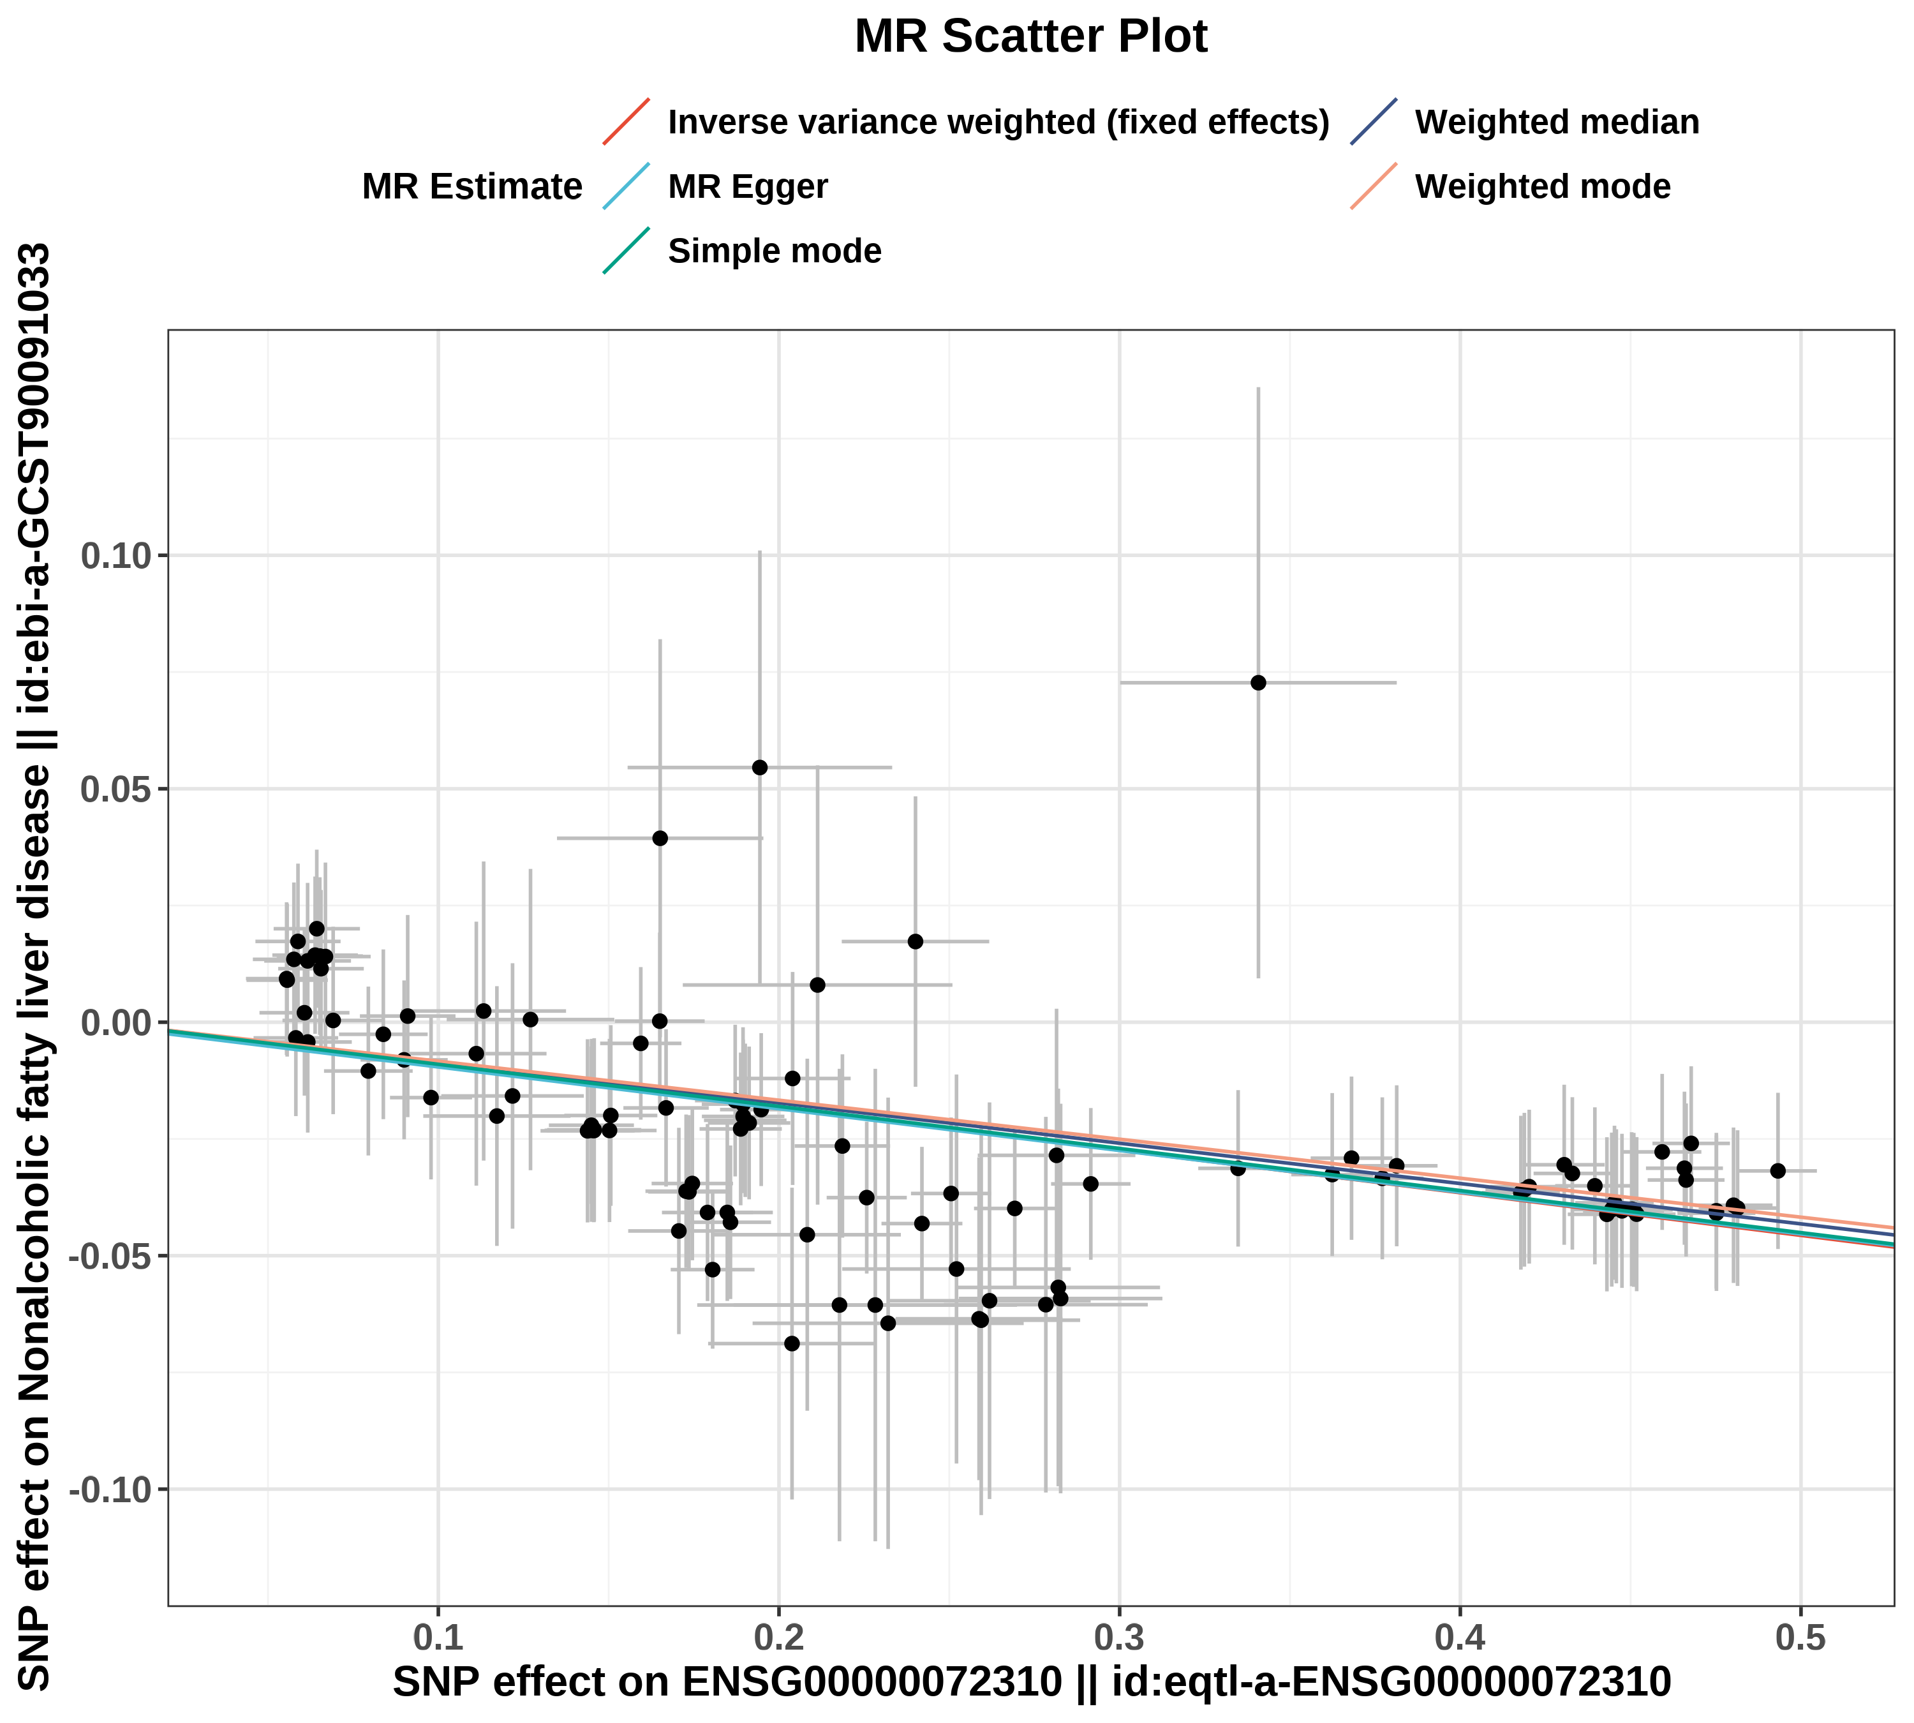
图注：x轴代表SNP对暴露的影响，y轴代表SNP对结局的影响。每一个点代表了一个工具变量SNP，每个点上的线实际反映的是95%置信区间。横坐标是SNP对暴露因素的效应；纵坐标是SNP对结局因素的效应，两个效应之比即暴露对结局的效应，即图中彩色线的斜率。不同颜色的线表示不同的算法，不同算法的线总体斜向上，则表示随着基因水平的升高，疾病的发病风险升高；不同算法的线总体斜向下，则表示随着基因水平的升高，疾病的发病风险降低。
图2：森林图（SNP效应）
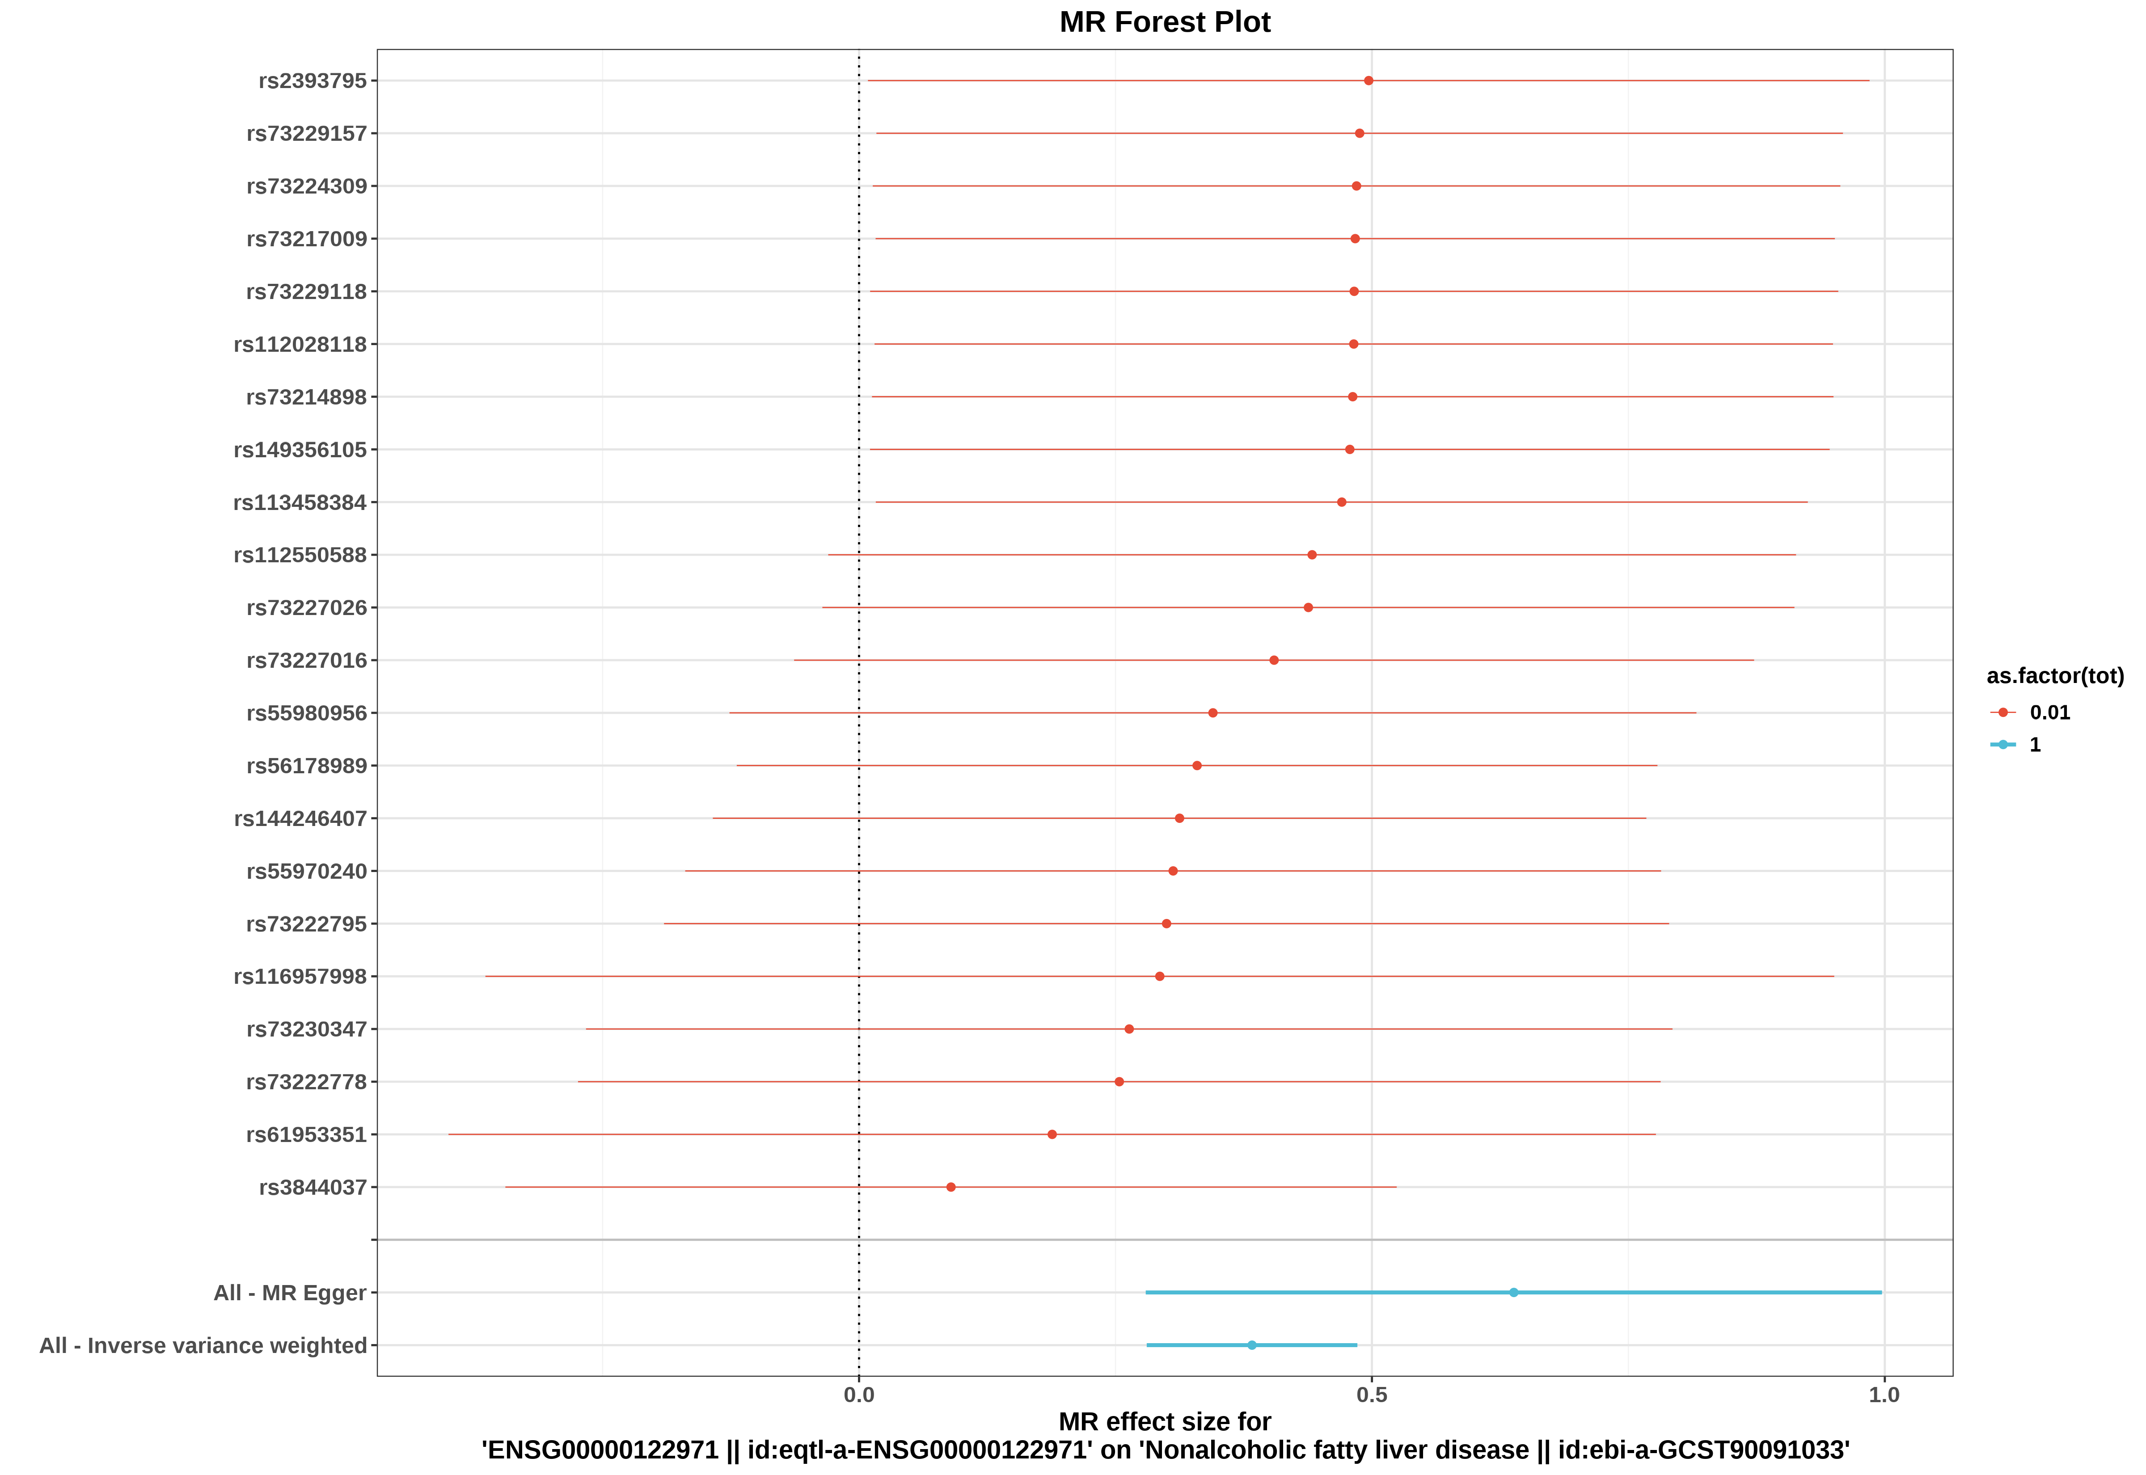
图注：每一条水平实线反映的是单个SNP对结局的效应。横坐标为效应值（OR），纵坐标为SNP名称。当效应值的95%置信区间不跨越0时，表明该SNP与结局存在显著关联。看最下面的红线（IVW算法），红线完全在0左边，说明基因水平增加能降低疾病的发病风险；红线完全在0右边，说明基因水平增加能增加疾病的发病风险。
图3：漏斗图（异质性）
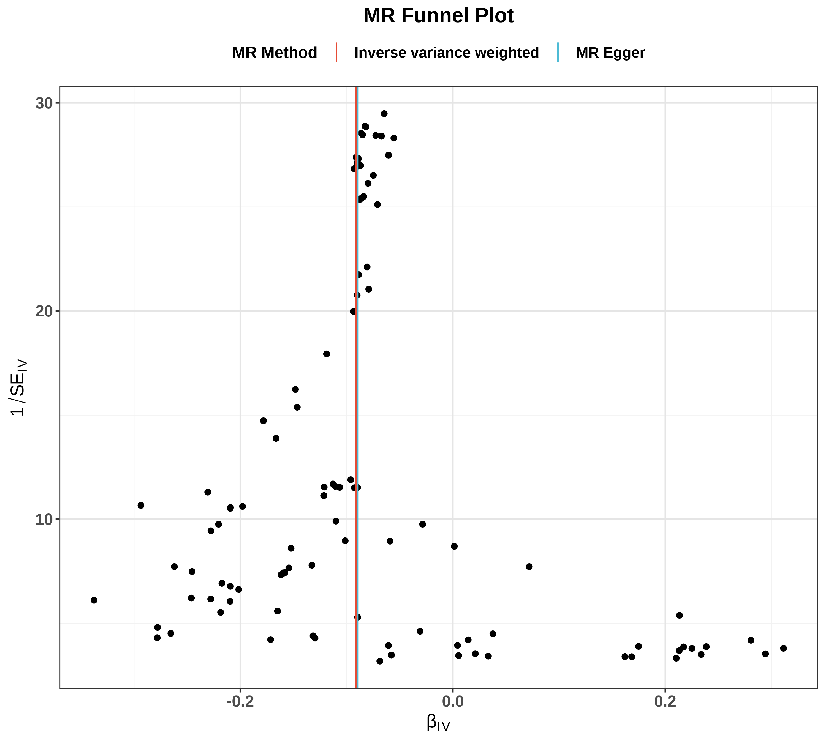
图注：可以观察SNP的异质性，主要关注IVW线的左右两边的点是否大致对称。如果有特别离群的点，说明存在离群值，分析结果的可靠性需要谨慎解读。
图4：逐个剔除检验图（敏感性）

图注：孟德尔随机化逐个剔除检验。逐步剔除每个SNP后，重新计算IVW效应值（图中每一条水平线代表剔除对应SNP后的IVW效应值和95%置信区间，最右端的菱形代表纳入全部SNP时的IVW合并效应）。若剔除某个SNP后结果发生显著改变，说明该SNP对结果影响较大，可能存在异常值。

