孟德尔随机化分析报告

1. 方法

1.1 孟德尔随机化分析
孟德尔随机化（MR）是一种利用遗传变异（单核苷酸多态性，SNPs）作为工具变量来推断暴露与结局之间因果关系的方法。本分析使用TwoSampleMR R包进行MR分析，基于全基因组关联研究（GWAS）的汇总统计数据。

1.2 统计方法
1) 逆方差加权法（IVW）- 主要MR方法，假设所有SNPs均为有效工具变量
2) MR-Egger - 对水平多效性具有稳健性
3) 加权中位数法 - 对最多50%的无效工具变量具有稳健性
4) 加权众数法 - 假设最大组的SNPs具有有效效应
5) 简单众数法 - 使用SNP特异性因果估计的众数

1.3 质量控制
1) F统计量：F > 10的工具变量被认为是强效的
2) 异质性检验：Q检验评估SNPs之间的异质性
3) 多效性检验：MR-Egger截距检验用于方向性多效性
4) Steiger检验：方向性检验以验证因果方向

2. 结果

2.1 汇总统计
无MR结果可用。

2.2 主要结果（IVW方法）
无结果可用。

2.3 异质性与多效性检验结果
（共88行）
Exposure | Outcome | Method | Heterogeneity_Q | Q_df | Q_P-value | Egger_intercept | SE | P-value
ABCC3 | ebi-a-GCST90091033 | MR Egger | 142.0249 | 107 | 0.013270000 | 0.010273 | 0.003417 | 0.00329554000
 | ebi-a-GCST90091033 | IVW | 154.0211 | 108 | 0.002429000
ACADS | ebi-a-GCST90091033 | MR Egger | 2.6296 | 20 | 1.000000000 | -0.035282 | 0.024252 | 0.16124600000
 | ebi-a-GCST90091033 | IVW | 4.7460 | 21 | 0.999900000
ACLY | ebi-a-GCST90091033 | MR Egger | 27.8517 | 30 | 0.578300000 | 0.053718 | 0.011795 | 0.00008177370
 | ebi-a-GCST90091033 | IVW | 48.5923 | 31 | 0.023070000
ACOT13 | ebi-a-GCST90091033 | MR Egger | 31.0230 | 40 | 0.844800000 | -0.012580 | 0.011312 | 0.27276400000
 | ebi-a-GCST90091033 | IVW | 32.2596 | 41 | 0.833700000
AHR | ebi-a-GCST90091033 | MR Egger | 32.0487 | 56 | 0.995800000 | -0.009987 | 0.005853 | 0.09347930000
 | ebi-a-GCST90091033 | IVW | 34.9604 | 57 | 0.990600000
CAV1 | ebi-a-GCST90091033 | MR Egger | 8.7650 | 32 | 1.000000000 | -0.002015 | 0.011924 | 0.86685900000
 | ebi-a-GCST90091033 | IVW | 8.7936 | 33 | 1.000000000
CCNC | ebi-a-GCST90091033 | MR Egger | 38.1855 | 33 | 0.245500000 | -0.058908 | 0.016715 | 0.00126896000
 | ebi-a-GCST90091033 | IVW | 52.5566 | 34 | 0.022010000
CERS4 | ebi-a-GCST90091033 | MR Egger | 23.4012 | 30 | 0.798400000 | -0.012665 | 0.007651 | 0.10827000000
 | ebi-a-GCST90091033 | IVW | 26.1415 | 31 | 0.714500000
DGAT1 | ebi-a-GCST90091033 | MR Egger | 27.4292 | 56 | 0.999500000 | 0.014725 | 0.009821 | 0.13940700000
 | ebi-a-GCST90091033 | IVW | 29.6772 | 57 | 0.999000000
DHCR24 | ebi-a-GCST90091033 | MR Egger | 11.7160 | 38 | 1.000000000 | 0.021290 | 0.006363 | 0.00185471000
 | ebi-a-GCST90091033 | IVW | 22.9132 | 39 | 0.981200000
ELOVL1 | ebi-a-GCST90091033 | MR Egger | 6.2792 | 34 | 1.000000000 | 0.021826 | 0.010848 | 0.05218720000
 | ebi-a-GCST90091033 | IVW | 10.3277 | 35 | 1.000000000
ELOVL6 | ebi-a-GCST90091033 | MR Egger | 24.7958 | 23 | 0.360900000 | -0.005297 | 0.007203 | 0.46952200000
 | ebi-a-GCST90091033 | IVW | 25.3789 | 24 | 0.385400000
FABP3 | ebi-a-GCST90091033 | MR Egger | 2.6467 | 16 | 0.999900000 | 0.047552 | 0.022822 | 0.05358890000
 | ebi-a-GCST90091033 | IVW | 6.9882 | 17 | 0.983700000
FADS2 | ebi-a-GCST90091033 | MR Egger | 50.3854 | 80 | 0.996100000 | 0.014243 | 0.003947 | 0.00053491000
 | ebi-a-GCST90091033 | IVW | 63.4066 | 81 | 0.925600000
FASN | ebi-a-GCST90091033 | MR Egger | 4.3482 | 27 | 1.000000000 | 0.008975 | 0.009021 | 0.32862900000
 | ebi-a-GCST90091033 | IVW | 5.3379 | 28 | 1.000000000
FDFT1 | ebi-a-GCST90091033 | MR Egger | 45.0758 | 92 | 1.000000000 | 0.016627 | 0.004161 | 0.00012991600
 | ebi-a-GCST90091033 | IVW | 61.0408 | 93 | 0.995800000
FDPS | ebi-a-GCST90091033 | MR Egger | 30.8657 | 58 | 0.998700000 | 0.048914 | 0.012716 | 0.00030044300
 | ebi-a-GCST90091033 | IVW | 45.6617 | 59 | 0.898400000
GGT1 | ebi-a-GCST90091033 | MR Egger | 13.2736 | 30 | 0.996400000 | 0.004598 | 0.008624 | 0.59785000000
 | ebi-a-GCST90091033 | IVW | 13.5578 | 31 | 0.997200000
GPAM | ebi-a-GCST90091033 | MR Egger | 0.5531 | 4 | 0.968100000 | 0.004576 | 0.136595 | 0.97488100000
 | ebi-a-GCST90091033 | IVW | 0.5542 | 5 | 0.990000000
GPX1 | ebi-a-GCST90091033 | MR Egger | 45.3427 | 56 | 0.844900000 | 0.005606 | 0.009572 | 0.56047000000
 | ebi-a-GCST90091033 | IVW | 45.6856 | 57 | 0.859000000
HADHA | ebi-a-GCST90091033 | MR Egger | 14.2250 | 45 | 1.000000000 | 0.026597 | 0.005309 | 0.00000889235
 | ebi-a-GCST90091033 | IVW | 39.3270 | 46 | 0.746000000
HMGCR | ebi-a-GCST90091033 | MR Egger | 32.0809 | 70 | 1.000000000 | 0.022726 | 0.009036 | 0.01419830000
 | ebi-a-GCST90091033 | IVW | 38.4067 | 71 | 0.999400000
HSD17B1 | ebi-a-GCST90091033 | MR Egger | 16.9963 | 37 | 0.998000000 | -0.016588 | 0.009106 | 0.07660450000
 | ebi-a-GCST90091033 | IVW | 20.3146 | 38 | 0.991600000
INSIG1 | ebi-a-GCST90091033 | MR Egger | 51.6134 | 40 | 0.103200000 | -0.002897 | 0.004942 | 0.56103300000
 | ebi-a-GCST90091033 | IVW | 52.0568 | 41 | 0.115500000
INSIG2 | ebi-a-GCST90091033 | MR Egger | 150.0986 | 81 | 0.000004851 | 0.009654 | 0.012078 | 0.42643400000
 | ebi-a-GCST90091033 | IVW | 151.2826 | 82 | 0.000005044
LIPE | ebi-a-GCST90091033 | MR Egger | 5.0605 | 36 | 1.000000000 | 0.019580 | 0.025861 | 0.45389700000
 | ebi-a-GCST90091033 | IVW | 5.6338 | 37 | 1.000000000
MBOAT7 | ebi-a-GCST90091033 | MR Egger | 18.6023 | 13 | 0.136000000 | 0.008993 | 0.013761 | 0.52480900000
 | ebi-a-GCST90091033 | IVW | 19.2135 | 14 | 0.157000000
NR1H2 | ebi-a-GCST90091033 | MR Egger | 0.3859 | 2 | 0.824500000 | -0.011525 | 0.026452 | 0.70557800000
 | ebi-a-GCST90091033 | IVW | 0.5758 | 3 | 0.902000000
PIK3R1 | ebi-a-GCST90091033 | MR Egger | 23.7436 | 42 | 0.989600000 | 0.002667 | 0.006556 | 0.68628200000
 | ebi-a-GCST90091033 | IVW | 23.9091 | 43 | 0.991900000
PPARGC1A | ebi-a-GCST90091033 | MR Egger | 39.6810 | 46 | 0.732800000 | -0.002615 | 0.005408 | 0.63104200000
 | ebi-a-GCST90091033 | IVW | 39.9148 | 47 | 0.758500000
PPP1CA | ebi-a-GCST90091033 | MR Egger | 3.1574 | 13 | 0.997300000 | 0.014295 | 0.021295 | 0.51380400000
 | ebi-a-GCST90091033 | IVW | 3.6080 | 14 | 0.997400000
PPP1CB | ebi-a-GCST90091033 | MR Egger | 55.5989 | 63 | 0.734700000 | 0.008231 | 0.006228 | 0.19108200000
 | ebi-a-GCST90091033 | IVW | 57.3455 | 64 | 0.709000000
PRKAB2 | ebi-a-GCST90091033 | MR Egger | 20.6068 | 40 | 0.995200000 | -0.032000 | 0.011806 | 0.00984735000
 | ebi-a-GCST90091033 | IVW | 27.9537 | 41 | 0.939900000
PTGS2 | ebi-a-GCST90091033 | MR Egger | 60.1477 | 56 | 0.328000000 | -0.006882 | 0.004964 | 0.17113000000
 | ebi-a-GCST90091033 | IVW | 62.2121 | 57 | 0.296000000
RORA | ebi-a-GCST90091033 | MR Egger | 15.2262 | 19 | 0.708100000 | -0.008401 | 0.011034 | 0.45579400000
 | ebi-a-GCST90091033 | IVW | 15.8059 | 20 | 0.728600000
SCD | ebi-a-GCST90091033 | MR Egger | 39.1061 | 50 | 0.867000000 | -0.024181 | 0.007417 | 0.00200752000
 | ebi-a-GCST90091033 | IVW | 49.7344 | 51 | 0.524000000
SGPP1 | ebi-a-GCST90091033 | MR Egger | 0.7096 | 14 | 1.000000000 | -0.127618 | 0.191259 | 0.51545900000
 | ebi-a-GCST90091033 | IVW | 1.1548 | 15 | 1.000000000
SMPD1 | ebi-a-GCST90091033 | MR Egger | 1.5557 | 5 | 0.906600000 | 0.022522 | 0.022759 | 0.36781600000
 | ebi-a-GCST90091033 | IVW | 2.5350 | 6 | 0.864500000
SMPD3 | ebi-a-GCST90091033 | MR Egger | 46.0383 | 66 | 0.970800000 | -0.004865 | 0.006667 | 0.46810100000
 | ebi-a-GCST90091033 | IVW | 46.5709 | 67 | 0.972900000
SPHK1 | ebi-a-GCST90091033 | MR Egger | 55.9449 | 49 | 0.230400000 | -0.008163 | 0.005987 | 0.17899900000
 | ebi-a-GCST90091033 | IVW | 58.0671 | 50 | 0.202500000
SREBF1 | ebi-a-GCST90091033 | MR Egger | 78.8266 | 101 | 0.949900000 | -0.003395 | 0.003608 | 0.34898900000
 | ebi-a-GCST90091033 | IVW | 79.7120 | 102 | 0.949900000
SREBF2 | ebi-a-GCST90091033 | MR Egger | 6.0726 | 14 | 0.964600000 | -0.029294 | 0.022696 | 0.21770300000
 | ebi-a-GCST90091033 | IVW | 7.7386 | 15 | 0.933800000
TSPO | ebi-a-GCST90091033 | MR Egger | 28.3237 | 47 | 0.985800000 | -0.006669 | 0.005913 | 0.26517200000
 | ebi-a-GCST90091033 | IVW | 29.5954 | 48 | 0.983100000
TXNRD1 | ebi-a-GCST90091033 | MR Egger | 16.1529 | 50 | 1.000000000 | -0.024714 | 0.008324 | 0.00457966000
 | ebi-a-GCST90091033 | IVW | 24.9672 | 51 | 0.999200000

2.4 三重筛选结果
成功分析基因数： 44
三重筛选标准：1) IVW p < 0.05；2) Steiger方向性检验 p < 0.05 且方向正确；3) MR-Egger截距 p > 0.05（无显著水平多效性）

2.4 可视化
图1 森林图（各SNP效应大小）
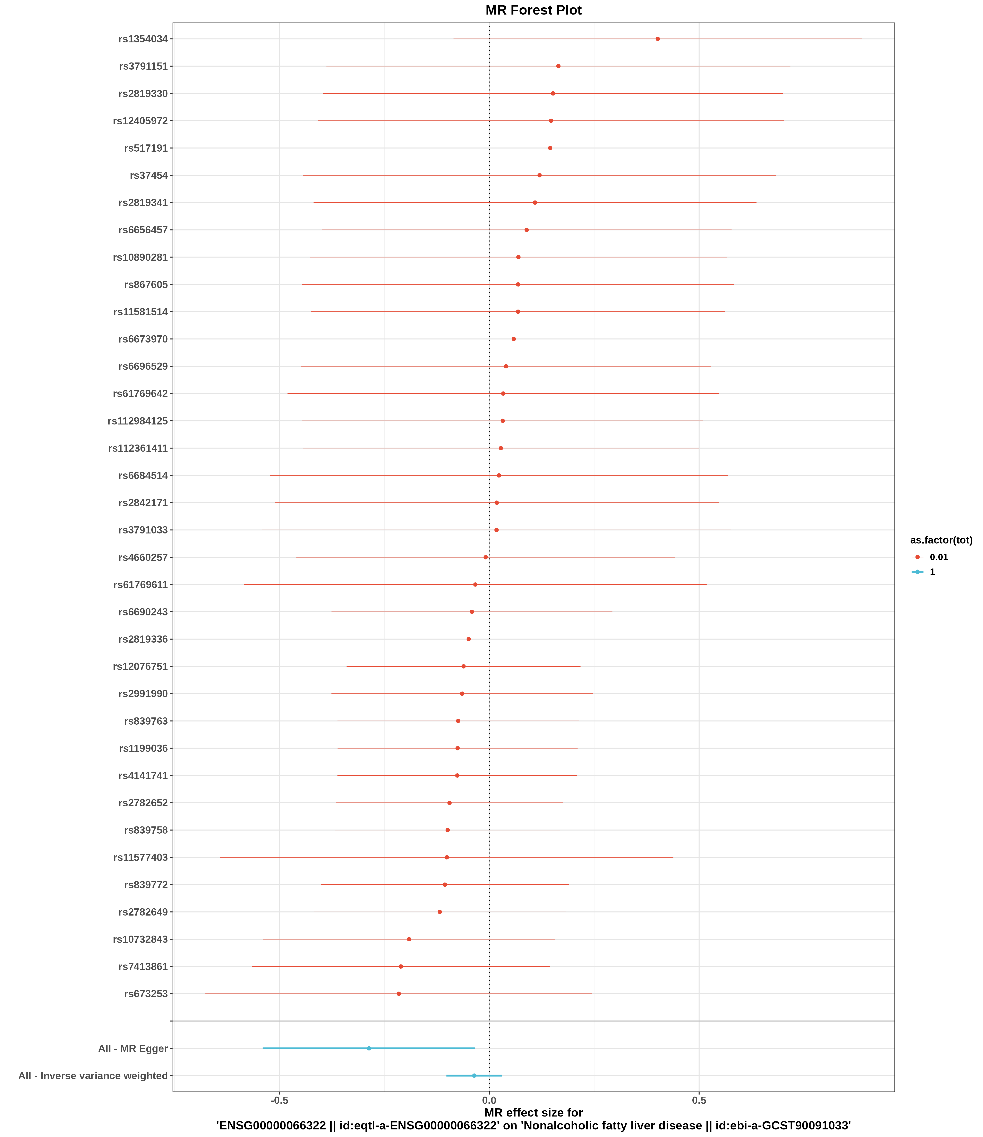
图2 漏斗图（发表偏倚评估）
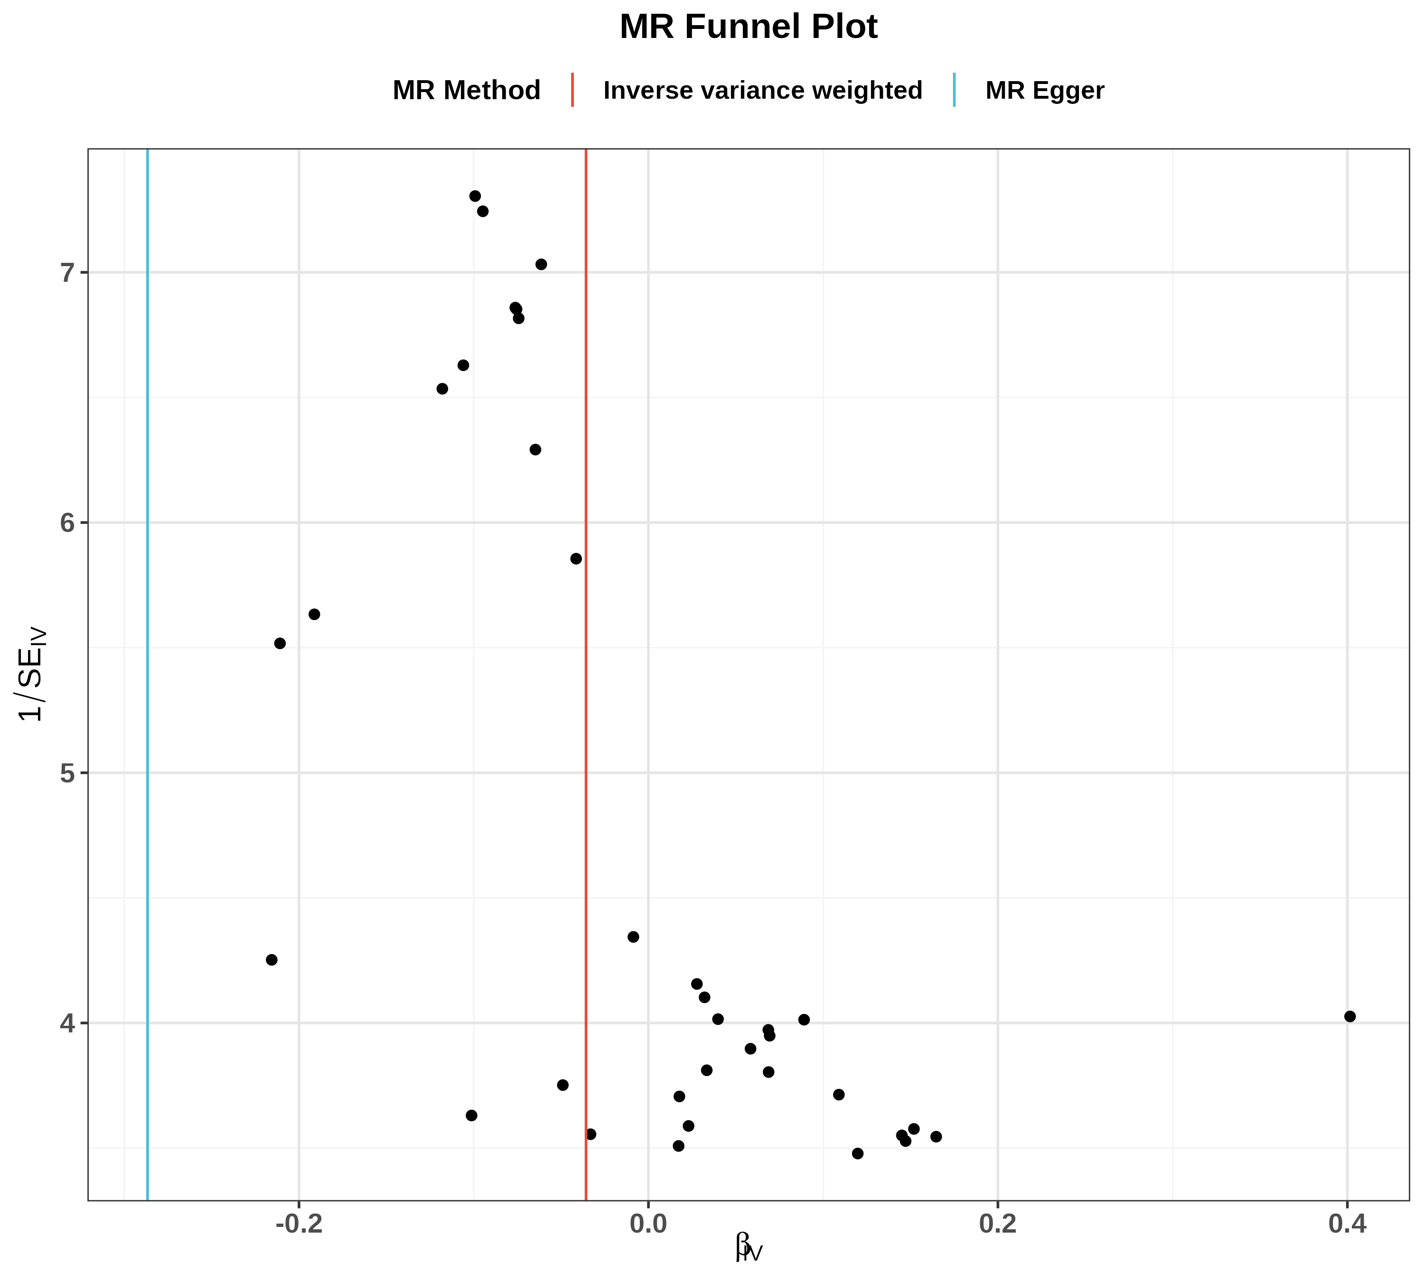
图3 散点图（SNP对暴露与结局的效应）
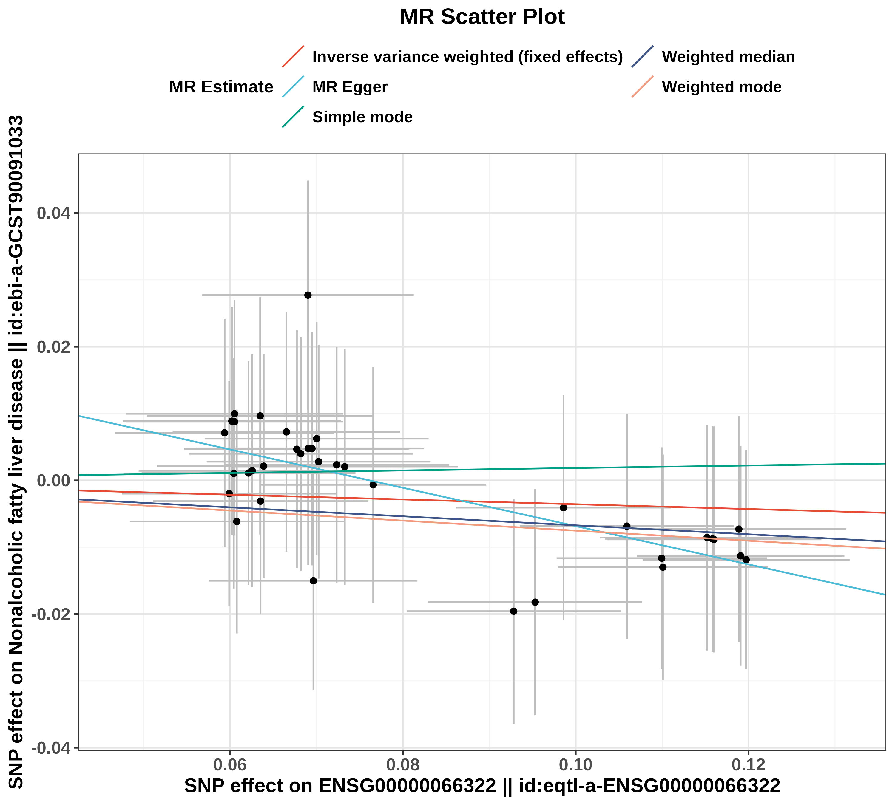
图4 留一法图（敏感性分析）
