孟德尔随机化分析报告

1. 方法

1.1 孟德尔随机化分析
孟德尔随机化（MR）是一种利用遗传变异（单核苷酸多态性，SNPs）作为工具变量来推断暴露与结局之间因果关系的方法。本分析使用TwoSampleMR R包进行MR分析，基于全基因组关联研究（GWAS）的汇总统计数据。

1.2 统计方法
1) 逆方差加权法（IVW）- 主要MR方法，假设所有SNPs均为有效工具变量
2) MR-Egger - 对水平多效性具有稳健性
3) 加权中位数法 - 对最多50%的无效工具变量具有稳健性
4) 加权众数法 - 假设最大组的SNPs具有有效效应
5) 简单众数法 - 使用SNP特异性因果估计的众数

1.3 质量控制
1) F统计量：F > 10的工具变量被认为是强效的
2) 异质性检验：Q检验评估SNPs之间的异质性
3) 多效性检验：MR-Egger截距检验用于方向性多效性
4) Steiger检验：方向性检验以验证因果方向

2. 结果

2.1 汇总统计
无MR结果可用。

2.2 主要结果（IVW方法）
无结果可用。

2.3 异质性与多效性检验结果（IVW显著基因）
（共91个IVW显著基因）
Exposure | Outcome | Method | Heterogeneity_Q | Q_df | Q_P-value | Egger_intercept | SE | P-value
ADAM28 | ebi-a-GCST90018894 | MR Egger | 48.7700 | 58 | 0.800799999999999956301622 | -0.003542 | 0.010185 | 0.729244000000
ADM | ebi-a-GCST90018894 | MR Egger | 65.1244 | 100 | 0.997299999999999964295228 | 0.016928 | 0.005034 | 0.001095980000
ALAS2 | ebi-a-GCST90018894 | MR Egger | 4.4630 | 18 | 0.999500000000000055067062 | 0.027032 | 0.028953 | 0.362848000000
ALPL | ebi-a-GCST90018894 | MR Egger | 17.9328 | 38 | 0.997700000000000031263880 | 0.001045 | 0.013063 | 0.936680000000
ANK1 | ebi-a-GCST90018894 | MR Egger | 47.9550 | 45 | 0.353899999999999992361666 | 0.038782 | 0.014898 | 0.012464800000
ASGR2 | ebi-a-GCST90018894 | MR Egger | 66.9762 | 101 | 0.996399999999999952393637 | -0.008196 | 0.006252 | 0.192817000000
AZU1 | ebi-a-GCST90018894 | MR Egger | 5.5356 | 11 | 0.902499999999999968913755 | 0.039020 | 0.035479 | 0.294902000000
BACE2 | ebi-a-GCST90018894 | MR Egger | 8.5412 | 16 | 0.931100000000000038724579 | 0.023560 | 0.016053 | 0.161592000000
BCAM | ebi-a-GCST90018894 | MR Egger | 4.0688 | 6 | 0.667399999999999993249844 | -0.032670 | 0.046479 | 0.508453000000
BPI | ebi-a-GCST90018894 | MR Egger | 97.9449 | 102 | 0.595199999999999951327823 | -0.011317 | 0.006273 | 0.074141600000
C1QB | ebi-a-GCST90018894 | MR Egger | 69.6484 | 68 | 0.421800000000000008260059 | 0.022373 | 0.006416 | 0.000859718000
CAMP | ebi-a-GCST90018894 | MR Egger | 17.1806 | 15 | 0.308199999999999973976372 | -0.019546 | 0.025365 | 0.452911000000
CAPZA2 | ebi-a-GCST90018894 | MR Egger | 87.7643 | 98 | 0.761199999999999987743138 | -0.043051 | 0.007545 | 0.000000123361
CD226 | ebi-a-GCST90018894 | MR Egger | 63.3169 | 79 | 0.901000000000000023092639 | -0.003711 | 0.008151 | 0.650172000000
CEACAM6 | ebi-a-GCST90018894 | MR Egger | 16.2165 | 29 | 0.972999999999999976019183 | 0.015734 | 0.013670 | 0.259127000000
CEACAM8 | ebi-a-GCST90018894 | MR Egger | 20.2941 | 29 | 0.883600000000000052047255 | 0.006483 | 0.014937 | 0.667491000000
CENPM | ebi-a-GCST90018894 | MR Egger | 34.1329 | 81 | 1.000000000000000000000000 | -0.030791 | 0.010420 | 0.004092920000
CHI3L1 | ebi-a-GCST90018894 | MR Egger | 47.3889 | 67 | 0.966799999999999992716937 | 0.002250 | 0.006804 | 0.741898000000
CHIT1 | ebi-a-GCST90018894 | MR Egger | 9.5859 | 17 | 0.920100000000000028954616 | 0.024160 | 0.022682 | 0.301698000000
CLEC18A | ebi-a-GCST90018894 | MR Egger | 104.0363 | 133 | 0.970099999999999962341235 | -0.009736 | 0.006209 | 0.119218000000
CLEC18A | ebi-a-GCST90018894 | MR Egger | 49.5759 | 93 | 0.999900000000000011013412 | 0.025524 | 0.011030 | 0.022871100000
CR1L | ebi-a-GCST90018894 | MR Egger | 23.0070 | 49 | 0.999399999999999955058172 | -0.037410 | 0.012273 | 0.003706370000
CTSG | ebi-a-GCST90018894 | MR Egger | 69.7932 | 106 | 0.997399999999999953281815 | 0.003735 | 0.005234 | 0.477091000000
CYP4F2 | ebi-a-GCST90018894 | MR Egger | 4.9400 | 10 | 0.895100000000000006750156 | -0.011413 | 0.040233 | 0.782452000000
DEFA3 | ebi-a-GCST90018894 | MR Egger | 12.0297 | 20 | 0.915100000000000024513724 | -0.019348 | 0.014830 | 0.206810000000
DEFA4 | ebi-a-GCST90018894 | MR Egger | 13.5892 | 17 | 0.695899999999999963051778 | 0.016811 | 0.018546 | 0.377351000000
ELANE | ebi-a-GCST90018894 | MR Egger | 18.6946 | 22 | 0.664100000000000023625546 | 0.008971 | 0.018530 | 0.633090000000
FAS | ebi-a-GCST90018894 | MR Egger | 72.0805 | 80 | 0.723999999999999976907361 | -0.012539 | 0.010675 | 0.243601000000
FSTL4 | ebi-a-GCST90018894 | MR Egger | 22.6028 | 15 | 0.092950000000000004840572 | -0.050760 | 0.040552 | 0.229838000000
GYPB | ebi-a-GCST90018894 | MR Egger | 45.5548 | 61 | 0.930000000000000048849813 | 0.019175 | 0.010618 | 0.075867800000
HS3ST1 | ebi-a-GCST90018894 | MR Egger | 14.1056 | 25 | 0.959899999999999975486276 | -0.028672 | 0.014370 | 0.057030400000
HTRA1 | ebi-a-GCST90018894 | MR Egger | 89.9702 | 85 | 0.335399999999999975930365 | -0.016306 | 0.009220 | 0.080569300000
HTRA3 | ebi-a-GCST90018894 | MR Egger | 4.6434 | 6 | 0.590300000000000046895821 | -0.016373 | 0.027418 | 0.572227000000
IFI27 | ebi-a-GCST90018894 | MR Egger | 24.2374 | 35 | 0.914100000000000023625546 | 0.040694 | 0.011659 | 0.001323560000
IGKV1D-8 | ebi-a-GCST90018894 | MR Egger | 4.8403 | 24 | 1.000000000000000000000000 | 0.161321 | 0.082269 | 0.061596500000
IL1R2 | ebi-a-GCST90018894 | MR Egger | 41.7862 | 67 | 0.993299999999999960742514 | -0.007558 | 0.010288 | 0.465110000000
IL4 | ebi-a-GCST90018894 | MR Egger | 11.4185 | 14 | 0.652900000000000035882408 | -0.013589 | 0.026414 | 0.614950000000
IL7 | ebi-a-GCST90018894 | MR Egger | 5.0022 | 9 | 0.834099999999999952571272 | -0.012910 | 0.037871 | 0.741012000000
KLF5 | ebi-a-GCST90018894 | MR Egger | 20.1868 | 47 | 0.999800000000000022026825 | -0.030896 | 0.012969 | 0.021300700000
LAMC1 | ebi-a-GCST90018894 | MR Egger | 100.7586 | 142 | 0.996500000000000052402527 | 0.011628 | 0.004718 | 0.014901600000
LCN2 | ebi-a-GCST90018894 | MR Egger | 26.8101 | 47 | 0.992199999999999970867748 | 0.014506 | 0.017459 | 0.410235000000
LEFTY1 | ebi-a-GCST90018894 | MR Egger | 17.0090 | 21 | 0.710600000000000009414691 | -0.021327 | 0.032253 | 0.515650000000
LIPH | ebi-a-GCST90018894 | MR Egger | 7.3891 | 21 | 0.997199999999999975308640 | -0.033859 | 0.018595 | 0.082912000000
LOXL3 | ebi-a-GCST90018894 | MR Egger | 17.6718 | 46 | 0.999900000000000011013412 | -0.000092 | 0.011607 | 0.993685000000
LPL | ebi-a-GCST90018894 | MR Egger | 39.3541 | 66 | 0.996299999999999963407049 | 0.005149 | 0.006242 | 0.412337000000
LRRC4 | ebi-a-GCST90018894 | MR Egger | 21.0530 | 59 | 1.000000000000000000000000 | 0.031714 | 0.012250 | 0.012107300000
LTBP1 | ebi-a-GCST90018894 | MR Egger | 14.4035 | 14 | 0.420099999999999973443465 | 0.044913 | 0.016896 | 0.018730300000
LTF | ebi-a-GCST90018894 | MR Egger | 8.5965 | 14 | 0.855999999999999983124610 | -0.008204 | 0.026160 | 0.758448000000
MANSC1 | ebi-a-GCST90018894 | MR Egger | 28.0559 | 27 | 0.408100000000000018296475 | 0.008325 | 0.014137 | 0.560817000000
MFAP3L | ebi-a-GCST90018894 | MR Egger | 38.1239 | 59 | 0.984099999999999974775733 | -0.034490 | 0.009633 | 0.000694767000
MME | ebi-a-GCST90018894 | MR Egger | 45.4015 | 64 | 0.962200000000000055244698 | 0.003253 | 0.011692 | 0.781716000000
MMP17 | ebi-a-GCST90018894 | MR Egger | 19.1091 | 25 | 0.791900000000000048316906 | -0.009760 | 0.021982 | 0.660855000000
MMP25 | ebi-a-GCST90018894 | MR Egger | 72.4513 | 57 | 0.081509999999999999120703 | 0.018592 | 0.009366 | 0.051957700000
MMP9 | ebi-a-GCST90018894 | MR Egger | 30.0644 | 64 | 0.999900000000000011013412 | 0.005826 | 0.007900 | 0.463573000000
MMRN1 | ebi-a-GCST90018894 | MR Egger | 276.9400 | 87 | 0.000000000000000000001161 | 0.042895 | 0.011373 | 0.000295069000
MPO | ebi-a-GCST90018894 | MR Egger | 54.4074 | 104 | 1.000000000000000000000000 | -0.002592 | 0.007699 | 0.737080000000
MS4A3 | ebi-a-GCST90018894 | MR Egger | 18.2142 | 24 | 0.792499999999999982236432 | -0.012184 | 0.021996 | 0.584750000000
MYCT1 | ebi-a-GCST90018894 | MR Egger | 2.4449 | 12 | 0.998399999999999954169994 | -0.019876 | 0.025102 | 0.443838000000
MYL4 | ebi-a-GCST90018894 | MR Egger | 17.5836 | 21 | 0.675200000000000022382096 | -0.020493 | 0.017048 | 0.242714000000
NID1 | ebi-a-GCST90018894 | MR Egger | 18.6938 | 20 | 0.541799999999999948308016 | 0.004697 | 0.016501 | 0.778832000000
NID2 | ebi-a-GCST90018894 | MR Egger | 1.3689 | 7 | 0.986500000000000043520743 | -0.019933 | 0.065475 | 0.769648000000
OLFM4 | ebi-a-GCST90018894 | MR Egger | 190.5870 | 145 | 0.006624999999999999812650 | -0.024476 | 0.006556 | 0.000270641000
ORM1 | ebi-a-GCST90018894 | MR Egger | 45.7659 | 52 | 0.716199999999999947775109 | -0.019494 | 0.009522 | 0.045693600000
ORM2 | ebi-a-GCST90018894 | MR Egger | 38.1772 | 55 | 0.958999999999999963584685 | -0.025045 | 0.010086 | 0.016099300000
OSBP2 | ebi-a-GCST90018894 | MR Egger | 73.8673 | 70 | 0.352999999999999980460075 | 0.000520 | 0.011672 | 0.964559000000
PCOLCE2 | ebi-a-GCST90018894 | MR Egger | 5.3508 | 9 | 0.802699999999999969091391 | 0.112605 | 0.048144 | 0.044099200000
PF4 | ebi-a-GCST90018894 | MR Egger | 26.4864 | 17 | 0.066040000000000001478817 | 0.096691 | 0.043740 | 0.041058000000
PGLYRP1 | ebi-a-GCST90018894 | MR Egger | 55.9608 | 50 | 0.261099999999999998756550 | 0.003765 | 0.008204 | 0.648296000000
PI3 | ebi-a-GCST90018894 | MR Egger | 65.4247 | 105 | 0.999099999999999988098409 | 0.004890 | 0.004647 | 0.295123000000
PLOD2 | ebi-a-GCST90018894 | MR Egger | 21.3574 | 30 | 0.876399999999999956834529 | 0.028715 | 0.012773 | 0.032074800000
PPBP | ebi-a-GCST90018894 | MR Egger | 59.7494 | 50 | 0.162599999999999994537703 | 0.022750 | 0.006914 | 0.001837320000
PRKD1 | ebi-a-GCST90018894 | MR Egger | 26.9619 | 43 | 0.973400000000000042987836 | -0.003216 | 0.010213 | 0.754370000000
PROK2 | ebi-a-GCST90018894 | MR Egger | 37.7862 | 56 | 0.970500000000000029309888 | -0.001536 | 0.006221 | 0.805890000000
PROS1 | ebi-a-GCST90018894 | MR Egger | 51.5390 | 63 | 0.848500000000000031974423 | 0.037420 | 0.009061 | 0.000108769000
PRTN3 | ebi-a-GCST90018894 | MR Egger | 9.0458 | 11 | 0.617700000000000026822988 | -0.007122 | 0.015447 | 0.653736000000
RASL11A | ebi-a-GCST90018894 | MR Egger | 16.6730 | 24 | 0.862299999999999955413443 | 0.023363 | 0.024426 | 0.348361000000
RHCE | ebi-a-GCST90018894 | MR Egger | 2.9252 | 18 | 1.000000000000000000000000 | 0.045143 | 0.041028 | 0.285701000000
SAP30 | ebi-a-GCST90018894 | MR Egger | 3.3063 | 21 | 1.000000000000000000000000 | 0.028328 | 0.019370 | 0.158420000000
SERPINB10 | ebi-a-GCST90018894 | MR Egger | 59.8647 | 69 | 0.775599999999999956123986 | -0.001037 | 0.007631 | 0.892340000000
SERPINI1 | ebi-a-GCST90018894 | MR Egger | 24.1607 | 40 | 0.977400000000000046540549 | 0.019526 | 0.012467 | 0.125184000000
SFRP5 | ebi-a-GCST90018894 | MR Egger | 17.1793 | 26 | 0.903599999999999958788521 | 0.000448 | 0.023132 | 0.984710000000
SLC1A3 | ebi-a-GCST90018894 | MR Egger | 31.6254 | 62 | 0.999500000000000055067062 | 0.008512 | 0.011105 | 0.446278000000
SLC25A39 | ebi-a-GCST90018894 | MR Egger | 52.6884 | 56 | 0.600999999999999978683718 | -0.021610 | 0.011668 | 0.069294300000
SLPI | ebi-a-GCST90018894 | MR Egger | 50.9249 | 61 | 0.817699999999999982414067 | 0.003762 | 0.008056 | 0.642207000000
TCN1 | ebi-a-GCST90018894 | MR Egger | 45.3141 | 101 | 1.000000000000000000000000 | 0.013316 | 0.008312 | 0.112256000000
TFPI | ebi-a-GCST90018894 | MR Egger | 18.8046 | 12 | 0.093350000000000002420286 | 0.026022 | 0.033771 | 0.455878000000
THBS4 | ebi-a-GCST90018894 | MR Egger | 2.1028 | 6 | 0.910000000000000031086245 | -0.064814 | 0.090357 | 0.500142000000
TNFSF4 | ebi-a-GCST90018894 | MR Egger | 88.0903 | 102 | 0.835200000000000053468341 | -0.003036 | 0.005511 | 0.582918000000
TPST1 | ebi-a-GCST90018894 | MR Egger | 94.3406 | 188 | 1.000000000000000000000000 | -0.011219 | 0.006172 | 0.070675300000
UCHL1 | ebi-a-GCST90018894 | MR Egger | 26.1642 | 17 | 0.071520000000000000239808 | -0.058634 | 0.071528 | 0.423711000000
VWCE | ebi-a-GCST90018894 | MR Egger | 33.3632 | 69 | 0.999900000000000011013412 | -0.008216 | 0.009443 | 0.387252000000

2.4 可视化
图1 森林图（各SNP效应大小）
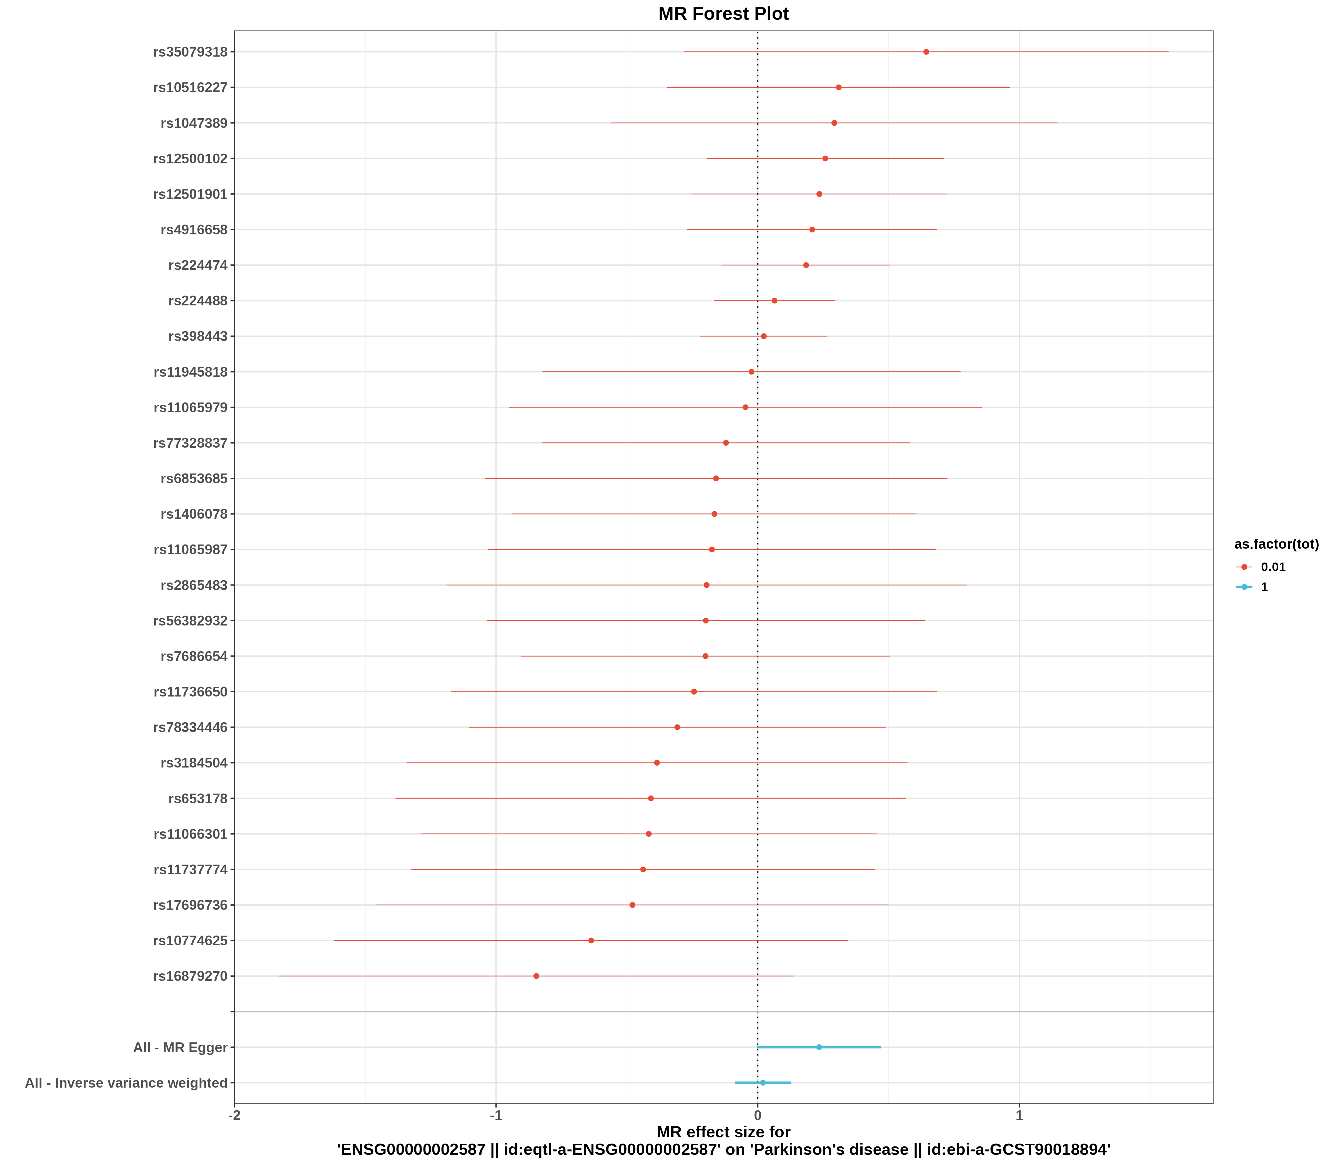
图2 漏斗图（发表偏倚评估）
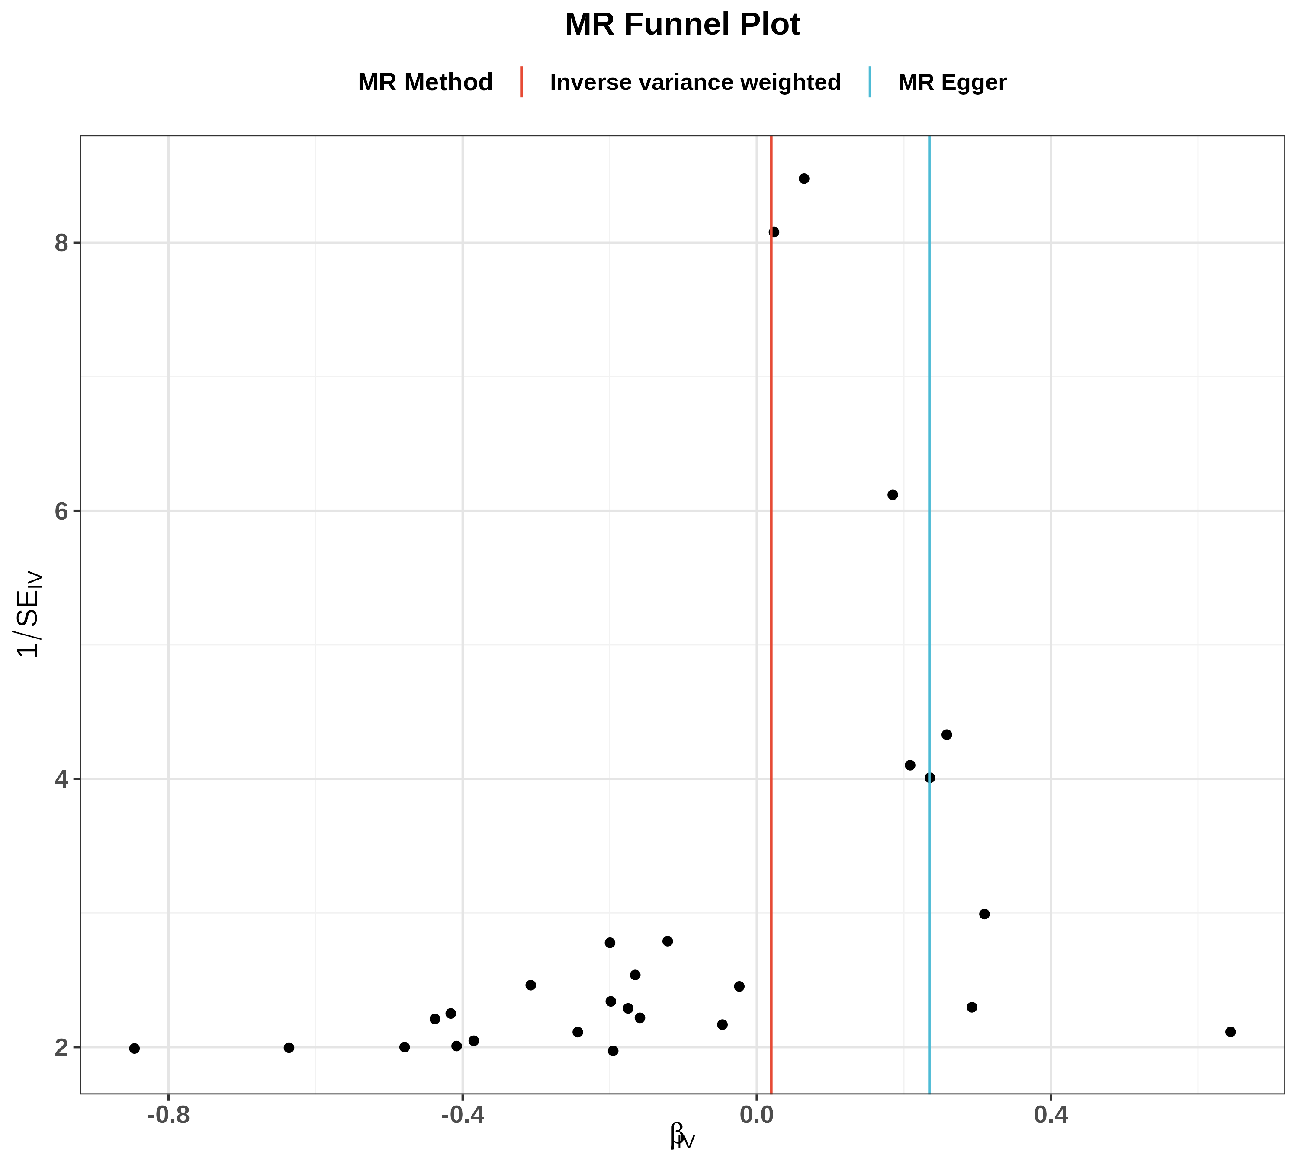
图3 散点图（SNP对暴露与结局的效应）
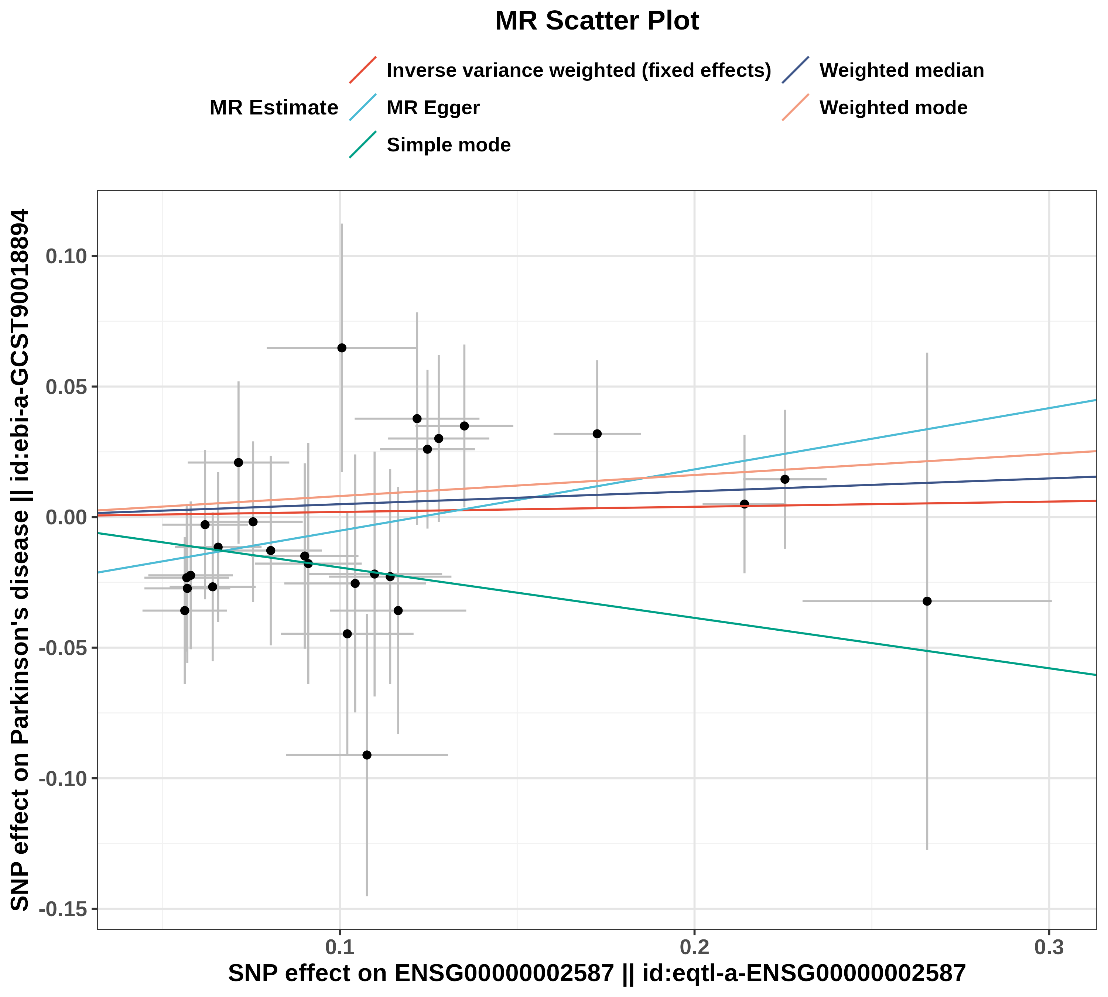
图4 留一法图（敏感性分析）
