孟德尔随机化分析报告

1. 方法

1.1 孟德尔随机化分析
孟德尔随机化（MR）是一种利用遗传变异（单核苷酸多态性，SNPs）作为工具变量来推断暴露与结局之间因果关系的方法。本分析使用TwoSampleMR R包进行MR分析，基于全基因组关联研究（GWAS）的汇总统计数据。

1.2 统计方法
1) 逆方差加权法（IVW）- 主要MR方法，假设所有SNPs均为有效工具变量
2) MR-Egger - 对水平多效性具有稳健性
3) 加权中位数法 - 对最多50%的无效工具变量具有稳健性
4) 加权众数法 - 假设最大组的SNPs具有有效效应
5) 简单众数法 - 使用SNP特异性因果估计的众数

1.3 质量控制
1) F统计量：F > 10的工具变量被认为是强效的
2) 异质性检验：Q检验评估SNPs之间的异质性
3) 多效性检验：MR-Egger截距检验用于方向性多效性
4) Steiger检验：方向性检验以验证因果方向

2. 结果

2.1 汇总统计
无MR结果可用。

2.2 主要结果（IVW方法）
无结果可用。

2.3 异质性与多效性检验结果
（共185行）
Exposure | Outcome | Method | Heterogeneity_Q | Q_df | Q_P-value | Egger_intercept | SE | P-value
ADAM28 | ebi-a-GCST90018894 | MR Egger | 48.7700 | 58 | 0.8007999999999999563016217507538 | -0.003542 | 0.010185 | 0.729244000000
 | ebi-a-GCST90018894 | IVW | 48.8910 | 59 | 0.8232000000000000428101998295460
ADM | ebi-a-GCST90018894 | MR Egger | 65.1244 | 100 | 0.9972999999999999642952275280550 | 0.016928 | 0.005034 | 0.001095980000
 | ebi-a-GCST90018894 | IVW | 76.4299 | 101 | 0.9675000000000000266453525910038
ALAS2 | ebi-a-GCST90018894 | MR Egger | 4.4630 | 18 | 0.9995000000000000550670620214078 | 0.027032 | 0.028953 | 0.362848000000
 | ebi-a-GCST90018894 | IVW | 5.3347 | 19 | 0.9990999999999999880984091760183
ALPL | ebi-a-GCST90018894 | MR Egger | 17.9328 | 38 | 0.9977000000000000312638803734444 | 0.001045 | 0.013063 | 0.936680000000
 | ebi-a-GCST90018894 | IVW | 17.9392 | 39 | 0.9985000000000000541788836017076
ANK1 | ebi-a-GCST90018894 | MR Egger | 47.9550 | 45 | 0.3538999999999999923616655905789 | 0.038782 | 0.014898 | 0.012464800000
 | ebi-a-GCST90018894 | IVW | 55.1767 | 46 | 0.1665000000000000091038288019263
 | ebi-a-GCST90018894 | IVW | 0.4895 | 1 | 0.4840999999999999747757328805164
 | ebi-a-GCST90018894 | IVW | 0.6976 | 1 | 0.4036000000000000142996725571720
ASGR2 | ebi-a-GCST90018894 | MR Egger | 66.9762 | 101 | 0.9963999999999999523936367040733 | -0.008196 | 0.006252 | 0.192817000000
 | ebi-a-GCST90018894 | IVW | 68.6950 | 102 | 0.9952999999999999625188706886547
AZU1 | ebi-a-GCST90018894 | MR Egger | 5.5356 | 11 | 0.9024999999999999689137553104956 | 0.039020 | 0.035479 | 0.294902000000
 | ebi-a-GCST90018894 | IVW | 6.7452 | 12 | 0.8739999999999999991118215802999
BACE2 | ebi-a-GCST90018894 | MR Egger | 8.5412 | 16 | 0.9311000000000000387245790989255 | 0.023560 | 0.016053 | 0.161592000000
 | ebi-a-GCST90018894 | IVW | 10.6951 | 17 | 0.8719999999999999973354647408996
BCAM | ebi-a-GCST90018894 | MR Egger | 4.0688 | 6 | 0.6673999999999999932498440102790 | -0.032670 | 0.046479 | 0.508453000000
 | ebi-a-GCST90018894 | IVW | 4.5629 | 7 | 0.7130999999999999561239860668138
BPI | ebi-a-GCST90018894 | MR Egger | 97.9449 | 102 | 0.5951999999999999513278226004331 | -0.011317 | 0.006273 | 0.074141600000
 | ebi-a-GCST90018894 | IVW | 101.2003 | 103 | 0.5316999999999999504396441807330
C1QB | ebi-a-GCST90018894 | MR Egger | 69.6484 | 68 | 0.4218000000000000082600593032112 | 0.022373 | 0.006416 | 0.000859718000
 | ebi-a-GCST90018894 | IVW | 82.1049 | 69 | 0.1340000000000000079936057773011
CAMP | ebi-a-GCST90018894 | MR Egger | 17.1806 | 15 | 0.3081999999999999739763723027863 | -0.019546 | 0.025365 | 0.452911000000
 | ebi-a-GCST90018894 | IVW | 17.8608 | 16 | 0.3321000000000000063060667798709
CAPZA2 | ebi-a-GCST90018894 | MR Egger | 87.7643 | 98 | 0.7611999999999999877431378081383 | -0.043051 | 0.007545 | 0.000000123361
 | ebi-a-GCST90018894 | IVW | 120.3169 | 99 | 0.0714999999999999941158179694867
CD226 | ebi-a-GCST90018894 | MR Egger | 63.3169 | 79 | 0.9010000000000000230926389122033 | -0.003711 | 0.008151 | 0.650172000000
 | ebi-a-GCST90018894 | IVW | 63.5242 | 80 | 0.9115999999999999658939486835152
CEACAM6 | ebi-a-GCST90018894 | MR Egger | 16.2165 | 29 | 0.9729999999999999760191826680966 | 0.015734 | 0.013670 | 0.259127000000
 | ebi-a-GCST90018894 | IVW | 17.5413 | 30 | 0.9655000000000000248689957516035
CEACAM8 | ebi-a-GCST90018894 | MR Egger | 20.2941 | 29 | 0.8836000000000000520472553944273 | 0.006483 | 0.014937 | 0.667491000000
 | ebi-a-GCST90018894 | IVW | 20.4824 | 30 | 0.9033999999999999808153461344773
CENPM | ebi-a-GCST90018894 | MR Egger | 34.1329 | 81 | 1.0000000000000000000000000000000 | -0.030791 | 0.010420 | 0.004092920000
 | ebi-a-GCST90018894 | IVW | 42.8650 | 82 | 0.9999000000000000110134124042816
CHI3L1 | ebi-a-GCST90018894 | MR Egger | 47.3889 | 67 | 0.9667999999999999927169369584590 | 0.002250 | 0.006804 | 0.741898000000
 | ebi-a-GCST90018894 | IVW | 47.4983 | 68 | 0.9723000000000000531130694980675
CHIT1 | ebi-a-GCST90018894 | MR Egger | 9.5859 | 17 | 0.9201000000000000289546164822241 | 0.024160 | 0.022682 | 0.301698000000
 | ebi-a-GCST90018894 | IVW | 10.7205 | 18 | 0.9058000000000000495603558192670
CLEC18A | ebi-a-GCST90018894 | MR Egger | 104.0363 | 133 | 0.9700999999999999623412350047147 | -0.009736 | 0.006209 | 0.119218000000
 | ebi-a-GCST90018894 | IVW | 106.4955 | 134 | 0.9616000000000000103028696685215
CLEC18A | ebi-a-GCST90018894 | MR Egger | 49.5759 | 93 | 0.9999000000000000110134124042816 | 0.025524 | 0.011030 | 0.022871100000
 | ebi-a-GCST90018894 | IVW | 54.9304 | 94 | 0.9996000000000000440536496171262
CR1L | ebi-a-GCST90018894 | MR Egger | 23.0070 | 49 | 0.9993999999999999550581719631737 | -0.037410 | 0.012273 | 0.003706370000
 | ebi-a-GCST90018894 | IVW | 32.2977 | 50 | 0.9755000000000000337507799486048
CTSG | ebi-a-GCST90018894 | MR Egger | 69.7932 | 106 | 0.9973999999999999532818151237734 | 0.003735 | 0.005234 | 0.477091000000
 | ebi-a-GCST90018894 | IVW | 70.3023 | 107 | 0.9976000000000000422772927777260
CYP4F2 | ebi-a-GCST90018894 | MR Egger | 4.9400 | 10 | 0.8951000000000000067501559897210 | -0.011413 | 0.040233 | 0.782452000000
 | ebi-a-GCST90018894 | IVW | 5.0205 | 11 | 0.9302000000000000268229882749438
DEFA3 | ebi-a-GCST90018894 | MR Egger | 12.0297 | 20 | 0.9151000000000000245137243837235 | -0.019348 | 0.014830 | 0.206810000000
 | ebi-a-GCST90018894 | IVW | 13.7319 | 21 | 0.8808000000000000273558953267639
DEFA4 | ebi-a-GCST90018894 | MR Egger | 13.5892 | 17 | 0.6958999999999999630517777404748 | 0.016811 | 0.018546 | 0.377351000000
 | ebi-a-GCST90018894 | IVW | 14.4109 | 18 | 0.7018999999999999683808482586755
ELANE | ebi-a-GCST90018894 | MR Egger | 18.6946 | 22 | 0.6641000000000000236255459640233 | 0.008971 | 0.018530 | 0.633090000000
 | ebi-a-GCST90018894 | IVW | 18.9290 | 23 | 0.7053000000000000380140363631654
FAS | ebi-a-GCST90018894 | MR Egger | 72.0805 | 80 | 0.7239999999999999769073610877967 | -0.012539 | 0.010675 | 0.243601000000
 | ebi-a-GCST90018894 | IVW | 73.4604 | 81 | 0.7118999999999999772626324556768
FSTL4 | ebi-a-GCST90018894 | MR Egger | 22.6028 | 15 | 0.0929500000000000048405723873657 | -0.050760 | 0.040552 | 0.229838000000
 | ebi-a-GCST90018894 | IVW | 24.9637 | 16 | 0.0704700000000000048583359557597
GYPB | ebi-a-GCST90018894 | MR Egger | 45.5548 | 61 | 0.9300000000000000488498130835069 | 0.019175 | 0.010618 | 0.075867800000
 | ebi-a-GCST90018894 | IVW | 48.8161 | 62 | 0.8885999999999999454658450304123
HS3ST1 | ebi-a-GCST90018894 | MR Egger | 14.1056 | 25 | 0.9598999999999999754862756162765 | -0.028672 | 0.014370 | 0.057030400000
 | ebi-a-GCST90018894 | IVW | 18.0864 | 26 | 0.8726000000000000422772927777260
HTRA1 | ebi-a-GCST90018894 | MR Egger | 89.9702 | 85 | 0.3353999999999999759303648261266 | -0.016306 | 0.009220 | 0.080569300000
 | ebi-a-GCST90018894 | IVW | 93.2806 | 86 | 0.2773999999999999799271677147772
HTRA3 | ebi-a-GCST90018894 | MR Egger | 4.6434 | 6 | 0.5903000000000000468958205601666 | -0.016373 | 0.027418 | 0.572227000000
 | ebi-a-GCST90018894 | IVW | 5.0000 | 7 | 0.6600000000000000310862446895044
IFI27 | ebi-a-GCST90018894 | MR Egger | 24.2374 | 35 | 0.9141000000000000236255459640233 | 0.040694 | 0.011659 | 0.001323560000
 | ebi-a-GCST90018894 | IVW | 36.4203 | 36 | 0.4490999999999999992006394222699
IGKV1D-8 | ebi-a-GCST90018894 | MR Egger | 4.8403 | 24 | 1.0000000000000000000000000000000 | 0.161321 | 0.082269 | 0.061596500000
 | ebi-a-GCST90018894 | IVW | 8.6854 | 25 | 0.9989999999999999991118215802999
IL1R2 | ebi-a-GCST90018894 | MR Egger | 41.7862 | 67 | 0.9932999999999999607425138492545 | -0.007558 | 0.010288 | 0.465110000000
 | ebi-a-GCST90018894 | IVW | 42.3259 | 68 | 0.9938000000000000166977542903624
IL4 | ebi-a-GCST90018894 | MR Egger | 11.4185 | 14 | 0.6529000000000000358824081558851 | -0.013589 | 0.026414 | 0.614950000000
 | ebi-a-GCST90018894 | IVW | 11.6831 | 15 | 0.7027999999999999802824390826572
IL7 | ebi-a-GCST90018894 | MR Egger | 5.0022 | 9 | 0.8340999999999999525712723880133 | -0.012910 | 0.037871 | 0.741012000000
 | ebi-a-GCST90018894 | IVW | 5.1184 | 10 | 0.8830999999999999960920149533194
KLF5 | ebi-a-GCST90018894 | MR Egger | 20.1868 | 47 | 0.9998000000000000220268248085631 | -0.030896 | 0.012969 | 0.021300700000
 | ebi-a-GCST90018894 | IVW | 25.8624 | 48 | 0.9962999999999999634070491083548
LAMC1 | ebi-a-GCST90018894 | MR Egger | 100.7586 | 142 | 0.9965000000000000524025267623074 | 0.011628 | 0.004718 | 0.014901600000
 | ebi-a-GCST90018894 | IVW | 106.8338 | 143 | 0.9896000000000000351718654201250
LCN2 | ebi-a-GCST90018894 | MR Egger | 26.8101 | 47 | 0.9921999999999999708677478338359 | 0.014506 | 0.017459 | 0.410235000000
 | ebi-a-GCST90018894 | IVW | 27.5005 | 48 | 0.9923999999999999488409230252728
LEFTY1 | ebi-a-GCST90018894 | MR Egger | 17.0090 | 21 | 0.7106000000000000094146912488213 | -0.021327 | 0.032253 | 0.515650000000
 | ebi-a-GCST90018894 | IVW | 17.4462 | 22 | 0.7382999999999999563016217507538
LIPH | ebi-a-GCST90018894 | MR Egger | 7.3891 | 21 | 0.9971999999999999753086399323365 | -0.033859 | 0.018595 | 0.082912000000
 | ebi-a-GCST90018894 | IVW | 10.7045 | 22 | 0.9787000000000000143884903991420
LOXL3 | ebi-a-GCST90018894 | MR Egger | 17.6718 | 46 | 0.9999000000000000110134124042816 | -0.000092 | 0.011607 | 0.993685000000
 | ebi-a-GCST90018894 | IVW | 17.6719 | 47 | 1.0000000000000000000000000000000
LPL | ebi-a-GCST90018894 | MR Egger | 39.3541 | 66 | 0.9962999999999999634070491083548 | 0.005149 | 0.006242 | 0.412337000000
 | ebi-a-GCST90018894 | IVW | 40.0347 | 67 | 0.9963999999999999523936367040733
LRRC4 | ebi-a-GCST90018894 | MR Egger | 21.0530 | 59 | 1.0000000000000000000000000000000 | 0.031714 | 0.012250 | 0.012107300000
 | ebi-a-GCST90018894 | IVW | 27.7552 | 60 | 0.9999000000000000110134124042816
LTBP1 | ebi-a-GCST90018894 | MR Egger | 14.4035 | 14 | 0.4200999999999999734434652509663 | 0.044913 | 0.016896 | 0.018730300000
 | ebi-a-GCST90018894 | IVW | 21.6726 | 15 | 0.1166999999999999981792342396147
LTF | ebi-a-GCST90018894 | MR Egger | 8.5965 | 14 | 0.8559999999999999831246100256976 | -0.008204 | 0.026160 | 0.758448000000
 | ebi-a-GCST90018894 | IVW | 8.6948 | 15 | 0.8929000000000000270006239588838
MANSC1 | ebi-a-GCST90018894 | MR Egger | 28.0559 | 27 | 0.4081000000000000182964754458226 | 0.008325 | 0.014137 | 0.560817000000
 | ebi-a-GCST90018894 | IVW | 28.4163 | 28 | 0.4425999999999999934274796942191
MFAP3L | ebi-a-GCST90018894 | MR Egger | 38.1239 | 59 | 0.9840999999999999747757328805164 | -0.034490 | 0.009633 | 0.000694767000
 | ebi-a-GCST90018894 | IVW | 50.9421 | 60 | 0.7913000000000000033750779948605
MME | ebi-a-GCST90018894 | MR Egger | 45.4015 | 64 | 0.9622000000000000552446977053478 | 0.003253 | 0.011692 | 0.781716000000
 | ebi-a-GCST90018894 | IVW | 45.4790 | 65 | 0.9687000000000000055067062021408
MMP17 | ebi-a-GCST90018894 | MR Egger | 19.1091 | 25 | 0.7919000000000000483169060316868 | -0.009760 | 0.021982 | 0.660855000000
 | ebi-a-GCST90018894 | IVW | 19.3063 | 26 | 0.8232000000000000428101998295460
MMP25 | ebi-a-GCST90018894 | MR Egger | 72.4513 | 57 | 0.0815099999999999991207033644969 | 0.018592 | 0.009366 | 0.051957700000
 | ebi-a-GCST90018894 | IVW | 77.4599 | 58 | 0.0448199999999999987299048598288
MMP9 | ebi-a-GCST90018894 | MR Egger | 30.0644 | 64 | 0.9999000000000000110134124042816 | 0.005826 | 0.007900 | 0.463573000000
 | ebi-a-GCST90018894 | IVW | 30.6082 | 65 | 0.9999000000000000110134124042816
MMRN1 | ebi-a-GCST90018894 | MR Egger | 276.9400 | 87 | 0.0000000000000000000011610000000 | 0.042895 | 0.011373 | 0.000295069000
 | ebi-a-GCST90018894 | IVW | 322.2246 | 88 | 0.0000000000000000000000000001944
MPO | ebi-a-GCST90018894 | MR Egger | 54.4074 | 104 | 1.0000000000000000000000000000000 | -0.002592 | 0.007699 | 0.737080000000
 | ebi-a-GCST90018894 | IVW | 54.5207 | 105 | 1.0000000000000000000000000000000
MS4A3 | ebi-a-GCST90018894 | MR Egger | 18.2142 | 24 | 0.7924999999999999822364316059975 | -0.012184 | 0.021996 | 0.584750000000
 | ebi-a-GCST90018894 | IVW | 18.5210 | 25 | 0.8195000000000000062172489379009
MYCT1 | ebi-a-GCST90018894 | MR Egger | 2.4449 | 12 | 0.9983999999999999541699935434735 | -0.019876 | 0.025102 | 0.443838000000
 | ebi-a-GCST90018894 | IVW | 3.0719 | 13 | 0.9977000000000000312638803734444
MYL4 | ebi-a-GCST90018894 | MR Egger | 17.5836 | 21 | 0.6752000000000000223820961764432 | -0.020493 | 0.017048 | 0.242714000000
 | ebi-a-GCST90018894 | IVW | 19.0286 | 22 | 0.6435999999999999499067371289129
NID1 | ebi-a-GCST90018894 | MR Egger | 18.6938 | 20 | 0.5417999999999999483080159734527 | 0.004697 | 0.016501 | 0.778832000000
 | ebi-a-GCST90018894 | IVW | 18.7749 | 21 | 0.5996000000000000218491891246231
NID2 | ebi-a-GCST90018894 | MR Egger | 1.3689 | 7 | 0.9865000000000000435207425653061 | -0.019933 | 0.065475 | 0.769648000000
 | ebi-a-GCST90018894 | IVW | 1.4615 | 8 | 0.9932999999999999607425138492545
OLFM4 | ebi-a-GCST90018894 | MR Egger | 190.5870 | 145 | 0.0066249999999999998126498645945 | -0.024476 | 0.006556 | 0.000270641000
 | ebi-a-GCST90018894 | IVW | 208.9080 | 146 | 0.0004952000000000000021552204466
ORM1 | ebi-a-GCST90018894 | MR Egger | 45.7659 | 52 | 0.7161999999999999477751089216326 | -0.019494 | 0.009522 | 0.045693600000
 | ebi-a-GCST90018894 | IVW | 49.9575 | 53 | 0.5934000000000000385469434149854
ORM2 | ebi-a-GCST90018894 | MR Egger | 38.1772 | 55 | 0.9589999999999999635846847922949 | -0.025045 | 0.010086 | 0.016099300000
 | ebi-a-GCST90018894 | IVW | 44.3434 | 56 | 0.8696000000000000396127575186256
OSBP2 | ebi-a-GCST90018894 | MR Egger | 73.8673 | 70 | 0.3529999999999999804600747665972 | 0.000520 | 0.011672 | 0.964559000000
 | ebi-a-GCST90018894 | IVW | 73.8693 | 71 | 0.3845999999999999974242825828696
PCOLCE2 | ebi-a-GCST90018894 | MR Egger | 5.3508 | 9 | 0.8026999999999999690913909944356 | 0.112605 | 0.048144 | 0.044099200000
 | ebi-a-GCST90018894 | IVW | 10.8212 | 10 | 0.3715999999999999858779631267680
 | ebi-a-GCST90018894 | IVW | 1.0895 | 1 | 0.2965999999999999747757328805164
PF4 | ebi-a-GCST90018894 | MR Egger | 26.4864 | 17 | 0.0660400000000000014788170688007 | 0.096691 | 0.043740 | 0.041058000000
 | ebi-a-GCST90018894 | IVW | 34.1002 | 18 | 0.0122399999999999991445731595263
PGLYRP1 | ebi-a-GCST90018894 | MR Egger | 55.9608 | 50 | 0.2610999999999999987565502124198 | 0.003765 | 0.008204 | 0.648296000000
 | ebi-a-GCST90018894 | IVW | 56.1965 | 51 | 0.2864999999999999769073610877967
PI3 | ebi-a-GCST90018894 | MR Egger | 65.4247 | 105 | 0.9990999999999999880984091760183 | 0.004890 | 0.004647 | 0.295123000000
 | ebi-a-GCST90018894 | IVW | 66.5318 | 106 | 0.9989999999999999991118215802999
PLOD2 | ebi-a-GCST90018894 | MR Egger | 21.3574 | 30 | 0.8763999999999999568345288025739 | 0.028715 | 0.012773 | 0.032074800000
 | ebi-a-GCST90018894 | IVW | 26.4113 | 31 | 0.7014000000000000234479102800833
PPBP | ebi-a-GCST90018894 | MR Egger | 59.7494 | 50 | 0.1625999999999999945377027188442 | 0.022750 | 0.006914 | 0.001837320000
 | ebi-a-GCST90018894 | IVW | 72.6887 | 51 | 0.0246700000000000009559020242023
PRKD1 | ebi-a-GCST90018894 | MR Egger | 26.9619 | 43 | 0.9734000000000000429878355134861 | -0.003216 | 0.010213 | 0.754370000000
 | ebi-a-GCST90018894 | IVW | 27.0611 | 44 | 0.9790999999999999703348407820158
PROK2 | ebi-a-GCST90018894 | MR Egger | 37.7862 | 56 | 0.9705000000000000293098878501041 | -0.001536 | 0.006221 | 0.805890000000
 | ebi-a-GCST90018894 | IVW | 37.8472 | 57 | 0.9762999999999999456434807143523
PROS1 | ebi-a-GCST90018894 | MR Egger | 51.5390 | 63 | 0.8485000000000000319744231092045 | 0.037420 | 0.009061 | 0.000108769000
 | ebi-a-GCST90018894 | IVW | 68.5959 | 64 | 0.3244000000000000216715534406831
PRTN3 | ebi-a-GCST90018894 | MR Egger | 9.0458 | 11 | 0.6177000000000000268229882749438 | -0.007122 | 0.015447 | 0.653736000000
 | ebi-a-GCST90018894 | IVW | 9.2584 | 12 | 0.6806999999999999717559262535360
RASL11A | ebi-a-GCST90018894 | MR Egger | 16.6730 | 24 | 0.8622999999999999554134433310537 | 0.023363 | 0.024426 | 0.348361000000
 | ebi-a-GCST90018894 | IVW | 17.5879 | 25 | 0.8594000000000000527577981301874
RHCE | ebi-a-GCST90018894 | MR Egger | 2.9252 | 18 | 1.0000000000000000000000000000000 | 0.045143 | 0.041028 | 0.285701000000
 | ebi-a-GCST90018894 | IVW | 4.1358 | 19 | 0.9999000000000000110134124042816
SAP30 | ebi-a-GCST90018894 | MR Egger | 3.3063 | 21 | 1.0000000000000000000000000000000 | 0.028328 | 0.019370 | 0.158420000000
 | ebi-a-GCST90018894 | IVW | 5.4451 | 22 | 0.9999000000000000110134124042816
SERPINB10 | ebi-a-GCST90018894 | MR Egger | 59.8647 | 69 | 0.7755999999999999561239860668138 | -0.001037 | 0.007631 | 0.892340000000
 | ebi-a-GCST90018894 | IVW | 59.8832 | 70 | 0.8004000000000000003552713678801
SERPINI1 | ebi-a-GCST90018894 | MR Egger | 24.1607 | 40 | 0.9774000000000000465405491922866 | 0.019526 | 0.012467 | 0.125184000000
 | ebi-a-GCST90018894 | IVW | 26.6136 | 41 | 0.9598999999999999754862756162765
SFRP5 | ebi-a-GCST90018894 | MR Egger | 17.1793 | 26 | 0.9035999999999999587885213259142 | 0.000448 | 0.023132 | 0.984710000000
 | ebi-a-GCST90018894 | IVW | 17.1797 | 27 | 0.9265999999999999792166249790171
SLC1A3 | ebi-a-GCST90018894 | MR Egger | 31.6254 | 62 | 0.9995000000000000550670620214078 | 0.008512 | 0.011105 | 0.446278000000
 | ebi-a-GCST90018894 | IVW | 32.2129 | 63 | 0.9996000000000000440536496171262
SLC25A39 | ebi-a-GCST90018894 | MR Egger | 52.6884 | 56 | 0.6009999999999999786837179271970 | -0.021610 | 0.011668 | 0.069294300000
 | ebi-a-GCST90018894 | IVW | 56.1185 | 57 | 0.5080999999999999960920149533194
SLPI | ebi-a-GCST90018894 | MR Egger | 50.9249 | 61 | 0.8176999999999999824140672899375 | 0.003762 | 0.008056 | 0.642207000000
 | ebi-a-GCST90018894 | IVW | 51.1430 | 62 | 0.8358999999999999763744540359767
TCN1 | ebi-a-GCST90018894 | MR Egger | 45.3141 | 101 | 1.0000000000000000000000000000000 | 0.013316 | 0.008312 | 0.112256000000
 | ebi-a-GCST90018894 | IVW | 47.8808 | 102 | 1.0000000000000000000000000000000
TFPI | ebi-a-GCST90018894 | MR Egger | 18.8046 | 12 | 0.0933500000000000024202861936828 | 0.026022 | 0.033771 | 0.455878000000
 | ebi-a-GCST90018894 | IVW | 19.7351 | 13 | 0.1019999999999999934496841547116
THBS4 | ebi-a-GCST90018894 | MR Egger | 2.1028 | 6 | 0.9100000000000000310862446895044 | -0.064814 | 0.090357 | 0.500142000000
 | ebi-a-GCST90018894 | IVW | 2.6174 | 7 | 0.9180000000000000381916720471054
TNFSF4 | ebi-a-GCST90018894 | MR Egger | 88.0903 | 102 | 0.8352000000000000534683408659475 | -0.003036 | 0.005511 | 0.582918000000
 | ebi-a-GCST90018894 | IVW | 88.3938 | 103 | 0.8468999999999999861444166526780
TPST1 | ebi-a-GCST90018894 | MR Egger | 94.3406 | 188 | 1.0000000000000000000000000000000 | -0.011219 | 0.006172 | 0.070675300000
 | ebi-a-GCST90018894 | IVW | 97.6452 | 189 | 1.0000000000000000000000000000000
UCHL1 | ebi-a-GCST90018894 | MR Egger | 26.1642 | 17 | 0.0715200000000000002398081733190 | -0.058634 | 0.071528 | 0.423711000000
 | ebi-a-GCST90018894 | IVW | 27.1985 | 18 | 0.0753500000000000003108624468950
VWCE | ebi-a-GCST90018894 | MR Egger | 33.3632 | 69 | 0.9999000000000000110134124042816 | -0.008216 | 0.009443 | 0.387252000000
 | ebi-a-GCST90018894 | IVW | 34.1203 | 70 | 0.9999000000000000110134124042816

2.4 三重筛选结果
成功分析基因数： 94
三重筛选标准：1) IVW p < 0.05；2) Steiger方向性检验 p < 0.05 且方向正确；3) MR-Egger截距 p > 0.05（无显著水平多效性）

2.4 可视化
图1 森林图（各SNP效应大小）
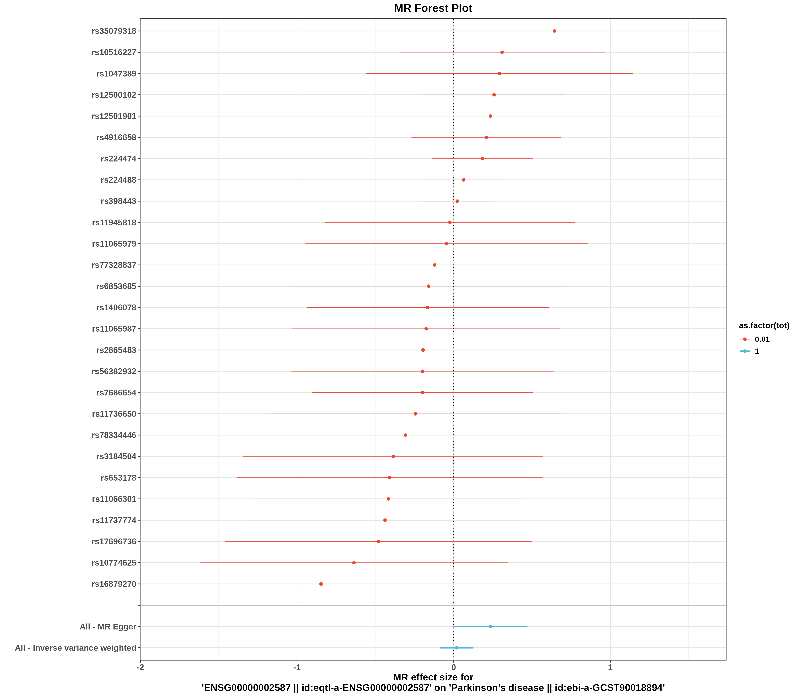
图2 漏斗图（发表偏倚评估）
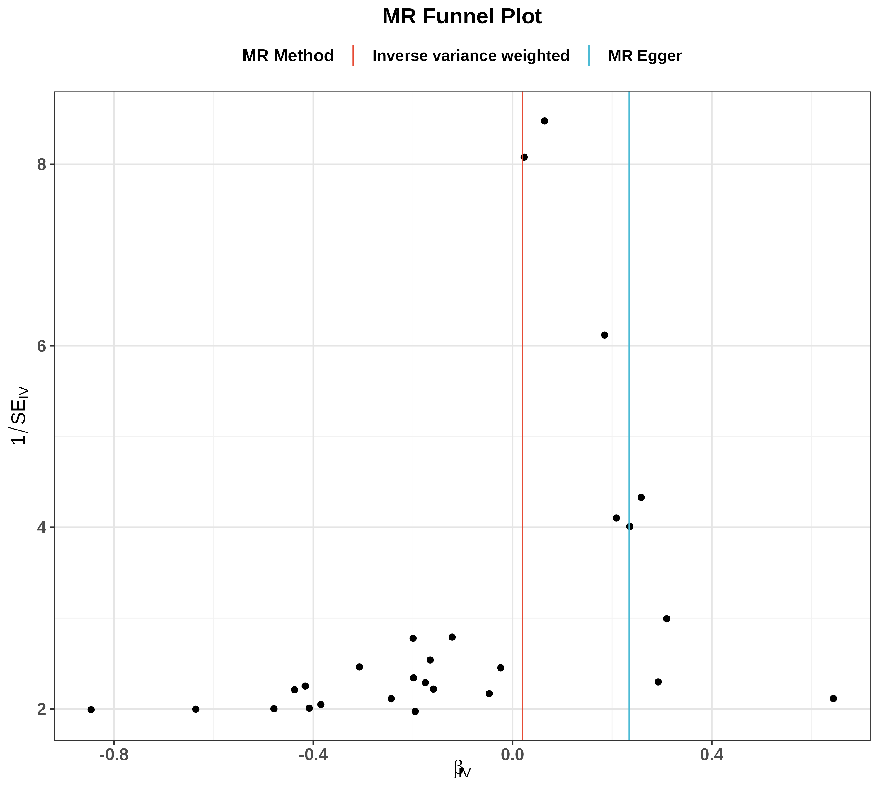
图3 散点图（SNP对暴露与结局的效应）
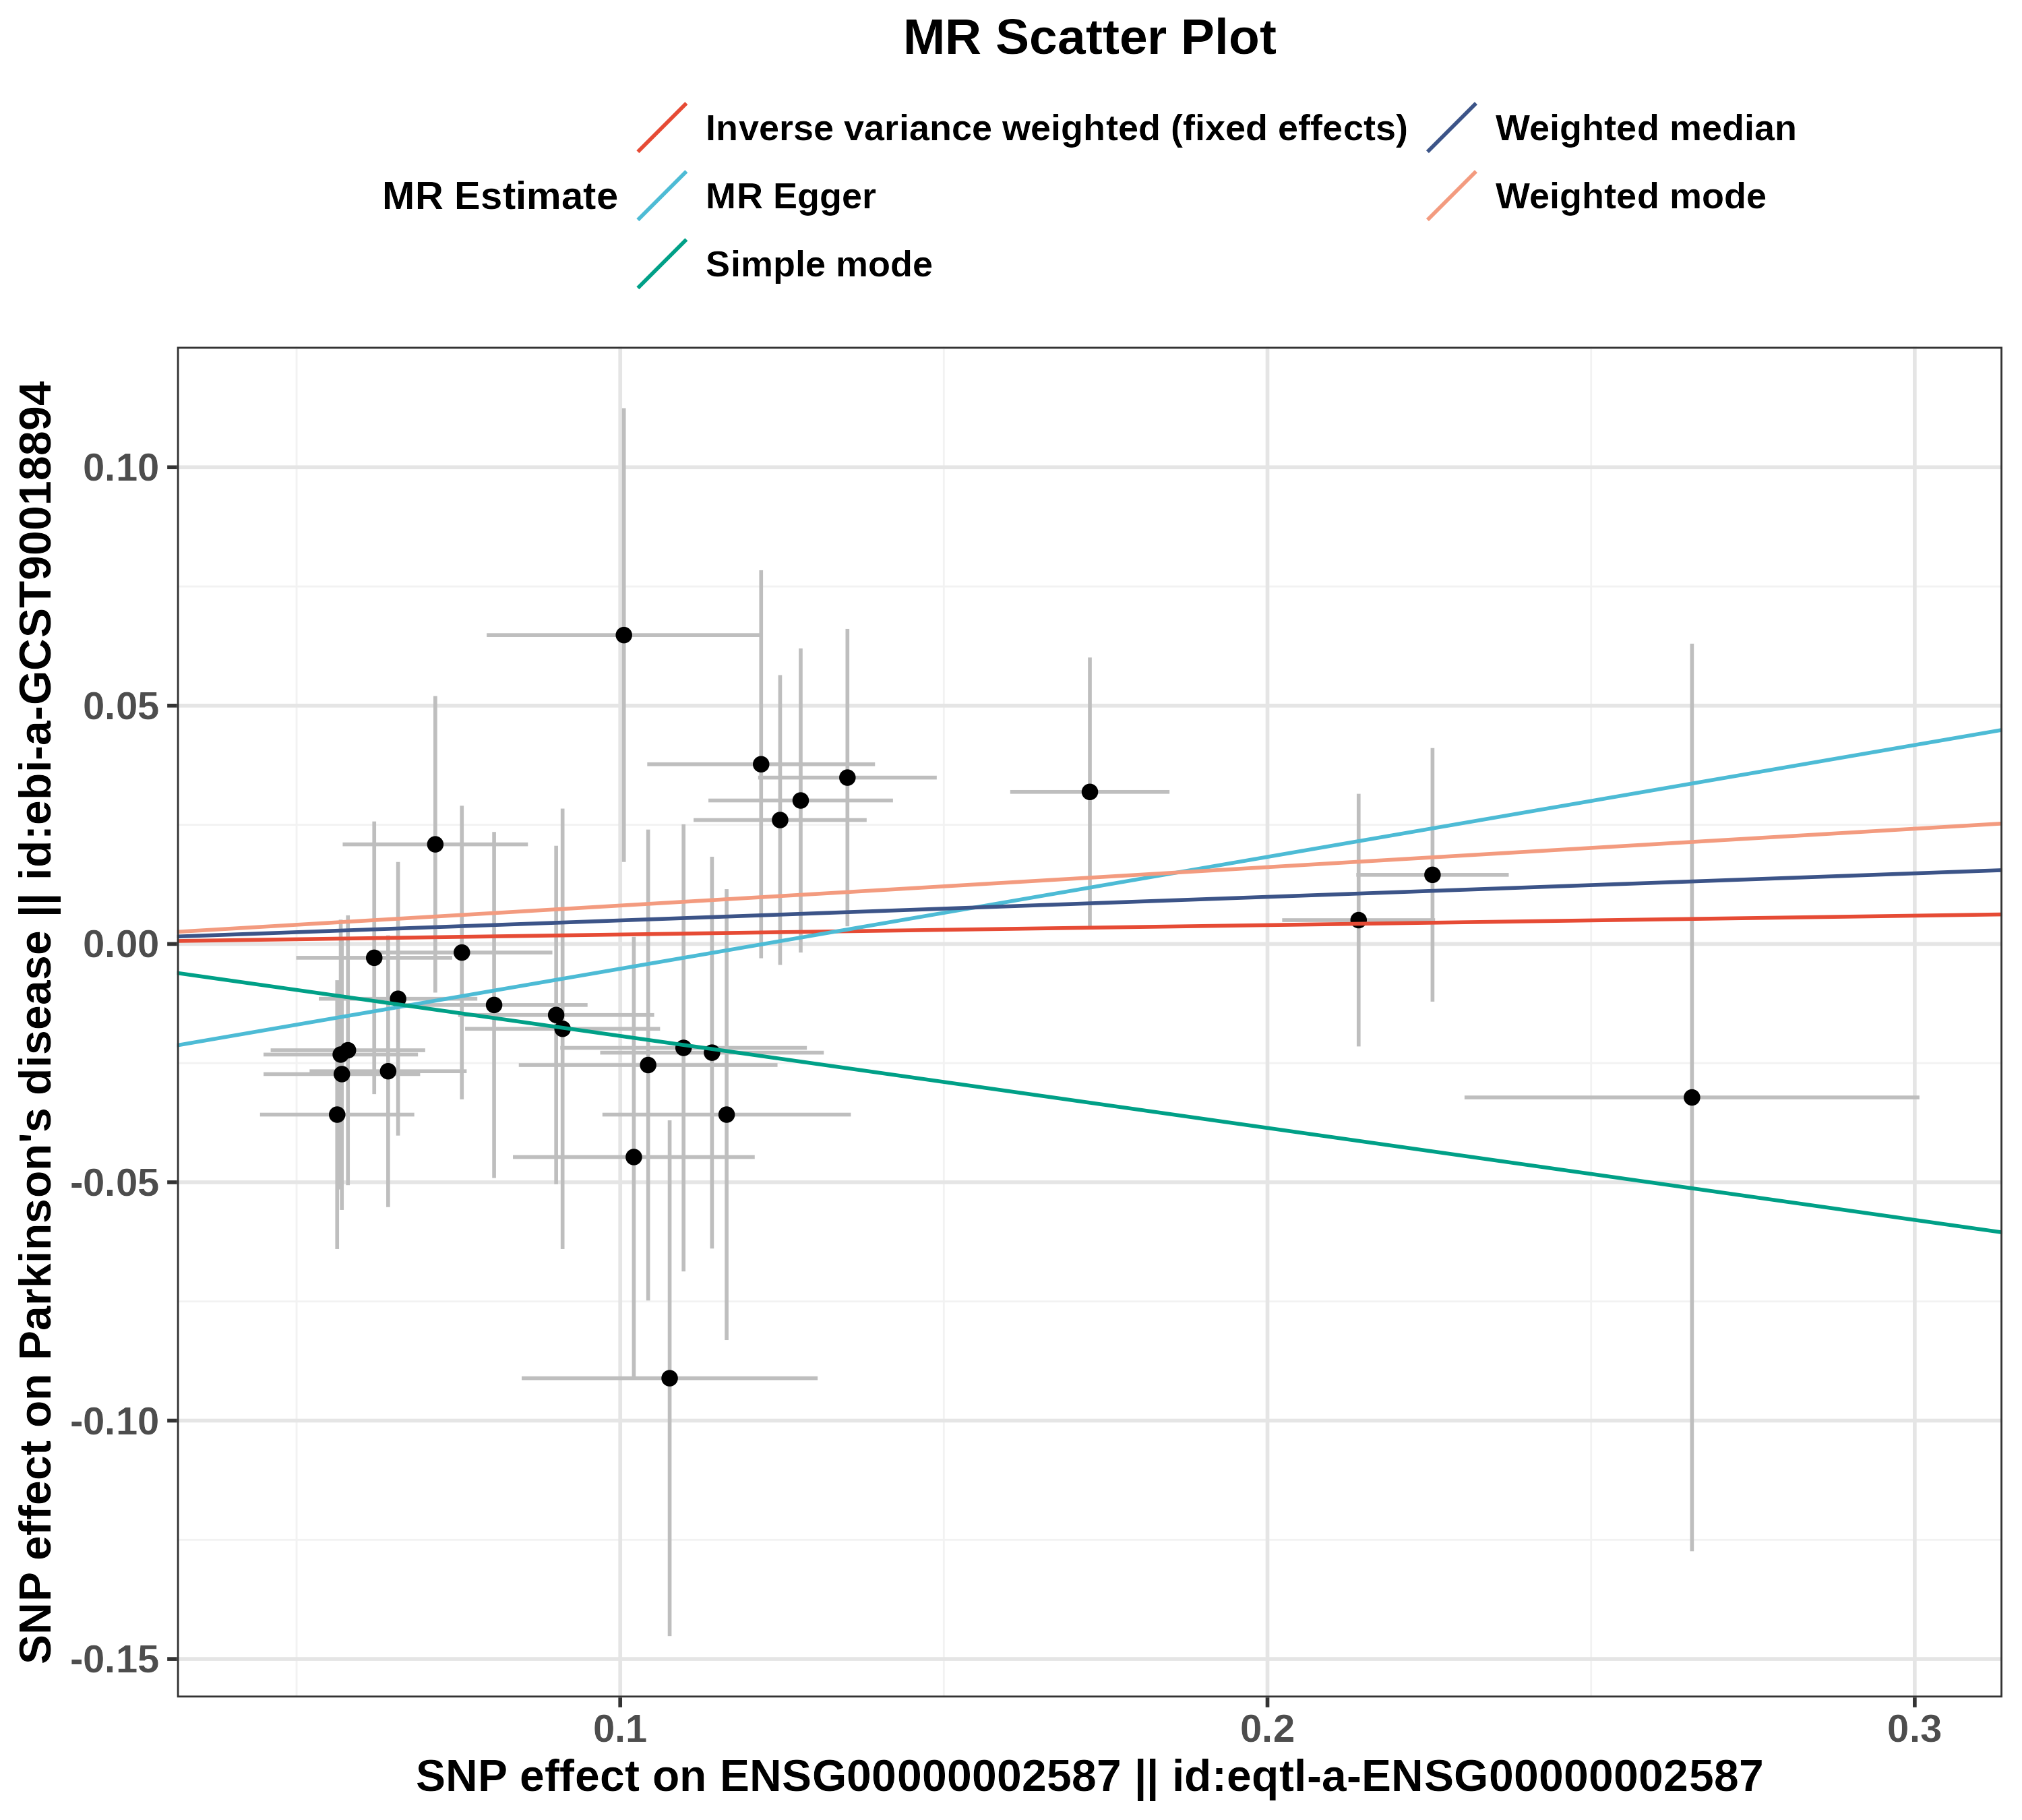
图4 留一法图（敏感性分析）
