Gene | Coefficient
EFHD2 | 0.077687
GZMB | 0.022458
CTSW | -0.022782
PTPN12 | -0.011155
ARL4C | 0.001459
CTSC | 0.099453
C12orf75 | 0.097566
PLCG2 | -0.181495
FLNA | 0.064809
TPM3 | 0.047895
PLEKHA1 | -0.049274
ARHGAP30 | 0.037734
GZMH | 0.034633
APRT | 0.018474
PSAP | -0.381204
DDIT4 | 0.131592
TRIM22 | -0.091186
WDR1 | -0.046790
ARF1 | 0.015880
NASP | 0.193392
RAB5C | 0.117492
RANBP1 | 0.103004
Gene | HR | 95%CI_Lower | 95%CI_Upper | P-value
KLRB1 | 1.056 | 0.941 | 1.185 | 0.3531
GNLY | 1.105 | 1.032 | 1.184 | 0.0044
EFHD2 | 1.344 | 1.157 | 1.560 | 0.0001
GZMB | 1.147 | 1.077 | 1.220 | 0.0000
PRF1 | 1.140 | 1.059 | 1.227 | 0.0005
FGFBP2 | 1.058 | 0.974 | 1.148 | 0.1821
SPON2 | 0.952 | 0.852 | 1.064 | 0.3880
CX3CR1 | 1.039 | 0.978 | 1.105 | 0.2164
NKG7 | 1.101 | 1.016 | 1.194 | 0.0191
PLEK | 0.992 | 0.907 | 1.085 | 0.8637
CTSW | 0.941 | 0.886 | 1.000 | 0.0496
ADGRG1 | 1.086 | 1.022 | 1.155 | 0.0077
ITGB2 | 1.064 | 0.991 | 1.142 | 0.0858
CD247 | 1.148 | 1.037 | 1.270 | 0.0078
IFITM2 | 0.975 | 0.873 | 1.090 | 0.6595
MT.CO2 | 1.377 | 1.163 | 1.630 | 0.0002
JAK1 | 0.972 | 0.783 | 1.206 | 0.7960
ID2 | 1.159 | 1.040 | 1.293 | 0.0076
BST2 | 0.997 | 0.816 | 1.220 | 0.9804
KLF2 | 1.031 | 0.899 | 1.183 | 0.6603
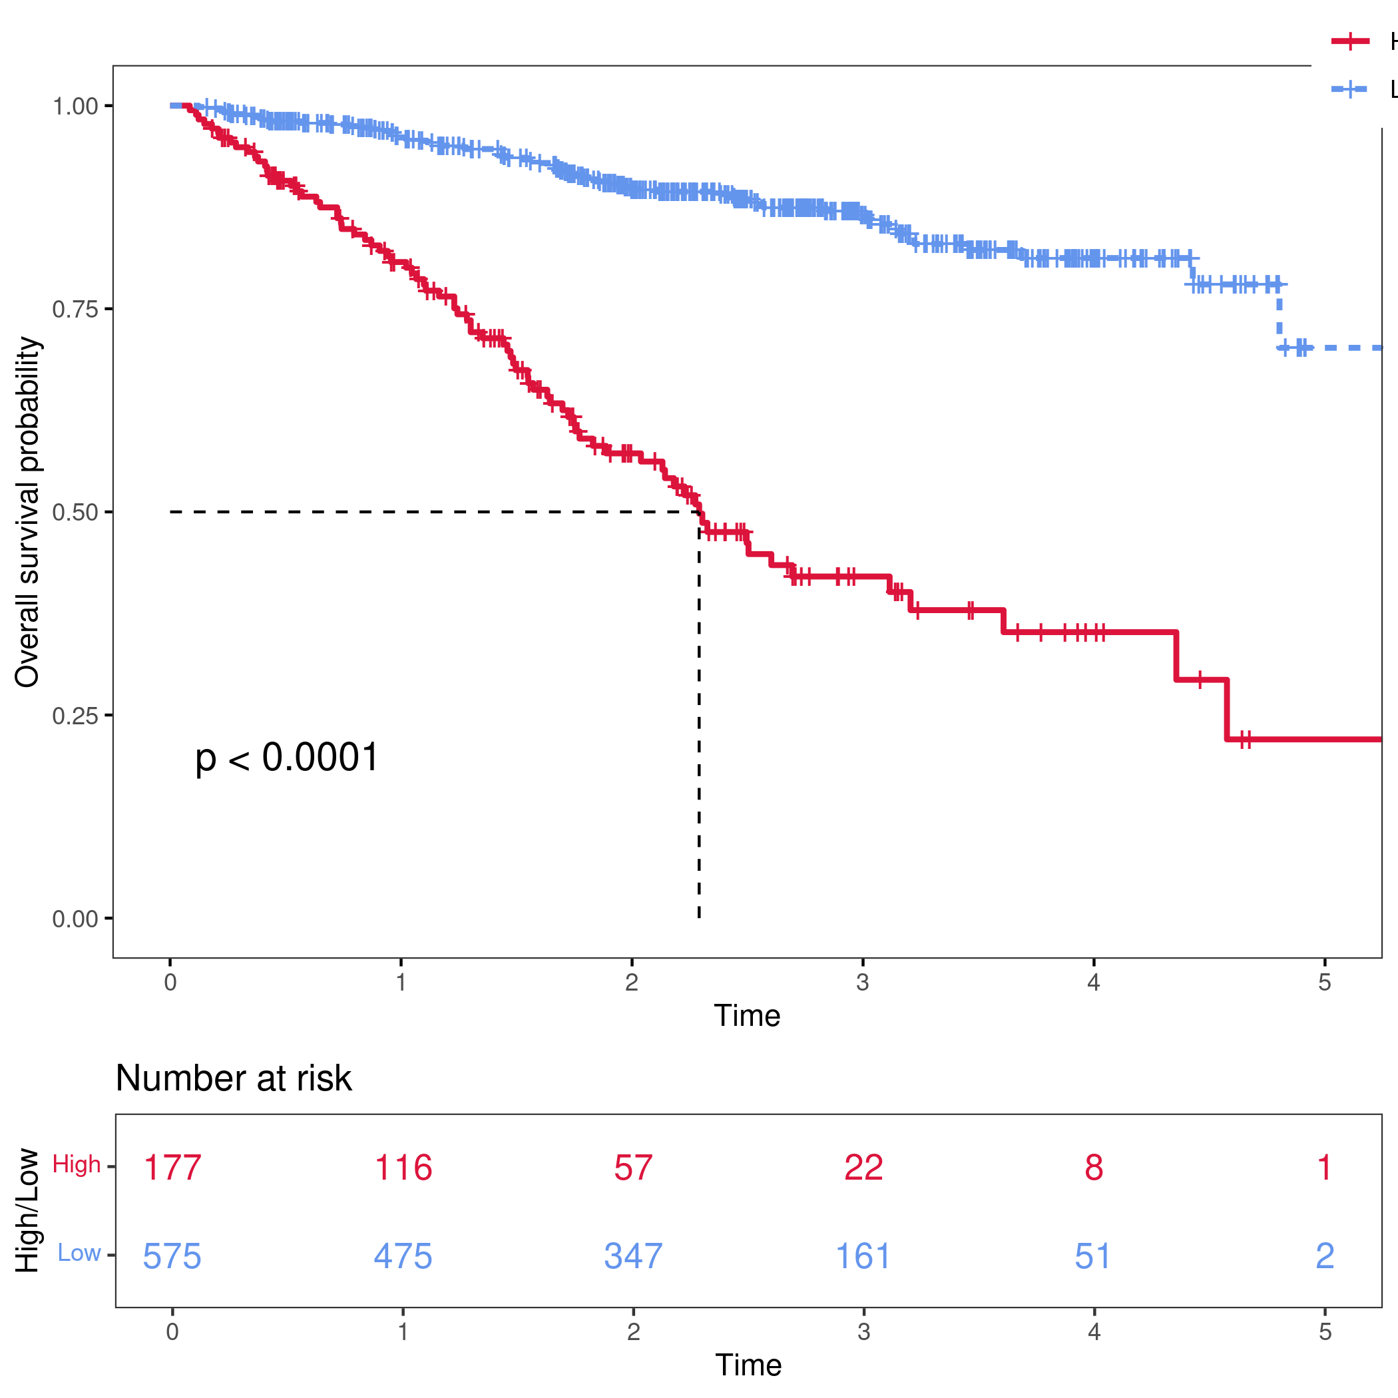
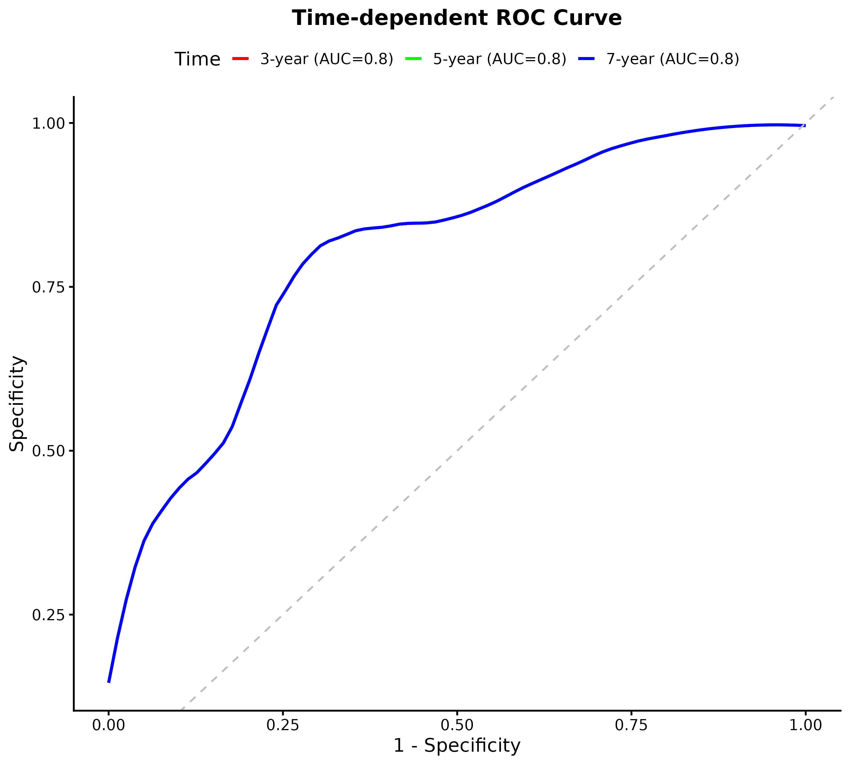
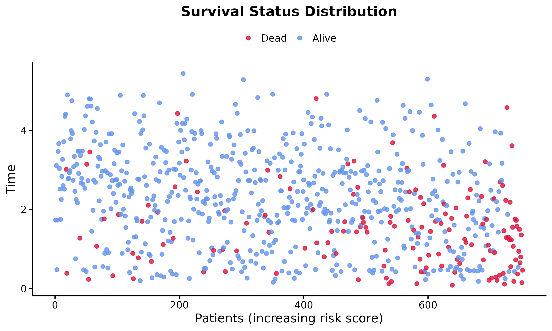
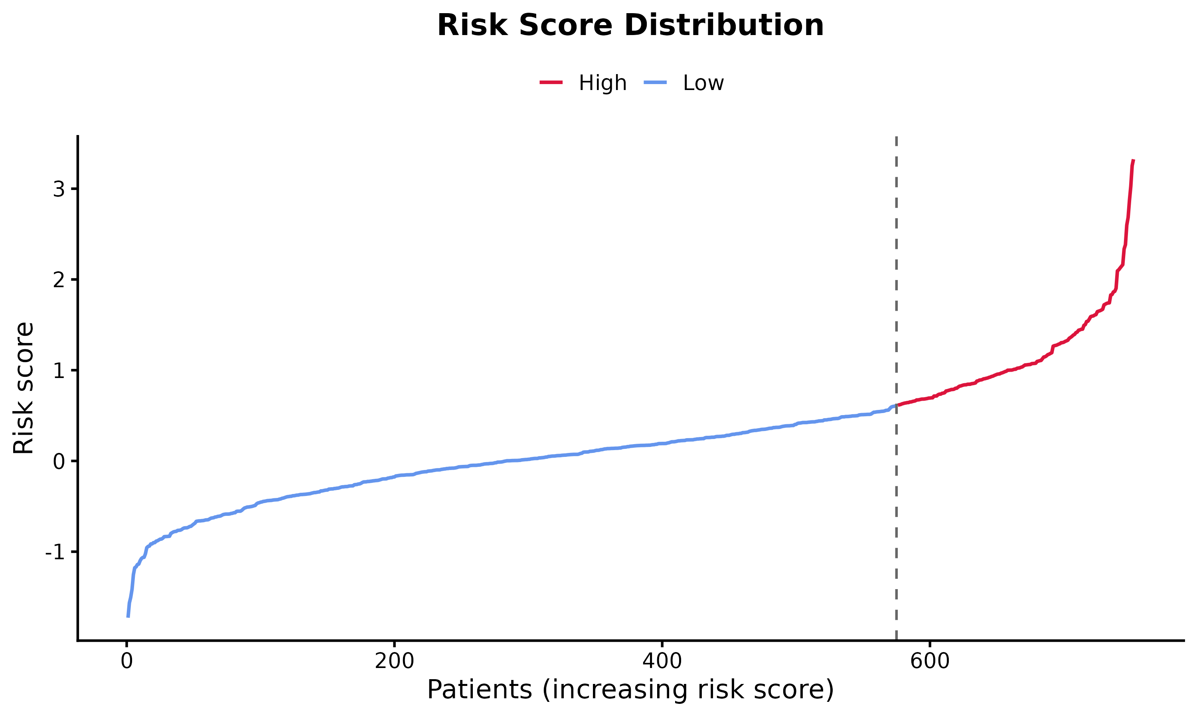
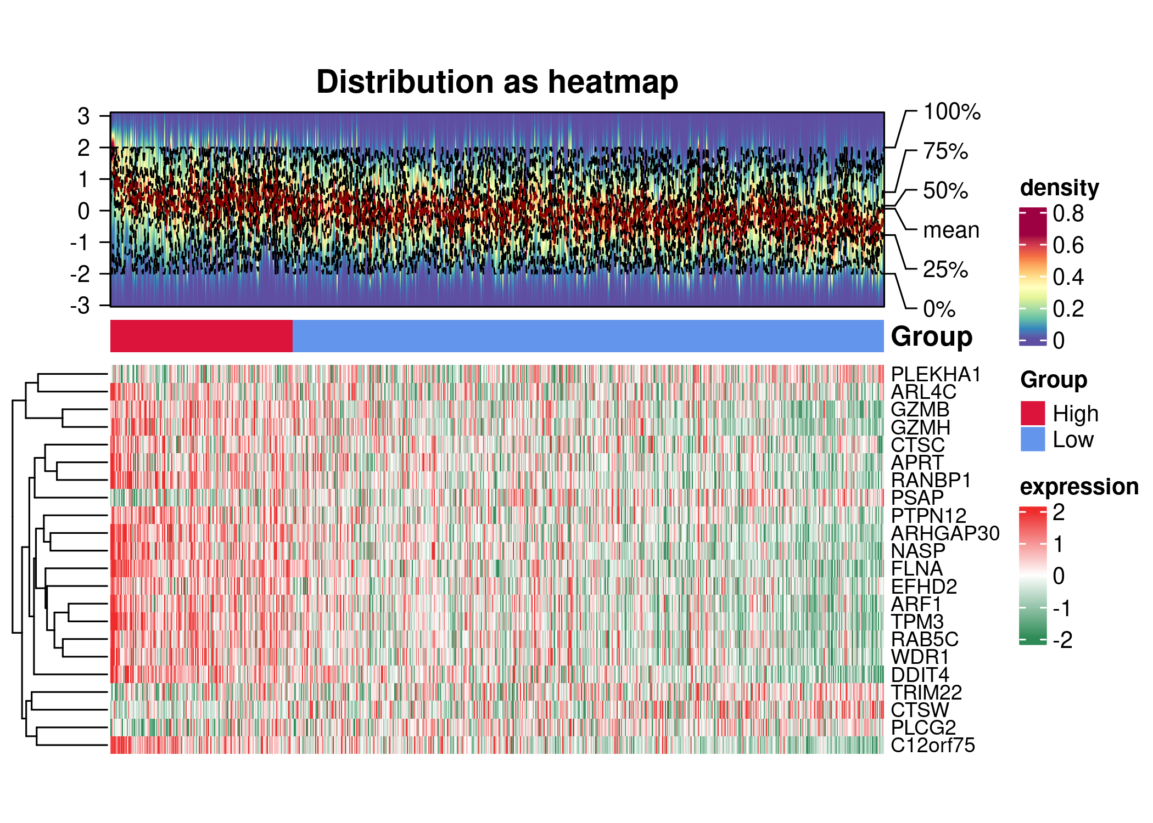

Columns represent patient samples (sorted by descending risk score). Rows represent the 22 Lasso-selected prognostic genes. Z-score normalization was applied, clipped to [-2, 2].
Figure 5. Prognostic Gene Expression Heatmap

Red dashed line indicates the median risk score used to stratify patients into High- and Low-risk groups.
Figure 4. Risk Score Distribution

Upper panel: scatter plot of survival status by patient (dots: alive; triangles: dead). Lower panel: risk score sorted by patient index. Gray dashed line indicates the median risk cutoff.
Figure 3. Survival Status Distribution

1-year AUC = 0.725, 3-year AUC = 0.756, 5-year AUC = 0.784. The model demonstrated good discriminative ability across all time points.
Figure 2. Time-Dependent ROC Curve

Log-rank test: p = 0.0000. The High-risk group showed significantly lower survival probability compared to the Low-risk group.
Figure 1. Kaplan-Meier Survival Curve
2.4 Visualization Results

Genes passing the PH assumption test: 219
A total of 269 genes were analyzed.
2.3 Univariate Cox Analysis Results

Lasso identified 22 prognostic genes. Table 1 shows the coefficients.
2.2 Lasso Feature Selection Results

1/3/5-year AUC = 0.725 / 0.756 / 0.784
Log-rank test: p = 0.0000
Deaths in Low-risk group: 69
Deaths in High-risk group: 79
Low-risk group: 575 samples
High-risk group: 177 samples
Total samples: 752
2.1 Summary Statistics

2. Results

All statistical analyses and visualizations were performed using R (v4.5.2, https://www.r-project.org). Word document generation was performed using the officer package (v0.7.3, https://cran.r-project.org/package=officer) and flextable package (v0.9.10, https://cran.r-project.org/package=flextable).
1.5 Statistical Analysis and Reporting

(1) Kaplan-Meier survival curves - survminer package (v0.5.0, https://cran.r-project.org/package=survminer), ggsurvplot function, with surv.median.line = 'hv'. (2) Log-rank test - survival package, survdiff function, compared between High- and Low-risk groups. (3) Time-dependent ROC curves - timeROC package (v0.4, https://cran.r-project.org/package=timeROC), marginal weighting, evaluated at 1-, 3-, and 5-year timepoints. (4) Expression heatmap - ComplexHeatmap package (v2.24.0, https://bioconductor.org/packages/release/bioc/html/ComplexHeatmap.html), z-score normalization, clipped to [-2, 2], clustered by rows.
Four evaluation approaches were employed:
1.4 Model Evaluation

A risk score model was constructed as: RiskScore = sum(coef_i * expression_i), where coef_i is the Lasso-derived coefficient for gene i. Patients were stratified into High- and Low-risk groups using the median risk score as the cutoff. Analysis was performed using R base functions, dplyr (v1.2.0, https://cran.r-project.org/package=dplyr), and ggplot2 (v4.0.0, https://cran.r-project.org/package=ggplot2).
1.3 Risk Score Model

Lasso (Least Absolute Shrinkage and Selection Operator) regression was applied using the glmnet package (v4.1-8, https://cran.r-project.org/package=glmnet) with 10-fold cross-validation (cv.glmnet, family = 'cox', lambda = lambda.min). This L1-penalized method selects the most informative prognostic genes and prevents overfitting in high-dimensional gene expression data.
1.2 Lasso Feature Selection

Univariate Cox proportional hazards (PH) regression was performed for each gene using the survival package (v3.8-3, https://cran.r-project.org/package=survival). The proportional hazards assumption was tested using cox.zph() (p > 0.05 required). Genes with p-value < 0.05 in univariate Cox analysis were retained as candidate prognostic genes for downstream analysis. Endpoints: Overall Survival (OS), defined as time from diagnosis to death.
1.1 Identification of Prognostic Genes

1. Methods

Prognosis Analysis Report

