**Page 2 Excercise 1**

Search

House

Layout

Room

TreasureCompartment

**Page 3 Exercise 2**

man.c

test.h

test.c

production.h

production.c

LiamGodin.h

Search.h

Search.c

Layout.h

Layout.c

Room.h

Room.c

House.h

House.c

Treasure.h

Treasure.c

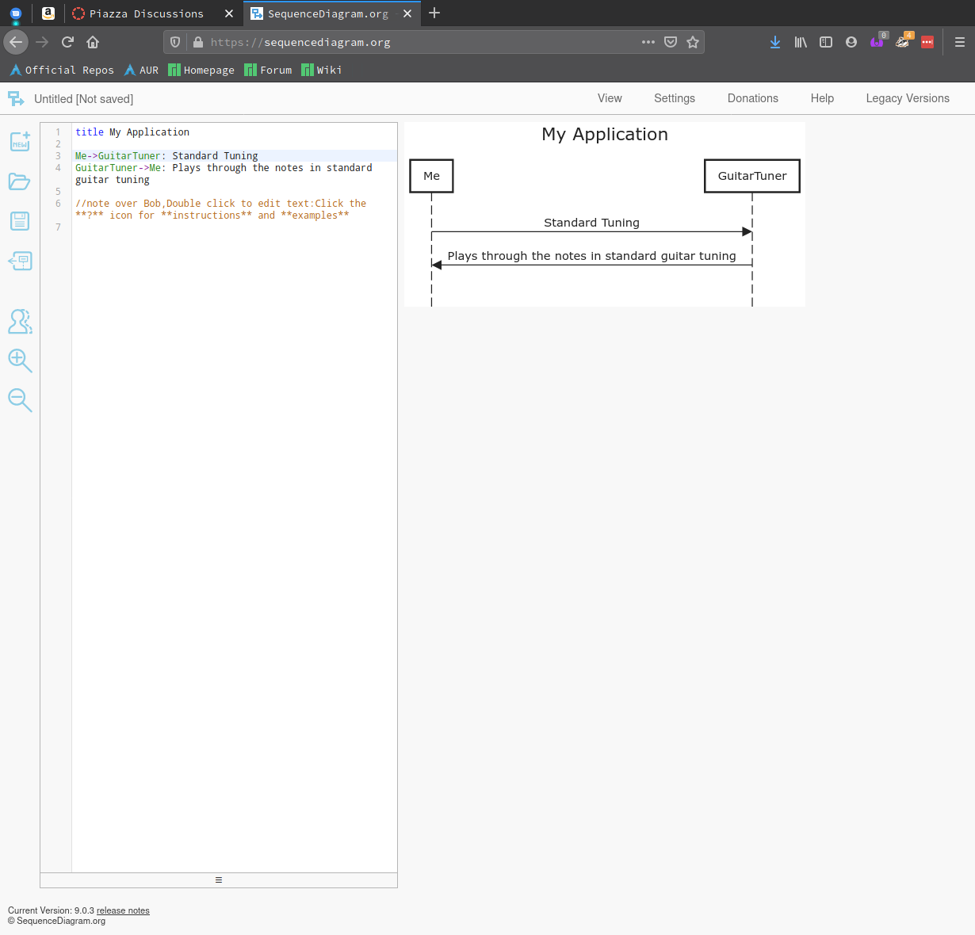**High Level Application Definition**

**Page 5 Exercise 1**

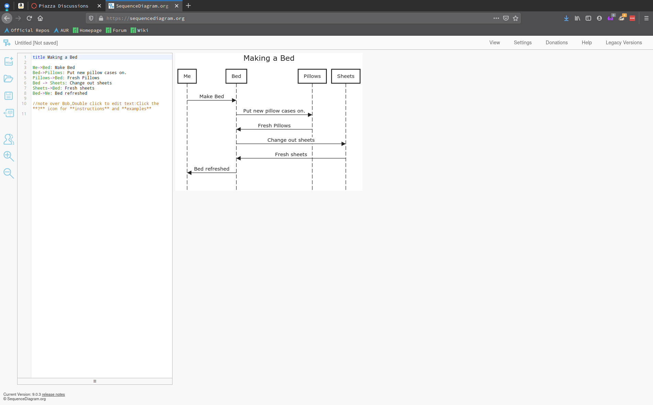

**Page 5 Exercise 2**

