Helm Phase 0: Solution Architecture & MVP Delivery Plan
  - Client meeting, 9 October 2026
Cyclone
Draft for discussion · v0.1 · evidence verified 8 October 2026
Table of Contents

How to read this document
Part I (sections 1–8) is for Business and the client. It explains what Members can do, which platform supplies each capability, what Cyclone builds, how fast an MVP can credibly launch and which decisions are needed at the meeting. It does not require the technical sections.
Part II (sections 9–16) is for the Tech teams. It refines the PRD and specifies the architecture, data flows, genealogy model, backlog, launch gate and responsibilities.
The appendix holds evidence links, assumptions, unresolved details and questions for providers.
Labels used throughout:
Label | Meaning
Verified | Read in the provider’s own documentation, API specification, contract source or pricing page on 8 October 2026 (links in Appendix A).
Correspondence | Stated in provider correspondence supplied by Business; not independently verified.
Recommended | Cyclone’s proposed design or default. Not yet approved.
TBD | Assumption or open item. Needs a decision or provider confirmation.
The stack is confirmed: PillarsHub (MLM core), Privy (login and wallets), Enzyme Onyx (vault infrastructure), Chatwoot (support), Cyclone’s Tap Prediction game and points, and a custom Helm Web App with its backend. This document does not compare or reselect providers. Terrel’s requirements (HELM Community Technology Requirements v0.2, 6 October 2026) are traced in section 9.

Part I: Business and client

Executive overview
Goal of Phase 0: capital is waiting to be deployed, so the MVP is cut to the fastest path that lets Business onboard Members, let them join the vault (referred to by Business as “staking”), capture the genealogy correctly, and pay a simple referral Commission. Everything else waits.
The confirmed stack can deliver this. Each capability is available from a confirmed provider or needs only configuration and a contained amount of Cyclone integration work. No evidenced blocker requires changing a provider. Terrel’s requirements (v0.2, 6 October 2026) have been mapped to this scope in section 9.
What Members will be able to do at launch:
- Join Helm through an invite link, or be imported from the alpha community, with their referral history kept.
- Log in with email or social login and receive a Helm wallet automatically. Only the Member can move its funds.
- Fund that wallet by sending USDC on one network from any exchange or wallet.
- Read the vault terms, deposit into the approved vault, see their confirmed position, and request a Redemption.
- See their direct team and referral link, and, as Builders, see Commissions as pending, held or paid.
- Receive Commission payouts in USDC directly to their Helm wallet, in batches approved by Finance.
- Play the existing Tap Prediction game and earn Points, which have no cash value.
- Chat with support from inside the app; support sees who they are and their status, never their keys.
Why this is the fastest credible path:
- Cyclone builds only the glue: the member experience, one backend that connects the providers, a ledger of identities, referrals and events, the payout executor, and the reconciliation and admin views that make every money flow auditable.
- Each provider does what it already does: Privy runs login and wallets; PillarsHub stores the genealogy and calculates Commissions with its existing Unilevel plan; Onyx issues vault shares and runs deposit and redemption queues; Chatwoot handles conversations.
- Payouts reuse PillarsHub’s batch mechanism. PillarsHub sends approved payout batches to a merchant endpoint that Helm builds; Helm pays USDC from a Business-controlled multisig treasury and reports the result back. Verified. No payment provider is needed.
- Direct crypto funding keeps payment-provider onboarding off the critical path.
What can start immediately (no provider or legal answer needed): the Helm Web App shell, Privy login and wallets, the member, referral and event data model, the PillarsHub staging sync, alpha-import tooling (once sample data arrives), the payout executor on testnet, the Chatwoot widget, chain indexing, and the full deposit and redemption journey on Enzyme’s Sepolia test network.
What gates live funds and payouts (none of these blocks the build):
- The vault strategy and its Manager. Onyx is vault infrastructure, not a strategy. Someone must run the strategy, report the vault’s value and return liquidity for Redemptions. Verified.
- Vault ownership and Enzyme’s upgrade rights. The vault Owner and Admins are fully trusted by the protocol, and Enzyme can upgrade vault contracts. The owning entity, a multisig and the upgrade terms in the licence agreement must be settled. Verified.
- Enzyme’s licence agreement (MLA) and commercial terms. Production use requires a commercial agreement. Verified.
- The Commission basis for the simple payout. Which event pays (for example, a confirmed vault deposit, or vault fee revenue), the three level rates, period, hold and minimum must be approved by Owen, Finance and counsel. Terrel’s requirements are explicit that “a raw deposit … must not silently replace approved eligible activity”.
- Legal applicability review of the operating entity, launch countries, KYC tier, vault terms and the referral payout model.
- Provider acceptance of the business model, in writing, from Privy, Enzyme and PillarsHub.
Earliest credible schedule (estimate, not a commitment): an end-to-end test slice including a test payout about 3 weeks after kickoff; a controlled launch with deposits in about 8–12 weeks, provided vault, licence, Commission-basis and legal answers arrive by around week 6. The first live payout follows the first approved period close and hold. Section 6 gives the assumptions, and section 6.1 sets out what is achievable within 30 days.

Confirmed stack: what each system provides
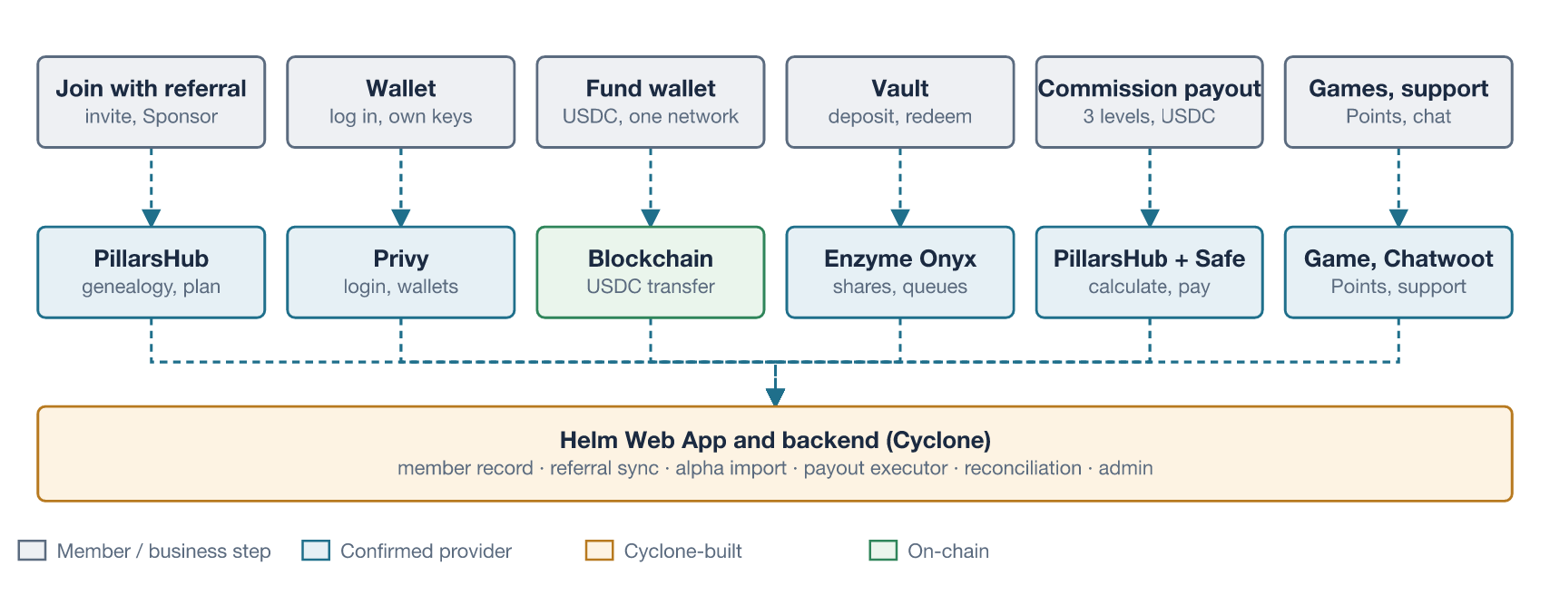
Business capabilities, the platform that provides each, and what Cyclone builds.
Capability | Provided by | Cyclone builds | Status
Join and log in; one stable Helm identity | Privy (login, identity token) | Member record with Customer and Builder status, Privy mapping | Feasible
Wallet | Privy embedded wallet, owned by the Member; gas sponsored by Helm | Wallet screens; balance display | Feasible
Referral, genealogy and alpha import | PillarsHub (customer with enroller, Unilevel tree, full-tree export, dated placements) | Referral capture and validation, sync, alpha import and reconciliation | Feasible with configuration
Wallet funding | Blockchain (USDC transfer to the Member’s address) | Address display, confirmation tracking, screening | Feasible
Vault deposit and redemption | Enzyme Onyx (allowlisted deposit queue, redemption queue, shares, public read API) | Terms screens, transaction flows, status tracking, allowlist updates | Feasible with configuration; live use blocked pending strategy, MLA and ownership
Simple Commission payout | PillarsHub (real-time calculation, bonus release, payout batches to a custom merchant) | Eligible-event posting, payout executor, treasury proposals, status callback, statements | Feasible with configuration and custom work; blocked pending approved Commission basis
Team view | PillarsHub tree and bonus data | Permission-filtered direct-team view in Helm | Feasible
Games and Points | Cyclone Tap Prediction and points service | Account linking, verified events, Points display | Feasible pending game API documentation
Support | Chatwoot Cloud (web widget with identity validation) | Widget, identity signing, agent context view in Helm admin | Feasible
Operations | Provider dashboards (Onyx Admin App, PillarsHub Portal, Chatwoot) | Helm admin: exceptions, approvals, reconciliation, audit log | Feasible

The Member journey
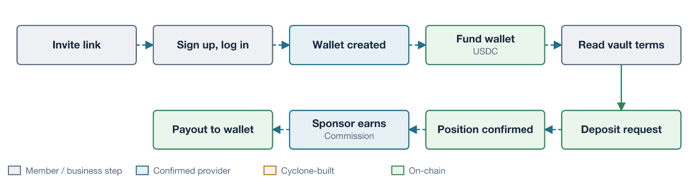
Main Member journey. Wallet funding, vault deposit and Commission are separate events; Points are separate from money.
- Invite and signup. The Member opens a Sponsor’s invite link and logs in with Privy. Helm records the Referral Request and confirms it once PillarsHub accepts it. Alpha-community Members are imported with their existing Sponsor.
- Wallet. Privy creates an embedded wallet. Only the Member can sign with it; Helm and Privy cannot move its funds.
- Wallet funding. Helm shows one supported network and asset (recommended: USDC on Arbitrum) and the Member’s address. Funding moves money into the Member’s own wallet; it is not an investment and creates no Commission.
- Vault deposit. The Member reads the vault terms, fees and risks, then signs two transactions: permission for the vault to take the amount, and the deposit request. The request is pending until vault operations process it at the next valuation. Only then does the Member hold vault shares.
- Position. Helm shows the confirmed share balance and its value as of the vault’s last valuation, with the valuation date.
- Commission. If the approved basis is met, PillarsHub calculates the Sponsor’s Commission (up to three levels). Builders see it as pending, held and then payable.
- Payout. After the period closes and the hold passes, Finance approves the batch. Helm pays USDC from the treasury to each Builder’s Helm wallet; the Builder sees it as paid, with the transaction reference.
- Redemption and engagement. Members can request a Redemption, processed when liquidity is available with each stage shown, and play Tap Prediction for Points.

Phase 0 scope
In scope (Pilot) | Deferred; stays disabled until approved
One network and one funding asset (recommended: USDC on Arbitrum One) | Integrated purchase or top-up (Paymenture or similar)
One approved Onyx vault, asynchronous deposits, queued Redemptions | Additional chains, assets or vaults; instant deposits
Privy embedded wallets with sponsored gas | Server wallets, automated strategies, policies
Referral capture, Customer and Builder status, full genealogy in PillarsHub, alpha import | Self-service or bulk placement moves; the governed placement window (GEN-04 to GEN-06)
Simple Commission: existing three-level Unilevel plan, one approved eligible event, USDC payout in Finance-approved batches | Ranks, qualification rules, matching or leadership bonuses, campaigns, contests
Direct-team view, referral link, earnings states and statements | Deep team analytics, leader contact tools, CRM
Existing Tap Prediction game and Points (no cash value) | Points redemption for value, new games, tokens
Chatwoot web chat with agent context; FAQ and runbooks | Telegram and WhatsApp support; AI agent
Sanctions screening of wallet addresses; country eligibility; Member terms | Full KYC unless counsel requires it (decision D6)

Feasibility summary
Area | Verdict | Key evidence | What remains
Login and identity | Feasible | Privy issues verifiable identity tokens; one Privy user maps to one Helm member. Verified. | Confirm Privy accepts the business model.
Wallet | Feasible | User-owned embedded EVM wallet; Arbitrum supported; native gas sponsorship; key export. Verified. | Losing the only login method loses the wallet; offer a second login method.
Genealogy and alpha import | Feasible with configuration | Customer records take a Helm-defined ID, signup date and enroller at creation; the whole tree can be listed with an as-of date; placements are dated. No bulk import API. Verified. | Alpha records; auto-placement, depth limits and correction method in staging.
Commission calculation | Feasible | Payable depth is set in the plan; custom volume sources carry an external ID; calculation is real time. Verified. | Approved basis, rates, period and hold; plan configured by PillarsHub.
Commission payout | Feasible with custom work | PillarsHub sends release batches to a custom merchant endpoint authenticated by a callback token; the merchant reports “Success”, “Failure” or “Pending” per payment; custom currency codes are allowed. Verified. | Helm builds the merchant endpoint and treasury executor; Finance approval flow.
Wallet funding | Feasible | Standard USDC transfer; Helm indexes the chain. | Choose network and asset.
Vault deposit and redemption | Feasible with configuration; live use blocked | Allowlisted deposit queue; Member must sign; admin executes after valuation; queued Redemptions; read-only API. Verified. | Strategy and Manager, MLA, ownership, upgrade terms, operating process.
Games and Points | Feasible pending evidence | No game documentation supplied. | API documentation, event verification and abuse controls.
Support | Feasible | Web widget with signed identity; Cloud plans from $19 per agent per month. Verified. | Agent context view; FAQ and runbooks (SUP-04 to SUP-06).
Compliance tooling | Gap within the stack | No confirmed provider offers usable KYC or screening for this model. | Counsel decision; add a screening service at the Helm backend if required.

MVP delivery plan
Delivery is organised so that engineering never waits for provider or legal answers. Those answers gate live funds and payouts, not the build.
Stage | Duration (estimate) | Outcome | Gate to next stage
0 – Access and decisions | Week 1 | Meeting decisions recorded; PillarsHub staging, Privy, Chatwoot, Onyx Sepolia vault, game docs and alpha sample data in hand | Access confirmed
1 – Thin end-to-end slice | Weeks 1–3 | On test networks: invite → signup → wallet → referral accepted → funding → deposit → executed position → test Commission → test payout batch → Redemption | Slice demonstrated
2 – MVP build | Weeks 3–8 | Member UI with team view and statements, admin approvals, alpha import rehearsal, reconciliation, screening, terms, support context, monitoring | Feature-complete on test networks
3 – Production readiness | Weeks 6–10 (overlaps) | Production vault deployed and handed over; plan configured and proven with Finance examples; treasury multisig set up; security review; legal sign-off; alpha import and payout rehearsal | Launch gate (section 15) passed
4 – Controlled launch | From about week 8–12 | Invitation-only cohort with exposure limits; first payout after first period close and hold | Agreed checks pass, then expand

30-day plan
What can realistically be in place 30 days after kickoff, by how much depends on engineering alone and how much on decisions outside it. All items are estimates for a team of five to six engineers with provider access in week 1.
Tier | What is live at day 30 | Depends on
1. Certain (engineering only) | Full journey on test networks: signup → wallet → referral → USDC funding → Vault Deposit → position → Commission calculation → test payout batch from the treasury Safe → Redemption. Alpha import tool run and reconciled on sample data. Admin roles, maker-checker, daily reconciliation, Chatwoot | Provider test access; alpha sample data
2. Likely, if Business decides in week 1 | Preregistration live with real users, no money yet: signup, wallet, referral link, genealogy in PillarsHub production, alpha community imported with original Sponsors and dates, direct-team view, support. Matches Terrel’s release sequence and ID-04: preregistered people keep attribution and cannot earn | Member terms and privacy notice; allowed countries; alpha records; PillarsHub production slot (Tuesday to Thursday)
3. Possible around day 30–35, only if every external item lands on time | Capped real-funds pilot: an invited cohort (for example alpha leaders) with per-Member and total limits deposits into the production vault | See the conditions below
4. Not realistic within 30 days | First real Commission payout; placement window, ranks and campaigns; full KYC if counsel requires it (adds about 1–2 weeks) | Payout needs an approved basis plus one period close and hold: about day 45–60 with a weekly period and a short hold
Conditions for tier 3:
Condition | Needed by
Vault strategy and Manager appointed; Owner multisig set up | Week 1
Enzyme MLA signed; production vault deployed and handed over | Signed in weeks 1–2; deployed by week 3 (Enzyme publishes no lead time)
Counsel confirms entity, launch countries, KYC tier and vault terms | Week 3
Focused security review of vault configuration, keys and integration | Week 4
Operations rehearsal with a small operator-funded amount | Week 4
Week by week:
Week | Engineering | Business, Finance and counsel
1 | Access, environments, Privy login and wallet, member and referral model, PillarsHub staging sync, Onyx Sepolia deposit | Decisions D1–D12; vault strategy and Manager; MLA; alpha records; Commission basis drafting; counsel engaged
2 | Thin slice on test networks; alpha import dry run; event pipeline; payout endpoint and Safe proposals on testnet | Member and Builder terms; allowed countries; MLA signature
3 | Team view, statements, admin approvals, screening, support context; preregistration release candidate | Counsel answers; production vault deployment; Commission basis approved
4 | Preregistration go-live; alpha cutover; load and recovery checks; security review fixes; real-funds rehearsal | Security review; operations rehearsal; go/no-go for the capped pilot
Recommended day-30 milestone for the meeting: preregistration live, alpha community imported, genealogy locked, vault and payout proven on test networks. Run the tier-3 conditions in parallel so real deposits open as soon as they clear, and approve the Commission basis early so the first payout is not delayed further.

Assumptions and running costs
Assumptions behind these ranges: a Cyclone team of about five to six engineers plus QA and a delivery lead; provider access and alpha sample data in week 1; game API documentation by week 2; vault strategy, MLA, ownership, Commission basis and legal answers by around week 6. PillarsHub only launches clients Tuesday to Thursday, 9:00–16:00 US Mountain Time. Verified. No date in this table is a commitment.
Indicative running costs (USD per month unless stated; prices verified on 8 October 2026 where marked):
Item | Cost | Status
Privy | Free up to 499 monthly active users; $299 up to 2,499; $499 up to 9,999. The free tier includes $1M of transaction volume per month. | Verified; overage and paid-tier volume limits TBD
Gas | Sponsored Member transactions plus treasury payout transactions | TBD (usage-based)
Enzyme Onyx | Public page: $2,000 per month, or 20% of vault fees with a $6,000 annual minimum. Correspondence: $5,000 deployment plus 0.25% of AUM, or 20% revenue share. | Verified (public) vs correspondence; reconfirm in the MLA
PillarsHub | Not published | TBD
Treasury multisig | Safe contracts (gas only) | Recommended
Chatwoot Cloud | $19 or $39 per agent (Startups, Business); $99 for Enterprise with audit logs and SSO | Verified
Sanctions address screening | Free Chainalysis sanctions API at pilot scale | Verified (discovery research)
KYC service, if counsel requires it | About $0.33–$1.85 per check at published prices | Verified (discovery research)
Security review of Helm’s deployment | Quotation needed | TBD

Security and compliance summary
- Custody. Member wallets are self-custodial: only the Member signs. Neither Cyclone nor Privy can move Member funds. Verified (Privy). The vault is different: its Owner and Admins can set the share value and withdraw vault assets to the strategy wallet, and Enzyme can upgrade the contracts. Who holds those roles, under what controls, is the main custody question for Business and counsel.
- Payout treasury. Commissions are paid from a Business-owned multisig treasury. Helm’s backend can only propose payout transactions; Finance signers approve them. Payouts go only to the Builder’s own Helm wallet, so no one can redirect a payment by changing a destination (PAY-01).
- Admission to the vault can be controlled on-chain. Onyx lets only allowlisted wallet addresses deposit. Helm adds a Member’s address only after its eligibility checks pass. Verified.
- No provider in the stack supplies usable KYC or sanctions screening for this model. Privy’s KYC runs on Bridge, whose terms prohibit MLM. If counsel requires identity checks, a screening service is added at the Helm backend.
- Minimum before real funds or payouts, whatever counsel concludes: screening of every Member wallet, funding source and Redemption destination; country eligibility; Member and Builder terms, risk, fee and earnings disclosures, and a privacy notice; a written procedure for flagged users and transactions; payee status required for payouts (PAY-04).
- Referral payouts on vault activity are the most sensitive legal point. Paying Commissions on deposits ties rewards to new money coming in; counsel must approve the basis before the first payout. Points have no cash value and are kept separate from money and Commissions.
- Provider audits do not cover Helm’s deployment. Helm’s vault configuration, keys, valuation process, payout executor and integrations need their own security review before funds.

Decisions needed at the meeting
# | Decision | Recommended answer | Why it matters
D1 | Network and funding asset | Arbitrum One, native USDC; test on Ethereum Sepolia | Fixes wallet, vault, payout and indexing work
D2 | Commission basis for the simple payout | One approved eligible event (confirmed vault deposit or vault fee revenue), three Unilevel levels, period, hold and minimum approved by Owen, Finance and counsel; engineering builds the event pipe now | Payout cannot go live without it; the basis drives legal risk
D3 | Vault strategy, Manager and ownership | Business appoints the Manager; vault Owner is a multisig controlled by Business | Gates live funds
D4 | Redemption service level | Publish an operational target (for example, within 5 business days, subject to liquidity) | Members see stages, not a guarantee
D5 | Integrated top-up at launch | No; direct crypto funding | Removes a provider from the critical path
D6 | Identity checks | Counsel decides the tier; build the gates now; screen addresses from day one | Avoids rework if KYC is required
D7 | Points rules | No cash value, not transferable, not awarded for deposit amounts | Keeps Points separate from investment activity
D8 | Members without a valid Sponsor | Attach to a company root account, flagged for review | Keeps the genealogy complete
D9 | Alpha community import | Import before launch with original Sponsors and dates; reconcile counts and edges (GEN-03) | Existing capital and relationships arrive with history intact
D10 | Placement window promised in the field call | Not in the Pilot; publish the policy first, then enable the governed workflow (GEN-04 to GEN-06) | Avoids building moves before the rules exist
D11 | Payout treasury and approvers | Safe multisig owned by Business; Finance approves each batch; payouts only to the Builder’s Helm wallet | Payout controls (PAY-01 to PAY-04)
D12 | PillarsHub status | Confirmed per Business; validate it with Terrel’s proof scenarios T01–T06 in staging, not a new selection | Reconciles Terrel’s “candidate” wording with the confirmed stack

Part II: Technical implementation

Traceability to Terrel’s requirements
Terrel’s HELM Community Technology Requirements v0.2 (6 October 2026) defines “Must” as required before the named capability is enabled, and states that a deferred capability stays disabled. That lets Phase 0 enable a small set of capabilities fully, rather than all capabilities partly. The table maps each requirement group to the Phase 0 Pilot.
Group | Requirement IDs | Phase 0 Pilot treatment | Where in this document
Identity and member records | ID-01 to ID-04 | In scope. Stable person ID; Customer and Builder status; prospect, preregistered, verified and enrolled states; country eligibility and agreement versions | FR-1, FR-15; section 13
Corporate administration | ADM-01 to ADM-03 | In scope. Separate view, configure, correct, approve and release roles; maker-checker on Sponsor corrections, holds and payout releases; test environments | FR-13, FR-19; section 11.3
Lifecycle actions | ADM-04 | Merges and recovery in scope as admin processes; suspension, termination and re-entry disabled until enabled | Section 13.2
Sponsor and genealogy | GEN-01 to GEN-03 | In scope. Referrer, sponsor (enroller) and placement recorded separately with effective dates; loop and duplicate checks; alpha import with reconciliation | FR-3, FR-4, FR-20; section 13
Placement window | GEN-04 to GEN-06 | Disabled until the placement policy is approved (decision D10); the data model already preserves original referral and history | Section 13.2
Compensation | COMP-01 to COMP-04 | In scope, simple plan only. One approved eligible event, versioned three-level Unilevel, replay-safe events, calculated, pending, held, payable and paid states, reconciliation to batches | FR-17, FR-18; sections 12, 13.4
Qualification and rank | QUAL-01 to QUAL-03 | Disabled. No ranks in the simple plan; QUAL-03 applies only when rank progress is promised | Scope table
Earnings audit | AUD-01 to AUD-03 | In scope. Explain each earning from source event to payout; preserve corrections; period statements separating vault performance from referral earnings | FR-18, FR-19
Rewards | REW-01 to REW-03 | Points only; no redemption, promotional credit or cash conversion | FR-11; decision D7
Builder back office | BO-01, BO-02, BO-04 | In scope. Referral link, permitted team data, earnings states, statements, dispute request; mobile web and release language | FR-16, FR-19
Team visibility | TEAM-01, TEAM-02 | In scope, minimum. Direct team and counts; no access to another branch or anyone’s balances, trades or support cases | FR-16
Team tools | TEAM-03 to TEAM-05 | Basic welcome step only (TEAM-05 Pilot); search, contact and automation deferred | Scope table
Campaigns | CAMP-01 | In scope. Referral link attribution, precedence and invalid referrals; CAMP-02 to CAMP-04 disabled | FR-3
Business intelligence | BI-01, BI-02 | In scope. Separate definitions for customers, Builders, deposits, Commissions, liabilities and payouts; reconciliation to sources | FR-14
Payouts | PAY-01 to PAY-04 | In scope. Payout instructions from approved payable amounts; restricted destinations; tracked states; reconciliation; payee status | FR-18; sections 12, 15
APIs and events | API-01 to API-03 | In scope. Sandbox, stable event IDs, replay and backfill, polling where webhooks are unsafe; export rights in contract | Sections 11, 12; launch gate
Support | SUP-01 to SUP-07 | In scope (Pilot). Agent context view, case links to person and event IDs, agent limits, FAQs and runbooks, metrics | FR-12
Compliance records | REC-01, REC-02 | In scope. Versioned agreements, consent and disclosures; country and product restrictions with rule version | FR-15; section 15.3
Operations | OPS-01 to OPS-04 | In scope. Load envelope, recovery targets, incident response, per-capability gates | Section 15
Implementation | IMP-01 to IMP-04 | In scope. Plan with owners, migration rehearsal, release acceptance, handover | Sections 14, 15
Where this document differs from Terrel’s draft:
- Provider status. Terrel’s draft lists Pillars and Infinite MLM Software as candidates, with neither selected. Business has since confirmed PillarsHub. This document treats PillarsHub as confirmed and proposes running Terrel’s proof scenarios as validation of the configuration (decision D12), not as a new selection.
- Proof scenarios for the Pilot. T01 (alpha migration), T02 (plan normal and boundary cases), T03 (duplicate and replayed events), T05 (reversal before and after payout), T06 (payout timeout and retry), T07 (leader access limits) and T11 (Customer, Builder and dual role) gate the Pilot. T04, T09, T12 and T13 gate the capabilities they relate to when those are enabled. T10 and T14 gate production handover.
- Still missing from Terrel’s “Waiting for” list: the compensation specification with worked examples, alpha enrollment and genealogy records, and a one-page release scope (audience, countries, languages, activities).

Refined high-level PRD

Objectives
- Onboard Members, including the alpha community, with one stable identity and a usable, self-custodial wallet.
- Let Members fund their wallet with crypto and join the approved vault, with a practical Redemption journey.
- Capture the complete genealogy, with referrer, sponsor and placement kept separately, from the first signup.
- Pay a simple three-level Commission on one approved eligible event, in Finance-approved USDC batches.
- Reuse the existing Tap Prediction game and Points to drive engagement.

Personas
- Member (Customer): joins through a referral, funds a wallet, deposits, plays, redeems, asks for support.
- Builder: a Member enrolled to refer others; sees the referral link, direct team and Commission states; receives payouts. Not every Member is a Builder (ID-01).
- Operations administrator: reviews referral, import and funding exceptions, maintains the vault allowlist, monitors queues and reconciliation, handles escalations.
- Finance approver: reviews and approves payout batches and holds; signs treasury transactions.
- Vault operator (Business-appointed): updates the vault valuation, executes deposit and redemption queues, manages liquidity. Uses the Onyx Admin App.
- Support agent: answers Members in Chatwoot with read-only context; cannot move funds, change Sponsors, release payouts or award Points.
- Business reviewer: reads funnel, participation, referral, Commission and engagement reports.

Functional requirements and acceptance criteria
ID | Requirement | Acceptance criteria
FR-1 | Authenticate with Privy and resolve one Helm member | Repeat logins with any linked method resolve to the same Helm member ID; the backend verifies every Privy token; duplicate-person cases go to an admin queue (ID-02)
FR-2 | Create one embedded EVM wallet per Member | Wallet exists after first login; address is read from Privy server-side; the Member can sign a test transaction; recovery and export behaviour is explained in the app
FR-3 | Capture a Referral Request at signup | Invite link captured before login and bound to the new member; attribution precedence and window applied (CAMP-01); self-referral rejected; missing or invalid Sponsor follows rule D8
FR-4 | Accept the Sponsor Edge in PillarsHub | Customer created with the Helm-defined ID, signup date and enroller; node read back with the expected upline; edge marked accepted only after read-back; retries never create duplicates; original referrer kept in Helm (GEN-01)
FR-5 | Show supported funding network and asset | Only one network and asset are offered; wrong-network warning is shown; funding moves through submitted → confirmed (N blocks) → credited; failed or unsupported transfers go to exceptions
FR-6 | Screen addresses | Member wallet on creation, each funding source and each Redemption destination are screened; a hit blocks the vault allowlisting, payout or action and opens a case
FR-7 | Gate vault access | Member must accept current vault terms (versioned) and pass eligibility checks; only then is the wallet added to the Onyx allowlist
FR-8 | Vault deposit | Member signs exact-amount approval and deposit request; Helm tracks approval → request → pending → executed or cancelled; position counts only after execution
FR-9 | Position display | Shares and value as of the vault’s last valuation, with the valuation timestamp; matches chain state
FR-10 | Redemption | Member signs a redemption request; Helm shows pending, awaiting liquidity, executed, cancelled; asset arrives in the Member’s wallet; position, business events and any Commission adjustment follow the approved rule
FR-11 | Games and Points | Linked game account; verified events award Points once; rules and daily limits visible; Points shown separately from money (REW-01)
FR-12 | Support | Verified chat identity; agent context view shows identity, Customer or Builder status, community status, earnings and payout state, and case history (SUP-01); cases link to person and event IDs (SUP-04); agent actions limited (SUP-05); FAQs and runbooks versioned (SUP-06); logout resets the chat
FR-13 | Admin and reconciliation | Separate view, configure, correct, approve and release roles (ADM-01); daily reconciliation of genealogy, funding, vault positions, Commissions, payouts and Points; mismatches in an exception queue with audit trail
FR-14 | Reporting | Separate definitions for customers, Builders, deposits, Commissions, liabilities and payouts, with cutoffs and freshness shown and no double counting (BI-01, BI-02)
FR-15 | Customer and Builder status, preregistration | Prospect, preregistered, verified and enrolled states tracked separately; Builder enrollment explicit and versioned; preregistered people cannot receive earnings (ID-04); restricted capabilities blocked by country and agreement version (ID-03, REC-02)
FR-16 | Team view | Builder sees referral link, direct team members and counts with freshness; cannot see another branch or anyone’s balances, positions, trades or support cases (TEAM-01, TEAM-02, BO-01)
FR-17 | Post eligible events for Commission | Only the approved eligible event type is posted, after on-chain confirmation, with a stable external ID; replays create one obligation; reversals create a traceable adjustment (COMP-01, COMP-02)
FR-18 | Simple payout | Released bonuses arrive as a PillarsHub batch at Helm’s merchant endpoint; Finance approves; Helm proposes treasury transactions to the Builder’s own Helm wallet only; each payment is reported back as Success, Failure or Pending with the transaction reference; a timeout and retry produce one payment or an explicit exception (PAY-01 to PAY-03, T06)
FR-19 | Earnings statement and dispute | Builder sees calculated, pending, held, payable and paid amounts with reasons (COMP-03); period statement separates vault performance from referral earnings (AUD-03); a dispute request carries the earning ID (BO-02)
FR-20 | Alpha community import | Alpha members imported Sponsors-first with original dates and provenance “import”; counts and edges reconcile; exceptions resolved or approved; rollback rehearsed (GEN-03, IMP-02, T01)

Operational requirements
- Every integration write is idempotent from Helm’s side, retried with backoff and reconciled daily (API-02).
- No private key, seed phrase or privileged provider credential reaches the browser, logs or support payloads (SUP-03).
- Separate test and production environments for every provider, with separate credentials (ADM-03).
- Monitoring and alerts for: stale vault valuation, deposit or redemption requests pending beyond target, reconciliation breaks, sync failures, screening hits, payout batches not confirmed within the agreed window.
- An agreed load envelope (people, tree depth, events per hour) and recovery targets before production testing (OPS-01, OPS-03).

Success metrics (targets TBD)
Time to first approved live deposit and to first payout; signup completion; signup-to-funded and funded-to-deposited conversion; referral attribution completeness (target 100% of accepted signups); alpha import reconciliation (target zero unexplained differences); payout batch accuracy; reconciliation exceptions per week; game participation; support first-response and resolution time.

Solution architecture
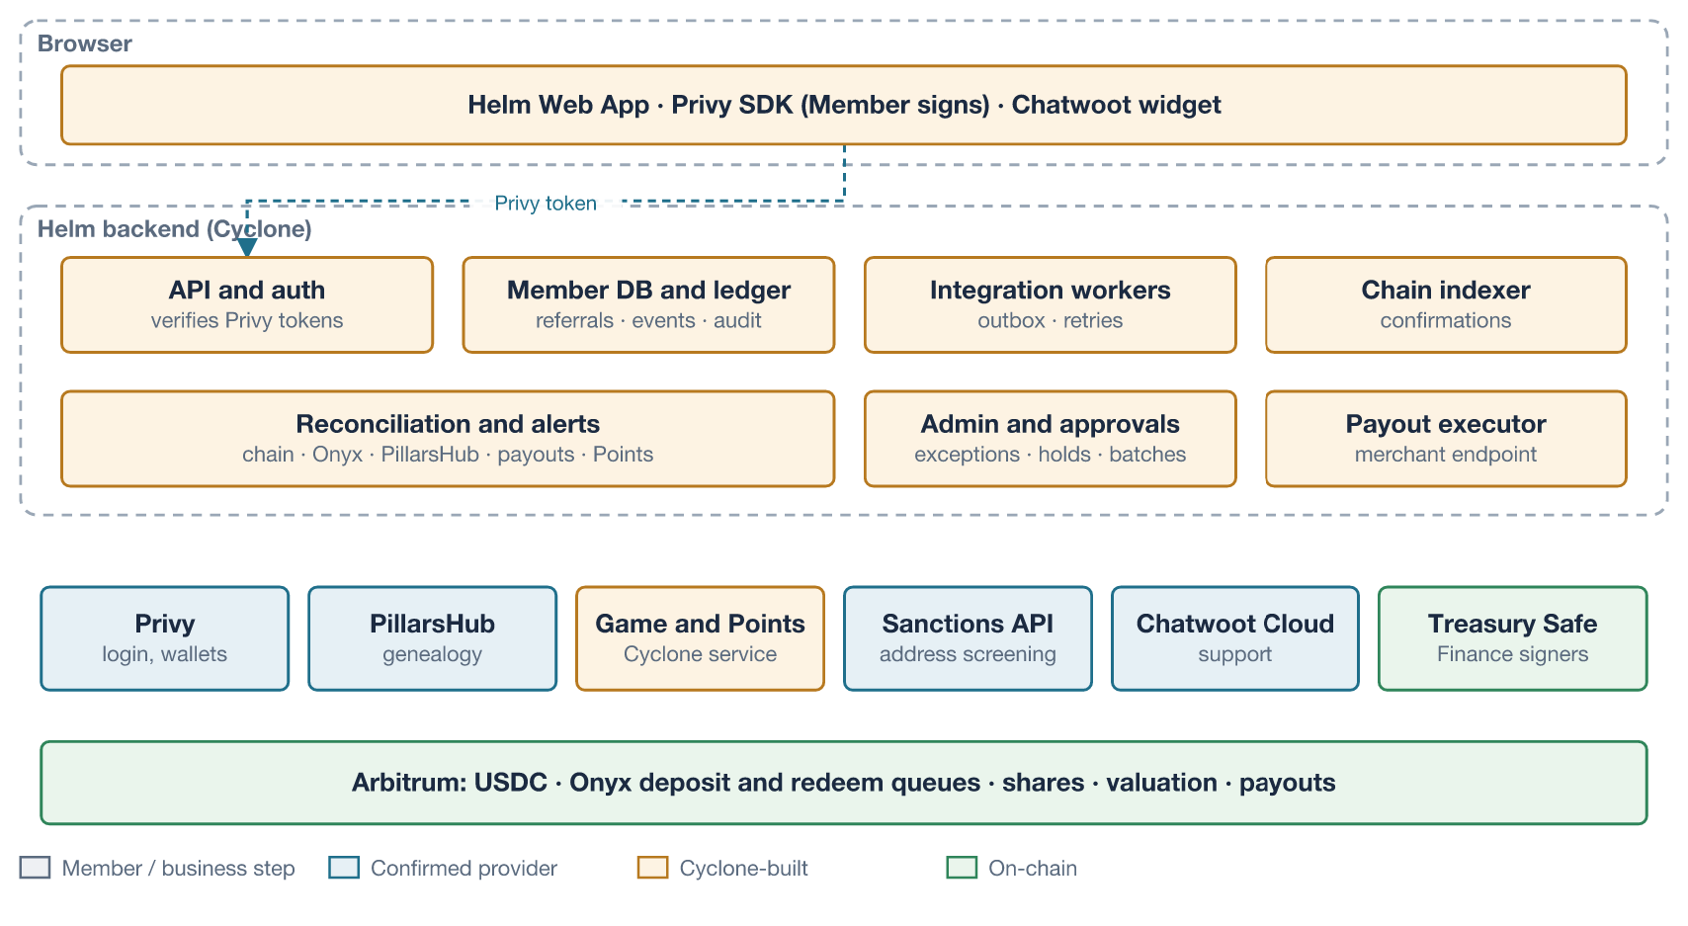
Technical architecture and trust boundaries.

Components and why each is needed
Component | Responsibility | Why custom
Helm Web App | Member and admin UI; Privy login; signing via the Member’s embedded wallet; Chatwoot widget | One Member experience across providers
API and auth | Verifies Privy access tokens; resolves Helm member ID; serves the app | Providers cannot share one identity on their own
Member DB and ledger | Members, provider-ID mappings, wallets, Referral Requests, Sponsor Edges and corrections, business events, consent records, audit log | Single place to reconcile identities and money events
Integration workers | Outbox jobs to PillarsHub, game service, screening and allowlist; retries and dead letters | No provider offers idempotency keys across all calls
Chain indexer | Indexes USDC transfers to Member wallets and Onyx queue, shares and valuation events at confirmation depth | Privy production webhooks need Enterprise; Onyx has no webhooks. Verified
Reconciliation | Daily checks against chain, Onyx API, PillarsHub tree and Points | Provider data can drift; must be provable
Admin console and approvals | Exceptions, screening cases, allowlist status, Sponsor corrections, import exceptions, payout batch review and holds, all with maker-checker | Approval workflows (ADM-02) span several providers
Payout executor | Receives PillarsHub payout batches at a custom merchant endpoint; validates the callback token; checks payees and holds; proposes USDC transfers to the treasury multisig; reports Success, Failure or Pending per payment | PillarsHub calculates and releases but does not move crypto; no payment provider in scope
Alpha import tool | Loads alpha members Sponsors-first, reconciles counts and edges, reports exceptions, supports rollback | No bulk import API in PillarsHub. Verified

Data authority
Object | Authoritative record | Helm keeps
Helm member identity and provider-ID mapping | Helm DB | Master
Login identity | Privy user (DID) | Mapping only
Wallet address | Privy (server-side read) and chain | Association with first-seen time
Accepted genealogy | PillarsHub tree (customer enroller plus node upline) | Pending requests, accepted-edge copy, audit log of corrections
Wallet funding | Blockchain | Indexed, confirmed events
Vault deposit requests, positions, Redemptions | Blockchain (Onyx contracts) | Indexed events; Onyx API as cross-check
Vault valuation | Onyx valuation contract (set by vault operator) | Displayed with timestamp
Commission obligations (calculated, released) | PillarsHub bonuses and batches | Statement copy with source event IDs
Payout execution | Blockchain (treasury transfers) | Payout record with batch, payment and transaction IDs; status reported to PillarsHub
Customer and Builder status, preregistration | Helm DB | Master; mirrored to PillarsHub customer type and status
Points balance | Cyclone points service | Display copy
Conversations | Chatwoot | Link to member ID
Terms acceptance, screening results, eligibility | Helm DB | Master

Credentials, signing and custody boundaries
Actor | Can sign or act | Cannot | Notes
Member | Wallet transfers, vault approval, deposit and redemption requests, cancellations | Admin actions | Privy embedded wallet; Onyx requires the Member’s own address to sign its requests. Verified
Helm backend | PillarsHub writes (customers, nodes, sources) with a limited token; game API; screening API; vault allowlist updates through a list-owner key; propose treasury payout transactions | Move Member funds; vault admin actions; execute a payout without Finance signatures | List-owner key held in a key management service; owns only the allowlist contract (to confirm with Enzyme)
Vault Owner (Business) | Add and remove Admins; any admin action | — | Recommended: Safe multisig with Business signers
Vault Admin / operator (Business) | Update valuation; execute queues; move assets to the strategy wallet; set fees | — | Fully trusted by the protocol. Verified
Treasury signers (Finance) | Approve and sign payout transactions from the treasury multisig | Change payout destinations | Payouts go only to the Builder’s Helm wallet; a threshold of Finance signers is required
Strategy Manager (Business-appointed) | Runs the strategy outside Onyx; returns liquidity | — | Custody of the strategy wallet sits outside Onyx. Verified
Enzyme | Deploys; upgrades contracts (global owner) | — | Upgrade governance must be in the MLA. Verified
Privy | Runs the signing enclave | Sign for the Member | Privy “is never an authorized signer”. Verified
Support agent | Reply in Chatwoot; read-only member status | Funds, Sponsors, Points | Enforced in Helm admin
PillarsHub tokens are environment-bound and do not expire; they can be made read-only. Recommended: a read-only token for reconciliation and a separate write token, with destructive areas denied if PillarsHub allows it (TBD). Bonus release and batch creation are Finance actions in the PillarsHub Portal, not calls from Helm’s backend; Helm only receives the resulting batch and reports payment status.

End-to-end data flows
Every flow distinguishes submitted (Helm has a request or transaction hash), confirmed (provider acknowledged or block confirmations reached) and synchronised (Helm’s copy matches the authority after reconciliation). Webhooks are treated as hints; polling and indexing are authoritative.
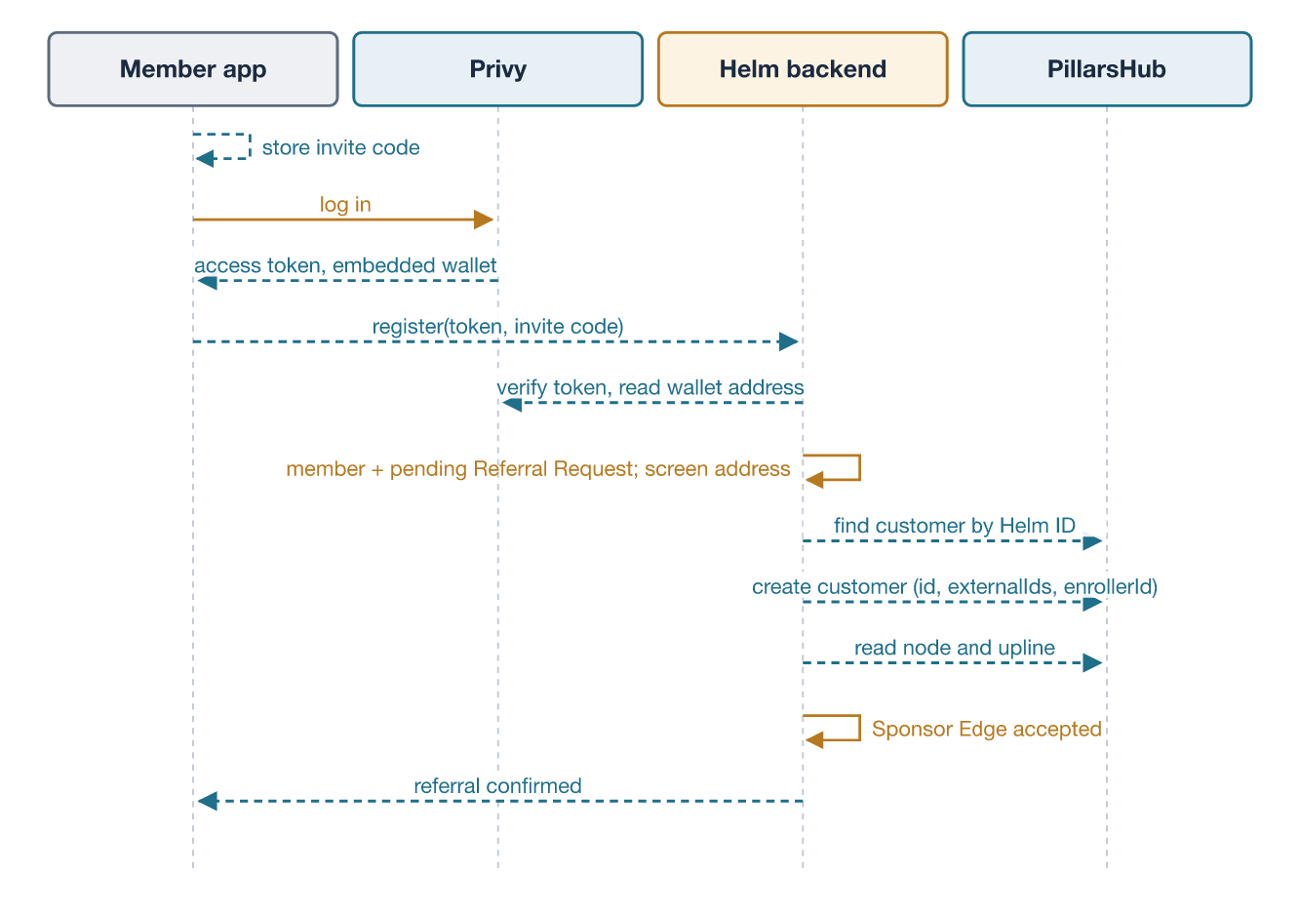
Invite, signup, wallet and accepted genealogy.
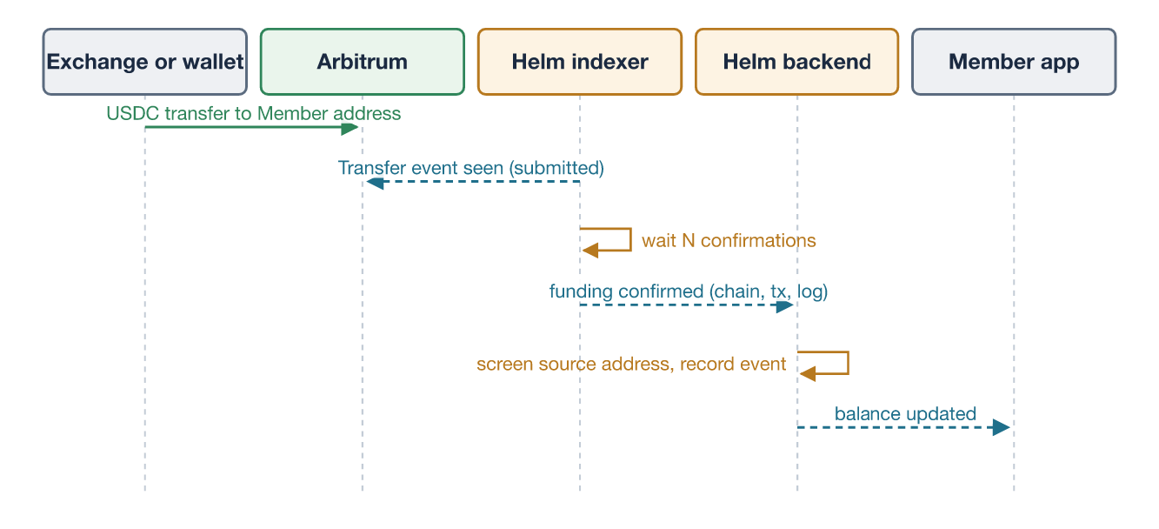
Direct wallet funding.
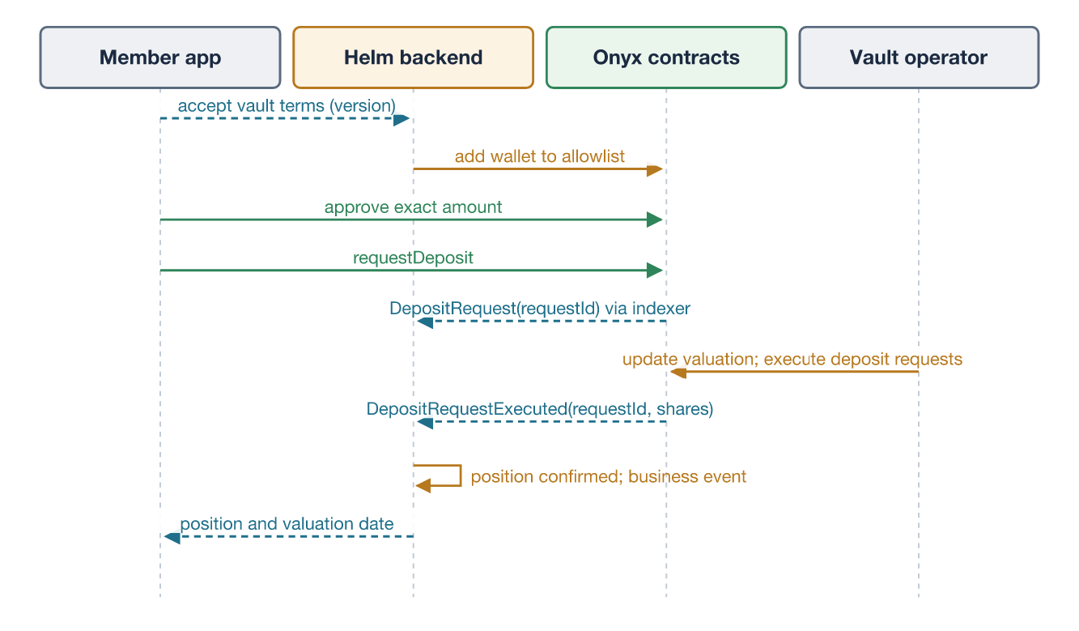
Vault deposit, execution and position.
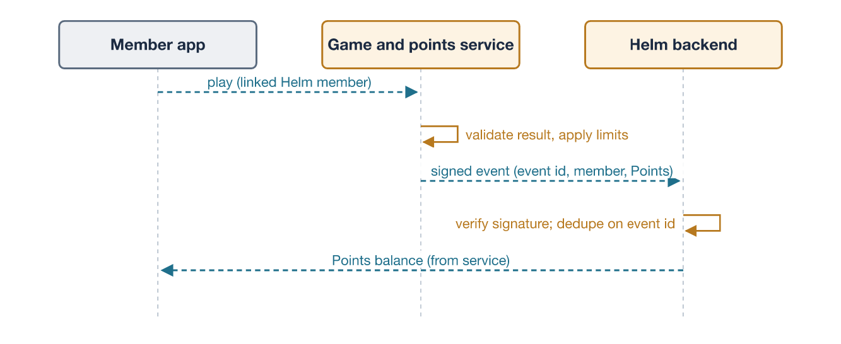
Game activity to Points.
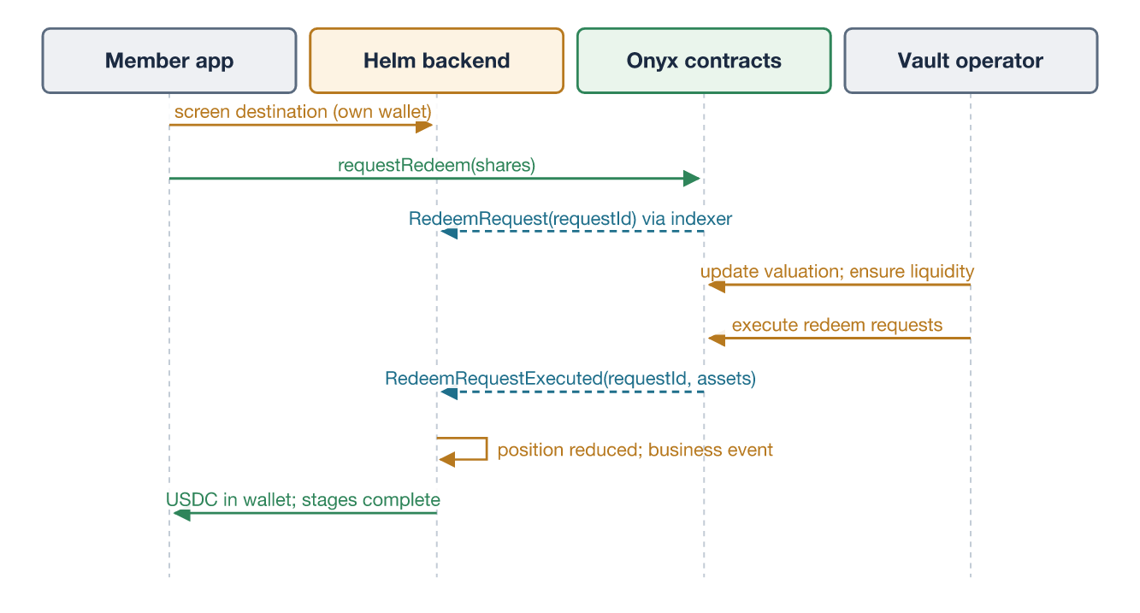
Redemption request to settlement.
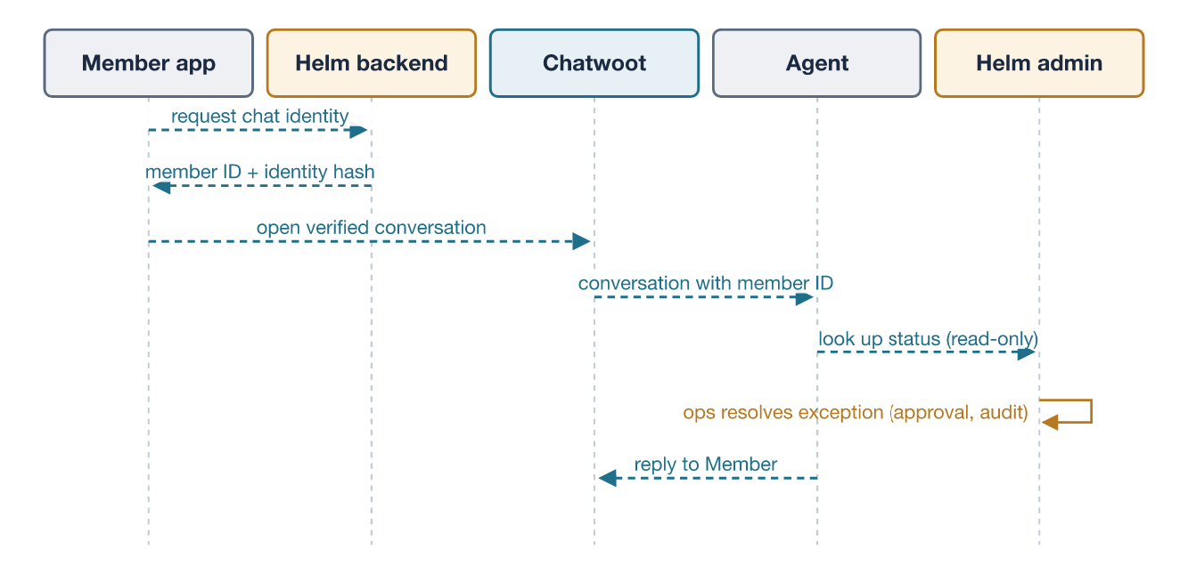
Support and admin exception resolution.
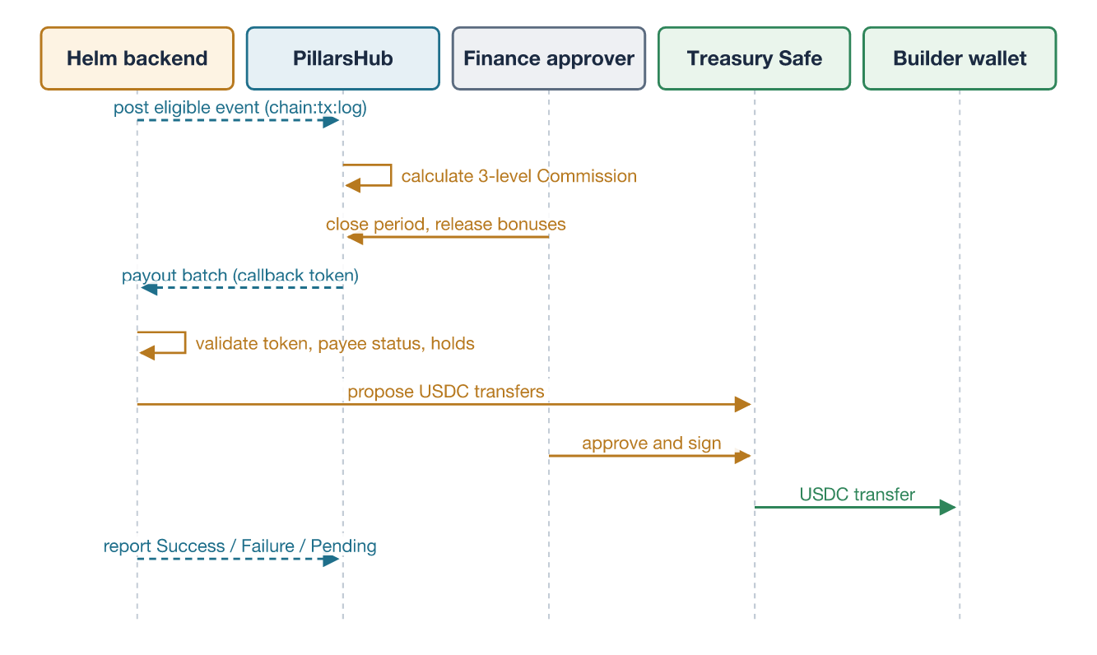
Eligible event to Commission and simple payout.

Flow matrix
Flow | Origin → destination | Minimum data | Authoritative record | Deduplication key | Failure and retry | User sees
Signup and referral | App → Helm → PillarsHub | Privy DID, wallet address, invite code, Sponsor member ID | PillarsHub tree (accepted edge) | Helm member ID (PillarsHub customer ID) | Look up before create; backoff; dead letter to ops; nightly tree reconciliation | “Referral pending” then “confirmed”
Wallet funding | Exchange → chain → Helm indexer | Chain, tx hash, log index, amount, from, to | Chain | (chain, tx hash, log index) | Re-index from last safe block; reorg handling by confirmation depth | Pending → confirmed balance
Vault deposit | App → Onyx contracts; indexer → Helm | Request ID, amount, wallet, terms version | Chain (queue and shares) | (chain, queue address, request ID) | Reverted transactions shown with reason; stale pending alert; Onyx API cross-check | Approval → requested → processing → position
Eligible event (approved basis only) | Helm → PillarsHub sources | Member node, amount, business time, receipt time, settlement state, rule version | Helm business event; PillarsHub source | Source externalId = chain:tx:log | Look up by externalId on conflict or timeout; reversal posts a linked adjustment | Builder sees Commission as pending
Commission payout | PillarsHub → Helm merchant endpoint → treasury → chain | Batch ID, payment ID, node, bonus, amount, currency, period | PillarsHub (obligation); chain (payment) | Batch ID plus payment ID; transaction hash | Batch ID is the same on retries; Helm never pays a payment ID twice; unconfirmed transfers stay Pending; failures reported per payment | Pending → held → payable → paid, with transaction link
Game to Points | Game service → Helm | Event ID, member ID, Points, rule ID | Points service | Event ID | Signed events; replay protection; daily limits | Points balance and history
Redemption | App → Onyx; indexer → Helm | Request ID, shares, destination | Chain | (chain, queue address, request ID) | Awaiting-liquidity alert; cancellation after minimum duration | Requested → awaiting liquidity → paid
Support | App → Chatwoot; agent → Helm admin | Member ID, identity hash, non-sensitive status | Chatwoot (conversation); Helm (actions) | Conversation ID | Widget reset on logout; signed Chatwoot webhooks logged | Chat thread
Unavailable providers: if PillarsHub is down, signups proceed with the referral pending and sync later. If the indexer lags, balances show “updating”. If Onyx’s API is unavailable, Helm relies on chain reads. If the game service is down, play is disabled and no Points are lost.

Genealogy, Commission and Phase 1 readiness

Minimum data model
Table | Key fields | Purpose
member | helm_member_id, handle (optional, proposed by Terrel), lifecycle_state (prospect, preregistered, verified, enrolled), is_builder, builder_enrolled_at, country, created_at | Stable identity; Customer and Builder distinction (ID-01, ID-04)
provider_identity | helm_member_id, provider (privy, pillarshub, chatwoot, game), external_id, linked_at | Explicit mappings
wallet | helm_member_id, chain_id, address, source (embedded), first_seen_at, screening_status, allowlist_status | One vault and payout wallet per Member
agreement_acceptance | helm_member_id, agreement (member terms, Builder terms, vault terms, privacy), version, accepted_at | Versioned consent (REC-01)
referral_request | id, helm_member_id, referrer_member_id, invite_code, channel, captured_at, status, rejection_reason | Pending and rejected referrals; original referrer (GEN-04)
sponsor_edge | id, member_id, sponsor_member_id (enroller), placement_upline_id, effective_at, accepted_at, provenance (signup, import, correction), policy_version, pillarshub_sync_status, superseded_by | Full graph at every depth; sponsor and placement kept separately (GEN-01)
edge_correction | id, edge_id, old values, new values, reason, requested_by, approved_by, approved_at, consent_ref | Audited changes (ADM-02)
business_event | id, type, member_id, amount, currency, business_time, receipt_time, settlement_state, product, country, attribution, reverses_event_id, rule_version, source_ref, idempotency_key | Terrel’s minimum event contract
commission_statement | helm_member_id, period, bonus lines with PillarsHub IDs, state (calculated, pending, held, payable, paid), payout_ref | Builder statements (COMP-03, AUD-03)
payout | batch_id, payment_id, helm_member_id, amount, currency, status (received, approved, proposed, signed, confirmed, failed), safe_tx_hash, chain_tx_hash, reported_at | Payout tracking (PAY-02)
import_run | run_id, source, counts, exceptions, approved_by, rolled_back | Alpha import evidence (IMP-02)
integration_outbox | id, target, payload hash, attempts, status, last_error | Reliable sync
Only data with an identified purpose is collected. No Sponsor or member data is written on-chain.

Rules
- Customer versus Builder: every Member starts as a Customer; Builder enrollment is an explicit, versioned step with Builder terms. Preregistered people keep their attribution but cannot earn (ID-04).
- Self-referral: rejected at capture (same member, same wallet, same verified email or phone).
- Invalid or missing Sponsor: attach to the company root account with provenance “no sponsor” and flag for review (decision D8).
- Cycles and duplicates: impossible for new Members; checked on every correction and import (GEN-02).
- Sponsor and placement changes: never self-service in the Pilot. Admin-only, with reason, consent reference, second approval and audit entry, then a PillarsHub node or placement update and read-back. The governed placement window (preview, consent, deadline, notifications; GEN-04 to GEN-06) is enabled only after the policy is approved (decision D10). Customer movements stay disabled in the PillarsHub tree so the two systems cannot drift.
- Account merges: admin process; keep the earliest accepted edge; re-point child edges with audit entries; retire the duplicate identity (ADM-04).
- Alpha community import: Sponsors before children, with original signup dates and provenance “import”; record by record because there is no bulk API. Verified. Reconcile counts and edges, resolve or approve every exception, and rehearse rollback before cutover (GEN-03, IMP-02).

Proving correctness
- Full export: page through every node of the tree with an as-of date, not the downline endpoint, which is capped at 10 levels. Verified.
- Nightly reconciliation: compare Helm’s accepted edges with PillarsHub nodes (count, edge-by-edge upline match, checksum). Any mismatch is an exception.
- Staging tests before launch: a synthetic tree at least 15 levels deep; the alpha import dry run (T01); Terrel’s scenarios T02, T03, T05, T06, T07 and T11 with Finance-prepared expected results.
- History: PillarsHub accepts an as-of date and keeps dated placements, and Helm keeps effective timestamps, so the tree on an original earning date can be shown after a later correction (GEN-01 proof).

Simple Commission and payout
- Plan. Use the three-level Unilevel plan already connected in PillarsHub staging (Correspondence). PillarsHub configures the approved rates; the plan is read-only through the API, so Helm cannot change economics. Verified.
- Eligible event. Helm posts only the approved event type (decision D2) to a dedicated source group, after on-chain confirmation, with external ID chain:tx:log. PillarsHub calculates in real time, so nothing is posted until the basis is approved. Verified.
- Reversals. If the approved rule adjusts Commissions on Redemption or failed events, Helm deletes the source or posts a linked adjustment before release; after payout, the agreed recovery rule applies (T05).
- Holds and release. Builders without required payee status or with a screening hit are held. Finance closes the period, reviews and releases bonuses in PillarsHub.
- Execution. PillarsHub sends the batch to Helm’s merchant endpoint with a callback token, which Helm validates against PillarsHub. Helm proposes USDC transfers to each Builder’s Helm wallet in the treasury Safe; Finance signers approve; Helm reports each payment’s status back. Verified (batch interface).
- Reconciliation. Daily: eligible events → PillarsHub sources → released bonuses → batch payments → on-chain transfers → statements (COMP-04).

Backlog, dependencies and schedule

Prioritised backlog
Priority | Work items | Depends on
Start immediately | App shell; Privy login and embedded wallet; member DB with Customer and Builder states; referral capture and validation; PillarsHub staging sync with read-back; alpha import tool on sample data; event pipeline and source posting (staging only); payout merchant endpoint and Safe proposals on testnet; chain indexer; Onyx deposit and redemption on Sepolia; Chatwoot widget; admin skeleton with roles; screening hook; CI, environments, secrets | Provider test access; alpha sample data
Thin slice (weeks 1–3) | End-to-end demo on test networks: signup → referral → deposit → test Commission → test payout batch → Redemption; one game-to-Points flow | Game API docs
Before live funds and payouts | Vault terms and disclosures; allowlist automation; team view and statements; Builder enrollment and terms; payout approvals, holds and reporting; alpha import rehearsal and reconciliation; support agent view, FAQs and runbooks; reconciliation jobs and alerts; country eligibility; production environments; load and recovery tests; security review fixes; operations rehearsal | Strategy, MLA, ownership, Commission basis, legal answers
Deferrable (disabled) | Governed placement window; ranks and qualification; campaigns; integrated top-up; additional chains and assets; Telegram and WhatsApp; commercial transaction monitoring; native mobile | Business demand and approved rules

Critical path
- Meeting decisions D1–D12.
- Vault readiness: strategy and Manager → vault configuration (asset, async queue, external allowlist, non-transferable shares, fees) → MLA signature → production deployment → ownership handover to the Business multisig.
- Commission basis and plan proof: approved eligible event, rates, period and hold → PillarsHub configuration → Finance expected results match (T02).
- Alpha data: records received → dry run → reconciliation → approved exceptions → rehearsed cutover (T01).
- Legal answers: entity, launch countries, KYC tier, vault terms, referral payout model.
- Security review of Helm’s integration, payout executor and vault configuration.
- Operations rehearsal: valuation, queue execution, Redemption liquidity and a small payout batch.
- PillarsHub production launch slot (Tuesday to Thursday).
Engineering runs in parallel with items 2–5; the launch date is set by whichever finishes last.

Launch and operational readiness

Gate for accepting real funds and paying Commissions
All must be true; none is waived to meet a date.
- Vault strategy, Manager, fees and Member terms approved by Business and counsel.
- MLA signed; deployed version and audit coverage confirmed by Enzyme; upgrade governance documented.
- Vault Owner multisig in place; Admin and list-owner keys in managed custody; no Owner or Admin key in Helm’s backend.
- Deposits and Redemptions proven on production with a small operator-funded amount.
- Daily reconciliation passing; monitoring and alerts live; incident contacts at each provider.
- Screening and eligibility live for the counsel-approved tier.
- Security review completed and high-severity findings fixed.
- Written provider acceptance of the business model (Privy, Enzyme, PillarsHub).
- Support agent view, FAQs, runbooks and escalation procedure, including handling of flagged users and earnings disputes (SUP-01 to SUP-06).
- Alpha import reconciled, exceptions resolved or approved, rollback rehearsed (GEN-03, IMP-02).
- Before the first payout: Commission basis, rates, period and hold approved by Owen, Finance and counsel; Finance-prepared plan examples match PillarsHub results (T02); duplicate, replay and reversal scenarios pass (T03, T05); a test batch with a forced timeout produces one payment (T06); treasury Safe with Finance signers in place; payee status captured (PAY-04).
- Load envelope and recovery targets agreed and tested (OPS-01 to OPS-03); full data export rights in the PillarsHub and Enzyme contracts (API-03).

Security boundaries
- Audit coverage. ChainSecurity audited the Onyx core (December 2025), the cross-chain wallet (May 2026) and the Chainlink compliance integration (July 2026). One deployment helper added after the last audit appears in no audit scope found. Verified. Enzyme must confirm which components Helm’s vault uses and that they are covered.
- Upgrade risk. Enzyme’s global owner can upgrade all vault contracts; the audit describes this role as able to “fully drain the system”, and no timelock was found. Verified. The MLA must cover notice and governance.
- Gas sponsorship. Privy’s native sponsorship upgrades Member wallets with EIP-7702; the delegation contract is part of the security review. Verified.
- Unsigned PillarsHub webhooks. Treat them as hints and re-fetch through the API. Verified.
- Payout callbacks. PillarsHub authenticates payout batches with a callback token that Helm validates against PillarsHub’s token endpoint before acting. Verified. The payout executor holds no signing key; it only proposes Safe transactions.
- Test and production separation for every provider, with separate credentials and no production keys on developer machines.

Compliance responsibility matrix
Accountable functions are proposals; named owners are TBD.
Control | Applicability question | Accountable (proposed) | Cyclone work | Provider capability relied on | Launch impact
Entity and custody classification | Does any entity have “control” of Member assets (vault roles, allowlist key)? | Business + counsel | Document signing authority and key flows | Privy self-custody (verified); Onyx roles (verified) | Blocker
Launch countries and geographic restriction | Which countries are allowed? | Business + counsel | Country attestation, IP checks, block list | None native | Blocker
Vault product characterisation | Is the vault offering a regulated product in launch countries? | Business + counsel | Terms, fee and risk screens with acceptance record | Onyx strategy and fees (TBD) | Blocker
KYC tier | Is any no-KYC tier allowed; at what thresholds? | Business compliance + counsel | Tier fields and gates now; vendor integration if required | None native (Privy KYC via Bridge unavailable) | Before funds
Sanctions: addresses | Which lists and when? | Business compliance | Screen wallet, funding source, Redemption destination | Chainalysis free API (verified, discovery) | Before funds
Sanctions: persons | Is name screening required? | Business compliance + counsel | Hook into identity tier | Vendor TBD | Before funds if required
Vault admission | Only eligible Members may deposit | Business + Enzyme | Allowlist automation after checks | Onyx deposit allowlist (verified) | Before funds
AML monitoring and escalation | What monitoring and reporting duties apply? | Business (compliance officer) | Thresholds, exception queue, case log | None native | Before funds (manual minimum)
Flagged users and transactions | What may Helm lawfully refuse or hold? | Counsel + Business | Restricted states in Helm; no assumed freezing power | Onyx admin discretion and policies (verified) | Before funds
Terms, privacy, consent, retention | Which notices and data-sharing consents? | Business (legal) | Versioned consent; data map per provider | Chatwoot Cloud hosted in the US (verified) | Before funds
Referral model and Points | Are referral rewards and Points disclosed and lawful? | Business + counsel | Rules pages; no earnings claims; Points separate from money | PillarsHub, game service | Before funds (disclosures)
Referral payout basis | Is paying Commissions on the chosen eligible event lawful in launch countries? | Owen + Finance + counsel | Configurable event pipe; nothing posted until approved | PillarsHub plan (verified) | Blocker for payouts
Payee status and tax reporting | What payee information is required before payout? | Finance + counsel | Payee status gate; hold process (PAY-04) | None native | Before payouts
Earnings disclosures | What earnings and income disclosures are required? | Business + counsel | Statements and disclosure screens (AUD-03) | — | Before payouts
Provider acceptance | Do providers accept the model on full disclosure? | Business | Avoid Stripe and Bridge features in Privy | Written confirmations | Before funds

Implementation decisions and feasibility gaps
Decision | Recommended answer | Evidence | Unresolved dependency | Responsible function (proposed) | Launch impact
Network and asset | Arbitrum One, native USDC; Sepolia for tests | Onyx and Privy support Arbitrum; Onyx test deployment is on Sepolia (verified) | Enzyme confirms production chain and asset | Business + Tech | High
Wallet model | User-owned Privy embedded wallet, no app signer, sponsored gas, export enabled | Privy docs (verified) | Privy accepts the business model; volume limit above $1M per month | Tech | Medium
Vault configuration | Async deposit queue; external allowlist owned by a dedicated list-owner key; non-transferable shares; one asset | Onyx contracts and docs (verified) | Enzyme confirms external list ownership at deployment | Business + Enzyme | High
Vault roles | Business Safe multisig as Owner; separate Admin wallet; limited admin for valuation updates | Onyx roles (verified) | Business signers; Manager appointment | Business | Blocker
Redemption target | Publish an operational target; show stages | No protocol SLA (verified) | Liquidity policy from Manager | Business | High
Genealogy authority | PillarsHub, with Helm pending requests and reconciled copy | Customer and tree APIs (verified) | Auto-placement and correction method in staging | Tech + PillarsHub | Medium
Simple Commission | Three-level Unilevel on one approved eligible event; Finance-approved USDC batches from a Safe treasury | PillarsHub plan, sources and custom merchant batches (verified) | Approved basis, rates, period and hold; counsel | Owen + Finance + counsel | Blocker for payouts
Alpha import | Import before launch with history; reconcile and rehearse | Customer create with ID, date and enroller; no bulk API (verified) | Alpha records | Business + Tech | High
Placement window | Disabled in the Pilot; enable after policy approval | GEN-04 to GEN-06 | Placement policy | Terrel + Tim | Medium
Customer and Builder | Separate states; explicit Builder enrollment | ID-01, ID-04 | Builder terms | Terrel + Owen | Medium
Funding path | Direct crypto; no top-up provider | Paymenture publishes no assets, countries or fees and bars “pyramid schemes” (verified) | Business requirement | Business | Low
Points | No cash value; not linked to deposit amounts | No game docs supplied | Game API documentation; counsel review | Business + Cyclone | Medium
Identity checks | Gates built now; tier set by counsel; address screening from day one | No KYC in stack (verified) | Counsel decision | Business + counsel | High
What would change these defaults: integrated top-up at launch adds a payment provider to the critical path; ranks, matching bonuses or a placement window at launch add plan configuration, proof scenarios and operating capacity; counsel requiring full KYC adds an identity vendor and a gate before vault access and payouts.

Appendix A: Evidence
All links were read on 8 October 2026.
PillarsHub: API authentication · Access tokens · Swagger UI · Customer API spec · Commission API spec · Webhooks · Webhook topics · Invoice dates and real-time commissions · Launch timing protocol · Money-out integrations · Terms
Privy: Pricing · Security FAQ · Supporting users · Webhooks · React quickstart · Acceptable use policy
Enzyme Onyx: Product and pricing · Architecture · Deposit control and allowlists · Redemptions · User roles · Deployments and upgrades · Risks and limitations · SDK · Public API · Contracts · Audits
Chatwoot: Developer docs · Pricing
Funding and compliance: Paymenture · Bridge developer agreement · Chainalysis sanctions oracle · FATF 2021 guidance
Detailed notes with every source and quotation are in work/notes/01-pillarshub.md, 02-enzyme-onyx.md, 03-privy.md and 04-chatwoot-funding-compliance.md.

Appendix B: Assumptions and gaps
- Terrel’s requirements v0.2 are traced in section 9. Still missing from its “Waiting for” list: the compensation specification with worked examples, alpha enrollment and genealogy records, and a one-page release scope (audience, countries, languages, activities). Owners in Terrel’s draft (Tim, Darren, JT, Finance, compliance) are proposals and are not repeated as commitments here.
- Commission basis: not yet approved. The design supports any single eligible event type; nothing is posted until Owen, Finance and counsel approve it.
- Game and Points: no API documentation was supplied. Needed: account linking method, event schema and signing, duplicate and replay protection, abuse controls, Points rules engine, whether Points can be redeemed for anything.
- Not verified with providers: PillarsHub auto-placement, depth limits, sponsor correction method, token permission granularity, rate limits, 409 semantics, pricing and security certifications; Privy paid-tier volume limits and business-model acceptance; Enzyme lead times, deployed version, external allowlist ownership, commercial terms; Chatwoot webhook retry behaviour.
- Pricing: Enzyme’s public price differs from the correspondence; PillarsHub pricing is not public.
- Team capacity, budget and launch cohort were not supplied; schedule ranges assume about five to six engineers.
- Placement-window expectations from Nic’s field call are not yet a published policy; the window stays disabled until it is.

Appendix C: Questions for providers
PillarsHub
- Does creating a customer with an enroller place the node in the Unilevel tree automatically, with the upline equal to the enroller?
- Is genealogy depth unlimited? Does listing tree nodes without node IDs return every node, and what is the page-size maximum?
- What is the supported, audited way to correct a Sponsor? Can customer movements be disabled?
- What does a 409 on posting a source mean? Is externalId unique per environment? Are duplicate customer IDs rejected?
- Can a source group exist that no bonus uses? Is backdated volume accepted for closed periods?
- Can access tokens be limited by area and deny deletes? What are the rate limits?
- Can webhooks be signed? Is there a placement or source topic?
- Please confirm in writing that API-based reconciliation of genealogy is permitted under the Terms, and explain the GLBA disclaimer in this context.
- Security documentation, data residency, pricing and launch-slot booking.
- Custom money-out merchant: can the batch carry a custom currency code such as USDC; retry behaviour when Helm reports Pending; how Failure is re-released; per-payment limits?
- Can Helm’s three-level Unilevel staging plan be configured with Finance’s rates, period, hold and minimum, and who changes it (the plan is read-only through the API)?
- Customer types or statuses for Customer versus Builder, and for preregistered people who must not earn.
Privy
- Do you accept this business model on full disclosure, and do embedded wallets, gas sponsorship and token verification require any Stripe or Bridge account?
- How is the $1M monthly transaction volume measured, and what applies above it on paid plans?
- Can production webhooks or an SLA be added without Enterprise?
- Security review material for the EIP-7702 delegation used by gas sponsorship.
Enzyme
- Upgrade governance: who controls upgrades, with what notice, and can Helm’s vault opt out?
- Deployed version and addresses; audit coverage of every component Helm uses, including the deployment helper.
- Confirm Sepolia for the test vault, Admin App access there, and API indexing of Sepolia.
- Production chain and recommended deposit asset for Arbitrum.
- Can an external allowlist owned by a Helm list-owner key be attached at deployment? Indexer delay?
- Configure shares as non-transferable.
- Redemption: notice-period or gate modules; recommended cadence; handling a batch that reverts on one request.
- Valuation automation: lead time, cost, data-provider subscriptions.
- Commercial terms (deployment fee, AUM option vs public plan, $6,000 minimum), MLA draft, onboarding form, lead times.
- Can Enzyme’s default investor interface be disabled so Members use only Helm?
Chatwoot
- Webhook retry and failure behaviour.
- Data residency options for Cloud; audit logs below Enterprise.
Cyclone game team
- API documentation, event signing, replay protection, abuse controls and Points rules engine.

