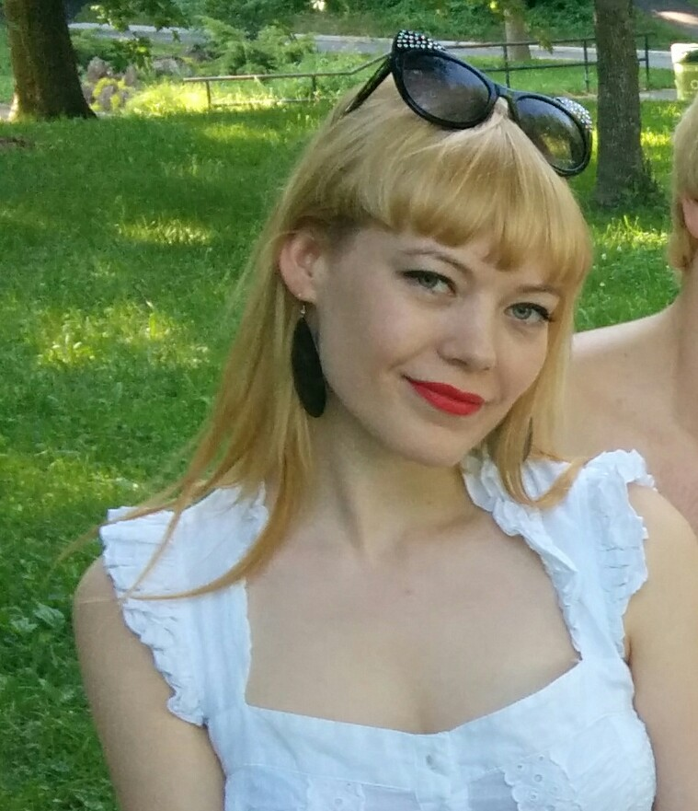**VANESSA SZOPSKI**

1005-3470 Simpson Street, Montreal, QC, H3G 2J5

Cell: 514-550-4740; vanessa@szopski.com

**PROFILE**

With experience in several retail and customer representative positions.

Friendly and personable, outgoing, attentive and welcoming with good energy.

Self-taught student of branding, marketing and sales.

Looking to build a new level of skills in experiential marketing, sales and promo modelling.

**RELEVANT WORK EXPERIENCE**

**Promo Representative for Nestle Aero Chocolate** Nov 2014  
Splash Modelling Marketing Agency; Jean Coutu In Store Demo

**Fundraiser, Donor Relationships Representative** Sept-Nov 2010

Concordia University Advancement and Alumni Relations

Annual Giving Call Centre, 1250 Guy Street Suite FB 52, Montreal, QC, H3H 2L3

**Postal Clerk at a Canada Post outlet** May - Sept 2010

Mega Mag, 289 Boulevard Saint-Jean, Pointe-Claire, QC, H9R 3J1

**Cashier, Sales Associate, Greeter** June-Aug 2009

Maison Piacente, 2136 Trans-Canada Highway, Dorval, QC, H9P 2X5

**Sales Associate** Nov 2008 - Jan 2009

Chapters, 6321 Trans-Canada Highway, Pointe-Claire, QC, H9R 5A5

**RELEVANT EDUCATION**

- Marketing Fundamentals Course by Lorrie Thomas Ross (lynda.com)

- High Performance Academy by Brendon Burchard

- Personal Power by Anthony Robbins

**RELEVANT COMPETITIONS AND AWARDS**

**Participant in a Beauty Pageant - Miss Polonia Montreal** Feb 2014

Competed in dance, public speaking, and magic in front of 300 people

**Proficiency Award - Commercial Activities** June 2006

Created and managed a team-based business.

Sold a simple innovative product with 400% profit.

**FORMAL EDUCATION**

**BA, Specialization in Translation, French-English** Sept 2008 – Dec 2012

Concordia University, Montreal, QC

**DEC, Liberal Arts** Sept 2006 – May 2008

John Abbott College, St. Anne de Bellevue, QC

Languages spoken fluently: English, French, Polish