# Title

Two decades of United States wildfire disaster data, 2000-2019

### Authors

Benjamin B. Steiger1, Milo Gordon1, Alexander J. Northrop2, Heather McBrien1, Nina Flores1, Brittany Shea1, Gabriella Y. Meltzer1, Neil Singh Bedi3, Elizabeth M. Blake5, Tarik Benmarhnia6, Francesca Dominici7, Danielle Braun7,8, Joan A. Casey1,5

**Affiliations**

1. Department of Environmental Health Sciences, Columbia University Mailman School of Public Health, New York, NY
2. Vagelos College of Physicians and Surgeons, Columbia University, New York, NY
3. Center for Climate and Health, Boston University School of Public Health, Boston, MA
4. Department of Environmental and Occupational Health Sciences, University of Washington School of Public Health, Seattle, WA
5. Scripps Institution of Oceanography, University of California San Diego, La Jolla, CA
6. Department of Biostatistics, Harvard T. H. Chan School of Public Health, Boston, MA
7. Department of Data Science, Dana Farber Cancer Institute, Boston, MA

Corresponding author(s): Joan A. Casey, [jacasey@uw.edu](mailto:jacasey@uw.edu), 3980 15th Avenue Northeast, Seattle, WA 98105

### Abstract

Due to climate change, wildfires are a growing population health concern. Most prior studies have investigated the health effects of wildfire smoke. Few large-scale studies have evaluated the health effects of wildfire disasters—wildfires that intrude into communities, cause fatalities, destroy infrastructure, or require extensive government management. Obstacles to wildfire disaster research include the lack of (a) consensus on a wildfire disaster definition, and (b) comprehensive wildfire disaster datasets readily linkable to epidemiological datasets. We defined wildfire disasters based on widely available disaster metrics. We then created a US-wide wildfire disaster dataset by harmonizing disaster-related and spatial information from eight pre-existing wildfire datasets. Our final 2000-2019 spatial dataset contained 5,509 wildfire disasters that killed a civilian, burned a structure, or received a federal Fire Management Assistance Declaration, and overlapped with a community. The annual number of wildfire disasters ranged between 72 in 2001 and 538 in 2011 (median X, IQR: X-Y). California had the most wildfire disasters (n=623, 11%). Our dataset has utility for population health studies on wildfire disasters and disaster management and planning.

### Background & Summary

Wildfires are a growing threat to public health as climate change contributes to larger,1-3 more frequent2,4-6 wildfires and longer wildfire seasons.1,2 Other contributing factors to changes in wildfire patterns include deforestation,7 less frequent land management, failure to update and climate-proof electrical systems,8 and increased agricultural and real estate development in the wildland-urban interface (WUI; regions where vegetative areas, such as forests, overlap with residences, agriculture, or infrastructure).9-11 As of 2010, over 43 million homes of the across the United States (U.S.), representing 32% of the population, were in the WUI.9 WUI communities are of particular concern for a few reasons: human activities (e.g., campfires, fireworks) and infrastructure in the WUI can trigger wildfires; structures in the WUI (such as homes) can act as fuel for wildfires; and wildfires that encroach on WUI communities can expose property to structural damage and people to both physiologic and psychologic harm.

When a wildfire “…enters a human settlement, burns people’s homes and businesses, and disrupts their lives…, it constitutes a human disaster.”12 Definitions for disasters vary across jurisdictions, government agencies, public health organizations, and researchers. However, common themes in disaster definitions include damage to infrastructure; overwhelm of governmental, economic, or community capacity; harm to human physical and mental health; and collective trauma.13-20 Actual andthreatened death or injury to self or others may be potential sources of trauma following disasters.13 Although many wildfires originate in sparsely populated regions, wildfires that cross into WUI communities can exhibit characteristics of a disaster.

Wildfires impose varying levels of financial and logistical strain on local and state governments, and some can exceed regional emergency response capacity and may require disaster assistance from the U.S. federal government, commonly provided by the Federal Emergency Management Agency (FEMA). Between 2016 and 2020, there was $5 billion of average annual federal spending on wildfire disaster assistance.21 Specifically, FEMA provides aid for managing wildfires via Fire Management Assistance Grants (FMAG). Between 2000-2019, US states filed 1,340 FMAG declarations.22An FMAG declaration indicates that a wildfire threatened life or property, exceeded state and local firefighting resources, exhibited high fire danger conditions, or threatened major economic impacts.23

Wildfires can cause extensive damage to property and infrastructure, with a recent peak of $24 billion in damages in 2017.24 In 2018, the Camp Fire in Butte County, California destroyed 14,000 homes and directly killed 85 people.25 Wildfires can harm ecosystems that people rely on for resources (e.g., agricultural fields26, watersheds27) or that hold cultural significance (e.g., sacred Indigenous sites).28,29 Wildfire management (e.g., using water to put out wildfires) can also exacerbate existing political and colonial conflicts over land and water rights.30 Wildfire damage to homes, health infrastructure, public utilities, energy infrastructure, and businesses may disrupt community functioning, social networks, or access to services.31-33 Adverse health effects may arise from these disruptions or from witnessing property destruction, displacement, injuries, or deaths due to wildfires.31

Most epidemiological studies on wildfires, however, have only focused on the health effects of wildfire smoke. Wildfire smoke contains toxic airborne chemicals and can travel long distances.34,35 In 2023, wildfire smoke from Canadian wildfires increased emergency department visits for asthma in New York City, hundreds of kilometers away.36 Many studies have found associations between fine particulate matter (PM2.5) from wildfire smoke and adverse respiratory, cardiovascular, reproductive, and mental health outcomes.37-46 Wildfires that cross into communities may burn a combination of vegetation, homes, cars, and other human-made structures.47 Burning insulation, plastic, vinyl, furniture upholstery, and other textiles can result in smoke containing additional toxic chemicals (e.g., benzene, formaldehyde).47

The link between wildfire smoke and health may operate via biological (e.g., inhalation of carbon-heavy wildfire PM2.5 causes inflammation),48,49 mental, and social mechanisms.50 Qualitative studies have linked self-reported stress, anxiety, depression, and feelings of social isolation from staying indoors during wildfire smoke events.31,50,51

Beyond wildfire smoke exposure, small-scale studies on single wildfire incidents have identified associations between wildfire exposure and adverse health outcomes among nearby residents.52-61 These studies characterized wildfire exposure in a variety of ways–proximity to the wildfire;62 questionnaires (e.g., Life Events Checklist);53 or recruitment of participants who evacuated from wildfires,54,55 sought wildfire relief,63 or were wildfire burn victims.58 Otheres assessed wildfire exposure based on living, working, or attending a school or hospital in the county or census-designated place where the wildfire occurred.32,60,64 The majority of these studies investigate mental health outcomes. To our knowledge, only a few case studies have characterized non-smoke related causes of adverse physical health outcomes or mortality, despite the high potential for extreme hazardous exposures.65,66

Large-scale, multi-fire, multi-state epidemiologic studies are not yet available, but would offer greater generalizability about associations between wildfire disaster stressors (e.g., deaths, property damage, governmental overwhelm) and health outcomes. Such research could inform targeted public health interventions to prepare for and respond to wildfire disasters. However, to our knowledge, no such studies exist,67,68 likely due to data limitations.

# One obstacle is the lack of consensus on the definition of a wildfire disaster or a disaster.69,70 Data on certain characteristics of disasters (e.g., collective trauma) are not widely collected, and when collected, metrics may vary between jurisdictions. A set of measurable, highly available criteria is necessary to distinguish wildfire disasters from other wildfire events.

A second obstacle is the lack of a national comprehensive, standardized system for reporting wildfire data, including disaster-related and spatial information. Various local, state, regional, and federal agencies collect and report information relevant for identifying and characterizing wildfire disasters. These datasets span different time periods and regions and contain distinct variables. For example, local agencies often collect wildfire perimeter data, guidelines for submitting perimeter data differ across fire management agencies (e.g., some agencies only collect perimeter data once a year) often resulting in incomplete datasets.71 Individual datasets may have discordant values for the same variables (e.g., number of burned acres, spatial perimeters, relevant dates) depending on the reporting agency and when they submitted the data.

Harmonizing wildfire datasets is challenging because agencies often use different (and sometimes internally inconsistent) methods to identify wildfires. Prior efforts to harmonize wildfire datasets have varied in methodology and inclusion criteria. For example, the National Interagency Fire Center (NIFC) created a wildfire perimeter dataset using data from seven different state and federal government agencies.

The U.S. Geological Survey (USGS) harmonized data from forty different government agencies and published a national dataset with wildfire perimeters from 1835-2020.72 Neither dataset, however, included disaster-related information, such as the number of civilian fatalities or destroyed structures.

St Denis and colleagues (2023) published a wildfire dataset including data on civilian fatalities and destroyed structures with IDs that link to wildfire perimeter datasets.73,74 However, this dataset lacked other data relevant for classifying wildfire as disasters, such as exceeding government capacity or whether the wildfires overlapped with a community.

In this paper, we created a spatial dataset of U.S. wildfire disasters from 2000-2019. We defined wildfire disasters with a set of measurable and available criteria, and harmonized multiple wildfire datasets with disaster-related and spatial information. Our dataset provides each wildfire disaster’s ignition and containment dates, its spatial extent, counts of civilian fatalities and destroyed structures, FMAG declaration status, and whether or not it overlapped with a community.

### Methods

After conducting a literature review to identify and select metrics for defining a wildfire disaster, we harmonized publicly available wildfire datasets with disaster-related and spatial data, and filtered to wildfires that met our disaster criteria. This resulted in our spatial dataset of U.S. wildfire disasters from 2000-2019.

**Wildfire Disaster Definitions**

We conducted a literature review to identify criteria for a wildfire disaster definition. The literature review included reviews of disaster definitions and websites of government agencies and non-governmental organizations involved in wildfire mitigation, adaptation, response, and recovery efforts. McFarlane and Norris (2006) noted that while most modern definitions characterize disasters as events that affect communities, most definitions differ in terms of their emphasis on political, social, or physical impacts.13 We identified themes from 27 disaster definitions (**Figure 1**, **Supplementary Table 1**). Recurring themes included disruptions to community functioning; governmental overwhelm; damage to infrastructure or the local environment; and harm to human health (e.g., death, injury, or trauma). We then identified widely available metrics in US wildfire datasets that corresponded to each of these themes and selected these metrics to define a wildfire disaster.

**Figure 1: Word cloud summarizing terms used in in 27 disaster definitions.** These terms represent disaster themes from which we derived our wildfire disaster definition.

A major theme of disaster definitions was a focus on the effect on communities rather than individuals. To identify wildfires that overlapped geographically with—and potentially disrupted or caused burn damage to—communities, we needed to define a community. U.S. fire management agencies have defined WUI communities as regions with a population density of ≥ 250 people per square mile (≥ 96 people per square kilometer).75,76 We used this population density threshold as our first criterion to identify wildfires that overlapped with a community.

Our second criterion was related to government overwhelm. FEMA has three disaster declaration types: FMAG, Emergency, and Major Disaster. A wildfire must first receive an FMAG declaration before it receives either a Major Disaster or Emergency declaration (both of which indicate greater levels of threatened or actual destruction compared to an FMAG declaration alone). We determined that wildfires that received an FMAG declaration from FEMA met the minimum criteria for indicating exceedance of state and local capacity. FMAG declarations use declaration titles to identify wildfires (e.g., “Woolsey Fire”) which often matched wildfire incident names in other wildfire datasets, allowing us to harmonize this information across datasets.

The last two criteria were related to human health and physical damage to infrastructure. Data on civilian fatalities and destroyed structures (e.g., homes, commercial properties) were most widely available and measured severe outcomes: death and destruction.

In summary, we defined a wildfire disaster as a wildfire that overlapped with a community (defined as ≥ 96 people per square kilometer) and met at least one of the following criteria: 1) destroyed at least one structure; 2) caused a civilian fatality; or 3) received an FMAG declaration (**Table 1**). Individual wildfire incidents within a similar timeframe and region under the management of the same incident commander,77 were combined into a single wildfire disaster complex (**Table X**).

We built a wildfire disaster dataset that harmonized and combined existing datasets. This posed a number of challenges. Underlying datasets employed different variable names and conventions for identifying wildfire incidents based on the agencies from which data was sourced. Agencies collected information for various purposes. One agency might collect the incident name and another the FMAG declaration title. We had to determine how to match these similar, but not identical datasets. We organized datasets, standardized variable names, defined variables, and listed synonymous or alternative variable names that appeared across datasets (**Table X**).

**Table 1: Domains included in the wildfire disaster definition, example effects, feasible metrics, and datasets used to measure them.**

|  |  |  |  |
| --- | --- | --- | --- |
| **Disaster domain** | **Examples of effects** | **Feasible metric** | **Dataset** |
| Material | Damage or destruction of property, infrastructure, or critical resources; economic losses | Number of destroyed structures | ICS-209-PLUS; Redbooks |
| Human health | Death, injuries, collective trauma, threats to safety or health | Number of deaths | ICS-209-PLUS; Redbooks |
| Political | Exceeds ability of a community to cope or recover; governmental disaster declarations; governmental request for external aid; require emergency response; require external support for recovery | Received an FMAG declaration | FEMA disaster declarations dataset |
| Social | Disruption to the functioning of a community; broken social ties | Wildfire overlaps geographically with a community | Wildfire perimeter datasets and SocScape population density |

FEMA, Federal Emergency Management Agency; FMAG, Fire Management Assistance Grant; ICS-209-PLUS, Incident Command System Form 209 PLUS

### Wildfire Datasets

We obtained information on our wildfire disaster criteria from three datasets—two national and one California-specific. To identify wildfire spatial extents, we used five national spatial datasets.

*ICS-209-PLUS Dataset*

St. Denis and colleagues (2023) used 1999-2020 U.S. wildfire data from the U.S. Incident Command System Form 209 (ICS-209) to create the ICS-209-PLUS wildfire dataset.78 The U.S. Incident Command System is the standard national approach for coordinating government responses to hazards (including wildfires) that threaten public health. ICS-209 forms are a federally mandated report for Incident Management Teams when wildfires require special attention, such as posing a threat to public safety or requiring significant aid.79 Each ICS-209 form reports the number of fatalities and damaged or destroyed structures due to the wildfire incident. The ICS-209-PLUS dataset contained the most up-to-date, complete, and verifiable information on the wildfire incident.78

Within our study period (2000-2019), the ICS-209 form was revised several times to include additional variables, U.S. states, and government agencies. Between 2000-2005, use of the ICS-209 form was not mandatory, but most states and agencies used it. From 2006 onward, the ICS-209 form became a mandatory component of U.S. incident management and was required for state, local, and tribal governments to receive federal funding.

We downloaded the *ics209plus-wildfire.zip* and used the *ics209-plus-wf-incidents_1999to2020.csv* (ICS-209-PLUS wildfire incident table) and the ics209-plus-*wf_complex_associations_1999to2020.csv* (ICS-209-PLUS wildfire complex associations table).80 The ICS-209-PLUS wildfire incident table contained variables for the incident name, year, ignition date, containment date, civilian fatalities, destroyed structures, damaged structures, acres burned, cause, state, city, county, location, and the latitude and longitude of the wildfire’s point of origin (location where fire first ignited). The ICS-209-PLUS wildfire incident table also contained three ID variables that linked it to three other files. The first file was the ICS-209-PLUS wildfire complex associations table, which lists all wildfire complex members and their associated wildfire complexes. The other two files are spatial datasets—the Monitoring Trends in Burned Severity (MTBS) dataset and the Fire Event Delineation (FIRED) dataset.

*FMAG Dataset*

The FEMA Disaster Declarations Summary dataset includes official Federal Disaster Declarations from 1953 to present for all hazard events (e.g., hurricanes, wildfire incidents). We downloaded *DisasterDeclarationsSummaries.csv*.81 The dataset included Major Disaster, Emergency, and FMAG declarations, the latter of which was the source of our disaster definition. We isolated wildfires from the dataset with FMAG declarations and thus refer to this dataset as the FMAG dataset.

Unlike the ICS-209-PLUS dataset, the FMAG dataset did not include unique identification (ID) variables that linked to spatial datasets. The FMAG dataset included an incident ID variable unique to the FMAG dataset, incident name, year, ignition date, containment date, state, county, designated area, declaration date, and declaration type (e.g., FMAG, Emergency, Major Disaster).

*Redbooks Dataset*

The California Department of Forestry & Fire Prevention (CAL FIRE) publishes annual reports on wildfires entitled Redbooks. PDFs of Redbooks between 2009-2019 were publicly available.82 The only non-publicly available data we used were Redbooks from 2000-2008, which we acquired from CAL FIRE and now host on GitHub. Redbooks include the number of damaged or destroyed structures and civilian fatalities for all “large fires.” Between 2000-2007, Redbooks defined large fires as wildfires that burned ≥ 30 acres of timber, ≥ 300 acres of brush, ≥ 1500 acres of woodland, ≥ 1500 acres of grass, ≥ 1500 acres of agricultural products, destroyed ≥ three structures, or caused ≥ $300,000 in damage. Between 2008-2019, Redbooks defined large fires as wildfires that burned ≥ 300 acres, regardless of type of vegetation burned. From 2007-2009, the Redbooks combined the counts of damaged and destroyed structures into a single variable; during this period, we assumed all counts referred to destroyed structures. For the rest of the study period, Redbooks included two distinct variables for damaged structures and destroyed structures, so we used the destroyed structure count variable when it was available.

Redbooks variables also included an incident ID unique to Redbooks, incident name, year, state, county, ignition date, containment date, acres burned, and cause of the wildfire incident.

**Spatial Data Sources**

We used five wildfire spatial perimeter datasets. Our goal was to link wildfires from the ICS-209-PLUS, FMAG, and Redbooks datasets to spatial perimeters. The wildfire perimeter datasets used different inclusion criteria, spatial and temporal resolutions, contributing data sources, and variables that identified the wildfire incidents associated with each perimeter. In addition to the wildfire perimeter datasets, we also used a census shapefile with state boundaries and two population density raster datasets.

*Monitoring Trends in Burned Severity (MTBS) Dataset*

The MTBS interagency program provides spatial datasets from 1984 to present (as of 2023) for large fires across the continental U.S., Alaska, Hawaii, and Puerto Rico.83 MTBS is run by the USGS Center for Earth Resources Observation and Science and the U.S. Department of Agriculture Forest Service Geospatial Technology and Applications Center.83 The data comes from the Landsat satellite program run by USGS and the National Aeronautics and Space Administration (NASA). For fires in 2015 onward, MTBS also used data from the European Space Agency Sentinel-2 satellite program, which provides data even in areas of persistent cloud coverage.

We used the MTBS Burned Areas Boundaries dataset, which contained the perimeters and acreage for wildfires that were ≥ 1000 acres in the Western U.S. and ≥ 500 in the Eastern U.S. MTBS defined the Western U.S. as states west of Minnesota, Iowa, Missouri, Arkansas, and Louisiana, including Alaska and Hawaii. The MTBS dataset contained a variable that distinguished between different types of wildland fires: wildfires (unplanned, unwanted wildland fires); prescribed fires (fires that agencies intentionally ignited); wildland fire use (wildland fires that ignited naturally and that agencies allowed to burn); and fires with unknown causes.

The MTBS dataset used the NAD83 projection (EPSG: 4269) and was at a 30-meter resolution. Available variables included: ID variable, incident name, year of wildfire ignition, ignition date, state, acres burned, and the perimeter geometry. A drawback of MTBS was that it only included large fires.

*Fire Event Delineation* *(FIRED) Dataset*

Mahood and colleagues (2022) developed the Fire Event Delineation (FIRED) dataset. The FIRED dataset contained the spatial perimeters of wildfires in the contiguous U.S. and Alaska from November 2001 to May 2021.84,85 We downloaded the zipfile *fired_conus_ak_to_January_2022_gpkg_shp.zip*. The FIRED dataset included a GeoPackage with daily estimates of burned areas for each wildfire incident and a GeoPackage with estimates for the total burned area of each wildfire incident. We used the latter.84 Mahood and colleagues created the FIRED dataset from sub-daily, 500-meter resolution raster grids of wildfire burned areas. These grids were produced from satellite imagery from the NASA Moderate Resolution Imaging Spectroradiometer (MODIS) Collection 6 MCD64 Burned Area product.84 The FIRED dataset used the MODIS sinusoidal projection (EPSG: X).

The FIRED dataset includes over three times as many wildfires as MTBS, including many wildfires that fell below the MTBS size criteria (Table X). The FIRED dataset lacked 8721 wildfires from the MTBS dataset, likely due to MODIS’ inability to detect wildfires in the presence of clouds, smoke, or intact canopy. The FIRED dataset links to the ICS-209-PLUS dataset via an incident ID variable. Additional variables available in FIRED dataset included: year of wildfire ignition, ignition date, containment date, duration, and acres burned. Unlike the MTBS dataset, the FIRED dataset lacked an incident name variable.

*USGS Dataset*

Welty and Jeffries (2021) from the USGS Forest and Rangeland Ecosystem Science Center produced a perimeter dataset called the Combined Wildland Fire Datasets for the United States and Certain Territories, which we refer to as the USGS dataset.86 We downloaded the zipfile *Fire_Feature_Data_Pro2_8_Geodatabase.zip*. The USGS dataset contained wildfire perimeters from 1800 to 2020 across the contiguous U.S., Alaska, and Hawaii. The USGS dataset combined data from 40 wildfire and prescribed fire datasets, including data from MTBS and GeoMAC.83,87 To our knowledge, the USGS dataset includes the most data sources of any wildfire dataset. Welty and Jeffries ranked each contributing dataset into eight tiers of quality and dissolved wildfire perimeters that belonged to the same year and tier, retaining only the highest tier of data for each wildfire.

The USGS dataset used the NAD83 Albers North America projection (EPSG: X). Variables included a USGS-assigned incident ID, fire type, year of wildfire ignition, burned acres, perimeter dataset tier, a list of perimeter dataset sources, a list of fire names (up to 46 per wildfire incident), a list of fire IDs, a list of fire dates and the dissolved perimeter. The USGS dataset lacked a state variable, so we added one via a spatial join with the census state shapefile.

Despite including 40 data sources, the USGS dataset may still lack wildfires (especially older and smaller fires). Contributing datasets used various and complementary mapping techniques and inclusion criteria. The accuracy of each wildfire perimeter in the USGS dataset depends on the accuracy of the contributing datasets. Therefore, the perimeters included may have varying degrees of accuracy. Further, because Welty and Jeffries combined wildfire perimeters from different datasets, larger perimeters with less detail could disproportionately contribute to the perimeter shape.

*Geospatial Multi-Agency Coordination (GeoMAC) Dataset*

The GeoMAC wildfire application was a national internet-based tool that provided maps of wildfire locations and perimeters in the contiguous U.S. and Alaska from 2000 to 2019. GeoMAC spatial data was sourced from fire manager field offices and included data contributions from state and local agencies and 20 different federal agencies. Agencies created the perimeters using nearly 20 mapping methods, including hand sketches, GPS-based methods, infrared images, and remote sensing.

We used two historical GeoMAC geodatabases with wildfire locations and perimeters, one from 2000-2018 and one from 2019.87,88 Both geodatabases used the NAD83 coordinate reference system (EPSG: 4269). The geodatabases contained the following variables: the GeoMAC-assigned ID, incident name, year of wildfire ignition, a perimeter date, state, and wildfire complex name.

*Interagency Dataset*

The National Interagency Wildfire Center hosts the *InterAgencyFirePerimeterHistory* (Interagency) data layer, which contained perimeters of wildfires and prescribed burns from 2000-2021.89 The Interagency dataset included perimeters from eight agencies: the Department of Agriculture Forest Service, Bureau of Land Management, National Park Service, Fish and Wildfire Service, Bureau of Indian Affairs, Wildland Fire Interagency Geospatial Services, California Department of Forestry and Fire Protection (Cal Fire), and Alaska Fire Service. Several of these contributing agencies (e.g., Bureau of Indian Affairs, Bureau of Land Management) overlap with the GeoMAC contributing agencies.

The Interagency dataset included many of the same mapping methods as GeoMAC (e.g., use of GPS, remote sensing, hand sketching). As with the USGS dataset, the Interagency dataset lacked a state variable. However, the Interagency dataset had a wildfire incident ID that included state abbreviations for some wildfire incidents. This perimeter dataset used a WGS84 geographic coordinate reference system (EPSG: 4326). Variables included an ID variable, year of wildfire ignition, date, burned acres, comments, and perimeters.

**Additional datasets**

*Census Datasets*

We downloaded 2010 census state-level and county-level shapefiles from the National Historical Geographic Information System (NHGIS) database.90 The shapefiles used the NAD83 coordinate reference system (ESPG: 4269) and included state and county perimeters. We used state boundaries for identifying the states that coincided with wildfire perimeters from the USGS and Interagency spatial datasets (which lacked a state variable). We used the county boundaries for matching FMAG declarations to the ICS-209 dataset ADD ME.

*SocScape Dataset*

The Social Landscape (SocScape) project produced GeoTiffs with U.S. decennial census-based population grids at a 30-m2 resolution. We used SocScape GeoTiffs from 2000 (for wildfire incidents between 2000-2009) and 2010 (for wildfire incidents between 2010-2019).91,92

**Cleaning and Combining Data**

All the R scripts that we used are publicly available on GitHub. We performed all data cleaning, harmonization and integration of the datasets, and summary statistics in R Studio version 2023.03.0+386 with R version 4.2.3, primarily using the *tidyverse, dplyr, stringr, lubridate,* and *sf* packages.

**Data processing**

We filtered all datasets to 2000-2019. We corrected likely data entry errors and standardized variable names, character values, and dates. Among datasets with a wildfire incident name variable, we standardized the variable format for matching purposes. When datasets listed different states for the same wildfire incident (e.g., when a wildfire incident spanned multiple states), we harmonized state names across datasets.

Some data processing assumptions were dataset-specific. For quantitative variables in the ICS-209-PLUS and Redbooks datasets (number of civilian fatalities, number of destroyed structures), we made the conservative assumption that missing data meant no fatalities or destroyed structures and changed missing values to 0. Some of the spatial datasets included wildfires and prescribed burns (e.g., the MTBS and USGS datasets), so we removed prescribed burns. We filtered the FMAG dataset to wildfire incidents with an FMAG declaration. The FMAG dataset listed separate rows for each wildfire-affected county (i.e., a wildfire incident that spanned multiple counties had multiple rows), so we filtered the dataset to one row per FMAG declaration and made a variable that listed all the counties covered by the FMAG declaration.

For the spatial datasets, we removed invalid and multi-surface geometries, recast all polygon topologies into multi-polygons, and projected all datasets into NAD 1983 Albers Contiguous USA in meters (EPSG: 102003). We calculated the burned area acreage after reprojecting the data using the *st_area* function in the *sf* package. For the USGS and Interagency spatial datasets, both of which lacked a state variable, we created a state variable by intersecting the wildfire perimeters with state boundaries from the census dataset.

**Aggregating to the wildfire complex level**

When multiple wildfire incidents occur in the same region at the same time and were covered by the same incident management, datasets often grouped them into wildfire complexes (e.g., the 2019 Cornucopia wildfire complex in Alaska included 12 smaller wildfires). We aggregated all datasets to the wildfire complex level so that each row of our dataset represented either a standalone wildfire incident or a wildfire complex. When datasets differed on whether a wildfire was a member of a wildfire complex or a standalone wildfire incident, we assumed it was a wildfire complex member. We created a variable that contained the name of the wildfire complex; for standalone wildfire incidents, this value was NA. Additionally, we made a variable that listed all wildfire complex members within the parent wildfire complex. We aggregated the number of civilian fatalities and the number of destroyed structures to the complex level by summing the counts of each variable from the wildfire complex members.

**Joining wildfire datasets**

We converted the annual Redbooks reports from PDFs to CSVs using the ABBYY FineReader PDF program (Milpitas, CA) and then joined them into a single dataset spanning 2000-2019. We joined the Redbooks dataset with the ICS-209-PLUS dataset using combinations of variables (e.g., year of ignition date, wildfire complex name, wildfire incident name) to identify matching wildfire incidents (**Figure 2**). Although the Redbooks dataset only included California wildfires, some of these wildfires crossed state boundaries into neighboring states. Thus, we only used matches between Redbooks and ICS-209-PLUS if the wildfire incident from the ICS-209-PLUS dataset was from California or a neighboring state. Sometimes states used the same incident names within the same calendar year (e.g., in 2011, four California wildfire incidents were named “Canyon”). We matched these wildfires based on those with the smallest difference between ignition dates from the ICS-209-PLUS and Redbooks datasets. We only kept matches between datasets when the difference in ignition dates between them was fewer than 14 days. Some values for variables differed between the two datasets. For differing ignition and containment dates, we prioritized and retained the ICS-209-PLUS values. For the number of civilian fatalities and number of destroyed structures, we included both dataset values in separate variables that indicated their data source.

We joined the Redbooks/ICS-209-PLUS dataset with the FEMA dataset using similar methods. We joined them using a combination of year of ignition, wildfire incident/wildfire complex names, and state. Occasionally the listed state differed between datasets, usually when a fire crossed state lines. We adjudicated these incidents manually. We chose matches with the smallest difference in ignition dates and individually checked matches in which the difference between ignition dates was > 14 days (n = 21). We dropped matches where the county receiving an FMAG declaration was implausibly far (150km) from the point of origin in the ICS-209-PLUS dataset (n = X).

After we joined the Redbooks, ICS-209-PLUS, and FEMA datasets, our dataset included X unique wildfires. We then filtered to wildfire incidents and wildfire complexes that killed at least 1 civilian, destroyed at least 1 structure, or received an FMAG declaration. This dataset included X wildfires, and we refer to it as the *preliminary wildfire disaster dataset* because we still needed to determine which of these wildfires met our population density criteria and thus qualified as disasters. To apply our population density criteria, we first needed to identify the spatial extents of the fires in the preliminary dataset.

**Figure 2: Wildfire datasets used to identify incidents and complexes that met our disaster criteria, 2000–2019.** This flow chart shows linkage across the datasets and how we arrived at a final non-spatial dataset containing wildfires that destroyed a structure, caused a civilian fatality, or received an FMAG declaration (Venn diagram inset).

FEMA, Federal Emergency Management Agency; FMAG, Fire Management Assistance Grant; ICS-209-PLUS, Incident Command System Form 209 PLUS

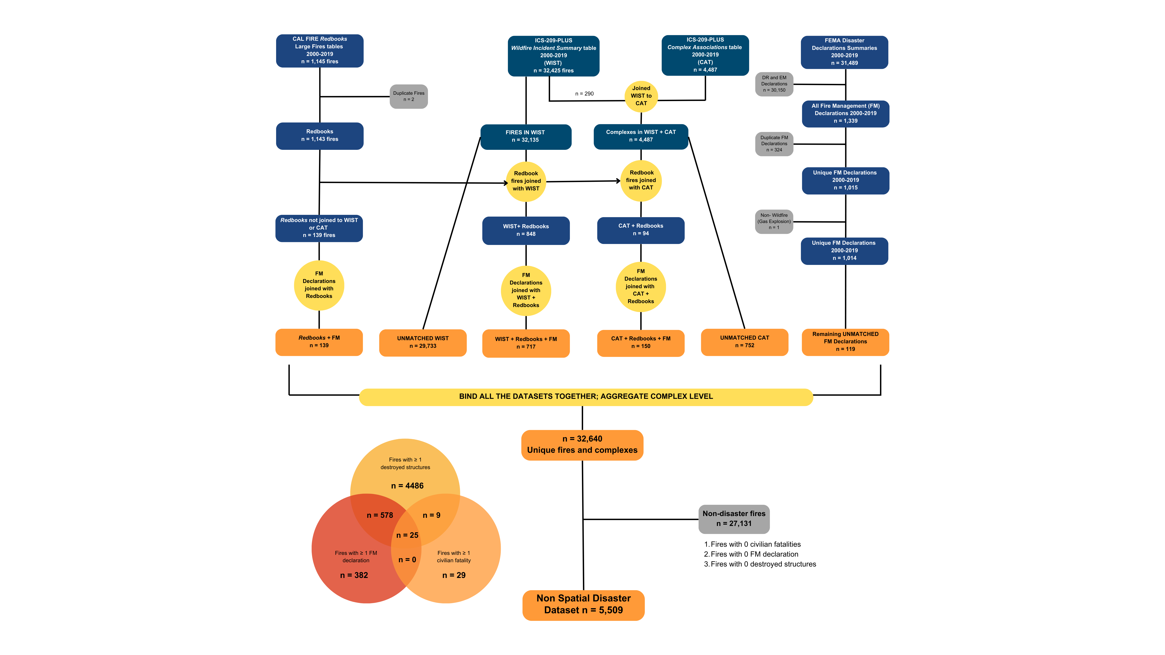

**Joining wildfire disaster data to wildfire perimeter data**

We linked wildfires from our preliminary dataset to one of five spatial wildfire perimeter datasets. We prioritized linkage among five datasets based on the availability of identifying information, such as incident IDs, incident names, dates, and location (**Figure 3).**

Correct perimeter identification presented several challenges: 1) datasets sometimes used different incident names or reported different ignition dates or locations, 2) wildfires with the same incident name sometimes occurred within the same year or region, and 3) many of the datasets used varying conventions for the unique incident IDs.

We prioritized the MTBS and FIRED datasets because they shared incident ID linking variables with the ICS-209-PLUS dataset. For wildfires that did not have linkable incident ID variables, we used combinations of other variables to link to the MTBS, USGS, GeoMAC, and InterAgency perimeter datasets. For each round of attempted perimeter matching, we created a subset of wildfires that we successfully matched and a subset of remaining wildfires still lacking a perimeter. For each subsequent round of perimeter matching, we attempted to match wildfires that still lacked a perimeter. After matching was complete, we had five wildfire perimeter spatial files (one for each wildfire perimeter dataset) and one data frame with the remaining wildfires without perimeters.

First, we attempted to join wildfires from the preliminary dataset to MTBS. For preliminary fires that appeared in ICS-209-PLUS, we linked them using a shared ID variable that contained the MTBS incident ID and wildfire incident name. For wildfire complexes, the MTBS incident ID variable listed all IDs and names for member wildfires within the complex. We joined X (%) wildfires from the preliminary dataset to MTBS using MTBS wildfire incident ID, incident name, and year. Some wildfires—including all wildfires from the Redbooks and FMAG datasets and some wildfires from the ICS-209-PLUS dataset—lacked MTBS incident IDs. We joined wildfires that lacked MTBS incident IDs to MTBS using incident/complex name, year, and state. We only kept matches with ignition dates that were ≤ 14 days apart (n [%]). For wildfire complexes, we completed a spatial union where we merged each individual wildfire’s MTBS spatial perimeter into a single complex-level perimeter using the *st_union* function in the *sf* package. We then recalculated the acreage of the combined complex perimeter using the *st_area* function. We joined a total of 1,774 (32.2%) wildfires from the preliminary dataset to MTBS perimeters.

For wildfires in the preliminary dataset that did not link to MTBS, we next attempted to link them to the FIRED dataset. We linked a total of 1,304 (40.3%) wildfires to FIRED using a FIRED incident ID linking variable. The FIRED incident ID linking variable was only available for some of the wildfires from the ICS-209-PLUS dataset and was unavailable for wildfires from the FMAG or Redbooks datasets. We could have attempted to use date and location information (e.g., ignition dates, points of origin, counties) to assign FIRED perimeters to additional wildfires. However, the FIRED dataset lacked an incident name variable, which meant we would have been unable to verify these matches.

Next, we attempted to match the remaining preliminary wildfire disasters to the USGS perimeter dataset using two methods. First, we created a point shapefile for the remaining wildfires that had a point of origin (n=2273 [%X]) and used the *st_intersection* function from the *sf* package to intersect the points of origin with perimeters in the USGS dataset. We retained matches in which the years and incident names matched (n=X [X%]). Second, we took the remaining wildfires without perimeters and joined them to the USGS dataset by wildfire incident name, year, and state. We retained matches with the smallest difference in ignition dates. If multiple perimeters matched on incident name, year, and state, with identical date differences, we chose the match with the largest acreage to correspond to the largest area burned by the wildfire (n=X [X%]). We linked a total of 296 (%) wildfire incidents to the USGS dataset.

For the remaining unmatched preliminary wildfire disasters, we attempted to join them to the GeoMAC dataset using incident/complex name, year, and state. We linked 12 (0.56%) wildfire incidents from the preliminary disaster dataset to perimeters in GeoMAC. GeoMAC sometimes included multiple perimeters for the same wildfire to reflect updates to its perimeter over time. GeoMAC indicated that perimeters were for the same wildfire by using the same GeoMAC incident ID. For X wildfires in the preliminary dataset that matched with multiple GeoMAC perimeters with the same wildfire ID, we combined the GeoMAC perimeters and recalculated the acreage of the combined polygons.

Finally, we matched five wildfires (0.24%) to the Interagency dataset using the same matching methods as with GeoMAC.

From these five spatial perimeter datasets, we obtained perimeters for 3,391 (61.6%) wildfires in our preliminary disaster dataset. We still had 2,118 (38.4%) wildfire incidents in the preliminary dataset without perimeters.

**Figure 3: Building the spatial wildfire disaster dataset**. We linked the non-spatial wildfire information to five different spatial datasets, preferentially. We started by attempting to link to MTBS, followed by FIRED, USGS, GeoMac, and NIFC. For unmatched fires that had a point of origin and listed acreage, we constructed circular buffers around the point of origin with size equivalent to the listed acreage. We then applied the population density criteria, using SocScape data to identify wildfires that spatially overlapped with a community of ≥ 96 individuals per km2.

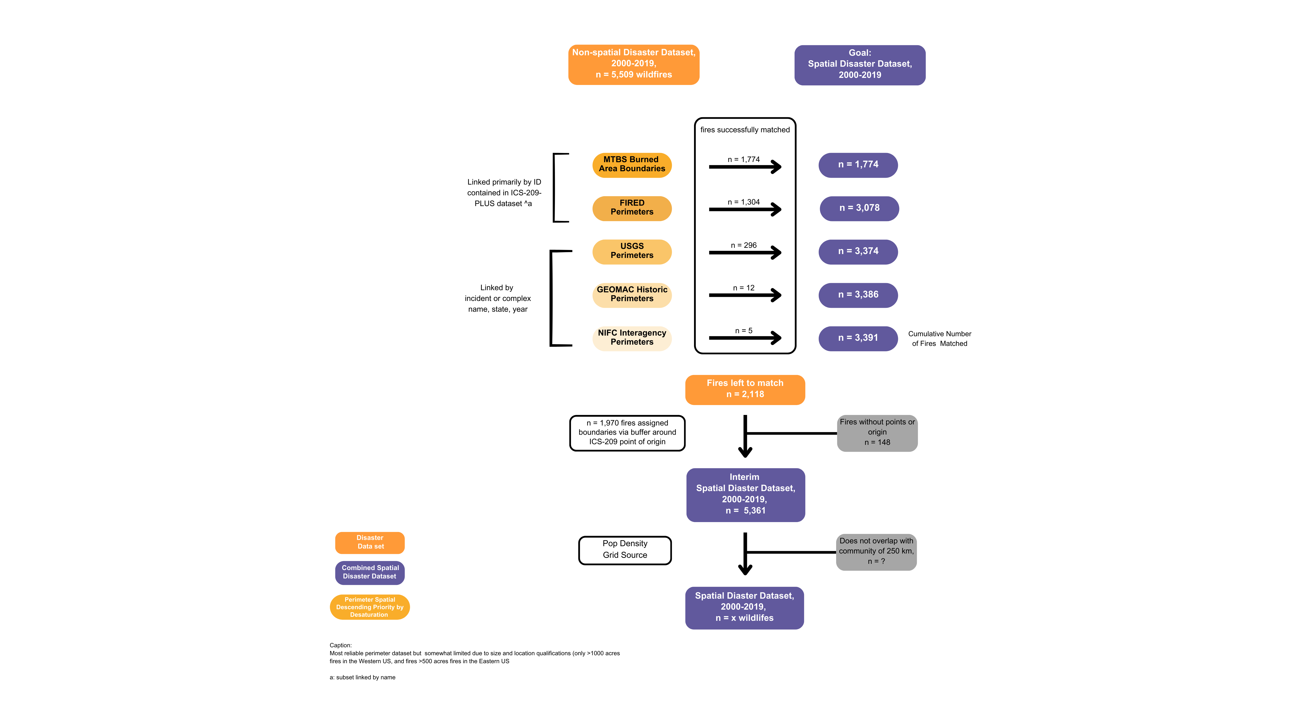FIRED, Fire Event Delineation Dataset; GeoMAC, Geospatial Multi-Agency Coordination; MTBS, Monitoring Trends in Burn Severity; NIFC, National Interagency Fire Center; USGS, The United States Geological Survey

**Wildfire spatial extent buffers**

Among the 2,118 identified wildfires without a perimeter, 1,970 (93.0%) had point of origin coordinates (latitude/longitude) and the number of acres burned from the ICS-209-PLUS dataset. Our goal was to use points of origin and burned acreage to create spatial buffers that approximated wildfire perimeters.

First, we excluded 12 wildfires with infeasible points of origin (e.g., outside the U.S.) and X wildfires with a reported burned acreage of 0. After these exclusions, we had 1,958 (99.3%) wildfires with points of origin and burned acreage.

We converted the point of origin coordinates into spatial data using the *st_as_sf* function. For spatial accuracy, we separated wildfires by Universal Transverse Mercator (UTM) zone based on state. We converted the burned acreage of each fire into square meters. We then created circular buffers using *st_buffer*, with the radius = (areaburned/π)1/2, centered at the point of origin for 1,958 wildfires. Finally, we bound wildfires together so that we had three shapefiles with wildfire buffers based on region (contiguous U.S., Alaska, and Hawaii).

**Manual data harmonization and newspaper searches for spatial extent data**

After we created buffers around wildfire points of origin, 223 (X%) wildfires had no spatial extent data (i.e., no perimeters or points origin and acreage). We split our approach for the remaining 223 wildfires based on the data source of each wildfire (i.e., the FMAG or ICS-209-PLUS dataset).

For the 115 wildfires that came from the FMAG dataset, we manually matched eight of these wildfires to wildfires in the ICS-209-PLUS dataset using county and ignition date. Of these eight matches, X had perimeters. We manually matched 16 wildfires from FMAG to wildfires in the USGS and MTBS datasets using counties and dates. Finally, we used the website *newspapers.com* to find newspaper articles with information on the remaining wildfires from the FMAG dataset. Keywords for our internet searches included combinations of wildfire incident name, county, nearby towns, names of streets and roads, and names of nearby businesses. We found newspaper articles for 44 wildfires. From these newspaper reports, we found points of origin and burned acreage for 38 wildfires and points of origin (no acreage) for 6 wildfires. In total, we matched X wildfires with perimeters and created 38 buffers from points of origin and burned acreage. We were unable to identify spatial extents for 55 wildfires from FMAG, however, we could include counties and states of their FMAG declarations.

For the 108 wildfires that came from the ICS-209-PLUS dataset, 52 (48%) had feasible points of origin but no burned acreage, 12 (11%) had infeasible points of origin, and 33 (31%) had no points of origin or burned acreage. All ICS-209-PLUS wildfires included the state and most included the county in the variables for point of origin state, point of origin county, short location description, or incident ID. We again used *newspapers.com* to search for newspaper articles for the 52 wildfires with feasible points of origin and found the burned acreage for one wildfire. Without points of origin for the 45 wildfires with missing or infeasible points of origin, we lacked sufficient granularity in spatial information to conduct newspaper searches.

Of the 223 wildfires that initially had no spatial extents (perimeters or buffers), we were able to provide X wildfires with perimeters and Y wildfires with buffers. A total of Z wildfires only had points of origin without acreage, N had only county and state information, and X only had state information.

**Separating the preliminary spatial disaster dataset by region**

After we matched wildfires to perimeters and created spatial buffers, we had perimeter shapefiles; buffer shapefiles; and a data frame of wildfires with neither perimeters nor buffers. We combined the shapefiles and the data frame into a single spatial file. This spatial file included a geometry variable with either the perimeter, buffer or point of origin. We included separate variables for all available point of origin latitudes and longitudes. Wildfires that lacked perimeters, buffers, or points of origin had empty geometries, and wildfires without points of origin had NA values for the latitude and longitude variables. Our *preliminary wildfire disaster spatial dataset* contained: 3,391 (X%) wildfires with perimeters; 1,970 (Y%) wildfires with buffers approximating perimeters; X wildfires with points of origin only; and 106 (Z%) wildfire with no perimeter, no buffer, and no point of origin.

We intersected each of these wildfire shapefiles with shapefiles containing county perimeters and dropped any wildfires that failed to intersect with a county (n=X); this step removed all wildfires with missing or inaccurate perimeters or buffers. We then separated wildfires into UTM zones by state to improve spatial accuracy when we joined the wildfire spatial data to the population grids.

**Joining the spatial wildfire disaster dataset to population grids**

Among the X wildfires with spatial extents (perimeters or buffers that approximated perimeters), we identified which wildfires overlapped with communities using a population density threshold of ≥ 96 individuals per km2.75,76 We hypothesized that wildfire disaster-related stressors had the greatest effects on individuals living within wildfire burn zones or in the immediate surrounding area. So, we created spatial buffers around each wildfire’s spatial extent. We anticipated that larger wildfires would affect people located farther away compared to smaller fires. Therefore, we used different buffer sizes based on wildfire acreage. For wildfires that were > 1000 acres, we used 20 km buffers based on work by McBrien and colleagues (2023).62 For wildfires that burned ≤ 1000 acres, we used 10 km buffers.

We estimated the population density within each buffer using SocScape 30-meter resolution population grids and quartic kernel density estimation93 with a 907-meter bandwidth (one square mile). For 2000-2009 wildfires, we used SocScape data based on the 2000 U.S. Census. For 2010-2019 wildfires, we used SocScape data based on the 2010 U.S. Census.

We created a binary variable that indicated whether the maximum kernel density estimation was ≥ 96 individuals per km2 (i.e., that the fire overlapped with a community). For the XX wildfire incidents that lacked spatial extent data (i.e., perimeters or point of origin-based buffers), we were unable to calculate population density or assess whether they overlapped with a community.

### Data Records

We produced a 2000-2019 US wildfire disaster dataset, which consists of three simple feature (sf) objects (contiguous United States [**Figure 4A**], Alaska, and Hawaii) to use projections best suited for each region. For wildfires in the contiguous U.S. (n = X), we used CONUS NAD83 (EPSG: 102003) projection. For wildfires in Hawaii (n = X), we used NAD83 UTM Zone 4 (EPSG: 26904) projection. For wildfires in Alaska (n = X), we used NAD83 UTM Zone 6 (EPSG: 26906) projection. The shapefiles had the same inclusion criteria and variables. The wildfire disaster dataset is available at Harvard Dataverse as a sf object with a geometrycollection (multipolygon and multipoint) geometry type and a number of attributes.

The dataset includes variables for identifying the wildfires (wildfire incident names, wildfire complex names, and IDs that link to the source datasets) and quantitative disaster data (number of civilian fatalities, number of destroyed structures, number of burned acres, and population density). It also includes temporal data (ignition year, ignition date, and containment date) and geographic information (state, county, point of origin data source, perimeter data source, wildfire point of origin, and wildfire spatial extent).

**Figure 4: Spatial distribution of wildfire disasters classified by type in a) the contiguous US; and b) California, 2000–2019**. Grey shading indicates the total number of wildfire disasters in each state (nationwide) or county (California) during the study period. The inset log-scaled bar charts display the total count of wildfires by the six disaster types from 2000–2019. Wildfire disaster boundary polygons appear on the maps in colors corresponding to the six disaster types displayed on the bar charts.

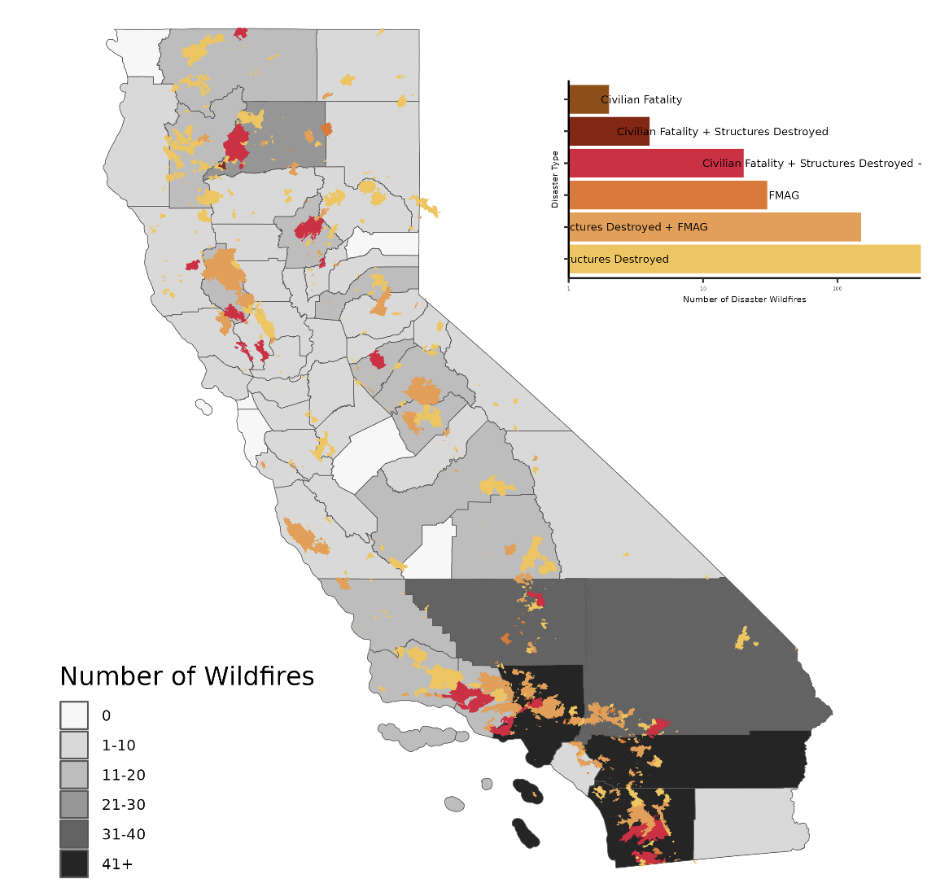

### Technical Validation

We identified X US wildfires between 2000–2019 that destroyed at least one structure, resulted in least one civilian fatality, or received an FMAG declaration. Among these fires, we included 3,391 (X%) with perimeter burn zones; 1,970 (Y%) with buffers approximating burn zones; X (X%) with points of origin only; N (Z%) with county and state of origin only, and N (X%) with only had state information. Of the X wildfires with burn zones (spatial perimeters or circular buffers), a total of XX wildfires additionally met the population density criteria and thus met all criteria of a wildfire disaster (Table 1). We considered these X fires the final spatial wildfire disaster dataset for 2000–2019 in the US.

In order to qualify as a wildfire disaster, wildfires had to destroy at least one structure, cause at least one civilian fatality, or receive an FMAG declaration and overlap with a community. Wildfires that met the population density criterion most commonly qualified as a disaster by also burning a structure (X%) or receiving an FMAG declaration (X%) or both (X%) (**Figure 3**). Least commonly, wildfires qualified as a disaster by killing a civilian (X%), and in these cases, an FMAG declaration almost always co-occurred (X%). Only X wildfires resulted in a direct civilian fatality during the study period and the vast majority occurred in California (X%). Only N wildfires met all four disaster criteria during the study period. In some states, it was more common for wildfires to meet one of the three initial criteria but not the population density criteria. For example...

Generally, counts of wildfire disasters were higher in XYZ. California (n = X) and Florida (n = Z) had the most wildfire disasters during the study period (**Figure 4**).

We noted no temporal trends in wildfire disasters nationwide between 2000–2019. From 2000-2009, the U.S. experienced a median of X wildfire disasters each year, compared to X wildfire disasters each year during 2010-2019. By the three criteria, we did see increased counts of fires doing ZYZ. Within certain states, including Florida, Oregon, North Carolina, and Pennsylvania we did observe increasing trends from 2000-2019 (**Figure 5**). A few states saw declining trends. These included XYZ.

**Figure 5:** **The number of wildfire disasters by US state, 2000–2019.** These wildfires met our disaster criteria: destroyed a structure, caused a civilian fatality, or received an FMAG declaration and overlapped with a community. The y-axis is log-scaled. When a wildfire disaster perimeter overlaps with multiple states, it appears in each of those state panels below. Orange bars indicate the number of wildfire disasters during each state-year.

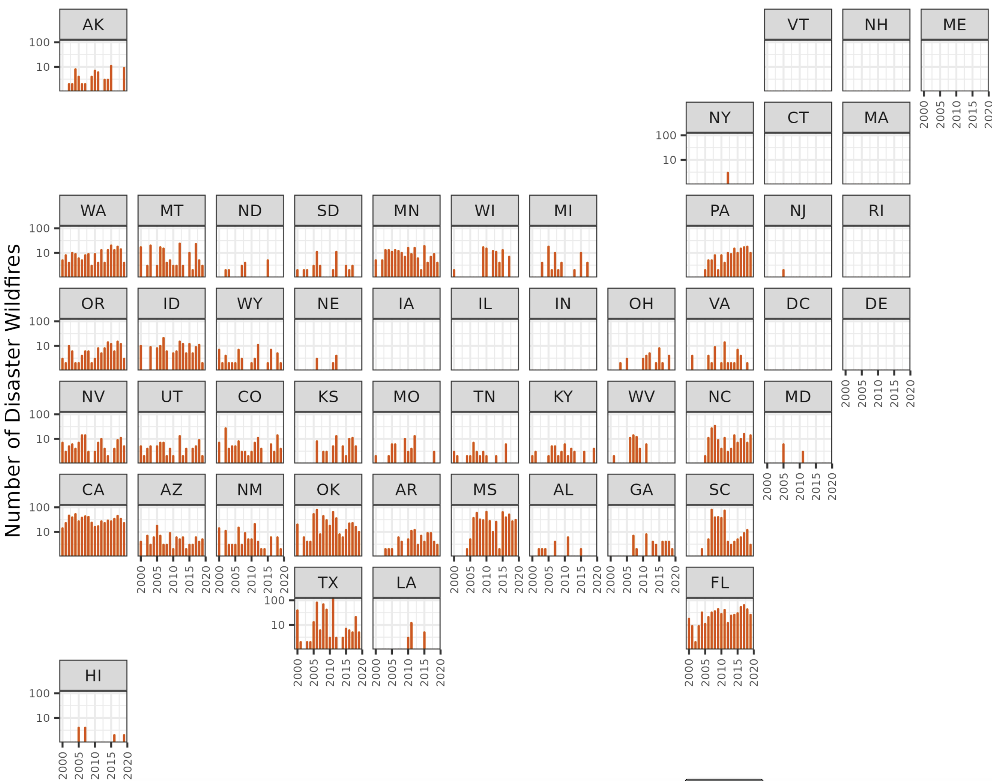

### Code Availability

All the R scripts that we used are publicly available on GitHub. We performed all data cleaning, data harmonization and integration, and summary statistics in R Studio version 2023.03.0+386, primarily using the *tidyverse, dplyr, stringr, lubridate, and sf* packages.

### Acknowledgements

We would like to acknowledge María Navarro for her assistance in locating wildfires in newspaper articles. We received funding from the National Institute on Aging (RF1AG071024) and the National Institutes of Environmental Health Sciences (T32ES007322-22; P30ES007033).

### Author contributions

**Benjamin Steiger**: concept and design; acquisition of data; data cleaning and harmonization; drafting of the manuscript; creation of figures; critical revision of the manuscript for important intellectual content.

**Milo Gordon**: acquisition of data; data cleaning and harmonization; drafting of the manuscript; critical revision of the manuscript for important intellectual content.

**Alexander J. Northrop**: data cleaning and harmonization; critical revision of the manuscript for important intellectual content.

**Heather McBrien**: data cleaning and harmonization; critical revision of the manuscript for important intellectual content.

**Nina Flores**: code review; critical revision of the manuscript for important intellectual content.

**Brittany Shea**: data cleaning and harmonization; critical revision of the manuscript for important intellectual content.

**Gabriella Y. Meltzer**: drafting of the manuscript; critical revision of the manuscript for important intellectual content.

**Neil Singh Bedi**: acquisition of data; data cleaning and harmonization; critical revision of the manuscript for important intellectual content

**Elizabeth M. Blake**: data cleaning and harmonization; production of figures

**Tarik Benmarhnia**: concept and design; critical revision of the manuscript for important intellectual content

**Francesca Dominici**: concept and design; critical revision of the manuscript for important intellectual content

**Danielle Braun**: concept and design; critical revision of the manuscript for important intellectual content

**Joan A. Casey**: concept and design; critical revision of the manuscript for important intellectual content; obtained funding; administrative, technical, or material support. Dr Casey had full access to the data and takes responsibility for the integrity of the dataset.

### Competing interests

The authors declare they have no competing interests.

### Tables

**Table 2**: Summary of disaster criteria met by wildfires in the 2000–2019 dataset.

|  |  |  |  |
| --- | --- | --- | --- |
| **Disaster Criteria** | **Met population density criteriaa** | **Did not meet population density criteriaa** | **Unable to assess population density criteriab** |
| **Met 1 criterium** |  |  |  |
| Structures Destroyed | 2208 | 1640 | 586 |
| FMAG Declaration | 184 | 35 | 149 |
| Civilian Fatality | 17 | 6 | 6 |
| **Met 2 criteria** |  |  |  |
| Structures Destroyed & FMAG Declaration | 361 | 73 | 131 |
| Structures Destroyed & Civilian Fatality | 4 | 3 | 2 |
| FMAG Declaration & Civilian Fatality | 0 | 0 | 0 |
| **Met 3 criteria** |  |  |  |
| Civilian Fatality & Structures Destroyed & FMAG Declaration | 22 | 0 | 3 |
| **Total, n (%)** | 2796 (ADD)  wildfire disasters | 1757 (ADD) | 877 (ADD) |

FMAG, Fire Management Assistance Grant

a After meeting one of the three main disaster criteria (Structures Destroyed, FMAG Declaration, or Civilian Fatality) we assessed whether wildfires met the population density criteria:

b For n = 877 wildfires, we could not assess population density because we lacked granular spatial information, including a wildfire point of origin and acreage or a wildfire perimeter.

**Definitions**

|  |  |  |  |
| --- | --- | --- | --- |
| Standard term we use | Alternative terms in datasets | Definition | Availability by dataset and year |
| Types of wildfire incidents | | | |
| Wildfire incident |  | A fire that occurs in a highly vegetative region that does not include prescribed burns |  |
| Standalone wildfire incident |  | A single wildfire incident that is not part of a wildfire complex  Use St Denis et al as template for definitions |  |
| Wildfire complex |  | Multiple wildfire incidents that happen within a similar timeframe and within close geographic proximity that are assigned to a single incident commander or unified command  See NWFCG for definition |  |
| Wildfire complex member |  | A wildfire incident that is part of a wildfire complex |  |
| Wildfire disaster |  | A standalone wildfire incident, wildfire complex, or wildfire complex member that meets the criteria for a disaster. The criteria are as follows:   1. Results in ≥ 1 civilian fatality 2. Destroys ≥ 1 structure 3. Receives an FMAG Declaration   In addition to meeting one of the 3 criteria above, the wildfire incident/wildfire complex overlaps with a community (population density of 96 people/km2 |  |
| Standalone wildfire disaster |  | A standalone wildfire incident that meets the criteria for a wildfire disaster |  |
| Wildfire disaster complex |  | A wildfire complex that meets the criteria for a wildfire disaster |  |
| Wildfire disaster complex member |  | A wildfire complex member that meets the criteria for a wildfire disaster |  |
| Variables for identifying wildfire disasters | | | |
| Damaged structure |  | Ask Ben what a structure is (see Redbooks, pg 18) |  |
| Destroyed structure |  |  |  |
| Civilian fatality |  |  |  |
| FMAG Declaration |  |  |  |
| Wildland-Urban Interface (WUI) Community |  | A region buffering a wildfire with a population density of 96 people/ km2. For wildfire incidents <1000 acres, the buffering region is 10km. For wildfire incidents >1000 acres, the buffering region is 20km. |  |
| Spatial, temporal, and identifying variables | | | |
| Ignition Date | Ignition date, start date, discovery date | The date that the reporting agency lists as when the wildfire first started burning |  |
| Containment Date | Containment date, end date | The date that the reporting agency lists as the when the wildfire stopped burning  At least 90% of the fire contained  Check CAL FIRE |  |
| Spatial extent |  | The surface area that a wildfire burned, which use either perimeters from spatial datasets or buffers that we made based on the point of origin of a fire and the number of acres burned |  |
| Point of origin |  | Coordinates where the wildfire started |  |
| Wildfire incident name | Incident name, fire name, declaration title |  |  |
| Wildfire complex name |  |  |  |
| Wildfire incident ID |  |  |  |
| Wildfire complex ID |  |  |  |

|  |  |  |
| --- | --- | --- |
| Variable | Meaning | Based on which dataset? |
| year | Year of ignition date |  |
| state | State where the wildfire burned |  |
| disaster_id |  |  |
| Incident_name |  |  |
| Complex_name |  |  |
| Ignition date |  |  |
| Containment date |  |  |
| St_area_acre_final |  |  |
| Ics_209_incident_id_list |  | ICS-209-PLUS |
| Ics_209_incident_name_list |  | ICS-209-PLUS |
| Ics_209_fatalities_public |  | ICS-209-PLUS |
| Ics_209_structures_destroyed_total |  | ICS-209-PLUS |
| Ics_209_cause |  | ICS-209-PLUS |
| Fema_declaration_string_list |  | FEMA |
| Fema_declaration_title_list |  | FEMA |
| Fema_designated_area_list |  | FEMA |
| Fema_fips_county_code_list |  | FEMA |
| Redbook_incident_number_list |  | Redbooks |
| Redbook_fire_name_list |  | Redbooks |
| Redbook_cause |  | Redbooks |
| Redbook_civilian_fatalities |  | Redbooks |
| Redbook_structures_destroyed |  | Redbooks |
| Perimeter_source |  |  |
| Mtbs_fire_list |  | MTBS |
| Mtbs_event_id |  | MTBS |
| Fired_id |  | FIRED |
| Usgs_assigned_id |  | USGS |
| Usgs_listed_fire_names |  | USGS |
| Geomac_uniquefireidentifier |  | GEOMAC |
| Geomac_incidentname |  | GEOMAC |
| Nifc_unqe_fire |  | NIFC |
| Nifc_incident |  | NIFC |
| Ics_209_poo_latitude | Latitude of the point of origin according to ICS-209 | ICS-209-PLUS |
| Ics_209_poo_longitude | Latitude of the point of origin according to ICS-209 | ICS-209-PLUS |
| Civilian_fatality_y_n |  | We made based on ICS-209-PLUS and Redbooks data |
| Structures_destroyed_y_n |  | We made based on ICS-209-PLUS or Redbooks |
| Fm_declaration_y_n |  | We made based on FEMA |
| Disaster_type |  | We made |
| Disaster_type_factor |  | We made |
| County_geoid_list |  |  |
| size |  |  |
| Kde_value |  | We made based on SocScape data |
| Density_criteria_met |  |  |
| shape |  |  |

|  |  |  |  |  |
| --- | --- | --- | --- | --- |
| Dataset Name | Number of total fires within study period | Geographic extent | Time period | Inclusion Criteria |
| ICS-209-PLUS |  |  |  |  |
| FMAG |  |  |  |  |
| RedBooks |  |  |  |  |
| MTBS | 22,714 |  |  |  |
| FIRED |  |  |  |  |
| USGS |  |  |  |  |
| GeoMAC |  |  |  |  |
| Interagency |  |  |  |  |

|  |  |  |
| --- | --- | --- |
| Data record | Number | Projection |
| Final_binded_conus_disaster_fires_2000_2019 |  |  |
| Final_binded_ak_disaster_fires_2000_2019 |  |  |
| Final_binded_hi_disaster_fires_2000_2019 |  |  |

|  |  |  |  |  |  |
| --- | --- | --- | --- | --- | --- |
| Matching approach | MTBS  N (%) | FIRED | USGS | GeoMAC | Interagency |
| Incident ID variable | X (%) | 1,304 (40.3%) |  |  |  |
| Name, year, and state | X (%) |  | X (%) | X (%) | X (%) |
| Intersection between points of origin and perimeters |  |  | X (%) |  |  |
| TOTAL | 1,774 (32.2%) | 1,304 (40.3%) |  |  |  |

### References

1. National Oceanic and Atmospheric Administration. Wildfire climate connection. <https://www.noaa.gov/noaa-wildfire/wildfire-climate-connection>. Published 2023. Updated July 24, 2023. Accessed July 11, 2023.

2. U.S. Environmental Protection Agency. Climate Change Indicators: Wildfires. US Environmental Protection Agency. <https://www.epa.gov/climate-indicators/climate-change-indicators-wildfires#ref4>. Published 2022. Updated March 21, 2023. Accessed July 11, 2023.

3. Dennison PE, Brewer SC, Arnold JD, Moritz MA. Large wildfire trends in the western United States, 1984–2011. *Geophysical Research Letters.* 2014;41(8):2928-2933.

4. Abatzoglou JT, Williams AP. Impact of anthropogenic climate change on wildfire across western US forests. *Proc Natl Acad Sci U S A.* 2016;113(42):11770-11775.

5. Zhuang Y, Fu R, Santer BD, Dickinson RE, Hall A. Quantifying contributions of natural variability and anthropogenic forcings on increased fire weather risk over the western United States. *Proc Natl Acad Sci U S A.* 2021;118(45).

6. Wehner MF, J.R. Arnold, T. Knutson, K.E. Kunkel, and A.N. LeGrande. Droughts, floods, and wildfires. In: Wuebbles DJ, D.W. Fahey, K.A. Hibbard, D.J. Dokken, B.C. Stewart, and T.K. Maycock, ed. *Climate Science Special Report: Fourth National Climate Assessment.* Vol I. Washington, DC, USA: U.S. Global Change Research Program; 2017.

7. Cardil A, de-Miguel S, Silva CA, et al. Recent deforestation drove the spike in Amazonian fires. *Environmental Research Letters.* 2020;15(12):121003.

8. Brown M, Fassett, C., Whittle, P., McConnaughey, J., Lo, J. Storms batter aging power grid as climate disasters spread. *AP News.* 2022. <https://apnews.com/article/wildfires-storms-science-business-health-7a0fb8c998c1d56759989dda62292379>. Published April 5, 2022. Accessed 2022.

9. Radeloff VC, Helmers DP, Kramer HA, et al. Rapid growth of the US wildland-urban interface raises wildfire risk. *Proc Natl Acad Sci U S A.* 2018;115(13):3314-3319.

10. Leber R. How power companies have caused and worsened wildfires. *Vox.* 2022. <https://www.vox.com/science-and-health/2022/9/13/23345164/california-wildfires-heat-blackouts-burning>. Published Sep 13, 2022. Accessed 2022.

11. Penn I, Eavis, P. Hawaiian Electric Was Warned of Its System’s Fragility Before Wildfire. *New York Times.* 2023. <https://www.nytimes.com/2023/08/19/business/energy-environment/hawaiian-electric-maui-wildfire-climate-change.html>. Published Aug 19, 2023. Accessed 2023.

12. Kumagai Y, Carroll MS, Cohn P. Coping with Interface Wildfire as a Human Event: Lessons from the Disaster/Hazards Literature. *Journal of Forestry.* 2004;102(6):28-32.

13. McFarlane AC, Norris, F.H. Methods for Disaster Mental Health Research. In:2006.

14. Barnett J, Dennis-Rouse M, Martinez V. Wildfire disaster leads to facilities evacuation. *Orthop Nurs.* 2009;28(1):17-20.

15. Karmarkar E, Jain S, Higa J, et al. Outbreak of Norovirus Illness Among Wildfire Evacuation Shelter Populations - Butte and Glenn Counties, California, November 2018. *Morbidity and Mortality Weekly Report.* 2020;69(20):613-617.

16. McCaffrey S, Wilson R, Konar A. Should I Stay or Should I Go Now? Or Should I Wait and See? Influences on Wildfire Evacuation Decisions. *Risk Anal.* 2018;38(7):1390-1404.

17. Hurteau MD, Westerling AL, Wiedinmyer C, Bryant BP. Projected effects of climate and development on California wildfire emissions through 2100. *Environ Sci Technol.* 2014;48(4):2298-2304.

18. Afolabi MO. Public Health Disasters: A Global Ethical Framework. 2018;12:1–24.

19. International Federation of the Red Cross. What is a disaster? International Federation of the Red Cross. <https://www.ifrc.org/our-work/disasters-climate-and-crises/what-disaster>. Accessed July 11, 2023.

20. Thériault L, Belleville G, Ouellet MC, Morin CM. The Experience and Perceived Consequences of the 2016 Fort McMurray Fires and Evacuation. *Front Public Health.* 2021;9:641151.

21. Campbell S. Wildfires. Congressional Budget Office. <https://www.cbo.gov/publication/58212>. Published 2022. Updated June 2022. Accessed2021.

22. Federal Emergency Management Agency. OpenFEMA Dataset: Disaster Declarations Summaries - v2. In: Agency FEM, ed2023.

23. Federal Emergency Management Agency. *Fire Management Assistance Grant Program and Policy Guide.* 2021.

24. Masters J. Reviewing the horrid global 2020 wildfire season. *Yale Climate Connections.* 2021. <https://yaleclimateconnections.org/2021/01/reviewing-the-horrid-global-2020-wildfire-season/>. Published January 4, 2021. Accessed 2021.

25. Butler K, Butry, D., Forney, G.P., Johnsson, E.L., Link, E., Maranghides, A., Prasad, K. Wildland-Urban Interface (WUI) Fire Data Collection on Parcel Vulnerabilities. <https://www.nist.gov/programs-projects/wildland-urban-interface-wui-fire-data-collection-parcel-vulnerabilities>. Published 2021. Updated June 2, 2021. Accessed November 21, 2023.

26. Kabeshita L, Sloat LL, Fischer EV, et al. Pathways framework identifies wildfire impacts on agriculture. *Nature Food.* 2023;4(8):664-672.

27. Hohner AK, Rhoades CC, Wilkerson P, Rosario-Ortiz FL. Wildfires Alter Forest Watersheds and Threaten Drinking Water Quality. *Accounts of Chemical Research.* 2019;52(5):1234-1244.

28. LaPier RR. Analysis: Burning of Lahaina’s sacred sites is a major loss for Native Hawaiians. But their history will live on. *PBS News Hour.* 2023. <https://www.pbs.org/newshour/nation/analysis-burning-of-lahainas-sacred-sites-is-a-major-loss-for-native-hawaiians-but-their-history-will-live-on>. Published August 12, 2023. Accessed 2023.

29. Peters J. First Nations lament cultural losses to B.C. wildfires. *CBC News.* 2023. <https://www.cbc.ca/news/canada/british-columbia/first-nations-wildfires-cultural-losses-1.6945729>. Published August 24, 2023. Accessed 2023.

30. Kelleher JS, Hong, J.C. Maui fires renew centuries-old tensions over water rights. The streams are sacred to Hawaiians. *AP News.* 2023. <https://apnews.com/article/hawaii-maui-fires-water-streams-531263684bf5106d635f29aec91115e4>. Published August 24, 2023. Accessed 2023.

31. Humphreys A, Walker EG, Bratman GN, Errett NA. What can we do when the smoke rolls in? An exploratory qualitative analysis of the impacts of rural wildfire smoke on mental health and wellbeing, and opportunities for adaptation. *BMC Public Health.* 2022;22(1):41.

32. Hamideh S, Sen P, Fischer E. Wildfire impacts on education and healthcare: Paradise, California, after the Camp Fire. *Natural Hazards.* 2022;111(1):353-387.

33. Schulze SS, Fischer, E. C., Hamideh, S. & Mahmoud, H. . Wildfire impacts on schools and hospitals following the 2018 California Camp Fire. *Nat Hazards.* 2020;104:901-925.

34. Western Fire Chiefs Association. How Far Can Wildfire Smoke Travel? <https://wfca.com/wildfire-articles/how-far-can-wildfire-smoke-travel/#:~:text=Wildfire%20smoke%20can%20travel%20long,be%20exposed%20to%20its%20smoke>. Published 2023. Updated November 8, 2023. Accessed2021.

35. U.S. Environmental Protection Agency. Why Wildfire Smoke is a Health Concern. <https://www.epa.gov/wildfire-smoke-course/why-wildfire-smoke-health-concern>. Published 2023. Updated October 13, 2023. Accessed December 1, 2023.

36. Chen K, Ma Y, Bell ML, Yang W. Canadian Wildfire Smoke and Asthma Syndrome Emergency Department Visits in New York City. *JAMA.* 2023;330(14):1385-1387.

37. Adetona O, Reinhardt TE, Domitrovich J, et al. Review of the health effects of wildland fire smoke on wildland firefighters and the public. *Inhal Toxicol.* 2016;28(3):95-139.

38. Gao Y, Huang W, Yu P, et al. Long-term impacts of non-occupational wildfire exposure on human health: A systematic review. *Environ Pollut.* 2023;320:121041.

39. Grant E, Runkle JD. Long-term health effects of wildfire exposure: A scoping review. *The Journal of Climate Change and Health.* 2021:100110.

40. Holm SM, Miller MD, Balmes JR. Health effects of wildfire smoke in children and public health tools: a narrative review. *J Expo Sci Environ Epidemiol.* 2021;31(1):1-20.

41. Liu JC, Pereira G, Uhl SA, Bravo MA, Bell ML. A systematic review of the physical health impacts from non-occupational exposure to wildfire smoke. *Environ Res.* 2015;136:120-132.

42. Reid CE, Brauer M, Johnston FH, Jerrett M, Balmes JR, Elliott CT. Critical Review of Health Impacts of Wildfire Smoke Exposure. *Environ Health Perspect.* 2016;124(9):1334-1343.

43. Rifkin DI, Long MW, Perry MJ. Climate change and sleep: A systematic review of the literature and conceptual framework. *Sleep Med Rev.* 2018;42:3-9.

44. To P, Eboreime E, Agyapong VI. The impact of wildfires on mental health: A scoping review. *Behavioral Sciences.* 2021;11(9):126.

45. Zhang Y, Workman A, Russell MA, Williamson M, Pan H, Reifels L. The long-term impact of bushfires on the mental health of Australians: a systematic review and meta-analysis. *Eur J Psychotraumatol.* 2022;13(1):2087980.

46. Gould CF, Heft-Neal S, Prunicki M, Aguilera J, Burke M, Nadeau K. Health Effects of Wildfire Smoke Exposure. *Annual Review of Medicine.* 2023;75.

47. National Academies of Sciences Engineering and Medicine, Division on Earth and Life Studies, Board on Chemical Sciences and Technology, Committee on the Chemistry of Urban Wildfires. The National Academies Collection: Reports funded by National Institutes of Health. In: *The Chemistry of Fires at the Wildland-Urban Interface.* Washington (DC): National Academies Press (US)

Copyright 2022 by the National Academy of Sciences. All rights reserved.; 2022.

48. Holm SM, Miller MD, Balmes JR. Health effects of wildfire smoke in children and public health tools: a narrative review. *Journal of Exposure Science & Environmental Epidemiology.* 2021;31(1):1-20.

49. Aguilera R, Corringham T, Gershunov A, Benmarhnia T. Wildfire smoke impacts respiratory health more than fine particles from other sources: observational evidence from Southern California. *Nat Commun.* 2021;12(1):1493.

50. Eisenman DP, Galway LP. The mental health and well-being effects of wildfire smoke: a scoping review. *BMC Public Health.* 2022;22(1):2274.

51. Mottershead KD, McGee TK, Christianson A. Evacuating a First Nation Due to Wildfire Smoke: The Case of Dene Tha’ First Nation. *International Journal of Disaster Risk Science.* 2020;11(3):274-286.

52. Warsini S, West C, Ed Tt GD, Res Meth GC, Mills J, Usher K. The psychosocial impact of natural disasters among adult survivors: an integrative review. *Issues Ment Health Nurs.* 2014;35(6):420-436.

53. Silveira S, Kornbluh M, Withers MC, Grennan G, Ramanathan V, Mishra J. Chronic Mental Health Sequelae of Climate Change Extremes: A Case Study of the Deadliest Californian Wildfire. *Int J Environ Res Public Health.* 2021;18(4).

54. Verstraeten BSE, Elgbeili G, Hyde A, King S, Olson DM. Maternal Mental Health after a Wildfire: Effects of Social Support in the Fort McMurray Wood Buffalo Study. *Can J Psychiatry.* 2021;66(8):710-718.

55. Belleville G, Ouellet MC, Lebel J, et al. Psychological Symptoms Among Evacuees From the 2016 Fort McMurray Wildfires: A Population-Based Survey One Year Later. *Front Public Health.* 2021;9:655357.

56. Jones RT, Ribbe DP, Cunningham P. Psychosocial correlates of fire disaster among children and adolescents. *J Trauma Stress.* 1994;7(1):117-122.

57. Psarros C, Theleritis C, Economou M, et al. Insomnia and PTSD one month after wildfires: evidence for an independent role of the "fear of imminent death". *Int J Psychiatry Clin Pract.* 2017;21(2):137-141.

58. Wasiak J, Mahar P, Lee S, et al. 12-month generic health status and psychological distress outcomes following an Australian natural disaster experience: 2009 Black Saturday Wildfires. *Injury.* 2013;44(11):1443-1447.

59. Jones RT, Ribbe DP, Cunningham PB, Weddle JD, Langley AK. Psychological impact of fire disaster on children and their parents. *Behav Modif.* 2002;26(2):163-186.

60. Agyapong B, Eboreime E, Shalaby R, et al. Mental Health Impacts of Wildfire, Flooding and COVID-19 on Fort McMurray School Board Staff and Other Employees: A Comparative Study. *Int J Environ Res Public Health.* 2021;19(1).

61. Sugg MM, Runkle JD, Hajnos SN, Green S, Michael KD. Understanding the concurrent risk of mental health and dangerous wildfire events in the COVID-19 pandemic. *Sci Total Environ.* 2022;806(Pt 1):150391.

62. McBrien H, Rowland ST, Benmarhnia T, Tartof SY, Steiger B, Casey JA. Wildfire Exposure and Health Care Use Among People Who Use Durable Medical Equipment in Southern California. *Epidemiology.* 2023;34(5):700-711.

63. Marshall GN, Schell TL, Elliott MN, Rayburn NR, Jaycox LH. Psychiatric disorders among adults seeking emergency disaster assistance after a wildland-urban interface fire. *Psychiatr Serv.* 2007;58(4):509-514.

64. Brown MRG, Agyapong V, Greenshaw AJ, et al. Significant PTSD and Other Mental Health Effects Present 18 Months After the Fort Mcmurray Wildfire: Findings From 3,070 Grades 7-12 Students. *Front Psychiatry.* 2019;10:623.

65. Stokes SC, Romanowski KS, Sen S, Greenhalgh DG, Palmieri TL. Wildfire Burn Patients: A Unique Population. *J Burn Care Res.* 2021.

66. Zane D, Henry J, Lindley C, et al. *Wildfire-related deaths--Texas, March 12-20, 2006.*  Aug 3 2007. 0149-2195.

67. Fonseca A, Vagos P, Moreira H, Pereira J, Canavarro MC, Rijo D. Psychometric Properties of the Portuguese Version of the Child Post-traumatic Cognitions Inventory in a Sample of Children and Adolescents Following a Wildfire Disaster. *Child Psychiatry Hum Dev.* 2020;51(6):876-887.

68. Grant E, Runkle JD. Long-term health effects of wildfire exposure: A scoping review. *The Journal of Climate Change and Health.* 2022;6:100110.

69. Mayner L. AP. Defining disaster: The need for harmonisation of terminology. *Australasian Journal of Disaster and Trauma Studies.* 2015;19:21-25.

70. Tedim F, Leone, V. The Dilemma of Wildfire Definition: What It Reveals and What It Implies. *Front For Glob Change.* 2020;3.

71. National Interagency Fire Center. InterAgencyFirePerimeterHistory All Years View. In:2022.

72. Welty JL, Jeffries MI. Combined wildland fire datasets for the United States and certain territories, 1800s-Present. 2021.

73. St. Denis LA, Mietkiewicz NP, Short KC, Buckland M, Balch JK. All-hazards dataset mined from the US National Incident Management System 1999–2014. *Scientific Data.* 2020;7(1):64.

74. Short KC. Spatial wildfire occurrence data for the United States, 1992-2020 [FPA_FOD_20221014]. In: Archive FSRD, ed. 6th edition ed. Fort Collins, CO2022.

75. Schulze SS, Fischer, E. C., Hamideh, S. & Mahmoud, H. . Wildfire impacts on schools and hospitals following the 2018 California Camp Fire. *Natural Hazards.* 2020;104(1):901-925.

76. Department of Agriculture, Forest Service, Department of the Interior, et al. *USDA and USDI (2001) Urban wildland interface communities within vicinity of federal lands that are at high risk from wildfire. FR 66:.* 2001.

77. National Wildfire Coordinating Group. Terminology. InciWeb Incident Information System Web site. <https://inciweb.nwcg.gov/terminology>. Accessed September 29, 2023.

78. St. Denis LA, Short KC, McConnell K, et al. All-hazards dataset mined from the US National Incident Management System 1999–2020. *Scientific Data.* 2023;10(1):112.

79. Federal Emergency Management Agency. INCIDENT STATUS SUMMARY (ICS 209). <https://training.fema.gov/emiweb/is/icsresource/assets/ics%20forms/ics%20form%20209,%20incident%20status%20summary%20(v3).pdf>. Accessed2021.

80. Denis LS, Mietkiewicz N, Short K, Buckland M, Balch J. ICS-209-PLUS - An all-hazards dataset mined from the US National Incident Management System 1999-2014. doi:10.6084/m9.figshare.8048252.v10. 2019.

81. Federal Emergency Management Agency. OpenFEMA Dataset: Disaster Declarations Summaries - v2. <https://www.fema.gov/openfema-data-page/disaster-declarations-summaries-v2>. Published 2023. Accessed Aug 5, 2022.

82. Cal Fire. Redbooks. In:2021.

83. Department of Agriculture, Forest Service, Department of the Interior, U.S. Geological Survey. Burned Areas Boundaries Dataset 1984-2022. In.

84. Mahood AL, Lindrooth, E.J., Mietkiewicz, N.P., Cook, M.C., Balch, J.K., Williams, T., McGlinchy, J., St. Denis, L.A. FIRED CONUS-AK. In. Boulder, Colorado2021.

85. Balch JK, St. Denis LA, Mahood AL, et al. FIRED (Fire Events Delineation): An Open, Flexible Algorithm and Database of US Fire Events Derived from the MODIS Burned Area Product (2001–2019). *Remote Sensing.* 2020;12(21):3498.

86. Welty JL, Jeffries MI. Combined wildland fire datasets for the United States and certain territories, 1800s-Present. In: Survey USG, ed2021.

87. National Interagency Fire Center. Historic Perimeters Combined 2000-2018 GeoMAC. In:2019.

88. National Interagency Fire Center. Historic Perimeters 2019. In:2020.

89. McClendon S., Kuenzi J., Kafka J., et al. InterAgencyFirePerimeterHistory All Years View. In:2023.

90. Manson S, Schroeder J, Riper DV, Ruggles S. IPUMS National Historical Geographic Information System: Version 13.0 [Database]. University of Minnesota. <http://doi.org/10.18128/D050.V12.0>. Published 2023. Accessed October 10, 2020.

91. A. Dmowska TFS, P. Netzel. SocScape - mapping residential segregation and racial diversity. In:2017.

92. Dmowska A ST, Netzel P Comprehensive framework for visualizing and analyzing spatio-temporal dynamics of racial diversity in the entire United States. *PLoS ONE.* 2017;12(3).

93. Dmowska A ST, Netzel P. Comprehensive framework for visualizing and analyzing spatio-temporal dynamics of racial diversity in the entire United States. . *PLoS ONE.* 2017;12(3):e0174993.