LUKE PIERCE

SOFTWARE ENGINEER

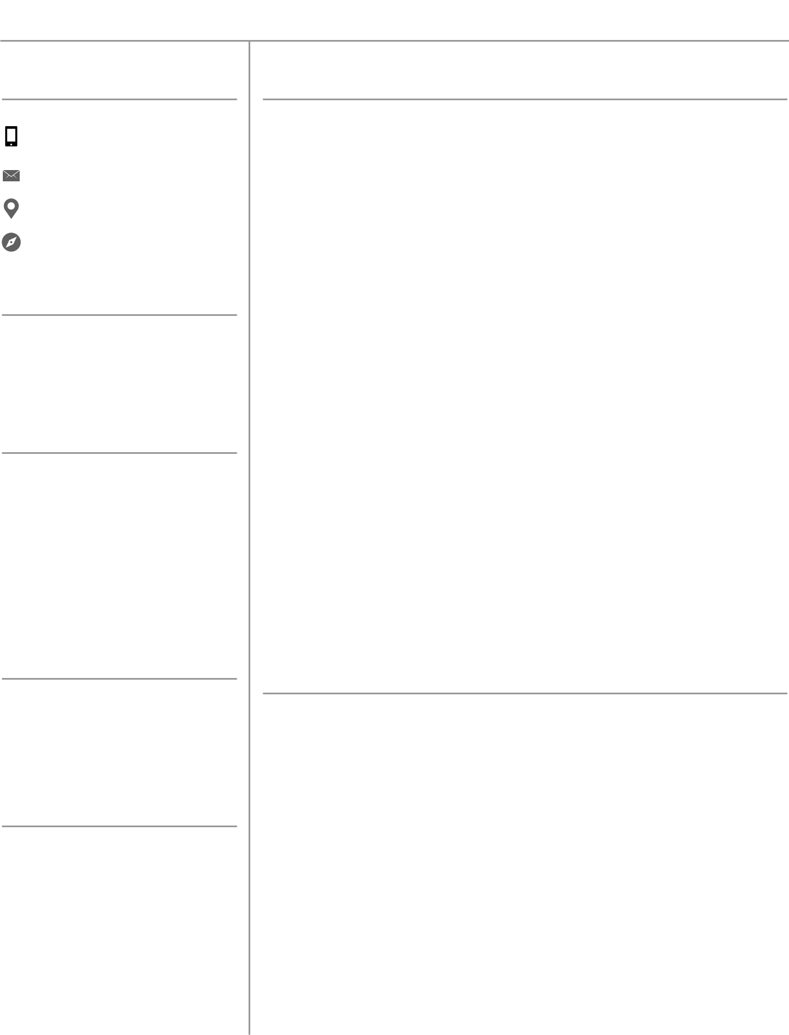

CONTACT

Cell | 720.854.9774 Work | 303.344.6262

luke.pierce@raytheon.com Lakewood, CO, USA www.github.com/lpierce1313

EDUCATION

B.S Electrical Engineering

Colorado School of Mines Golden, CO | 2016 - 2018 | 3.76

CERTIFICATES

* Responsive Web Design
* Javascript Algorithms and Data Structures
* Front-end Libraries
* Data Visualization
* APIs and Microservices

LANGUAGES

C++, C, Java, Javascript, HTML, CSS, jQuery, NodeJS, HFSS, Verilog HDL, Python, Matlab, PH, MySQL, Ruby

AWARDS

Outstanding Graduating Senior

Represented the Electrical Engineering department for high scholastic achievement and active involvement within my department

Dean’s List

Recognized for academic achievement by the dean of Colorado School of Mines.

EXPERIENCE

Software Engineer I

Raytheon | Aurora, CO | May 2019 - Present

Develops software solutions by studying information needs; conferring with users; studying systems flow, data usage, and work processes; investigating problem areas; following the software development lifecycle.

Electrical Engineer Intern

Vortek Instruments, LLC | Longmont, CO | May 2018 - May 2019

I developed a modbus web program in NodeJS which opened a virtual comport. It had the ability to read and write data back and forth from a flow meter simulator. I enabled the functionality of an existing simulator program which was originally written in C++ to work with the NodeJS V8 engine on a web application. I used a netburner device to update an existing and outdated web application to look more modern and run more quickly.

Software Development Intern

Digiquatics | Lakewood, CO | May 2017 - March 2018

I worked as a Full Stack web developer using Ruby and Rails, AngularJS, CoffeeScript, MySQL, and Rspec. I gained database experience as this was my first time using MySQL; I had to deal with thousands of records containing user information. I added new features to the existing web application, made existing features perform better, and performed various tests using Rspec to ensure the application was working correct and as expected for the company.

PROJECTS

Antenna Glasses

Colorado School of Mines | Golden, CO | Fall 2017 - Spring 2018

Worked with Ball Aerospace and my team at Colorado School of Mines to design a pair of glasses that had an embedded dipole antenna on the inside of the left arm. The frame was developed in SolidWorks and the antenna in HFSS. The model was then 3D printed at UTEP and then tested at the Ball facility.

The Ideal Solar Cell

Colorado School of Mines | Golden, CO | Fall 2017

Developed a program in Matlab simulated how solar cells convert sunlight to solar energy in order to determine solutions to improve its efficiency.

References available upon request