Python Functions – Worksheet 2
CDS 230
Spring 2018

Problem
Use the function from the first problem in the Python Functions – Worksheet 1. (In my examples, I named the function by the name of Function. You can use any name that is valid.) Add the help comments to the function so that the popup help looks like Figure 1 and the full help should look like Figure 2.
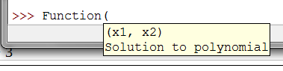Figure 1: Popup help.
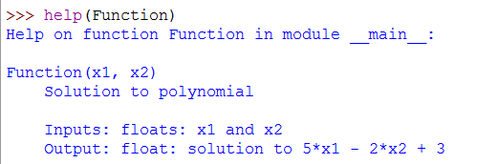Figure 2: The full help.

def problem1n1(x1, x2):
"""Solution to polynomial

Inputs: floats: x1 and x2
Outputs: float: solution to 5*x1 - 2*x2 + 3
"""
return 5*x1 - 2*x2 + 3

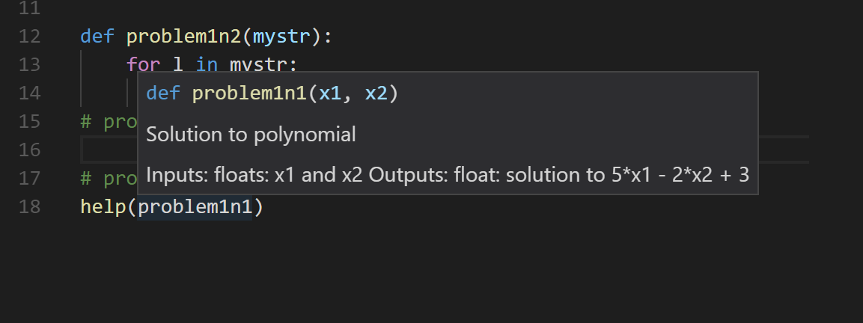
Help on function problem1n1 in module __main__:

problem1n1(x1, x2)
Solution to polynomial

Inputs: floats: x1 and x2
Outputs: float: solution to 5*x1 - 2*x2 + 3

