Solution “Gatw”.

**Framework:** NetCore 3.1

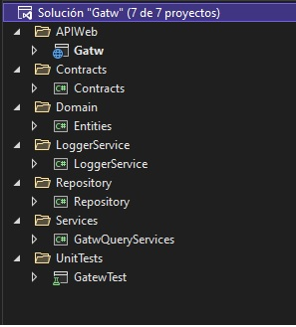

Projects:

* **Gatw:** Contains controllers (DevicesController, GatewayController), internal_logs and logs folders, migration files. ExceptionMiddlewareExtensions to handler all exceptions of the API and ServicesExceptions to configurate services.

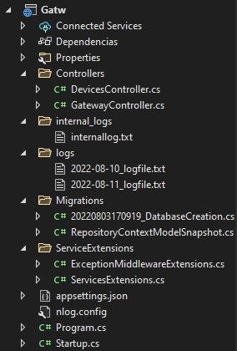

* **Contracts:** Maintains the interfaces.

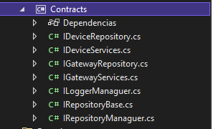

**Entities:** Contains the entities in the folder Models(Gateway,Device), RepositoryContext for communication with the database.Folder Configuration contains configuration classes for populate databse with some initial data. ErrorDetails for the details of error message.RequestFeatures for paging results.

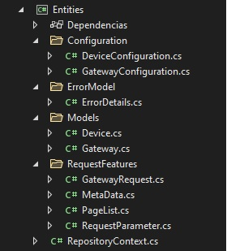

* **LoggerService:** Contains logger logic of the application in LoggerManaguer.



* **Repository:** Generic repository that provide the CRUD methods.

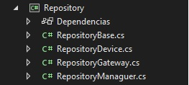

**GatwQueryServices:** Contains Data Transfer Objects, classes to mapping objects in Profiles folder and business logic in the classes DeviceQueryServices, GatewayQueryServices.

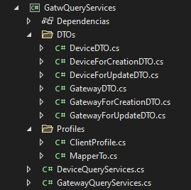

* **GatewTest:** Contains classes to test configuration (AppDbMeConfiguration,AppDbContextInMemory) and unit test classes (DeviceUnitTest,GatewayUnitTest).

