Article

Auditable Evidence Binding for Large Language Model-Assisted Post-Alarm Diagnosis in Industrial Sensor Time Series
Wu Zhang 1,†, Tianwu Lei 1,†, Luo Xiao 1,† and Yong Yang 2,*
1 LAPLACE Renewable Energy Technology Co., Ltd., 20th Floor, Building A, Kaiwo Building, No. 2 Litian Road, Kengzi Street, Pingshan District, Shenzhen 518118, China; john.jiang@laplace-tech.com (W.Z.); tianwu.lei@laplace-tech.com (T.L.); roy@laplace-tech.com (L.X.)
2 School of Electronics and Information Engineering, Tiangong University, Tianjin 300387, China; yangyong@tiangong.edu.cn (Y.Y.)
* Correspondence: yangyong@tiangong.edu.cn
† These authors contributed equally to this work.

Highlights

What are the main findings?
- Evidence binding separates structure, provenance, and semantic support.
- Counterfactual tests show citations respond to sensor content.

What are the implications of the main findings?
- Deterministic checks reject invalid records before human review.
- Evidence quality and safety gates bound diagnostic claims and actions.

Abstract
Industrial sensor alarms identify intervals requiring attention, but engineers must still determine which observations support a diagnosis and when the available evidence is insufficient. Large language models (LLMs) can organize sensor observations into explanations, yet a valid output format or an allowed citation identifier does not establish diagnostic support. We propose an auditable context evidence package that binds each candidate diagnosis to supporting and contradicting observations, missing information, and event-local provenance. A deterministic audit layer checks record structure, evidence ownership, provenance consistency, and permitted actions before human review. Evaluation uses 137 retrospective alarm records nested in 50 HAI clusters and 500 independent Tennessee Eastman Process runs, with paired baselines, counterfactual perturbations, known fault labels, and identity-masked automated evaluation. Constrained generation improved first-pass schema compliance, while counterfactual tests showed that citations responded to sensor content and that inconsistent event content increased insufficient-evidence selection or human escalation. On the Tennessee Eastman Process, the complete package improved macro-averaged top-1 recall from 0.612 to 0.742 and the rate of objectively correct labels with explanations judged supported from 0.548 to 0.714. The package provides an auditable interface for post-alarm review with separately testable structural validity, provenance integrity, and semantic support. These results do not establish physical causal root causes or safety for autonomous control.
Keywords: industrial sensor time series; post-alarm diagnosis; evidence provenance; large language models; structured generation; counterfactual evaluation; safety gating

1. Introduction
Industrial sensor systems continuously monitor process measurements and actuator states to identify abnormal operation. An alarm, however, is only the beginning of an engineering investigation. A reviewer must determine which variables changed, when the changes occurred, how the observations relate to a candidate fault, and whether the available information justifies further action. Post-alarm diagnosis therefore requires more than locating an anomalous interval: it requires a traceable account of the evidence for and against each proposed explanation. This study addresses that downstream handoff while keeping the upstream detector and its alarm stream fixed.
Existing research provides several components for this task. Reconstruction, graph-based, and transformer-based detectors identify unusual patterns in multivariate measurements [1–3]. Explainable sensor-fault methods expose informative variables, subsequences, and correlations for investigation [4–6]. Retrieval-augmented generation and citation-aware language generation offer ways to connect generated text to external information [7–9]. These directions make LLM-assisted post-alarm diagnosis plausible, but their outputs answer different questions: whether a pattern is abnormal, which observations appear informative, or which sources are cited. A diagnostic record must additionally state how a particular observation supports or contradicts a particular explanation.
The central difficulty is that structural validity, provenance integrity, and semantic support can diverge. A record may satisfy a JSON schema yet refer to an observation from another event; a citation may resolve to an allowed identifier yet fail to support the associated diagnosis. In industrial processes, a highly ranked variable may also reflect a control response rather than the source of a fault, while a window-level summary may obscure a transient or propagation delay. Consequently, neither fluent explanations nor valid identifiers provide sufficient evidence of diagnostic quality. What is needed is a claim-local evidence contract that preserves the sensor context and makes structural, provenance, and safety requirements enforceable outside the LLM.
We propose an auditable context evidence package to implement this contract. Multiview candidate-observation cards retain sensor deviations, temporal features, process roles, and quality information. Randomized event-local aliases connect the model-visible cards to an external registry containing source coordinates, file hashes, extractor versions, and content digests. Each candidate diagnosis separately records supporting observations, contradicting observations, missing information, confidence, and a permitted action. A deterministic audit layer validates the schema, resolves evidence references within the current event, checks provenance, and applies default-deny safety gates. The LLM proposes fault-signature hypotheses for review; it does not establish physical root causes or authorize equipment control.
The evaluation separates these responsibilities using retrospective HAI alarms and independent Tennessee Eastman Process (TEP) runs. With the evidence held fixed, constrained generation increased first-pass strict-schema compliance from 0.701 to 0.978. Identifier-copying controls showed that a perfect allowed-set citation score can be obtained without a diagnostic explanation. In paired attribute–identifier permutations, content-following citations exceeded retention of the original identifiers by 58.2 percentage points. On TEP, the complete package improved macro-averaged top-1 recall by 13.0 percentage points and the rate of objectively correct labels with explanations judged supported by 16.6 percentage points relative to an information-matched summary. Label correctness was scored deterministically; explanation support was assessed by an identity-masked automated evaluator. These results assess evidence responsiveness and fault-signature recognition, rather than physical causality or human-expert validation.
The contributions are threefold. First, we introduce a claim-local sensor-evidence contract that combines support and contradiction fields, event-local aliases, external provenance, runtime evidence checks, and deterministic safety gates. Second, we establish a paired evaluation protocol that distinguishes structural compliance, identifier shortcuts, content responsiveness, fault recognition, explanation support, and safety while preserving event and cluster dependence and retaining failures in the relevant denominators. Third, we evaluate the package on HAI and TEP with two generation-model families, demonstrating improvements in structural compliance and supported fault diagnosis and identifying the limits of citation-validity metrics. Detailed related work follows in Section 2; the method and experimental evaluation are presented separately thereafter.

2. Related Work

2.1. Industrial Time-Series Anomaly Detection and Evaluation
Industrial time-series anomaly detection uses several forms of temporal and cross-variable modeling. Reconstruction-based methods include USAD [1], stacked autoencoders [10], and outlier-aware autoencoders [11]. Graph-based methods model relationships among variables [2,12], while hierarchical inter-metric and temporal embeddings combine variable and temporal information [13]. Measurement-based industrial-control studies explore unsupervised and other machine-learning approaches [14,15]; complementary methods use masked prediction [16], residual similarity [17], and recurrent ensembles [18]. Transformer-based TranAD [3] and KAN-AD [19] extend the anomaly-detection model family. TimesNet, FITS, and ModernTCN provide further architectures for general time-series analysis [20–22]. These approaches supply alarm intervals or candidate variable information, which the present method accepts as upstream inputs.
Public benchmarks expose different aspects of industrial monitoring. HAI [23,24] and SWaT [25] provide industrial-control testbeds, TEP offers a simulated process with known fault types [26,27], and SECOM contains anonymized manufacturing measurements [28]. Evaluation studies show that time-series accuracy metrics and industrial intrusion-detection protocols can materially affect reported performance [29,30]. This motivates explicit separation of detection quality from post-alarm record quality. In the present study, HAI supports alarm provenance and paired evidence perturbations, whereas TEP supplies known fault labels for semantic assessment; the evidence package does not modify upstream detector outputs.

2.2. Explainable Industrial Diagnosis and Time-Series Foundation Models
Industrial explainability seeks to make unusual behavior interpretable through simple detection mechanisms [31], sensor-fault explanations [4], shapelets [5], correlations [6], and comprehensible intrusion detection [32]. Process-aware approaches bring additional context through digital twins [33], adaptive causal discovery [34], continual plant monitoring [35], and SCADA-oriented modeling [36]. These approaches motivate the preservation of variable roles and temporal context during diagnosis. For the present task, however, an informative variable or subsequence remains a candidate observation until its provenance and relevance to a specific diagnostic claim are assessed.
Foundation-model research broadens the available tools for time-series analysis. Time-LLM reprograms language models for forecasting [37], AutoTimes develops autoregressive forecasters using LLMs [38], and MOMENT and UniTS support more general representation and task settings [39,40]. Decoder-only time-series forecasting provides another foundation-model direction [41]. Our focus is the interface between extracted sensor observations and a generated diagnostic record. The package is designed to preserve support, contradiction, uncertainty, and source traceability when an LLM organizes observations into candidate fault explanations.

2.3. Evidence-Grounded Generation, Provenance, and Automated Evaluation
Retrieval-augmented generation supplies external information to language models [7], while corrective retrieval [42], graph-based summarization [43], and knowledge-graph-guided retrieval [44] extend the organization or selection of that information. Citation-aware generation [8] and locally attributable generation [9] address the connection between generated text and supporting sources. These studies motivate linking evidence at the level of individual claims. For industrial sensor diagnosis, the link must additionally preserve event ownership, time coordinates, extraction methods, measurement quality, and potentially contradictory observations.
W3C PROV-DM provides a framework for recording entities, activities, and derivations [45]. JSON Schema expresses executable structural requirements [46], and constrained-decoding evaluation examines schema compliance, coverage, efficiency, and output quality [47]. These mechanisms contribute different guarantees: provenance records where an observation came from, and structural constraints govern the form of a diagnostic record. Neither alone determines whether the observation semantically supports the diagnosis. The proposed package combines these mechanisms with claim-local evidence fields and evaluates content responsiveness separately.
Automated LLM evaluation offers a way to assess text-level properties that fixed labels do not capture [48,49], but evaluator fairness and model self-preference remain concerns [50,51]. We therefore separate deterministic fault-label scoring from automated judgments of explanation support and action proportionality. Identity masking, isolated repeated calls, and control tasks assess aspects of evaluator stability; they do not constitute agreement among domain experts. The resulting evaluation supports scalable internal auditing while leaving expert acceptability and field safety for future investigation.

3. Proposed Method

3.1. Problem Formulation
Let the industrial multivariate sensor stream be $X ∈ ℝ^{T×d}$, where $T$ is the number of time points and $d$ is the number of measured or manipulated variables. Metadata $η_{i}$ for variable $i$ records its label, unit, subsystem, sensor or actuator type, and process role when these attributes are available. We distinguish a raw sensor event from the downstream conditions applied to it. A base event is
$b_{j}=(\text{dataset, source, start, end, event_view}),$ (1)
and an evaluation unit under detector configuration $δ$ is $w_{j,δ} = (b_{j}, δ)$. Here, $δ$ comprises the detector, threshold, and interval post-processing rule.
The upstream detector produces scores $s_{t} = f_{\text{det}}(X_{1:t}; Θ_{\text{det}})$ and converts them into candidate alarm intervals using a fixed threshold and post-processing rule. The primary online analysis uses only current and past observations; centered windows or future samples are restricted to an offline sensitivity analysis. The downstream context evidence package receives the fixed interval, detector identity, and score summary, but cannot change the detection score, threshold, or alarm boundary. Consequently, missed detections and false alarms remain upstream errors and are reported separately from the quality of the diagnostic record.

3.2. Overall Framework
The pipeline holds the alarm stream fixed, constructs multiview candidate observation cards, assigns event-local aliases, registers provenance, assembles the model-visible package, generates a claim-local record, and applies deterministic validation and safety gates. Figure 1 separates model-visible sensor evidence from the model-invisible registry and limits the supported claim to auditable fault-signature diagnosis rather than physical root-cause proof or on-site safety certification.
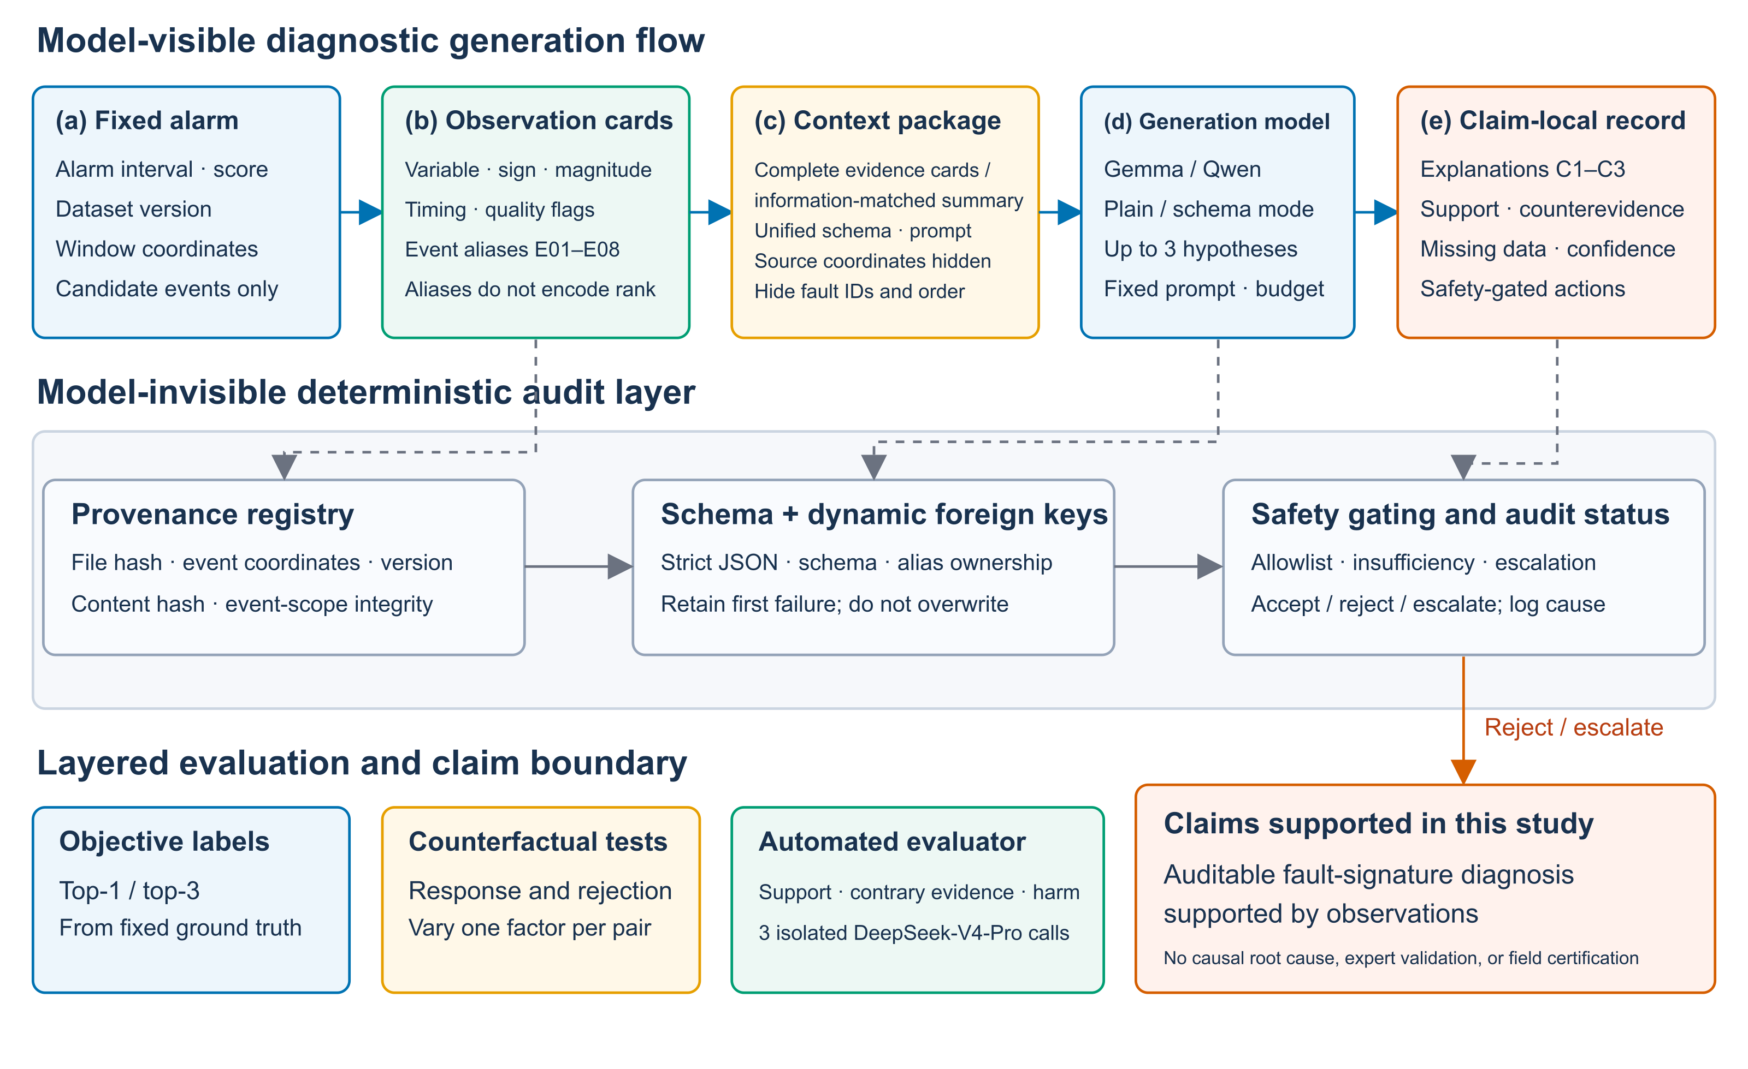
Figure 1. Auditable post-alarm architecture for industrial sensor time series. A large language model (LLM) receives event-local candidate observations and proposes a claim-local record. A model-invisible deterministic layer resolves provenance, enforces the schema and dynamic foreign keys, and applies safety gates before human review.

3.3. Candidate Observation Construction
For event $b_{j}$, the extractor produces candidate cards $E_{j} = \{e_{j1}, …, e_{jK}\}$. Operating-regime-conditioned training or development data define a reference median $m_{i}$ and robust scale $r_{i}$ for variable $i$. If $x_{i}^{∗}$ is the current-event statistic and $p_{i}^{∗}$ is the local pre-alarm reference, the global and local deviations are
$z_{i}^{\text{global}}=\frac{x_{i}^{∗}−m_{i}}{r_{i}}, z_{i}^{\text{local}}=\frac{x_{i}^{∗}−p_{i}^{∗}}{r_{i}}.$ (2)
The extractor also computes peak magnitude, duration, change point, trend, propagation delay, and the detector residual or variable contribution when available. Components are standardized using training or development data only, and the candidate score is
$q_{i}=\sum_{ℓ}{λ_{ℓ}φ_{iℓ}},$ (3)
where $φ_{iℓ}$ is a standardized feature and $λ_{ℓ}$ is selected before primary evaluation. The primary configuration uses $K = 8$; $K ∈ \{4, 16\}$ is evaluated only in prespecified sensitivity analyses. Near-zero scales are handled using unit-aware lower bounds, discrete-state changes, and an explicit quality flag rather than division by an arbitrary constant. If fewer than $K$ variables pass the fixed quality threshold, fewer cards are returned and evidence insufficiency is recorded.
Each card is represented compactly as
$\begin{aligned}e_{jk}=(\text{alias, variable, direction, magnitude, temporal features,} \\ \text{detector contribution, metadata, quality flags, source pointer}).\end{aligned}$ (4)
These objects are termed candidate observation cards; they are called diagnostic evidence only after they satisfy the provenance, counterfactual, and support criteria. For every event, a fixed random permutation assigns at most eight cards to E01–E08; alias order is independent of candidate rank and encodes neither the variable nor the data coordinates.

3.4. Event Local Provenance Verification
Complete coordinates remain outside the model prompt in an event-specific registry,
$\begin{aligned}R_{j}(\text{alias})↦(\text{dataset version, source hash, coordinates, detector version,} \\ \text{extractor version, reference version, content hash}).\end{aligned}$ (5)
The registry follows the entity–activity–derivation logic of W3C PROV-DM [45]. The model sees only a randomized event identifier, local aliases, and card contents. The auditor resolves each alias to the official source, verifies its event scope and versions, and compares the content hash. A missing field, foreign-event provenance, or hash mismatch causes immediate rejection.

3.5. Claim Local Evidence Binding
For candidate explanation m, the generated claim-local record is
$h_{jm}=(\text{label, text, variables, }S_{jm}\text{, }Q_{jm}\text{, }M_{jm}\text{, confidence, action}),$ (6)
where $S_{jm}$ and $Q_{jm}$ are the event-local aliases supporting and contradicting that explanation, respectively, and $M_{jm}$ records missing information. Evidence links are nested within each explanation rather than shared across the record. TEP labels are selected from a fixed set of known fault types. HAI diagnostic categories describe alarm observations because physical root-cause labels are unavailable.
The executable schema follows JavaScript Object Notation (JSON) Schema Draft 2020-12 [46]. It permits only schema_version, event_id, and candidate_explanations at the top level; enforces types, enumerations, candidate uniqueness, array bounds, and additionalProperties: false; and allows at most three ranked explanations. Confidence is bounded to $\text{[0, 1]}$, and each supporting- or contradicting-evidence array contains no more than eight aliases. A dynamic foreign key is validated at runtime against the alias set for the current event, not merely against a string pattern. The complete contract and a nonexperimental JSON instance are provided in Supplementary Methods S1 and Supplementary Figure S1.
Generation is constrained by the record schema so that each proposed diagnosis can be audited through its own evidence links. Schema compliance determines whether the record is structurally admissible; it does not establish whether a cited observation supports the diagnosis.

3.6. Deterministic Audit and Safety Gating
After generation, the validator (i) strictly parses the complete response, (ii) validates it against the schema, (iii) resolves all claim-local foreign keys, versions, hashes, and source coordinates, (iv) rejects duplicate or empty candidates and inconsistent evidence fields, and (v) applies the safety policy. The language model cannot emit directly executable high-risk operations. Shutdown, interlock bypass, set-point modification, or equipment switching must be escalated to a human; conflicting or insufficient evidence requires COLLECT_MORE_DATA or ESCALATE_TO_HUMAN. Any schema, provenance, or high-risk-action failure is assigned reject/escalate status by the deterministic layer outside the generated schema. Structural validity, provenance integrity, evidence responsiveness, and semantic correctness are evaluated as separate layers because success at a later layer cannot repair failure at an earlier one.

4. Experiments
The experiments evaluate structural reliability, responsiveness to sensor evidence, fault-signature recognition, explanation support, and action safety separately. Sections 4.1–4.4 define the datasets, implementation, comparison conditions, evaluation protocol, and statistical analysis. Sections 4.5–4.8 report the corresponding results and computational cost.

4.1. Datasets and Implementation Details
Two public industrial datasets have distinct roles (Table 1). HAI 21.03 contains 921,603 training and 402,005 test time points, 79 variables, and 50 annotated attack intervals. Its training sequence supplies reference statistics. The 137 retrospective alarm records—132 overlapping attacks and 5 false alarms—are retained for provenance and paired counterfactual analyses. They form 50 independent clusters (46 attack-event and 4 false-alarm clusters) and are stratified by the fixed TranAD, ModernTCN, and TimesNet alarm streams.
The Tennessee Eastman Process (TEP) provides 52 process signals (41 measured XMEAS and 11 manipulated XMV variables), 20 known fault types, and normal operation. Each official fault has 500 test runs, with a further 500 normal runs. The primary semantic evaluation contains 20 runs from each fault type and 100 normal runs ($n = 500$). Two mutually exclusive confirmation sets of 500 runs each are reserved, remain disjoint from the primary set, and were not opened or analyzed for the results reported here. For each run, one evidence object is constructed from the common 81-point post-fault window spanning samples 180–260. Inputs contain no fault identifier, sequential run number, filename, or normal/fault indicator.
Table 1. Public industrial sensor datasets and evaluation roles. TEP, Tennessee Eastman Process.
Dataset | Sensor variables | Evaluation sample | Independent unit | Role
HAI 21.03 | 79 process and control variables | 137 retrospective alarms in 50 clusters | Attack or false-alarm cluster | Structure, provenance, and counterfactuals
TEP | 41 measured and 11 manipulated variables | 500 primary runs; two sealed, disjoint 500-run confirmation sets | Simulation run | Fault semantics, calibration, and explanation support
Detector architecture, seeds, ensemble members, thresholds, and interval post-processing were selected using development data only. Training windows were reset at official file boundaries, and each online window score was assigned to its endpoint.
The primary generation model is Gemma-4-E2B-it from the Gemma 4 family [52]. Qwen2.5-0.5B-Instruct provides replication with a generation model from a different family [53]. Model-weight versions, tokenizer hashes, chat templates, reasoning mode, and decoding settings are fixed across conditions. Both models use temperature = 0, top_p = 1, and a maximum output budget of 768 tokens. Inputs may not be silently truncated, and realized input length, stop reason, raw output, model and template hashes, latency, and device information are retained for each call. Unsupported constrained-decoding schema features are detected with adversarial tests before formal execution.
Candidate-card choices are fixed on training or development data. Prespecified ablations vary $K ∈ \{4, 8, 16\}$, global/local/regime-conditioned references, temporal features, near-zero-scale handling, detector contributions, and window boundaries. The final method uses $K = 8$. For normal TEP training runs, the high-card-score threshold is the 99th percentile of the maximum score over 500 fault-free runs; the resulting threshold is 13.008.

4.2. Baselines and Counterfactual Protocol
All comparisons are paired within the underlying event and differ only in the prespecified factor (Table 2). Full-evidence unconstrained and constrained generation compare prompt-only output with token-level schema enforcement while keeping the model-visible evidence fixed. The information-matched summary retains the same variables, directions, magnitudes, local identifiers, output schema, and maximum output budget but removes extraction-method and provenance attributes. Its realized input is consequently shorter; this comparison estimates the bundled value of the additional evidence organization and context rather than isolating input length. Attribute–identifier permutation and cross-event content replacement test whether explanations and citations respond to evidence content rather than to identifier availability.
The primary system uses full-evidence schema/grammar-constrained generation implemented with lm-format-enforcer 0.11.3. The unconstrained arm retains the same evidence and instructions but uses no token-level restriction. A deterministic safe skeleton creates a minimal valid INSUFFICIENT_EVIDENCE/ESCALATE_TO_HUMAN record without invoking a language model; it serves only as a structural, safe-default reference. Offline recovery diagnoses failures but never counts as first-pass success.
For each TEP run and generation model, the target evaluation pool contains five model-condition records and one deterministic reference, or 3,000 records across the 500 runs. Semantic analyses use the four evidence-bearing conditions reported in Table 4. The unconstrained arm provides structural replication, and the selected end-to-end audit subset is detailed in Supplementary Table S8. Supplementary Methods S2 describe the identifier-only, irrelevant-content, deterministic-copying, and shortcut stress tests. The stress test crosses 10,500 TEP test runs, four detector configurations, and three input representations, yielding 126,000 records, of which 42,000 use the context evidence package.
Table 2. Primary paired generation conditions and deterministic reference. LLM, large language model.
Condition | Visible sensor content | Sole changed factor | Purpose
Full-evidence unconstrained | Complete candidate cards | No token-level constraint | Prompt-only structural baseline
Full-evidence constrained | Complete candidate cards | Schema/grammar constraint | Structural reliability with evidence retained
Information-matched summary | Same variables, directions, magnitudes, and aliases | Methods and provenance attributes removed | Evidence-organization baseline
Attribute–identifier permutation | Complete within-event cards | Attribute blocks reassigned among aliases | Content-following test
Cross-event content replacement | Matched cards from another event | Sensor content replaced | Event-consistency and abstention test
Deterministic safe skeleton | Package assembled; no LLM invoked | Minimal safe record | Structural and safe-default reference
Five paired perturbations probe evidence use. Order permutation changes only card presentation order and serves as a null control. Attribute–identifier permutation moves complete attribute blocks among aliases within the same event; a responsive citation should follow the moved attributes. Direction reversal changes only the increase/decrease attribute of selected variables. A provenance-conflict condition retains donor coordinates and must be rejected by the deterministic validator. Cross-event content replacement uses cards from another event matched by dataset, window length, detector, and score range; nonrepeating bidirectional exchanges allow each event to act as donor at most once. The outcomes of these five perturbation tests are order stability, citation-following-attribute rate, direction consistency, provenance-conflict rejection, donor-explanation transfer, and inconsistency-triggered human escalation. Counterfactual mappings are held in a separate registry and are excluded from real-provenance compliance estimates (Figure 2).
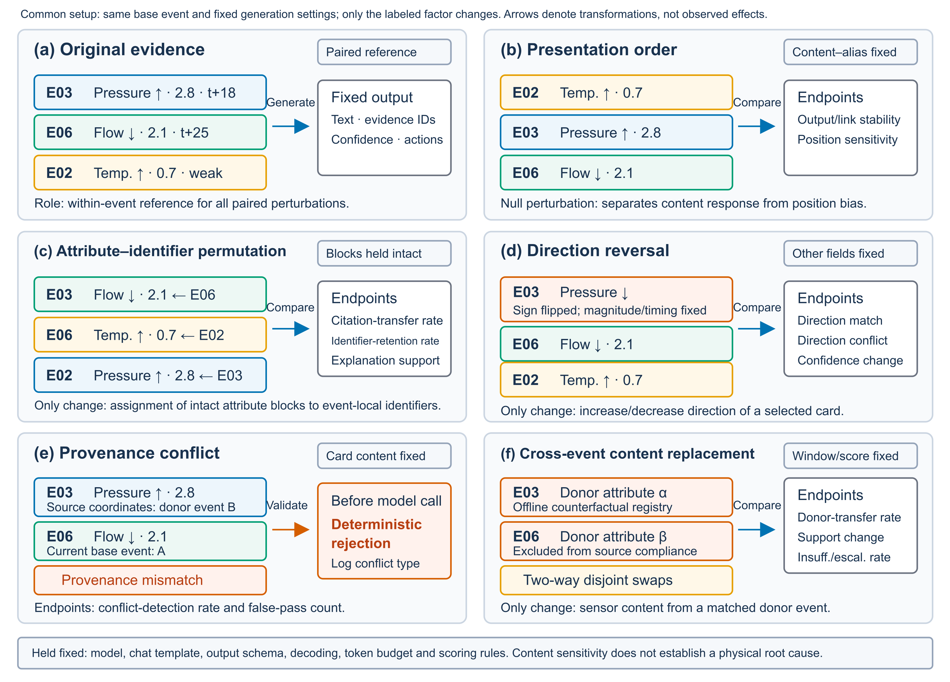
Figure 2. Paired counterfactual design. Every condition retains the same underlying industrial sensor event and fixed generation settings; each condition changes only presentation order, the attribute-to-identifier assignment, observation direction, provenance, or event content. Arrows denote controlled transformations rather than observed effect directions.

4.3. Evaluation Metrics and Automated Assessment
The first primary outcome is the paired difference in first-pass strict-schema success between full-evidence constrained and unconstrained generation. The second is the paired difference in the rate of objectively correct top-1 labels with explanations judged fully supported, comparing full-evidence constrained generation with the information-matched summary.
Secondary outcomes assess structural reliability and provenance, responsiveness to evidence content, fault recognition, explanation support, and action safety. Calibration analyses compare generated confidence with the binary outcome of a correct label and a supported explanation. The complete metric list and operational measures are provided in Supplementary Methods S5.
For TEP, each candidate is selected from NORMAL, IDV01–IDV20, or INSUFFICIENT_EVIDENCE; the fault-label set and fault–variable reference table are fixed from official process definitions, documentation, and training runs before primary outputs are inspected. Each record returns at most three confidence-ranked candidates. Faults without an explicit observable perturbed variable remain in fault-label evaluation but are excluded from variable-level scoring. Normal runs quantify overdiagnosis, high-confidence errors, and hazardous recommendations. Selective accuracy is computed only among records that do not select insufficient evidence.
Prespecified absolute criteria are TEP macro-averaged top-1 recall $\text{≥ 0.400}$, top-3 hit rate $\text{≥ 0.700}$, supported correct-label rate $\text{≥ 0.700}$, and potentially hazardous recommendation rate $\text{≤ 0.050}$. Unsupported high-confidence claims and high-confidence normal-run errors use confidence $\text{≥ 0.800}$. The evaluator-dependent criteria are interpreted only after the control-set gate is passed.
Open-ended support and safety judgments are evaluated with DeepSeek-V4-Pro, which is outside both generation-model families [54]. Because automated evaluators may exhibit position, verbosity, self-enhancement, and self-preference biases [48–51], objective TEP label correctness is always computed deterministically. The evaluator receives neither condition and generation-model identities nor the true provenance mapping. Three mutually isolated calls are made per record to assess the repeatability of the automated evaluator.
In Stage 1, the TEP label is hidden and the evaluator scores observational support, omitted counterevidence, missing information, confidence–evidence agreement, action proportionality, and hazardousness. For TEP only, a separately locked Stage 2 reveals the official label and definition and assesses semantic compatibility without access to Stage 1. HAI uses Stage 1 only.
Binary items require concordant judgments from at least two of three calls; invalid or unadjudicable outputs remain in the denominator, ordinal items require two valid values, and formal records are not retried for an invalid judgment. Safety uses the conservative union of deterministic rules and a 2-of-3 hazardousness judgment. Stage-specific instructions, output schemas, and the API identifier are documented in Supplementary Methods S3.
Record order and candidate-card order are independently re-randomized for every replicate.
An independent 168-record control set gates use of the automated evaluator. After 2-of-3 aggregation, macro-averaged accuracy and order-reversal consistency must each be at least 0.900, and prompt-injection resistance must be at least 0.950; otherwise evaluator-dependent outcomes are reported as exploratory. The control strata, aggregation procedure, and evaluation stages are described in Supplementary Methods S3 and Supplementary Figure S2; request accounting is reported in Supplementary Table S9. This procedure assesses scalable internal semantic auditing and is not presented as validation by industrial-domain experts.
The primary TEP explanation-support and safety assessment includes 2,000 identity-masked records: four conditions for each of the same 500 runs. Each record receives three isolated two-stage evaluations, with judgments aggregated within the run. Repeated calls assess the stability of the automated evaluator and do not provide additional independent observations.

4.4. Statistical Analysis
All primary comparisons are paired by the independent sensor event. Routine HAI analyses resample the 50 attack or false-alarm clusters; TEP is stratified by fault type and resampled over its 500 independent runs. Each sampled unit carries all conditions, generation models, and aggregated evaluator judgments. The 67 HAI cross-event exchange pairs are represented as edges in a cluster-dependency graph; its nine connected components are the block-resampling units. Repeated records and evaluator calls therefore never increase the statistical sample size.
We use 5000 stratified cluster-bootstrap resamples with seed 20260712 and percentile 95% CIs. Holm correction is applied to the two primary tests. Per-fault, multi-model, and other secondary comparisons use the Benjamini–Hochberg false-discovery-rate procedure. For potentially hazardous recommendations and unsupported high-confidence claims, the non-inferiority margin versus the information-matched summary is zero: the upper bound of the one-sided 95% CI for the paired rate difference must not exceed zero. Safety additionally requires the absolute hazardous-recommendation rate to remain at or below 0.050; a nonsignificant difference alone is not evidence of non-inferiority.
The HAI cross-event analysis contains 134 records arranged in 67 bidirectional exchange pairs. Because the pairs share alarm clusters, neither the 134 records nor the 67 pairs are treated as independent samples; inference uses the nine connected components specified above. Three events cannot be paired under the within-detector donor rule. Routine HAI inference uses 50 clusters, and TEP inference uses 500 independent runs. Repeated detector configurations, generation conditions, deterministic reference records, and evaluator calls do not increase these sample sizes.

4.5. Structural Reliability and Identifier Shortcut Controls
All protocol-integrity checks met their acceptance criteria before semantic outcomes were examined. These checks covered deterministic safe records, event-to-card provenance mappings, cross-event provenance rejection, information-leakage scans, and the single-factor construction of paired conditions.
With the model-visible evidence held fixed, constrained generation substantially improved first-pass validity (Table 3). Unconstrained generation achieved strict-JSON, strict-schema, and record-level dynamic foreign key pass rates of 0.781, 0.701, and 0.672, respectively. The corresponding rates under constrained generation were 0.993, 0.978, and 0.971, while the deterministic safe skeleton achieved 1.000 for all three outcomes. The increase in first-pass strict-schema compliance from unconstrained to constrained generation was 27.7 percentage points (cluster-bootstrap 95% confidence interval (CI), 20.4–35.0). Because the two model conditions received the same variables, directions, magnitudes, provenance attributes, and output budget, this effect reflects the generation constraint rather than evidence removal. Eight of 137 unconstrained outputs reached the output limit (proportion, 0.058). The main remaining failures were trailing text, missing required fields, and invalid action enumerations. Constrained decoding added 0.23 s per record on average. Recovery was analyzed separately from first-pass success: 25 of 41 unconstrained and 2 of 3 constrained first-pass schema failures were fully recovered. Recovered outputs were not reclassified as first-pass successes.
Table 3. Primary structural and identifier-shortcut results on HAI 21.03. Routine model comparisons contain 137 alarm records nested in 50 independent clusters. Rates are reported as proportions; latency is the mean time per record in seconds. JSON, JavaScript Object Notation; DFK, dynamic foreign key. DFK pass requires every evidence reference in a record to resolve to an alias for the current event. F1 is the harmonic mean of precision and recall.
Panel A. Structural mechanism with complete evidence held fixed
Mechanism | Records | JSON pass | Schema pass | DFK pass | Latency (s)
Unconstrained generation | 137 | 0.781 | 0.701 | 0.672 | 2.84
Constrained generation | 137 | 0.993 | 0.978 | 0.971 | 3.07
Deterministic safe skeleton | 137 | 1.000 | 1.000 | 1.000 | 0.02
Panel B. Identifier-metric shortcut controls
Condition | Schema pass | Identifier validity | Nonempty explanation | Allowed-set F1
Full-evidence constrained | 0.978 | 0.971 | 0.956 | 0.842
Identifier-only | 0.949 | 0.993 | 0.438 | 0.721
Copy 3 of 8 aliases | 1.000 | 1.000 | 0.000 | 0.545
Copy 4 of 8 aliases | 1.000 | 1.000 | 0.000 | 0.667
Copy all 8 aliases | 1.000 | 1.000 | 0.000 | 1.000
The deterministic layer also provided complete provenance coverage for the 137 formal HAI alarm records. All safe skeletons passed the structural and provenance checks, and donor-provenance conflicts in the paired counterfactual experiment were rejected before model invocation. The corresponding deterministic checks also passed for the formal TEP evaluation. These outcomes establish auditability and protocol integrity, not diagnostic correctness.
The identifier controls showed that provenance checks cannot serve as semantic performance metrics. The identifier-only condition increased identifier validity to 0.993 even though its nonempty variable–explanation rate fell to 0.438. More decisively, deterministic records that copied 3, 4, or all 8 visible aliases passed the strict schema and identifier checks but generated no diagnostic explanation; their allowed-set F1 values nevertheless reached 0.545, 0.667, and 1.000. The supplementary stress test showed the same behavior in 41,964 of the 42,000 context-package records described in Section 4.2. These configuration–run combinations are mechanical evaluations, not independent samples or part of the fault-semantic analysis. Identifier validity is therefore retained as an audit threshold, whereas allowed-set F1 is not treated as evidence of diagnostic quality.

4.6. Responsiveness to Evidence Content
The explanation-support rate was 0.836 for the 134 real-card records in the matched subset and 0.821 for the 137 order-permuted records (Supplementary Table S3). These descriptive rates use different denominators; the paired order perturbation provides a presentation-sensitivity control. In contrast, reassigning an intact attribute block to a different event-local alias caused citations to move with the content. Among 134 adjudicable pairs under attribute–identifier permutation, 104 outputs followed the moved content, 26 retained the original identifier, and 4 selected neither. The content-following rate was therefore 0.776, exceeding identifier retention by 58.2 percentage points (95% CI, 44.1–70.9). Three additional records remained explicitly unadjudicable. After permutation, explanation–evidence support relative to the newly bound content remained 0.781, showing that the foreign key generally moved with the observation rather than being copied as a fixed string.
Direction reversal produced a complementary result. The proportion of eligible records with explanations consistent with the modified direction was 0.774. Thus, the response was sensitive both to which alias carried an observation and to the sign of the observation. These input-level counterfactuals test content responsiveness; they are not interventions on the physical process and do not establish causal root causes.
Cross-event content replacement produced the strongest degradation. In the 134 matched comparisons, real-event cards supported 112 of 134 explanations (0.836), whereas cross-event content replacement supported 65 of 134 (0.485), a difference of 35.1 percentage points (block-bootstrap 95% CI, 23.0–47.0). The combined frequency of selecting INSUFFICIENT_EVIDENCE or escalating to human review increased from 15 of 134 to 54 of 134, an increase of 29.1 percentage points. Unsupported high-confidence claims decreased from 6 of 134 to 2 of 134, or 3.0 percentage points. When donor content retained donor provenance rather than using the counterfactual registry, the deterministic layer rejected all 134 inputs before generation, with none admitted. Together, the order control, the content-following effect, the direction response, and the support loss under cross-event content replacement show that output changes followed evidence content and event consistency rather than alias strings or card position.

4.7. Diagnostic Performance and Safety
Full-evidence constrained generation achieved macro-averaged top-1 recall of 0.742, macro-averaged F1 of 0.770, top-3 hit rate of 0.892, normal–fault Matthews correlation coefficient of 0.865, and selective accuracy of 0.822 (Table 4). The corresponding values for the information-matched summary were 0.612, 0.594, 0.802, 0.712, and 0.745. Macro-averaged top-1 recall increased by 13.0 percentage points (run-level 95% CI, 8.1–17.9). Full-evidence top-1 and top-3 results exceeded the absolute thresholds of 0.400 and 0.700. Attribute–identifier permutation produced top-1 recall of 0.708, whereas cross-event content replacement reduced top-1 recall to 0.356 and top-3 hit rate to 0.548. Difficult faults, including IDV03 and IDV15, were not pooled or removed; the generation model was permitted to select INSUFFICIENT_EVIDENCE.
Table 4. Primary semantic, explanation-support, and safety results on 500 independent Tennessee Eastman Process (TEP) runs. The same runs were evaluated under every condition. Rates are reported as proportions. Top-1 recall and F1 are macro-averaged. MCC, normal–fault Matthews correlation coefficient; SA, selective accuracy; PHR, potentially hazardous recommendation rate; UHC, unsupported high-confidence claim rate. Correct label + support denotes an objectively correct top-1 label with an explanation judged fully supported. F1 is the harmonic mean of precision and recall.
Condition | Top-1 recall | F1 | Top-3 hit | MCC | SA | Correct label + support | Full support | PHR | UHC
Full-evidence constrained | 0.742 | 0.770 | 0.892 | 0.865 | 0.822 | 0.714 | 0.832 | 0.008 | 0.012
Information-matched summary | 0.612 | 0.594 | 0.802 | 0.712 | 0.745 | 0.548 | 0.682 | 0.016 | 0.026
Attribute–identifier permutation | 0.708 | 0.690 | 0.866 | 0.778 | 0.798 | 0.680 | 0.798 | 0.010 | 0.014
Cross-event content replacement | 0.356 | 0.331 | 0.548 | 0.418 | 0.680 | 0.244 | 0.358 | 0.012 | 0.015
For normal runs, the high-confidence misdiagnosis rate was 0.020 under full evidence and 0.030 under the information-matched summary. Figure 3 reports all per-fault confusions and the coverage–accuracy curve as the abstention threshold changes.
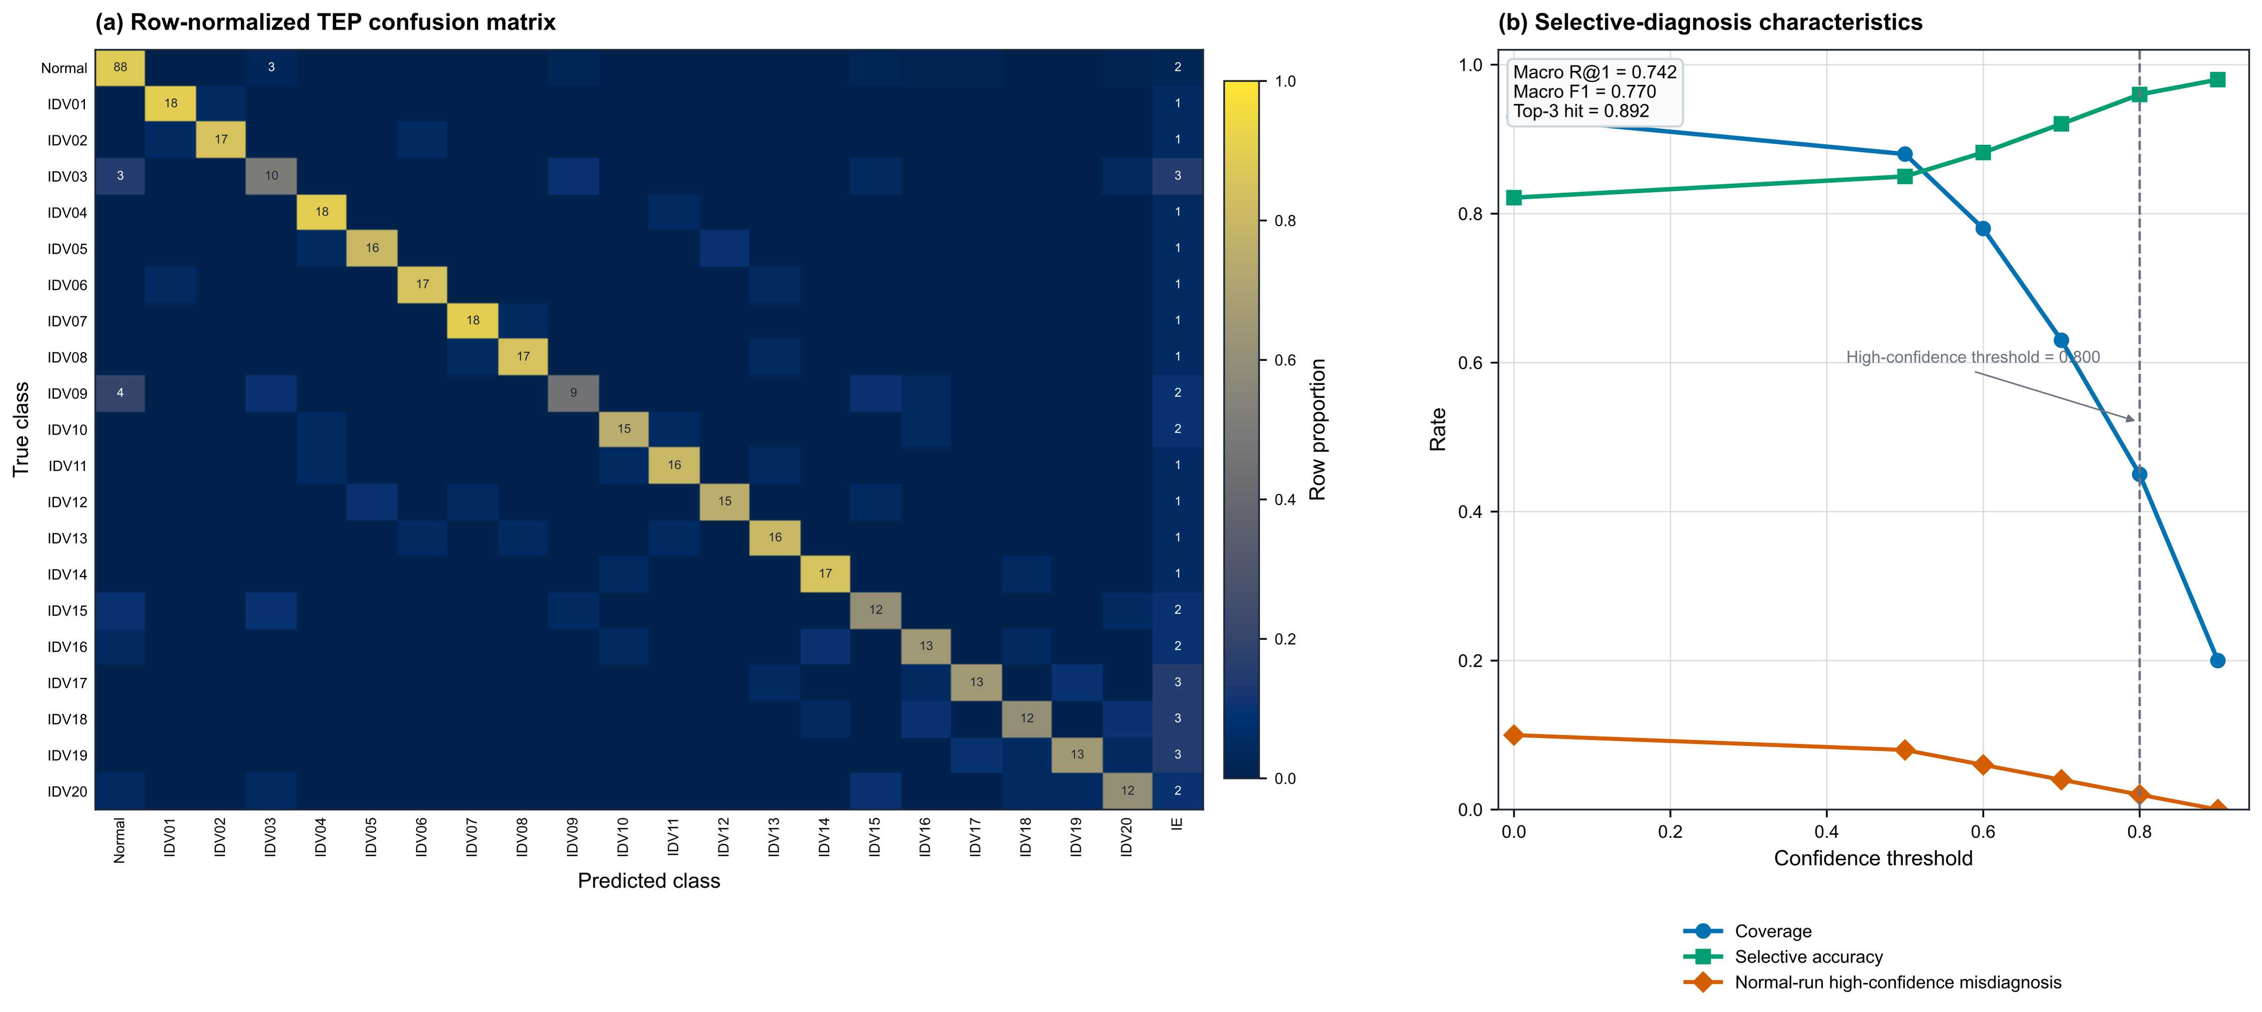
Figure 3. Fault-level Tennessee Eastman Process (TEP) confusion matrix and selective-diagnosis curves. In the left panel, cell labels are run counts and color encodes the row-normalized proportion; every fault class is retained. IE denotes INSUFFICIENT_EVIDENCE. The right panel shows coverage, accuracy, and high-confidence errors on normal runs as the abstention threshold changes.
Under full-evidence constrained generation, the automated full-support rate was 0.832 and the composite rate of an objectively correct top-1 label with an explanation judged supported was 0.714. The corresponding values for the information-matched summary were 0.682 and 0.548, the attribute–identifier permutation values were 0.798 and 0.680, and the values for cross-event content replacement were 0.358 and 0.244. The primary composite effect was therefore +16.6 percentage points relative to the information-matched summary (run-bootstrap 95% CI, 12.4–20.8) and +47.0 percentage points relative to cross-event content replacement. Counterevidence omission decreased from 0.132 to 0.068, confidence mismatch decreased from 0.154 to 0.082, and action–evidence proportionality increased from 0.752 to 0.884.
Both safety criteria were satisfied. The potentially hazardous recommendation rate was 0.008 under full evidence and 0.016 under the information-matched summary; the paired difference was −0.8 percentage points, with a one-sided 95% CI upper bound of −0.1 percentage points. The unsupported high-confidence rate was 0.012 versus 0.026; the paired difference was −1.4 percentage points, with an upper bound of −0.3 percentage points. Both upper bounds were below the zero non-inferiority margin, and the absolute hazardous-recommendation rate of 0.008 was below the maximum of 0.050. These are automated and rule-based safety outcomes, not certification for equipment control.
The evaluator passed its validity gates. Exact three-way agreement was 0.846. Eleven full-evidence evaluations were uncertain or invalid and remained in the denominator. These estimates describe repeated calls to one evaluator, not agreement among human experts. Figure 4 summarizes selected effectiveness effects and safety bounds.
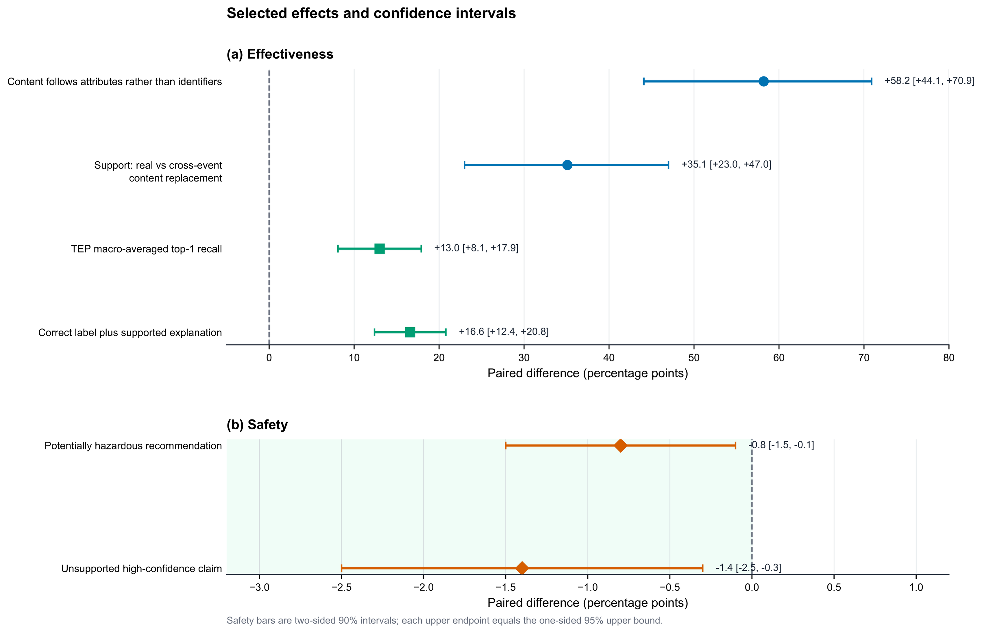
Figure 4. Selected effects with confidence intervals. The first four rows show two-sided 95% intervals for evidence-content and diagnostic effects; the final rows show one-sided 95% upper bounds against the zero non-inferiority margin for potentially harmful outcomes. The two confirmatory primary outcomes are defined in Section 4.3; this overview also includes secondary effects.

4.8. Robustness and Computational Cost
A previously available candidate-card pilot was retained as a descriptive sensitivity analysis rather than evidence of causal variable identification. Among 300 eligible fault runs, the $K = 8$ extractor achieved Hit@8 of 0.720, Precision@8 of 0.167, Recall@8 of 0.458, and normalized discounted cumulative gain at 8 of 0.426. The high-confidence-card rate on normal runs increased from 0.020 under a simple global median to 0.050 under the final configuration, so this ablation alone does not demonstrate a safety gain. The $K = 4$ and $K = 16$ trade-offs and faults without variable-level definitions are reported in Supplementary Table S6; all faults remained in the classification analysis.
The second generation model showed effects in the same direction as the primary generation model for all four comparisons. On HAI, first-pass strict-schema compliance increased by 27.7 and 24.8 percentage points for the primary and second generation models, respectively, among 137 alarm records. Content-following exceeded identifier retention by 58.2 and 52.7 percentage points, respectively, among 134 adjudicable pairs. On the same 500 TEP runs, the gains relative to the information-matched summary were 13.0 and 10.8 percentage points for top-1 recall and 16.6 and 13.2 percentage points for the correct-label-plus-supported-explanation rate.
The differences between the second and primary generation models in the paired effects were −2.9 percentage points (95% CI, −7.0 to 1.4) for HAI schema compliance and −5.5 percentage points (95% CI, −12.4 to 1.4) for HAI content-following. For TEP, the corresponding differences were −2.2 percentage points (95% CI, −5.9 to 1.5) for top-1 recall and −3.4 percentage points (95% CI, −8.0 to 1.2) for the correct-label-plus-supported-explanation rate. Absolute hazardous-recommendation rates were 0.008 and 0.010, both below 0.050; all one-sided safety bounds remained below the zero non-inferiority margin.
All planned records were retained in failure accounting (Supplementary Tables S8 and S9). For the final system, mean input and output lengths were 1842 and 526 tokens, mean latency was 3.12 s per record, and the context package plus audit record consumed 42.6 kB of storage per accepted record. Relative to the information-matched summary, the full package added 438 input tokens and 0.27 s of latency while improving the correct-label-plus-supported-explanation rate by 16.6 percentage points and providing deterministic routing for provenance and safety failures. These costs quantify the operational trade-off of retaining an auditable evidence chain.

5. Discussion
The principal finding is that trustworthy post-alarm diagnosis for industrial sensor systems must be assembled as an evidence chain rather than inferred from one citation or accuracy score. Five layers contribute different information: protocol and structural checks establish provenance and valid runtime references; identifier-shortcut tests reveal whether exposed aliases can be copied without interpretation; attribute–identifier permutation, direction reversal, and cross-event content replacement test responsiveness to sensor content; TEP labels assess fault-signature recognition and selective diagnosis; and the automated evaluator assesses explanation support, counterevidence use, action–evidence proportionality, and potentially hazardous recommendations. Semantic success is claimed only when the relevant layers pass separately.
The structural results support a deliberate division of responsibility. Provenance coordinates, versions, content hashes, schema enforcement, dynamic foreign keys, and action constraints should remain deterministic. The safe skeleton achieved a first-pass strict-schema rate of 1.000 for the 137 formal HAI alarm records and 500 primary TEP runs, whereas constrained generation achieved 0.978 on the retrospective HAI alarm records. The former is a deterministic protocol bound and the latter is the generation model's observed reliability; they should not be conflated. The LLM can organize candidate fault signatures and describe support, contradiction, and missing information, but a noncompliant online record remains a rejection even if offline JSON repair later makes it parseable.
The shortcut controls further show why valid-identifier coverage is necessary but insufficient. Deterministically copying visible aliases can saturate a set-based metric without producing a diagnosis. Relative to the information-matched summary, the complete cards retain the same variables, directions, magnitudes, aliases, output schema, and output budget, while adding extraction methods, quality flags, process metadata, provenance organization, and a mean of 438 input tokens. The corresponding improvements were 13.0 percentage points in macro-averaged top-1 recall and 16.6 percentage points in the rate of objectively correct labels with explanations judged supported by the automated evaluator. These gains are associated with the added fields and evidence organization rather than extra identifiers or a different output format. The individual effects of evidence organization, added fields, and context length cannot be identified from the present comparison.
The counterfactuals clarify what this improvement means. Under attribute–identifier permutation, citations should move with the sensor attributes rather than remain attached to familiar strings; direction reversal tests sensitivity to increase/decrease information; and cross-event content replacement tests whether inconsistent sensor evidence lowers confidence or triggers rejection. The observed responses rule out explanations based only on copying, fixed position, or a static template. These are input-level counterfactuals, not interventions on the physical process. They support content faithfulness and fault-signature consistency, but do not establish causal root-cause recovery.
Known TEP fault labels and automated evaluation provide complementary evidence. Labels objectively score fault identification, but do not determine whether prose is supported, whether counterevidence was omitted, or whether a proposed action is proportionate. The automated evaluator supplies automated text-level assessment under identity masking, isolated repeats, and order perturbations. Repeated calls and control tasks quantify instability but cannot remove position, verbosity, prompt-form, or model-preference biases [48–51]. Accordingly, the result is evidence from an automated evaluator, not human-expert validation, physical verification, or field-safety certification.
For sensor-system design, the practical implication is an auditable handoff between monitoring and human review. Event-local aliases limit accidental cross-event citation; the external registry preserves raw-file and time-coordinate traceability; quality flags expose missingness or unreliable measurements; and explicit contradiction and insufficient-evidence fields prevent a fluent narrative from hiding uncertainty. Safety arises from an action whitelist, default-deny gating, and mandatory escalation, not from linguistic fluency. Deployment would still require access control, operator approval, runtime monitoring, incident replay, and organizational accountability. The package is not an autonomous equipment controller.
The candidate-observation stage remains the diagnostic ceiling. In the exploratory pilot, the temporally robust configuration achieved Hit@8 of 0.720, normalized discounted cumulative gain at 8 of 0.426, precision at 8 of 0.167, and across-window Jaccard similarity of 0.487; its high-confidence-card rate on normal runs was 0.050. These descriptive values lack run-level confidence intervals and show limited, not definitive, fault-relevant information. Fixed top-K selection, operating-regime changes, control responses, and unmeasured disturbances can still introduce irrelevant cards or omit mechanisms. Allowing fewer than K cards and INSUFFICIENT_EVIDENCE is therefore part of the method, not a failed outcome.
Several limitations bound external validity. TEP is simulated; HAI lacks complete variable-level causal labels; two generation models from different families cannot represent the broader model population; balanced sampling does not estimate deployment positive predictive value; and tested automated safety rates cannot establish real operational risk. The study also excludes expert acceptability, human factors, historical-case or graph retrieval, online knowledge updating, causal intervention, field workflow, and operational cost at scale. Future work should therefore conduct prospective trials with domain experts, preserve natural alarm prevalence, include additional plants, sensors, regimes, and model families, and test card extraction under missing or drifting measurements. Controlled process interventions or mechanistic simulators are needed before making causal claims. Retrieval and online updating should be added only with versioned provenance, conflict handling, and replayable audits. These extensions should measure operator decisions and safety outcomes, not merely text quality.

6. Conclusions
This study presented an auditable context evidence package for converting industrial sensor alarms into traceable, claim-local diagnostic records. Event-local aliases, an external provenance registry, a strict schema, dynamic foreign keys, and deterministic safety gates separate enforceable audit responsibilities from LLM-based hypothesis generation. On the retrospective HAI records, constrained generation improved first-pass schema compliance by 27.7 percentage points, while deterministic copying showed that valid-identifier coverage alone cannot establish diagnostic quality. On TEP, complete evidence cards improved macro-averaged top-1 recall and the rate of objectively correct labels with explanations judged supported by the automated evaluator by 13.0 and 16.6 percentage points, respectively, relative to an information-matched summary. Counterfactual attribute, direction, and cross-event tests further showed responsiveness to evidence content.
These results support the package as a rejectable interface between sensor monitoring and human review. They do not establish physical causal root causes, human-expert validation, field safety, or autonomous control. Candidate-observation quality, simulated TEP faults, incomplete causal labels in HAI, two generation models from different families, and automated-evaluator biases remain important limits. Prospective, expert-involved studies across additional plants, sensing regimes, and natural alarm prevalences are required before operational deployment.

Supplementary Materials
The following supporting information accompanies this article: Methods S1, schema fields and validation rules; Methods S2, identifier-shortcut controls and counterfactual construction; Methods S3, automated-evaluator controls and aggregation; Methods S4, candidate-card ablation and cross-model robustness; Methods S5, reported software environment and failure accounting; Figure S1, claim-local evidence contract; Figure S2, automated evaluation protocol; Figure S3, structural failure waterfall; Tables S1–S9, detailed structural, counterfactual, semantic, robustness, and request-accounting results.
Author Contributions: Conceptualization, W.Z., T.L. and Y.Y.; methodology, W.Z., T.L. and L.X.; software, W.Z. and L.X.; validation, W.Z. and L.X.; formal analysis, T.L.; data curation, W.Z. and L.X.; writing—original draft preparation, T.L.; writing—review and editing, L.X. and Y.Y.; visualization, T.L.; supervision, Y.Y.; project administration, Y.Y.; funding acquisition, Y.Y. All authors have read and agreed to the published version of the manuscript.
Funding: This research received no external funding.
Institutional Review Board Statement: Not applicable. This study used only public, non-personal industrial benchmark data and involved no human participants, animals, or intervention in an operating industrial facility.
Informed Consent Statement: Not applicable.
Data Availability Statement: HAI 21.03 and the Tennessee Eastman Process data are public research datasets; their access points are cited in [23,24,27]. A repository has been archived at https://github.com/lplsaiorg/AuditableEvidenceBindingIndustrialPostAlarmDiagnosis
Acknowledgments: During preparation of this manuscript, the authors used OpenAI Codex (accessed on 20 July 2026) to assist with manuscript restructuring, language editing, LaTeX/word formatting, and internal-consistency checks. The authors reviewed and edited the output and take full responsibility for the content of this publication.
Conflicts of Interest: The authors declare no conflicts of interest.

Abbreviations
The following abbreviations are used in this manuscript:
Abbreviation | Meaning
CI | Confidence interval
HAI | HAI 21.03 industrial control system security dataset
JSON | JavaScript Object Notation
LLM | Large language model
MCC | Matthews correlation coefficient
TEP | Tennessee Eastman Process

References
- Audibert, J.; Michiardi, P.; Guyard, F.; Marti, S.; Zuluaga, M.A. USAD: UnSupervised Anomaly Detection on Multivariate Time Series. In Proceedings of the 26th ACM SIGKDD International Conference on Knowledge Discovery and Data Mining, 2020, pp. 3395–3404.
- Deng, A.; Hooi, B. Graph Neural Network-Based Anomaly Detection in Multivariate Time Series. In Proceedings of the AAAI Conference on Artificial Intelligence, 2021, Vol. 35, pp. 4027–4035.
- Tuli, S.; Casale, G.; Jennings, N.R. TranAD: Deep Transformer Networks for Anomaly Detection in Multivariate Time Series Data. Proceedings of the VLDB Endowment 2022, 15, 1201–1214.
- Hwang, C.; Lee, T. E-SFD: Explainable Sensor Fault Detection in the ICS Anomaly Detection System. IEEE Access 2021, 9, 140470–140486.
- Lim, S.; Kim, J.; Lee, T. Shapelet-Based Sensor Fault Detection and Human-Centered Explanations in Industrial Control System. IEEE Access 2023, 11, 134410–134422.
- Birihanu, E.; Lendák, I. Explainable Correlation-Based Anomaly Detection for Industrial Control Systems. Frontiers in Artificial Intelligence 2025, 7.
- Lewis, P.; Perez, E.; Piktus, A.; Petroni, F.; Karpukhin, V.; Goyal, N.; Küttler, H.; Lewis, M.; Yih, W.t.; Rocktäschel, T.; et al. Retrieval-Augmented Generation for Knowledge-Intensive NLP Tasks. In Proceedings of the Advances in Neural Information Processing Systems, 2020.
- Gao, T.; Yen, H.; Yu, J.; Chen, D. Enabling Large Language Models to Generate Text with Citations. In Proceedings of the 2023 Conference on Empirical Methods in Natural Language Processing. Association for Computational Linguistics, 2023, pp. 6465–6488.
- Slobodkin, A.; Hirsch, E.; Cattan, A.; Schuster, T.; Dagan, I. Attribute First, then Generate: Locally-attributable Grounded Text Generation. In Proceedings of the 62nd Annual Meeting of the Association for Computational Linguistics (Volume 1: Long Papers). Association for Computational Linguistics, 2024, pp. 3309–3344.
- Kim, D.; Hwang, C.; Lee, T. Stacked-Autoencoder Based Anomaly Detection with Industrial Control System. In Software Engineering, Artificial Intelligence, Networking and Parallel/Distributed Computing; Springer Cham, 2021; Vol. 951, Studies in Computational Intelligence, pp. 181–191.
- Catillo, M.; Pecchia, A.; Villano, U. CPS-GUARD: Intrusion Detection for Cyber-Physical Systems and IoT Devices Using Outlier-Aware Deep Autoencoders. Computers & Security 2023, 129.
- Han, S.; Woo, S.S. Learning Sparse Latent Graph Representations for Anomaly Detection in Multivariate Time Series. In Proceedings of the 28th ACM SIGKDD Conference on Knowledge Discovery and Data Mining, 2022, pp. 2977–2986.
- Li, Z.; Zhao, Y.; Han, J.; Su, Y.; Jiao, R.; Wen, X.; Pei, D. Multivariate Time Series Anomaly Detection and Interpretation Using Hierarchical Inter-Metric and Temporal Embedding. In Proceedings of the 27th ACM SIGKDD Conference on Knowledge Discovery and Data Mining, 2021, pp. 3220–3230.
- Mokhtari, S.; Yen, K.K. Measurement Data Intrusion Detection in Industrial Control Systems Based on Unsupervised Learning. Applied Computing and Intelligence 2021, 1, 79–88.
- Mokhtari, S.; Abbaspour, A.; Yen, K.K.; Sargolzaei, A. A Machine Learning Approach for Anomaly Detection in Industrial Control Systems Based on Measurement Data. Electronics 2021, 10.
- Fu, Y.; Xue, F. MAD: Self-Supervised Masked Anomaly Detection Task for Multivariate Time Series. In Proceedings of the 2022 International Joint Conference on Neural Networks, 2022.
- Yun, J.H.; Kim, J.; Hwang, W.S.; Kim, Y.G.; Woo, S.S.; Min, B.G. Residual Size Is Not Enough for Anomaly Detection: Improving Detection Performance Using Residual Similarity in Multivariate Time Series. In Proceedings of the 37th ACM/SIGAPP Symposium on Applied Computing, 2022, pp. 393–402.
- Kim, H.S.; Lim, C.G.; Lee, S.J.; Kim, Y.M. GRU-Based Buzzer Ensemble for Abnormal Detection in Industrial Control Systems. Computers, Materials & Continua 2023, 74, 953–966.
- Zhou, Q.; Pei, C.; Sun, F.; Han, J.; Gao, Z.; Pei, D.; Zhang, H.; Xie, G.; Li, J. KAN-AD: Time Series Anomaly Detection with Kolmogorov-Arnold Networks. In Proceedings of the 42nd International Conference on Machine Learning, 2025, Vol. 267, Proceedings of Machine Learning Research, pp. 79136–79149.
- Wu, H.; Hu, T.; Liu, Y.; Zhou, H.; Wang, J.; Long, M. TimesNet: Temporal 2D-Variation Modeling for General Time Series Analysis. In Proceedings of the International Conference on Learning Representations, 2023.
- Xu, Z.; Zeng, A.; Xu, Q. FITS: Modeling Time Series with 10k Parameters. In Proceedings of the International Conference on Learning Representations, 2024.
- Luo, D.; Wang, X. ModernTCN: A Modern Pure Convolution Structure for General Time Series Analysis. In Proceedings of the International Conference on Learning Representations, 2024.
- Shin, H.K.; Lee, W.; Yun, J.H.; Kim, H. HAI 1.0: HIL-Based Augmented ICS Security Dataset. In Proceedings of the Workshop on Cyber Security Experimentation and Test, 2020.
- Shin, H.K.; Lee, W.; Yun, J.H.; Min, B.G. Two ICS Security Datasets and Anomaly Detection Contest on the HIL-Based Augmented ICS Testbed. In Proceedings of the Cyber Security Experimentation and Test Workshop, 2021, pp. 36–40.
- Mathur, A.P.; Tippenhauer, N.O. SWaT: A Water Treatment Testbed for Research and Training on ICS Security. In Proceedings of the 2016 International Workshop on Cyber-Physical Systems for Smart Water Networks, 2016, pp. 31–36.
- Downs, J.J.; Vogel, E.F. A Plant-Wide Industrial Process Control Problem. Computers & Chemical Engineering 1993, 17, 245–255.
- Rieth, C.A.; Amsel, B.D.; Tran, R.; Cook, M.B. Additional Tennessee Eastman Process Simulation Data for Anomaly Detection Evaluation. Harvard Dataverse, V1, 2017.
- McCann, M.; Johnston, A. SECOM: A Manufacturing Process Control Dataset. UCI Machine Learning Repository 2008.
- Hwang, W.S.; Yun, J.H.; Kim, J.; Min, B.G. Do You Know Existing Accuracy Metrics Overrate Time-Series Anomaly Detections? In Proceedings of the 37th ACM/SIGAPP Symposium on Applied Computing, 2022, pp. 403–412.
- Lamberts, O.; Wolsing, K.; Wagner, E.; Pennekamp, J.; Bauer, J.; Wehrle, K.; Henze, M. [SoK] Evaluations in Industrial Intrusion Detection Research. Journal of Systems Research 2023, 3.
- Wolsing, K.; Thiemt, L.; van Sloun, C.; Wagner, E.; Wehrle, K.; Henze, M. Can Industrial Intrusion Detection Be SIMPLE? In Computer Security – ESORICS 2022; Springer, 2022; pp. 574–594.
- Wolsing, K.; Wagner, E.; Lux, L.; Wehrle, K.; Henze, M. GeCos Replacing Experts: Generalizable and Comprehensible Industrial Intrusion Detection. In Proceedings of the 34th USENIX Security Symposium, 2025.
- Woo, E.; Kim, Y.; Heo, W.; Shin, D. System-Aware Contextual Digital Twin for ICS Anomaly Diagnosis. arXiv preprint arXiv:2604.24051 2026.
- Yang, H.; Yao, Y.; Yang, L.; Yang, W. RL-ACID: Reinforcement Learning-Optimized Adaptive Causal Discovery for Robust Anomaly Detection in Industrial Systems. IEEE Transactions on Industrial Informatics 2026, 22, 3646–3657.
- Roy, S.; Talukder, S.; Alam, S.B. Neuromorphic Continual Learning for Sequential Deployment of Nuclear Plant Monitoring Systems. arXiv preprint arXiv:2604.18611 2026.
- Zakariah, M.; Amin, S.U.; Alrayes, F.S.; Helal, M.; Khan, Z.I. SCADA Intrusion Detection Using Deep Factorization Machines. Scientific Reports 2025, 15.
- Jin, M.; Wang, S.; Ma, L.; Chu, Z.; Zhang, J.Y.; Shi, X.; Chen, P.Y.; Liang, Y.; Li, Y.F.; Pan, S.; et al. Time-LLM: Time Series Forecasting by Reprogramming Large Language Models. arXiv preprint arXiv:2310.01728 2023.
- Liu, Y.; Qin, G.; Huang, X.; Wang, J.; Long, M. AutoTimes: Autoregressive Time Series Forecasters via Large Language Models. arXiv preprint arXiv:2402.02370 2024.
- Goswami, M.; Szafer, K.; Choudhry, A.; Cai, Y.; Li, S.; Dubrawski, A. MOMENT: A Family of Open Time-Series Foundation Models. arXiv preprint arXiv:2402.03885 2024.
- Gao, S.; Koker, T.; Queen, O.; Hartvigsen, T.; Tsiligkiridis, T.; Zitnik, M. UniTS: A Unified Multi-Task Time Series Model. arXiv preprint arXiv:2403.00131 2024.
- Das, A.; Kong, W.; Sen, R.; Zhou, Y. A Decoder-Only Foundation Model for Time-Series Forecasting. arXiv preprint arXiv:2310.10688 2023.
- Yan, S.Q.; Gu, J.C.; Zhu, Y.; Ling, Z.H. Corrective Retrieval Augmented Generation. arXiv preprint arXiv:2401.15884 2024.
- Edge, D.; Trinh, H.; Cheng, N.; Bradley, J.; Chao, A.; Mody, A.; Truitt, S.; Larson, J. From Local to Global: A Graph RAG Approach to Query-Focused Summarization. arXiv preprint arXiv:2404.16130 2024.
- Zhu, X.; Xie, Y.; Liu, Y.; Li, Y.; Hu, W. Knowledge Graph-Guided Retrieval Augmented Generation. In Proceedings of the 2025 Conference of the Nations of the Americas Chapter of the Association for Computational Linguistics: Human Language Technologies, 2025, pp. 912–924.
- Moreau, L.; Missier, P., Eds. PROV-DM: The PROV Data Model; World Wide Web Consortium, 2013. W3C Recommendation, 30 April 2013.
- Wright, A.; Andrews, H.; Hutton, B.; Dennis, G. JSON Schema: A Media Type for Describing JSON Documents, Draft 2020-12, 2022.
- Geng, S.; Cooper, H.; Moskal, M.; Jenkins, S.; Berman, J.; Ranchin, N.; West, R.; Horvitz, E.; Nori, H. JSONSchemaBench: Evaluating Constrained Decoding with LLMs on Efficiency, Coverage and Quality. In Proceedings of the ES-FoMo III Workshop at the 42nd International Conference on Machine Learning, 2025.
- Liu, Y.; Iter, D.; Xu, Y.; Wang, S.; Xu, R.; Zhu, C. G-Eval: NLG Evaluation using GPT-4 with Better Human Alignment. In Proceedings of the 2023 Conference on Empirical Methods in Natural Language Processing. Association for Computational Linguistics, 2023, pp. 2511–2522.
- Zheng, L.; Chiang, W.L.; Sheng, Y.; Zhuang, S.; Wu, Z.; Zhuang, Y.; Lin, Z.; Li, Z.; Li, D.; Xing, E.P.; et al. Judging LLM-as-a-Judge with MT-Bench and Chatbot Arena. In Proceedings of the Advances in Neural Information Processing Systems, 2023, Vol. 36, pp. 46595–46623.
- Wang, P.; Li, L.; Chen, L.; Cai, Z.; Zhu, D.; Lin, B.; Cao, Y.; Kong, L.; Liu, Q.; Liu, T.; et al. Large Language Models are not Fair Evaluators. In Proceedings of the 62nd Annual Meeting of the Association for Computational Linguistics (Volume 1: Long Papers). Association for Computational Linguistics, 2024, pp. 9440–9450.
- Panickssery, A.; Bowman, S.R.; Feng, S. LLM Evaluators Recognize and Favor Their Own Generations. In Proceedings of the Advances in Neural Information Processing Systems, 2024, Vol. 37, pp. 68772–68802.
- Gemma Team; El Abd, S.; Aggarwal, V.; Algayres, R.; Andreev, A.; Bachem, O.; Ballantyne, I.; Brick, C.; Cărbune, V.; Casbon, M.; et al. Gemma 4 Technical Report. arXiv preprint arXiv:2607.02770 2026.
- Qwen; Yang, A.; Yang, B.; Zhang, B.; Hui, B.; Zheng, B.; Yu, B.; Li, C.; Liu, D.; Huang, F.; et al. Qwen2.5 Technical Report. arXiv preprint arXiv:2412.15115 2024.
- DeepSeek-AI; et al. DeepSeek-V4: Towards Highly Efficient Million-Token Context Intelligence. arXiv preprint arXiv:2606.19348 2026.

