Supplementary Materials
  - Auditable Evidence Binding for Large Language Model-Assisted Post-Alarm Diagnosis in Industrial Sensor Time Series
Wu Zhang ^{1,†}, Tianwu Lei ^{1,†}, Luo Xiao ^{1,†} and Yong Yang ^{2,*}
¹ LAPLACE Renewable Energy Technology Co., Ltd., 20th Floor, Building A, Kaiwo Building, No. 2 Litian Road, Kengzi Street, Pingshan District, Shenzhen 518118, China; john.jiang@laplace-tech.com (W.Z.); tianwu.lei@laplace-tech.com (T.L.); roy@laplace-tech.com (L.X.)
² School of Electronics and Information Engineering, Tiangong University, Tianjin 300387, China; yangyong@tiangong.edu.cn (Y.Y.)
* Correspondence: yangyong@tiangong.edu.cn
† These authors contributed equally to this work.

S1. Schema Fields and Validation Rules
The machine-executable schema contains only schema_version, event_id, and candidate_explanations at the top level and sets additionalProperties: false. Each record contains one to three candidates ordered by non-increasing confidence. Every candidate must include a claim identifier, diagnostic label, text, variables, supporting evidence, contradicting evidence, missing information, confidence in $[0,1]$, and a whitelisted recommended action. An abbreviated, nonexperimental instance is shown below.
{
"schema_version": "1.0",
"event_id": "EVT-0123456789AB",
"candidate_explanations": [
{
"claim_id": "C1",
"diagnostic_label": "ANOMALOUS_PROCESS_STATE",
"text": "Illustrative explanation; not an experimental output.",
"variables": ["XMEAS(1)"],
"supporting_evidence_ids": ["E03"],
"contradicting_evidence_ids": [],
"missing_evidence": ["An approved measurement is required."],
"confidence": 0.800,
"recommended_action": "ESCALATE_TO_HUMAN"
}
]
}
JSON Schema cannot statically express the current event’s evidence set. The runtime validator therefore checks that event identifiers match; supporting and contradicting aliases belong to the current event and do not overlap; provenance mappings are unique; source and content hashes match; candidates are not duplicated; confidence ordering is valid; and actions belong to the whitelist. First-pass parsing, JSON Schema success, dynamic foreign key validation, and provenance validation are reported as separate layers. The primary strict-schema outcome requires complete-response parsing and JSON Schema validation on the first attempt; end-to-end acceptance additionally requires the downstream dynamic, provenance, and safety gates. Substring extraction, diagnostic recovery, repeated calls, and deterministic safe records are retained separately and do not reclassify first-pass outcomes.
The complete online procedure is:
Input: frozen event, detector configuration, official data,
and training-period references
1. Construct multiview candidate observation cards
2. Assign randomized event-local aliases and register provenance
3. Assemble the model-visible context package
4. Generate up to three claim-local candidates under the frozen schema
5. Perform parsing, schema, dynamic foreign key, and provenance checks
6. Apply the deterministic action and safety policy
7. Reject and escalate if any deterministic gate fails
8. Otherwise return the record, audit trail, and execution log
Figure S1 details the mapping from a sensor interval to claim-local evidence links. Numerical values shown in the illustration are structural examples and not experimental observations.
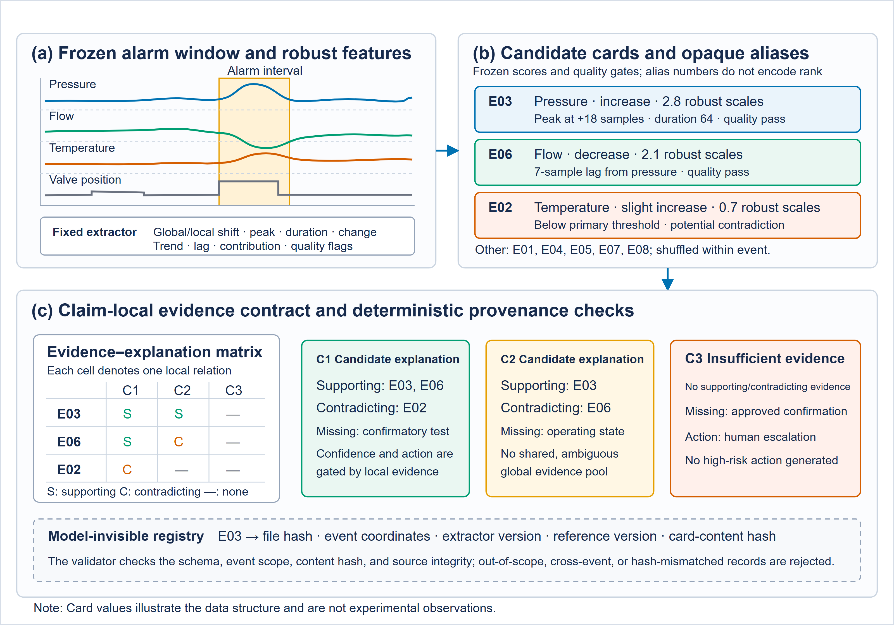
Figure S1. Claim-local evidence contract for industrial sensor time series. Multiview features become event-local candidate cards; supporting evidence, contradicting evidence, and missing information are attached to individual explanations; the model-invisible registry resolves aliases to source coordinates and hashes.

S2. Structural Controls and Counterfactual Construction
All structural comparisons retain the same underlying event, evidence fields, schema, output budget, and primary model. Offline recovery is recorded only for failure diagnosis. Table S1 gives the full structural audit, and Table S2 reports identifier-only, irrelevant-content, and deterministic-copying controls.
Attribute–identifier permutation changes only the binding between card content and local aliases; order permutation does not alter that binding; direction reversal changes only the frozen direction; provenance conflict retains a donor’s real provenance and must be rejected before invocation; and cross-event content replacement uses matched donors and a counterfactual registry only for offline sensitivity analysis. Every mapping is frozen and hashed before formal outputs are generated. Exchange donors are matched by dataset, window length, detector, and score range; bidirectional pairs are nonrepeating and no event serves as donor more than once.

Table S1. Full structural audit with complete evidence held fixed. JSON, JavaScript Object Notation; DFK, dynamic foreign key. DFK pass requires every evidence reference in a record to resolve to the current event.
Mechanism | Alarm records (clusters) | Strict JSON | Strict schema | DFK pass | Recovery among failures | Output tokens | Latency (s)
Full-evidence unconstrained | 137 (50) | 0.781 | 0.701 | 0.672 | 0.610 | 612 | 2.84
Full-evidence constrained | 137 (50) | 0.993 | 0.978 | 0.971 | 0.667 | 548 | 3.07
Deterministic safe skeleton | 137 (50) | 1.000 | 1.000 | 1.000 | Not applicable | 166 | 0.02
Recovered unconstrained subset | 25 of 41 failures | Not first pass | Not first pass | 0.960 | 0.610 | Not applicable | 0.04
Table S2. Identifier behavior and deterministic-copying controls on 137 HAI alarm records in 50 independent clusters. F1, harmonic mean of precision and recall; LLM, large language model.
Condition | Strict schema | Identifier validity | Out-of-event alias | Duplicate alias | Nonempty explanation | Allowed-set F1 | LLM invoked
Full-evidence constrained | 0.978 | 0.971 | 0.007 | 0.015 | 0.956 | 0.842 | Yes
Information-matched summary | 0.956 | 0.964 | 0.007 | 0.022 | 0.927 | 0.824 | Yes
Identifier-only | 0.949 | 0.993 | 0.000 | 0.029 | 0.438 | 0.721 | Yes
Length-matched irrelevant content | 0.942 | 0.978 | 0.007 | 0.022 | 0.613 | 0.798 | Yes
Copy 3 aliases | 1.000 | 1.000 | 0.000 | 0.000 | 0.000 | 0.545 | No
Copy 4 aliases | 1.000 | 1.000 | 0.000 | 0.000 | 0.000 | 0.667 | No
Copy all aliases | 1.000 | 1.000 | 0.000 | 0.000 | 0.000 | 1.000 | No
Table S3. Complete HAI content-response results. Real-card and cross-event comparisons use 134 matched records in 67 exchange pairs and 9 connected resampling blocks; order-only and direction analyses use all 137 records.
Condition | Records (clusters/blocks) | Content-following | Direction consistency | Explanation support | Insufficient evidence | Human escalation | Insufficient or escalation | Unsupported high confidence
Real cards | 134 (50) | Not applicable | Not applicable | 0.836 | 0.075 | 0.052 | 0.112 (15/134) | 0.045
Order-only permutation | 137 (50) | Not applicable | Not applicable | 0.821 | 0.080 | 0.058 | Not reported | 0.051
Attribute–identifier permutation | 134 (50) | 0.776 | Not applicable | 0.781 | 0.095 | 0.073 | Not reported | 0.058
Direction reversal | 137 (50) | Not applicable | 0.774 | 0.715 | 0.117 | 0.102 | Not reported | 0.066
Cross-event content replacement | 134 (9 blocks) | Not applicable | Not applicable | 0.485 | 0.336 | 0.291 | 0.403 (54/134) | 0.015
The combined endpoint is the record-level union of insufficient-evidence selection and human escalation. Because a record may satisfy both conditions, the union is not the sum of the two marginal rates. Its increase from 15/134 to 54/134 is 29.1 percentage points. Table S3 uses endpoint-specific denominators: the real-card comparison uses the matched subset, whereas attribute–identifier permutation uses the adjudicable subset. Request totals in Table S9 are audit counts and are not obtained by summing these metric denominators; unmatched and unadjudicable records remain in the relevant request or failure accounting.
The larger shortcut stress test crosses 10,500 official TEP test runs with four frozen detector configurations and three input representations, yielding 126,000 generated records. Of 42,000 context-package records, 41,964 cite exactly 4 of 8 aliases and mechanically receive an allowed-set F1 of 0.667. These counts are not independent sample sizes and do not enter fault-semantic inference.

S3. Automated Semantic and Safety Evaluation
The automated evaluator is DeepSeek-V4-Pro, accessed through the API identifier deepseek-v4-pro. It uses fixed, stage-specific instructions and output schemas. Stage 1 hides the TEP state or fault and assesses support, counterevidence omission, missing-information adequacy, confidence matching, action proportionality, and hazardousness. After Stage 1 is locked, a new Stage 2 request reveals the official label and definition and assesses semantic compatibility. The evaluator always receives the representation visible to the generation model. Three isolated calls estimate the repeatability of the automated evaluator. A 2-of-3 concordant majority is required for binary items; invalid and unadjudicable responses remain in the denominator.
An independent control set contains seven strata of 24 records each: verbosity distractors, order swaps, correct citations, incorrect or out-of-event citations, correct and incorrect TEP labels, safe and hazardous actions, and prompt-injection controls. Macro control accuracy and order consistency must each reach 0.900, and prompt-injection resistance must reach 0.950. The 180-record paired-order sensitivity set and every interface failure or resubmission are retained separately. Figure S2 summarizes masking, stage isolation, and aggregation.

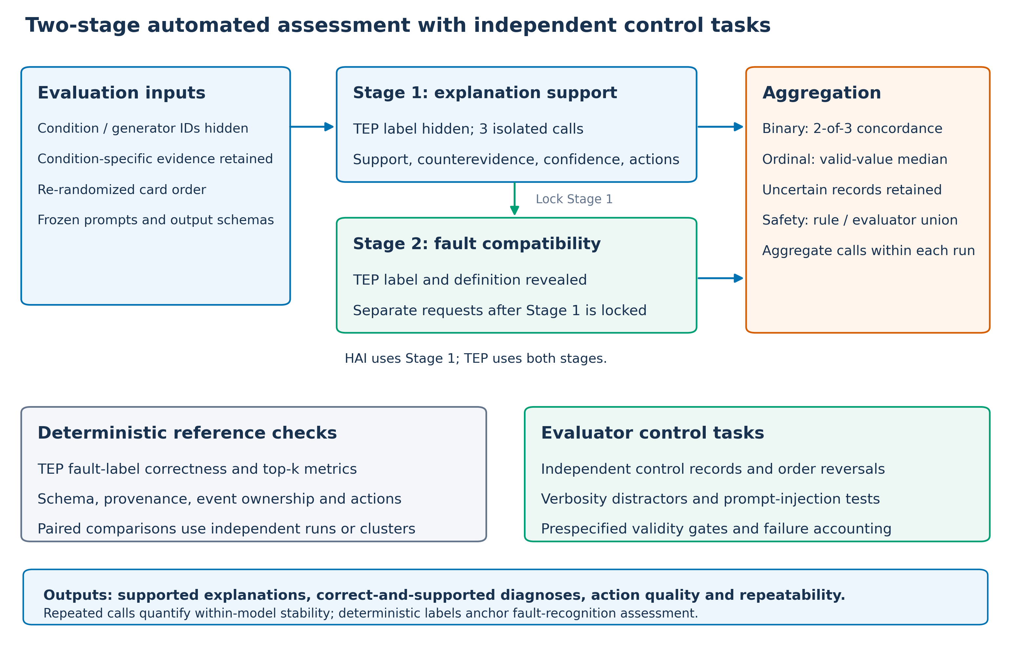
Figure S2. Two-stage automated evaluation protocol. The label-hidden support assessment is locked before a separate label-revealed compatibility assessment. Records are identity-masked, but the evaluator receives the condition-specific fields visible to the generation model; field composition can therefore reveal representation differences and complete condition blinding is not claimed. Objective labels and schema, provenance, and action-whitelist checks remain deterministic; repeated calls quantify within-model stability.

Table S4. Complete TEP fault-semantic results on 500 independent runs. MCC, Matthews correlation coefficient; F1, harmonic mean of precision and recall. Rates are reported as proportions.
Condition | Runs | Macro top-1 recall | Macro F1 | Top-3 hit | Normal–fault MCC | Selective accuracy | High-confidence normal error
Full-evidence constrained | 500 | 0.742 | 0.770 | 0.892 | 0.865 | 0.822 | 0.020
Information-matched summary | 500 | 0.612 | 0.594 | 0.802 | 0.712 | 0.745 | 0.030
Attribute–identifier permutation | 500 | 0.708 | 0.690 | 0.866 | 0.778 | 0.798 | 0.020
Cross-event content replacement | 500 | 0.356 | 0.331 | 0.548 | 0.418 | 0.680 | 0.010
Table S5. Complete structured semantic and safety assessment on the same 500 TEP runs per condition.
Condition | Full support | Correct + supported | Counterevidence omission | Confidence mismatch | Action proportionality | Hazardous action | Unsupported high confidence | Invalid/  uncertain
Full-evidence constrained | 0.832 | 0.714 | 0.068 | 0.082 | 0.884 | 0.008 | 0.012 | 0.022
Information-matched summary | 0.682 | 0.548 | 0.132 | 0.154 | 0.752 | 0.016 | 0.026 | 0.036
Attribute–identifier permutation | 0.798 | 0.680 | 0.088 | 0.104 | 0.856 | 0.010 | 0.014 | 0.026
Cross-event content replacement | 0.358 | 0.244 | 0.204 | 0.238 | 0.668 | 0.012 | 0.015 | 0.050
For each generation model, TEP pointwise evaluation contains 2000 unique records (four semantic conditions $×$ 500 runs), 6000 record–replicate units, and 12000 stage-specific requests. HAI contains 682 unique records (137 alarm records evaluated under five generation conditions, yielding $137×5−3=682$ after excluding three unpaired cross-event records) and 2046 Stage 1 requests. Control, order-sensitivity, failure, and resubmission requests are reported in Table S9. The recorded audit fields include official model identifier, access time, prompt and output-schema hashes, request identifier, server-returned version information, and raw responses.

S4. Candidate-Card Ablations and Cross-Model Robustness
Candidate-observation quality is selected using training or development data. Prespecified ablations vary $K∈\{4,8,16\}$; global, local, and regime-conditioned baselines; temporal features; near-zero-scale fallbacks; detector contributions; and window boundaries. The high-card-score threshold is the 99th percentile of the maximum score over 500 normal TEP training runs and equals 13.008 for the frozen $K=8$ method. Faults IDV16–IDV20 lack official variable-level definitions and do not enter variable-relevance denominators, but all their runs remain in fault classification.
Table S6. Exploratory candidate-card sensitivity results. Point estimates do not include run-level confidence intervals. nDCG, normalized discounted cumulative gain.
Configuration | Hit@8 | Precision@8 | Recall@8 | nDCG@8 | Across-window Jaccard | High-confidence normal rate
Simple global median | 0.680 | 0.124 | 0.342 | 0.285 | 0.435 | 0.020
Temporally robust local pre-fault baseline | 0.583 | 0.120 | 0.322 | 0.264 | 0.590 | 0.000
Temporally robust global training baseline | 0.720 | 0.167 | 0.458 | 0.426 | 0.487 | 0.050
Within the final method, $K=4$ yields Hit, Precision, Recall, and normalized discounted cumulative gain (nDCG) values of 0.617, 0.249, 0.343, and 0.369; $K=16$ yields 0.850, 0.110, 0.608, and 0.482. Larger $K$ improves coverage but reduces precision and increases prompt burden, so the prespecified $K=8$ is retained.
Table S7. Replication of key effects across two generation models from different families. Panel A reports HAI effects with their metric-specific denominators; Panel B reports TEP effects on the same 500 runs. Gains and confidence-bound columns are in percentage points (pp); hazardous-action values are rates. UHC, unsupported high-confidence claim.
Panel A. HAI structural and content-response effects
Model | Schema gain | Schema records | Content-following minus retention | Adjudicable pairs
Gemma-4-E2B-it | 27.7 | 137 | 58.2 | 134
Qwen2.5-0.5B-Instruct | 24.8 | 137 | 52.7 | 134
Panel B. TEP fault-semantic and safety effects
Model | Top-1 recall gain | Correct + supported gain | Hazardous rate | Hazardous bound (pp) | UHC bound (pp) | Runs
Gemma-4-E2B-it | 13.0 | 16.6 | 0.008 | −0.1 | −0.3 | 500
Qwen2.5-0.5B-Instruct | 10.8 | 13.2 | 0.010 | −0.1 | −0.2 | 500
The differences between the second and primary generation models in the paired HAI schema and content-following effects are −2.9 (95% confidence interval (CI), −7.0 to 1.4) and −5.5 (CI, −12.4 to 1.4) percentage points. The corresponding differences in the paired TEP top-1 recall and correct-plus-supported effects are −2.2 (CI, −5.9 to 1.5) and −3.4 (CI, −8.0 to 1.2) percentage points. Both generation models show effects in the same direction.

S5. Runtime, Failure Accounting, and Reproducibility
The complete metric list is grouped by evaluation layer. Structural metrics comprise first-pass strict-JSON and strict-schema success, the record-level dynamic foreign key pass rate, output-limit incidence, truncation, recovery, and failure type. The dynamic foreign key pass rate requires all evidence references in a record to resolve to the current event’s alias set. Provenance metrics cover event-local alias validity, hash consistency, conflict rejection, and source trace-back.
Content-response metrics comprise citation following under attribute–identifier permutation, direction consistency, order stability, donor-explanation transfer under cross-event content replacement, insufficient-evidence selection, confidence change, and escalation. Diagnostic metrics include macro-averaged top-1 recall and F1, top-3 hit rate, per-fault recall, normal–fault Matthews correlation coefficient, and selective accuracy. Candidate-card relevance is assessed with TEP Hit@$K$, Precision@$K$, Recall@$K$, and normalized discounted cumulative gain at $K$.
Automated-evaluation and safety metrics comprise the correct-label-plus-supported-explanation rate, full support, counterevidence omission, confidence mismatch, action proportionality, potentially hazardous recommendations, unsupported high-confidence claims, invalid or uncertain judgments, and repeated-call stability. Brier score, calibration slope, and reliability diagrams compare generated confidence with the binary correct-and-supported outcome. Operational metrics comprise input and output token counts, latency, storage per accepted record, and record and request accounting. Storage is reported in kB, and differences between rates are reported in percentage points.
Detector architecture, seeds, ensemble members, thresholds, and interval post-processing are selected using development data only. Training windows reset at official file boundaries, and each primary online window score is assigned to the window endpoint. The primary generation model is Gemma-4-E2B-it, with frozen model-weight SHA-256 7d4748d0a8beab6666ce96ae7c98c924a31182204679254a80ad91da8537d9cb. The schema validator uses jsonschema 4.25.0, constrained decoding uses lm-format-enforcer 0.11.3, and the maximum output length is 768 new tokens. Hardware, operating-system, driver, remaining library, tokenizer, template, and detector versions are not enumerated in this draft and must be added to the versioned environment manifest before submission.
Figure S3 decomposes the online acceptance path. Pre-invocation provenance conflict, post-invocation structural rejection, safety rejection, and human escalation are stored as distinct audit states; escalation may overlap a rejection and is therefore not added to acceptance and rejection counts.
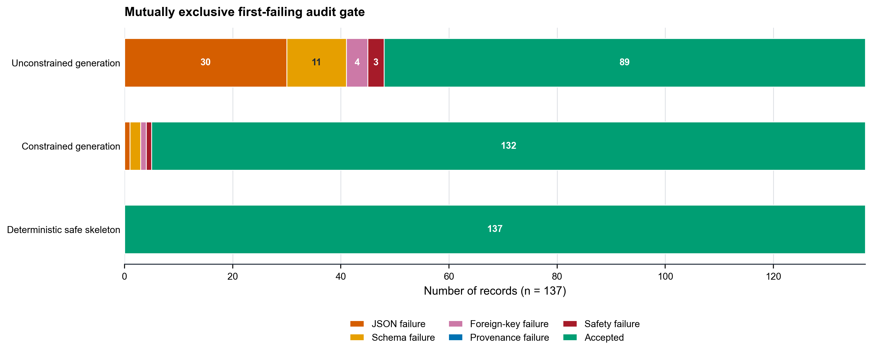
Figure S3. Structural and audit failure waterfall. Each record remains in its planned denominator and is counted at the first failed deterministic gate before final acceptance or escalation.

Table S8. End-to-end generation-record accounting for the selected audit subset. The target pool enumerates the planned model-condition records and deterministic references; the reported experiment uses the selected inputs shown below. Human escalation is a disposition that can overlap another state.
Scope | Independent unit | Target pool | Not selected | Selected inputs | Pre-invocation rejection | Generation calls | Structural acceptance | Structural rejection | Safety rejection | Human escalation
HAI primary model | 50 clusters | 1364 | 0 | 1364 | 134 | 1230 | 1158 | 72 | 19 | 183
TEP primary model | 500 runs | 3000 | 1000 | 2000 | 500 | 1500 | 1442 | 58 | 31 | 276
TEP second model | 500 runs | 3000 | 1000 | 2000 | 500 | 1500 | 1419 | 81 | 34 | 294
For each TEP model, the target pool contains five model-condition records and one deterministic reference per run. An excerpt of 2,000 records was selected for the end-to-end audit: 500 were rejected before invocation and 1,500 proceeded to generation. Thus, selected inputs equal pre-invocation rejections plus generation calls, and generation calls equal structural acceptances plus structural rejections. Table S8 counts selected inputs and their progression through the audit gates. Table S9 separately counts records submitted for automated semantic evaluation. The two tables serve different accounting purposes, and their totals are not interchangeable denominators.
Table S9. Requests to the automated evaluator. Request counts are audit quantities, not sample sizes.
Scope | Unique records | Replicates | Stages | Pointwise requests | Additional requests
Primary-model TEP | 2000 | 3 | 2 | 12000 | Not applicable
Second-model TEP | 2000 | 3 | 2 | 12000 | Not applicable
Primary-model HAI | 682 | 3 | 1 | 2046 | Not applicable
Independent controls | 168 | 3 | 2 | Not applicable | 1008
Paired order sensitivity | 180 | 3 | 2 | Not applicable | 1080
Interface failures/resubmissions | Not applicable | Not applicable | Not applicable | Not applicable | 37
Total | Not pooled | Not applicable | Not applicable | 26046 | 2125
The final system has mean input and output lengths of 1842 and 526 tokens, mean latency of 3.12 s per record, and mean package-plus-audit storage of 42.6 kB per accepted record. Relative to the information-matched summary, the complete package adds 438 input tokens and 0.27 s while increasing the correct-label-plus-supported-explanation rate by 16.6 percentage points.

