Claims Processing Solution
Developer Case Study - Java & AWS

Prepared by: Lebogang Ndlovu

Prepared for the Claims Processing Developer Case Study

1. Executive Summary
The proposed solution introduces a Claims Processing Service that acts as an orchestration layer between the existing Claims System, Client Registry System, Policy Manager System, and Payment System.
The existing Claims System remains the authoritative system for claim business data, while the new Claims Processing Service coordinates the end-to-end workflow and maintains processing-related metadata such as status, priority, idempotency information, retry state, correlation identifiers, and processing timestamps.
The solution uses a hybrid synchronous and asynchronous architecture. Claim submissions are accepted through a REST API, persisted with an outbox event, and processed asynchronously. In production, the processing event would be routed through Amazon SQS. Client and policy validations are performed synchronously within the processing workflow because subsequent steps depend on their outcomes. Payment is initiated only after successful validation and approval, while final payment completion is handled asynchronously.
Time-sensitive claims, such as death claims, are assigned a higher processing priority and routed through a dedicated high-priority queue.
The sample implementation uses Java 17, Spring Boot, Spring Data JPA, H2, REST/OpenAPI and Spring application events for a self-contained local demonstration. The proposed production target uses Amazon API Gateway, ECS/Fargate, ECR, Amazon RDS/PostgreSQL, Amazon SQS, CloudWatch, SNS, IAM and Secrets Manager.

2. Problem Statement
The current environment contains several systems responsible for different parts of the claims process, but these systems are not currently connected.
- Client Registry System handles client validation and client-related processing.
- Policy Manager System handles validations relating to policies, plans and benefits.
- Payment System processes payments once validation and approval are complete.
- Payment System updates the claim with payment status once payment is complete.
The objective is not to rebuild these systems, but to introduce the components necessary to connect and coordinate them reliably.
The solution must also support defined SLA requirements, particularly for time-sensitive claims such as death claims.

2.1 Objectives
- Provide a stable REST API for claim submission.
- Orchestrate the end-to-end claims workflow.
- Preserve existing system responsibilities.
- Support asynchronous processing.
- Prioritise time-sensitive claims.
- Prevent unintended duplicate processing.
- Handle transient downstream failures.
- Provide claim status visibility.
- Provide monitoring and operational alerting.
- Support SLA monitoring.
- Expose API documentation through Swagger/OpenAPI.
- Demonstrate maintainable Java engineering practices.

3. Scope

3.1 In Scope
- POST /api/v1/claims.
- GET /api/v1/claims/{claimId}.
- Claim request validation.
- Claim priority determination.
- Workflow state management.
- Integration with the existing Claims System.
- Client Registry integration.
- Policy Manager integration.
- Payment System integration.
- Asynchronous claim processing.
- Payment status handling.
- Idempotency.
- Technical failure handling.
- Retry strategy and dead-letter/manual-review handling
- SLA monitoring.
- Logging and operational monitoring.
- Swagger/OpenAPI documentation.
- Sample Spring Boot implementation and dummy integrations.

3.2 Out of Scope
- Rebuilding the existing Claims System.
- Rebuilding Client Registry.
- Rebuilding Policy Manager.
- Rebuilding Payment System.
- Complete insurance business rules.
- Real payment processing.
- Production authentication infrastructure.
- Production AWS deployment.
- A new customer-facing frontend.

4. Assumptions
- The existing Claims System remains the authoritative system for claim business data.
- Client Registry, Policy Manager, Payment System and the existing Claims System expose or can expose suitable integration interfaces.
- Each accepted claim can be identified using a unique claimId.
- Downstream systems may occasionally be unavailable or respond slowly.
- Payment processing may complete asynchronously.
- For the sample integration contract, Policy Manager returns the payable benefit amount after successful validation. The fixed ZAR 50,000 value is dummy data only and is not part of the incoming claim JSON.
- Payment requests should support idempotent behaviour to prevent duplicate payments.
- Exact SLA durations have not been provided and will therefore be externally configurable.
- An existing organisational identity provider authenticates users and can issue an access token to the submission channel.
- The AWS architecture represents the proposed production target; the sample application does not need to deploy every AWS component.
- Business rules used to identify duplicate real-world claims must be confirmed with business stakeholders.

5. Proposed Solution

5.1 Claims Processing Service
A new Claims Processing Service acts as the orchestration layer.
- Accept claim submissions.
- Perform request/schema validation.
- Prevent duplicate technical submissions.
- Determine claim priority.
- Coordinate creation/update of the authoritative claim.
- Publish processing events.
- Coordinate downstream systems.
- Track workflow state.
- Handle technical failures.
- Expose claim processing status.
- Record timestamps and correlation information.
The service does not duplicate client, policy or payment business rules. The sample uses dummy integration adapters behind interfaces so that local demonstrations can run without external systems, while production adapters can be introduced without changing orchestration logic.

6. System Boundaries
One of the key design decisions is preserving clear ownership between systems.

6.1 Existing Claims System
Owns the authoritative business claim record.

6.2 Claims Processing Service
Owns orchestration and processing metadata, for example:
claimId
workflowStatus
priority
idempotencyKey
correlationId
retryCount
processing timestamps

6.3 Client Registry
Owns client validation and client-related processing.

6.4 Policy Manager
Owns policy validation, plan validation, benefit validation, and claim-related policy rules. In the sample integration contract, Policy Manager also returns the payable benefit amount after successful validation; the demonstration adapter returns a fixed amount of ZAR 50,000 for valid policies.

6.5 Payment System
The Payment System owns payment execution and the final payment outcome. The Claims Processing Service does not calculate or execute payments itself; it only initiates a payment after client and policy validations have succeeded and the claim has been approved.
For the sample implementation, the Claims Processing Service sends the Payment System a payment request containing the claimId, the payable amount returned by Policy Manager, the currency, and a payment idempotency key.
Example payment request:
{
"claimId": "CLM-10001",
"amount": 50000.00,
"currency": "ZAR",
"idempotencyKey": "CLM-10001-PAYMENT"
}
The Payment System may immediately acknowledge the request with a paymentId and a PROCESSING status. The claim then moves to PAYMENT_PROCESSING. When the payment finishes, the Payment System sends the final outcome (COMPLETED or FAILED) back through an event or, in the sample application, the POST /api/v1/payments/status callback.
This boundary prevents duplicate ownership of payment rules: Policy Manager remains responsible for the payable benefit amount, Payment System remains responsible for executing the payment, and the Claims Processing Service remains responsible for orchestration and workflow status.

7. High-Level Architecture
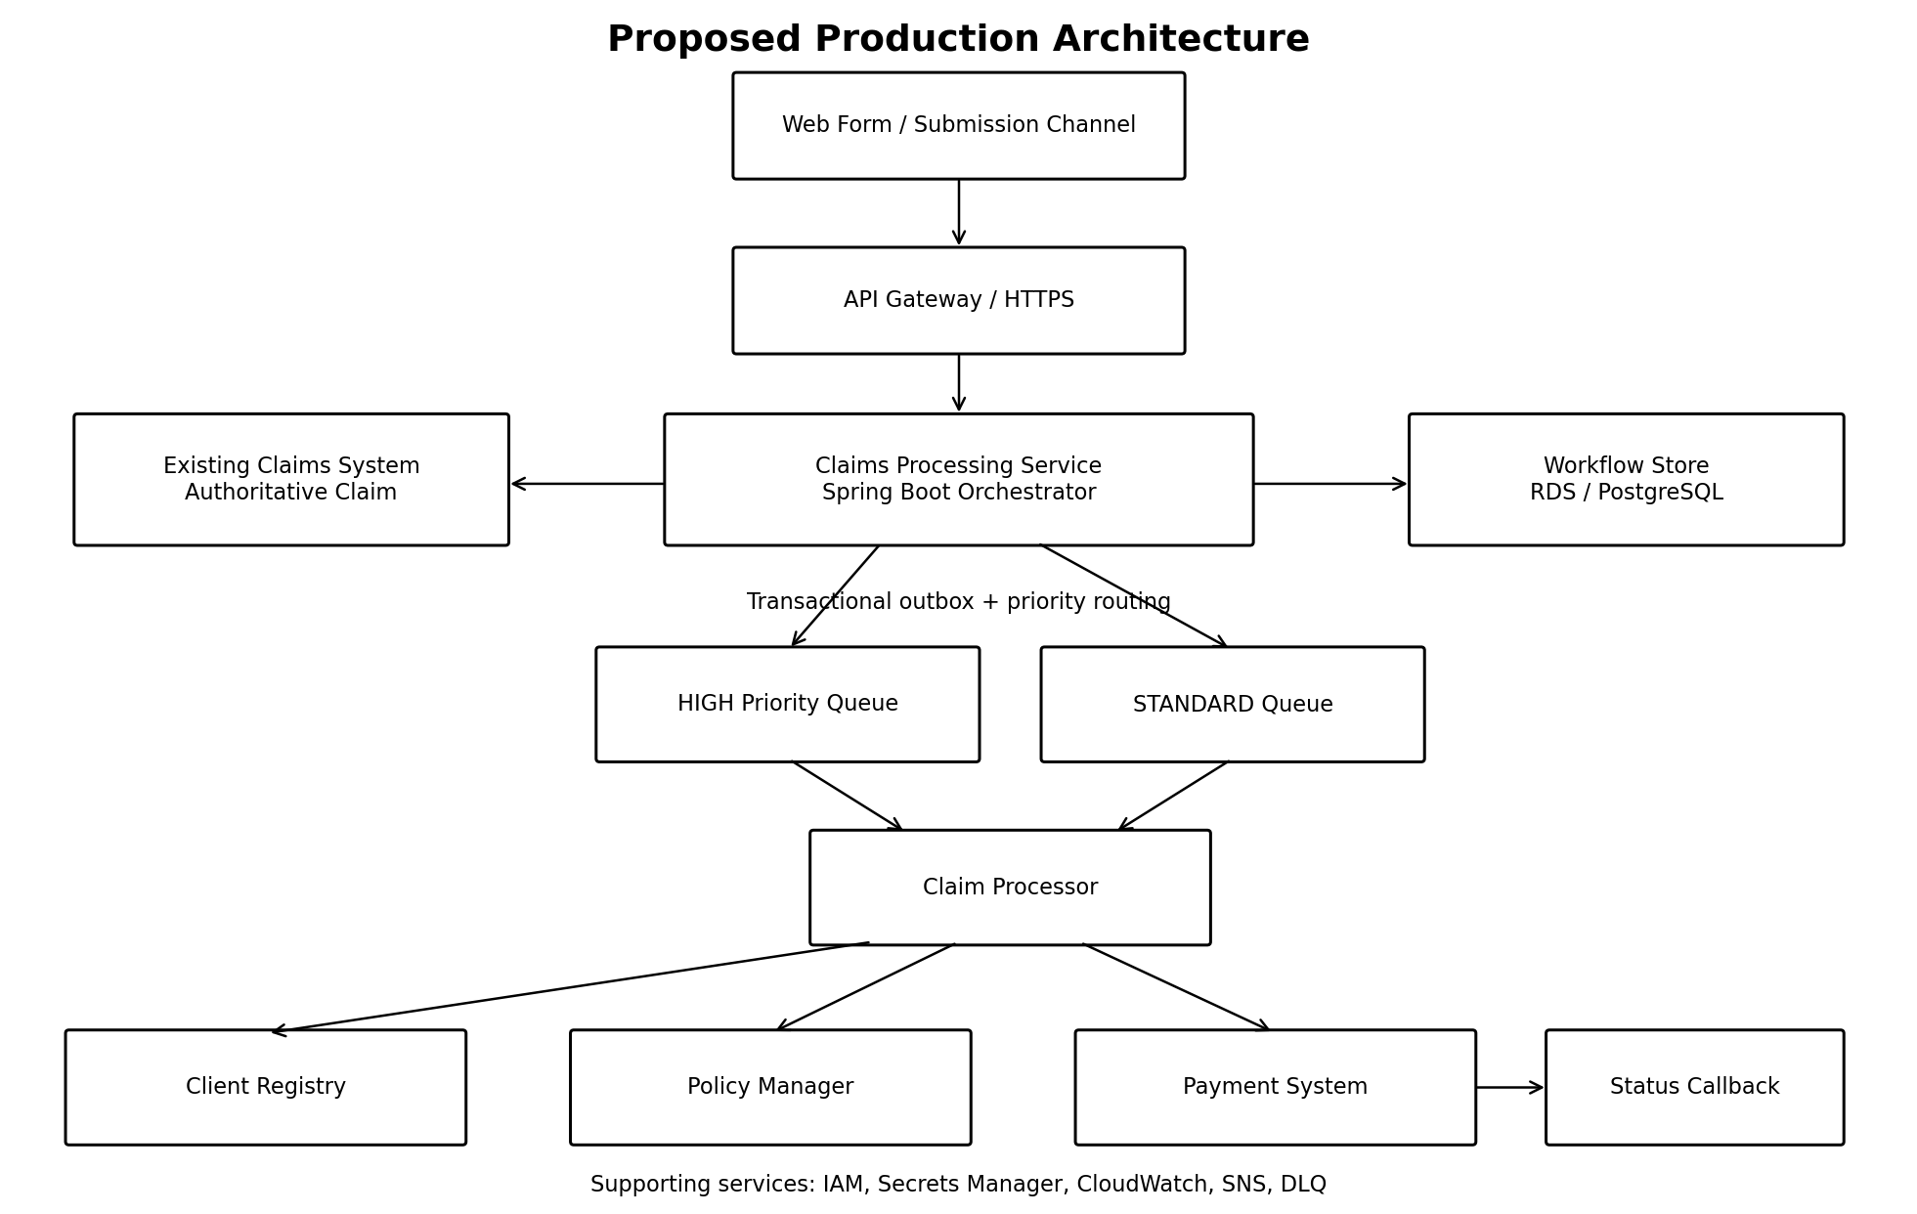
Figure 1. Proposed production architecture and system boundaries.
Figure 1 summarises the proposed production topology and the ownership boundaries between the orchestration layer and existing systems.
Supporting AWS services: These services represent the proposed production deployment; the local sample uses H2 and Spring application events.
IAM -> controls AWS permissions
Secrets Manager -> protects credentials/secrets
CloudWatch -> logs, metrics and SLA monitoring
CloudWatch Alarm -> detects warning/breach conditions
SNS -> notifies operations/support

8. Claim Submission Flow
The Web Form sends a request similar to:
POST /api/v1/claims
Authorization: Bearer <token>
Idempotency-Key: REQ-123
Example payload:
{
"clientId": "CLIENT123",
"policyNumber": "POL456",
"claimType": "DEATH"
}
The Claims Processing Service performs the following:
Receive request
|
Validate JSON / required fields
|
Check Idempotency-Key
|
Create authoritative claim in Existing Claims System
|
Determine priority (DEATH -> HIGH, OTHER -> NORMAL)
|
Store workflow state + PENDING outbox event atomically
|
Return 202 Accepted
|
OutboxPublisher dispatches event for asynchronous processing
Example response:
{
"claimId": "CLM-10001",
"status": "RECEIVED",
"priority": "HIGH"
}
202 Accepted means the claim has been accepted for processing. It does not mean the claim has been approved.
Retrying the same submission with the same Idempotency-Key returns 200 OK with the original claim rather than a second 202 Accepted, so a channel-side retry after a timeout reads as “here is what you already submitted”, not as a new claim being created.

9. Claim Processing Workflow
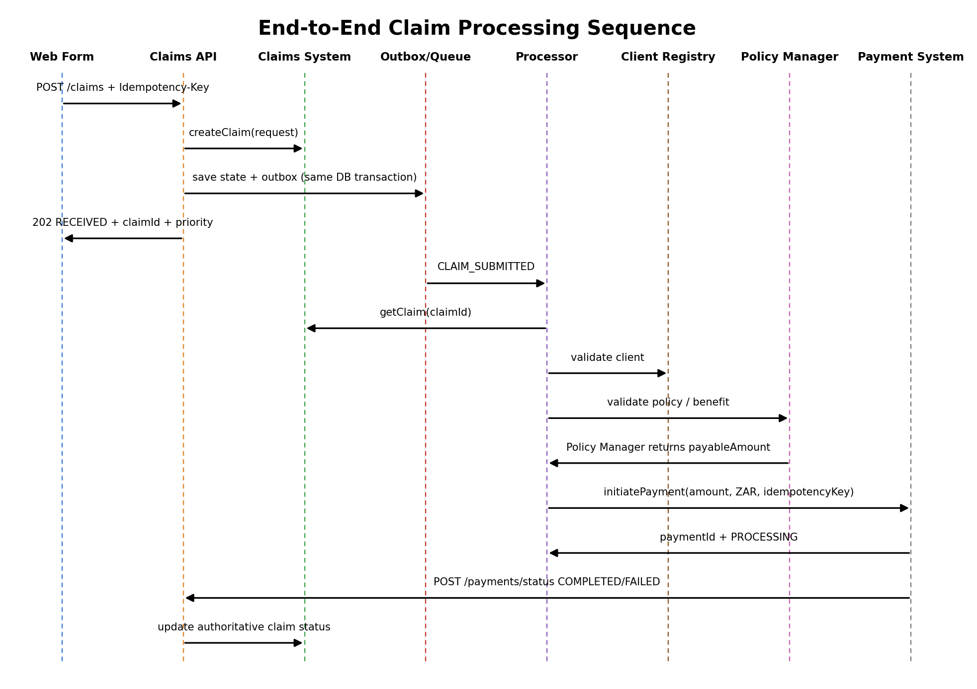
Figure 2. End-to-end sequence from submission through asynchronous payment completion.
RECEIVED -> CLIENT_VALIDATION_PENDING -> CLIENT_VALIDATED -> POLICY_VALIDATION_PENDING -> POLICY_VALIDATED -> APPROVED -> PAYMENT_REQUESTED -> PAYMENT_PROCESSING -> PAYMENT_COMPLETED
PROCESSING_FAILED (technical failure, retried with backoff) -> MANUAL_REVIEW (retries exhausted)
Possible failure states include:
CLIENT_VALIDATION_FAILED
POLICY_VALIDATION_FAILED
PAYMENT_FAILED
PROCESSING_FAILED
MANUAL_REVIEW
CLIENT_VALIDATION_FAILED and POLICY_VALIDATION_FAILED represent business validation outcomes and are terminal for the current workflow. PAYMENT_FAILED represents a final unsuccessful payment outcome. PROCESSING_FAILED represents a retriable technical failure and only becomes MANUAL_REVIEW—the sample’s operational representation of a dead-letter outcome—once retries are exhausted. See section 12.4.

10. Synchronous vs Asynchronous Processing

10.1 Asynchronous Claim Submission
Claim submission is processed asynchronously after acceptance. This prevents the Web Form from waiting while the entire claim journey completes.
Web Form -> API -> Existing Claims System + Workflow State/Outbox -> 202 Accepted -> Background Publisher/Processor

10.2 Synchronous Calls Within the Worker
Client Registry and Policy Manager calls are synchronous because each subsequent step depends on the result of the previous validation.
Processor -> Client Registry -> Valid? -> Policy Manager

10.3 Asynchronous Payment Completion
Payment initiation may return an acknowledgement while final completion happens later.
{
"paymentId": "PAY-5001",
"status": "PROCESSING"
}
The claim then moves to PAYMENT_PROCESSING. In production, the preferred integration would be a payment status event, for example:
{
"eventType": "PAYMENT_COMPLETED",
"claimId": "CLM-10001",
"paymentId": "PAY-5001",
"status": "COMPLETED"
}

If the existing Payment System cannot publish events, a secured REST callback can act as an integration adapter. The sample application demonstrates this approach using POST /api/v1/payments/status. Polling would be considered only as a fallback.

11. Priority and SLA Design
Time-sensitive claims such as death claims are assigned a higher processing priority.
DEATH -> HIGH
OTHER -> NORMAL
The actual business mapping should be configurable.
Priority and status represent different concepts:
Priority = how urgent is the claim?
Status = where is the claim in its processing journey?
High-priority claims are routed to a dedicated SQS queue so urgent claims are not blocked by a standard-claim backlog.
Claim
|
Determine Priority
/ \
HIGH NORMAL
| |
v v
High Queue Standard Queue

11.1 SLA Measurement
The end-to-end SLA clock starts when the claim is accepted and continues through downstream dependency delays. Component timings are captured separately to identify where delays occurred.
Illustrative SLA breakdown example:
Total processing: 20 minutes
Client Registry waiting: 8 minutes
Policy processing: 2 minutes
Payment processing: 7 minutes
Internal processing: 3 minutes
Actual SLA durations are not provided in the case study, so thresholds remain configurable.
The sample implements this locally as SlaMonitor, a scheduled check that compares elapsed time since receivedAt against a per-priority threshold (claims.sla.high-priority-minutes, claims.sla.standard-minutes) and logs a breach. GET /api/v1/claims/{claimId} also exposes this as slaBreached, so a claims analyst querying the new service sees the same signal an ops CloudWatch alarm would raise.
Approaching SLA -> Warning
SLA breached -> Critical alert

12. Reliability and Failure Handling

12.1 Retry
Transient failures such as timeouts or temporary service unavailability should be retried using configured retry limits and backoff. Retries must not continue indefinitely.
In the sample, a technical failure (DownstreamTechnicalException) moves a claim to PROCESSING_FAILED with an exponential backoff timer (claims.retry.initial-backoff-ms, claims.retry.backoff-multiplier, claims.retry.max-backoff-ms). ClaimRetryScheduler polls for claims whose backoff window has elapsed and re-drives them, up to claims.retry.max-attempts.

12.2 Timeout
Downstream calls should have configured timeouts so processing threads do not wait indefinitely.

12.3 Business vs Technical Failure
Client Registry says INVALID
|
Business failure
|
CLIENT_VALIDATION_FAILED
|
STOP
A technical failure is handled differently:
Client Registry unavailable
|
Technical failure
|
RETRY

12.4 Dead-Letter Queue
SQS
|
Processing fails
|
Retry
|
Retry limit exceeded
|
DLQ
|
CloudWatch Alarm
|
SNS
|
Operations / Support
In the sample, retries exhausted (claims.retry.max-attempts) move the claim to MANUAL_REVIEW instead of a real SQS DLQ -- the local demonstration of the operational outcome that a production DLQ + CloudWatch Alarm + SNS flow would support. A claims analyst investigates from there. ClaimRetryWorkflowIntegrationTest exercises this end to end: a claim that keeps failing technically is redriven with backoff and asserted to land in MANUAL_REVIEW once attempts are exhausted.

13. Idempotency and Duplicate Claims

13.1 Technical Duplicate
The Web Form should generate an idempotency key and reuse it when technically retrying the same submission.
Idempotency-Key: REQ-123
If REQ-123 is received again, the existing result is returned rather than creating another claim.
REQ-123 -> CLM-10001
The same concept should be applied to payment requests where supported.
Idempotency-Key: CLM-10001-PAYMENT

Two requests carrying the same Idempotency-Key can race before either transaction has committed. A database unique constraint on idempotency_key provides the final concurrency guard. The sample includes handling for a losing concurrent submission, while production implementations should validate this behaviour against the selected database and transaction-isolation strategy. ClaimStatePersisterTest verifies the application-level handling of the duplicate-insert scenario.

13.2 Business Duplicate Claim
A client may make a completely new submission that actually relates to an existing incident. That is not an idempotency problem.
Potential matching criteria could include:
- Client.
- Policy.
- Claim type.
- Incident date.
- Event or benefit reference.
Exact duplicate-detection rules must be confirmed with the business. A suspected duplicate may be flagged for review rather than automatically rejected.

14. Transactional Outbox
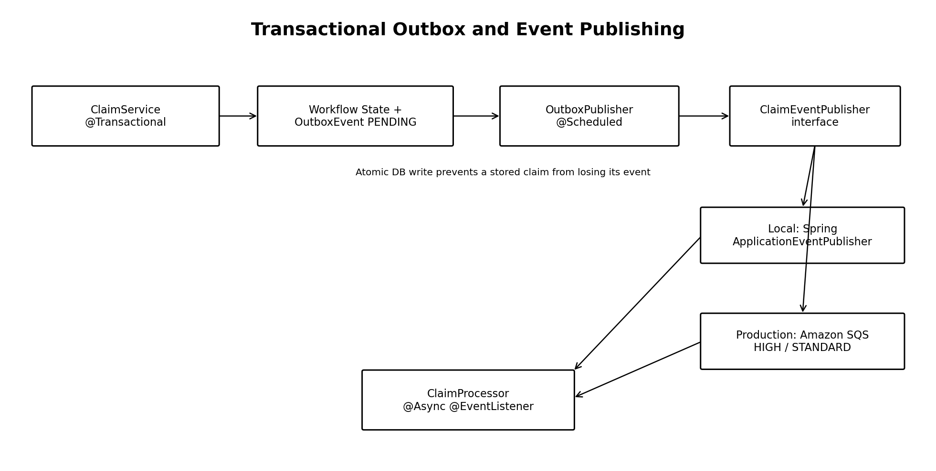
Figure 3. Implemented outbox flow with local event adapter and production SQS replacement.
The sample implements the transactional outbox pattern to address the dual-write problem between persisting workflow state and publishing the processing event.
Without an outbox:
Save claim successfully
|
Application crashes
|
SQS publish never happens
|
Claim becomes stuck
With an outbox, workflow state and the event are stored in the same database transaction:
BEGIN TRANSACTION
Save ClaimProcessingState
Save OutboxEvent(eventType=CLAIM_SUBMITTED, status=PENDING)
COMMIT
Local: Outbox -> Scheduled Publisher -> Spring Application Event -> @Async ClaimProcessor -> Mark PUBLISHED
Production: Outbox -> Scheduled Publisher -> Amazon SQS -> Consumer -> Mark PUBLISHED after publish
This prevents a successfully stored claim from silently losing its processing event. Consumers must still be idempotent because duplicate event delivery remains possible.
In the sample, ClaimService coordinates submission and delegates persistence to ClaimStatePersister, which stores ClaimProcessingState and a PENDING OutboxEvent in the same local transaction. OutboxPublisher polls pending events and publishes them through the ClaimEventPublisher abstraction. The local adapter uses Spring ApplicationEventPublisher; in production the same interface can be implemented with Amazon SQS. An event is marked PUBLISHED only after successful publication, and consumers must remain idempotent because duplicate delivery is still possible.
ClaimStatePersister owns this transaction as a dedicated Spring bean rather than a private method on ClaimService, because a @Transactional method reached through a same-class call bypasses Spring's proxy and would silently run without a transaction at all. The call to the existing Claims System (ClaimsSystemClient.createClaim) happens before this transaction and outside it: in production that is a real network call to another system, which cannot itself participate in a local ACID transaction, and holding a database transaction open for the duration of an external call is a connection-pool and lock-contention risk under load. This leaves one explicit, accepted gap rather than a hidden one: if that external call succeeds but the local transaction then fails for a reason other than the idempotency race (for example the database itself becomes unreachable), the authoritative system would have a claim with no local processing state or outbox event, and it would never be picked up for orchestration. Closing that gap fully would require an additional reliability mechanism, such as reconciliation, an upstream idempotent creation contract, or an event-driven integration from the authoritative Claims System. Implementing such a mechanism is outside the scope of this case study.

15. API Design
Endpoint | Purpose | Typical Response
POST /api/v1/claims | Submit a new claim for processing | 202 Accepted (new submission); 200 OK (idempotent retry)
GET /api/v1/claims/{claimId} | Retrieve claim processing status | 200 OK
POST /api/v1/payments/status | Payment callback fallback where events are unavailable | 200 OK

Example claim status response:
{
"claimId": "CLM-10001",
"status": "PAYMENT_PROCESSING",
"priority": "HIGH",
"correlationId": "...",
"paymentId": "PAY-5001",
"retryCount": 0,
"failureReason": null,
"receivedAt": "...",
"updatedAt": "...",
"nextRetryAt": null,
"slaBreached": false
}

15.1 Error Responses
Request validation and API-level exceptions return a consistent error shape via GlobalExceptionHandler rather than being handled ad hoc per endpoint. HTTP status is mapped according to the exception type, for example 404 for an unknown claimId, 409 for an invalid payment-status operation, and 400 for request validation failures. Business validation outcomes that occur during asynchronous claim processing are represented through claim workflow statuses rather than HTTP errors.
{
"timestamp": "2026-08-31T10:15:00",
"status": 400,
"error": "Bad Request",
"message": "Request validation failed",
"validationErrors": {
"policyNumber": "must not be blank"
}
}

15.2 OpenAPI / Swagger
The application exposes its API contract using OpenAPI. Swagger UI provides interactive documentation and allows the endpoints to be demonstrated without building an additional frontend.

16. Security

16.1 HTTPS
In production, external API traffic would be encrypted using HTTPS/TLS, with API Gateway providing the external API entry point.
Web Form -> HTTPS -> API Gateway

16.2 Authentication
The solution assumes an existing organisational identity provider.
Client
|
Existing Identity Provider
|
JWT
|
Web Form
|
API Gateway
|
Claims API
The case study does not define the authentication platform, so building a new login system is outside scope.

16.3 Authorisation
Authenticated callers should only access operations and claims they are permitted to access.

16.4 IAM
AWS IAM roles provide least-privilege access between AWS workloads and resources.
Claim Processor
|
IAM Role
|
+--> Read/Delete Claims SQS
|
+--> Read required secret

16.5 Secrets Manager
Credentials and API secrets must not be hardcoded in source code or configuration committed to source control. The sample configuration supports environment-variable placeholders (for example DB_USERNAME and DB_PASSWORD) with local H2 defaults; production credentials would be sourced from AWS Secrets Manager through IAM-controlled access.
Claims Service -> IAM permission -> Secrets Manager -> Downstream credential

16.6 Logging
Logs should contain identifiers such as claimId, correlationId, status and processing stage. Sensitive client information should not be unnecessarily written to logs.
In the sample, ClaimProcessor puts claimId and correlationId into SLF4J's MDC for the duration of each processing run, and the console log pattern includes both, so every log line for a claim's workflow can be correlated without threading the identifiers through every log call by hand.

17. Proposed AWS Architecture
Requirement | Proposed AWS Service
Secure API entry point | API Gateway
Run Spring Boot containers | ECS/Fargate
Store Docker images | ECR
Workflow persistence | RDS/PostgreSQL
Asynchronous processing | SQS
Failed messages | SQS DLQ
Logging/metrics | CloudWatch
Operational alerts | CloudWatch Alarm + SNS
AWS permissions | IAM
Credentials/secrets | Secrets Manager

The Java application is packaged as a Docker image:
Java source
|
Maven build
|
Spring Boot JAR
|
Docker image
|
ECR
|
ECS/Fargate
This AWS architecture is a proposed design choice because the case study specifies Java and AWS but does not prescribe individual AWS services.

18. Recommended Changes to Existing Systems

18.1 Web Form
- Generate an idempotency key for each submission.
- Reuse the key when technically retrying the same submission.
- Handle 202 Accepted for new submissions and 200 OK when an idempotent retry returns an existing claim.
- Retain the returned claimId.
- Use the status API for processing updates.
- Route new claim submissions through the Claims Processing Service's POST /api/v1/claims. The service then coordinates creation of the authoritative claim in the Existing Claims System and the subsequent processing workflow. This positions the Claims Processing Service as the orchestration entry point while the Existing Claims System remains the authoritative source of claim business data.

18.2 Existing Claims System
- Remain the authoritative claim system.
- Expose stable versioned APIs/events for claim creation and status updates.
- Avoid direct database integration from the orchestration service.
- Surface the new service's processing status (workflowStatus, priority, retryCount, correlationId) in the existing Claims System UI -- or have that UI call the new service's GET /api/v1/claims/{claimId} -- so a Claims Analyst retains a single view of a claim instead of needing to check two systems to see why it is stuck.

18.3 Client Registry
- Expose a stable validation API.
- Return clear business validation responses.
- Distinguish business failures from technical failures.

18.4 Policy Manager
- Expose a stable policy validation API.
- Maintain ownership of policy/plan/benefit rules.
- Expose consistent error responses.

18.5 Payment System
- Support idempotent payment initiation.
- Publish asynchronous payment status events where possible.
- Include claimId and paymentId for correlation.
- Provide a secured callback as fallback where event publishing is unavailable.

18.6 Cross-System Integration
- API versioning.
- The Claims Processing Service applies this principle to itself as well: all endpoints are exposed under /api/v1.
- Correlation IDs.
- Consistent error structures.
- Documented API/event contracts.
- Timeout expectations.
- Observability across system boundaries.

19. Proposed Project Structure
claims-processing-case-study/
|
+-- README.md
+-- pom.xml
+-- Dockerfile
+-- src/
+-- main/
| +-- java/za/co/claims/processing/
| | +-- client/
| | +-- config/
| | +-- controller/
| | +-- dto/
| | +-- entity/
| | +-- enums/
| | +-- event/
| | +-- exception/
| | +-- mapper/
| | +-- repository/
| | +-- service/
| +-- resources/application.yml
+-- test/java/za/co/claims/processing/
The sample remains a single Spring Boot application with strong logical separation rather than introducing unnecessary independently deployed microservices. External systems are represented by small client interfaces with dummy adapters for local execution. PaymentRequest carries claimId, payableAmount, currency (ZAR) and a payment idempotency key; PaymentResult carries paymentId and the immediate payment status.

19.1 Sample Implementation Alignment
- ClaimSubmissionRequest contains clientId, policyNumber and claimType only; payable amount is not supplied by the claimant.
- ClaimType contains DEATH and OTHER. PriorityResolver maps DEATH to HIGH and OTHER to NORMAL.
- ClaimService performs the initial idempotency check and creates the authoritative claim through ClaimsSystemClient. It then delegates local persistence to ClaimStatePersister, which stores ClaimProcessingState and OutboxEvent in the same transaction.
- OutboxPublisher polls PENDING events and publishes through ClaimEventPublisher. LocalClaimEventPublisher uses Spring ApplicationEventPublisher; the production adapter would publish to SQS.
- ClaimProcessor runs asynchronously, performs Client Registry and Policy Manager validation, obtains the payable amount from Policy Manager, initiates payment, and tracks workflow status.
- Payment status is completed through POST /api/v1/payments/status. ClaimResponseMapper exposes status, priority, correlationId, paymentId, retryCount, failureReason, timestamps, nextRetryAt and slaBreached.
- Optimistic locking protects ClaimProcessingState from stale concurrent updates. The processor reuses the entity returned by each save to maintain the current version.
- Swagger/OpenAPI is enabled for demonstration. H2 is used locally, while production persistence is proposed on Amazon RDS/PostgreSQL.
- ClaimStatePersister provides application-level handling for a duplicate insert, while the database unique constraint on idempotency_key remains the final concurrency guard. Production behavior should be validated against the selected database and transaction isolation strategy. ClaimService calls the external ClaimsSystemClient before this transaction, not inside it.
- POST /api/v1/claims returns 200 OK for a retried Idempotency-Key and 202 Accepted only for a genuinely new claim.
- ClaimRetryScheduler re-drives PROCESSING_FAILED claims with exponential backoff (claims.retry.*) and moves a claim to MANUAL_REVIEW once retries are exhausted -- the sample's manual-review outcome after retry exhaustion.
- SlaMonitor flags claims that exceed their per-priority SLA window (claims.sla.*); this is reflected in the status response as slaBreached.
- ClaimProcessor puts claimId and correlationId into MDC for the duration of each processing run so log lines can be correlated per claim.

20. Testing Strategy
The sample includes automated JUnit/Mockito and Spring integration tests covering key workflow scenarios, supplemented by manual end-to-end testing through Swagger to PAYMENT_COMPLETED:
- Valid submission -> 202 + claimId.
- DEATH claim -> HIGH priority.
- Same idempotency key twice -> one claim.
- Invalid client -> CLIENT_VALIDATION_FAILED and Policy Manager is not called.
- Invalid policy -> POLICY_VALIDATION_FAILED and Payment System is not called.
- Valid client + valid policy -> payment initiated.
- Technical downstream failure -> retryable failure and not treated as a business rejection.
- Repeated technical failure -> retried with backoff, then MANUAL_REVIEW once retries are exhausted (ClaimRetryWorkflowIntegrationTest).
- Duplicate-insert handling logic is covered by ClaimStatePersisterTest. A real concurrent database race should additionally be validated as an integration test against the target database.
JUnit and Mockito are used for unit testing, and Spring MockMvc integration tests (polling the status endpoint with Awaitility for asynchronously processed scenarios) validate API behaviour and orchestration boundaries end to end.

21. Technical Decisions and Trade-offs
The solution intentionally uses a hybrid synchronous/asynchronous model.
Asynchronous submission improves responsiveness and isolates the Web Form from downstream processing delays.
Synchronous Client Registry and Policy Manager calls are appropriate inside the processor because subsequent steps depend on their responses.
Payment completion is asynchronous because it may be long-running.
Separate high-priority and standard SQS queues prevent urgent claims from being blocked by standard backlog.
The Claims Processing Service is an orchestration layer rather than another claims system.
A relational workflow store provides transactional state management and supports idempotency, timestamps and workflow transitions. ClaimProcessingState also uses optimistic locking (@Version) to protect concurrent workflow updates; each saved state is reassigned to keep the latest persistence version during asynchronous processing.
Transactional Outbox is implemented in the sample: workflow state and the outbox event are written atomically, then a scheduled publisher dispatches pending events. Local execution uses Spring application events; the production design replaces that adapter with Amazon SQS.
The architecture deliberately avoids unnecessary microservices. Logical boundaries are maintained inside a manageable Spring Boot application and could later be separated where scaling or organisational requirements justify doing so.

22. AI Usage
AI assistance was used throughout this case study as a productivity accelerator, to speed up delivery within the time available alongside my own design work and review, for:
- Explore architectural options.
- Clarify AWS and event-driven concepts.
- Evaluate technical trade-offs.
- Structure documentation.
- Review proposed code organisation.
- Improve clarity of technical explanations.
- Scaffolding boilerplate (DTOs, repository interfaces, test skeletons) that I then reviewed, corrected and adjusted.
- Drafting a first pass of this document's structure and the accompanying diagrams, which I then corrected before including them.
AI-generated suggestions were evaluated against the case-study requirements and refined rather than accepted without review.
AI was used to accelerate mechanical and exploratory work, while the final architecture, trade-offs, assumptions and implementation decisions were reviewed and selected for this solution.

23. Conclusion
The proposed solution connects the existing claims ecosystem through a dedicated orchestration layer while preserving the responsibilities of the existing Claims System, Client Registry, Policy Manager and Payment System.
The architecture combines asynchronous claim processing with synchronous business validation, asynchronous payment completion, priority processing, idempotency, retry handling, a production DLQ strategy, SLA monitoring and operational observability.
The AWS architecture provides managed services for API exposure, application hosting, messaging, persistence, security and monitoring while keeping the core implementation centred around a maintainable Java Spring Boot application.
The sample implementation intentionally focuses on demonstrating architecture, code quality, engineering practices and system boundaries rather than attempting to reproduce a complete production insurance platform.

Source Note
This document is based on the supplied Developer Case Study 1.pdf. Where the case study does not specify implementation details (for example exact SLA durations, authentication platform, or individual AWS services), those items are explicitly treated as assumptions or proposed design choices.

