Logan Murray

CSC 355-502 – Database Systems

January 16, 2019

Assignment #1 –

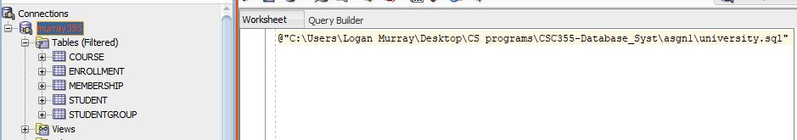1)

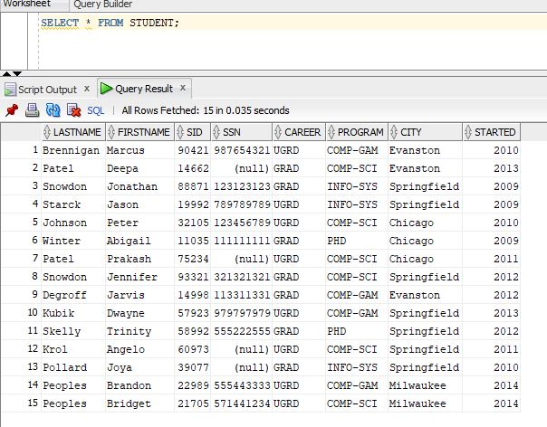2)

3)

a. List the attribute(s) that make up the primary key (if one exists) in ASSIGNMENT.

Primary Key (PK) attributes are (EID, PCode) and they are Foreign Keys (FK) in other tables.

b. List the attribute(s) that make up the primary key (if one exists) in EMPLOYEE.

The PK attribute is just (ID)

c. List the attribute(s) that make up the primary key (if one exists) in DEPARTMENT.

(Code) is the PK

d. List the attribute(s) that make up the foreign key(s) (if any exist) in ASSIGNMENT.

The two PKs are also FKs for this table

e. List the attribute(s) that make up the foreign key(s) (if any exist) in EMPLOYEE.

(DCode) is a FK

f. List the attribute(s) that make up the foreign key(s) (if any exist) in DEPARTMENT.

There are no FK in DEPARTMENT

g. Construct a new tuple that can be inserted into EMPLOYEE without violating any constraints.

INSERT INTO EMPLOYEE VALUES (8237, Ross Geller, 4);

His ID is unique, but as you can see he is not currently assigned to a project therefore he is not in ASSIGNMENT. His name is unique. And finally, he is working in the Human Resources department and has the proper code “4”.

h. Construct a new tuple that cannot be inserted into EMPLOYEE because doing so would violate a key constraint (but would not violate any other constraints).

INSERT INTO EMPLOYEE VALUES (1120, Rachel Green, 3);

Well here it is obvious that this cannot be because her ID is the same as Ted Mosby’s and they cannot share an identifier such as that.

i. Construct a new tuple that can be inserted into ASSIGNMENT without violating any constraints.

INSERT INTO ASSIGNMENT VALUES (3212, 551, 20)

This works because Barney Stinson has the Employee ID of 3212 and then there is a project titled Regulatory Compliance with the ID of 551, and finally just some amount of hours.

j. Construct a new tuple that cannot be inserted into ASSIGNMENT because doing so would violate referential integrity (but would not violate any other constraints)

INSERT INTO ASSIGNMENT VALUES (8237, 203, 30)

This would violate such integrity because that particular employee ID is not located within the EMPLOYEE table, yet it has to be in that table to be referenced.

k. Which tuples in PROJECT could be removed without violating referential integrity, and which tuples in PROJECT would cause referential integrity to be violated if they were removed?

Well the Market Research could be taken out, along with the Regulatory Compliance. But the rest are used in ASSIGNMENT. Everything else would violate referential integrity.