CS 498 – Applied Machine Learning

Homework 2

Larry Poon (lpoon2) & Titus Fong (thfong2)

12th February, 2018

Training a support vector machine on the Adult Data Set from UCL using stochastic gradient descent

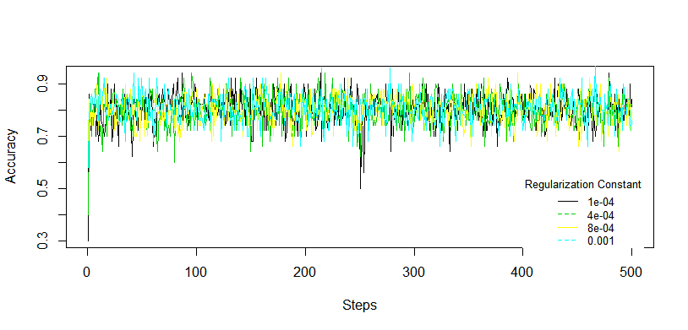

Figure 1. SVM accuracy for every 30 steps per epoch

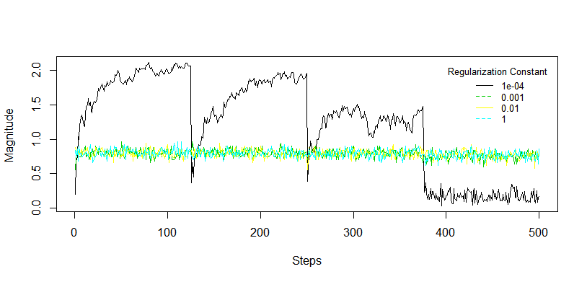

Figure 2. Magnitude of the coefficient every 30 steps

**Estimate of the best regularization constant**

|  |  |  |  |  |  |  |  |
| --- | --- | --- | --- | --- | --- | --- | --- |
| λ(Regularization const.) | 1e-05 | 1e-04 | 4e-04 | 8e-04 | 0.001 | 0.01 | 1 |
|  | 0.797 | 0.796 | 0.804 | 0.809 | 0.813 | 0.807 | 0.757 |

Table 1. Accuracy on validation set with different regularization constant

The above table shows the accuracy of the support vector machine with different regularization constants. We have tested with constants ranging from 1e-05 to 1. The potential maximum of the accuracy value occurs between 8e-4 to 0.01, since the accuracy drops and increases, respectively, outside of the range.