**Proyecto # 2: Máquinas de Turing – Definición**

* **Primera máquina: Reconocedor de cadenas palíndromas**

Definición formal:

Mpal = ({q0, q1, q2, q3, q4, q5, q6, q7, q8} , {a, b, c} , {a, b, c, β} , δ , q0 , β , {q8})

Tabla de estados:

|  |  |  |  |  |
| --- | --- | --- | --- | --- |
|  | a | b | c | B |
| q0 | q1, B, R | q2, B, R | q3, B, R | q8, B, R |
| q1 | q1, a, R | q1, b, R | q1, c, R | q6, B, L |
| q2 | q2, a, R | q2, b, R | q2, c, R | q7, B, L |
| q3 | q3, a, R | q3, b, R | q3, c, R | q4, B, L |
| q4 | - | - | q5, B, L | q8, B, R |
| q5 | q5, a, L | q5, b, L | q5, c, L | q0, B, R |
| q6 | q5, B, L | - | - | q8, B, R |
| q7 | - | q5, B, L | - | q8, B, R |
| q8 | - | - | - | - |

Diagrama de estados:

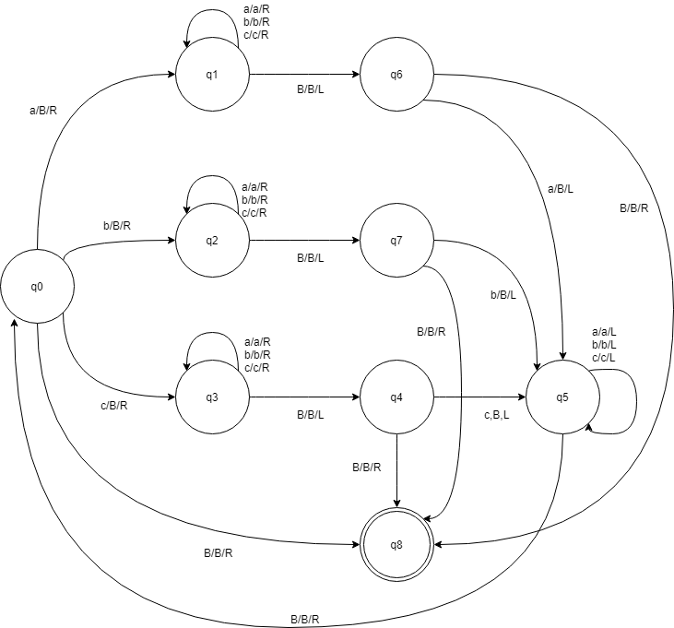

* **Segunda máquina: Copia de patrones**

Definición formal:

Mpat = ({q0, q1, q2, q3, q4, q5, q6} , {a, b, c} , {a, b, c, β, x, y, z} , δ , q0 , β , {q6})

Tabla de estados:

|  |  |  |  |  |  |  |  |
| --- | --- | --- | --- | --- | --- | --- | --- |
|  | a | b | c | B | x | y | z |
| q0 | q1, x, R | q2, y, R | q3, z, R | q5, B, L | q0, x, R | q0, y, R | q0, z, R |
| q1 | q1, a, R | q1, b, R | q1, c, R | q4, x, L | q1, x, R | q1, y, R | q1, z, R |
| q2 | q2, a, R | q2, b, R | q2, c, R | q4, y, L | q2, x, R | q2, y, R | q2, z, R |
| q3 | q3, a, R | q3, b, R | q3, c, R | q4, z, L | q3, x, R | q3, y, R | q3, z, R |
| q4 | q4, a, L | q4, b, L | q4, c, L | q0, B, R | q4, x, L | q4, y, L | q4, z, L |
| q5 | - | - | - | q6, B, R | q5, a, R | q5, b, R | q5, z, R |
| q6 | - | - | - | - | - | - | - |

Diagrama de estados:

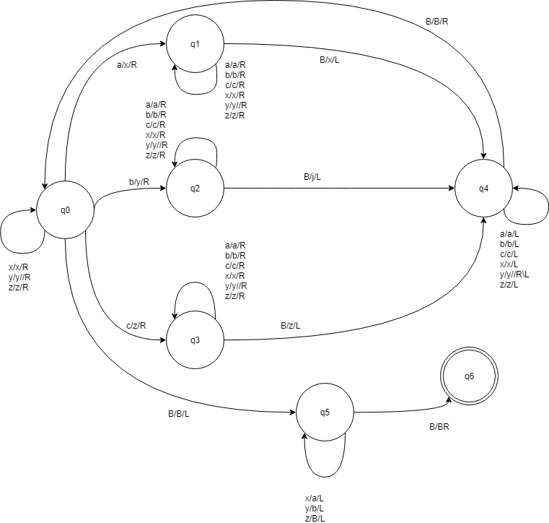

* **Tercera máquina: Multiplicación unaria**

Definición formal:

Mmult = ({q0, q1, q2, q3, q4, q5, q6, q7, q8} , {1,*} , {1, *, B, =, x, y} , δ , q0 , β , {q8})

Tabla de estados:

|  |  |  |  |  |  |  |
| --- | --- | --- | --- | --- | --- | --- |
|  | 1 | * | B | = | x | y |
| q0 | q0, 1, R | q0, *, R | q1, = , L | q2, =, L | q0, x, R | - |
| q1 | q1, 1, R | q1, *, R | q, B, R | - | - | - |
| q2 | q3, x, L | q8, *, L | - | - | q2, x, L | - |
| q3 | q3, 1, L | q3, *, L | q4, B, R | - | - | - |
| q4 | q5, y, R | q7, *, L | - | - | - | q4, y, R |
| q5 | q5, 1, R | q5, *, R | q6, 1, L | q5, =, R | q5, x, R | - |
| q6 | q6, 1, L | q6, *, L | q4, B, R | q6, =, L | q6, x, L | q6, y, L |
| q7 | - | - | q0, B, R | - | - | q7, 1, L |
| q8 | - | - | - | - | - | - |

Diagrama de estados:

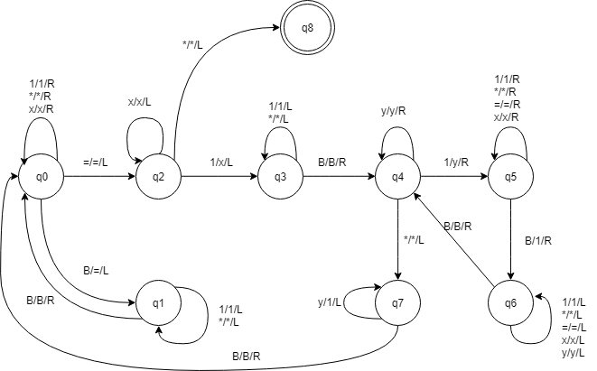

* **Cuarta máquina: Suma unaria**

Definición formal:

Msum = ({q0, q1, q2, q3} , {1,+} , {1, +, B} , δ , q0 , β , {q3})

Tabla de estados:

|  |  |  |  |
| --- | --- | --- | --- |
|  | 1 | + | B |
| q0 | q1, B, R | q3, B, R | - |
| q1 | q1, 1, R | q1, +, R | q2, 1, L |
| q2 | q2, 1, L | q2, +, L | q0, B, R |
| q3 | - | - | - |

Diagrama de estados:

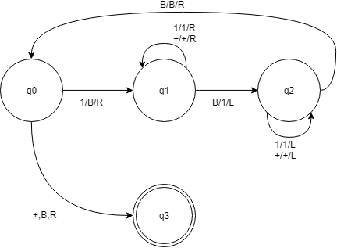

* **Quinta máquina: Resta unaria**

Definición formal:

Mres = ({q0, q1, q2, q3, q4, q5} , {1,-} , {1, -, B} , δ , q0 , β , {q5})

Tabla de estados:

|  |  |  |  |
| --- | --- | --- | --- |
|  | 1 | - | B |
| q0 | q0, 1, R | q0, -, R | q1, B , L |
| q1 | q2, B, L | q5, b, L | - |
| q2 | q2, 1, L | q2, -, L | q3, B, R |
| q3 | q4, B, R | q5, -, L | - |
| q4 | q0, 1, R | q5, -, R | - |
| q5 | - | - | - |

Diagrama de estados:

