December 10, 2002

Mathematical Derivation of the Total Requirements Tables for Input-Output Analysis

From make and use tables, the following are defined:

q: Total commodity output. It is a commodity-by-one vector.

g: A column sector in which each entry shows the total amount of each industry's output, including its production of scrap. It is an industry-by-one vector.

U: Intermediate portion of the use matrix in which the column shows for a given industry the amount of each commodity it uses, including noncomparable imports and scrap, used and secondhand goods. This is a commodity-by-industry matrix.

V: Make matrix, in which the column shows for a given commodity the amount produced in each industry. It is an industry-by-commodity matrix. V has columns showing only zero entries for noncomparable imports and for scrap.

^: A symbol that, when placed over a vector, indicates a square matrix in which the elements of the vector appear on the main diagonal and zeros elsewhere.

B: Direct input coefficients matrix in which entries in each column show the amount of a commodity used by an industry per dollar of output of that industry. It is a commodity-by-industry matrix.

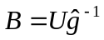 ( )

D: A matrix in which entries in each column show, for a given commodity (excluding scrap), the proportion of the total output of that commodity produced in each industry. It is assumed that each commodity (other than scrap) is produced by the various industries in fixed proportions (industry technology assumption). D is an industry-by-commodity matrix. D is also referred to as the market share matrix or transformation matrix.

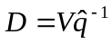 ( )

i: Unit (summation) vector containing only l's.

I: Identity matrix, where I = .
e: A column vector in which each entry shows the total final demand purchases for each commodity from the use table.

h: A column vector in which each entry shows the total amount of each industry's production of scrap. Scrap is separated to prevent its use as an input from generating output in the industries in which it originates.

p: A column vector in which each entry shows the ratio of the value of scrap produced in each industry to the industry's total output.

W: An industry-by-commodity matrix in which the entries in each column show, for a given commodity, the proportion of the total output of that commodity produced in each industry adjusted for scrap produced by the industry.

From the above definitions, the following identities are derived:

q = Ui + e ( )

g = Vi + h ( )
Scrap output in each industry is proportional to total output of the industry, then:
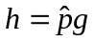 ( )

The model expressed in equations (1) through (5) thus involves three constants (B, D, p) and six variables (U, V, h, e, q, g). The model solution is derived as follows:

From (1) and (3), we derive:

q = Bg + e ( )

From (2) and (4), we derive:

g - h = Dq ( )

Substituting (5) into (7) and solving for g:

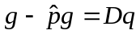
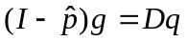

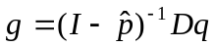 ( )

Let 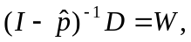 then

g = Wq ( )

Substituting (9) into (6) and solving for q:

q = BWq + e

(I - BW)q = e

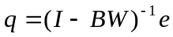 ( )

Substituting (10) into (9) gives:
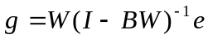 ( )
Therefore, three total requirements coefficients matrices are derived:

Commodity-by-commodity total requirements matrix:

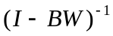 ( )
which shows commodity output required per dollar of each commodity delivered to final users.

Industry-by-commodity total requirements matrix:
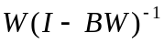 ( )
which shows the industry output required per dollar of each commodity delivered to final users.

And the industry-by-industry total requirements matrix:
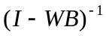 ( )
which shows the industry output required per dollar of each industry product delivered to final users.

The notation and derivation of the tables presented follow the System of National Accounts recommended by the United Nations. See: A System of National Accounts Studies in Methods, Series F No. 2 Rev. 3, United Nations, New York, 1968; also, Stone, R., Bacharach, M. & Bates, J., "Input-Output Relationships, 1951-1966," Programme for Growth, Volume 3, London, Chapman and Hall, 1963.
Tables are prepared at the detailed, summary and sector levels of aggregation.

