# Folder structure and explanation of files

The below table explains the various files that are present as part of the submission for this assignment:

|  |  |  |  |
| --- | --- | --- | --- |
| ID | File name | Folder containing file | Description of contents |
| 1 | DMM_LeagueOfLegends_Report.docx | Root | The report for the CA |
| 2 | Matches.csv | Data | The raw data that was obtained from Kaggle |
| 3 | Processed_matches.csv | Data | The processed data after transforming the time series data to aggregates |
| 4 | Bans_basket.csv | Data | The processed data for the bans after the transformation for association analysis. |
| 5 | RawDataDiscovery.Rmd | R source code | The R markdown file that contains all the R code that was developed for the discovery on the raw data |
| 6 | DataPreparation.Rmd | R source code | The R markdown file that contains all the R code that was developed to process the raw file and generated the Processed_matches.csv file |
| 7 | Modeling.Rmd | R source code | The R markdown file that contains all the R code that was developed to generate the models and perform grid search and 10 fold cross validation |
| 8 | AssociationAnalysis.Rmd | R source code | The R markdown file that contains all R code to perform association analysis on the bans basket data |

# Executing the R code in the markdown files

1. After the contents in the ZIP has been unzipped, please copy the data folder and put it into the R source code folder
2. Start RStudio and open the markup file by selecting it as shown below:

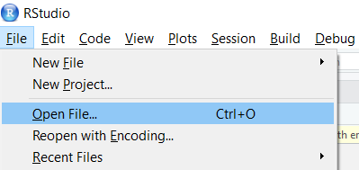

1. After the contents have been unzipped, please set the working directory to the current directory by updating the setwd function in the file. It can generally be found at the beginning of the code.



1. Execute the chunks one by one or all the chunks in one go by selecting the appropriate option from the menu as shown below:

