**LIBRARY**

Mission Statement – Why We Exist

The Greenfield Public Library serves as a public center for enrichment, entertainment, access to technology, self-directed learning, and the exploration of ideas. The library serves all member of the community, regardless of age, income, education, religious, or political beliefs and makes no judgment on the nature of individual inquiry.

Significant Budget & Staffing Changes for FY2018

The library’s budget has been level funded for FY2018, which means we will need to apply for a waiver in order to be certified by the Massachusetts Board of Library Commissioners (MBLC) as we will not meet the Municipal Appropriation Requirement (MAR), which is calculated using the prior 3 years' municipal appropriations for operating expenses. The average of the 3 years' figures is increased by 2.5% to determine the MAR figure for the current fiscal year. Certification allows the library to be eligible to receive State Aid (app. $35,000 in FY2017) and gives Greenfield residents borrowing privileges at area libraries and allows them to borrow materials from libraries around the state for free. There are no significant staffing level changes.

Recent Accomplishments

* 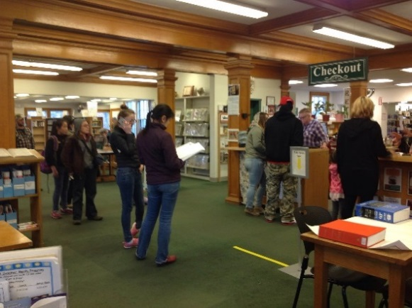Completed and submitted Construction Grant to the MBLC. The Grant was the culmination of work done by over seventy town residents over the past three years.
* Continued popular First Wednesday Speaker Series for adults.
* Increased number of individualized ‘Tech Help Sessions’ offered to public looking for help with technology (cell phones, social media, word processing, downloading e-books).
* Hosted over 400 people at four separate multi-generational “Experience the Book” parties, run by the Children’s Room staff.
* Expanded offerings of Teen programming, including book discussions, movie nights, and craft activities.
* Implemented highly successful adult component for the statewide Summer Reading Program.
* Worked with town’s IT Department to replace five antiquated staff computers with more efficient ones that are in line with models used at Town Hall.

FY2018 Goals and Objectives

* Continue offering programs to patrons of all ages – story times, lectures and author events, summer reading programs, etc.
* Work with town’s IT Department to create a technology plan that ensures in-house computer resources are updated and replaced on a timely basis.
* Collaborate with social service agencies to share information with residents about services/programs offered in town.
* Begin a Capital Campaign in support of a new public library for Greenfield.
* Administer a Massachusetts Public Library Construction Grant.

How FY2018 Departmental Goals Relate to City’s Overall Long & Short Term Goals

* The Library’s continues to emphasize excellent customer service in person, via email and social media, and over the phone, which helps maintain a high level of accessibility and responsiveness Greenfield residents as well as keeping people abreast of Library programs and offerings.
* 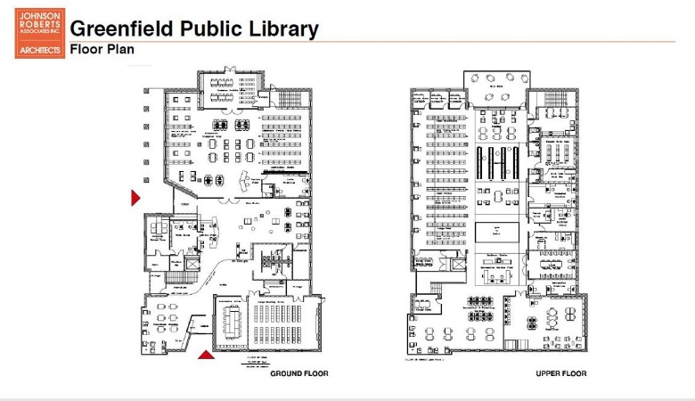As a member of C/W MARS and by accessing the Commonwealth Catalog, the library stretches tax dollars by providing access to materials a single library could not afford on its own.
* Online services are offered to allow our patrons access to the library 24/7. These services include the ability to manage patron accounts online, request and renew materials, and download e-books, e-audios and videos, magazines, and music at any time day or night.
* Submitting the Library’s Construction Grant application acts in accordance with Strategy 5 of the city’s Sustainable Master Plan to “improve Greenfield’s Public Library facilities to include adequate parking, accessibility, and community gathering space.”