|  |  |
| --- | --- |
| Use Case Name | Online Task Management System |
| Domain | Any |
| Complexity | Medium |

Table of Contents

1. Business Objective 3

2. Functionality 3

3. Services for Customer 4

4. Scope and Limitations 4

5. Design Considerations / Assumptions: 4

6. UI Screens / Pages 5

a. Login Page 5

b. Register 7

c. Manager home page 9

d. Add task- Manager 10

e. Assign Task-Manager 11

f. Review Task 13

g. View All Task- Manager 14

h. Employee home page 15

i. Employee status page 16

j. View all Task- Employee 18

k. Application Flow 19

# Business Objective

Online Task Management System can be used by any team which wishes to manage the tasks within the team. There would be two roles, i.e., manager and employee.

Managers can create new tasks for themselves as well as their team. They can use this application to add and manage their own daily tasks. They can also create and assign tasks to employee, view task completion status, update/delete the tasks if required. They can review the allocation changes done by employees.

Employees can view the tasks assigned to them and their expected completion date. Once the tasks have been completed, they can update the tasks. They can assign the task to other employees which goes through managers’ approval.

Below are the Functionalities that manager is enabled with:

* Login
* Home page
* Add task
* Assign task
* Delete task
* View task
* Review task allocation change
* Logout

Below are the Functionalities that employee is enabled with:

* Login
* Home page
* View task
* Change task allocation
* Logout

# Functionality

This application will provide a facility to the team to organize their tasks.

# Services for Customer

This service provide manager to keep track of the task and its management. It allow employee to look all the task assigned to him and raise request for change in task. Manager can approve or reject the request raised by the employee to modify the status of the task.

# Scope and Limitations

Online task manager does not allow employee to edit his task without manager’s approval, if manager reject the application to remove task then employee has no option. This application allow interaction of multiple employees but a single manager with the portal.

# Design Considerations / Assumptions:

1. You can store the data in HttpSession or Cache or in-memory database
2. The manager credentials to login to the application : **admin / admin123**

URL: [*http://host:port/contextroot/{rest*](http://localhost:8080/contextroot/%7brest) *of the URI}*

In the above URL**,** *contextroot* isthe Context root of the application. You can use any value for contextroot in your local environment during development but **do not hardcode it in the application source code**, as the system will replace it with the dynamically generated name as context root and deploy in the application server to validate the functional test cases using selenium web driver API. In case if you are not using the context root (say for example**, Dot Net core and NodeJS applications may not really have the context root**), it will be replaced with blank.

For example:

Java: [http://host:port/contextroot/login](http://localhost:8080/onlinebanking/login)

Dot Net: <http://localhost:5001/login>

NodeJS: <http://localhost:3000/login>

1. Do not refer any third-party libraries (CSS/JS libraries) directly from internet in the code, instead download them and use as local reference.
2. Variable **Identifier** of HTML should be id/name for input types, id for <div> and anchor text for <a> tags. It should be followed strictly.
3. Do not hard code port number and context root anywhere in the code

# UI Screens / Pages

**Please read the below points carefully before you start the development of the use case.**

Each page should have the following:

* Title of the page
* All the input elements to capture the user input
* Buttons/Links for any action like submit, cancel etc.,
* **All the HTML elements should have id or name attribute**
* **Element id or name should be unique and is case sensitive. If you use different names, the automated functional test cases will fail.**
* Success or Error message to be displayed should be wrapped in a <div> tag with the documented id/name. Please note the div id name is case sensitive.
* **Please use the success / error messages documented as is, otherwise the automated functional test cases will fail.**
* **Please use the** **design considerations / assumptions section** **to configure the master data like admin credentials, etc., without which the functional tests will fail.**

## Login Page

This page allows the Employee and Manager to login into the application.

Employee and Manager should be able to login into the application by providing all the data in mandatory fields.

Manager can login using credentials “admin” as username and “admin123” as password.

Employee has to register first then can login using those credentials.

An error message should be displayed when the mandatory field is missing. On successful login take Employee to the employee home page and manager to manager home page.

*http://host:port*[/](http://localhost:8080/onlinetaskmanager/login)*contextroot*[/login](http://localhost:8080/onlinetaskmanager/login)

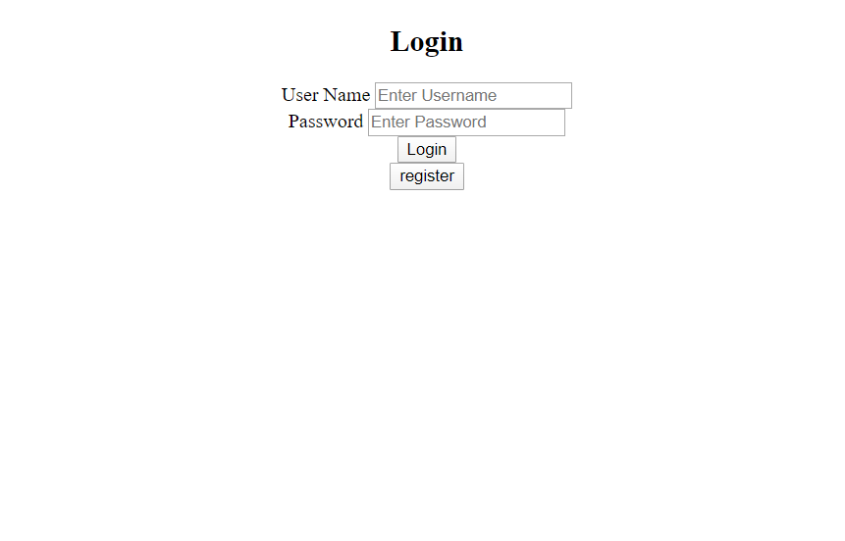

|  |  |  |  |  |  |
| --- | --- | --- | --- | --- | --- |
| **Field / Page attribute** | **HTML Element Type** | **Required** | **Identifier** | **Validation Message** | **Remarks** |
| URL |  |  | *http://host:port/contextroot/login* | | |
| Title of the page |  |  | Login | | |
| User Name | Label |  |  |  |  |
| User Name | Text Box | Yes | id=”name” |  |  |
| Password | Label |  |  |  |  |
| Password | Password | Yes | Id=”password” |  |  |
| Login | Button |  | Id=”login” |  | Click on the button should validate the provided credentials and on successful validation the page should navigate to Home Page. Otherwise display the error message on top of the page |
| Register | Button |  | Id=”register” |  | Takes employee to the register page |
| Error Message | div |  | Id=”error” |  | Global div tag to display the error message  “Invalid Details” when employee does not exists.  Or when there is empty field |

## Register

New Employee can register themselves. No manager registration is required.

After registration of a new employee navigate to login page. Auto generated empid will be generated for every employee starting with 10000 and stored in database/session.

Eg. For first registered employee, empid should be 10000

For second registered employee, empid should be 10001



|  |  |  |  |  |  |
| --- | --- | --- | --- | --- | --- |
| **Field / Page attribute** | **HTML Element Type** | **Required** | **Identifier** | **Validation Message** | **Remarks** |
| URL |  |  | *http://host:port/contextroot/*  *register* |  |  |
| Title of the page |  |  | Register |  |  |
| User Name | Label |  |  |  |  |
| User Name | Text Box | Yes | id=”name” |  |  |
| Password | Label |  |  |  |  |
| Password | Password | Yes | Id=”password” |  |  |
| Confirm Password | Label |  |  |  |  |
| Confirm Password | Text Box | Yes | Id= “cpassword” |  |  |
| Register | Button |  | Id=”register” | Invalid Credentials | Click on the button should validate the provided credentials and on successful validation the page should navigate to Login Page. Otherwise display the error message on top of the page |
| Error Message | div |  | Id=”error” |  | Global div tag to display the error message “**Invalid Details**” password do not match with confirm password.  “**Invalid Details”** when field is empty |

All the input text fields should not allow more than 30 characters.

## Manager home page

After login through the manager credentials navigate to manager homepage.

1. If the login Id password matches with the credentials of the manager, then Manager home page should be displayed.

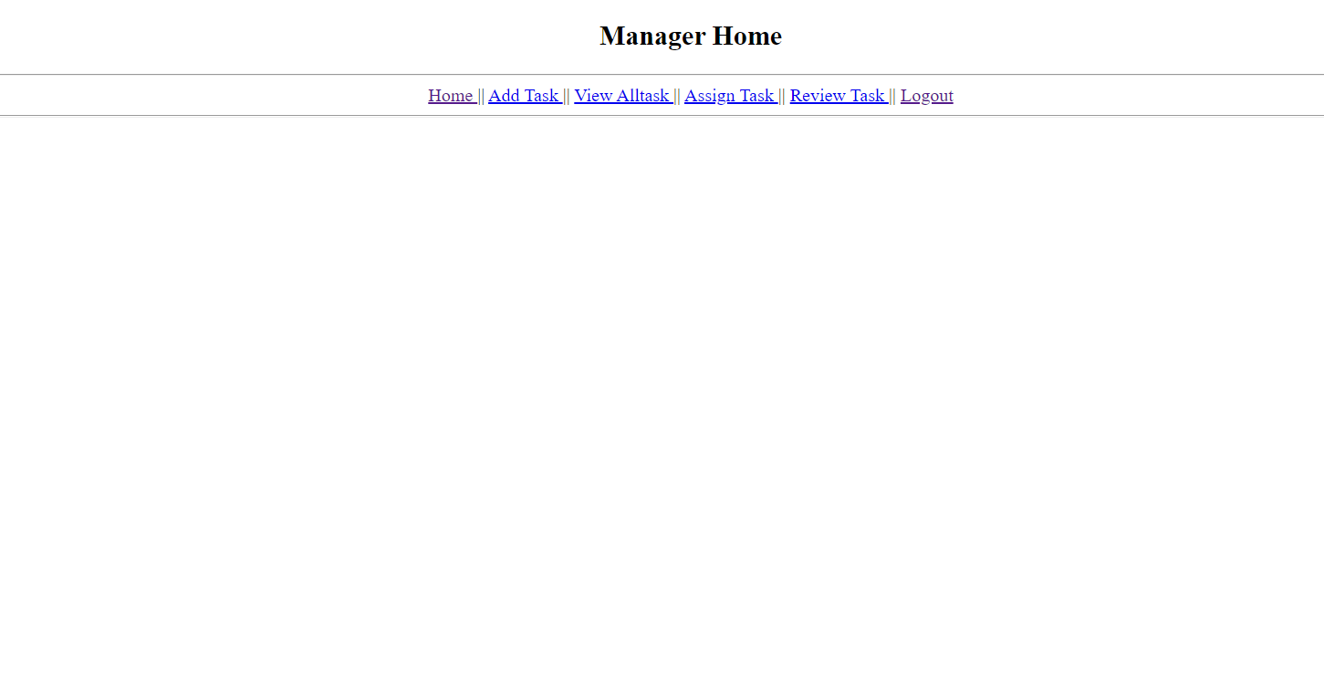

|  |  |  |  |
| --- | --- | --- | --- |
| **Field / Page attribute** | **HTML Element Type** | **Identifier** | **Remarks** |
| URL |  | *http://host:port/contextroot/manager/home* |  |
| Title of the page |  | Home |  |
| Home | Link | Link Text =”Home” | Display Manager’s Home Page |
| Add Task | Link | Link Text =”Add Task” | Display Add Task – Manager page |
| View All Task | Link | Link Text =”View All Task” | Display View all task – Manager page |
| Assign Task | Link | Link Text =”Assign Task” | Display Assign task – Manager page |
| Review Task | Link | Link Text=”Review Task” | Display Review task – Manager page |
| Logout | Link | Link Text =”logout” | Bring user to login page |

## Add task- Manager

On clicking Add task page, manager would be able to add task using the task name, description and time need to complete it. Autogenerated taskid for every task will be generated starting with 1000.

For task1 taskid should be 1000, for task 2 taskid should 1001.

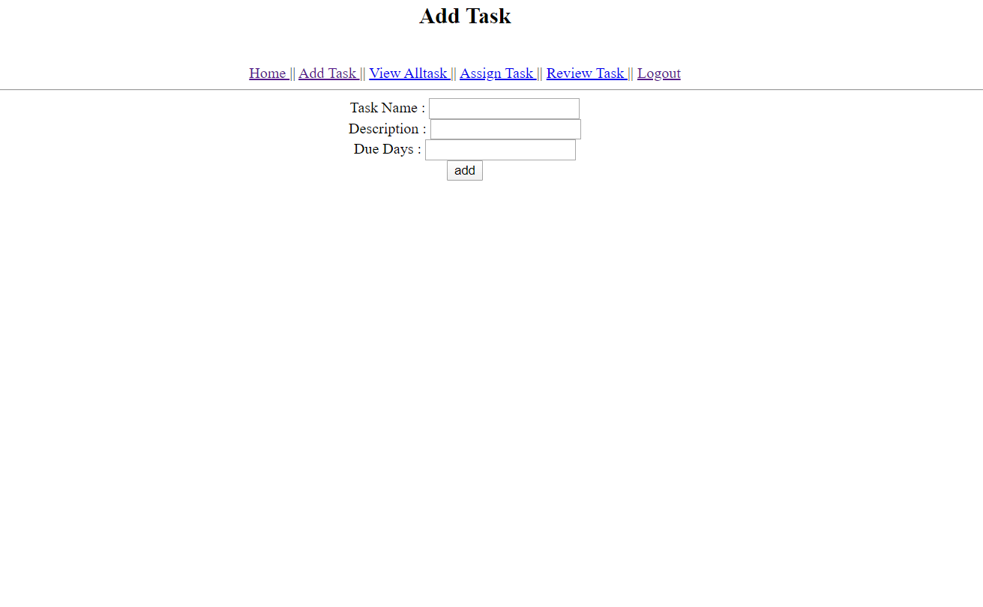

|  |  |  |  |  |  |
| --- | --- | --- | --- | --- | --- |
| **Field / Page attribute** | **HTML Element Type** | **Required** | **Identifier** | **Validation Message** | **Remarks** |
| URL |  |  | *http://host:port/contextroot/*manager/addtask | | |
| Title of the page |  |  | Add Task | | |
| Home | Link |  | Link Text =”Home” |  | Display Manager’s Home Page |
| Add Task | Link |  | Link Text =”Add Task” |  | Display Add Task page |
| View All Task | Link |  | Link Text =”View All Task” |  | Display View all task page |
| Assign Task | Link |  | Link Text =”Assign Task” |  | Display Assign task page |
| Review Task | Link |  | Link Text=”Review Task” |  | Display Review task page |
| Logout | Link |  | Link Text =”logout” |  | Bring user to login page |
| Task Name | Text Box | Yes | Id=”name” |  |  |
| Description | Text Box | Yes | Id=” description” |  |  |
| Due Days | Text Box | Yes | Id=”duetime” |  |  |
| Add | Button |  | id=”add” |  | After clicking add button, values should be stored in the database and then route to the viewAll task page and display the values |
| Error Message | Div |  | Id=”error” |  | Global div tag to display the error message:  “Invalid Data” when the field is empty |

## View All Task- Manager

All task added by Manager must be displayed in a table according to the order of task added by manager and link must be provide in front of each row to delete the task, **if no task is added by manager then error message should be displayed.**

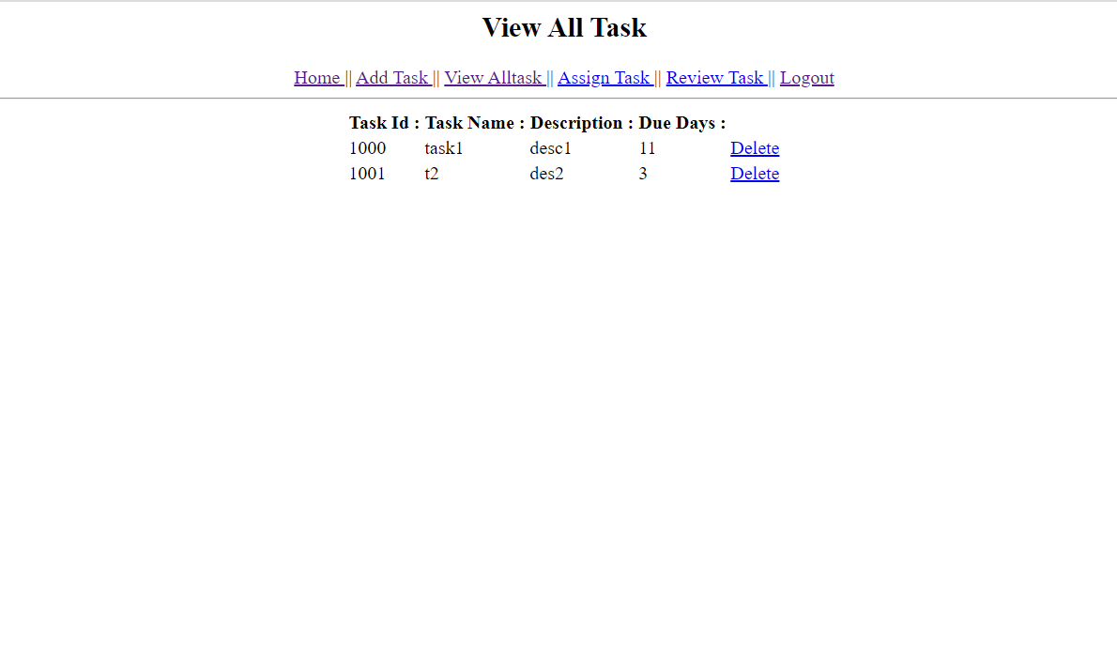

|  |  |  |  |  |  |
| --- | --- | --- | --- | --- | --- |
| **Field / Page attribute** | **HTML Element Type** | **Required** | **Identifier** |  | **Remarks** |
| URL |  |  | *http://ip:port/{contextroot}/manager/viewalltask* | | |
| Title of the page |  |  | Assign Task | | |
| Home | Link |  | Link Text =”Home” | | Display Manager’s Home Page |
| Add Task | Link |  | Link Text =”Add Task” | | Display Add Task page |
| View All Task | Link |  | Link Text =” View All Task” | | Display Add Task page |
| Assign Task | Link |  | Link Text =”Assign Task” | | Display Add Task page |
| Review Task | Link |  | Link Text=”Review Task” | | Display Add Task page |
| Logout | Link |  | Link Text =”logout” | | Display Add Task page |
| Task Id | Text Box | Yes | Id=”taskid_1” for row 1  Id=”taskid_2” for row 2 | | Eg:  id=” taskid_1” for row 1  id=” taskid_2” for row2 |
| Task Name | Label |  | Id=”taskname_1” for row 1 | | Eg:  id=”taskname_1” for row1  id=”taskname_2” for row2 |
| Description | Label |  | Id=”desc_1” for row 1 | | Eg:  id=” desc_1” for row1  id=” desc_2” for row2 |
| Due Days | Label |  | Id=”duetime_1” for row 1 | | id=” duetime_1” for row 1 |
| Delete Task | Link |  | Link text=”delete” | | Delete the task |
| Error Message | Div |  | Id=”error” | | Global div tag to display the error message:  **“No Task”** when no task is added. |

## Assign Task-Manager

Task added by manager can be assigned to any employee using employee id and task id.

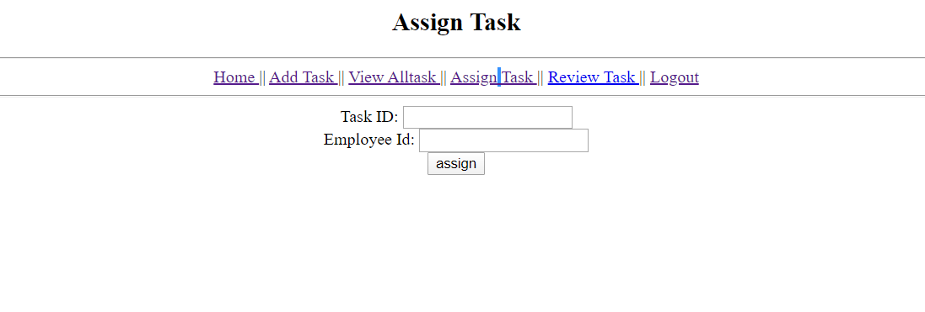

|  |  |  |  |  |  |
| --- | --- | --- | --- | --- | --- |
| **Field / Page attribute** | **HTML Element Type** | **Required** | **Identifier** |  | **Remarks** |
| URL |  |  | *http://host:port/contextroot/manager/assigntask* | | |
| Title of the page |  |  | Assign Task | | |
| Home | Link |  | Link Text =”Home” | | Display Home page |
| Add Task | Link |  | Link Text =”Add Task” | | Display Add Task page |
| View All Task | Link |  | Link Text =” View All Task” | | Display Add Task page |
| Assign Task | Link |  | Link Text =”Assign Task” | | Display Add Task page |
| Review Task | Link |  | Link Text=”Review Task” | | Display Add Task page |
| Logout | Link |  | Link Text =”logout” | | Display Add Task page |
| Task Id | Text Box | Yes | id=”taskid” | |  |
| Employee Id | Text Box | Yes | id=”empid” | |  |
| Assign | Button |  | id=”assign” | | Assigned task should update to Employee. |
| Error Message | Div |  | Id=”error” | | Global div tag to display the error message:  “**Invalid data**” when data is not found in database |
| Error Message | Div |  | Id=”error” | | Global div tag to display the error message:  “Invalid Details” when the field is empty |

## Review Task

Tasked request for change by employees must be displayed to manager. Manager can either approve or reject the request for a change.

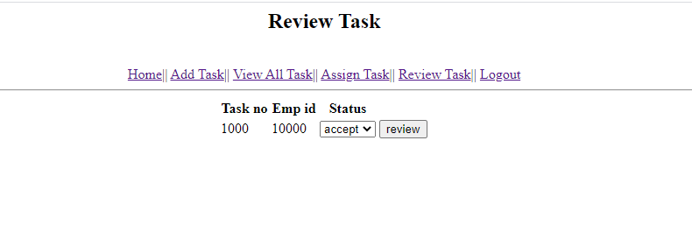

|  |  |  |  |  |  |
| --- | --- | --- | --- | --- | --- |
| **Field / Page attribute** | **HTML Element Type** | **Required** | **Identifier** |  | **Remarks** |
| URL |  |  | *http://host:port/contextroot/manager/reviewtask* | | |
| Title of the page |  |  | Assign Task | | |
| Home | Link |  | Link Text =”Home” | | Display Add Task page |
| Add Task | Link |  | Link Text =”Add Task” | | Display Add Task page |
| View All Task | Link |  | Link Text =”View All Task” | | Display Add Task page |
| Assign Task | Link |  | Link Text =”Assign Task” | | Display Add Task page |
| Review Task | Link |  | Link Text=”Review Task” | | Display Add Task page |
| Logout | Link |  | Link Text =”logout” | | Display Add Task page |
| Task Id | Text Box | Yes | Id=”task_id1” for row 1  Id=”task_id2” for row 2 | | For e.g.:  <label id=” task_id1”>1000</label>  <label id=” task_id2”>1001</label> |
| Status Id | Dropdown |  | Id=”status_1” for row 1  values=”accept”  values=”reject” | |  |
| Employee Id | Text Box | Yes | Id=”emp_id1” for row 1  Id=”emp_id2” for row 2 | | <label id=”emp_id1”>10000</label>  <label id=”emp_id2”>10001</label> |
| Review | Button |  | id=”review” | | After clicking review if status id value is accept then delete the task assigned to employee else don’t delete. |
| Error Message | Div |  | Id=”error” | | Global div tag to display the error message:  “Invalid data” when data is in wrong format. |
| Error Message | Div |  | Id=”error” | | Global div tag to display the error message:  default required error message when fields are empty. |

## Employee home page

After login through the employee’s credentials, navigate to employee’s homepage. If the login Id and password matches with the credentials of the manager, then home designed for manager should be displayed.



|  |  |  |  |
| --- | --- | --- | --- |
| **Field / Page attribute** | **HTML Element Type** | **Identifier** | **Remarks** |
| URL |  | *http://host:port/contextroot/employee/home* | Display Employee’s home page |
| Title of the page |  | Home |  |
| View All Task | Link | Link Text =”View All Task” | Display employee all task which are assigned to him by manager. |
| Status | Link | Link Text =”Status” | Display status of task |
| Logout | Link | Link Text =”Logout” | Bring employee to the login page |

## View All Task - Employee

Employee can view all tasks assigned to him by manager.

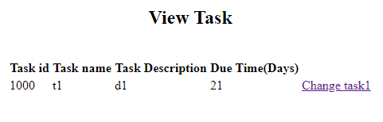

|  |  |  |  |
| --- | --- | --- | --- |
| **Field / Page attribute** | **HTML Element Type** | **Identifier** | **Remarks** |
| URL |  | *http://host:port/contextroot/employee/viewalltask* | Display Employee’s status page |
| Title of the page |  | Status |  |
| View All Task | Link | Link Text =”View All Task” | Display employee all task assigned to him by manager. |
| Status | Link | Link Text =”Status” | Display status of task |
| Logout | Link | Link Text =”logout” | Bring employee to the login page |
| Task Id | Label | Id=”task_id1” for row1 | Id=”task_1” for row1 and so on |
| Task Name | Label | Id=”task_name1” for row1 | Eg Id=”name_1” and so on |
| Description | Label | Id=”task_desc1” for row1 | Eg id=”desc_1” and so on |
| Due Time | Label | Id=”task_duetime1” for row1 | Eg id=”duetime_1” and so on |
| Change Task | Link | Link Text =”change” |  |
| Error message | Div | id=”error” | error message =”No Task” when there is no task added for employee. |

## Employee Status Page

Employee can view status of the request for change applied by him to the manager in order assigned by manager. Manager can either accept or reject the request, if manager has not reviewed the task then pending status must be displayed.



|  |  |  |  |
| --- | --- | --- | --- |
| **Field / Page attribute** | **HTML Element Type** | **Identifier** | **Remarks** |
| URL |  | *http://host:port/contextroot/employee/status* | Display Employee’s status page |
| Title of the page |  | Status |  |
| View All Task | Link | Link Text =”View All Task” | Display employee all task assigned to him by manager. |
| Status | Link | Link Text =”Status” | Display status of task |
| Logout | Link | Link Text =”logout” | Bring employee to the login page |
| Task Id |  | Id=”task_id1” for row1 | Eg id=”task_1” for row 1  Id=”task_2” for row 2 and so on |
| Employee Id |  | Id=”emp_id1” for row1 | Eg id=”emp_1” for row 1 and so on |
| Status |  | Id=”task_status1” for row1 | Id=”status_1” for row1 and so on |
| Error Message | Div | Id=”error” | error message=”No Task” when there is no task assigned to employee or not requested change. |

# Application Flow

|  |  |  |
| --- | --- | --- |
| **Current Page** | **Action** | **Next / Landing Page** |
| Login | Submit – Success | Home Page of manager for manager’s credentials and home page of employee for employee’s credentials. |
| Login | Submit – Failure | Display Login page with error message |
|  | Click on “Home” Link | Home Page |
| Register Page | Submit- success | Employee has to get register to access the service, for failure display the failure messgae. |
| Manager Section | Login- sucesss | Manager home page has four options to add task, assign task, review task and view all task. |
| Add task | Click on Add task | Manager can add task with description. |
| View all task | Click on view all task | All task added by manager to employee must be displayed here with a delete option. |
| Assign task | Click on Assign task | Task added by manager can be assigned to any employee |
| Review task | Click on review task | Employee can request change in task which manager can review in review page and accept or delete the request. |
| Employee section | Login-success | Employee home page has 2 options to view all task assigned to him and to check change in task request status. |
| View all task-employee | Click on view all task | Display all task assigned to employee else display error message.  If manager has accepted the request to change the task then remove the task from the table else it must be displayed. |
| status | Click on status | Employee can request change in task from manager. |