Downfall game

The UML based analysis, design and construction of a system following the Unified Development Process

Case study

written by
Balázs Goldschmidt
Szabolcs Szigeti
dr. Zoltán László

Project definition

Introduction
In this document we describe the analysis, design, and (partial) construction of a simple system, the implementation of a popular game, Downfall.
We shall use the notation and semantics of the Unified Modelling Language, and we shall follow the Unified Development Process. For the analysis and design, and the drawing of figures we used Rational Rose 98 Enterprise Edition as a CASE tool.

Description
The downfall game is played by two players. There are two sides of the game board. One player sees only one side.
Each side contains a container, a collector and a number of wheels. Initially each container contains a number of balls, different colour for each side (player). The balls are numbered from 1. The number of balls and wheels are configurable.
The container, wheels and collector are connected to each other in a way that ball may fall from the container to the wheels, and from the wheels to the collector if the wheels are turned to such position. Wheels are turned by the player. Wheels on the two sides are locked to each other, so when one wheel is turned on one side, the locked wheel will also turn on the other side. There is an offset in the angles of the locked wheels.
The objective of the game is to transfer the balls from the container to the collector via the wheels. Based on the game type the initial order of the balls is ascending, descending or random. The balls have to be transferred in ascending order into the collector. The player to transfer all the balls in the right order wins. If the order is wrong the game is lost and the other player wins.
A player may not turn a wheel that was turned by the other player in the last step, except when it is the last wheel to the collector containing the last ball of either colour.
The players may turn one wheel at a time alternately.

Glossary:
Player | human or computer who plays the Downfall game
Game Board | object on screen which contains a container, wheels and a collector for both of its sides.
Balls | a coloured and numbered object. Containers, wheels and collectors may hold one or more balls in their slots. Every player has different colours.
Container | an object which contains a number of balls. It can transfer balls to the firs wheel on its side.
Wheel | an object with several slots. Each slot can hold one ball. The wheel may be turned by a player, so different slots are connected to other wheels, containers or collectors.
Collector | an object that can receive balls from the last wheel on the board. Balls are transferred to the collector during the play.
Game Type | Different initial set ups of the Downfall game.
Configuration | Set up of the game parameters. Configuration contains the geometry of the game board, the number and position of the wheels, game type, etc.

Analysis phase I

Use cases
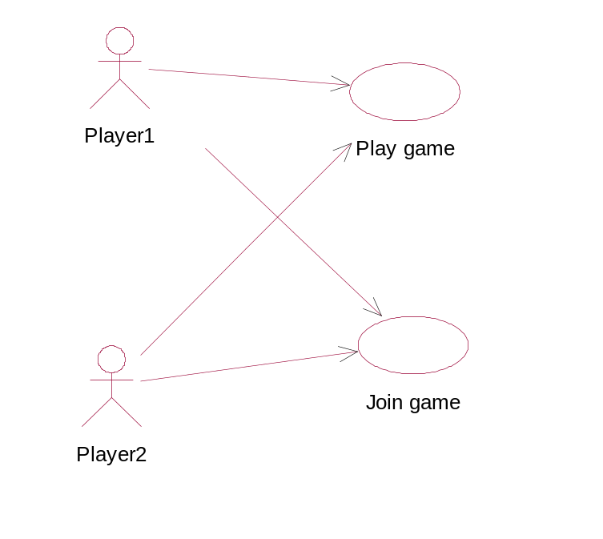
Figure 1: System use case diagram

Join game
Use case: | Join game
Actors: | Player1, Player2
Description: | The players join the game. There has to be exactly two players in each game.  The first player initiates the game. She enters her name, and sets some parameters, like the order of the balls, the number of players, wheels and balls, etc.  Then several players (their number set by the first player) can join the game, giving their names.  After every player logged in, the play initialises itself (the wheels, axles, the balls in the storage, etc.), and then it starts.

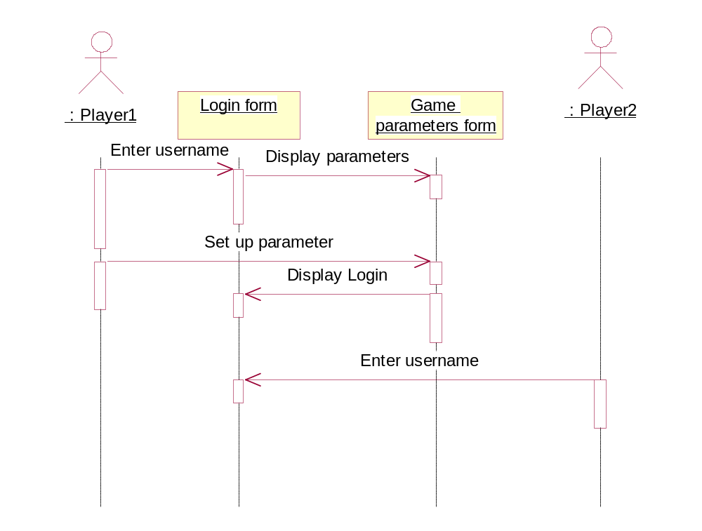
Figure 2: Use case Join game

Play game
Use case: | Play game
Actors: | Player1, Player2
Description: | This use case defines what happens during the game. All the players have their turn, when they turn their wheel, and thus make the balls to fall down. The players turn after each other in the order they logged in.  To turn a wheel they indicate which wheel they want to turn, and by how much degree. The chosen wheel can be turned by as many times, as wished.  The balls have to arrive in the order set by the first player, and the order as they arrive should be watched to indicate that the player has won or lost the game, if necessary.

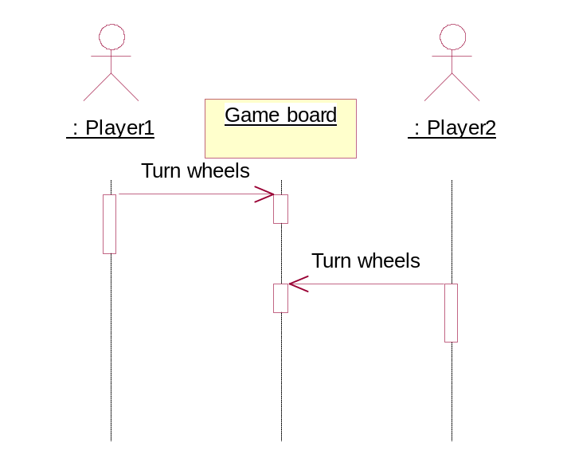
Figure 3: Use case Play game

The Conceptual Model
First we have to identify the domain objects. At this phase we only focus on the second use case. The identified objects are the following:
- GameBoard: it consists of several containers, and it sends the actors messages to the wheels.
- Container: the parent class of Wheels, Storages and Collectors. Its main purpose is to hold the balls (it has slots for that), to know how much balls it has. It has to know at what angle its balls are, to know with which other Containers it is connected, at what angle, and by what means (as either a donor, i.e. able to hand over balls; or an acceptor, i.e. able to receive balls).
- Wheel: one of the most important classes in the system. It is a child class of Container, and can serve as both donor and acceptor. It can be tied (or locked) to another wheel (on the other side of the gameboard) - called its ‘partner’ - so that they may turn together.
- Storage: also the child of Container has to store the balls at the beginning, and to give them over the Container it is connected to at certain circumstances.
- Collector: child of Container is the final container of the balls. It has to know by what order the balls were given to it, and if the order is wrong, or the order is right and the last ball of both colours is ended, it sends a message to the GameBoard, to end the game, and announce the winner.
- Ball: the object passed around during the game between containers is just a simple class, holding the information about the ball’s number and colour.
Thinking about it, it turned out we need an association class between wheels locked to each other, for the gameboard should not know to what other wheels a given wheel is locked to. Furthermore, it is neither simple, nor elegant, nor object-oriented to make the gameboard ask the wheels for their partners. Thus we needed a new class for holding this information. This class is the Axle. The gameboard now knows only about the axles (not the wheels), it turns only axles, and if an axle is turned, then the axle announces it among its wheels. The Axle has the responsibility to know its wheels, to turn them, and to know the ratio how much a degree should turn the wheel during turning, and to what direction.

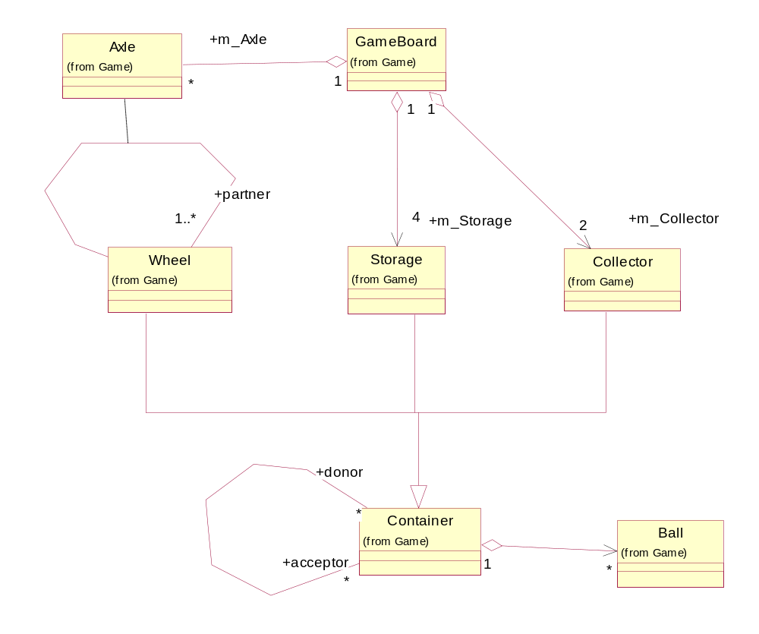
Figure 4: The Conceptual Object Model

The associations
As can be seen in figure 4, the GameBoard class has several composite classes: some Axles, four Storages, and two Collectors. There is but exactly one GameBoard object in the system. It takes care of its composites.
The Container classes (Wheel, Storage, and Collector) have several donors and acceptors. A donor is a Container able to give away (offer) balls, an acceptor is a Container able to receive balls. The common feature of Containers (as their name indicates) is that they can contain several balls. They take care of the holding and the transport of the balls.
Furthermore the Wheel class has several (at least one) partners. It is connected with its partners, through an Axle object. The Axle has them turned. In the original game there was only one partner for each wheel, but at this phase we wanted to extend the system to be capable of multi-player games, not just dual-player ones.
The Axle has several Wheels, and it is connected to the Gameboard.

The dynamic behaviour
The most important design problem is how the balls are transferred between the containers. The following diagrams and descriptions are our solution.
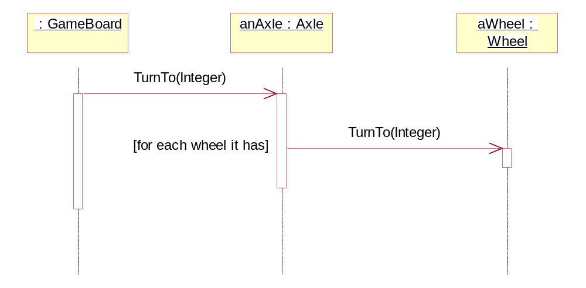
Figure 5: Dynamic behaviour when turning an axle
The gameboard turns the appropriate axle. Then the axle knows the wheels it has, and sends them a TurnTo message, indicating them that they should turn a certain angle. It is possible that the wheels are turned by different angles. For instance if the gameboard makes the axle to turn by ϕ degree, the axle can have the wheels turned by 0.5ϕ, -2.71ϕ, etc. degrees.
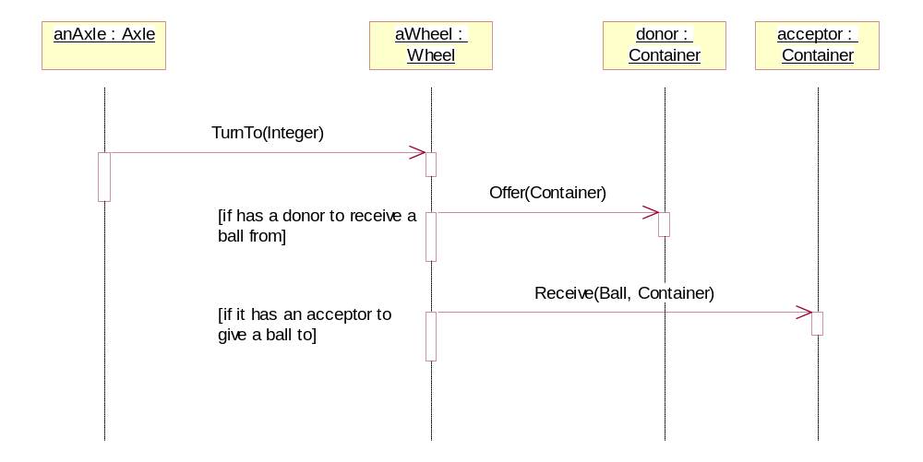
Figure 6: The dynamic behaviour of the wheels
When an axle is turned, it notifies all its wheels to turn. (Previously we mentioned, that it may mean more than a simple one-to-one ratio.)
When a wheel has to turn a certain degree, during the turn it checks if there are donors or acceptors. If it finds one, and is able to receive or give a ball, it asks the neighbour if it is ready to transfer a ball, and if so, then the ball is transferred.
In the messages used in this transaction the caller must identify itself, for this is the simplest way to indicate where the ball may arrive from or can be given to. The caller could give the angle of the direction as well, but than some transformations should be made, and we should have some assumptions about the geometry of the game (for example either wheel should give or subtract 180 degrees off the angle).
Our solution, however, has some problems too. That way the called container has to find the angle where the caller may give or receive the ball. But it is a minor implementation problem, which can have both elegant and efficient solutions.

Design Phase I

Assigning operations and attributes
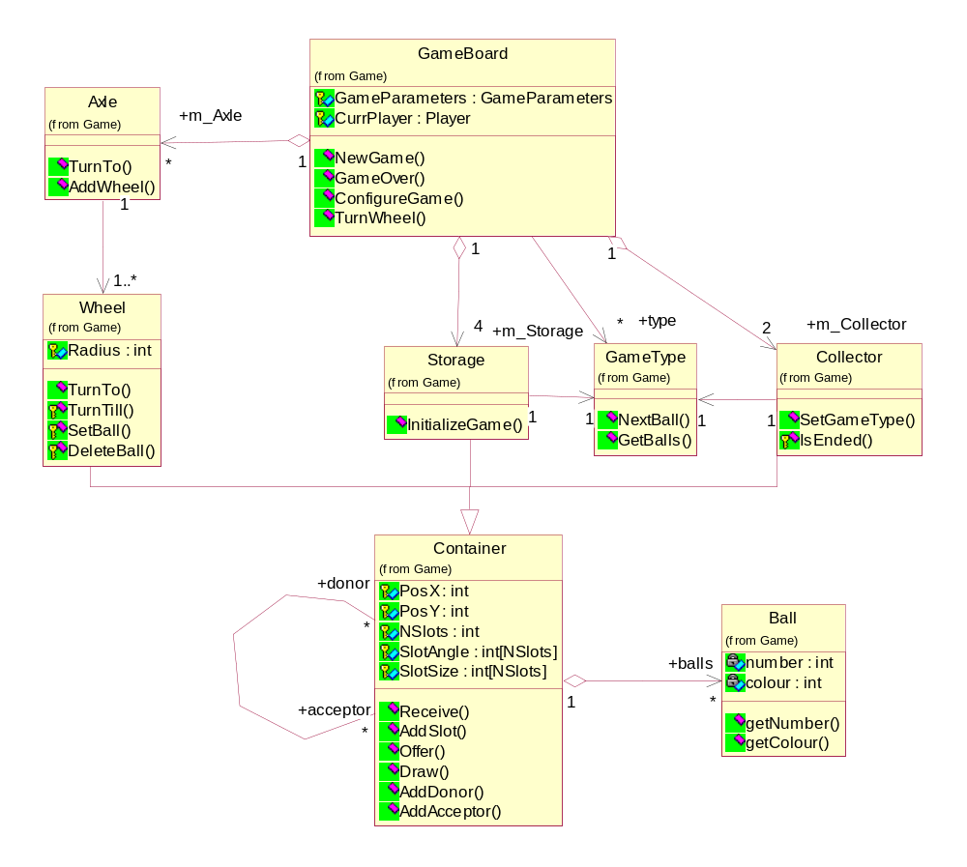
Figure 7: The Design Class Diagram
In this phase new classes can emerge, and we have to identify the methods and attributes of the classes.
The new class is the GameType. This class is responsible for the rules of the game. The GameBoard has several GameTypes, representing the possible sets of rules. The storage and the collector uses them, to determine the state of the balls at the beginning, and whether the game has ended, respectively.
This new class has to know the initial order of the balls, as they should be placed in the storage, and the final order of the balls, when they arrive in the collector.
The concept of having a separate class holding the rules can be find among Gamma’s Design Patterns, it is the Strategy Pattern. If we have to add a new rule or mode to the game we only have to add a new GameType object or subclass, and do not have to modify the other classes.
We have also defined the operations and attributes for our classes. They are the following:
GameBoard
Protected Attributes:
GameParameters GameParameters
Stores game parameters (number of axles, game type, etc.)
Player CurrPlayer
The current player. Game board is drawn based on this.

Public Operations:
void NewGame ()
Start a new game. Initialize game objects.
void GameOver (Boolean WinOrLoose)
Collector calls Game Over, if the game is finished. The winner player is indicated.
void ConfigureGame ()
Configure game parameters.
Boolean TurnWheel (int WheelNo, int Angle)
User input to turn the wheel to Angle. Returns False if not successful.

Container
Protected Attributes:
int PosX
X position of the object on the screen.
int PosY
Y position of the object on the screen.
int NSlots
Number of slots in this object
int[NSlots] SlotAngle
The vector of all slots, having the exact angle the slot is placed at.
int[NSlots] SlotSize
This vector shows for each slot how much balls it can contain.

Public Operations:
Boolean Receive (Ball BallNumber, Container donor)
Check if the Container is able to receive a ball at Angle. If it is, it accepts the ball indicated by BallNumber and returns True. Otherwise it returns False.
void AddSlot (Integer Angle = 0, Integer Size = 1)
Add a slot to the container. The slot is at Angle, and able to hold Size balls.
Ball Offer (Container acceptor)
Accept a ball at an agle. If the neighbour (donor) is able to transfer a ball at angle, it returns the BallNumber. Otherwise it returns zero.
void Draw ()
Draw the object on the sceen.
void AddDonor (Container Donor, Integer Angle)
Add a donor at angle. If there is a ball at an slot, which is set to this angle, ball transfer from donor is initiated.
void AddAcceptor (Container Acceptor, Integer Angle)
Add an acceptor at angle. If there is a ball at an slot, which is set to this angle, ball transfer to acceptor is initiated.

Wheel
Protected Attributes:
int Radius
the radius of the wheel. Necessary when drawing.
int Angle
the angle of relative displacement at the moment.

Public Operations:
void TurnTo (Integer Angle = 0)
Turn wheel to angle. If slots are turned to neighbor angles, Receive and Offer messages are triggered.

Protected Operations:
Container TurnTill (Integer angle)
The wheel turns itself until either it reaches the specified angle, or it finds a neighbour being capable to receive a ball from or to give a ball to.
void SetBall (Container Donor, Ball Ball)
Inserts the ball into the slot that is at the angle of the donor
void DeleteBall (Ball ball)
Deletes the given ball from the slot it has it

Storage
Public Operations:
void InitializeGame (GameType GameType)
Initialize game based on GameType. The order of Balls in storage is set up based on this.

Collector
Protected Attributes:
GameType GameType
The type of game. Collector decides when to end the game based on this.

Public Operations:
void SetGameType ()
Sets the GameType.

Protected Operations:
Boolean IsEnded ()
Checks whether the game has ended.
Returns true if yes, false if not.

Axle
Public Operations:
void TurnTo ()
Turns all its wheels with the given angle
void AddWheel ()
Adds a new wheel to the axle.

Ball
Private Attributes:
int number
int colour

Public Operations:
void getNumber ()
Returns the ball’s number.
void getColour ()
Returns the ball’s colour.
GameType
Public Operations:
NextBall (ball : Ball) : Enumeration
Checks if the ball given is in the correct order, and if the game has ended.
The returned value means either the game can continue, or the game is lost to the given player, or the game is won by the given player.
GetBalls () : Ball[]
Returns a vector of balls, the storage must be filled with.

Dynamic behaviour
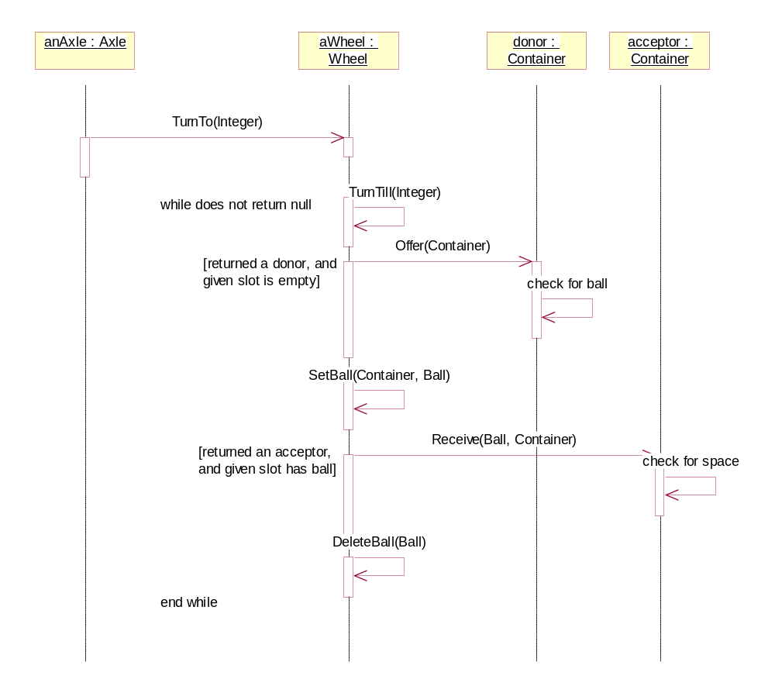
Figure 8: Elaborated dynamic behaviour
In the sequence diagram shown on figure 8 one can see the design idea behind the previously described dynamic behaviour.
When a wheel has to turn a certain angle, it does it in small steps. Each step is the minimal turn of the wheel to the point when a slot is adjacent to a neighbour. After each step the adjacent slot is examined whether the neighbour is a donor or an acceptor, and depending on it the slot has to carry a ball or must be empty.
If the neighbour is a donor, and the slot is empty, then the neighbour is asked to offer a ball. The donor checks if it can give a ball to the given container. If yes, it returns a ball, and deletes it from its slot (while the caller registers this ball to the slot). If not, it returns a null.
If the neighbour is an acceptor, and the slot has a ball to transfer, the wheel sends a receive message, containing the ball and the wheels identifier. The acceptor checks if it has a slot adjacent to the wheel, and if this slot is empty. If yes it receives the ball, and returns true, otherwise it returns false. In the former case the caller deletes the ball from its slot.
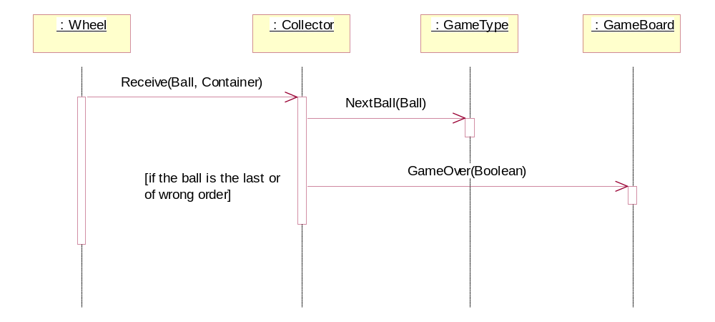
Figure 9: A collector is the acceptor
There is a special case of ball transferring, when the acceptor is a collector. In this situation (see figure 9) the collector has to determine whether the balls are arriving in proper order. The knowledge for that is stored in the GameType class. The collector tells the gametype what ball it has just accepted. The gametype then decides what to do. If everything is normal (the ball was not the last, and arrived in proper order), it returns an OK, otherwise it indicates if the game is lost or won.

Construction phase I

The skeleton model
After the first design we have to implement and test the systems ready parts. For this purpose we use the skeleton model. It is a very basic system architecture, where no method is really implemented, but merely the consecutive method calls. Every method has to write out its name, and the messages it wants to send, and sends them. If there is a decision point in the method, it asks us, what the result is, and then continues.
The architecture used for skeleton can be seen on figure 10.
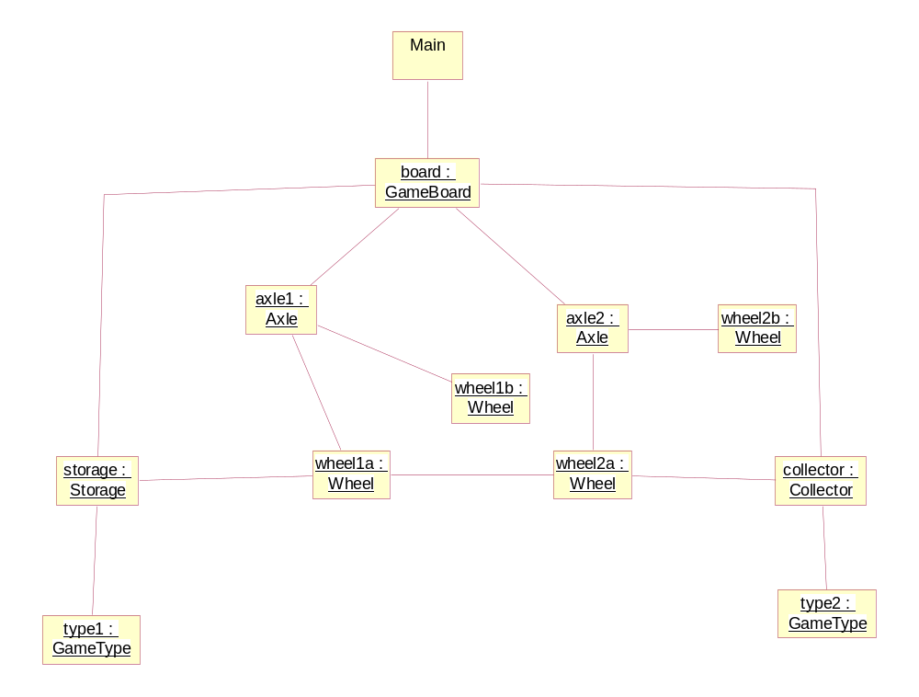
Figure 10: The skeleton architecture
We have a GameBoard, four Wheels (wheel1a, …, wheel2b), two Axles (axle1, axle2), a Collector, a Storage, and two GameTypes (type1, type2).
The axles have two wheels each (axle1 has wheel1a, wheel1b; axle2 has wheel2a, wheel2b). Wheel1a is connected to the storage and to wheel2a, wheel2a is connected to the collector too.
There is only one ball in storage. Type2 does not know anything, it will ask us if needed.
The Main object initiates every turn, and acts on behalf of the players.
We show now two more diagrams (figure 11 and 12), that represent a possible run of the skeleton system. Now we have but two players, and the second does not have any balls.
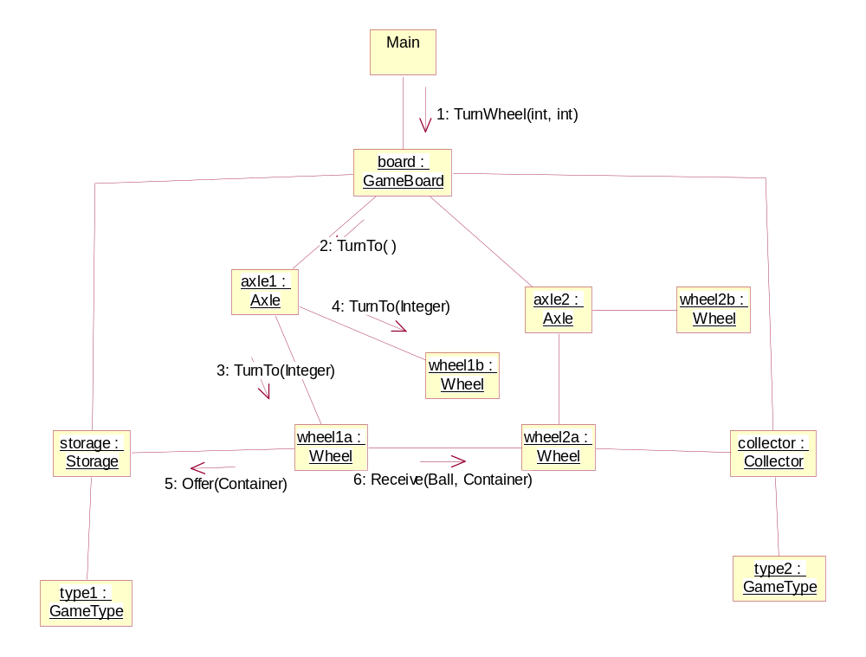
Figure 11: The first player’s turn
The first player begins. Main sends a TurnWheel message to the board, to turn axle1. The board delegates the message. Axle1 sends a TurnTo message to its wheels, wheel1a and wheel1b. The latter has no neighbours, thus it merely turns to the given angle, and waits. The former has two neighbours. It reaches first storage, and sends an Offer message, the storage returns a ball. Then it turns towards wheel2a, and sends a Receive message, but wheel2a has no slot adjacent to wheel1a, thus no ball is transferred. The first turn ends.
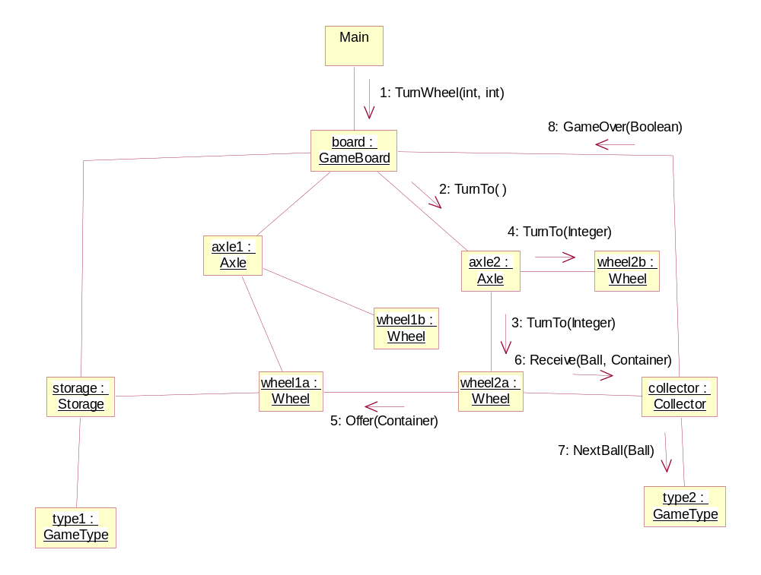
Figure 12: The second player’s turn
In the second turn Main again sends a TurnWheel message to board, but now it has to turn axle2. Similar actions are performed, as before: board sends TurnTo to axle2, which delegates it to wheel2a and wheel2b. Wheel2b has no neighbour, so it does nothing. Wheel2a first reaches wheel1a, and receives a ball. Then it turns to the collector, and makes it to receive the ball. The collector gives the ball to type2, which answers that the game has ended. Thus the collector sends a GameOver message to the board.

Analysis phase II
In the previous phases we analysed the second use case (Play game), designed the model of the game, and even built a skeleton implementation to show its inner work. Now we have to analyse the first use case and the input-output features of the game.

The new classes
First we have to decide how to show the states of the wheels, storages, collectors and balls to the players. Then we have to think about the input from the actors.
We could include the responsibility of visualisation into the Container classes, but it would cause some problems later on. For instance if we want to change the look-and-feel of the game, or if we want the game to be network capable (using CORBA for example), we would have to change the model classes. Instead of this approach we can create separate ContainerView classes. Here is the class diagram for it:
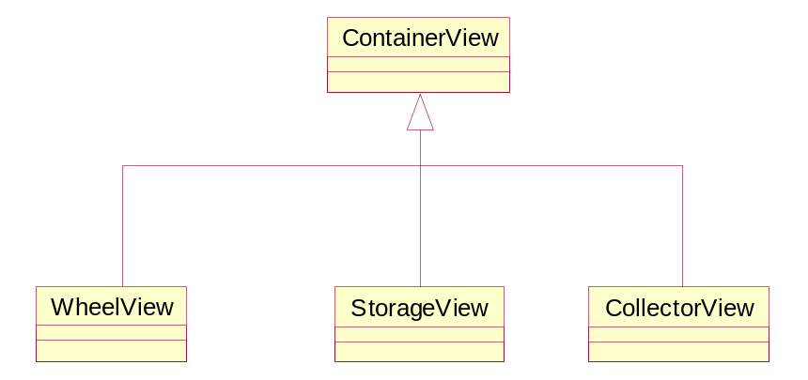
Figure 13: The ContainerView classes
The ContainerView class has the responsibility of drawing to the display, according to the states of the classes it represents. It has three subclasses, each representing a certain Container class. They have to draw their image differently, this is why we need these subclasses.
We need new classes to handle the user inputs as well. For this purpose we created the WheelInput and LoginInput classes. The former has the responsibility to take care of the players intentions of turning the wheel. The latter has the responsibility to perform the necessary input tasks at the beginning of the game.
The last new class is a singleton. There will be only one of it, its the main coordinator, called Main. It acts between the inputs and the GameBoard. Thus the gameboard does not have to take care of the inputs, the creation of the object at initialisation, etc.

The new associations
The associations between the models and the views can be seen on figure 14.
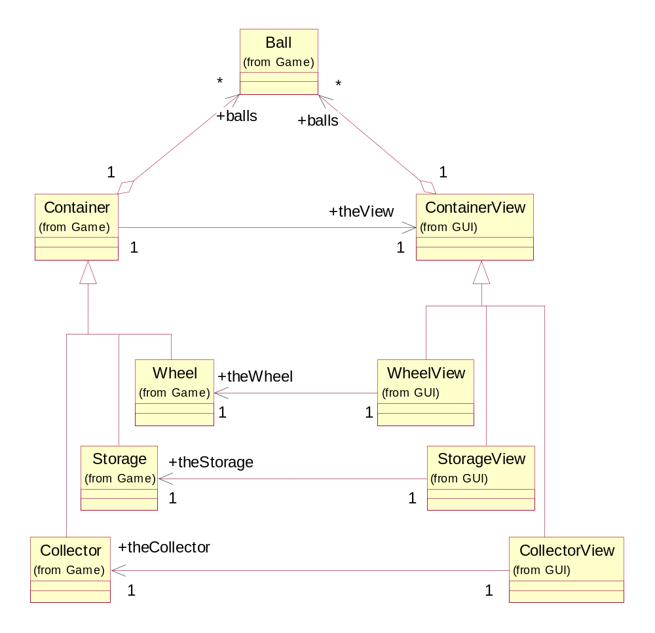
Figure 14: Associations among models and views
The figure shows a simple Observer Pattern. The Containers only know the ContainerView superclass, which can be informed about a change of state. Its subclasses know the subclasses of the Container superclass, but not in the other direction, and thus their implementation can change without notifying (i.e. changing) the Container classes.
Every ContainerView needs to know what balls its model class has, in order to draw them appropriately. This is why the ContainerViews know the Ball class.
In the next figure can be seen the creation of the views and models, and their signup to each other.
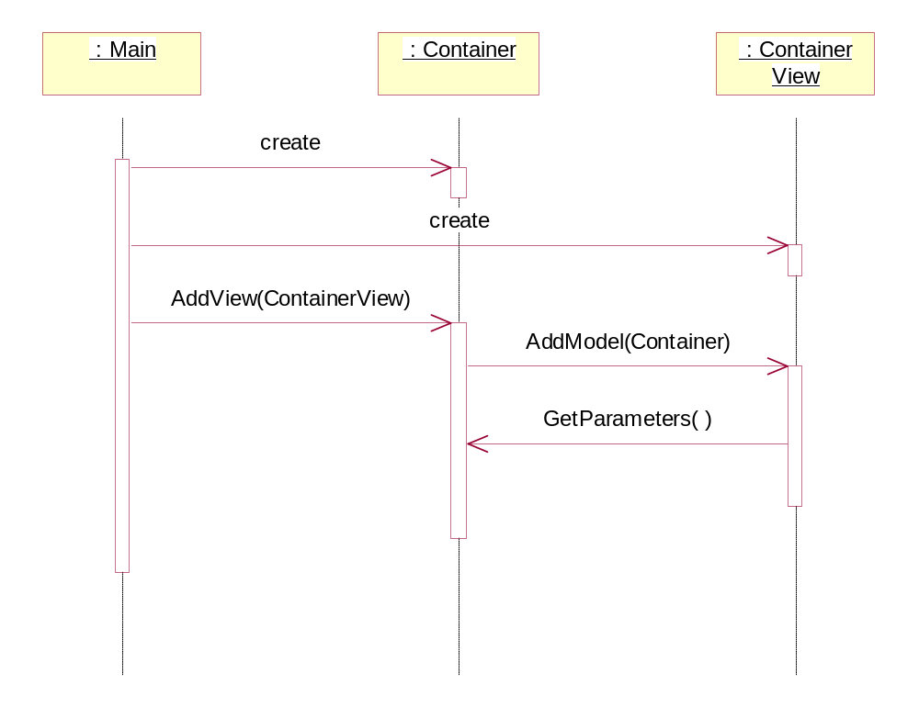
Figure 15: The creation of the models and views
The Main creates a Container and a View, and then it adds the view to the container. The container signs up at the view, which in turn asks for the non-changing parameters, like number, size, and angle of slots, etc.

The dynamic behaviour
Now that the models have their views, and vice versa, we can look at the dynamic behaviour of these objects. First we show how a wheel behaves, if it is turned.
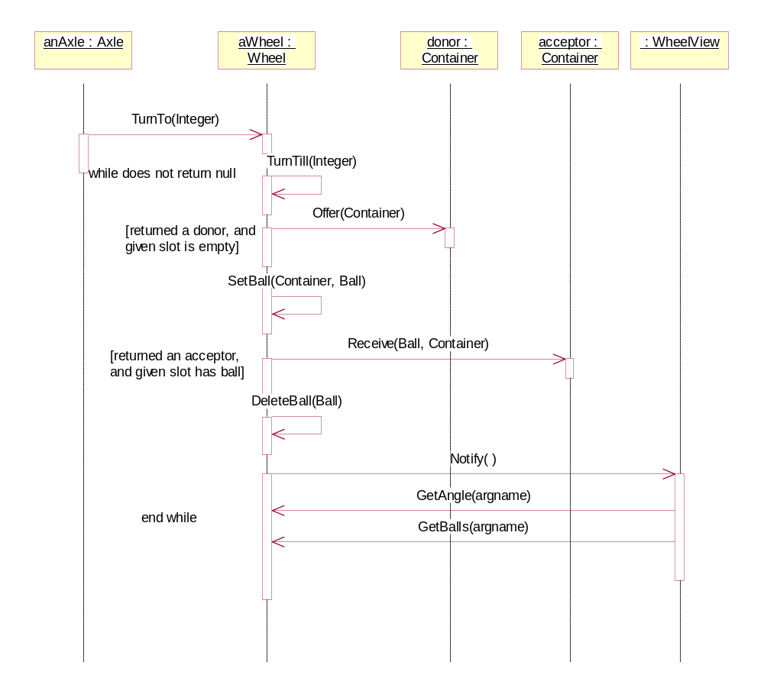
Figure 16: Turning a wheel with view
There is only a slight change to the behaviour described in the previous phase. After a change happens, the wheel notifies its view, and the view asks it about the new angle, and the balls it has currently.
The next figure shows what happens after an Offer method (the same applies to Receive).
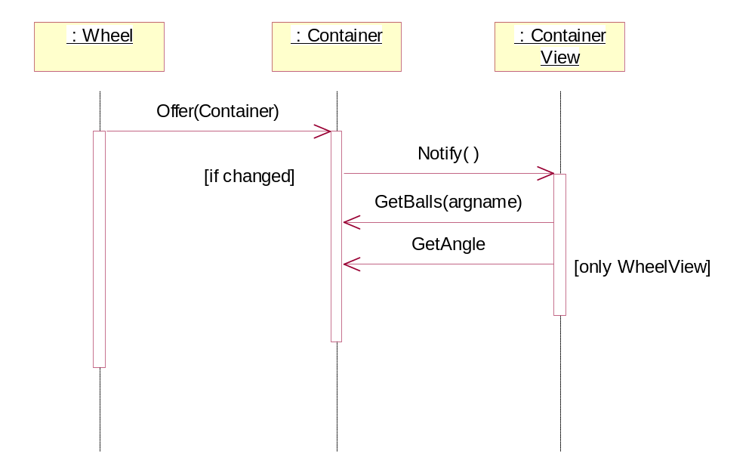
Figure 17: The model and view after an offer
If a wheel wants a ball from a donor, it sends the Offer method. Then the donor notifies its view if there was a change, which in turn asks for the changed values (GetAngle is only called if the view is a WheelView).
A possible initialisation can happen as on figure 18. The main object first asks the players for certain parameters, like names, the number of players, and the type of the game (it is described in use case Join Game).
After these information are known, the main creates the wheels, storages, collectors, axles and the gameboard, and assigns them to each other, as needed. With these the creation of the static architecture of the current game is finished.
On figure 19 the next steps can be seen.
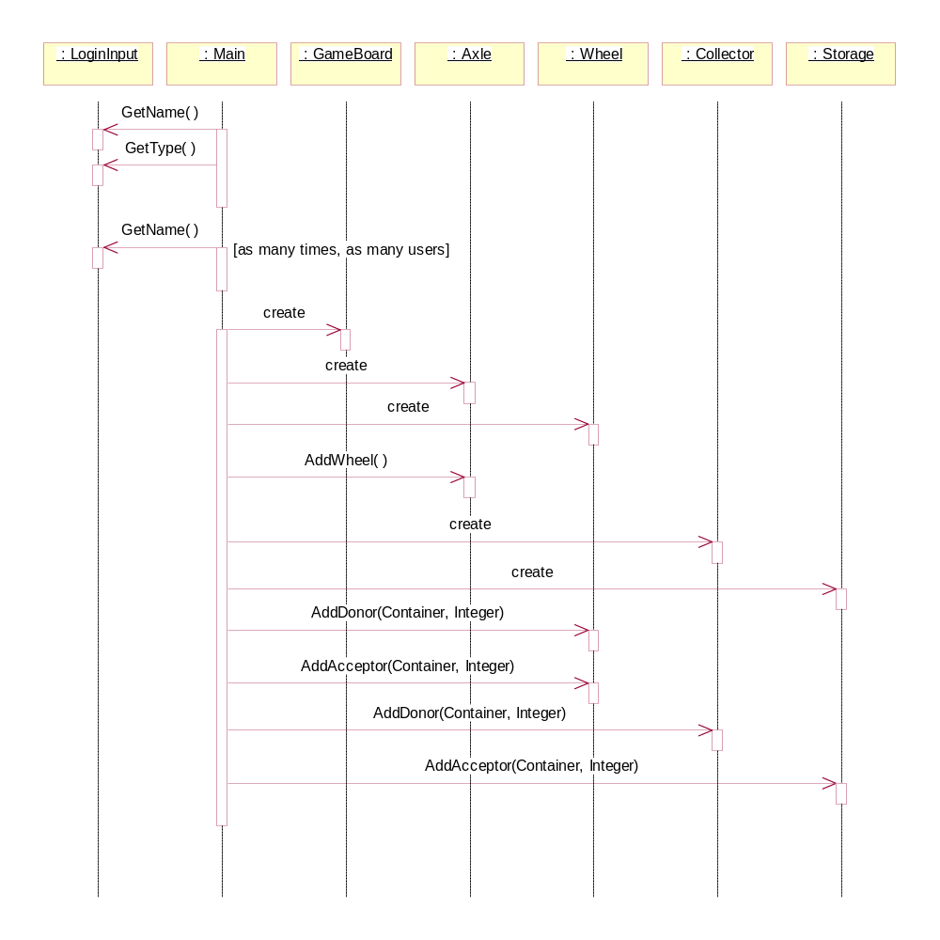
Figure 18: Initialisation I
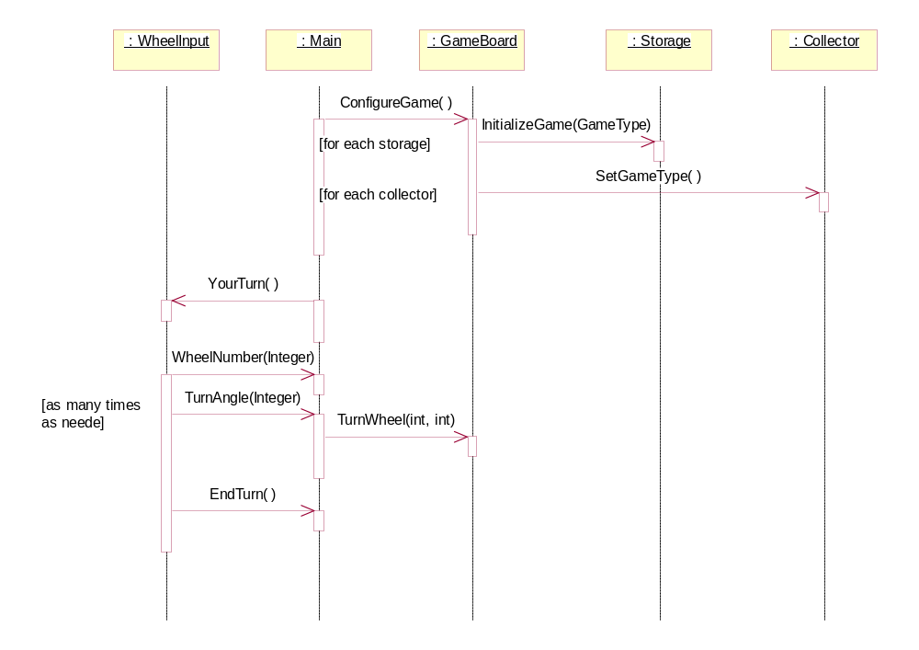
Figure 19: Initialisation II
After the static form is created, the main configures the game with the parameters it got from the first player. The gameboard initialises each storage and collector with appropriate GameType objects. Now the game may start.
The main notifies the first player (a WheelInput object), that it is its turn. Then the input lets the main know the wheel-number and the angle, by which to turn the wheel. It can give as many angle as it wishes. If there is no need to turn, it sends an EndTurn message. During each turn the gameboard is sent a message to turn a wheel by an angle, and if a game over happens, it is indicated to the main object at once (but it is a minor issue).
The state chart showing the main’s states is the following:
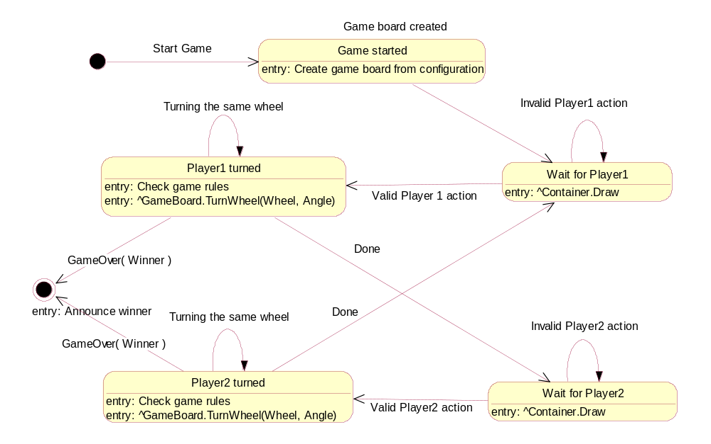
Figure 20: The state chart of the Main object

Design phase II

Assigning new operations and attributes
To achieve the behaviour described above we need to define the new methods and attributes for the old and new classes.
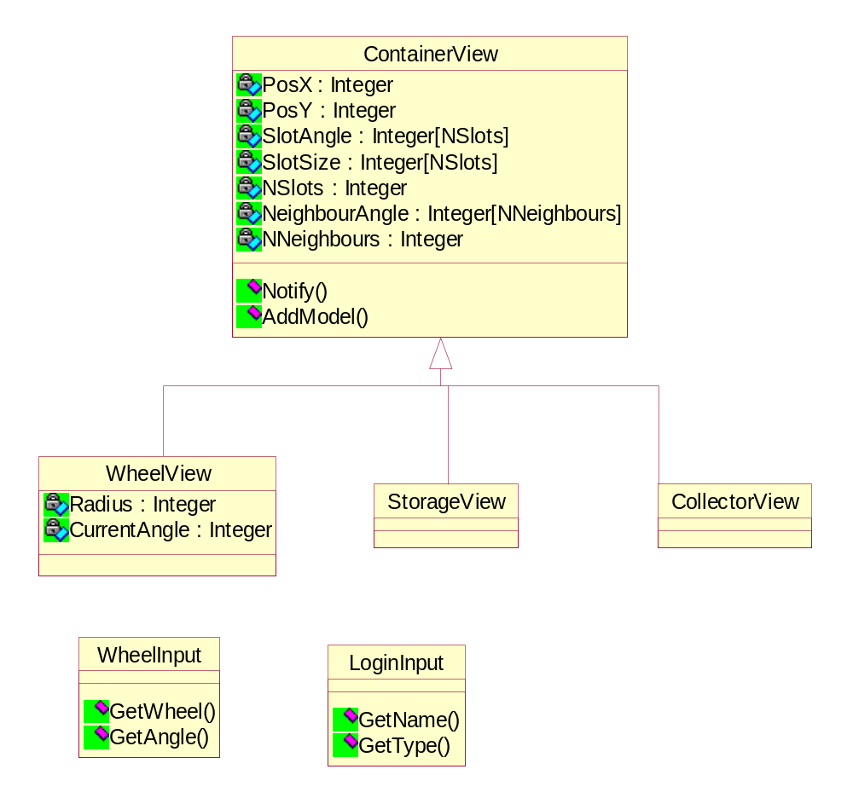
Figure 21: The attributes and methods of the classes in package GUI
They are the following:
WheelView
Derived from ContainerView
Private Attributes:
Radius : Integer
The radius of the wheel
CurrentAngle : Integer
The current displacement of the wheel

ContainerView
This class is the parent of the view classes, that represent the containers towards to players.
Private Attributes:
PosX : Integer
The x coordinate of the object
PosY : Integer
The Y coordinate of the object
SlotAngle : Integer[NSlots]
the angles of the slots
SlotSize : Integer[NSlots]
The size of each slot
NSlots : Integer
The number of the slots
NeighbourAngle : Integer[NNeighbours]
The angles where the neighbours are
NNeighbours : Integer
The number of neighbours

Public Operations:
Notify () : void
the model calls this method if it changed.
AddModel (model : Container) :
With this method we can add a model to the view. If it is notified about some change, it can ask the model for its parameters, and redraw itself.

StorageView
Derived from ContainerView

CollectorView
Derived from ContainerView

WheelInput
Public Operations:
YourTurn() : void
It indicates to the WheelInput object, that it is now up to it, to turn a wheel.

LoginInput
Public Operations:
GetName () : String
Returns the name of the player
GetType () : GameType
Return the type of the game

The Main object is not part of any package, but it has several methods too.
Main
Public Operations:
WheelNumber (wheel Integer) : void
Indicates the next wheel (axle) to be turned
TurnAngle (angle Integer) : void
Indicates that the selected wheel must be turned by angle degrees
EndTurn () : void
Indicates, that the current player has passed on the right to turn
GameOver (Boolean) : void
The gameboard notifies the main object, that the game is over. True means the current player won; false means the current player lost.

The classes defined in Phase I have the following new methods and attributes:
Container
Public Operations:
GetBalls () : Ball[NSlotNumber][]
Returns a two dimensional matrix of the slots and the balls they have.
GetParameters () : Integer[]
This method is invoked after a view has been signed up, and returns the non changing parameters (number of slots, their size, their angle, etc).
AddView (ContainerView) : void
With this method we can attach a view to the Container, and if some change in its state occurs, the view can be notified.

Wheel
Public Operations:
GetAngle () : Integer
Returns the current angle.

Construction phase II

The prototype model
After we described every method and attribute, we show the prototype model of the system. It is fully functional, it only lacks the Graphical User Interface. The ContainerView classes now only print what changes occurred, and the WheelInput class accepts only keyboard messages.
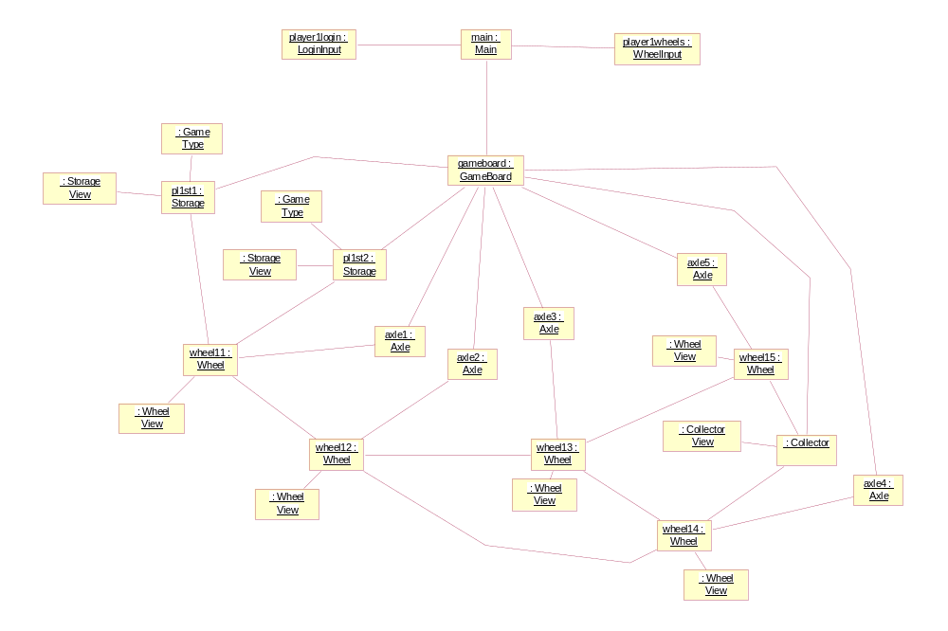
Figure 22: The half prototype object diagram
On figure 22 we only have shown the half of the system, the objects of player one. Every object should be duplicated, except gameboard and main.
The views in this model print the following to the screen.
The StorageView at the left side prints the colour and number of balls it has.
The CollectorView prints to the right side the colour and number of balls it has.
The WheelView is given a number at initialisation, and it prints at the column indicated by that number the number of the wheel, the angle of its displacement, and then line by line the slot numbers, and the colour and number of balls for every slot.
For instance:
12345678901234567890123456789012345678901234567890123456789012345678901234567890
+----------+----------+----------+----------+----------+----------+-----------+

W2: 48°
s1:
s2: red2

W1: 25°
s1:
Here the red ball number two was transferred to wheel2 form wheel1
red 13
W1: 150°
s1: red5

Here the red number 5 ball was transferred from the red storage to wheel1
green 1234

W5: 130°
s1:
s2: green5
s3:
s4: red4
s5:

Here the fourth green ball was transferred from wheel5 to the storage.
W2: 48°
s1:
s2: red5

W1: 25°
s1:

And finally here the fifth red was transferred from wheel1 to wheel2.
The inputs are taken from the last two lines. The player can indicate which wheel to turn, then the angle of turn as many times as wished, and 0 means, that there is no more turn.

Conclusion
We tried to analyse, design, and construct a simple system using the Unified Modelling Language and following the Unified Development Process. However we emphasised the analysis and the design. The construction lacked both the implementation level description of the methods, and the details of the language implementation. However, we found that it is only a minor issue, and can be done easily. If the design is good enough, the implementation can not fail easily.

Table of contents
1 Project definition 2
1.1 Introduction 2
1.2 Description 2
1.3 Glossary: 3
2 Analysis phase I 4
2.1 Use cases 4
2.1.1 Join game 4
2.1.2 Play game 5
2.2 The Conceptual Model 6
2.3 The associations 8
2.4 The dynamic behaviour 9
3 Design Phase I 11
3.1 Assigning operations and attributes 11
3.2 Dynamic behaviour 15
4 Construction phase I 17
4.1 The skeleton model 17
5 Analysis phase II 20
5.1 The new classes 20
5.2 The new associations 21
5.3 The dynamic behaviour 22
6 Design phase II 28
6.1 Assigning new operations and attributes 28
7 Construction phase II 31
7.1 The prototype model 31
8 Conclusion 33
9 Table of contents 34
10 Table of figures 35

Table of figures
Figure 1: System use case diagram 4
Figure 2: Use case Join game 5
Figure 3: Use case Play game 6
Figure 4: The Conceptual Object Model 8
Figure 5: Dynamic behaviour when turning an axle 9
Figure 6: The dynamic behaviour of the wheels 10
Figure 7: The Design Class Diagram 11
Figure 8: Elaborated dynamic behaviour 15
Figure 9: A collector is the acceptor 16
Figure 10: The skeleton architecture 17
Figure 11: The first player’s turn 18
Figure 12: The second player’s turn 19
Figure 13: The ContainerView classes 20
Figure 14: Associations among models and views 21
Figure 15: The creation of the models and views 22
Figure 16: Turning a wheel with view 23
Figure 17: The model and view after an offer 24
Figure 18: Initialisation I 25
Figure 19: Initialisation II 26
Figure 20: The state chart of the Main object 27
Figure 21: The attributes and methods of the classes in package GUI 28
Figure 22: The half prototype object diagram 31

