|  |  |  |  |  |  |  |
| --- | --- | --- | --- | --- | --- | --- |
| 字段 | 类型 | 空 | 默认 | 链接到 | 注释 | MIME |
| id (主键) | int(10) | 否 |  |  | 主键ID |  |
| username | char(64) | 否 |  |  | 用户名 |  |
| password | char(255) | 否 |  |  | 密码 |  |
| header | char(255) | 否 | default.jpg |  | 头像 |  |
| status | tinyint(3) | 否 | 1 |  | 状态 默认：1、正常 0、禁用 |  |
| create_at | int(10) | 否 |  |  | 创建时间 |  |
| token | char(50) | 否 |  |  | 用户token |  |

|  |  |  |  |  |  |  |
| --- | --- | --- | --- | --- | --- | --- |
| 字段 | 类型 | 空 | 默认 | 链接到 | 注释 | MIME |
| id (主键) | int(10) | 否 |  |  | 主键ID |  |
| title | char(64) | 否 |  |  | 标题 |  |
| content | text | 否 |  |  | 内容 |  |
| author | char(64) | 否 |  |  | 作者 |  |
| img | char(255) | 否 |  |  | 封面图 |  |
| ctime | int(10) | 否 |  |  | 创建时间 |  |
| utime | int(10) | 否 |  |  | 修改时间 |  |

|  |  |  |  |  |  |  |  |  |
| --- | --- | --- | --- | --- | --- | --- | --- | --- |
| 键名 | 类型 | 唯一 | 紧凑 | 字段 | 基数 | 排序规则 | 空 | 注释 |
| PRIMARY | BTREE | 是 | 否 | id | 0 | A | 否 |  |
| admin_username_unique | BTREE | 是 | 否 | username | 0 | A | 否 |  |

|  |  |  |  |  |  |  |  |  |
| --- | --- | --- | --- | --- | --- | --- | --- | --- |
| 键名 | 类型 | 唯一 | 紧凑 | 字段 | 基数 | 排序规则 | 空 | 注释 |
| PRIMARY | BTREE | 是 | 否 | id | 0 | A | 否 |  |
| article_title_unique | BTREE | 是 | 否 | title | 0 | A | 否 |  |

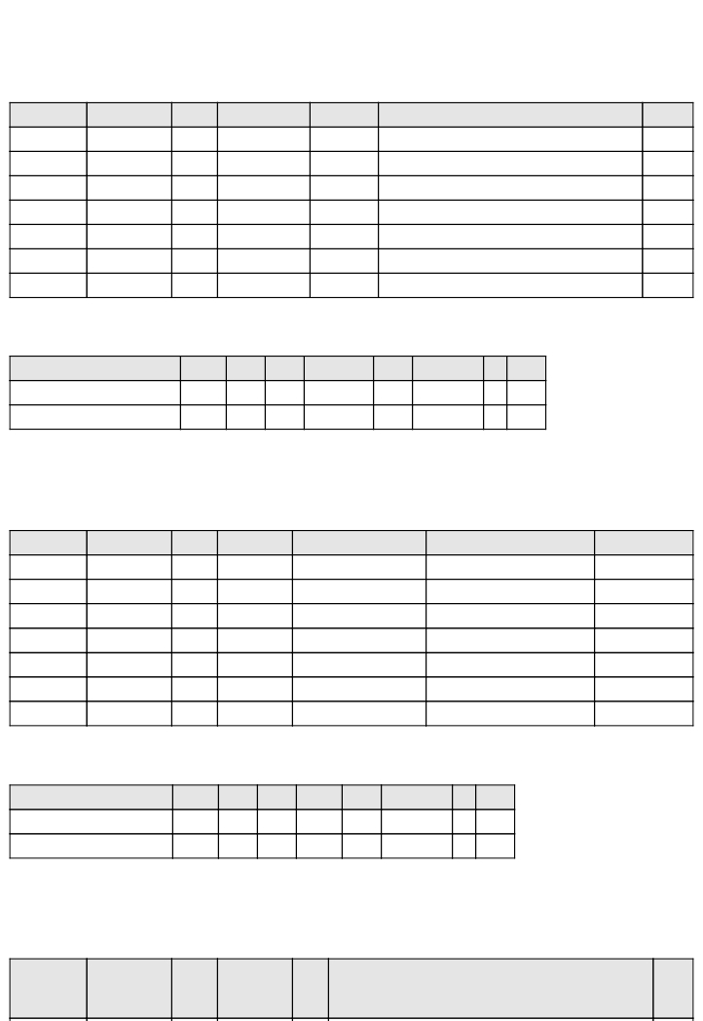

m_admin

表注释： 管理员表

索引

表注释： 文章表

m_article

索引

表注释： 属性名表

m_attr_name

字段 类型 空 默认

链

接

到

注释                   MIME

|  |  |  |  |  |  |  |
| --- | --- | --- | --- | --- | --- | --- |
| 字段 | 类型 | 空 | 默认 | 链接到 | 注释 | MIME |
| id (主键) | int(10) | 否 |  |  | 主键ID |  |
| cid | int(10) | 否 |  |  | 分类ID |  |
| name | char(255) | 否 |  |  | 品牌名 |  |
| desc | varchar(512) | 否 |  |  | 品牌描述 |  |
| img | char(255) | 否 | default.jpg |  | 品牌图片 |  |
| status | tinyint(3) | 否 | 1 |  | 状态：1：正常 2：热门 |  |

|  |  |  |  |  |  |  |
| --- | --- | --- | --- | --- | --- | --- |
| 字段 | 类型 | 空 | 默认 | 链接到 | 注释 | MIME |
| id (主键) | int(10) | 否 |  |  | 主键ID |  |
| anid | int(10) | 否 |  |  | 属性名ID |  |
| value | char(64) | 否 |  |  | 属性值 |  |

|  |  |  |  |  |  |  |
| --- | --- | --- | --- | --- | --- | --- |
| name | char(64) | 否 |  |  | 属性名 |  |
| type | tinyint(3) | 否 | 1 |  | 字段类型 1:input 2:select 3:checkbox  4:radio 5:file 6:address |  |

|  |  |  |  |  |  |  |  |  |
| --- | --- | --- | --- | --- | --- | --- | --- | --- |
| 键名 | 类型 | 唯一 | 紧凑 | 字段 | 基数 | 排序规则 | 空 | 注释 |
| PRIMARY | BTREE | 是 | 否 | id | 0 | A | 否 |  |
| attr_name_name_unique | BTREE | 是 | 否 | name | 0 | A | 否 |  |

|  |  |  |  |  |  |  |  |  |
| --- | --- | --- | --- | --- | --- | --- | --- | --- |
| 键名 | 类型 | 唯一 | 紧凑 | 字段 | 基数 | 排序规则 | 空 | 注释 |
| PRIMARY | BTREE | 是 | 否 | id | 0 | A | 否 |  |

|  |  |  |  |  |  |  |  |  |
| --- | --- | --- | --- | --- | --- | --- | --- | --- |
| 键名 | 类型 | 唯一 | 紧凑 | 字段 | 基数 | 排序规则 | 空 | 注释 |
| PRIMARY | BTREE | 是 | 否 | id | 0 | A | 否 |  |

索引

id (主键) int(10)    否                   主键ID

表注释： 属性值表

m_attr_value

索引

表注释： 品牌表

m_brand

索引

表注释： 购物车表

m_cart

|  |  |  |  |  |  |  |
| --- | --- | --- | --- | --- | --- | --- |
| 字段 | 类型 | 空 | 默认 | 链  接  到 | 注释 | MIME |
| id (主键) | int(10) | 否 |  |  | 主键ID |  |
| code | char(64) | 否 |  |  | 代金券码 |  |
| amount | decimal(10,2) | 否 | 10.00 |  | 面额 |  |
| status | tinyint(3) | 否 | 1 |  | 状态:1：未下发未使用 2：已下发未使用  3：已下发已使用 4：已下发已过期 |  |

|  |  |  |  |  |  |  |
| --- | --- | --- | --- | --- | --- | --- |
| uid | int(11) | 否 |  |  | 用户ID |  |
| gid | int(10) | 否 |  |  | 商品ID |  |
| mid | int(10) | 否 |  |  | 商户ID |  |
| money | decimal(10,2) | 否 |  |  | 单价 |  |
| standard | text | 是 | NULL |  | 规格详细信息 json数据 |  |
| num | int(10) | 否 |  |  | 数量 |  |
| create_at | int(10) | 否 |  |  | 创建时间 |  |

|  |  |  |  |  |  |  |
| --- | --- | --- | --- | --- | --- | --- |
| 字段 | 类型 | 空 | 默认 | 链接到 | 注释 | MIME |
| id (主键) | int(10) | 否 |  |  | 主键ID |  |
| name | char(64) | 否 |  |  | 分类名 |  |
| pid | int(10) | 否 | 0 |  | 父分类ID |  |
| path | char(255) | 否 | 0 |  | 路径 |  |
| status | tinyint(3) | 否 | 1 |  | 状态 1:正常 2:禁用 |  |

|  |  |  |  |  |  |  |  |  |
| --- | --- | --- | --- | --- | --- | --- | --- | --- |
| 键名 | 类型 | 唯一 | 紧凑 | 字段 | 基数 | 排序规则 | 空 | 注释 |
| PRIMARY | BTREE | 是 | 否 | id | 0 | A | 否 |  |

|  |  |  |  |  |  |  |  |  |
| --- | --- | --- | --- | --- | --- | --- | --- | --- |
| 键名 | 类型 | 唯一 | 紧凑 | 字段 | 基数 | 排序规则 | 空 | 注释 |
| PRIMARY | BTREE | 是 | 否 | id | 0 | A | 否 |  |

表注释： 代金券表

字段        类型       空     默认     链接到                注释                MIME

m_cashcoupon

索引

表注释： 分类表

m_cate

索引

表注释： 分类表

m_cate_attr

|  |  |  |  |  |  |  |
| --- | --- | --- | --- | --- | --- | --- |
| 字段 | 类型 | 空 | 默认 | 链接到 | 注释 | MIME |
| id (主键) | int(10) | 否 |  |  | 主键ID |  |
| uid | int(10) | 否 |  |  | 用户ID |  |
| gid | int(10) | 否 |  |  | 商品ID |  |
| level | tinyint(3) | 否 | 0 |  | 星级：1：1个星星... |  |
| title | char(255) | 否 |  |  | 标题 |  |
| content | varchar(512) | 否 |  |  | 内容 |  |
| status | tinyint(3) | 否 | 1 |  | 状态 1:审核中 2:正常显示 3:已屏蔽 |  |
| create_at | int(10) | 否 |  |  | 创建时间 |  |

|  |  |  |  |  |  |  |
| --- | --- | --- | --- | --- | --- | --- |
| 字段 | 类型 | 空 | 默认 | 链接到 | 注释 | MIME |
| id (主键) | int(10) | 否 |  |  | 主键ID |  |
| cid | int(10) | 否 |  |  | 分类ID |  |
| bid | int(10) | 否 |  |  | 品牌ID |  |
| mid | int(10) | 否 |  |  | 商户ID |  |
| code | char(24) | 否 |  |  | 商品编号 |  |
| name | char(255) | 否 |  |  | 商品名 |  |
| img | char(255) | 否 | default.jpg |  | 商品图片 |  |

|  |  |  |  |  |  |  |
| --- | --- | --- | --- | --- | --- | --- |
| 字段 | 类型 | 空 | 默认 | 链接到 | 注释 | MIME |
| cmid | int(10) | 否 |  |  | 评论ID |  |
| img | char(255) | 否 |  |  | 图片 |  |

|  |  |  |  |  |  |  |
| --- | --- | --- | --- | --- | --- | --- |
| 字段 | 类型 | 空 | 默认 | 链接到 | 注释 | MIME |
| cid | int(10) | 否 |  |  | 分类ID |  |
| anid | int(10) | 否 |  |  | 属性名ID |  |

|  |  |  |  |  |  |  |  |  |
| --- | --- | --- | --- | --- | --- | --- | --- | --- |
| 键名 | 类型 | 唯一 | 紧凑 | 字段 | 基数 | 排序规则 | 空 | 注释 |
| PRIMARY | BTREE | 是 | 否 | id | 0 | A | 否 |  |

表注释： 评论表

m_comment

索引

表注释： 评论配图表

m_comment_img

表注释： 商品表

m_goods

|  |  |  |  |  |  |  |
| --- | --- | --- | --- | --- | --- | --- |
| 字段 | 类型 | 空 | 默认 | 链接到 | 注释 | MIME |
| id (主键) | int(10) | 否 |  |  | 主键ID |  |
| uid | int(10) | 否 |  |  | 用户ID |  |
| oid | int(10) | 否 |  |  | 订单ID |  |
| gid | int(10) | 否 |  |  | 商品ID |  |
| order_no | char(24) | 否 |  |  | 订单编号 |  |
| company | char(64) | 否 |  |  | 物流公司名 |  |
| logi_no | char(64) | 否 |  |  | 物流单号 |  |
| content | text | 否 |  |  | 物流信息 |  |
| create_at | int(10) | 否 |  |  | 下单时间 |  |

|  |  |  |  |  |  |  |
| --- | --- | --- | --- | --- | --- | --- |
| 字段 | 类型 | 空 | 默认 | 链接到 | 注释 | MIME |
| id (主键) | int(10) | 否 |  |  | 主键ID |  |
| mid | int(10) | 否 |  |  | 商户ID |  |
| gid | int(10) | 否 |  |  | 商品ID |  |
| anid | int(10) | 否 |  |  | 属性名ID |  |
| avid | int(10) | 否 | 0 |  | 属性值ID |  |
| mavid | int(10) | 否 | 0 |  | 扩展商品属性值ID |  |

|  |  |  |  |  |  |  |
| --- | --- | --- | --- | --- | --- | --- |
| price | decimal(10,2) | 否 | 0.00 |  | 单价 |  |
| nums | int(10) | 否 | 0 |  | 数量 |  |
| create_at | int(10) | 否 |  |  | 创建时间 |  |
| update_at | int(10) | 否 |  |  | 更新时间 |  |
| status | tinyint(3) | 否 | 1 |  | 状态 1:下架 2:正常(上架) 3:已删除 |  |
| recomm | tinyint(3) | 否 | 0 |  | 是否推荐 0:不推荐 1：推荐 |  |

|  |  |  |  |  |  |  |  |  |
| --- | --- | --- | --- | --- | --- | --- | --- | --- |
| 键名 | 类型 | 唯一 | 紧凑 | 字段 | 基数 | 排序规则 | 空 | 注释 |
| PRIMARY | BTREE | 是 | 否 | id | 0 | A | 否 |  |

|  |  |  |  |  |  |  |  |  |
| --- | --- | --- | --- | --- | --- | --- | --- | --- |
| 键名 | 类型 | 唯一 | 紧凑 | 字段 | 基数 | 排序规则 | 空 | 注释 |
| PRIMARY | BTREE | 是 | 否 | id | 0 | A | 否 |  |

索引

desc      text          否                       商品描述

表注释： 商品属性表

m_goods_attr

索引

表注释： 退货表

m_goods_back

|  |  |  |  |  |  |  |
| --- | --- | --- | --- | --- | --- | --- |
| 字段 | 类型 | 空 | 默认 | 链接到 | 注释 | MIME |
| id (主键) | int(10) | 否 |  |  | 主键ID |  |
| hcid | int(10) | 否 |  |  | 帮助分类ID |  |
| title | char(64) | 否 |  |  | 标题 |  |
| content | text | 否 |  |  | 内容 |  |
| ctime | int(10) | 否 |  |  | 创建时间 |  |
| utime | int(10) | 否 |  |  | 修改时间 |  |

|  |  |  |  |  |  |  |
| --- | --- | --- | --- | --- | --- | --- |
| 字段 | 类型 | 空 | 默认 | 链接到 | 注释 | MIME |
| id (主键) | int(10) | 否 |  |  | 主键ID |  |
| mid | int(10) | 否 |  |  | 商户ID |  |
| gid | int(10) | 否 |  |  | 商品ID |  |
| name | char(64) | 否 |  |  | 参数名 |  |
| value | char(255) | 否 |  |  | 参数值 |  |

|  |  |  |  |  |  |  |
| --- | --- | --- | --- | --- | --- | --- |
| 字段 | 类型 | 空 | 默认 | 链接到 | 注释 | MIME |
| gid | int(10) | 否 |  |  | 商品ID |  |
| title | char(128) | 否 |  |  | 图片描述 |  |
| img | char(255) | 否 |  |  | 图片路径 |  |
| sq | tinyint(4) | 否 | 0 |  | 排序 |  |

|  |  |  |  |  |  |  |  |  |
| --- | --- | --- | --- | --- | --- | --- | --- | --- |
| 键名 | 类型 | 唯一 | 紧凑 | 字段 | 基数 | 排序规则 | 空 | 注释 |
| PRIMARY | BTREE | 是 | 否 | id | 0 | A | 否 |  |

|  |  |  |  |  |  |  |  |  |
| --- | --- | --- | --- | --- | --- | --- | --- | --- |
| 键名 | 类型 | 唯一 | 紧凑 | 字段 | 基数 | 排序规则 | 空 | 注释 |
| PRIMARY | BTREE | 是 | 否 | id | 0 | A | 否 |  |

update_at int(10) 否 更新时间

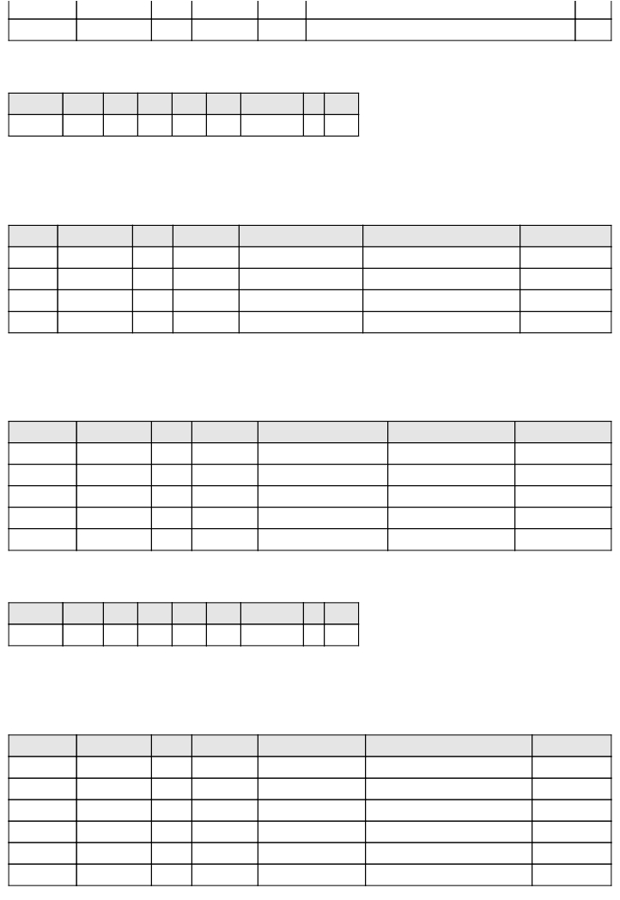

status tinyint(3) 否 1 状态:不为空 1:退货中 2:已退货 3:已退款

索引

表注释： 商品配图表

m_goods_img

表注释： 商品详细参数表

m_goods_params

索引

表注释： 帮助文章表

m_help

|  |  |  |  |  |  |  |
| --- | --- | --- | --- | --- | --- | --- |
| 字段 | 类型 | 空 | 默认 | 链接到 | 注释 | MIME |
| id (主键) | bigint(20) | 否 |  |  |  |  |
| queue | varchar(255) | 否 |  |  |  |  |
| payload | longtext | 否 |  |  |  |  |
| attempts | tinyint(3) | 否 |  |  |  |  |
| reserved | tinyint(3) | 否 |  |  |  |  |
| reserved_at | int(10) | 是 | NULL |  |  |  |
| available_at | int(10) | 否 |  |  |  |  |
| created_at | int(10) | 否 |  |  |  |  |

|  |  |  |  |  |  |  |
| --- | --- | --- | --- | --- | --- | --- |
| 字段 | 类型 | 空 | 默认 | 链接到 | 注释 | MIME |
| id (主键) | int(10) | 否 |  |  | 主键ID |  |
| name | char(64) | 否 |  |  | 分类名 |  |
| pid | int(10) | 否 | 0 |  | 父分类ID |  |
| path | char(255) | 否 | 0 |  | 路径 |  |
| status | tinyint(3) | 否 | 1 |  | 状态 1:正常 2:禁用 |  |

|  |  |  |  |  |  |  |  |  |
| --- | --- | --- | --- | --- | --- | --- | --- | --- |
| 键名 | 类型 | 唯  一 | 紧凑 | 字段 | 基数 | 排序规则 | 空 | 注释 |
| PRIMARY | BTREE | 是 | 否 | id | 0 | A | 否 |  |
| jobs_queue_reserved_reserved_at_index | BTREE | 否 | 否 | queue | 0 | A | 否 |  |
| reserved | 0 | A | 否 |
| reserved_at | 0 | A | 是 |

|  |  |  |  |  |  |  |  |  |
| --- | --- | --- | --- | --- | --- | --- | --- | --- |
| 键名 | 类型 | 唯一 | 紧凑 | 字段 | 基数 | 排序规则 | 空 | 注释 |
| PRIMARY | BTREE | 是 | 否 | id | 0 | A | 否 |  |
| help_title_unique | BTREE | 是 | 否 | title | 0 | A | 否 |  |

|  |  |  |  |  |  |  |  |  |
| --- | --- | --- | --- | --- | --- | --- | --- | --- |
| 键名 | 类型 | 唯一 | 紧凑 | 字段 | 基数 | 排序规则 | 空 | 注释 |
| PRIMARY | BTREE | 是 | 否 | id | 0 | A | 否 |  |

m_logistics

索引

表注释： 帮助分类表

m_help_cate

索引

索引

m_jobs

|  |  |  |  |  |  |  |
| --- | --- | --- | --- | --- | --- | --- |
| 字段 | 类型 | 空 | 默认 | 链接  到 | 注释 | MIME |
| id (主键) | int(10) | 否 |  |  | 主键ID |  |
| username | char(64) | 否 |  |  | 商户登录名 |  |
| password | char(255) | 否 |  |  | 商户登录密码 |  |
| name | char(128) | 否 |  |  | 商户名称 |  |
| account | decimal(10,2) | 否 | 0.00 |  | 保证金 |  |
| logo | char(255) | 否 | default.jpg |  | LOGO |  |
| desc | varchar(512) | 否 |  |  | 描述信息 |  |
| token | varchar(50) | 否 |  |  | 密码重置token |  |
| create_at | int(10) | 否 |  |  | 创建时间 |  |
| update_at | int(10) | 否 |  |  | 更新时间 |  |
| status | tinyint(3) | 否 | 1 |  | 状态:1、正常 0、禁用 |  |
| is_real_check | tinyint(3) | 否 | 0 |  | 是否已实名认证:1、已认证 0、未  认证 |  |

|  |  |  |  |  |  |  |
| --- | --- | --- | --- | --- | --- | --- |
| 字段 | 类型 | 空 | 默认 | 链接  到 | 注释 | MIME |
| id (主键) | int(10) | 否 |  |  | 主键ID |  |
| oid | int(10) | 否 |  |  | 订单ID |  |
| mid | int(10) | 否 |  |  | 商户ID |  |
| order_no | char(24) | 否 |  |  | 订单编号 |  |
| company | char(64) | 否 |  |  | 物流公司名 |  |
| logi_no | char(64) | 否 |  |  | 物流单号 |  |
| content | text | 否 |  |  | 物流信息 |  |
| create_at | int(10) | 否 |  |  | 创建时间 |  |
| update_at | int(10) | 否 |  |  | 更新时间 |  |
| status | tinyint(3) | 否 | 1 |  | 状态:不为空 1：已发货 2：在途中 3：已  送达 |  |

|  |  |  |  |  |  |  |  |  |
| --- | --- | --- | --- | --- | --- | --- | --- | --- |
| 键名 | 类型 | 唯一 | 紧凑 | 字段 | 基数 | 排序规则 | 空 | 注释 |
| PRIMARY | BTREE | 是 | 否 | id | 0 | A | 否 |  |

表注释： 物流表

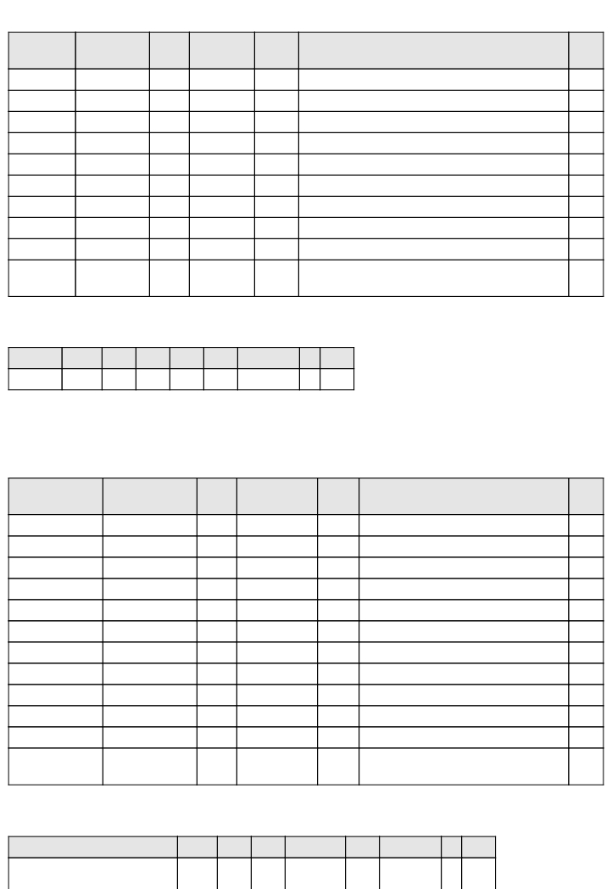

索引

表注释： 商户表

m_merchant

索引

键名 类型 唯一 紧凑  字段  基数 排序规则 空 注释

PRIMARY BTREE 是 否 id 0 A 否

|  |  |  |  |  |  |  |
| --- | --- | --- | --- | --- | --- | --- |
| 字段 | 类型 | 空 | 默认 | 链接到 | 注释 | MIME |
| mid | int(10) | 否 |  |  | 商户ID |  |
| name | char(64) | 否 |  |  | 负责人真实姓名 |  |
| email | char(128) | 否 |  |  | 负责人Email |  |
| phone | char(11) | 否 |  |  | 负责人手机 |  |
| sex | tinyint(3) | 否 | 0 |  | 性别 0:女,1:男 |  |
| cid_no | char(18) | 否 |  |  | 身份证号码 |  |
| cid_img | char(255) | 否 |  |  | 手持证件照片 |  |
| create_at | int(10) | 否 |  |  | 创建时间 |  |
| update_at | int(10) | 否 |  |  | 更新时间 |  |

|  |  |  |  |  |  |  |
| --- | --- | --- | --- | --- | --- | --- |
| 字段 | 类型 | 空 | 默认 | 链接到 | 注释 | MIME |
| id (主键) | int(10) | 否 |  |  | 主键ID |  |
| mid | int(10) | 否 |  |  | 商户ID |  |
| anid | int(10) | 否 |  |  | 标准属性ID |  |
| value | char(64) | 否 |  |  | 商户扩展属性值 |  |

|  |  |  |  |  |  |  |
| --- | --- | --- | --- | --- | --- | --- |
| 字段 | 类型 | 空 | 默认 | 链接到 | 注释 | MIME |
| id (主键) | int(10) | 否 |  |  | 主键ID |  |
| title | char(255) | 否 |  |  | 标题 |  |
| content | varchar(1024) | 否 |  |  | 内容 |  |

|  |  |  |  |  |  |  |  |  |
| --- | --- | --- | --- | --- | --- | --- | --- | --- |
| 键名 | 类型 | 唯一 | 紧凑 | 字段 | 基数 | 排序规则 | 空 | 注释 |
| merchant_detail_mid_unique | BTREE | 是 | 否 | mid | 0 | A | 否 |  |

|  |  |  |  |  |  |  |  |  |
| --- | --- | --- | --- | --- | --- | --- | --- | --- |
| 键名 | 类型 | 唯一 | 紧凑 | 字段 | 基数 | 排序规则 | 空 | 注释 |
| PRIMARY | BTREE | 是 | 否 | id | 0 | A | 否 |  |

merchant_username_unique BTREE 是 否 username 0 A 否

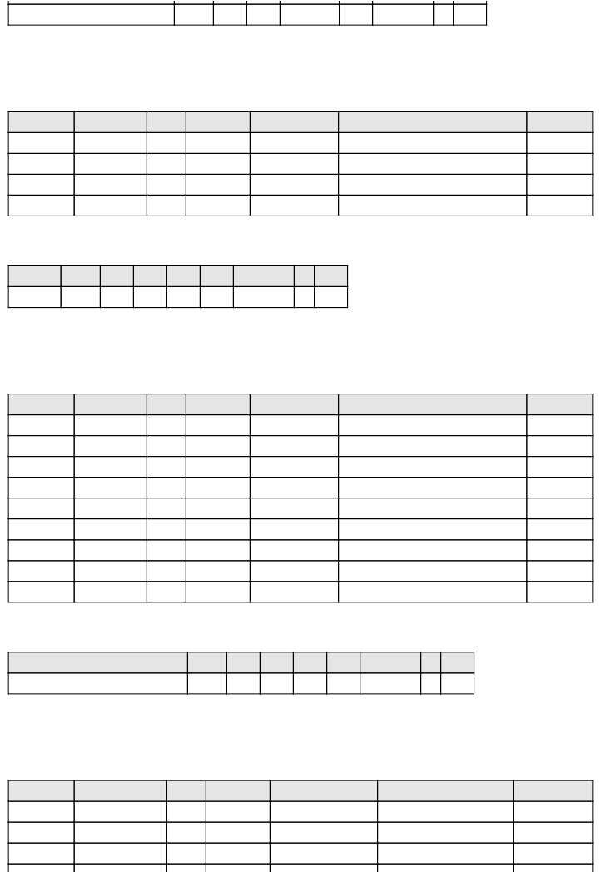

m_merchant_attr_value

表注释： 商户扩展属性值表

索引

表注释： 商户详情表

m_merchant_detail

索引

表注释： 站内消息表

m_messages

|  |  |  |  |  |  |  |
| --- | --- | --- | --- | --- | --- | --- |
| 字段 | 类型 | 空 | 默认 | 链  接  到 | 注释 | MIME |
| id (主键) | int(10) | 否 |  |  | 主键ID |  |
| uid | int(10) | 否 |  |  | 用户ID |  |
| order_no | char(24) | 否 |  |  | 订单编号 |  |
| title | char(255) | 否 |  |  | 订单名称 |  |
| desc | varchar(512) | 否 |  |  | 订单描述 |  |
| total | decimal(10,2) | 否 |  |  | 订单总金额 |  |
| expires_in | int(10) | 否 | 7200 |  | 有效时间:秒 默认2*3600 |  |
| create_at | int(10) | 否 |  |  | 创建时间 |  |
| update_at | int(10) | 否 |  |  | 修改时间 |  |
| status | tinyint(3) | 否 | 1 |  | 状态 1:待支付 2:已取消 3:交易关闭 4:已  支付 5:待发货 6:已发货 7:已收货 8:已完  成 9:退货中 10:已退货 11:已退款 |  |

|  |  |  |  |  |  |  |
| --- | --- | --- | --- | --- | --- | --- |
| 字段 | 类型 | 空 | 默认 | 链接到 | 注释 | MIME |
| oid | int(10) | 否 |  |  | 订单ID |  |
| aid | int(10) | 否 |  |  | 地址ID |  |

|  |  |  |  |  |  |  |
| --- | --- | --- | --- | --- | --- | --- |
| 字段 | 类型 | 空 | 默认 | 链接到 | 注释 | MIME |
| migration | varchar(255) | 否 |  |  |  |  |
| batch | int(11) | 否 |  |  |  |  |

|  |  |  |  |  |  |  |  |  |
| --- | --- | --- | --- | --- | --- | --- | --- | --- |
| 键名 | 类型 | 唯一 | 紧凑 | 字段 | 基数 | 排序规则 | 空 | 注释 |
| PRIMARY | BTREE | 是 | 否 | id | 0 | A | 否 |  |

|  |  |  |  |  |  |  |  |  |
| --- | --- | --- | --- | --- | --- | --- | --- | --- |
| 键名 | 类型 | 唯一 | 紧凑 | 字段 | 基数 | 排序规则 | 空 | 注释 |
| PRIMARY | BTREE | 是 | 否 | id | 0 | A | 否 |  |

create_at int(10) 否 创建时间

索引

表注释： 订单表

m_migrations

m_order

索引

表注释： 订单地址关联表

m_order_address

|  |  |  |  |  |  |  |
| --- | --- | --- | --- | --- | --- | --- |
| 字段 | 类型 | 空 | 默认 | 链  接  到 | 注释 | MIME |
| uid | int(10) | 否 |  |  | 用户ID |  |
| oid | int(10) | 否 |  |  | 订单ID |  |
| gid | int(10) | 否 |  |  | 商品ID |  |
| mid | int(10) | 否 |  |  | 商户ID |  |
| order_no | char(24) | 否 |  |  | 订单编号 |  |
| price | decimal(10,2) | 否 | 0.00 |  | 单价 |  |
| standard | text | 是 | NULL |  | 规格详细信息 json数据 |  |
| nums | int(10) | 否 | 0 |  | 数量 |  |
| create_at | int(10) | 否 |  |  | 创建时间 |  |
| update_at | int(10) | 否 |  |  | 修改时间 |  |
| status | tinyint(3) | 否 | 1 |  | 状态 1:待支付 2:已取消 3:交易关闭 4:已  支付 5:待发货 6:已发货 7:已收货 8:已完  成 9:退货中 10:已退货 11:已退款 |  |

|  |  |  |  |  |  |  |
| --- | --- | --- | --- | --- | --- | --- |
| 字段 | 类型 | 空 | 默认 | 链  接  到 | 注释 | MIME |
| id (主键) | int(10) | 否 |  |  | 主键ID |  |
| order_no | char(24) | 否 |  |  | 订单编号 |  |
| trade_no | char(64) | 否 |  |  | 支付平台流水号 |  |
| trade_status | tinyint(3) | 否 | 1 |  | 交易状态 1:处理中 2:交易成功  3:交易失败 |  |
| subject | char(255) | 否 |  |  | 商品名称 |  |
| body | varchar(3124) | 否 |  |  | 商品描述 |  |

|  |  |  |  |  |  |  |
| --- | --- | --- | --- | --- | --- | --- |
| 字段 | 类型 | 空 | 默认 | 链接到 | 注释 | MIME |
| oid | int(10) | 否 |  |  | 订单ID |  |
| payid | tinyint(3) | 否 | 1 |  | 支付方式ID |  |
| order_no | char(24) | 否 |  |  | 订单编号 |  |

m_order_detail

表注释： 订单详情表

表注释： 订单支付关联表

m_order_payway

表注释： 支付表

m_pay

手机号码

buyer_email         char(255)     否                 买家支付宝账号，可以是Email或

|  |  |  |  |  |  |  |
| --- | --- | --- | --- | --- | --- | --- |
| buyer_id | char(32) | 否 |  |  | 买家支付宝账户号买家支付宝账  号对应的支付宝唯一用户号 |  |
| total_fee | decimal(10,2) | 否 | 0.00 |  | 该笔订单的总金额 |  |
| is_total_fee_adjust | tinyint(3) | 否 | 0 |  | 是否调整总价 0:没有 1:调整过 |  |
| use_coupon | tinyint(3) | 否 | 0 |  | 是否在交易过程中使用了红包 0:  未使用 1:已使用 |  |
| extra_common_param | char(255) | 否 |  |  | 用于商户回传参数，该值不能包  含“=”、“&”等特殊字符。如  果用户请求时传递了该参数，则  返回给商户时会回传该参数。 |  |
| create_at | int(10) | 否 |  |  | 创建时间 |  |
| update_at | int(10) | 否 |  |  | 修改时间 |  |

|  |  |  |  |  |  |  |
| --- | --- | --- | --- | --- | --- | --- |
| 字段 | 类型 | 空 | 默认 | 链接  到 | 注释 | MIME |
| id (主键) | int(10) | 否 |  |  | 主键ID |  |
| username | char(64) | 否 |  |  | 登录名 |  |
| password | char(255) | 否 |  |  | 登录密码 |  |
| account | decimal(10,2) | 否 | 0.00 |  | 金额 |  |
| header | char(255) | 否 | default.jpg |  | 头像 |  |
| email | char(128) | 否 |  |  | Email |  |

|  |  |  |  |  |  |  |
| --- | --- | --- | --- | --- | --- | --- |
| 字段 | 类型 | 空 | 默认 | 链接到 | 注释 | MIME |
| id (主键) | int(10) | 否 |  |  | 主键ID |  |
| type | tinyint(3) | 否 | 1 |  | 类型 1:平台支付 2:网银支付 |  |
| way | tinyint(3) | 否 | 1 |  | 方式 1:支付宝 2:微信 |  |

|  |  |  |  |  |  |  |  |  |
| --- | --- | --- | --- | --- | --- | --- | --- | --- |
| 键名 | 类型 | 唯一 | 紧凑 | 字段 | 基数 | 排序规则 | 空 | 注释 |
| PRIMARY | BTREE | 是 | 否 | id | 0 | A | 否 |  |
| pay_order_no_unique | BTREE | 是 | 否 | order_no | 0 | A | 否 |  |

|  |  |  |  |  |  |  |  |  |
| --- | --- | --- | --- | --- | --- | --- | --- | --- |
| 键名 | 类型 | 唯一 | 紧凑 | 字段 | 基数 | 排序规则 | 空 | 注释 |
| PRIMARY | BTREE | 是 | 否 | id | 0 | A | 否 |  |

phone         char(11)      否                      手机号码

索引

表注释： 支付方式表

m_payway

索引

表注释： 用户表

m_user

|  |  |  |  |  |  |  |
| --- | --- | --- | --- | --- | --- | --- |
| 字段 | 类型 | 空 | 默认 | 链接到 | 注释 | MIME |
| id (主键) | int(10) | 否 |  |  | 主键ID |  |
| uid | int(10) | 否 |  |  | 用户ID |  |
| name | char(64) | 否 |  |  | 联系人 |  |
| phone | char(20) | 否 |  |  | 联系方式 |  |
| country | char(32) | 否 | 86 |  | 国家 |  |
| province | char(32) | 否 | 110000 |  | 省 |  |
| city | char(32) | 否 | 110100 |  | 市 |  |
| area | char(32) | 否 | 110101 |  | 区域 |  |
| detail | char(255) | 否 |  |  | 详细地址 |  |
| is_default | tinyint(3) | 否 | 0 |  | 是否为默认地址 0：否 1：是 |  |
| status | tinyint(3) | 否 | 1 |  | 状态 0：禁用 1：正常 |  |
| create_at | int(10) | 否 |  |  | 创建时间 |  |
| update_at | int(10) | 否 |  |  | 修改时间 |  |

|  |  |  |  |  |  |  |
| --- | --- | --- | --- | --- | --- | --- |
| score | int(10) | 否 | 50 |  | 积分 |  |
| max_score | int(10) | 否 | 50 |  | 最高积分 |  |
| level | tinyint(3) | 否 | 1 |  | 等级 |  |
| token | varchar(50) | 否 |  |  | 密码重置token |  |
| create_at | int(10) | 否 |  |  | 创建时间 |  |
| update_at | int(10) | 否 |  |  | 更新时间 |  |
| status | tinyint(3) | 否 | 1 |  | 状态:1、正常 0、禁用 |  |
| is_real_check | tinyint(3) | 否 | 0 |  | 是否已实名认证:1、已认证 0、未  认证 |  |

|  |  |  |  |  |  |  |  |  |
| --- | --- | --- | --- | --- | --- | --- | --- | --- |
| 键名 | 类型 | 唯一 | 紧凑 | 字段 | 基数 | 排序规则 | 空 | 注释 |
| PRIMARY | BTREE | 是 | 否 | id | 0 | A | 否 |  |
| user_username_unique | BTREE | 是 | 否 | username | 0 | A | 否 |  |

|  |  |  |  |  |  |  |  |  |
| --- | --- | --- | --- | --- | --- | --- | --- | --- |
| 键名 | 类型 | 唯一 | 紧凑 | 字段 | 基数 | 排序规则 | 空 | 注释 |
| PRIMARY | BTREE | 是 | 否 | id | 0 | A | 否 |  |

索引

表注释： 用户收藏表

m_user_address

索引

表注释： 用户代金券表

m_user_cash

|  |  |  |  |  |  |  |
| --- | --- | --- | --- | --- | --- | --- |
| 字段 | 类型 | 空 | 默认 | 链接到 | 注释 | MIME |
| uid | int(10) | 否 |  |  | 用户ID |  |
| name | char(64) | 否 |  |  | 真实姓名 |  |
| age | tinyint(3) | 否 | 0 |  | 年龄 |  |
| sex | tinyint(3) | 否 | 0 |  | 性别 0:女,1:男 |  |
| qq | char(64) | 否 |  |  | QQ |  |
| cid_no | char(18) | 否 |  |  | 身份证号码 |  |
| cid_prev_img | char(255) | 否 |  |  | 身份证正面照片 |  |
| cid_reverse_img | char(255) | 否 |  |  | 身份证反面照片 |  |
| create_at | int(10) | 否 |  |  | 创建时间 |  |
| update_at | int(10) | 否 |  |  | 更新时间 |  |

|  |  |  |  |  |  |  |
| --- | --- | --- | --- | --- | --- | --- |
| uid | int(10) | 否 |  |  | 用户ID |  |
| cashid | int(10) | 否 |  |  | 代金券ID |  |
| expires_in | int(10) | 否 | 604800 |  | 有效时间:秒 |  |
| get_time | int(10) | 否 |  |  | 获取时间 |  |
| use_time | int(10) | 否 |  |  | 使用时间 |  |
| end_time | int(10) | 否 |  |  | 结束时间 |  |

|  |  |  |  |  |  |  |
| --- | --- | --- | --- | --- | --- | --- |
| 字段 | 类型 | 空 | 默认 | 链接到 | 注释 | MIME |
| id (主键) | int(10) | 否 |  |  | 主键ID |  |
| uid | int(10) | 否 |  |  | 用户ID |  |
| action | tinyint(3) | 否 | 1 |  | 动作：0：减 1：加 |  |
| value | int(10) | 否 |  |  | 数值 |  |
| create_at | int(10) | 否 |  |  | 创建时间 |  |

|  |  |  |  |  |  |  |  |  |
| --- | --- | --- | --- | --- | --- | --- | --- | --- |
| 键名 | 类型 | 唯一 | 紧凑 | 字段 | 基数 | 排序规则 | 空 | 注释 |
| user_detail_uid_unique | BTREE | 是 | 否 | uid | 0 | A | 否 |  |

|  |  |  |  |  |  |  |  |  |
| --- | --- | --- | --- | --- | --- | --- | --- | --- |
| 键名 | 类型 | 唯一 | 紧凑 | 字段 | 基数 | 排序规则 | 空 | 注释 |
| PRIMARY | BTREE | 是 | 否 | id | 0 | A | 否 |  |

表注释： 用户详情表

字段       类型      空     默认        链接到               注释              MIME

m_user_detail

索引

表注释： 用户积分表

m_user_score

索引

|  |  |  |  |  |  |  |
| --- | --- | --- | --- | --- | --- | --- |
| 字段 | 类型 | 空 | 默认 | 链接到 | 注释 | MIME |
| id (主键) | int(10) | 否 |  |  | 主键ID |  |
| uid | int(10) | 否 |  |  | 用户ID |  |
| type | tinyint(3) | 否 | 1 |  | 类型：1：商品 2：品牌 |  |
| typeid | int(10) | 否 |  |  | 商品|品牌ID |  |
| create_at | int(10) | 否 |  |  | 创建时间 |  |

|  |  |  |  |  |  |  |  |  |
| --- | --- | --- | --- | --- | --- | --- | --- | --- |
| 键名 | 类型 | 唯一 | 紧凑 | 字段 | 基数 | 排序规则 | 空 | 注释 |
| PRIMARY | BTREE | 是 | 否 | id | 0 | A | 否 |  |

使用配置文件中定义的控制用户连接失败。

m_user_store



表注释： 用户积分表

索引