Gene expression coding challenge – output
Summary Statistics
Number of significantly upregulated and downregulated genes:
File | Total Genes Analysed | Upregulated Genes | Downregulated Genes
G vs D | 6343 | 825 | 1175
I vs E | 6343 | 994 | 1279

Summary of log2 Fold Changes and p-values
G vs D
Stat | Log2 Fold Change | P value | Adjusted p value
Min | -26.06 | 0 | 0
Median | -0.046 | 0.0257 | 0.0513
Mean | -0.177 | 0.207 | 0.247
Max | 20.50 | 1 | 1

I vs E
Stat | Log2 Fold Change | P value | Adjusted p value
Min | -24.89 | 0 | 0
Median | -0.0027 | 0.0145 | 0.0289
Mean | -0.153 | 0.198 | 0.234
Max | 20.84 | 1 | 1

Volcano plots
G vs D. Figure 1.
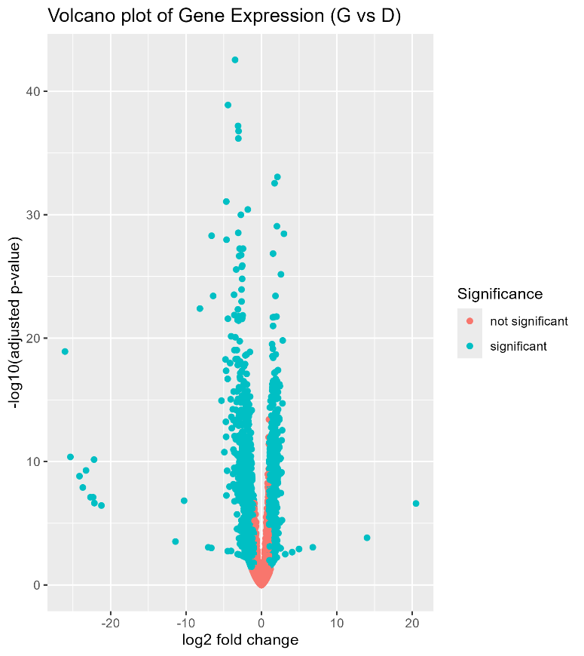
Figure. 1. Volcano plot of differential gene expression for the G vs D files summarising magnitude and significance of changes in gene expression for each comparison. The x-axis represents log2 fold change, showing size and direction of expression differences, while the y axis shows the adjusted p value. Colours indicate whether a gene has met the significance threshold (adjusted p value <0.05 and log2FC at ≥ 1) highlighted in the teal shade, and non significant genes highlighted in red. Most of the genes are clustering at log2 fold change close to zero, this indicates the majority of genes are showing minimal difference in expression between G and D. A large number of the genes are statistically significant even at smaller log2fc values.

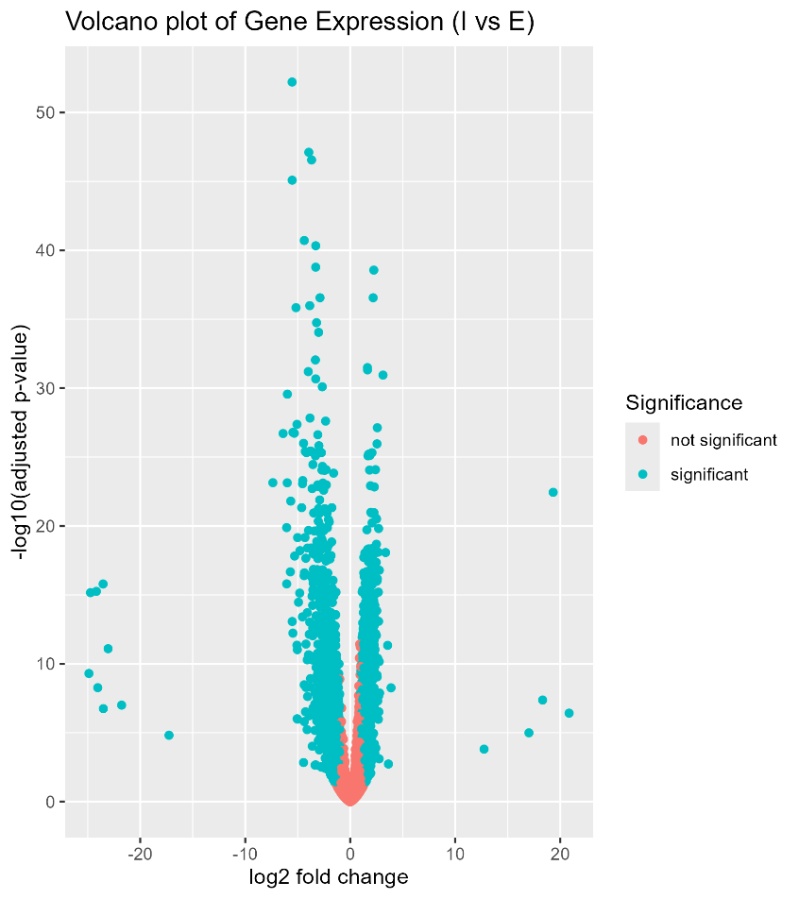
I vs E

Figure.2. The volcano plot visualises the magnitude and statistical significance of gene expression changes. The x-axis represents log2 fold change, showing size and direction of expression differences, while the y axis shows the adjusted p value. Colours indicate whether a gene has met the significance threshold (adjusted p value <0.05 and log2FC at ≥ 1) highlighted in the teal shade, and non significant genes highlighted in red. A small number of outlier genes exhibit higher statistical significance here, indicating good evidence.

MA plots
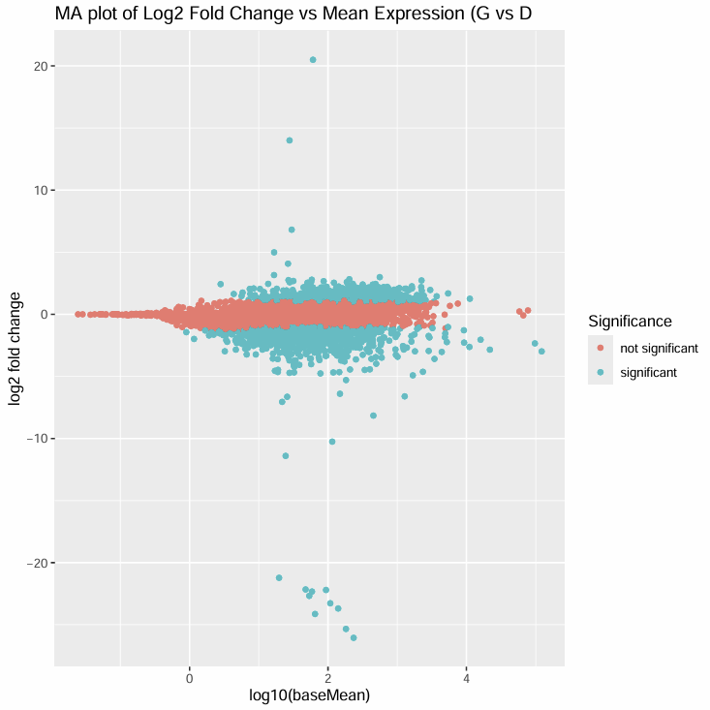
Figure. 3. An MA plot of differential gene expression (G vs D). The x axis represents log19(baseMean) while the Y axis depicts log2 fold change. Genes meeting the significance criteria (adjusted p value <0.05 and log2FC at ≥ 1) are highlighted in teal while non significant are highlighted in red, showing the relationship between log fold change and mean expression.
I vs E
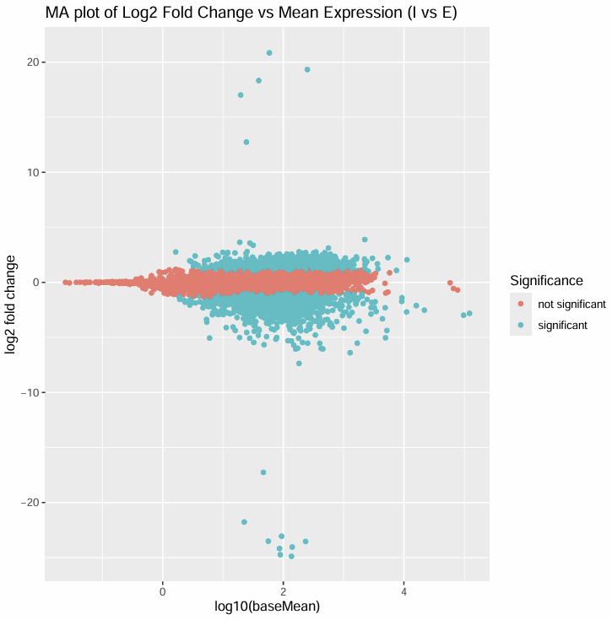
Figure.4. An MA plot of differential gene expression (I vs E). The x axis represents log19(baseMean) while the Y axis depicts log2 fold change. Genes meeting the significance criteria (adjusted p value <0.05 and log2FC at ≥ 1) are highlighted in teal while non significant are highlighted in red, showing the relationship between log fold change and mean expression.
P – Value Distributions
G vs D
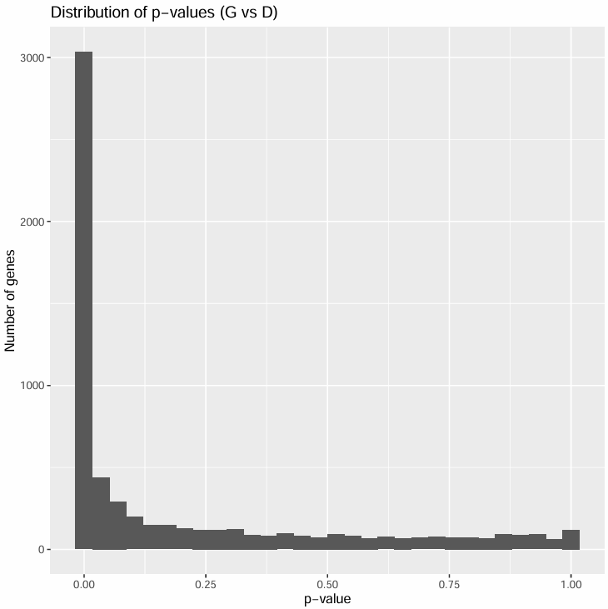
Figure.5. Histogram depicting distribution of raw p values across all the genes that were in the G vs D files. High number of genes with lower p-valyes indicates that many genes show statistically significant differences in expression.

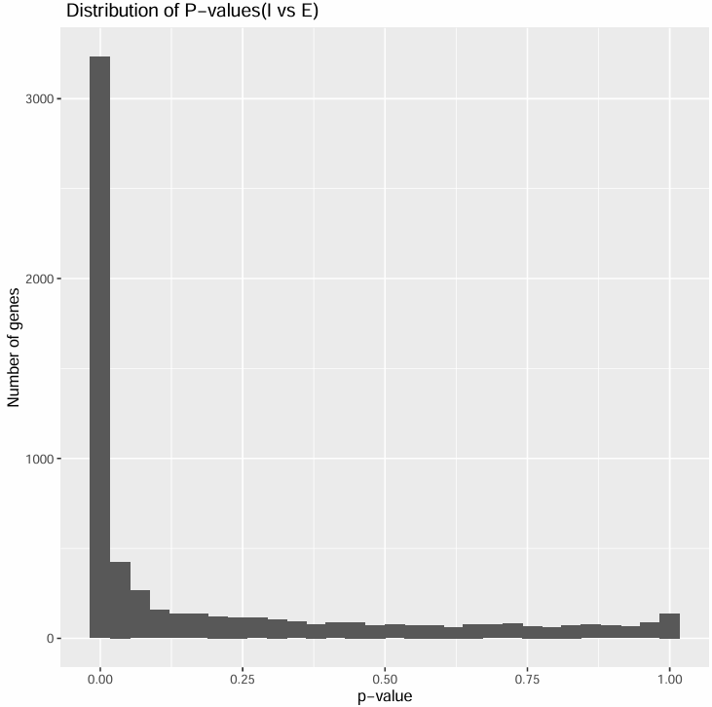
I vs E

Figure.6. Histogram depicting distribution of raw p values across all the genes that were in the I vs E files. High number of genes with lower p-valyes indicates that many genes show statistically significant differences in expression.

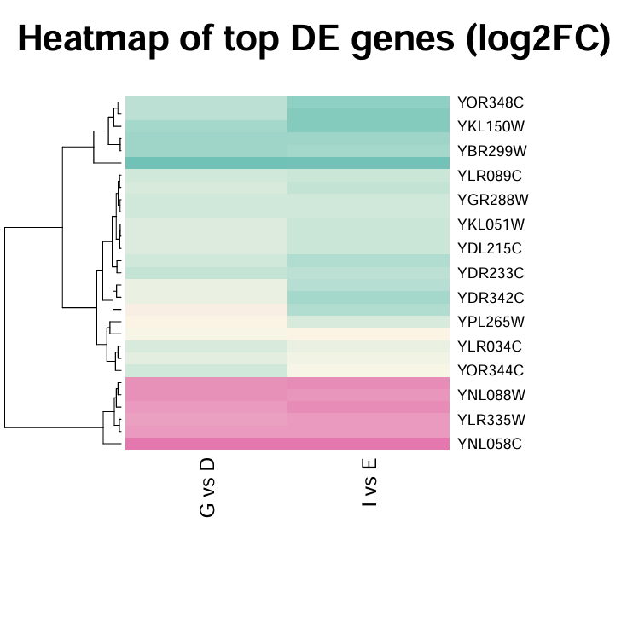
Heatmap of Differentially Expressed Genes

Figure.7. The heatmap shows log2 fold change values for the most significant genes from the G vs D and I vs E conditions (genes from both were merged into a single heatmap) Colours represent the log2 fold change values, with negative values (representing down regulation) highlighted in teal, values near zero (which also included NA values), and positive values (representing upregulation) in pink.

Tables
Top 10 significantly upregulated and downregulated genes per file ( G vs D, I vs E). Full tables of significant genes are provided in the csv files in the repo.
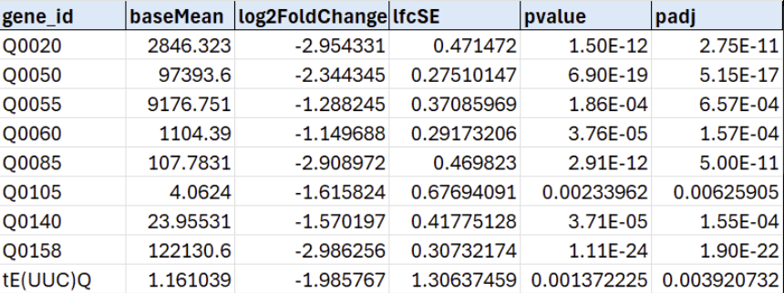
G vs D significantly downregulated genes:

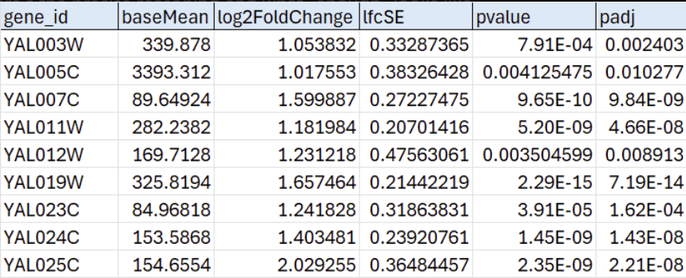
G vs D significantly upregulated genes:

I vs E significantly downregulated genes:
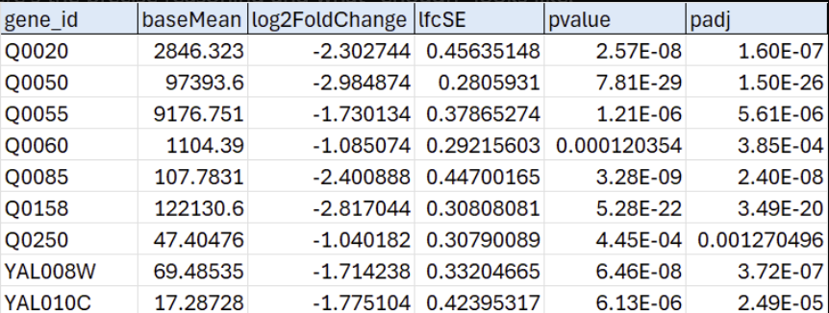

I vs E significantly upregulated genes:
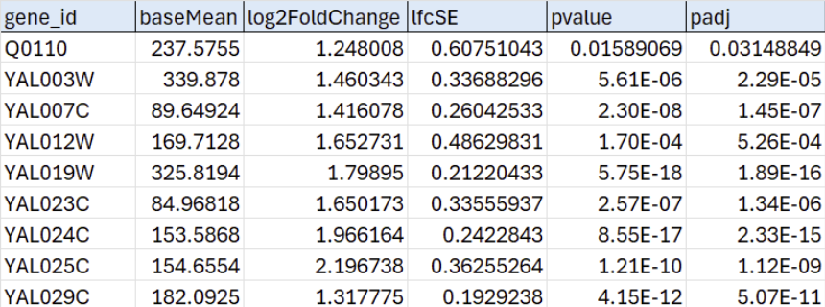
Additional Analyses:
Using some of the significant genes outlined on the heatmap, it can be proposed that amino acid uptake may be impacted by differentially expressed genes. For example, the gene identified as YOR348C on the heatmap (PUT4) encodes a proline permease which is an amino acid transporter. Furthermore, DIP5 (YPL265W) encodes a transporter for the amino acids glutamate and aspartate, so if these two genes are upregulated then it would increase the import of these amino acids. The inverse also applies where downregulation would limit uptake and reduce the availability of these amino acids.
Another biological pathway that may be impacted is lipid biosynthesis. YKL150W corresponds to the gene MCR1, which encodes a mitochondrial NADH-cytochrome b5 reductase. This helps move electrons from NADH onto cytochrome b5 which is then used to support ergosterol reactions that require an electron transfer. Ergosterol is found in cell membranes of fungi, differential expression of MCR1 could lead to increased or decreased permeability and impact how cells are able to respond to environmental stimuli.

