Identify the heaviest pumpkin grown in any of the competitions – what variety was it? Where was it from and when was it grown?
The heaviest pumpkin in the dataset:
Variety: Howden
Where: Castelfiorentino Tuscany Italy
When: 2021
Plot the relationship between estimated weight and actual weight of the pumpkins
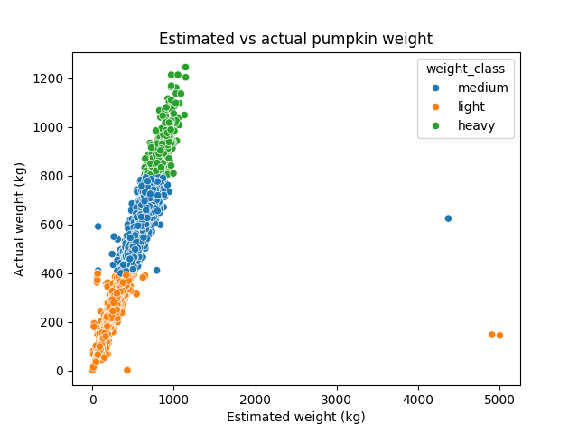

This scatterplot depicts the relationship between estimated weight and actual weight of the pumpkins in kg. Data points are coloured by weight classification (light, medium or heavy). There is a positive relationship, higher estimated weights correspond to higher actual weights. A small number of points are extreme outliers for the light and medium pumpkins, with estimates that are improbably high relative to the actual weight. This is likely due to data entry mistakes.
a. Identify the mean weight of pumpkins for each of your three countries. Which country had the highest mean pumpkin weight?
- Mean weight by country (kg)
Canada 350.707673
Germany 279.605169
United States 384.199060
The country with the highest mean pumpkin weight was the United States

b. Identify the mean weight for each variety of pumpkin for each of your countries. Which variety in which country had the lowest mean weight?
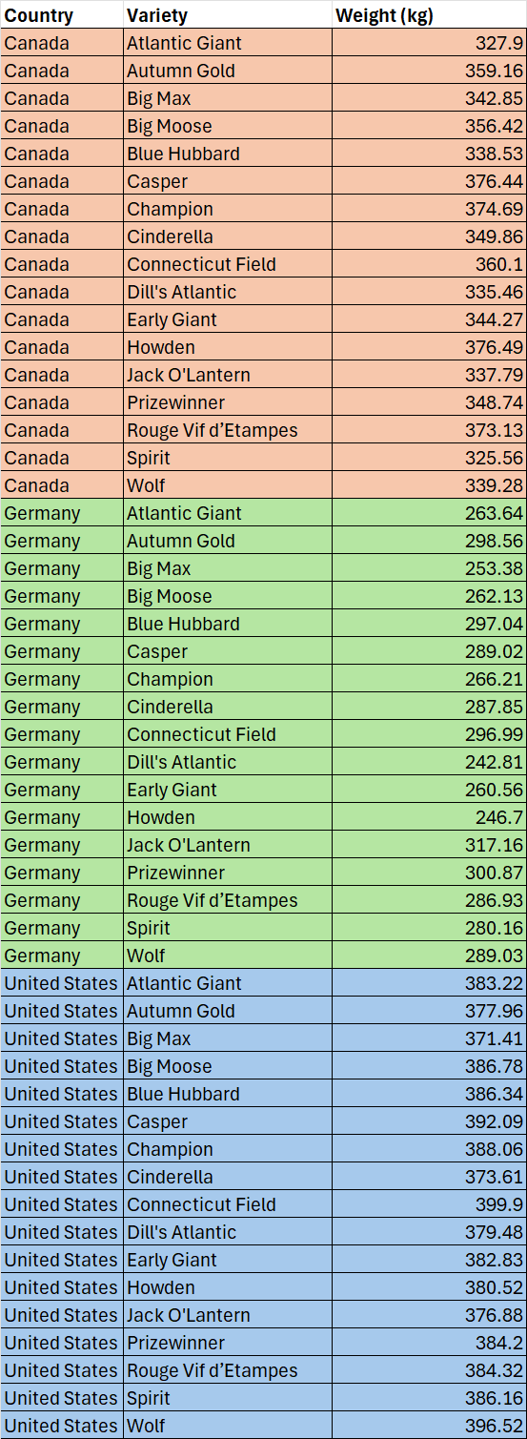
b)

The lowest mean weight was for Dill’s Atlantic in Germany

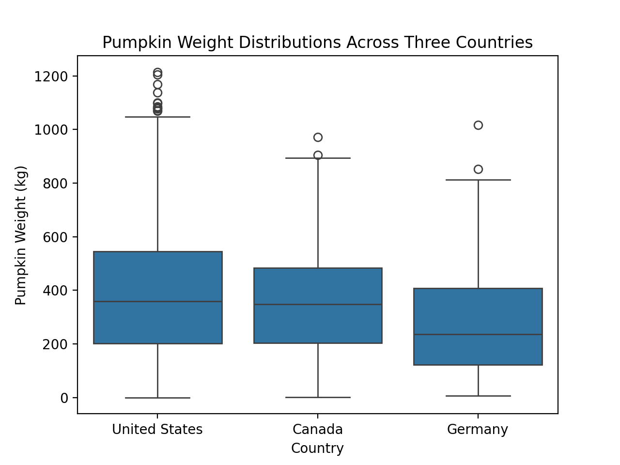
Using your filtered data set from question 6, plot pumpkin weight distributions (in either lbs or kg) for your three countries as a boxplot.
This boxplot compares the distribution of pumpkin weights for the three selected countries. The US and Canada have higher medians around the 350kg range while Germany’s median is lower at around 250kg range. The US has the widest interquartile range, Canada’s is similar and Germany’s distribution is lower overall. The US has the largest outliers both in weight and frequency, reaching at 1200kg. Canada and Germany have fewer numbers of outliers. Overall, pumpkins are heavier in the US and Canada than in Germany.

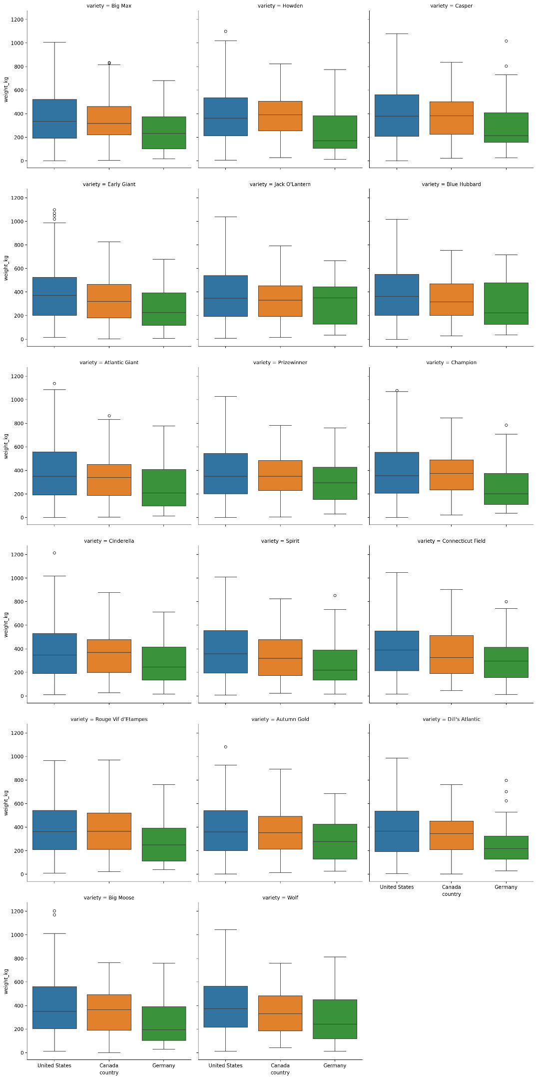
Redraw your plot from question 8 as a facet plot showing the data from each variety of pumpkin as a separate sub-plot.

This is a facet plot, each panel is a pumpkin variety and within that there is a comparison of weight distribution across the three selected countries. Blue represents the US. Orange represents Canada and green represents Germany.

