EJERCICIO PRÁCTICO ED RUBÉN LÓPEZ 44870861T

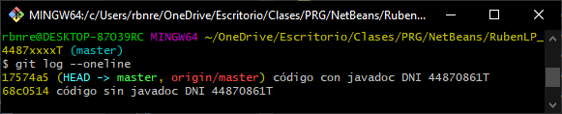

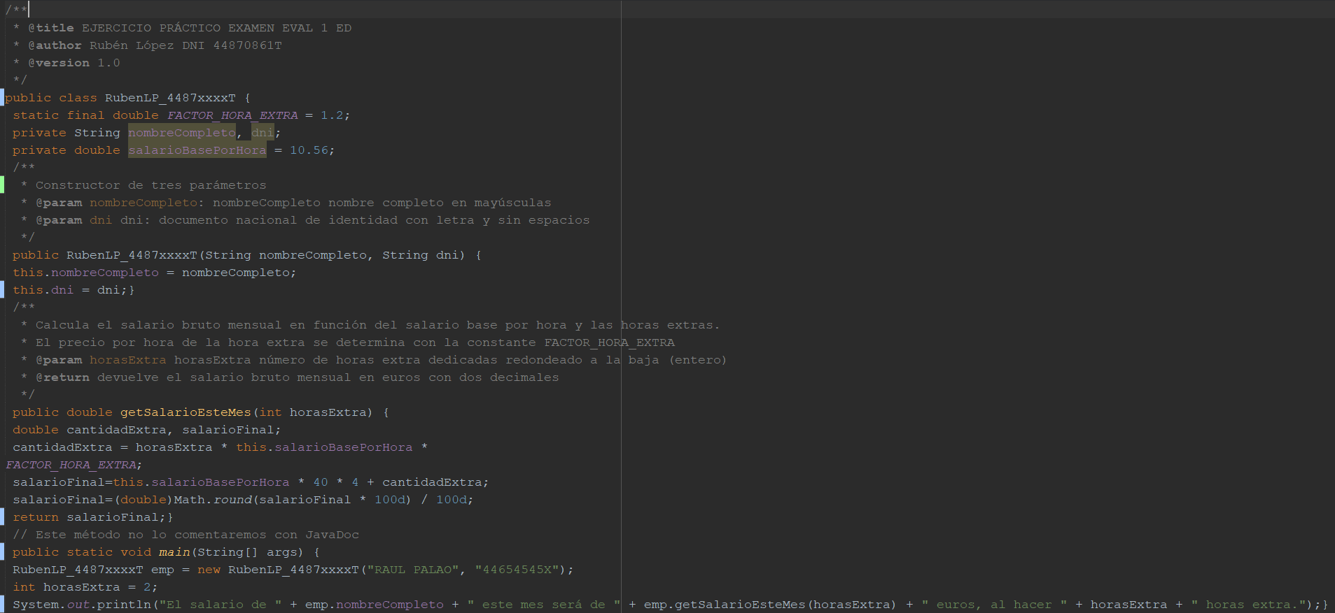

<https://github.com/lpxrevolution/-ED_EXAMEN_TURNO_C>

<https://github.com/lpxrevolution/ED_EXAMEN_TURNO_C_JAVADOC>

<https://rubenlopezjavadoc-c.netlify.app/rubenlp_4487xxxxt>