**We install the virtual disks.**

**As it is a test we do not need a lot of capacity.**

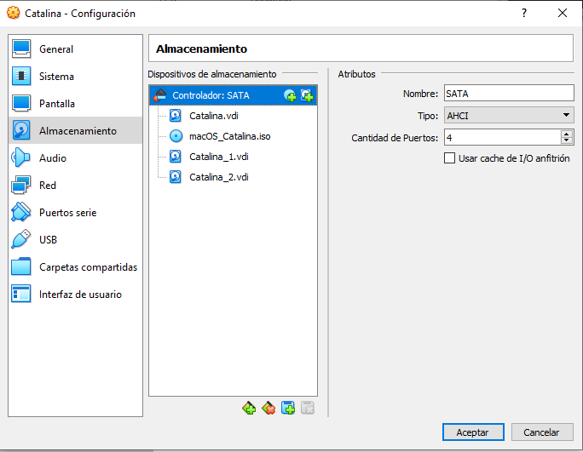

**Once inside the system, it warns us that there are new discs.**

**We initialize them or we won't be able to use them.**

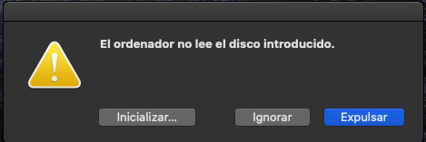

**We open the terminal.**



**We use the *diskutil list* command to list them and know which ones to use.**

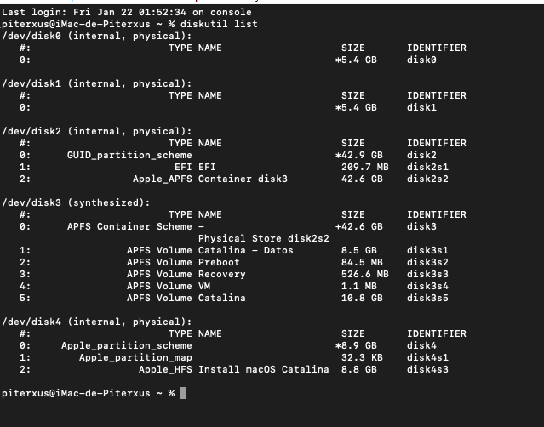

**Now by**

***diskutil ar create stripe TestRAID JHFS + disk0 disk1***

**the process will begin.**

**(I point out that testRAID is the name that I have given to my RAID, we can use whatever we want. JHFS refers to the file system and obviously we indicate the disks involved).**

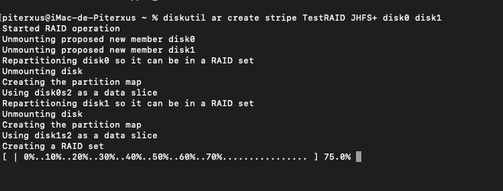

**Once created, it will notify us if the process has been successful.**

**We can check it by, again, the *diskutil list* command or by interface.**

