Tow

**MyTest**MyTestList

Document Title

A plain paragraph having some **bold** and some *italic.*

# Heading, level 1

Intense quote

* first item in unordered list

1. first item in ordered list

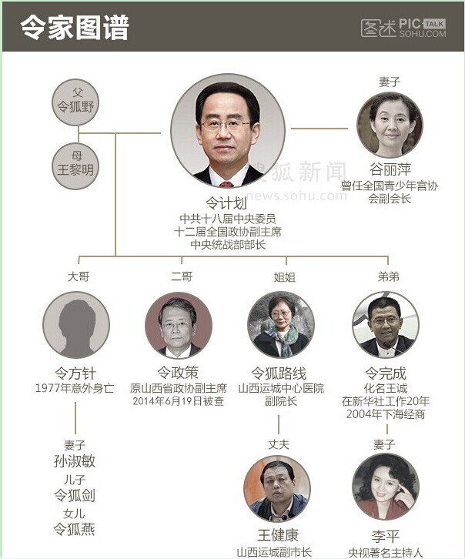









Intense quote

|  |  |  |
| --- | --- | --- |
| Qty | Id | Desc |
| li | 1   |  |  |  | | --- | --- | --- | | Qty | Id | Desc | | lipeng |
| tan | 2 | laotan |

|  |  |  |
| --- | --- | --- |
| Qty | Id | Desc |
| li | 1 | lipeng |
| tan | 2 | laotan |